Question | 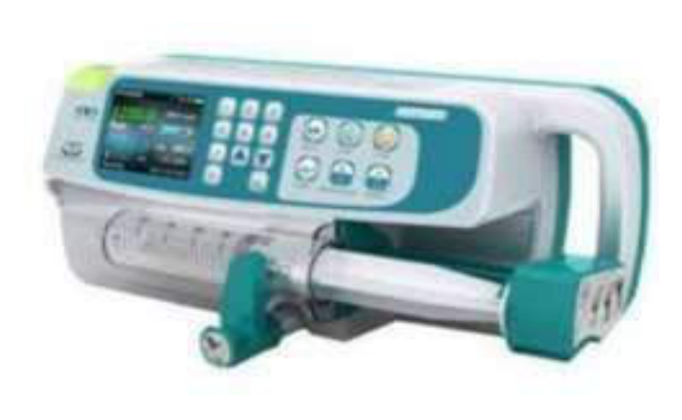  Identify the image?
Type | multiple_choice
Option | Aplasto pump
Option | Infusion Pump
Option | Syringe pump
Option | Infusion controller
Answer | 2
Solution | Rationale: Infusion Pump: An electronic device that delivers fluids, medications, and nutrients at controlled rates. Uses pressure sensors and microprocessors to ensure accurate delivery with occlusion and air detection. Key Clues: Electronic device with digital display, controls flow rate Why Not Others: B-Aplasto pump is not standard; C-Syringe pump uses syringe; D-Infusion controller is simpler without pressure sensing Exam Trap: Infusion pump vs controller - pump has pressure sensing and alarms, controller just regulates drip rate PNC Pearl: Infusion pump: Always verify programming. Check for air bubbles. Know occlusion alarm (yellow/red). Most common error: programming error (wrong rate/volume).
Positive Marks | 1
Negative Marks | 0.33

Question | 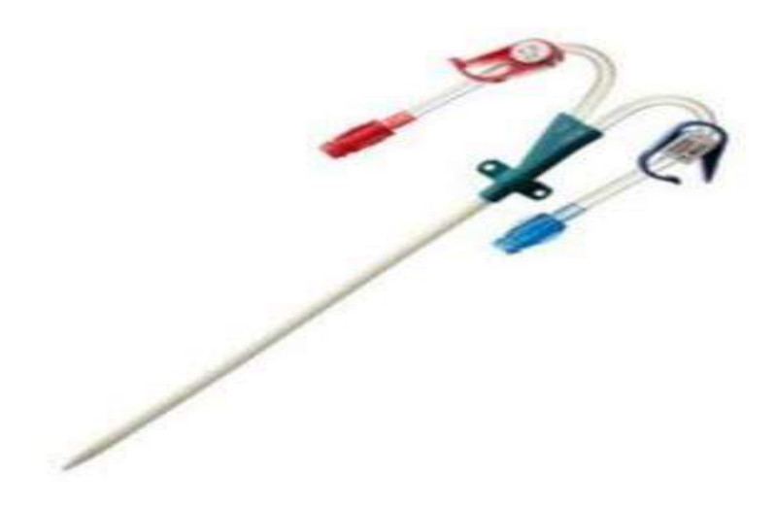  Identify the image:
Type | multiple_choice
Option | Central line
Option | PICC line
Option | Dialysis catheter
Option | Suction catheter
Answer | 3
Solution | Rationale: Dialysis Catheter: A large-bore dual or triple lumen catheter inserted into a large vein (usually femoral, internal jugular, or subclavian) for hemodialysis. Allows high blood flow rates. Key Clues: Dual/triple lumen, large bore, for dialysis access Why Not Others: A-Central line is for CVP/medications; B-PICC is peripherally inserted; D-Suction catheter is for airway Exam Trap: Dialysis catheter vs central line - dialysis catheter is larger bore for higher flow rates PNC Pearl: Dialysis catheter: Temporary = femoral (short-term), Tunneled = subclavian/IJ (long- term). Flow rate 200-400 ml/min. Always check for kinks and proper position.
Positive Marks | 1
Negative Marks | 0.33

Question | 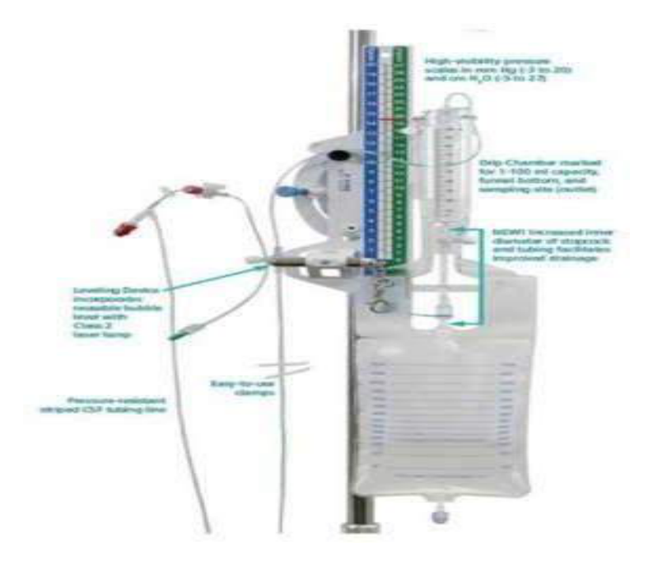  Identify the image:
Type | multiple_choice
Option | CVP set
Option | EVD set
Option | ICD set
Option | EBT
Answer | 1
Solution | Rationale: CVP Set (Central Venous Pressure Monitoring Set): A system for measuring central venous pressure through a central line. Includes manometer, stopcocks, transducer, and connecting tubing. Key Clues: Manometer/transducer, stopcocks, for CVP monitoring Why Not Others: A-EVD is for brain;B-ICD is for chest;C-EBT is for esophagus Exam Trap: CVP set vs arterial line - CVP measures venous pressure, arterial line measures arterial pressure PNC Pearl: CVP: Normal 2-6 mmHg. Measured at phlebostatic axis (4th ICS, mid-clavicular line). Use zero reference. Measure at end-expiration. Interpret: Low = hypovolemia, High = fluid overload/cardiac tamponade.
Positive Marks | 1
Negative Marks | 0.33

Question | 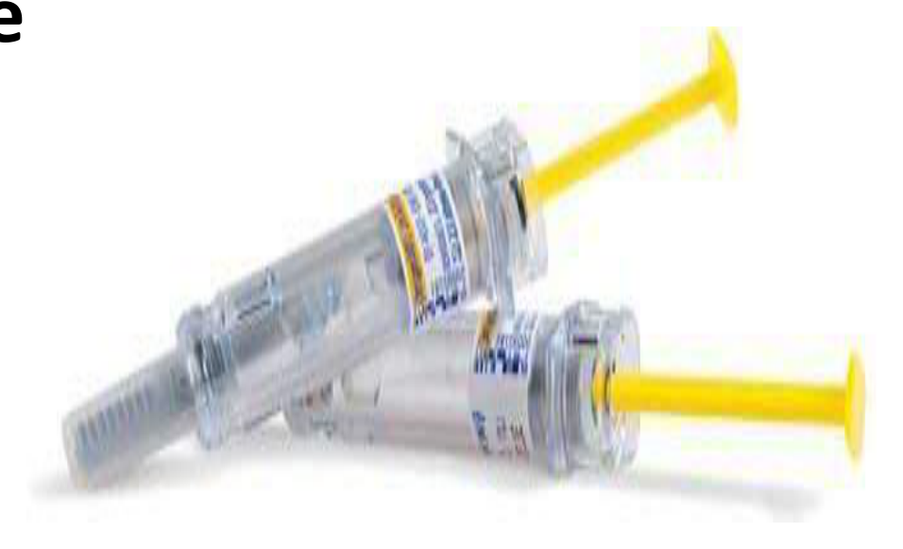  Identify the image:
Type | multiple_choice
Option | Enoxaparin
Option | Tuberculin syringe
Option | AST syringe
Option | Insulin syringe
Answer | 4
Solution | Rationale: Insulin Syringe: A small syringe (0.3-1ml) with fine needle (29-31G) designed for subcutaneous insulin injection. Has units (U-100) marked instead of milliliters for precise dosing. Key Clues: Fine needle, units marked, for subcutaneous insulin Why Not Others: B-Enoxaparin syringe is pre-filled;C-Tuberculin is for TB testing;D-AST syringe is not standard Exam Trap: Insulin vs tuberculin syringe - insulin has U-100 units marked, tuberculin has ml markings PNC Pearl: Insulin syringe: Always use correct syringe (U-100). Rotate injection sites (abdomen, thigh, arm). Never share syringes. Store opened insulin at room temperature for 28 days.
Positive Marks | 1
Negative Marks | 0.33

Question | 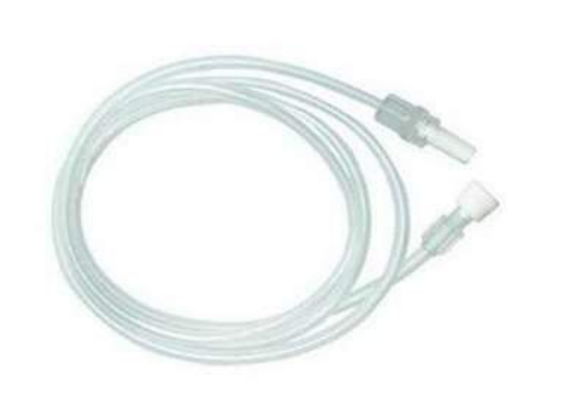  Identify the image:
Type | multiple_choice
Option | CVP line
Option | IV set
Option | PMO line
Option | Extension adapter
Answer | 1
Solution | Rationale: CVP Line (Central Venous Pressure Line): A catheter inserted into a large central vein (IJ, subclavian, femoral) for CVP monitoring, fluid resuscitation, and medication administration. Key Clues: Inserted into central vein, for CVP monitoring Why Not Others: A-IV set is peripheral;C-PMO line is for medication;D-Extension adapter extends tubing Exam Trap: CVP line vs peripheral IV - CVP enters central circulation, peripheral stays in extremity veins PNC Pearl: CVP line: Normal 2-6 mmHg. Never use for CT contrast. Monitor for: infection, pneumothorax (subclavian), thrombosis. Document insertion date, site, length. Change dressings per protocol.
Positive Marks | 1
Negative Marks | 0.33

Question | 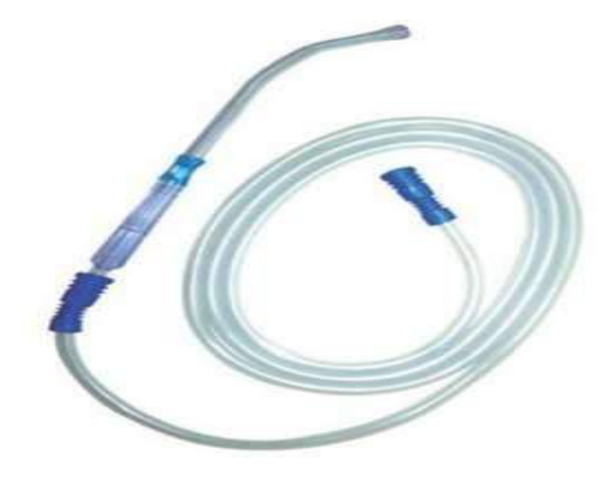  Identify the image:
Type | multiple_choice
Option | Suction catheter
Option | KY adapter
Option | PMO line
Option | Yankur catheter
Answer | 4
Solution | Rationale: Yankauer Catheter: A rigid, large-bore suction catheter with a bulbous tip, used for oropharyngeal suctioning. Provides effective removal of secretions from the mouth and throat. Key Clues: Rigid, bulbous tip, for oropharyngeal suction Why Not Others: B-Suction catheter is flexible;C-KY adapter is not standard;D-PMO line is for medication Exam Trap: Yankauer vs flexible suction - Yankauer is rigid (oropharyngeal), flexible is for deeper suctioning PNC Pearl: Yankauer: Use for oral/pharyngeal suctioning. Apply suction only on withdrawal. Suction pressure 80-120 mmHg (adult), 60-80 mmHg (pediatric). Max 10 seconds per pass.
Positive Marks | 1
Negative Marks | 0.33

Question | 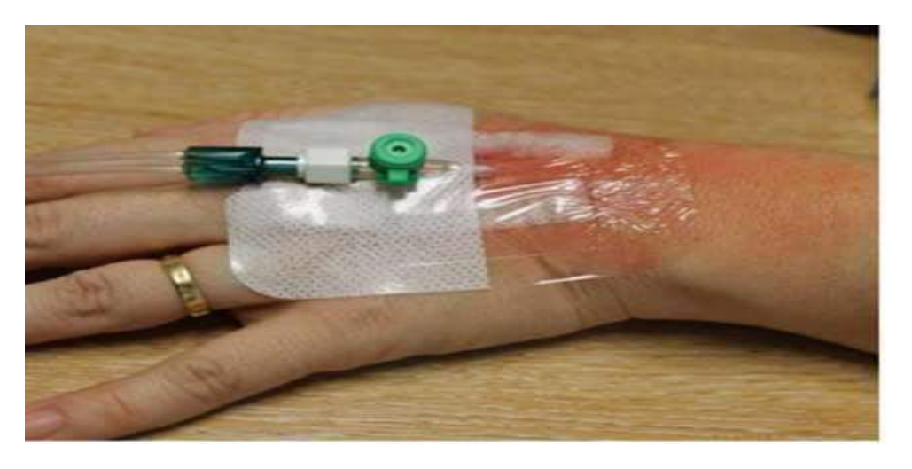  Identify the cannula:
Type | multiple_choice
Option | 20 G
Option | 22 G
Option | 16 G
Option | 18 G
Answer | 4
Solution | Rationale: 18 Gauge IV Cannula: Green-colored cannula used for rapid fluid resuscitation, blood transfusion, and emergency IV access. Provides high flow rate (~60 ml/min). Key Clues: Green color, 18G, large bore, high flow rate Why Not Others: A-20G is pink; C-22G is blue; D-16G is gray/white Exam Trap: IV cannula color coding: 22G=Blue, 20G=Pink, 18G=Green, 16G=Gray, 14G=Orange PNC Pearl: IV Cannula colors (remember: Big Orange Grows Very Fast, while Small People Never Get Greasy): 14G=Orange, 16G=Gray, 18G=Green, 20G=Pink, 22G=Blue, 24G=Yellow, 26G=Purple.
Positive Marks | 1
Negative Marks | 0.33

Question | 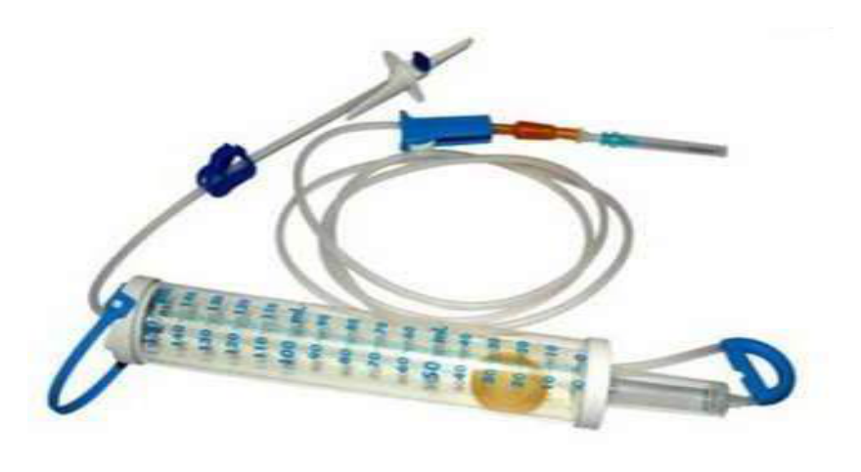  Identify the image:
Type | multiple_choice
Option | Pedia drip set
Option | Macro drip set
Option | Micro drip set
Option | Adult drip set
Answer | 3
Solution | Rationale: Micro Drip Set (Pediatric Drip Set): An IV administration set with 60 drops per ml (60 gtt/ml). Used for accurate small-volume fluid and medication delivery, especially in pediatric and cardiac patients. Key Clues: 60 drops/ml, for pediatric/cardiac patients Why Not Others: A-Pediatric drip set is not standard;C-Macro drip is 10-20 drops/ml;D-Adult drip set is same as macro Exam Trap: Micro vs macro - micro is 60 gtt/ml (pediatric), macro is 10-20 gtt/ml (adult) PNC Pearl: Micro drip: 60 gtt/mL. Formula: drops/min = (volume × 60) / time in minutes. Used when precise fluid delivery needed. Common in NICU and ICU.
Positive Marks | 1
Negative Marks | 0.33

Question | 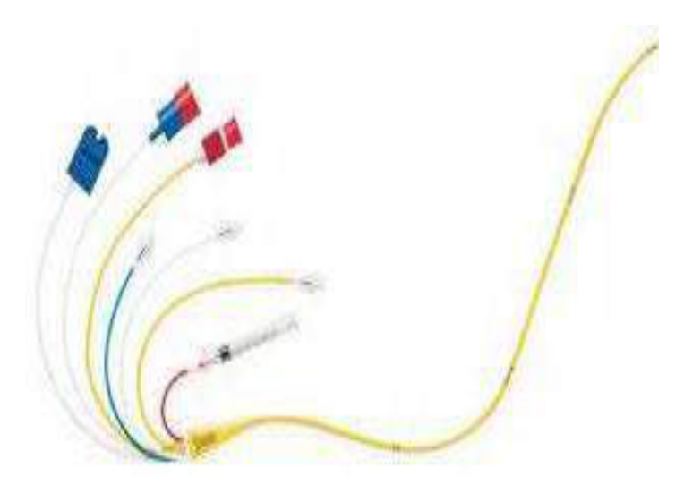  Identify the image:
Type | multiple_choice
Option | CVP catheter
Option | Swan ganz catheter
Option | Cardiac output catheter
Option | Central line catheter
Answer | 2
Solution | Rationale: Swan-Ganz Catheter (Pulmonary Artery Catheter): A flow-directed balloon-tipped catheter with multiple ports for measuring cardiac output, pulmonary artery pressure, wedge pressure, and mixed venous O· saturation. Key Clues: Balloon-tipped, multiple ports, measures PA pressures and CO Why Not Others: A-CVP catheter only measures central pressure; B-Cardiac output catheter is simpler; D-Central line is for general access Exam Trap: Swan-Ganz vs CVP - Swan-Ganz goes to PA, CVP stays in SVC/RA PNC Pearl: Swan-Ganz: Measures PA pressure, PCWP (wedge pressure), CO, SvO·. Normal PCWP 6-12 mmHg. Complications: Arrhythmias, PA rupture, infection. Always deflate balloon before withdrawal.
Positive Marks | 1
Negative Marks | 0.33

Question | 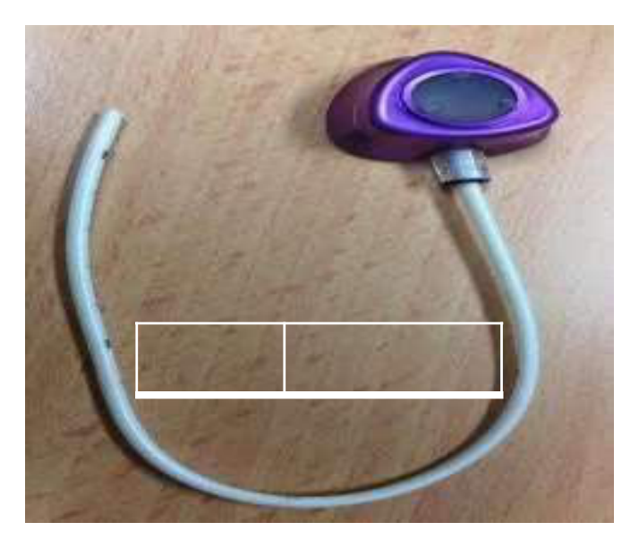  Identify the image:
Type | multiple_choice
Option | Suction port
Option | Chemo port
Option | Hemo port
Option | Venous port
Answer | 2
Solution | Rationale: Chemo Port (Implantable Port): A small reservoir implanted under the skin, connected to a central venous catheter. Used for long-term chemotherapy, blood draws, and medication administration. Accessed with Huber needle. Key Clues: Implanted under skin, Huber needle access Why Not Others: A-Suction port is not standard;C-Hemo port is for hemodialysis;D-Venous port is generic Exam Trap: Chemo port vs PICC - chemo port is fully implanted (no external parts), PICC has external tubing PNC Pearl: Chemo port: Accessed with non-coring Huber needle. Flush with heparinized saline after use. Cap with needless connector. Change dressing q7 days. Flush with 10ml saline, then 3-5ml heparin.
Positive Marks | 1
Negative Marks | 0.33

Question | 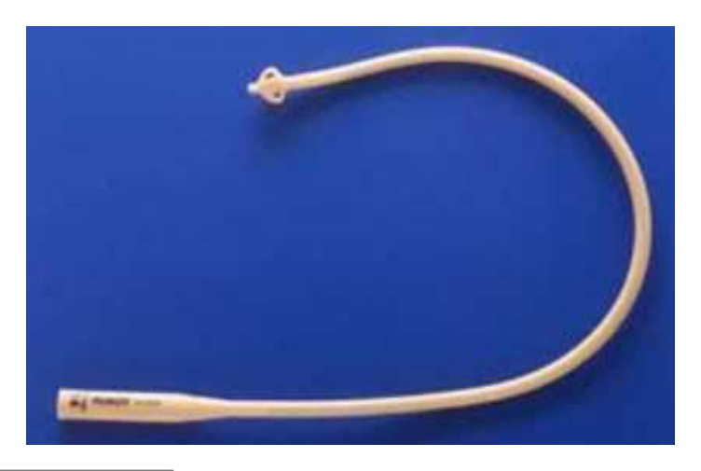  Identify the image:
Type | multiple_choice
Option | Malecot catheter
Option | Simple rubber catheter
Option | Mashroom catheter
Option | Foleys catheter
Answer | 1
Solution | Rationale: Malecot Catheter: A self-retaining catheter with wing-like projections at the tip that expand inside the bladder. Used for suprapubic catheterization. No balloon needed - retention by wing shape. Key Clues: Wing-shaped tip, self-retaining, for suprapubic use Why Not Others: A-Simple rubber catheter has no retention;B-Mushroom is for drainage;D-Foley has balloon Exam Trap: Malecot vs Foley - Malecot uses wings for retention, Foley uses balloon PNC Pearl: Malecot catheter: Inserted suprapubically. Wings expand inside bladder. Used for: urinary retention when urethral catheterization fails, suprapubic cystostomy. Monitor for blockage.
Positive Marks | 1
Negative Marks | 0.33

Question | 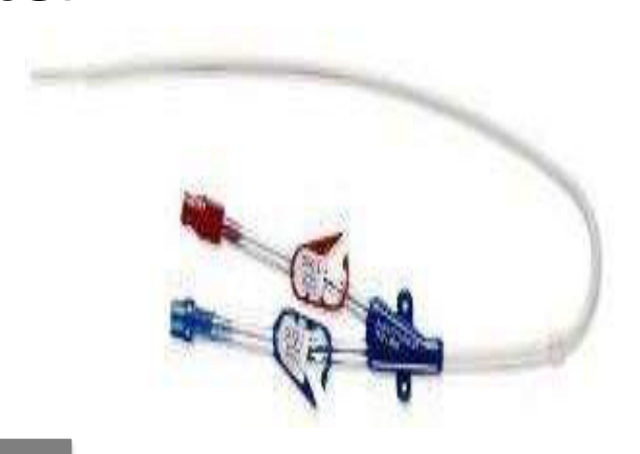  Identify the image:
Type | multiple_choice
Option | Suction catheter
Option | Double lumen CVP catheter
Option | Dialysis catheter
Option | Double lumen PICC catheter
Answer | 2
Solution | Rationale: Double Lumen CVP Catheter: A catheter with two lumens (distal and proximal ports) for central venous access. Used for CVP monitoring, medication administration, and fluid resuscitation. Key Clues: Two lumens, central access, for CVP and medications Why Not Others: B-Suction catheter is for airway; C-Dialysis catheter is larger bore; D-PICC is peripherally inserted Exam Trap: Double lumen CVP vs dialysis catheter - CVP is smaller bore, dialysis is larger bore PNC Pearl: CVP catheter: Inserted via IJ, subclavian, or femoral. Always confirm position with CXR. Normal CVP 2-6 mmHg. Never use for CT contrast injection.
Positive Marks | 1
Negative Marks | 0.33

Question | 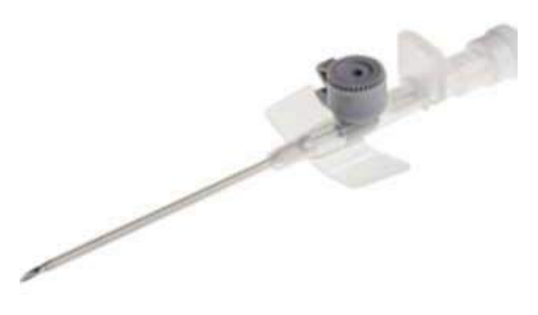  Identify the image:
Type | multiple_choice
Option | Intra venous cannula 16G size
Option | Intravenous cannula 14 G size
Option | Intravenous cannula 18G size
Option | Intravenous cannula 20 G size
Answer | 2
Solution | Rationale: 14 Gauge IV Cannula: Orange-colored, largest bore cannula used for massive blood transfusion and rapid fluid resuscitation. Flow rate ~240 ml/min. Used in trauma and major hemorrhage. Key Clues: Orange color, largest bore, for massive transfusion Why Not Others: A-16G is gray; B-18G is green; D-20G is pink Exam Trap: Remember: 14G is orange and is the largest IV cannula commonly available PNC Pearl: 14G cannula: Used only in massive hemorrhage/trauma. Inserted in large veins (antecubital). Risk: Phlebitis, vessel damage. Always flush after insertion.
Positive Marks | 1
Negative Marks | 0.33

Question | 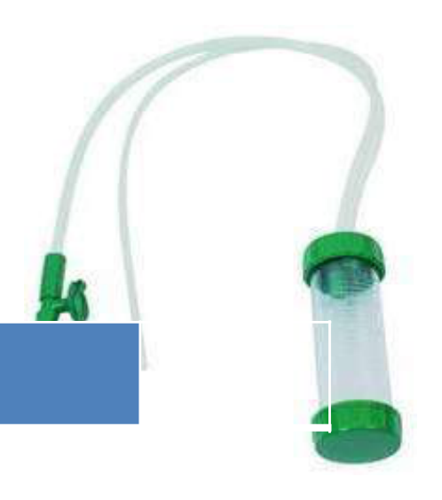  Identify the image:
Type | multiple_choice
Option | Drip chamber
Option | Piggy back
Option | Mucus extractor
Option | Suction chamber
Answer | 1
Solution | Rationale: Drip Chamber: A transparent chamber in an IV administration set where drops of fluid can be counted to regulate infusion rate. Also acts as a trap for air bubbles and allows visual monitoring of flow. Key Clues: Transparent, counts drops, monitors flow Why Not Others: B-Pigback is for secondary infusion;C-Mucus extractor is for neonates;D-Suction chamber is for drainage Exam Trap: Drip chamber vs filter - drip chamber counts drops, filter removes particles PNC Pearl: Drip chamber: Fill 1/2 to 2/3 full for drop counting. If too full, can't count drops. If too empty, air enters tubing. Prime all tubing before connecting to patient.
Positive Marks | 1
Negative Marks | 0.33

Question | 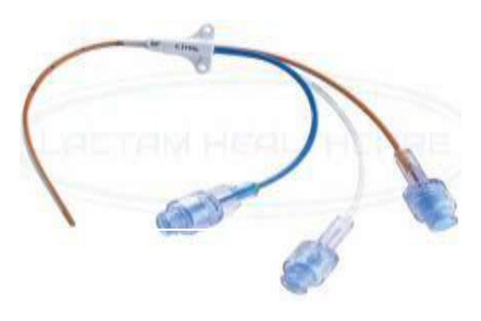  Identify the image:
Type | multiple_choice
Option | Pig tail catheter
Option | Central arterial catheter
Option | Cardiac catheter
Option | Central venous catheter
Answer | 3
Solution | Rationale: Cardiac Catheter: A thin, flexible tube inserted into the heart for diagnostic and therapeutic purposes. Used for coronary angiography, angioplasty, and hemodynamic monitoring. Key Clues: Thin, flexible, inserted into heart chambers/vessels Why Not Others: A-Pigtail catheter is a specific shape; C-Central arterial catheter is for arterial monitoring; D-Central venous catheter is for venous access Exam Trap: Cardiac cath vs coronary stent - catheter is the tube, stent is the implant PNC Pearl: Cardiac catheterization: Femoral or radial approach. Monitor for bleeding, hematoma, pseudoaneurysm. NPO before procedure. Check renal function (contrast nephropathy risk).
Positive Marks | 1
Negative Marks | 0.33

Question | 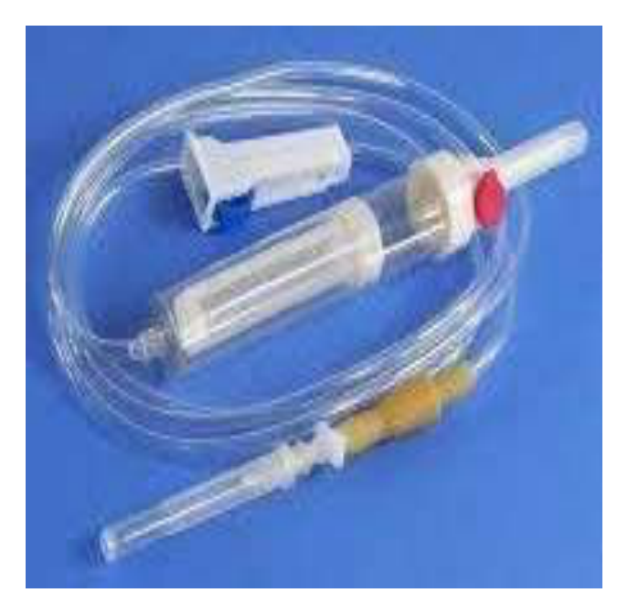  Identify the image:
Type | multiple_choice
Option | Blood transfusion set
Option | IV set
Option | IV set with filter
Option | Two chamber set
Answer | 1
Solution | Rationale: Blood Transfusion Set: An IV administration set with a filter (170-260 micron) to trap clots and debris. Has a drip chamber and Y-connector for blood and saline. Used exclusively for blood product transfusion. Key Clues: Filter (170-260 micron), Y-connector, for blood products Why Not Others: A-IV set has no large filter;B-IV set with filter is smaller;D-Two chamber set is not standard Exam Trap: Blood transfusion set vs regular IV set - transfusion set has larger filter to prevent clot/debris infusion PNC Pearl: Blood transfusion set: 170-260 micron filter. Y-connector allows saline between blood products. Must complete transfusion within 4 hours. Never add medications to blood. Monitor for reactions.
Positive Marks | 1
Negative Marks | 0.33

Question | 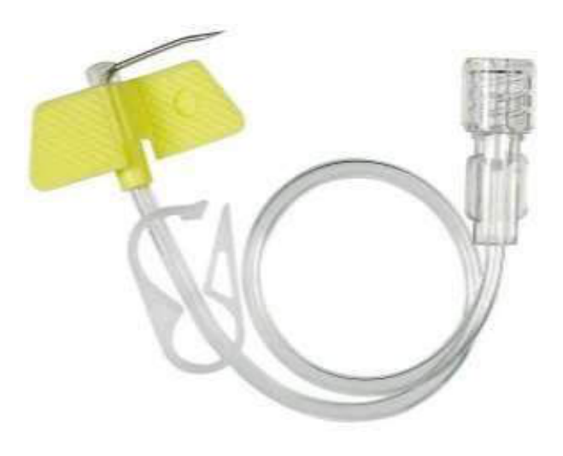  Identify the image:
Type | multiple_choice
Option | Chemo needle
Option | Scalp vein needle
Option | Central vein needle
Option | Huber needle
Answer | 4
Solution | Rationale: Huber Needle: A non-coring needle specifically designed for accessing implantable ports and central venous access devices. The tip deflects tissue rather than coring it, preserving the septum. Key Clues: Non-coring, for port access, preserves septum Why Not Others: A-Chemo needle is generic;C-Scalp vein is butterfly;D-Central vein needle is different Exam Trap: Huber vs regular needle - Huber is non-coring (preserves port septum), regular is coring (damages septum) PNC Pearl: Huber needle: Available in various gauges (19-22G). Butterfly shape for easy grip. Always use non-coring type for ports. Change every 7 days. Flush with saline then heparin.
Positive Marks | 1
Negative Marks | 0.33

Question | 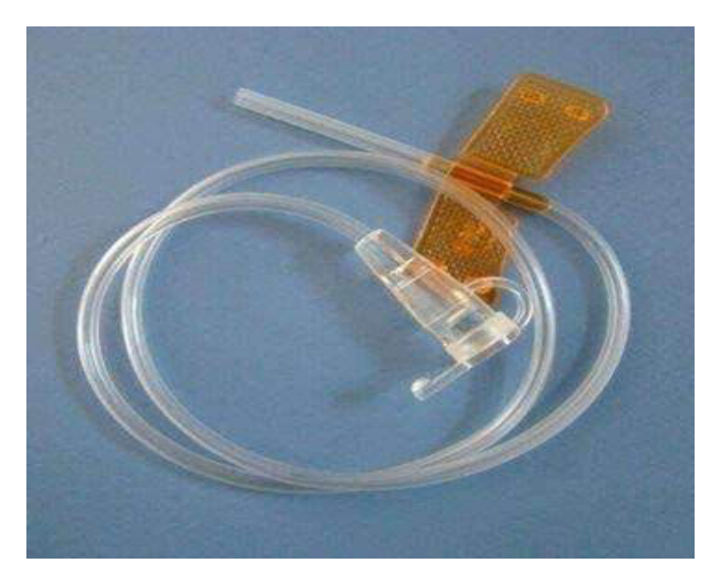  ldentify the Instrument/:
Type | multiple_choice
Option | IV transfusion set
Option | Ryles tube
Option | Scalp vein set.
Option | IV canula
Answer | 3
Solution | Rationale: Scalp Vein Set (Butterfly Needle): A small-gauge winged needle with flexible tubing. Used for IV access in patients with difficult veins, especially in pediatrics and oncology. Wings provide stability. Key Clues: Winged needle, flexible tubing, for difficult access Why Not Others: A-IV transfusion set is larger;B-Ryles tube is for feeding;D-IV cannula is rigid Exam Trap: Scalp vein set vs IV cannula - scalp vein has flexible tubing, IV cannula is rigid and stays in place PNC Pearl: Scalp vein set: Wings folded for grip. Gauge 19-27. Used for short procedures, difficult veins, pediatrics. Not for continuous infusion (can dislodge easily). Secure well with tape.
Positive Marks | 1
Negative Marks | 0.33

