Question | 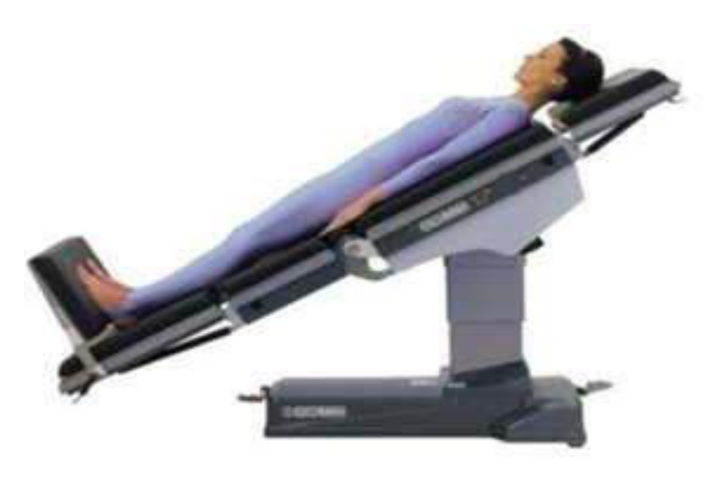  Show Position given in which of:
Type | multiple_choice
Option | Shock
Option | GERD
Option | Cord prolapse
Option | Asthma
Answer | 3
Solution | Rationale: Cord Prolapse: The umbilical cord descends through the cervix before the fetus, leading to cord compression and fetal hypoxia. Immediate treatment: position mother in Trendelenburg or knee-chest position to relieve pressure. Key Clues: Emergency position for cord prolapse, elevate pelvis Why Not Others: A-Shock uses Trendelenburg;B-GERD uses semi-Fowler;D-Asthma uses high Fowler Exam Trap: Cord prolapse position: Trendelenburg or knee-chest to reduce cord pressure PNC Pearl: Cord prolapse: Emergency cesarean section required. Until then: knee-chest position or Trendelenburg, push presenting part up, IV fluids, fetal monitoring. Do NOT push cord back in.
Positive Marks | 1
Negative Marks | 0.33

Question | 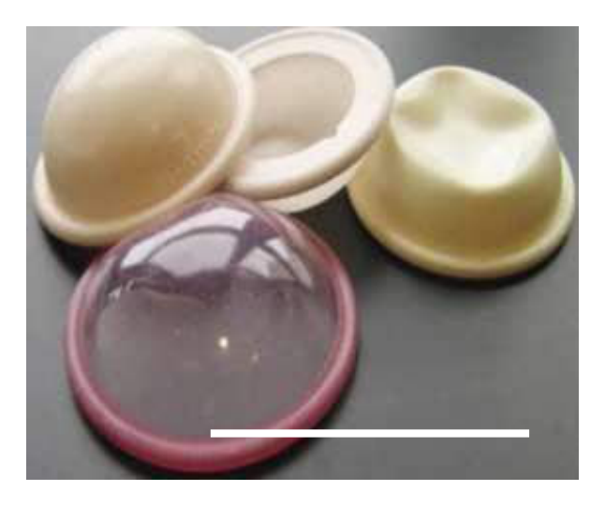  Identify the image:
Type | multiple_choice
Option | Female catheter
Option | Vaginal douhe
Option | Cervical cap
Option | Diaphragm
Answer | 4
Solution | Rationale: Diaphragm: A barrier contraceptive device inserted into the vagina before intercourse. It covers the cervix, preventing sperm from entering the uterus. Used with spermicide for better protection. Key Clues: Dome-shaped, covers cervix, barrier method Why Not Others: B-Female catheter is for drainage;C-Vaginal douche is for cleaning;D-Cervical cap is smaller Exam Trap: Diaphragm vs cervical cap - diaphragm is larger, covers cervix and fornices PNC Pearl: Diaphragm: Insert up to 6 hours before intercourse. Leave in place 6-8 hours after. Check for tears before each use. Fit by healthcare provider. Not effective against STIs.
Positive Marks | 1
Negative Marks | 0.33

Question | 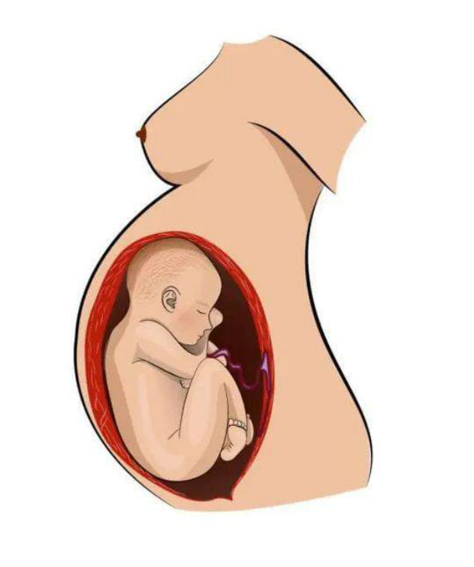  Identify the image:
Type | multiple_choice
Option | Breach presentation
Option | Vertex presentation
Option | Cord presentation
Option | Shoulder presentation
Answer | 4
Solution | Rationale: Shoulder Presentation: Fetal lie where the shoulder is the presenting part. This is an oblique lie. Requires cesarean delivery as vaginal delivery is not possible without rotation. Key Clues: Shoulder as presenting part, oblique lie Why Not Others: A-Breech is buttocks first;B-Vertex is head first;D-Cord is umbilical cord prolapse Exam Trap: Shoulder vs transverse lie - shoulder presentation is a form of transverse lie PNC Pearl: Shoulder presentation: Cannot deliver vaginally. Emergency C-section required. External cephalic version may be attempted before labor. Risk of cord prolapse and uterine rupture.
Positive Marks | 1
Negative Marks | 0.33

Question | 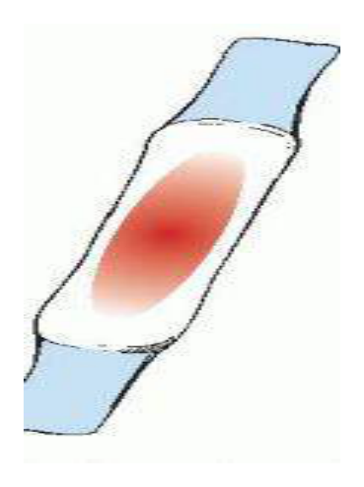  Identify the amount of lochia shows:
Type | multiple_choice
Option | Moderate amount
Option | Scant amount
Option | Mild amount
Option | Heavy amount
Answer | 1
Solution | Rationale: Lochia: Post-partum vaginal discharge consisting of blood, mucus, and tissue from the uterine site. Moderate amount on day 3-4 (lochia rubra transitioning to serosa). Changes from red to pink to white. Key Clues: Post-partum discharge, changes color over time Why Not Others: A-Scant is very little;B-Mild is not standard;D-Heavy may indicate hemorrhage Exam Trap: Lochia progression: Rubra (red, 1-3 days) · Serosa (pink, 4-10 days) · Alba (white, 10-21 days) PNC Pearl: Lochia monitoring: Should gradually decrease in amount and change from red to pink to white. Report if: heavy soaking of pad in 1 hour, foul odor, fever, or return to red color after serosa/alba stage.
Positive Marks | 1
Negative Marks | 0.33

Question | 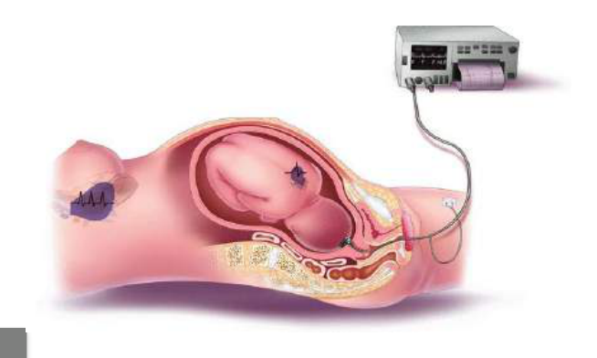  Identify the image:
Type | multiple_choice
Option | Non stress machine
Option | Internal FHR monitor device
Option | Contraction test stress machine
Option | Fetal Doppler
Answer | 2
Solution | Rationale: Internal FHR Monitor Device (Intrauterine Pressure Catheter/IUPC): A catheter inserted into the uterine cavity to directly measure intrauterine pressure and fetal heart rate during labor. Key Clues: Intrauterine catheter, for direct FHR monitoring Why Not Others: B-NST machine monitors non-stress test;C-CTG monitors contractions externally;D-Fetal Doppler uses ultrasound Exam Trap: Internal vs external monitoring - internal is invasive (direct), external is non- invasive PNC Pearl: IUPC: Indications: inadequate external monitoring, need for precise contraction measurement. Risk: infection, uterine perforation. Normal contraction: 40-60 mmHg, 2-5 in 10 min.
Positive Marks | 1
Negative Marks | 0.33

Question | 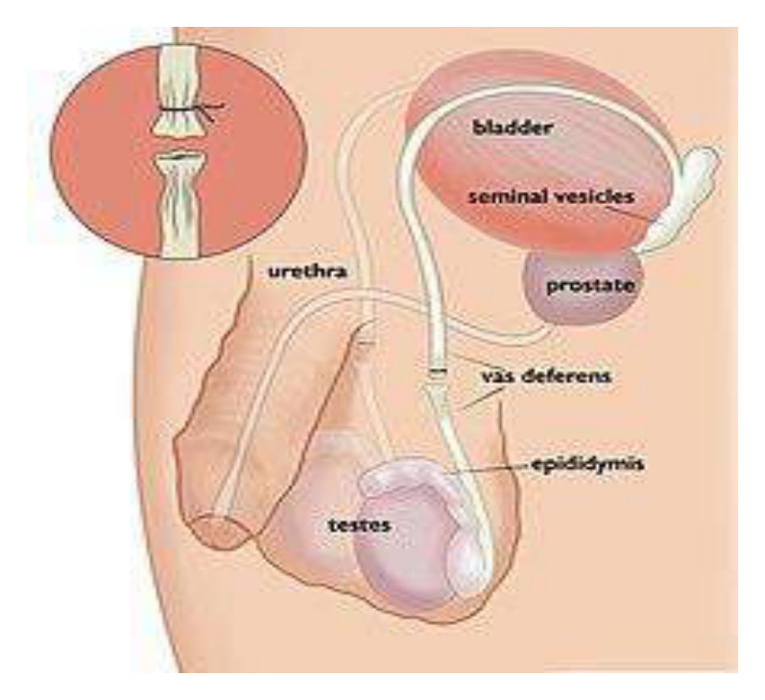  Identify the image?
Type | multiple_choice
Option | Tubectomy
Option | Both B and C
Option | vasectomy
Option | NSV
Answer | 2
Solution | Rationale: Vasectomy/NSV (No-Scalpel Vasectomy): A male sterilization procedure where the vas deferens is cut/sealed to prevent sperm from entering the ejaculate. NSV uses a puncture technique. Key Clues: Male sterilization, vas deferens cut/sealed Why Not Others: A-Tubectomy is female;B-Vasectomy is correct;C-NSV is correct Exam Trap: Both B (vasectomy) and C (NSV) are correct - D (both B and C) is the answer PNC Pearl: NSV: No-scalpel technique. Less pain, faster recovery, fewer complications. Success verified by semen analysis (azoospermia) after 3 months.
Positive Marks | 1
Negative Marks | 0.33

Question | 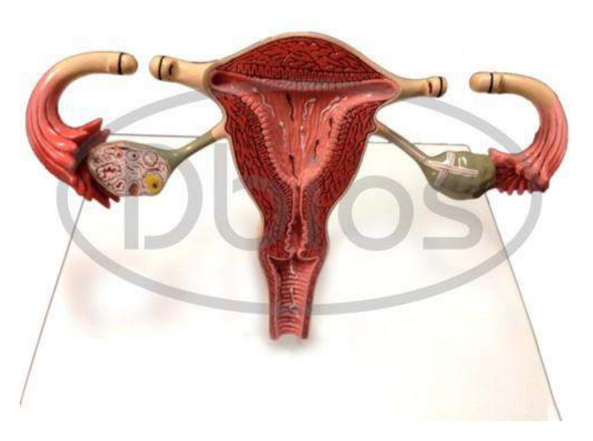  Identify the image?
Type | multiple_choice
Option | vasectomy
Option | Tubectomy
Option | Hystrectomy
Option | Both B and C
Answer | 1
Solution | Rationale: Vasectomy: Male sterilization procedure where the vas deferens is cut, tied, or sealed. Simple outpatient procedure under local anesthesia. Effective immediately (after clearance semen analysis). Key Clues: Vas deferens cut/tied, male sterilization Why Not Others: A-Tubectomy is female;C-Hysterectomy removes uterus;D-Both B and C is incorrect Exam Trap: Vasectomy vs tubectomy - vasectomy is male, tubectomy is female sterilization PNC Pearl: Vasectomy: Local anesthesia. Bilateral through scrotal incision. Post-op: ice, scrotal support, rest 48h. Contraception until semen analysis confirms azoospermia (3 months/20 ejaculations).
Positive Marks | 1
Negative Marks | 0.33

Question | 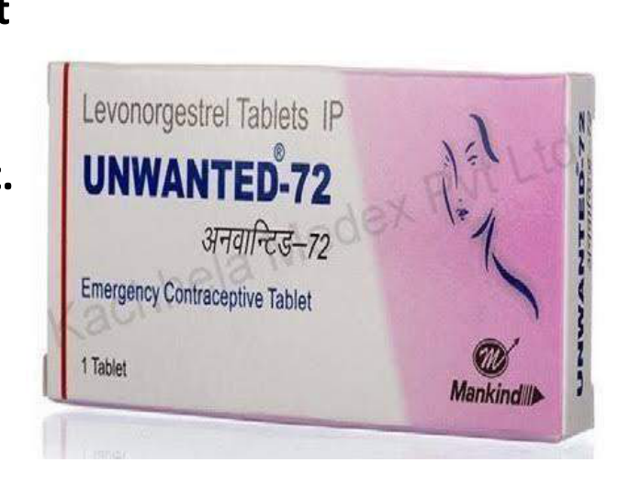  Recommended method of use of pill shown in:
Type | multiple_choice
Option | 0.75 mg 1 pill.
Option | 0.75 mg each 2 pills [1 + 1) 12 hours apart
Option | 0.75 mg each 4 pills (2 + 2) 12 hours apart.
Option | 1.5 mg 1 pill.
Answer | 2
Solution | Rationale: Emergency Contraception (Morning After Pill): 0.75mg levonorgestrel taken as 2 pills, 12 hours apart, within 72 hours of unprotected intercourse. Key Clues: 0.75mg × 2 pills, 12 hours apart Why Not Others: B-0.75mg single pill is incorrect;C-0.75mg × 4 pills is incorrect;D-1.5mg single pill is an alternative regimen Exam Trap: Two-pill regimen: 0.75mg now + 0.75mg in 12 hours. Alternative: 1.5mg single dose. PNC Pearl: Emergency contraception: Levonorgestrel 0.75mg × 2 (12h apart) or 1.5mg single dose. Within 72h. Not regular contraception. Efficacy decreases with delay.
Positive Marks | 1
Negative Marks | 0.33

Question | 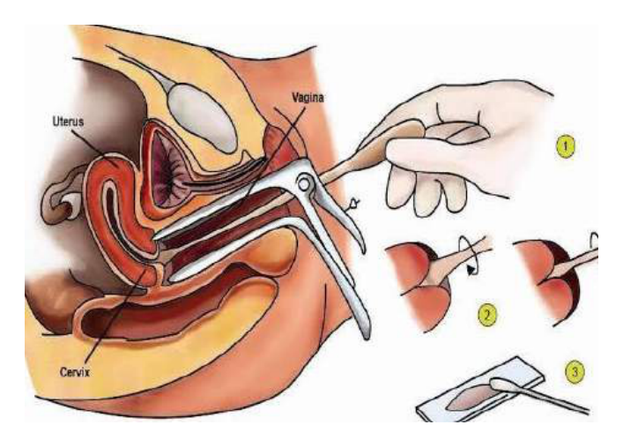  . Gynecological procedure:
Type | multiple_choice
Option | Swab of Vaginal discharge.
Option | VIA test.
Option | Punch biopsy.
Option | Pap smear.
Answer | 4
Solution | Rationale: Pap Smear (Papanicolaou Test): A gynecological screening test where cells are collected from the cervix and examined for precancerous or cancerous changes. Key Clues: Cervical cell collection, for cancer screening Why Not Others: A-Vaginal discharge swab is different;C-VIA is visual inspection;D-Punch biopsy takes tissue Exam Trap: Pap smear vs VIA - Pap smear is cytology (lab), VIA is visual inspection (bedside) PNC Pearl: Pap smear: Collect cells from transformation zone. Fix in preservative. Screen for: cervical dysplasia, carcinoma. Start at age 21, repeat every 3 years. After 30: co- testing with HPV every 5 years.
Positive Marks | 1
Negative Marks | 0.33

Question | 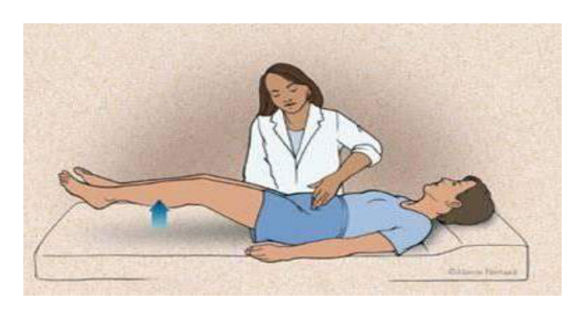  . Clinical sign being:
Type | multiple_choice
Option | Castell's sign.
Option | Balance's sign.
Option | Carnett's sign.
Option | Fothergill's sign.
Answer | 4
Solution | Rationale: Fothergill's Sign: Used to differentiate uterine fibroids from ovarian tumors. When the cervix is pulled with a tenaculum, the fibroid moves with the uterus while ovarian tumors remain stationary. Key Clues: Cervix pulled, fibroid moves with uterus Why Not Others: B-Castell's sign is for cholecystitis;C-Balance's sign is for splenic injury;D-Carnett's sign differentiates abdominal wall vs visceral pain Exam Trap: Fothergill's: Fibroid moves with uterus during manipulation. Ovarian mass stays fixed. Helps differentiate pelvic masses clinically. PNC Pearl: Fothergill's: Fibroid moves with uterus during manipulation. Ovarian mass stays fixed. Helps differentiate pelvic masses clinically.
Positive Marks | 1
Negative Marks | 0.33

Question | 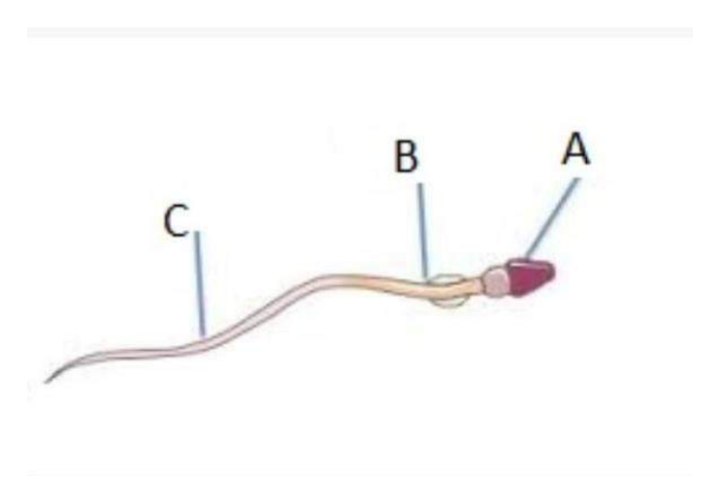  . Spermatic structure(marked:
Type | multiple_choice
Option | Head
Option | Neck
Option | Middle piece
Option | End piece
Answer | 3
Solution | Rationale: Sperm Middle Piece: The midpiece of a sperm cell contains mitochondria (energy source for motility). Located between the head and tail. Mitochondria provide ATP for flagellar movement. Key Clues: Contains mitochondria, for energy/motility Why Not Others: A-Head contains DNA;B-Neck connects head to midpiece;D-End piece is the tail Exam Trap: Sperm structure: Head (DNA + acrosome) · Neck · Middle piece (mitochondria) · Tail (flagellum) PNC Pearl: Sperm anatomy: Head = genetic material + acrosome (penetration enzyme). Midpiece = mitochondria (energy). Tail = flagellum (motility).
Positive Marks | 1
Negative Marks | 0.33

Question | 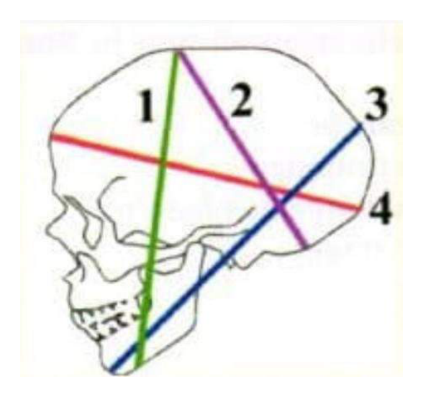  . Largest diameter:
Type | multiple_choice
Option | 3.
Option | 1.
Option | 2.
Option | 4
Answer | 1
Solution | Rationale: Largest Pelvic Diameter: The largest diameter of the true pelvis is the transverse diameter (13.5cm), which is larger than the anteroposterior diameter (11cm). Key Clues: Transverse diameter is largest Why Not Others: A-1,B-2 are unspecified;D-4 is unspecified Exam Trap: Pelvic diameters: Transverse (13.5cm) > AP (11cm) > Oblique (12cm) PNC Pearl: Pelvic measurements: Inlet: AP 10cm, Transverse 13.5cm. Midpelvis: AP 11.5cm. Outlet: AP 9.5cm, Transverse 11cm. Key for vaginal delivery assessment.
Positive Marks | 1
Negative Marks | 0.33

Question | 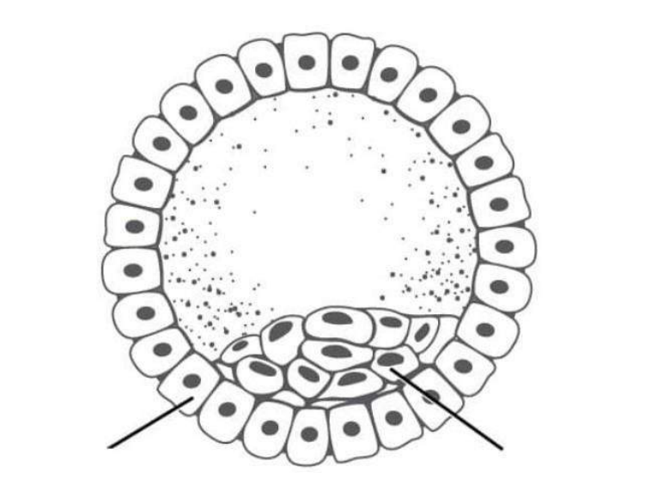  . Cell cleavage type in:
Type | multiple_choice
Option | Morula
Option | Fertilized egg
Option | Blastocyst
Option | None
Answer | 1
Solution | Rationale: Morula: An early stage of embryonic development (day 3-4) where the fertilized egg has divided into a solid ball of 16-32 cells. Named for its mulberry-like appearance. Key Clues: Solid ball of 16-32 cells, mulberry appearance Why Not Others: A-Fertilized egg is earlier;C-Blastocyst is later (cavity);D-None is incorrect Exam Trap: Morula: Solid ball of cells. Occurs 3-4 days post-fertilization. Before blastocyst (which has a cavity). PNC Pearl: Morula: Solid ball of cells. Occurs 3-4 days post-fertilization. Before blastocyst (which has a cavity).
Positive Marks | 1
Negative Marks | 0.33

Question | 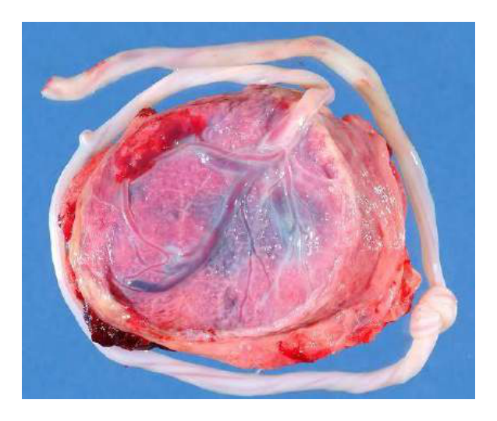  . ldentify the Type of:
Type | multiple_choice
Option | Succenturiate
Option | Velamentous
Option | Circum-marginate
Option | Circumvallate
Answer | 1
Solution | Rationale: Succenturiate Placenta: An accessory placental lobe connected to the main placenta by blood vessels. The vessels may cross the internal os, creating risk of vasa previa. Key Clues: Accessory placental lobe with connecting vessels Why Not Others: A-Velamentous is vessel insertion;B-Circum-marginate is margin;D-Circumvallate is rolled edge Exam Trap: Succenturiate vs vasa previa - succenturiate has accessory lobe, vasa previa has vessels over cervix PNC Pearl: Succenturiate placenta: Risk of vasa previa (vessels crossing cervix). Risk of retained placental tissue. Always examine placenta after delivery for completeness.
Positive Marks | 1
Negative Marks | 0.33

Question | 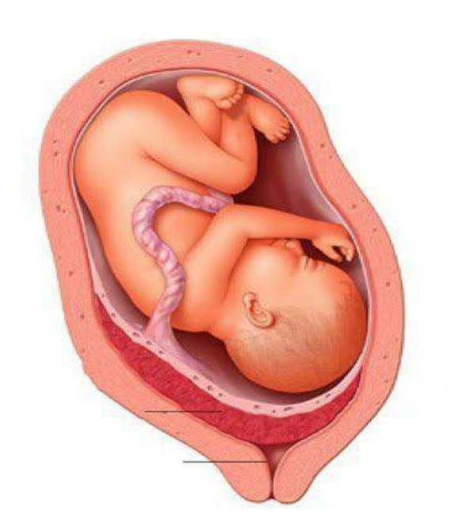  . Identify the placental:
Type | multiple_choice
Option | Placenta previa.
Option | Placenta percreta.
Option | Placenta accreta.
Option | None of the above
Answer | 3
Solution | Rationale: Placenta Accreta: Abnormal placental attachment where villi attach directly to the myometrium without intervening decidua. Risk increases with previous C-section and placenta previa. Key Clues: Villi attach directly to myometrium Why Not Others: A-Previa is low-lying;C-Percreta goes through myometrium;D-None is incorrect Exam Trap: Accreta vs percreta vs increta - accreta attaches to surface, increta invades muscle, percreta penetrates through PNC Pearl: Placenta accreta: Risk factors: previa, prior C-section, Asherman syndrome. Treatment: planned C-section + hysterectomy. Monitor for massive hemorrhage.
Positive Marks | 1
Negative Marks | 0.33

Question | 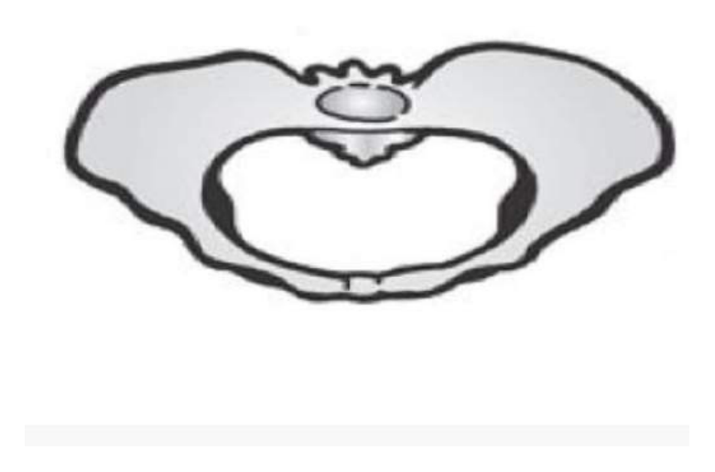  . Pelvis shape type as:
Type | multiple_choice
Option | Android.
Option | Gynaecoid
Option | Platypelloid.
Option | Anthropoid
Answer | 2
Solution | Rationale: Gynecoid Pelvis: The normal female pelvis shape, characterized by a round or slightly oval inlet, wide subpubic angle, and straight sacrum. Most favorable for vaginal delivery. Key Clues: Round inlet, wide subpubic, for vaginal delivery Why Not Others: B-Android is male-shaped;C-Platypelloid is flat;D-Anthropoid is long Exam Trap: Gynecoid vs android - gynecoid is favorable for delivery, android is not PNC Pearl: Pelvic types: Gynecoid (normal female, 50%), Android (male-shaped, 20%), Anthropoid (long AP, 25%), Platypelloid (flat, 5%).
Positive Marks | 1
Negative Marks | 0.33

Question | 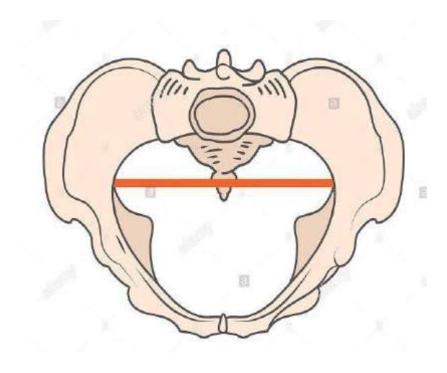  . Pelvis shape type as:
Type | multiple_choice
Option | Gynaecoid
Option | Platypelloid
Option | Android.
Option | Anthropoid.
Answer | 3
Solution | Rationale: Android Pelvis: Male-shaped pelvis with heart-shaped inlet, narrow subpubic angle, and forward-projecting sacral promontory. Not favorable for vaginal delivery. Key Clues: Heart-shaped inlet, narrow, male-shaped Why Not Others: A-Gynecoid is normal female;C-Platypelloid is flat;D-Anthropoid is long AP Exam Trap: Android pelvis: Higher risk of operative delivery. Narrow inlet may cause arrest of descent. Cesarean section may be required. PNC Pearl: Android pelvis: Higher risk of operative delivery. Narrow inlet may cause arrest of descent. Cesarean section may be required.
Positive Marks | 1
Negative Marks | 0.33

Question | 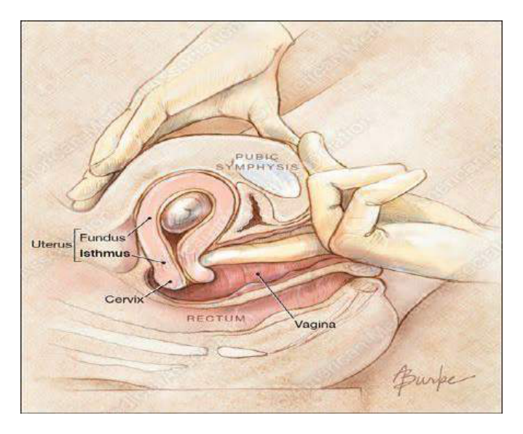  . Clinical sign shown in:
Type | multiple_choice
Option | Osiander's sign.
Option | Chadwick's sign.
Option | Palmer's sign.
Option | Hegar's sign.
Answer | 2
Solution | Rationale: Chadwick's Sign: Bluish discoloration of the cervix, vagina, and vulva seen in early pregnancy (6-8 weeks). Caused by increased vascularity and venous congestion. Key Clues: Bluish cervical/vaginal discoloration, early pregnancy Why Not Others: B-Osiander's sign is pulsation in lateral vaginal fornix;C-Palmer's sign is uterine contractions;D-Hegar's sign is softening of lower uterine segment Exam Trap: Chadwick's vs Osiander's - Chadwick's is color change, Osiander's is pulsation PNC Pearl: Chadwick's sign: Appears 6-8 weeks. Due to pelvic congestion. Also seen with: uterine fibroids, pelvic tumors. Not 100% specific for pregnancy.
Positive Marks | 1
Negative Marks | 0.33

