Question | 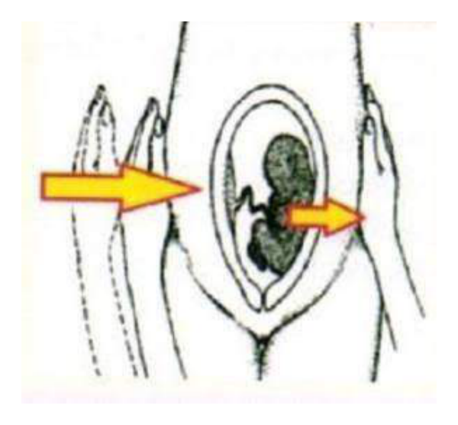  . Diagnose the sign shown:
Type | multiple_choice
Option | Internal ballottement.
Option | Central ballottement.
Option | External ballottement.
Option | None.
Answer | 3
Solution | Rationale: External Ballottement: A technique to assess a floating mass (usually uterus in early pregnancy or ascites) by pushing on the abdomen and feeling the object bounce back. Key Clues: Push and feel bounce back, for floating mass Why Not Others: A-Internal ballottement is done vaginally;C-Central is not standard;D-None is incorrect Exam Trap: External vs internal ballottement - external is through abdomen, internal is through vagina PNC Pearl: External ballottement: Patient supine. Fingers press into abdomen. If floating structure (uterus/tumor) is present, it bounces back. Used for: early pregnancy, ascites, ovarian cyst.
Positive Marks | 1
Negative Marks | 0.33

Question | 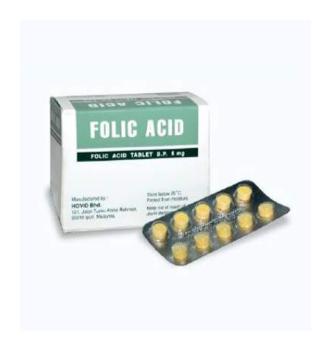  . Drug Supplementation as:
Type | multiple_choice
Option | Anemia.
Option | Megaloblastic anemia.
Option | Neural tube defects.
Option | Neonatal hypothermia.
Answer | 3
Solution | Rationale: Folic Acid Supplementation: Recommended throughout pregnancy to prevent neural tube defects (spina bifida, anencephaly). Dose: 400-800 mcg daily, starting before conception. Key Clues: Prevents neural tube defects, throughout pregnancy Why Not Others: A-Anemia is treated with iron;B-Megaloblastic is from B12/folate deficiency;C-Hypothermia is unrelated Exam Trap: Folic acid: 400-800 mcg/day throughout pregnancy. Higher dose (4-5mg) if previous NTD. Start before conception. Essential for neural tube closure (day 21-28). PNC Pearl: Folic acid: 400-800 mcg/day throughout pregnancy. Higher dose (4-5mg) if previous NTD. Start before conception. Essential for neural tube closure (day 21-28).
Positive Marks | 1
Negative Marks | 0.33

Question | 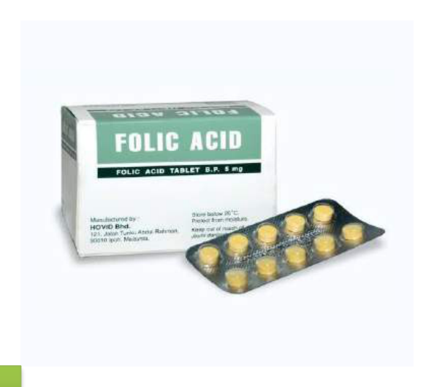  . Drug supplementation as shown:
Type | multiple_choice
Option | Throughout pregnancy
Option | First
Option | Second.
Option | Third
Answer | 1
Solution | Rationale: Iron supplementation in pregnancy: Recommended throughout pregnancy to prevent iron deficiency anemia. Dose: 60-120mg elemental iron daily. Key Clues: Throughout pregnancy Why Not Others: A-First trimester only;B-Second;C-Third Exam Trap: Iron supplementation: Daily throughout pregnancy. Take on empty stomach with vitamin C. Avoid with antacids, tea, coffee. Monitor: Hb, ferritin. Side effects: constipation, nausea. PNC Pearl: Iron supplementation: Daily throughout pregnancy. Take on empty stomach with vitamin C. Avoid with antacids, tea, coffee. Monitor: Hb, ferritin. Side effects: constipation, nausea.
Positive Marks | 1
Negative Marks | 0.33

Question | 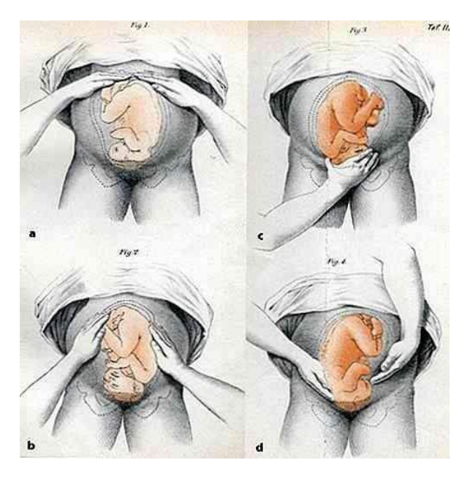  . Maneuver shown in the:
Type | multiple_choice
Option | Fundal Palpation.
Option | Lateral Palpation.
Option | Leopard maneuver
Option | Pawlik's grip
Answer | 3
Solution | Rationale: Leopold Maneuvers (Leopard Maneuver): A systematic method of abdominal palpation to determine fetal lie, presentation, and position. Four maneuvers: Fundal, Lateral, Pawlik's, and Pelvic. Key Clues: Four maneuvers for fetal assessment Why Not Others: A-Fundal is 1st maneuver;B-Lateral is 2nd maneuver;D-Pawl's grip is 3rd maneuver Exam Trap: Leopold maneuvers: 1st (Fundal - fetal part), 2nd (Lateral - position), 3rd (Pawlik's - presenting part), 4th (Pelvic - engagement) PNC Pearl: Leopold maneuvers: 1st: Fundal grip (what is up?). 2nd: Umbilical grip (position). 3rd: Pawlik's grip (presentation). 4th: Pelvic grip (engagement).
Positive Marks | 1
Negative Marks | 0.33

Question | 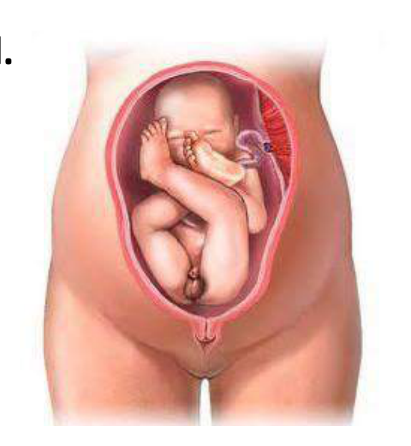  . The chief cause of perinatal mortality in:
Type | multiple_choice
Option | Intracranial hemorrhage.
Option | Prolapse of umbilical cord.
Option | Delay in delivery of head.
Option | Abnormalities
Answer | 3
Solution | Rationale: Delay in delivery of head (prolonged second stage): The chief cause of perinatal mortality when associated with cord prolapse, as cord compression leads to fetal hypoxia. Key Clues: Delayed delivery causes perinatal mortality Why Not Others: A-Intracranial hemorrhage is a consequence;B-Cord prolapse is cause;D-Abnormalities are unrelated Exam Trap: Prolonged second stage: Risk of cord prolapse, fetal hypoxia, birth injuries. Intervention: assisted delivery (vacuum/forceps) or C-section. PNC Pearl: Prolonged second stage: Risk of cord prolapse, fetal hypoxia, birth injuries. Intervention: assisted delivery (vacuum/forceps) or C-section.
Positive Marks | 1
Negative Marks | 0.33

Question | 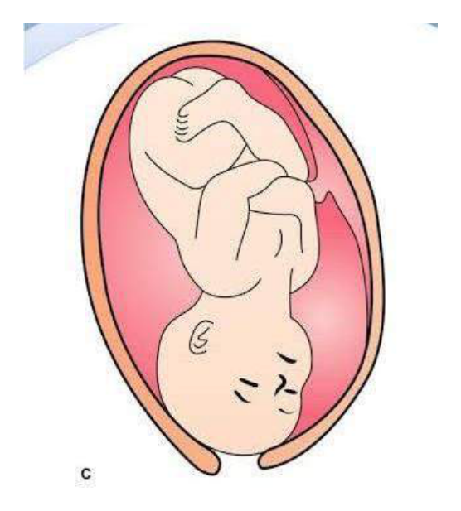  . Fetal attitude as shown in:
Type | multiple_choice
Option | Deflexed.
Option | Partial extended.
Option | Extended.
Option | Flexed.
Answer | 4
Solution | Rationale: Flexed Fetal Attitude: The fetal head is well-flexed with chin touching chest. This is the normal attitude for vertex presentation. The smallest diameter (suboccipitobregmatic, 9.5cm) presents. Key Clues: Head flexed, chin to chest, normal attitude Why Not Others: B-Deflexed shows head partially extended;C-Partial extension;D-Extended is face presentation Exam Trap: Flexed vs extended - flexed = vertex (smallest diameter), extended = face (largest diameter) PNC Pearl: Fetal attitudes: Flexed (vertex), deflexed (sinciput/brow), partially extended (mentum/brow), fully extended (face). Engagement occurs in flexed position.
Positive Marks | 1
Negative Marks | 0.33

Question | 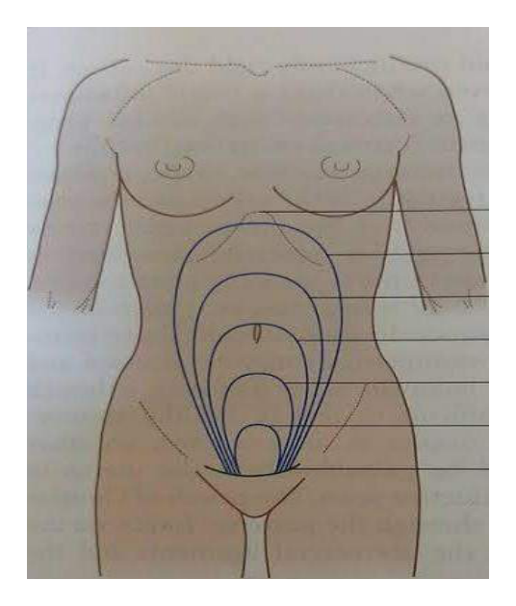  . Uterine size as represented:
Type | multiple_choice
Option | 32 weeks POG.
Option | 4 weeks POG.
Option | 12 weeks POG.
Option | 40 weeks POG
Answer | 1
Solution | Rationale: Uterine Size at 32 weeks: Fundal height approximately 32 cm (within 2 cm). The fundus is between the xiphoid and umbilicus. Quickening has occurred. Key Clues: Fundal height ~32cm, between xiphoid and umbilicus Why Not Others: A-4 weeks is not palpable;B-12 weeks is at umbilicus;D-40 weeks is at xiphoid Exam Trap: Fundal height rule: Weeks · cm (McDonald's rule). 32 weeks = 32cm ± 2cm. PNC Pearl: Fundal height rule: Weeks · cm (McDonald's rule). 32 weeks = 32cm ± 2cm.
Positive Marks | 1
Negative Marks | 0.33

Question | 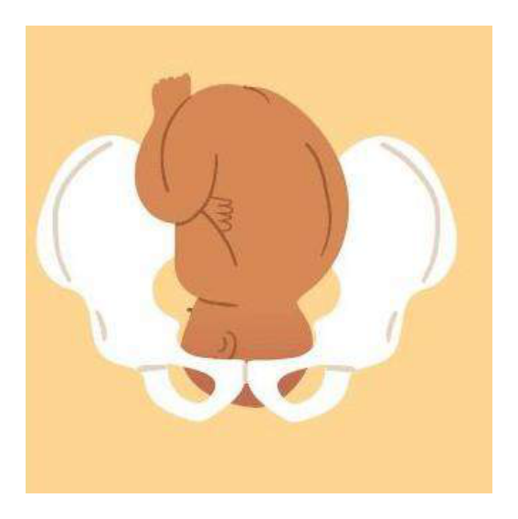  Fetal position as:
Type | multiple_choice
Option | Left Occipito-
Option | Occipito-anterior
Option | Left Occipito-Posterior.
Option | Left Occipito-anterior.
Answer | 4
Solution | Rationale: Left Occipito-Anterior (LOA): The most common fetal position where the occiput is directed toward the left anterior quadrant of the pelvis. Favorable for vaginal delivery. Key Clues: Occiput left anterior, most common position Why Not Others: A-Left lateral is incomplete;C-Occipito-anterior is unspecified;D-Left Occipito- Posterior is OP Exam Trap: LOA vs LOP - LOA is anterior (favorable), LOP is posterior (may cause back labor) PNC Pearl: LOA: Most common position (60-70%). Occiput in left anterior quadrant. Vertex delivers with flexion. Shoulders rotate normally. Favorable for vaginal delivery.
Positive Marks | 1
Negative Marks | 0.33

Question | 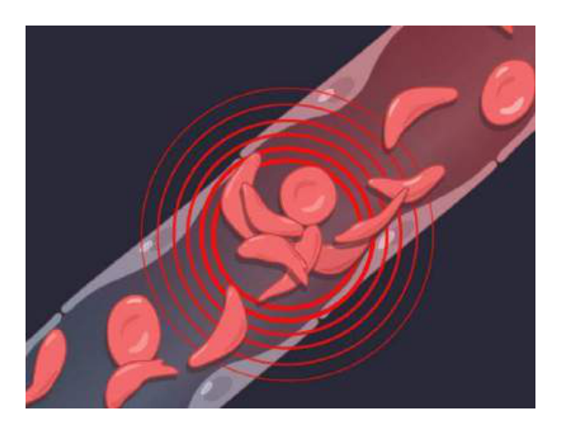  . Type of maternal anemia based on:
Type | multiple_choice
Option | lron deficiency anemia.
Option | Thalassemia
Option | Sickle cell anemia.
Option | Sideroblastic anemia.
Answer | 1
Solution | Rationale: Iron Deficiency Anemia in Pregnancy: Most common type of maternal anemia. Characterized by microcytic, hypochromic RBCs. Hb <11 g/dL in first and third trimesters. Key Clues: Microcytic hypochromic, most common Why Not Others: B-Thalassemia is genetic;C-Sickle cell is genetic;D-Sideroblastic is rare Exam Trap: Iron deficiency anemia: MCV <80, MCH <27. Treat with: ferrous sulfate 325mg TID. Monitor: Hb, ferritin, reticulocyte count. Severe anemia: transfusion. PNC Pearl: Iron deficiency anemia: MCV <80, MCH <27. Treat with: ferrous sulfate 325mg TID. Monitor: Hb, ferritin, reticulocyte count. Severe anemia: transfusion.
Positive Marks | 1
Negative Marks | 0.33

Question | 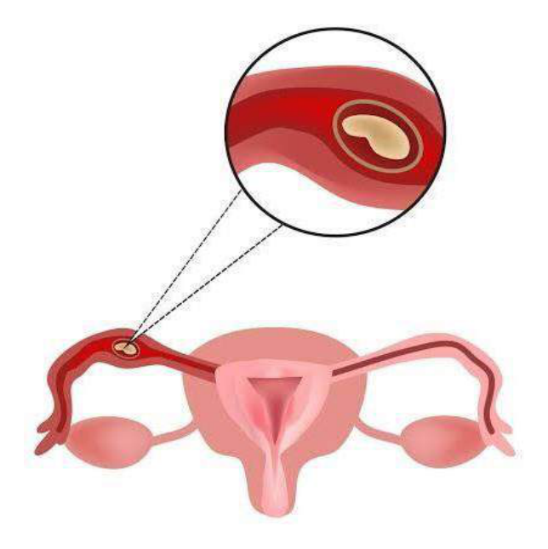  . Which among the following is the most:
Type | multiple_choice
Option | Infundibulum.
Option | Isthmus.
Option | Interstitium.
Option | Ampulla.
Answer | 4
Solution | Rationale: Ampulla of Fallopian Tube: The most common site of fertilization (where sperm meets egg). It is the widest and longest part of the fallopian tube. Key Clues: Most common fertilization site Why Not Others: A-Infundibulum is the funnel end;C-Isthmus is narrow;D-Interstitium is within uterine wall Exam Trap: Ampulla: Site of fertilization. Fimbriae capture the ovum. Cilia transport the zygote to uterus. PNC Pearl: Ampulla: Site of fertilization. Fimbriae capture the ovum. Cilia transport the zygote to uterus.
Positive Marks | 1
Negative Marks | 0.33

Question | 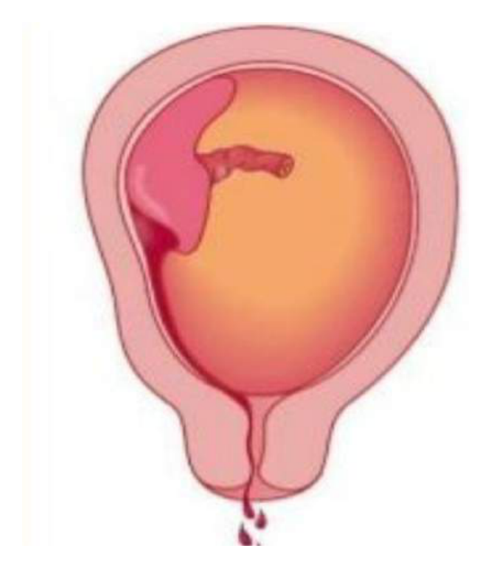  . Type of abruptio placentae as:
Type | multiple_choice
Option | Marginal separation.
Option | Complete separation.
Option | Partial separation.
Option | None of the above.
Answer | 2
Solution | Rationale: Complete Placental Separation: In abruptio placentae, complete separation means the entire placenta has detached from the uterine wall. This is a life-threatening emergency for both mother and fetus. Key Clues: Entire placenta detached, emergency Why Not Others: A-Marginal is edge only;B-Partial is partial;D-None is incorrect Exam Trap: Abruptio placentae types: Marginal (edge), Partial (part), Complete (entire). Complete separation = fetal death risk. PNC Pearl: Abruptio placentae types: Marginal (edge), Partial (part), Complete (entire). Complete separation = fetal death risk.
Positive Marks | 1
Negative Marks | 0.33

Question | 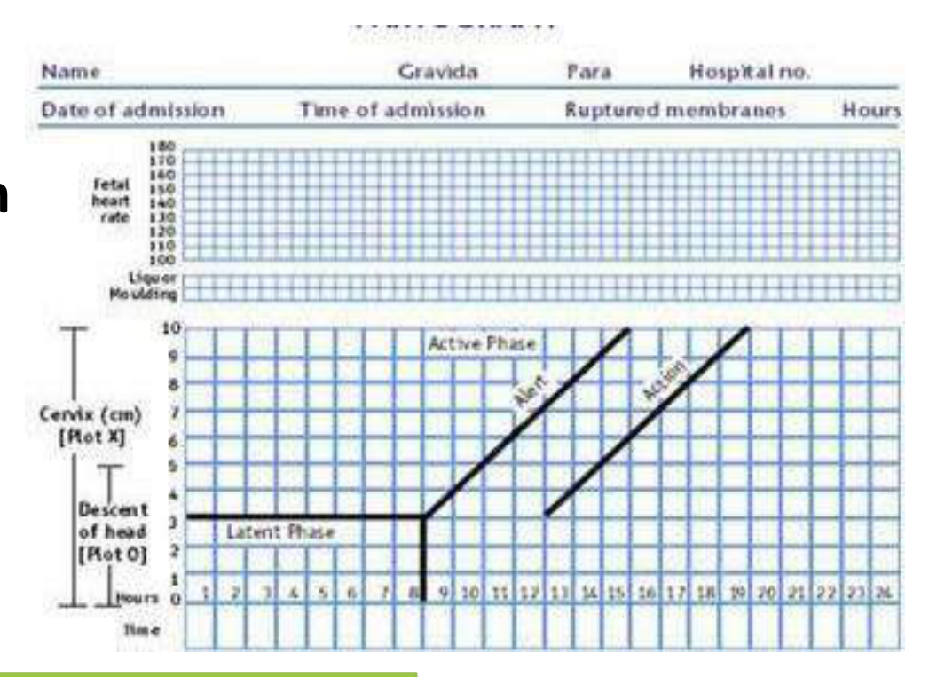  . Identify the graph shown in the:
Type | multiple_choice
Option | Partogram
Option | Cervical dilatation curve.
Option | BP charting.
Option | Cervicogram
Answer | 1
Solution | Rationale: Partogram: A graphical record of cervical dilatation, fetal head descent, uterine contractions, and vital signs during labor. Used to identify abnormal labor progress and intervene early. Key Clues: Graphical record of labor progress Why Not Others: A-Cervical dilatation curve is part of partogram;C-BP charting is different;D-Cervicogram is not standard Exam Trap: Partogram: Plots cervical dilatation (alert/action lines), descent, contractions, vitals. Alert line = 1cm/hr. Action line = crossed alert line = intervention. PNC Pearl: Partogram: Plots cervical dilatation (alert/action lines), descent, contractions, vitals. Alert line = 1cm/hr. Action line = crossed alert line = intervention.
Positive Marks | 1
Negative Marks | 0.33

Question | 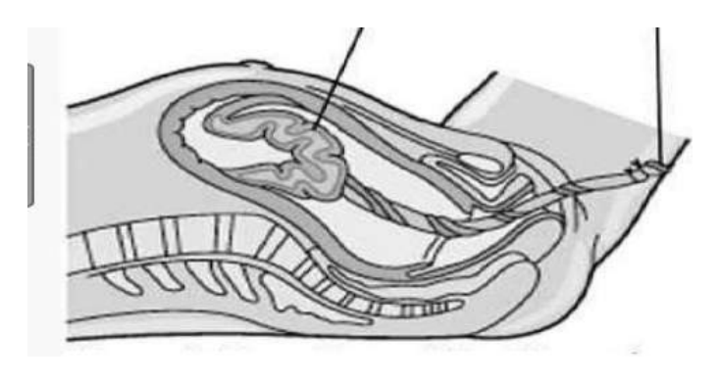  . Stage of labour process shown in:
Type | multiple_choice
Option | First stage Activephase
Option | First stage Latent phase
Option | Second stage
Option | Third stage
Answer | 2
Solution | Rationale: First Stage Latent Phase: The early phase of first stage of labor where cervix dilates slowly from 0-4 cm. Contractions are irregular and mild. Lasts variable time. Key Clues: Cervix 0-4cm, slow dilation Why Not Others: B-Active phase is 4-10cm;C-Second stage is delivery;D-Third stage is placenta Exam Trap: First stage: Latent (0-4cm) · Active (4-10cm). Active phase: intervention if <1cm/hr. PNC Pearl: First stage: Latent (0-4cm) · Active (4-10cm). Active phase: intervention if <1cm/hr.
Positive Marks | 1
Negative Marks | 0.33

Question | 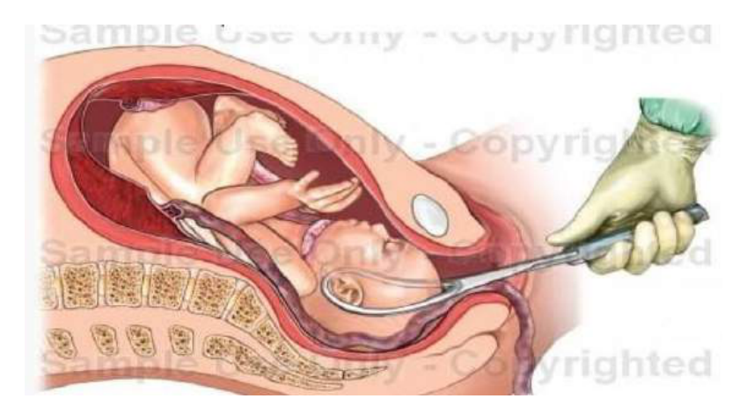  . Block given for Type of Delivery:
Type | multiple_choice
Option | Pudendal
Option | Ilio-inguinal
Option | Genitofemoral
Option | Posterior femoral
Answer | 1
Solution | Rationale: Pudendal Nerve Block: Anesthetic injection near the pudendal nerve to provide perineal anesthesia during delivery. Used for: episiotomy, forceps delivery, repair of lacerations. Key Clues: Perineal anesthesia for delivery Why Not Others: A-Ilio-inguinal is for inguinal area;B-Genitofemoral is for genital area;D-Posterior femoral is for leg Exam Trap: Pudendal block: Transvaginal or transperineal approach. Provides perineal anesthesia. Does not affect uterine contractions. PNC Pearl: Pudendal block: Transvaginal or transperineal approach. Provides perineal anesthesia. Does not affect uterine contractions.
Positive Marks | 1
Negative Marks | 0.33

Question | 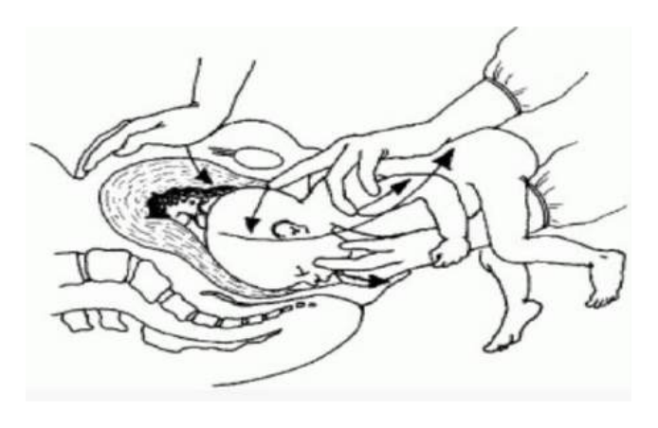  . Maneuver shown in the:
Type | multiple_choice
Option | Pinard maneuvere
Option | Burns Marshall
Option | Loveset's maneuver
Option | Marcieu-Smellie-Veit maneuver
Answer | 2
Solution | Rationale: Burns Marshall Maneuver: Technique used to deliver the aftercoming head in breech delivery. Fingers are placed in the mouth to flex the head and guide delivery. Key Clues: Deliver aftercoming head in breech Why Not Others: A-Pinard is for footling;C-Loveet's is foot extraction;D-Mauriceau-Smellie-Veit is similar Exam Trap: Burns Marshall: Flexion of head by finger in mouth. Used when head is not engaged. Similar to Mauriceau-Smellie-Veit maneuver. PNC Pearl: Burns Marshall: Flexion of head by finger in mouth. Used when head is not engaged. Similar to Mauriceau-Smellie-Veit maneuver.
Positive Marks | 1
Negative Marks | 0.33

Question | 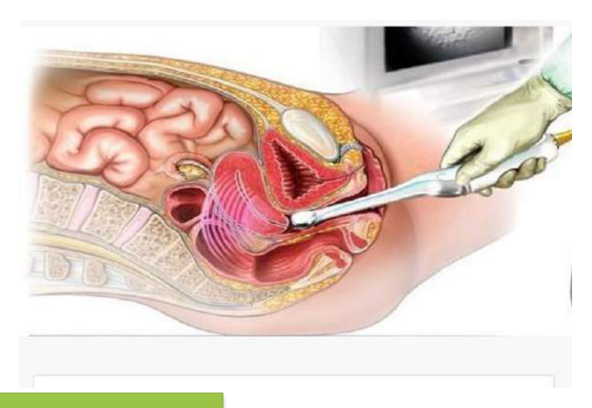  . Method shown in Photograph:
Type | multiple_choice
Option | 3-4 weeks POG
Option | 5-6 weeks POG
Option | 4-5 weeks POG
Option | 7-8 weeks POG
Answer | 2
Solution | Rationale: Ultrasound at 5-6 weeks POG: Gestational sac visible, yolk sac may be seen, fetal pole starting to develop. Heart activity may be detected. Key Clues: 5-6 weeks gestation on ultrasound Why Not Others: A-3-4 weeks is too early;B-4-5 weeks shows gestational sac only;D-7-8 weeks shows more development Exam Trap: Early ultrasound: 5 weeks = gestational sac. 6 weeks = yolk sac + fetal pole. 7 weeks = heart activity. CRL measurement for dating. PNC Pearl: Early ultrasound: 5 weeks = gestational sac. 6 weeks = yolk sac + fetal pole. 7 weeks = heart activity. CRL measurement for dating.
Positive Marks | 1
Negative Marks | 0.33

Question | 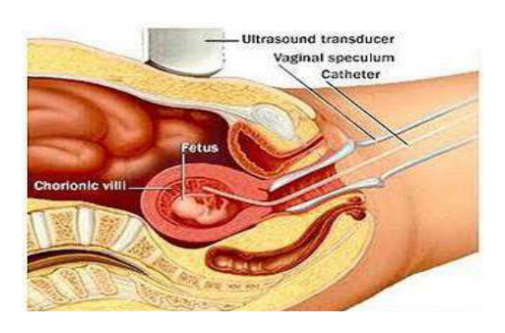  . Prenatal diagnostic procedure:
Type | multiple_choice
Option | 12-14 weeks
Option | 16-18 weeks
Option | 14-16 weeks
Option | 10-12 weeks
Answer | 2
Solution | Rationale: Amniocentesis: Prenatal diagnostic procedure performed at 15-18 weeks to obtain amniotic fluid for genetic analysis, fetal lung maturity, and infection diagnosis. Key Clues: 15-18 weeks, amniotic fluid sampling Why Not Others: A-12-14 weeks is chorionic villus sampling;B-14-16 is too early;D-10-12 is too early Exam Trap: Amniocentesis: 15-18 weeks for karyotyping. 32-36 weeks for lung maturity (L/S ratio). Risk: 0.5% miscarriage. USG-guided. PNC Pearl: Amniocentesis: 15-18 weeks for karyotyping. 32-36 weeks for lung maturity (L/S ratio). Risk: 0.5% miscarriage. USG-guided.
Positive Marks | 1
Negative Marks | 0.33

Question | 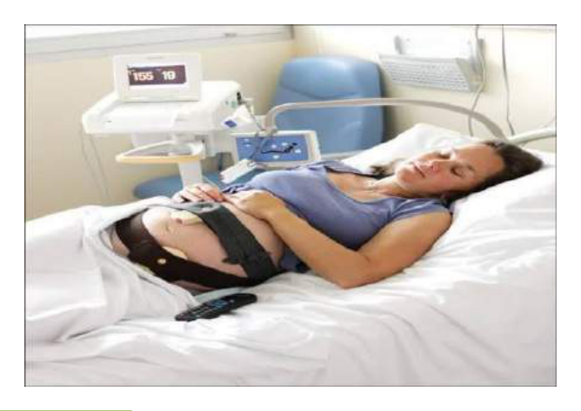  . Identify the given procedure:
Type | multiple_choice
Option | NST
Option | Amniotic fluid index
Option | MCA Doppler
Option | Amniocentesis
Answer | 4
Solution | Rationale: Amniocentesis: A prenatal diagnostic procedure where a needle is inserted through the abdominal wall into the amniotic sac to collect amniotic fluid for testing. Key Clues: Needle into amniotic sac, for fluid collection Why Not Others: A-NST monitors fetal heart rate;B-AFI measures fluid volume;D-MCA Doppler measures blood flow Exam Trap: Amniocentesis: USG-guided. 20G spinal needle. 15-20ml fluid. Test for: karyotype, genetic disorders, lung maturity, infection. PNC Pearl: Amniocentesis: USG-guided. 20G spinal needle. 15-20ml fluid. Test for: karyotype, genetic disorders, lung maturity, infection.
Positive Marks | 1
Negative Marks | 0.33

