Question | 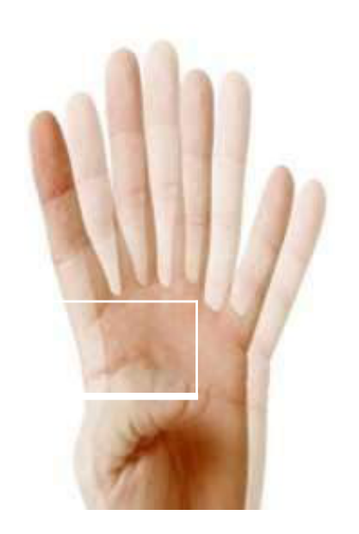  Identify the image:
Type | multiple_choice
Option | Myopia
Option | Diplopia
Option | Hyperopia
Option | Presbyopia
Answer | 3
Solution | Rationale: Hyperopia (Farsightedness): Difficulty focusing on near objects while distant vision is clear. The eyeball is too short or the cornea has too little curvature. Light focuses behind the retina. Key Clues: Near vision blurry, distant clear, eyeball too short Why Not Others: A-Myopia is near-sighted;C-Diplopia is double vision;D-Presbyopia is age-related Exam Trap: Hyperopia vs presbyopia - hyperopia is structural (short eyeball), presbyopia is age- related lens stiffness PNC Pearl: Hyperopia: Corrected with convex (+) lens. Prevalence: 25% of population. May cause eye strain, headaches. Complications: strabismus, amblyopia in children. LASIK can correct permanently.
Positive Marks | 1
Negative Marks | 0.33

Question | 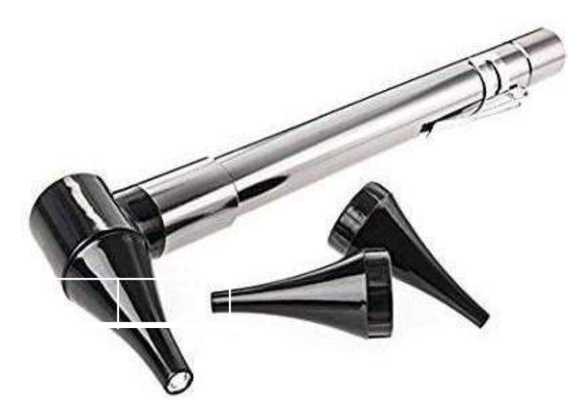  Identify the image:
Type | multiple_choice
Option | Otoscope
Option | Laryngoscope
Option | Opthelmoscope
Option | Tonometer
Answer | 3
Solution | Rationale: Ophthalmoscope: An instrument used to examine the internal structures of the eye (fundus examination). Has a light source, lenses of varying power, and an aperture for viewing the retina, optic disc, and blood vessels. Key Clues: Light source, lenses, for fundus examination Why Not Others: A-Otoscope examines ear;B-Laryngoscope is for intubation;D-Tonometer measures eye pressure Exam Trap: Ophthalmoscope vs otoscope - ophthalmoscope for eyes, otoscope for ears PNC Pearl: Ophthalmoscope: Darken room. Patient looks at distant object. Approach from 15cm. Use red reflex as guide. Look for: optic disc, vessels, macula. Complications: cataract, glaucoma, diabetic retinopathy.
Positive Marks | 1
Negative Marks | 0.33

Question | 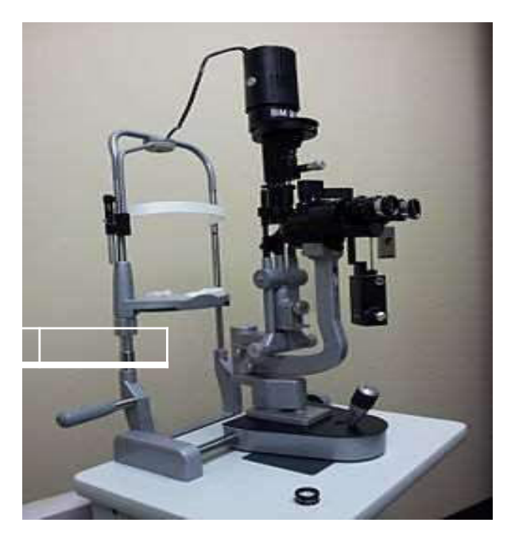  Identify the image:
Type | multiple_choice
Option | Slit lamp
Option | Ophthalmoscope
Option | Tonometry
Option | Microscope
Answer | 1
Solution | Rationale: Slit Lamp: A binocular microscope with a adjustable slit beam of light used for examining the anterior segment of the eye. Allows microscopic examination of cornea, iris, lens, and anterior chamber. Key Clues: Binocular microscope, slit beam, anterior eye exam Why Not Others: B-Ophthalmoscope is for fundus;C-Tonometry measures pressure;D-Microscope is general purpose Exam Trap: Slit lamp vs ophthalmoscope - slit lamp examines anterior segment (cornea/lens), ophthalmoscope examines posterior segment (retina) PNC Pearl: Slit lamp: Essential for diagnosing cataracts, glaucoma, corneal abrasions, anterior uveitis. Used with fluorescein dye for corneal staining. Patient sits with chin on rest.
Positive Marks | 1
Negative Marks | 0.33

Question | 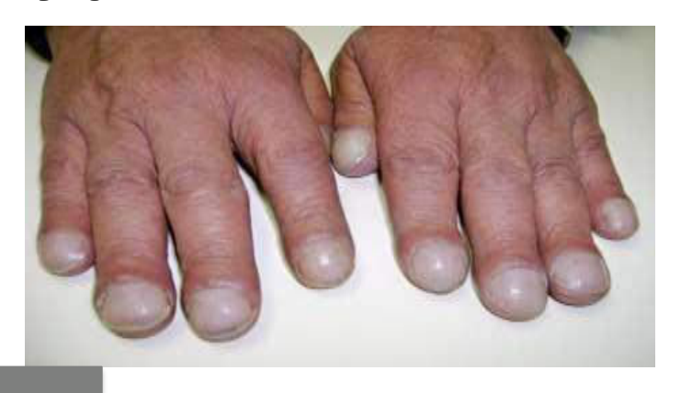  Following condition of nail occurred:
Type | multiple_choice
Option | High concentration of OZ therapy
Option | Chronic hypoxia
Option | Vitamin deficiency
Option | Decrease intake of dietary protein
Answer | 1
Solution | Rationale: Clubbing of nails (Drumstick nails): Occurs with high concentration oxygen therapy, chronic hypoxia, lung diseases (bronchiectasis, lung cancer, interstitial lung disease). The nail bed angle exceeds 180 deg. Key Clues: Nail bed angle >180 deg, drumstick appearance Why Not Others: B-Chronic hypoxia causes cyanosis not clubbing;C-Vitamin deficiency causes different nail changes;D-Protein deficiency causes different changes Exam Trap: Clubbing vs cyanosis - clubbing is structural change, cyanosis is color change PNC Pearl: Clubbing: MeasureLovibond angle (>180 deg positive). Schamroth sign: no diamond gap when nails pressed together. Associated with: lung cancer, bronchiectasis, cyanotic heart disease, IBD.
Positive Marks | 1
Negative Marks | 0.33

Question | 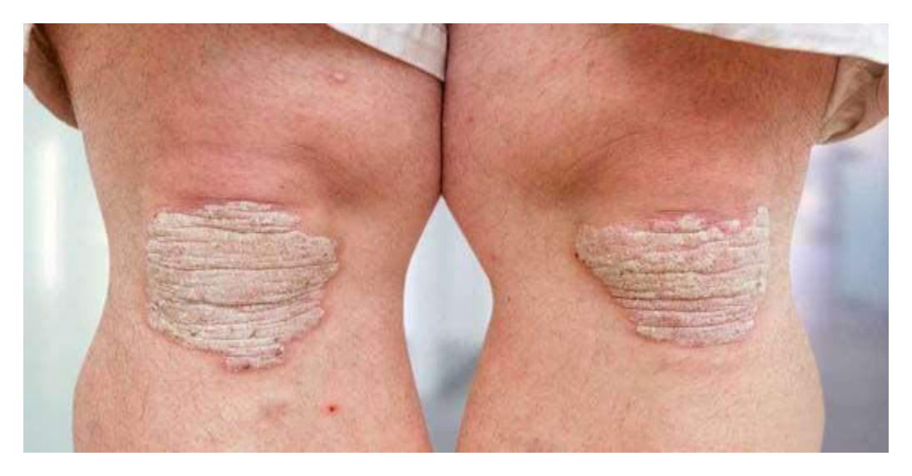  Following condition mainly seen in:
Type | multiple_choice
Option | Psoriasis
Option | Scleroderma
Option | Imptgo
Option | Tenia pedis
Answer | 2
Solution | Rationale: Scleroderma: Chronic autoimmune condition causing hardening and thickening of skin and connective tissue. Shows tight, shiny skin, especially on fingers, face, and extremities. Can affect internal organs. Key Clues: Hardened, thickened skin, autoimmune Why Not Others: A-Psoriasis has scaly plaques;C-Impetigo has honey-colored crusts;D-Tinea pedis is fungal foot infection Exam Trap: Scleroderma vs psoriasis - scleroderma hardens skin, psoriasis creates scaly plaques PNC Pearl: Scleroderma types: Limited (CREST syndrome) and Diffuse. CREST = Calcinosis, Raynaud's, Esophageal dysmotility, Sclerodactyly, Telangiectasia. Monitor for: pulmonary fibrosis, renal crisis.
Positive Marks | 1
Negative Marks | 0.33

Question | 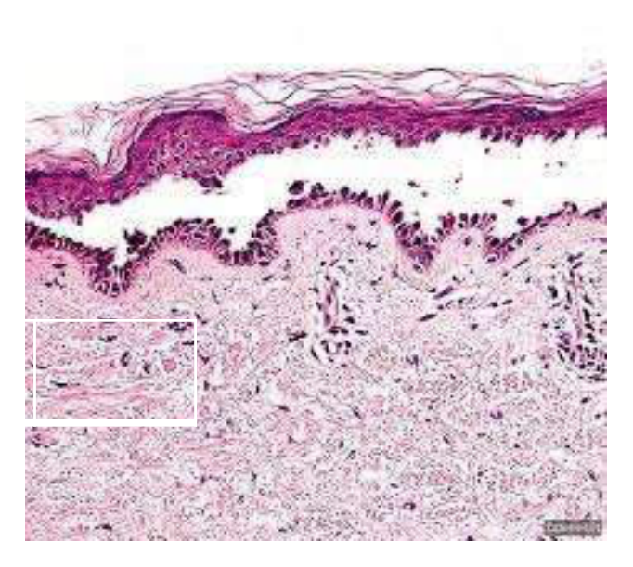  Identify the image:
Type | multiple_choice
Option | Scabies
Option | Psoriasis
Option | Pemphigus vulgaris
Option | Eczema
Answer | 2
Solution | Rationale: Psoriasis: Chronic autoimmune skin condition with well-demarcated, erythematous plaques covered with silvery-white scales. Commonly affects extensor surfaces, scalp, and nails. Auspitz sign positive. Key Clues: Silvery scales, well-demarcated plaques, extensor surfaces Why Not Others: A-Scabies is burrows with intense itch;C-Pemphigus vulgaris has flaccid bullae;D-Eczema has ill-defined patches Exam Trap: Psoriasis vs eczema - psoriasis has well-defined scaly plaques, eczema has poorly defined itchy patches PNC Pearl: Psoriasis: Chronic, relapsing. Koebner phenomenon (appears at trauma sites). Nail changes: pitting, oil spots. Associated with arthritis. Treatment: emollients, topical steroids, vitamin D analogues, biologics.
Positive Marks | 1
Negative Marks | 0.33

Question | 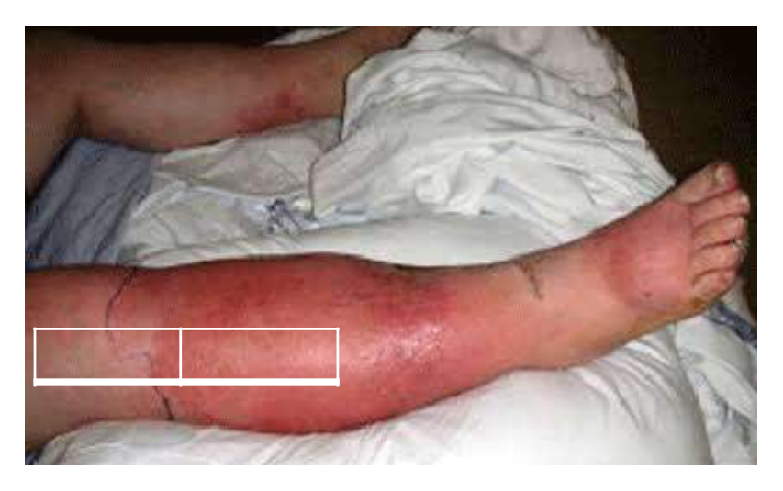  Identify the image:
Type | multiple_choice
Option | Folliculitis
Option | Fluid overload
Option | Filariasis
Option | Cellulitis
Answer | 4
Solution | Rationale: Cellulitis: Acute bacterial skin infection causing redness, swelling, warmth, and pain. Usually caused by Streptococcus or Staphylococcus. Requires antibiotics and monitoring for spread. Key Clues: Red, hot, swollen, painful skin, bacterial infection Why Not Others: A-Folliculitis is hair follicle infection;B-Fluid overload is systemic;D-Filariasis is parasitic lymphatic Exam Trap: Cellulitis vs erysipelas - cellulitis is deeper (dermis/subcutaneous), erysipelas is superficial (dermis) PNC Pearl: Cellulitis: Elevate affected area. Antibiotics (flucloxacillin or cefalexin). Monitor for: sepsis, necrotizing fasciitis, osteomyelitis. Mark borders to track spread.
Positive Marks | 1
Negative Marks | 0.33

