Question | 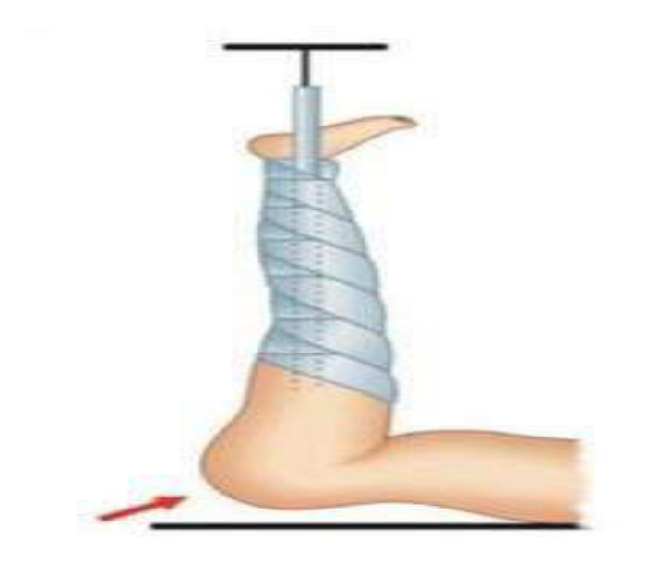  Identify the image:
Type | multiple_choice
Option | Buck·s traction
Option | Gallow traction
Option | Smith traction
Option | Russell·s traction
Answer | 1
Solution | Rationale: Buck's traction is skin traction applied to the lower extremity using an adhesive strip or boot. A weight is attached via pulley system. Used for femoral fractures, hip fractures, and pre-operative immobilization. Key Clues: Skin traction on leg with weight and pulley, bed-based Why Not Others: A-Gallows traction is for pediatric femur fractures (vertical); B-Smith traction uses knee flexion; C-Russell traction combines skin and skeletal Exam Trap: Buck's vs Russell - Buck's is simple skin traction; Russell uses pulley system with knee flexion PNC Pearl: Buck's traction: Weights 5-7 lbs for skin traction. Check neurovascular status q2h (5 P's). Never elevate foot of bed. Adhesive traction uses moleskin or Buck's boot.
Positive Marks | 1
Negative Marks | 0.33

Question | 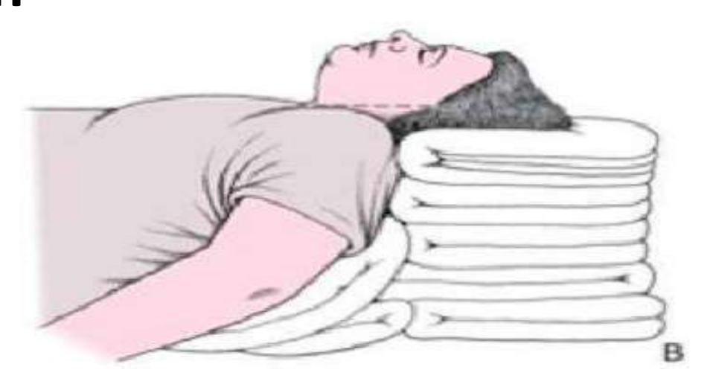  Identify the Position?
Type | multiple_choice
Option | Rose position
Option | Ramped position
Option | Sniffing position
Option | Durant position
Answer | 3
Solution | Rationale: Sniffing Position: Head extended at atlanto-occipital joint, neck flexed at cervical spine. Creates alignment of oral, pharyngeal, and laryngeal axes. Optimal position for endotracheal intubation. Key Clues: Head extended, neck flexed, for intubation alignment Why Not Others: A-Rose is for prone;C-Ramped elevates entire body;D-Durant is left lateral for air embolism Exam Trap: Sniffing vs ramped - sniffing is head/neck only, ramped elevates entire body to ear- sternal notch level PNC Pearl: Sniffing position: Ear-to-sternal notch alignment. Use pillow under head (10-15cm). Essential for laryngoscopy and intubation. Modified sniffing for obese patients.
Positive Marks | 1
Negative Marks | 0.33

Question | 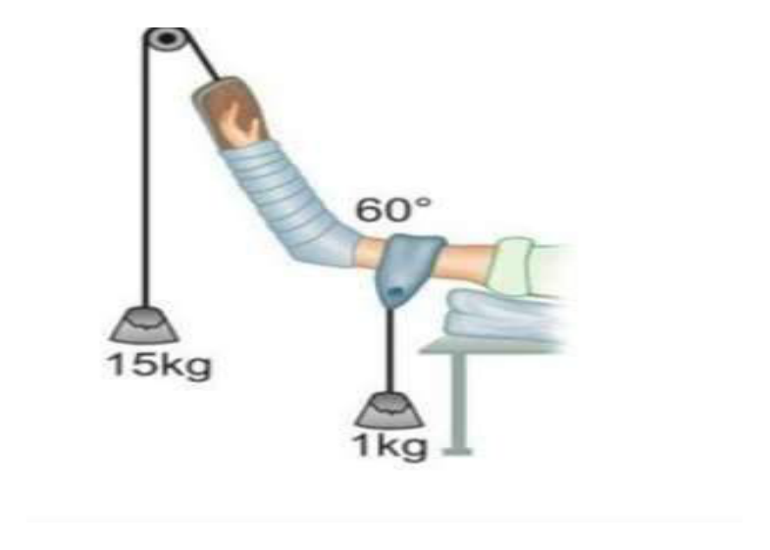  Identify the image:
Type | multiple_choice
Option | Dunlop traction
Option | Smith traction
Option | Bucks traction
Option | Gallows traction
Answer | 1
Solution | Rationale: Dunlop's Traction: A type of skin traction applied to the upper extremity or trunk, commonly used for cervical spine injuries and upper extremity fractures. Uses adhesive strips and weights. Key Clues: Applied to upper body/trunk, skin traction, for cervical/upper extremity Why Not Others: A-Smith is for femur fractures with knee flexion; C-Buck's is lower extremity skin traction; D-Gallows is vertical pediatric Exam Trap: Dunlop's vs Buck's - Dunlop's is for upper body, Buck's is for lower extremity PNC Pearl: Dunlop's traction: Used in pediatric cervical spine injuries and humeral fractures. Maintain alignment. Check neurovascular status frequently.
Positive Marks | 1
Negative Marks | 0.33

Question | 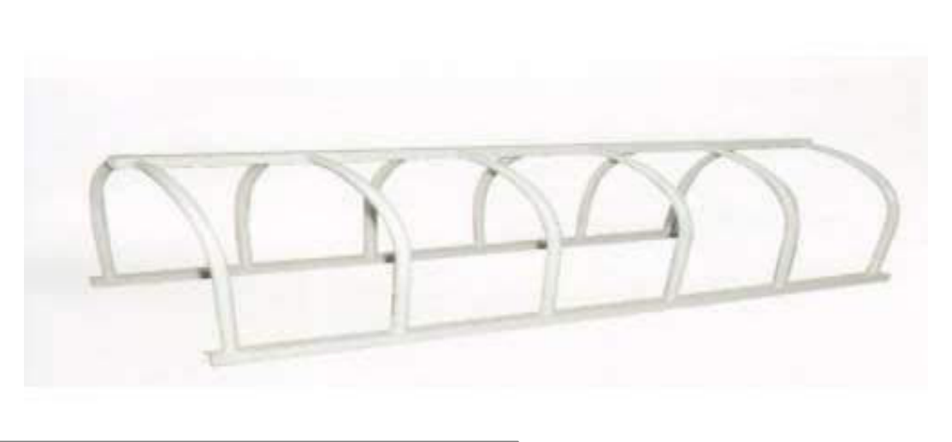  Identify the image:
Type | multiple_choice
Option | Canopy
Option | Thomus splint
Option | Bed cradle
Option | Foot rest
Answer | 2
Solution | Rationale: Thomas Splint: A padded ring at the proximal end with two metal bars and a distal strap. Used for temporary immobilization of femur fractures during transport. Provides balanced suspension traction. Key Clues: Padded ring, metal bars, for femur fracture transport Why Not Others: A-Canopy is bed cover;B-Bed cradle keeps linens off;D-Foot rest supports feet Exam Trap: Thomas splint vs Buck's traction - Thomas splint is for transport, Buck's is for bed- based traction PNC Pearl: Thomas splint: Originally designed by Hugh Thomas for TB hip. Now used in prehospital femur fracture management. Check distal pulses, sensation, movement before and after application.
Positive Marks | 1
Negative Marks | 0.33

Question | 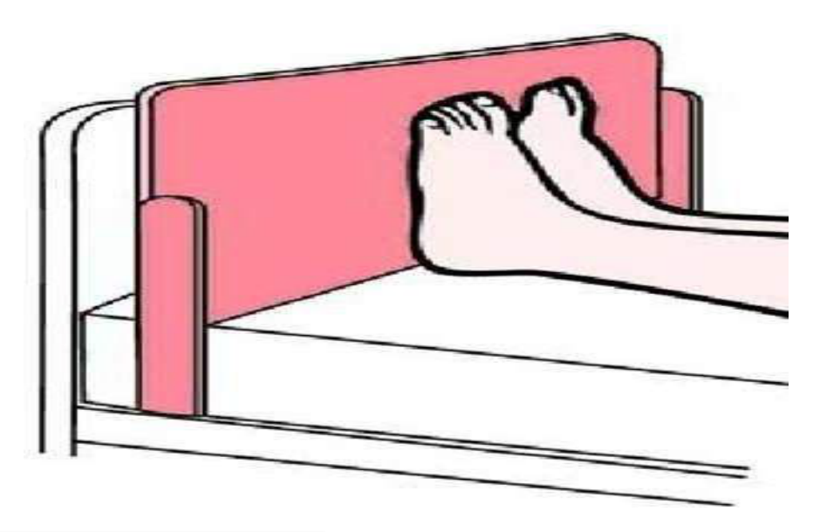  Identify the image:
Type | multiple_choice
Option | Foot board
Option | Canopy
Option | Bed cradle
Option | Thomus splint
Answer | 1
Solution | Rationale: Foot Board: A board attached to the foot of the bed to support feet in proper alignment. Prevents foot drop (dorsiflexion contracture) in bedridden patients by maintaining neutral position. Key Clues: Board at foot of bed, prevents foot drop Why Not Others: A-Canopy covers bed;B-Bed cradle lifts linens;C-Thomas splint is for fractures Exam Trap: Foot board vs foot drop - foot board prevents foot drop by maintaining ankle at 90 deg PNC Pearl: Foot board: Essential for long-term bedridden patients. Paired with foot cradle. Also used to push against for positioning. Check for pressure on heels.
Positive Marks | 1
Negative Marks | 0.33

Question | 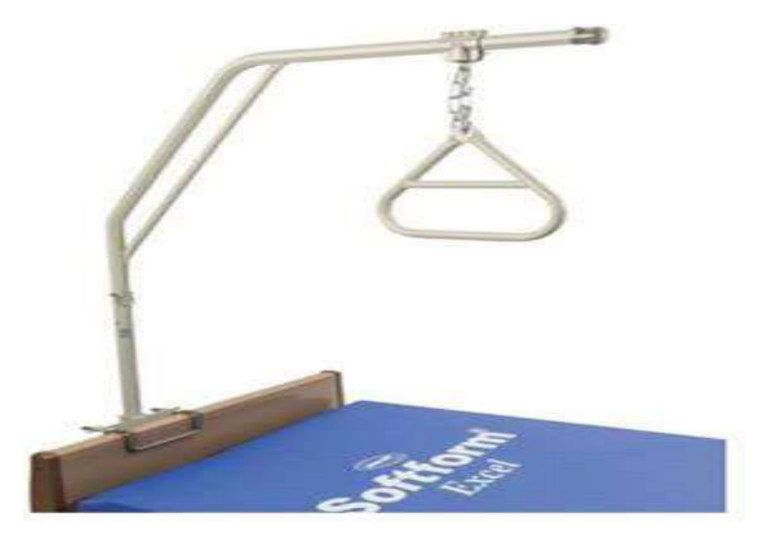  Identify the image:
Type | multiple_choice
Option | Side rail
Option | Trapeze bar
Option | Over heard rail
Option | Traction set
Answer | 2
Solution | Rationale: Trapeze Bar: A triangular bar hanging from an overhead frame that allows patients to lift themselves for repositioning, turning, and mobility in bed. Promotes independence and prevents pressure injuries. Key Clues: Triangular bar, overhead frame, patient self-lifting Why Not Others: A-Side rail prevents falls;B-Overhead rail is a grab bar;D-Traction set applies pull Exam Trap: Trapeze vs overhead grab bar - trapeze is suspended and can swing, grab bar is fixed PNC Pearl: Trapeze bar: Attach to bed frame. Teach patient to use. Allows independent repositioning. Especially useful for: hip fractures, spinal injuries, post-operative patients.
Positive Marks | 1
Negative Marks | 0.33

Question | 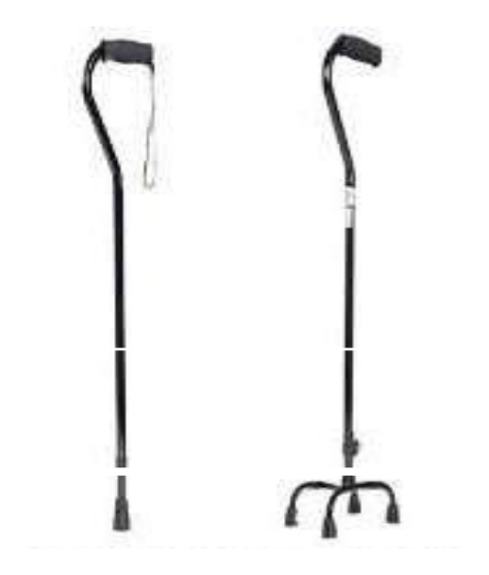  Identify the image:
Type | multiple_choice
Option | Crutches
Option | Canes
Option | Walker
Option | Trapeze
Answer | 2
Solution | Rationale: Canes: Walking aids used to provide support and stability for patients with mild balance or weight-bearing difficulties. Made of wood or metal with rubber tip. Used on the contralateral side of weakness. Key Clues: Walking stick, rubber tip, contralateral side support Why Not Others: A-Crutches are for more support;C-Walker provides maximum support;D-Trapeze is bed- mounted Exam Trap: Canes vs walkers - canes are for mild support, walkers for moderate-severe support PNC Pearl: Canes: Correct height = wrist crease level when standing. Hold in opposite hand of weakness. Four-point gait. Rubber tip replacement when worn. Quad canes provide more stability.
Positive Marks | 1
Negative Marks | 0.33

Question | 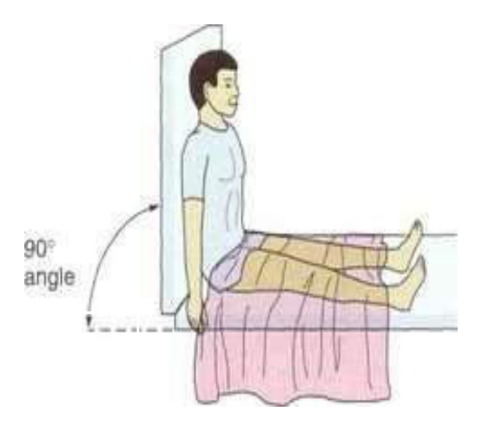  Identify the image:
Type | multiple_choice
Option | Dorsal recumbent position
Option | Fowler position
Option | Semi fowler position
Option | High fowler position
Answer | 1
Solution | Rationale: Dorsal Recumbent Position: Patient lies on back with knees flexed and feet flat on bed. Used for abdominal assessment, pelvic examination, catheterization, and post- delivery care. Key Clues: Supine, knees flexed, feet flat Why Not Others: A-Fowler is head elevated 45-60 deg;C-Semi-Fowler is 30-45 deg;D-High Fowler is 90 deg Exam Trap: Dorsal recumbent vs supine - dorsal recumbent has knees flexed, supine has legs straight PNC Pearl: Dorsal recumbent: Common in nursing for catheterization, abdominal exam, and post- delivery. Reduces abdominal muscle tension. Ensure privacy and proper draping.
Positive Marks | 1
Negative Marks | 0.33

Question | 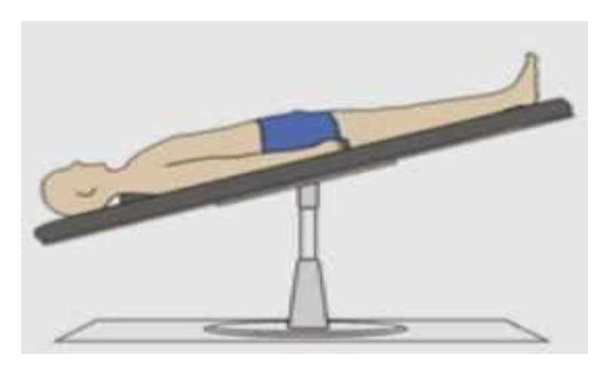  Identify the image:
Type | multiple_choice
Option | Fowler position
Option | Reverse fowler position
Option | Trendelenberg position
Option | Reverse trendelenberg position
Answer | 4
Solution | Rationale: Reverse Trendelenburg Position: Table/bed tilted with head up and feet down. The entire body is angled, not just the head. Used to reduce intracranial pressure, decrease gastroesophageal reflux, and during certain surgeries. Key Clues: Entire body tilted head-up, feet-down angle Why Not Others: A-Fowler is head up with flat bed;B-Reverse Fowler is head down;D-Trendelenburg is head-down, feet-up Exam Trap: Reverse Trendelenburg vs Fowler - reverse uses whole body tilt, Fowler elevates head only PNC Pearl: Reverse Trendelenburg: Used in laparoscopic surgery, to reduce ICP, for GERD. Different from Trendelenburg (which is feet-up). Monitor for patient sliding.
Positive Marks | 1
Negative Marks | 0.33

Question | 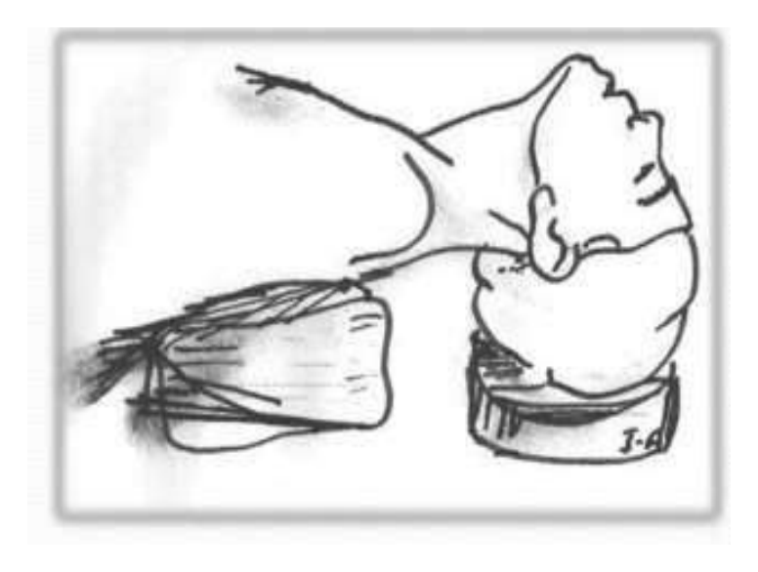  Identify the image:
Type | multiple_choice
Option | Rose position
Option | fowlers position
Option | Intubation position
Option | Sims position
Answer | 4
Solution | Rationale: Sims' Position (Left Lateral): Patient lies on left side with right knee flexed and left arm behind back. Used for rectal/vaginal examination, enema administration, and perineal care. Key Clues: Left lateral, right knee flexed, for rectal/vaginal procedures Why Not Others: A-Rose is for prone;B-Fowler is supine with head elevated;D-Intubation is sniffing Exam Trap: Sims' vs lateral - Sims' is specifically left lateral with right knee flexed for procedures PNC Pearl: Sims' position: Most commonly used for enemas, rectal exams, vaginal exams, and perineal care. Named after J. Marion Sims, father of gynecology. Use draw sheet for positioning.
Positive Marks | 1
Negative Marks | 0.33

Question | 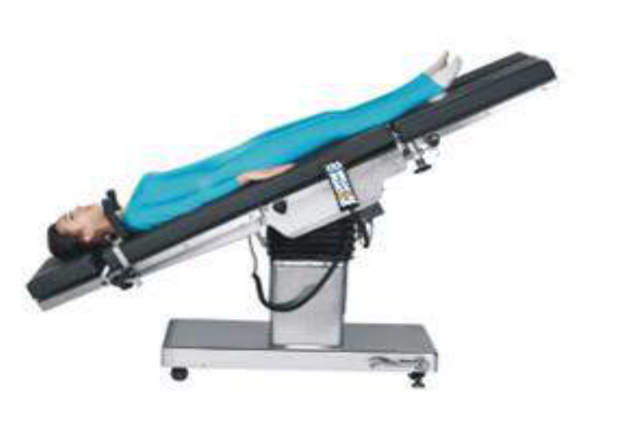  Identify the image:
Type | multiple_choice
Option | Reverse Trendelenberg position
Option | Counter Trendelenberg position
Option | Trendelenberg position
Option | Super position
Answer | 3
Solution | Rationale: Trendelenburg Position: Bed tilted with feet elevated 15-30 deg above head level. Used for shock management, post-spinal anesthesia headache prevention, and certain surgical procedures. Key Clues: Feet elevated above head, bed tilted Why Not Others: A-Reverse Trendelenburg is head up;C-Counter Trendelenburg is same as reverse;D-Super position is not standard Exam Trap: Trendelenburg vs reverse - Trendelenburg = feet UP, Reverse = head UP PNC Pearl: Trendelenburg: Used for shock (improve venous return), lumbar puncture headache, pelvic surgery. Monitor for respiratory compromise, facial edema. Time-limited use.
Positive Marks | 1
Negative Marks | 0.33

Question | 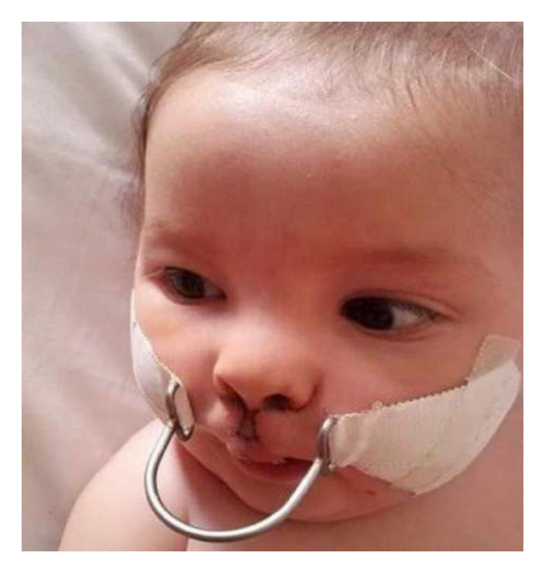  Identify the image:
Type | multiple_choice
Option | Logan bow
Option | Nasal retractor
Option | Halo traction
Option | None
Answer | 3
Solution | Rationale: Halo Traction: A circular metal ring fixed to the skull with pins, connected to a vest or bed frame. Used for cervical spine fractures and post-operative cervical spine immobilization. Key Clues: Metal ring on skull, for cervical spine stabilization Why Not Others: A-Logan bow is for jaw fractures;C-Nasal retractor is for nose;D-None is incorrect Exam Trap: Halo traction vs cervical collar - halo provides rigid immobilization, collar is less rigid PNC Pearl: Halo traction: Pins placed under local anesthesia. Pin care q8-12h. Monitor for: infection, neurological deficit, skin breakdown under vest. Never remove without authorization.
Positive Marks | 1
Negative Marks | 0.33

Question | 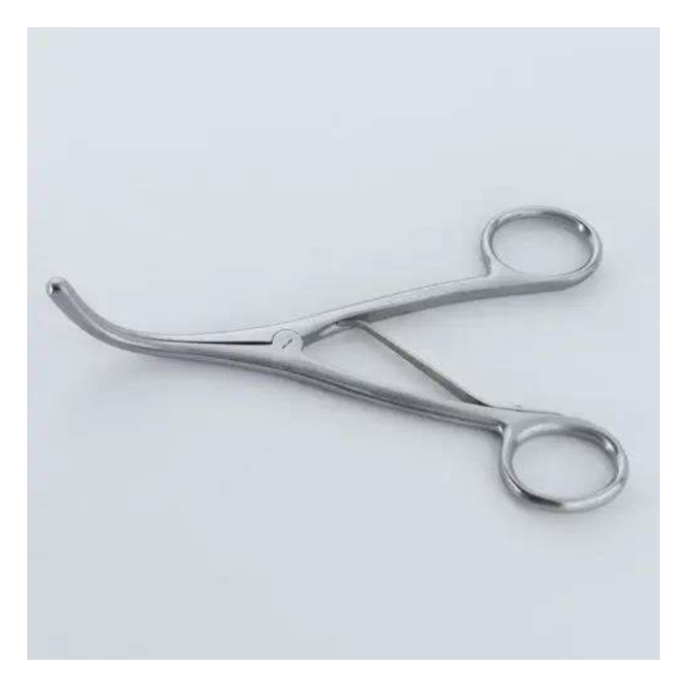  Identify the image:
Type | multiple_choice
Option | Uterine dilator
Option | Tracheal dilator
Option | Uretheral dilator
Option | Cervical dilator
Answer | 4
Solution | Rationale: Cervical Dilator (Hegar Dilator): A set of graduated metal rods used to progressively dilate the cervix. Used before D&C, IUD insertion, and other cervical procedures. Key Clues: Graduated metal rods, for cervical dilation Why Not Others: A-Uterine dilator is for uterus;C-Tracheal is for airway;D-Urethral is for urethra Exam Trap: Hegar dilator: Start small, increase gradually. Never force. Monitor for: perforation, bleeding, cervical laceration. PNC Pearl: Hegar dilator: Start small, increase gradually. Never force. Monitor for: perforation, bleeding, cervical laceration.
Positive Marks | 1
Negative Marks | 0.33

