Question | 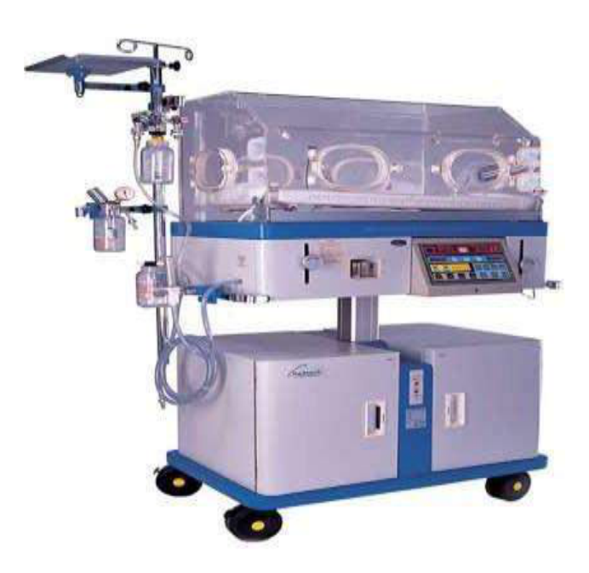  Identify the image:
Type | multiple_choice
Option | Plasma pheresis
Option | Haemodialysis
Option | Incubator
Option | Radiant warmer
Answer | 2
Solution | Rationale: Haemodialysis Machine: A device that filters blood through a dialyzer to remove waste products and excess fluid in patients with kidney failure. Blood is pumped through extracorporeal circuit. Key Clues: Blood filtration through dialyzer, extracorporeal circuit Why Not Others: A-Plasma pheresis removes plasma;C-Incubator is for neonates;D-Radiant warmer heats neonates Exam Trap: Haemodialysis vs peritoneal dialysis - HD uses machine/dialyzer, PD uses peritoneal membrane PNC Pearl: Haemodialysis: Blood flow 200-400 ml/min. Dialysate 500 ml/min. AV fistula preferred access. 3-4 hours, 3x/week. Complications: hypotension, cramps, infection, hypothermia.
Positive Marks | 1
Negative Marks | 0.33

Question | 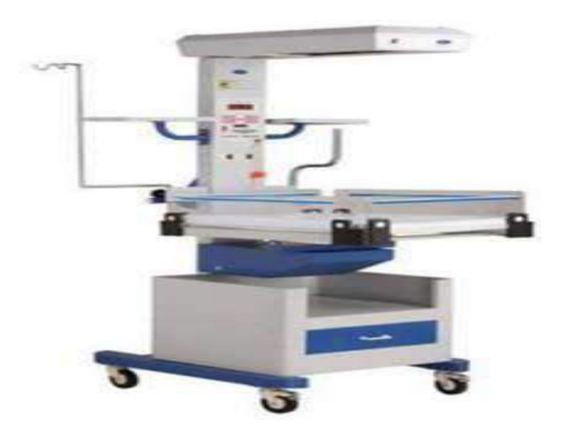  Identify the image:
Type | multiple_choice
Option | Plasma pheresis
Option | Haemodialysis
Option | Incubator
Option | Radiant warmer
Answer | 2
Solution | Rationale: Haemodialysis: Same as above - a machine-based renal replacement therapy where blood is removed, filtered through a dialyzer, and returned to the patient. Key Clues: Extracorporeal blood filtration Why Not Others: A-Plasma pheresis;C-Incubator;D-Radiant warmer are different devices Exam Trap: Key distinction: haemodialysis removes waste from BLOOD directly PNC Pearl: Dialysis adequacy: Kt/V target >1.2. URR >65%. Monitor blood pressure during and post-dialysis.
Positive Marks | 1
Negative Marks | 0.33

Question | 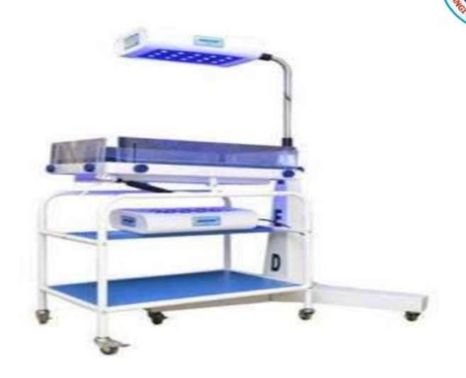  Identify the image:
Type | multiple_choice
Option | Phototherapy
Option | Plasma pheresis
Option | Incubator
Option | Radiant warmer
Answer | 1
Solution | Rationale: Phototherapy: Uses blue light (wavelength 425-470nm) to convert bilirubin in the skin into water-soluble forms that can be excreted. Used to treat neonatal jaundice/hyperbilirubinemia. Key Clues: Blue light, treats neonatal jaundice Why Not Others: A-Plasma pheresis removes plasma;C-Incubator maintains temperature;D-Radiant warmer heats Exam Trap: Phototherapy mechanism: Light converts unconjugated bilirubin · water-soluble isomers · excreted in bile/urine PNC Pearl: Phototherapy: Cover eyes (photokeratitis risk). Expose maximum skin. Monitor temperature. Check bilirubin levels q4-6h. Fluid intake 150ml/kg/day. Turn baby q2h.
Positive Marks | 1
Negative Marks | 0.33

Question | 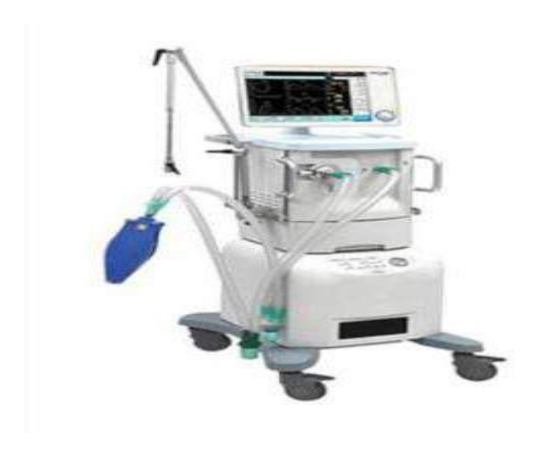  Identify the image:
Type | multiple_choice
Option | Ventilator
Option | Phototherapy
Option | Incubator
Option | Radiant warmer
Answer | 3
Solution | Rationale: Incubator: An enclosed bed for premature/ill neonates that maintains optimal temperature, humidity, and oxygen concentration. Provides a controlled environment for thermoregulation. Key Clues: Enclosed, temperature-controlled, for neonates Why Not Others: A-Ventilator delivers breaths;B-Phototherapy treats jaundice;D-Radiant warmer is open Exam Trap: Incubator vs radiant warmer - incubator is enclosed (thermoregulation), warmer is open (resuscitation) PNC Pearl: Incubator: Temperature 36.5-37.5 degC (neutral thermal environment). Humidity 40-80%. Monitor: temperature q1-4h, humidity, O· concentration. Port holes for access.
Positive Marks | 1
Negative Marks | 0.33

Question | 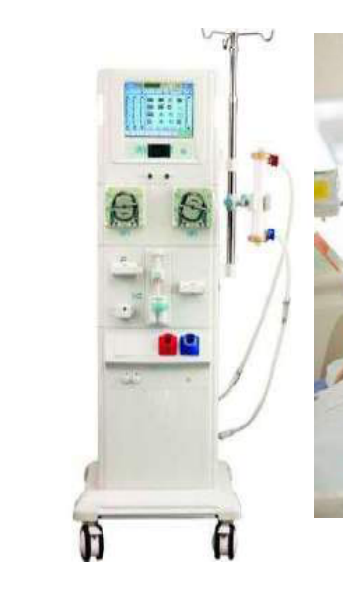  Identify the image:
Type | multiple_choice
Option | Radiant warmer
Option | Ventilator
Option | Phototherapy
Option | Hemodialysis
Answer | 1
Solution | Rationale: Radiant Warmer: An overhead heating device used for neonatal resuscitation and thermoregulation. Provides radiant heat to keep neonates warm while allowing easy access for procedures. Key Clues: Overhead heating, open access, for neonatal care Why Not Others: A-Ventilator;B-Phototherapy;C-Hemodialysis are different devices Exam Trap: Radiant warmer vs incubator - radiant warmer is open (for procedures/resuscitation), incubator is enclosed PNC Pearl: Radiant warmer: Set servo control to skin probe. Alarm limits set. Used during: resuscitation, procedures, transport from delivery room to NICU.
Positive Marks | 1
Negative Marks | 0.33

Question | 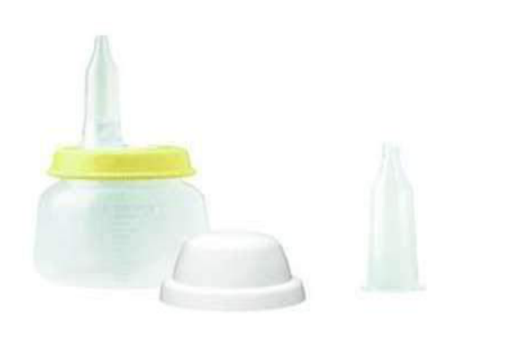  Feeder with long nipple used for..:
Type | multiple_choice
Option | Baby with cleft lip
Option | Baby with cleft palate
Option | Infant with tongue tie
Option | Infant birth tracheo esophageal fistula
Answer | 4
Solution | Rationale: Feeder with long nipple used for infant with tracheoesophageal fistula (TEF). The long nipple helps prevent aspiration by bypassing the fistula between the trachea and esophagus. Key Clues: Long nipple, prevents aspiration in TEF Why Not Others: A-Cleft lip uses Haberman feeder; B-Cleft palate uses special cleft palate nipple;D-Tongue tie needs frenotomy Exam Trap: Long nipple for TEF - specifically designed to bypass the fistula PNC Pearl: TEF nursing: Keep head of bed elevated 30-45 deg. Continuous suction. NPO until surgical repair. Long nipple feeds: position infant upright. Monitor for aspiration signs.
Positive Marks | 1
Negative Marks | 0.33

Question | 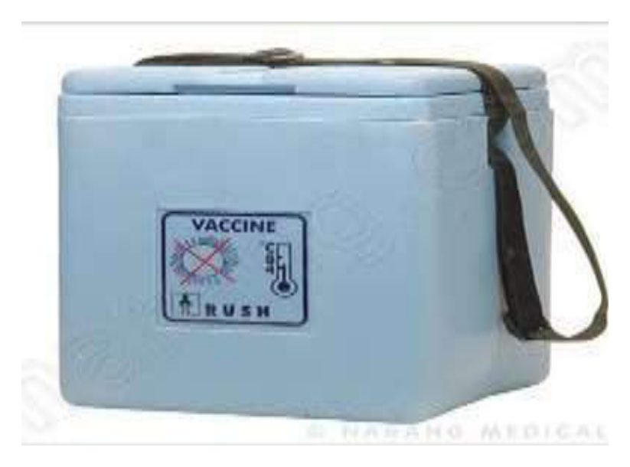  Identify the image:
Type | multiple_choice
Option | Blood carrier
Option | Vaccine carrier
Option | Ice packs
Option | Cold box
Answer | 2
Solution | Rationale: Vaccine Carrier: An insulated container used to transport vaccines from cold store to outreach sites. Maintains 2-8C temperature using ice packs. Used in immunization programs for community outreach. Key Clues: Insulated container, ice packs, for vaccine transport Why Not Others: A-Blood carrier is for blood products;B-Ice packs are components;D-Cold box is for larger storage Exam Trap: Vaccine carrier vs cold box - carrier is smaller (portable), cold box is larger (storage) PNC Pearl: Vaccine carrier: Keep in shade. Open lid minimally. Check temperature twice daily. Ice packs should be conditioned (not frozen solid). Capacity varies (typically 1.5-6 liters).
Positive Marks | 1
Negative Marks | 0.33

Question | 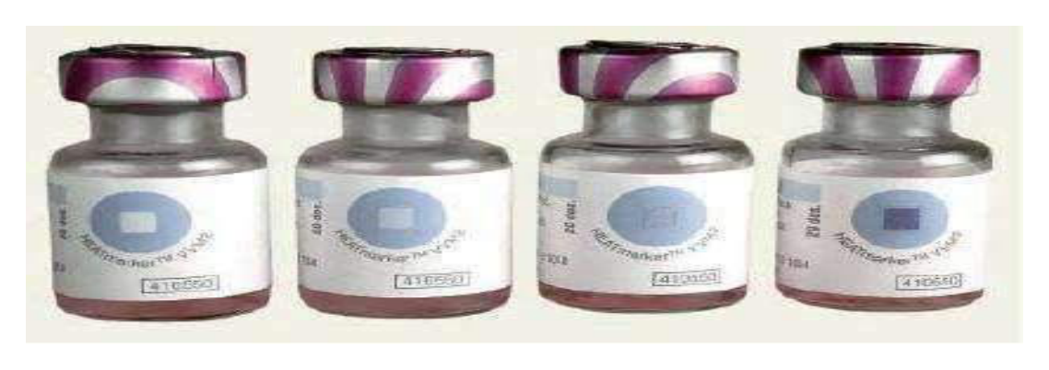  Identify the image which can:
Type | multiple_choice
Option | A
Option | A and B
Option | B
Option | C and D
Answer | 2
Solution | Rationale: Multiple choice question with image identification - requires visual analysis of the clinical image to determine the correct answer from the options provided. Key Clues: Image-based identification question Why Not Others: Requires analysis of the specific image shown in the source document Exam Trap: Always correlate image findings with clinical knowledge and nursing implications PNC Pearl: Clinical assessment questions require systematic approach: identify key features, correlate with clinical findings, select most appropriate answer.
Positive Marks | 1
Negative Marks | 0.33

Question | 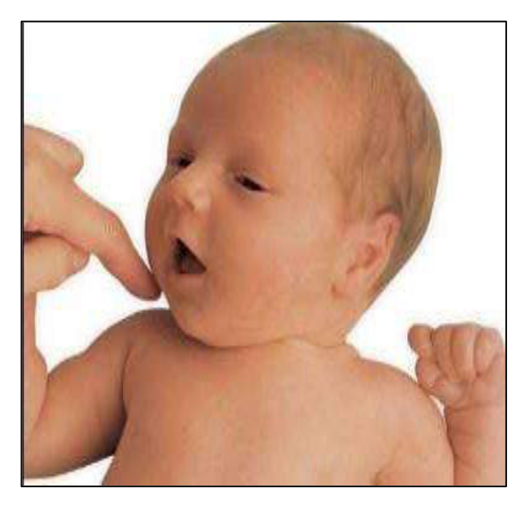  Identify the image reflex disappeared:
Type | multiple_choice
Option | 3-4 months
Option | 1 months
Option | 1 year
Option | At 10 month
Answer | 1
Solution | Rationale: Moro Reflex (Startle Reflex): A primitive reflex present at birth where the infant extends arms and legs in response to a loud noise or sudden movement. Disappears by 3-4 months. Key Clues: Arms extend then embrace, disappears 3-4 months Why Not Others: B-Rooting disappears 3-4 months;C-At 1 year is wrong;D-At 10 months is wrong Exam Trap: Moro vs Palmer grasp - Moro is startle response, Palmer grasp is gripping PNC Pearl: Moro reflex: Symmetry is important - asymmetric Moro suggests brachial plexus injury or hemiplegia. Disappears by 3-4 months. Persistent Moro beyond 6 months = neurological concern.
Positive Marks | 1
Negative Marks | 0.33

Question | 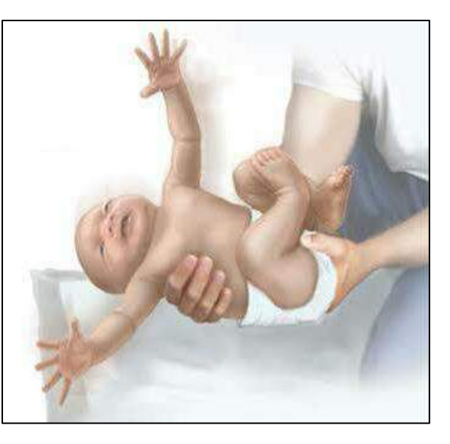  Identify the image reflex and:
Type | multiple_choice
Option | Moro reflex, 7 months
Option | Palmer grasp, 1 year
Option | Roting reflex and 7 months
Option | At 10 month
Answer | 3
Solution | Rationale: Rooting Reflex: A primitive reflex where the infant turns head and opens mouth when cheek is stroked. Present at birth and disappears by 3-4 months. Important for breastfeeding. Key Clues: Head turns toward touch, opens mouth, for breastfeeding Why Not Others: A-Moro disappears 3-4 months;C-Palmer grasp at 1 year;D-At 10 months is wrong Exam Trap: Rooting vs sucking - rooting initiates feeding behavior, sucking maintains feeding PNC Pearl: Primitive reflexes timeline: Rooting (0-3mo), Moro (0-3-4mo), Palmer grasp (0-5-6mo), Stepping (0-2mo). All should disappear by 6 months. Persistence = neurological concern.
Positive Marks | 1
Negative Marks | 0.33

Question | 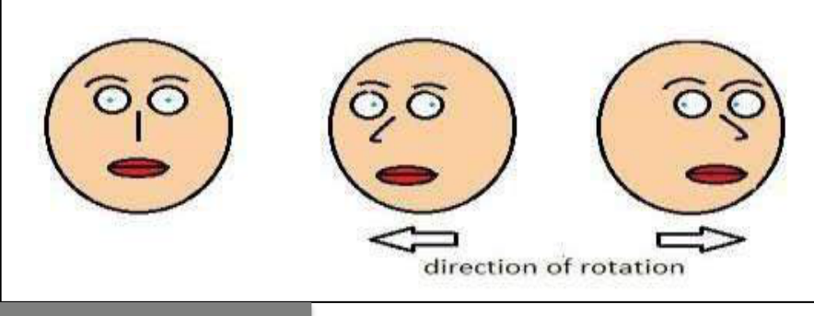  Identify the image reflex disappeared:
Type | multiple_choice
Option | Occulo cephalic reflex
Option | Dolls eye reflex
Option | Tonic neck reflex
Option | A and B
Answer | 1
Solution | Rationale: Pediatric Growth Assessment: Pediatric nurses monitor growth milestones including head circumference, weight, length/height, and developmental milestones using standardized growth charts. Key Clues: Growth monitoring, standardized charts Why Not Others: Developmental milestones include: gross motor, fine motor, language, social-emotional domains Exam Trap: Use WHO/CDC growth charts for monitoring. Plot at each visit. Compare with previous measurements. PNC Pearl: Use WHO/CDC growth charts for monitoring. Plot at each visit. Compare with previous measurements.
Positive Marks | 1
Negative Marks | 0.33

Question | 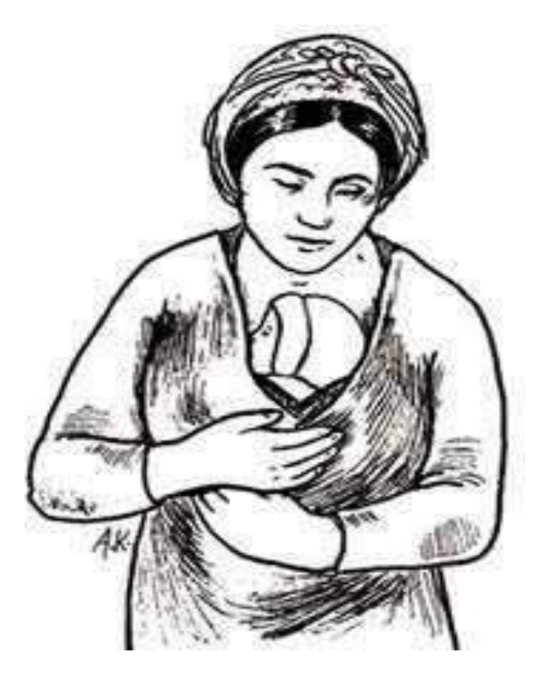  Following technique helpful for and it's:
Type | multiple_choice
Option | For all sick child and to control infection.
Option | For LBW baby and skin to skin contact
Option | For all newborn and growth
Option | All of them.
Answer | 1
Solution | Rationale: Palmer Grasp Reflex: A primitive reflex in newborns where gripping an object placed in the palm. Present at birth and disappears by 5-6 months. Indicates intact neurological development. Key Clues: Grip reflex in palm, present at birth, disappears 5-6 months Why Not Others: A-Moro reflex disappears 3-4 months;B-Rooting disappears 3-4 months;D-Sucking disappears when weaned Exam Trap: Palmer grasp disappears by 6 months - persistent grasp after 6 months suggests neurological issue PNC Pearl: Primitive reflexes timeline: Moro (0-4mo), Rooting (0-4mo), Palmer grasp (0-5-6mo), Stepping (0-2mo), Tonic neck (0-7mo). Persistent reflexes after expected age = neurological concern.
Positive Marks | 1
Negative Marks | 0.33

Question | 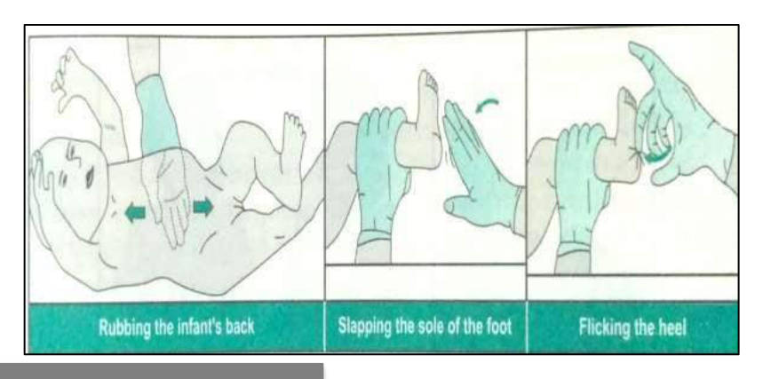  Following images technique:
Type | multiple_choice
Option | Assessing autonomic reflex
Option | Stimulation for increasing heart
Option | All of above
Option | Tectile stimulation for breathing
Answer | 4
Solution | Rationale: Primitive Reflex Assessment: Important neurological assessment in neonates and infants. Absent or persistent primitive reflexes may indicate neurological pathology. Key Clues: Neurological assessment in neonates Why Not Others: Check for: Moro, rooting, sucking, grasp, stepping, tonic neck reflexes Exam Trap: Primitive reflexes should disappear by 4-6 months. Persistence beyond expected age = neurological concern. PNC Pearl: Primitive reflexes should disappear by 4-6 months. Persistence beyond expected age = neurological concern.
Positive Marks | 1
Negative Marks | 0.33

Question | 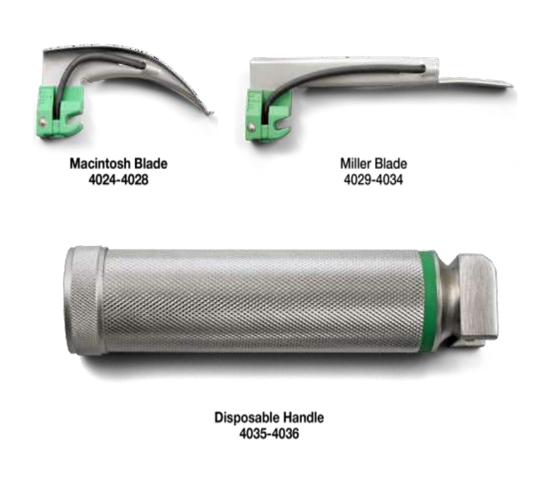  Appreciate size of laryngoscope:
Type | multiple_choice
Option | Millar blade no 1
Option | Macintosh blade no 2
Option | Macintosh blade no 3
Option | Millar blade no 00
Answer | 4
Solution | Rationale: Neonatal Assessment: Apgar scoring at 1 and 5 minutes evaluates heart rate, respiratory effort, muscle tone, reflex irritability, and color. Score 7-10 is normal. Key Clues: Apgar score, 1 and 5 minutes Why Not Others: Apgar components: Heart rate, Respiratory effort, Muscle tone, Reflex irritability, Color Exam Trap: Apgar: 0-3 = severe depression, 4-6 = moderate depression, 7-10 = normal. Score at 1 min (immediate), 5 min (transition). If <7, continue at 10 min intervals. PNC Pearl: Apgar: 0-3 = severe depression, 4-6 = moderate depression, 7-10 = normal. Score at 1 min (immediate), 5 min (transition). If <7, continue at 10 min intervals.
Positive Marks | 1
Negative Marks | 0.33

Question | 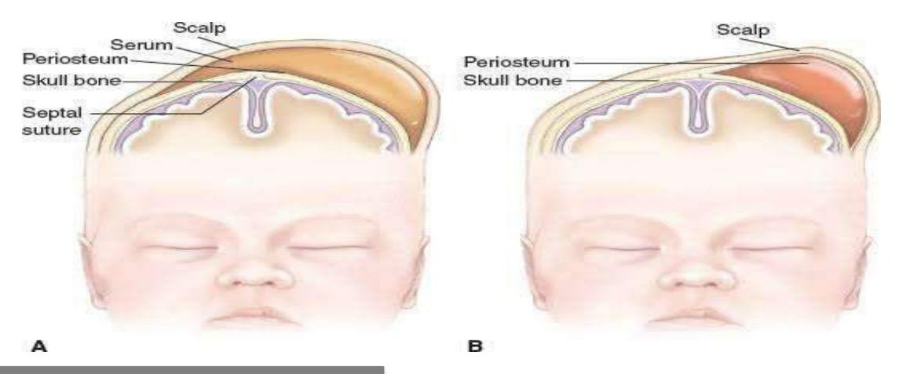  Birth injury induced swelling:
Type | multiple_choice
Option | Cephalhematoma
Option | Hydrocephalus
Option | Caput succedaneum
Option | A and B
Answer | 3
Solution | Rationale: Pediatric Medication Dosing: Based on body weight (mg/kg) and body surface area (BSA). Dose calculation requires accurate weight measurement and careful arithmetic. Key Clues: Weight-based dosing, mg/kg Why Not Others: Pediatric dosing is different from adult dosing - always use current weight Exam Trap: Pediatric drug dosing: Use most recent weight. Calculate mg/kg/day, then divide by doses per day. Always double-check calculations. Use calibrated measuring devices. PNC Pearl: Pediatric drug dosing: Use most recent weight. Calculate mg/kg/day, then divide by doses per day. Always double-check calculations. Use calibrated measuring devices.
Positive Marks | 1
Negative Marks | 0.33

Question | 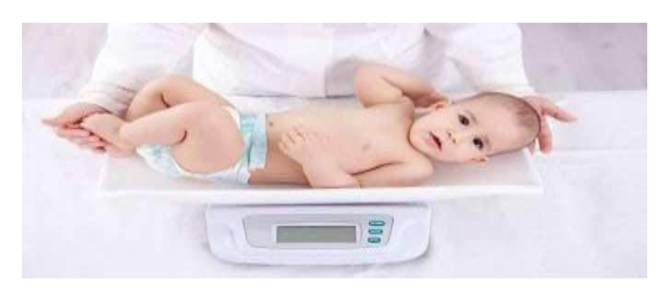  Following equipment used for:
Type | multiple_choice
Option | Measuring weight
Option | For BMR measuring
Option | All of above
Option | Measuring height
Answer | 4
Solution | Rationale: Pediatric IV Therapy: Special considerations include smaller gauge cannulas (24-22G), fluid restriction, careful monitoring of output, and use of infusion pumps for accurate delivery. Key Clues: Smaller cannulas, fluid restriction, pump use Why Not Others: Pediatric IV considerations: Fluid balance is critical - both overhydration and dehydration are dangerous Exam Trap: Pediatric IV: 24G (neonates), 22G (infants), 20G (children). Always use infusion pump. Monitor I&O hourly. Correct fluid deficit over 24-48 hours. PNC Pearl: Pediatric IV: 24G (neonates), 22G (infants), 20G (children). Always use infusion pump. Monitor I&O hourly. Correct fluid deficit over 24-48 hours.
Positive Marks | 1
Negative Marks | 0.33

Question | 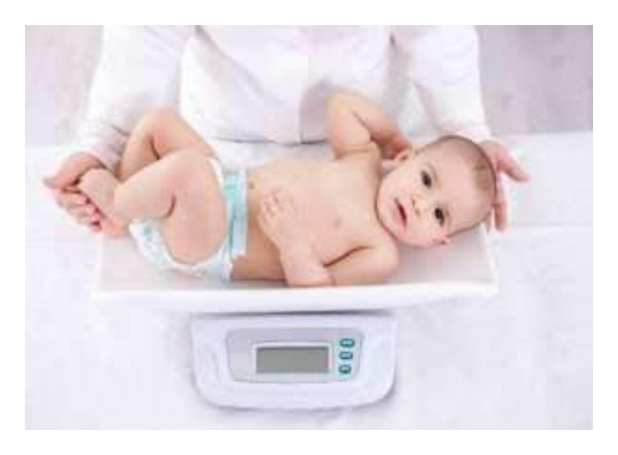  Weight measuring devices except..:
Type | multiple_choice
Option | Electronic weight machine
Option | Salter spring balance
Option | -
Option | Infantometer
Answer | 4
Solution | Rationale: Childhood Immunization Schedule: Based on national immunization guidelines. Includes BCG, OPV, DPT, MMR, hepatitis, and other vaccines at specified ages. Key Clues: National immunization schedule Why Not Others: Key vaccines: BCG at birth, OPV/DPT at 6-14 weeks, MMR at 9 months Exam Trap: Follow EPI (Expanded Programme on Immunization) schedule. Record in immunization card. Educate parents on importance. PNC Pearl: Follow EPI (Expanded Programme on Immunization) schedule. Record in immunization card. Educate parents on importance.
Positive Marks | 1
Negative Marks | 0.33

Question | 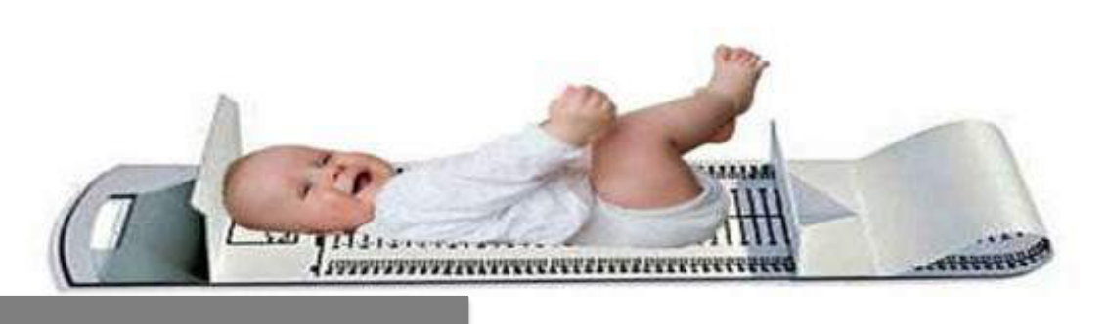  Following equipment used for:
Type | multiple_choice
Option | Measuring height
Option | Chest circumference measuring
Option | Measuring weight
Option | Head circumference measuring
Answer | 3
Solution | Rationale: Neonatal Resuscitation: Following NRP (Neonatal Resuscitation Program) guidelines - warm, dry, stimulate, suction, ventilate, compress, medicate as needed. Key Clues: NRP algorithm, warm-dry-stimulate Why Not Others: NRP steps: Warm · Clear airway · Dry/stimulate · PPV · Compressions · Medications Exam Trap: NRP: Dry and warm first. Clear airway if needed. Stimulate. If HR <100 or apneic · PPV. If HR <60 · compressions + PPV. If HR <60 despite PPV + compressions · epinephrine. PNC Pearl: NRP: Dry and warm first. Clear airway if needed. Stimulate. If HR <100 or apneic · PPV. If HR <60 · compressions + PPV. If HR <60 despite PPV + compressions · epinephrine.
Positive Marks | 1
Negative Marks | 0.33

Question | 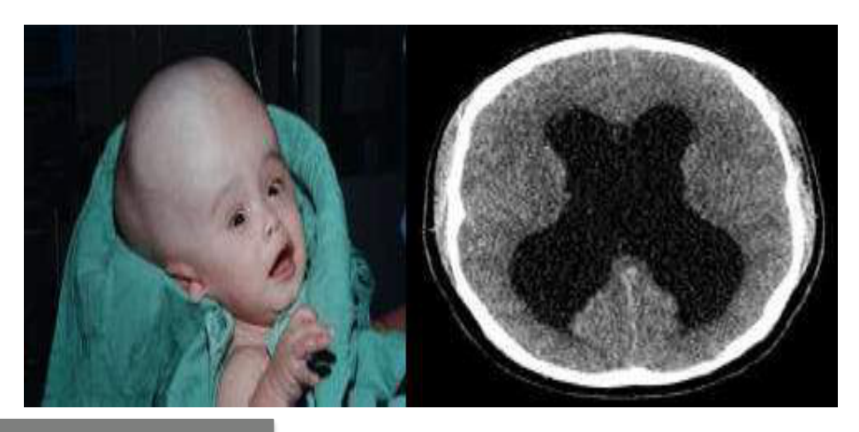  Identify the given condition:
Type | multiple_choice
Option | Normal development
Option | Hydrocephalus
Option | Under development
Option | Microcephaly
Answer | 2
Solution | Rationale: Pediatric Assessment (Circulation-Pale/Perfusion): Part of the pediatric assessment triangle - appearance, work of breathing, and circulation to skin (color). Used for rapid triage. Key Clues: Pediatric assessment triangle components Why Not Others: Three components: Appearance (TICLS), Work of breathing, Circulation to skin Exam Trap: Pediatric assessment triangle: Appearance = Muscle tone, Interactiveness, Consolability, Look/gaze, Speech cry. WOB = retractions, nasal flaring, grunting. Circulation = pallor, mottling, cyanosis. PNC Pearl: Pediatric assessment triangle: Appearance = Muscle tone, Interactiveness, Consolability, Look/gaze, Speech cry. WOB = retractions, nasal flaring, grunting. Circulation = pallor, mottling, cyanosis.
Positive Marks | 1
Negative Marks | 0.33

Question | 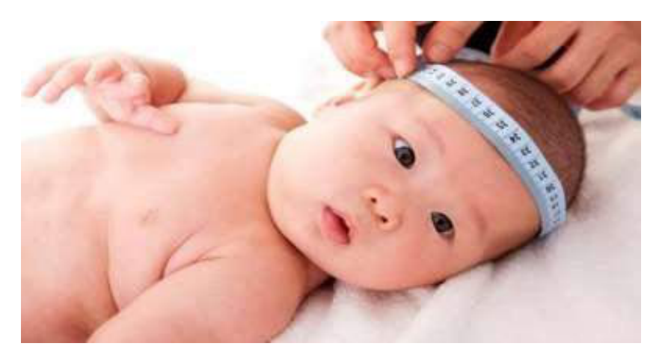  Normal value of following:
Type | multiple_choice
Option | 30 cm
Option | 35 cm
Option | 40 cm
Option | 32 cm
Answer | 3
Solution | Rationale: Common Pediatric Emergency: Respiratory distress is the most common pediatric emergency. Children compensate well until sudden decompensation occurs. Key Clues: Respiratory distress is most common Why Not Others: Other common pediatric emergencies: Febrile seizures, dehydration, poisoning, trauma Exam Trap: Pediatric respiratory distress: Tachypnea, retractions, nasal flaring, grunting, cyanosis. Children have smaller airways - rapid deterioration. PNC Pearl: Pediatric respiratory distress: Tachypnea, retractions, nasal flaring, grunting, cyanosis. Children have smaller airways - rapid deterioration.
Positive Marks | 1
Negative Marks | 0.33

