Question | 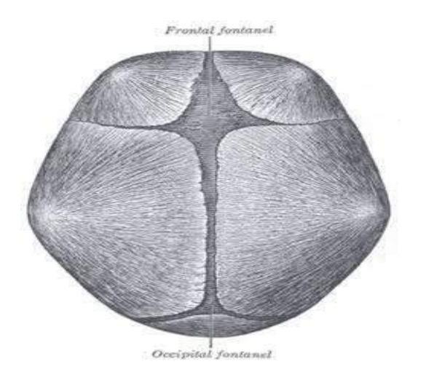  Closing of fontanelle as per given image..:
Type | multiple_choice
Option | Anterior at 18 weeks and posterior at 6-8
Option | -
Option | Anterior at 18 months and Posterior at 6-
Option | Both are closed just after delivery.
Answer | 2
Solution | Rationale: Pediatric Vital Signs: Normal ranges differ significantly from adults. Neonatal HR: 120-160, RR: 30-60. Toddler HR: 90-150, RR: 24-40. School-age HR: 70-120, RR: 18-30. Key Clues: Age-specific vital sign ranges Why Not Others: Children have higher HR and RR than adults. BP increases with age Exam Trap: Pediatric vital signs vary by age. Always use age-appropriate reference ranges. Normal neonatal BP: 60-80/40-50 mmHg. PNC Pearl: Pediatric vital signs vary by age. Always use age-appropriate reference ranges. Normal neonatal BP: 60-80/40-50 mmHg.
Positive Marks | 1
Negative Marks | 0.33

Question | 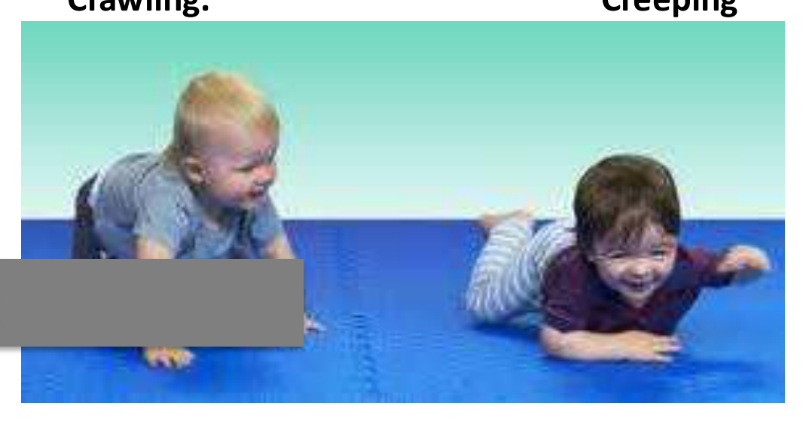  Following milestone infant:
Type | multiple_choice
Option | At 4 to 6 months
Option | Within one month
Option | At 11 months
Option | At 8 to 9 month
Answer | 2
Solution | Rationale: Pediatric Nutrition: Breastfeeding is recommended exclusively for first 6 months. Complementary foods introduced at 6 months. Breast milk provides optimal nutrition and antibodies. Key Clues: Breastfeeding + complementary foods at 6 months Why Not Others: Exclusive breastfeeding for 6 months, then introduce solids while continuing breastfeeding Exam Trap: Pediatric nutrition: Exclusive breastfeeding 6 months. Introduce iron-rich foods at 6 months. Avoid honey before 1 year. Cow's milk after 1 year. PNC Pearl: Pediatric nutrition: Exclusive breastfeeding 6 months. Introduce iron-rich foods at 6 months. Avoid honey before 1 year. Cow's milk after 1 year.
Positive Marks | 1
Negative Marks | 0.33

Question | 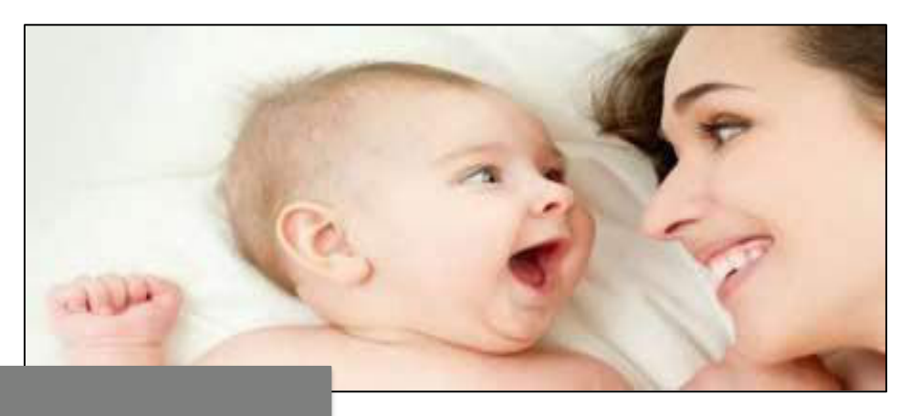  Infantile play in which baby:
Type | multiple_choice
Option | -
Option | Unoccupied play
Option | Solitary independent play
Option | Onlooker play
Answer | 3
Solution | Rationale: Pediatric Fever Management: Tepid sponging, antipyretics (paracetamol/ibuprofen), adequate hydration, and monitoring for signs of serious infection. Key Clues: Antipyretics + tepid sponging + hydration Why Not Others: Never give aspirin to children (Reye syndrome risk) Exam Trap: Pediatric fever: Paracetamol 10-15mg/kg q4-6h. Ibuprofen 5-10mg/kg q6-8h (>6 months). Tepid sponging. Monitor: activity, feeding, rash, fontanelle (infants). PNC Pearl: Pediatric fever: Paracetamol 10-15mg/kg q4-6h. Ibuprofen 5-10mg/kg q6-8h (>6 months). Tepid sponging. Monitor: activity, feeding, rash, fontanelle (infants).
Positive Marks | 1
Negative Marks | 0.33

Question | 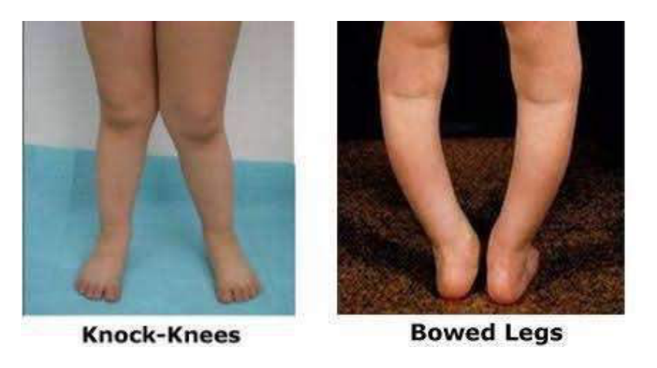  Following limb deformity:
Type | multiple_choice
Option | Vitamin A
Option | -
Option | Vitamin c
Option | Vitamin k
Answer | 1
Solution | Rationale: Child Health Programs: Growth monitoring, immunization, ORS (Oral Rehydration Solution), breastfeeding promotion, and vitamin A supplementation are key child health interventions. Key Clues: Growth monitoring, immunization, ORS, breastfeeding Why Not Others: ORS: 1 liter water + sodium chloride 3.5g + sodium bicarbonate 2.9g + potassium chloride 1.5g + glucose 20g Exam Trap: ORS for dehydration: WHO formula. Give after each loose stool. Continue breastfeeding. Monitor for signs of severe dehydration requiring IV fluids. PNC Pearl: ORS for dehydration: WHO formula. Give after each loose stool. Continue breastfeeding. Monitor for signs of severe dehydration requiring IV fluids.
Positive Marks | 1
Negative Marks | 0.33

Question | 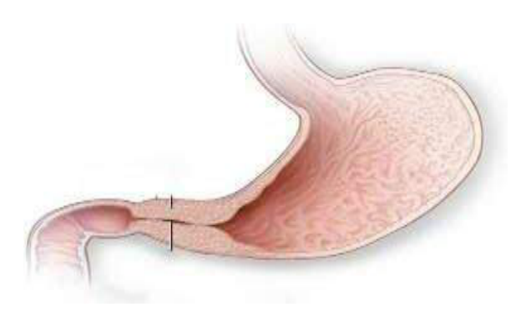  Following clinical condition mainly:
Type | multiple_choice
Option | 3 to 12 weeks of age
Option | At 6 month
Option | At birth
Option | At 2 year
Answer | 3
Solution | Rationale: Pediatric Dehydration Assessment: Classified as mild (5%), moderate (10%), or severe (15%). Signs include decreased skin turgor, sunken eyes, dry mucous membranes, decreased urine output. Key Clues: Skin turgor, urine output, mucous membranes Why Not Others: Severe dehydration: Lethargy, absent tears, sunken fontanelle, very dry mouth, weak pulse Exam Trap: Pediatric dehydration: Mild = ORS. Moderate = ORS + monitor. Severe = IV fluids (NS 20ml/kg bolus). Monitor weight as best indicator of fluid status. PNC Pearl: Pediatric dehydration: Mild = ORS. Moderate = ORS + monitor. Severe = IV fluids (NS 20ml/kg bolus). Monitor weight as best indicator of fluid status.
Positive Marks | 1
Negative Marks | 0.33

Question | 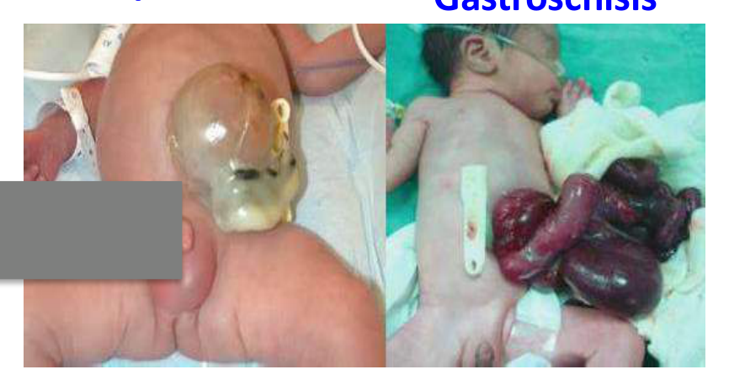  What we can do to preventing fluid:
Type | multiple_choice
Option | -
Option | Cover with sterile plastic sheet
Option | Saline dressing
Option | All
Answer | 3
Solution | Rationale: Pediatric Respiratory Support: Oxygen therapy via nasal cannula (0.5-2L/min pediatric), face mask, or non-invasive ventilation (BiPAP/CPAP) as needed. Key Clues: Oxygen delivery methods for children Why Not Others: Nasal cannula: 0.25-1L/min infant, 1-4L/min child. Face mask: 5-10L/min Exam Trap: Pediatric oxygen: Use appropriate device. Monitor SpO2 continuously. Humidify oxygen. Watch for: nasal drying, skin irritation, CO2 retention. PNC Pearl: Pediatric oxygen: Use appropriate device. Monitor SpO2 continuously. Humidify oxygen. Watch for: nasal drying, skin irritation, CO2 retention.
Positive Marks | 1
Negative Marks | 0.33

Question | 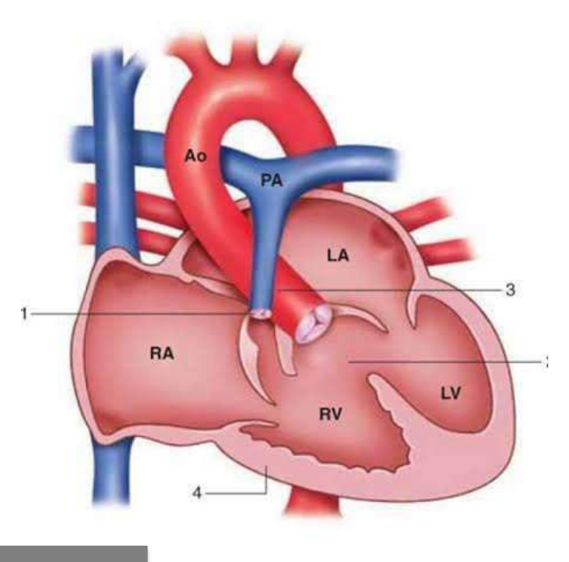  Patient have which cardiac problem:
Type | multiple_choice
Option | Cyanotic CHD
Option | Acynotic CHD
Option | None of these
Option | Obstructive CHD
Answer | 3
Solution | Rationale: Pediatric Medication Administration: Oral medications given with calibrated syringes (not spoons). Liquid formulations preferred. Taste-masking techniques improve compliance. Key Clues: Calibrated syringes, liquid formulations Why Not Others: Never use kitchen spoons - they are not accurate for medication measurement Exam Trap: Pediatric medication: Use oral syringe. Round dosages to nearest measurable amount. Check for allergies. Educate parents on home administration. PNC Pearl: Pediatric medication: Use oral syringe. Round dosages to nearest measurable amount. Check for allergies. Educate parents on home administration.
Positive Marks | 1
Negative Marks | 0.33

Question | 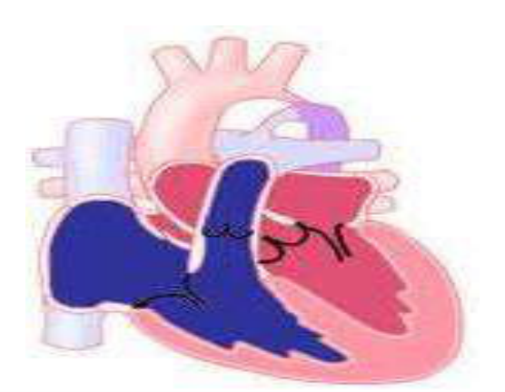  Hypertension and overgrowth of upper:
Type | multiple_choice
Option | Aortic stenosis
Option | Tetralogy of fallot
Option | Coaraction of aorta
Option | Ventricular septal defect
Answer | 4
Solution | Rationale: Pediatric Pain Assessment: Use age-appropriate tools - FLACC (<3 years), Wong-Baker FACES (3+), Numeric scale (7+). Pain management includes pharmacological and non- pharmacological approaches. Key Clues: Age-appropriate pain scales Why Not Others: FLACC: Face, Legs, Activity, Cry, Consolability. FACES: Smiley face scale. Exam Trap: Pediatric pain: Assess regularly. Use appropriate tool. Non-pharmacological: distraction, comfort measures. Pharmacological: paracetamol, ibuprofen (age- appropriate doses). PNC Pearl: Pediatric pain: Assess regularly. Use appropriate tool. Non-pharmacological: distraction, comfort measures. Pharmacological: paracetamol, ibuprofen (age- appropriate doses).
Positive Marks | 1
Negative Marks | 0.33

Question | 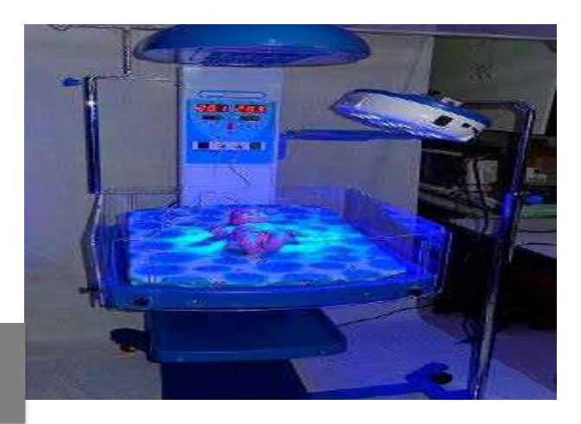  Following technical used to treat..:
Type | multiple_choice
Option | Neonatal hypothermia
Option | Neonatal hyperglycemia
Option | Excess conjugated bilirubin
Option | Neonatal hyperbilirubinemia
Answer | 4
Solution | Rationale: Common Childhood Infections: Respiratory infections (pneumonia, bronchiolitis), gastrointestinal infections (rotavirus), skin infections (impetigo), and ear infections (otitis media). Key Clues: Respiratory, GI, skin, ear infections Why Not Others: Pneumonia: Most common cause of death in children worldwide Exam Trap: Childhood infections: Pneumonia (tachypnea, chest indrawing), Rotavirus (watery diarrhea), Impetigo (honey-colored crusts), Otitis media (ear pain, fever). PNC Pearl: Childhood infections: Pneumonia (tachypnea, chest indrawing), Rotavirus (watery diarrhea), Impetigo (honey-colored crusts), Otitis media (ear pain, fever).
Positive Marks | 1
Negative Marks | 0.33

Question | 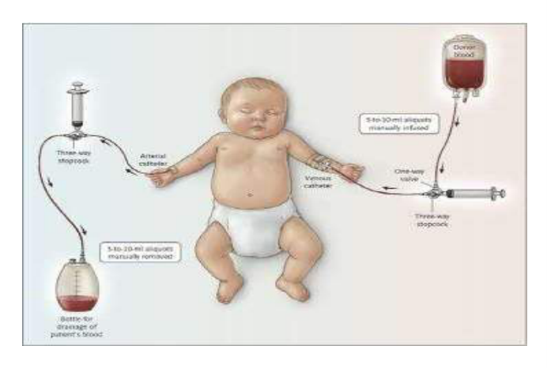  Exchange blood transfusion method:
Type | multiple_choice
Option | Severe hemorrhage
Option | Severe hyper bilirubinemia
Option | B& C
Option | Prevent kernicterus
Answer | 4
Solution | Rationale: Pediatric Asthma Management: Stepwise approach with bronchodilators (salbutamol) for acute relief and inhaled corticosteroids (beclomethasone) for long-term control. Key Clues: Bronchodilators + corticosteroids, stepwise approach Why Not Others: Acute: Salbutamol nebulization. Preventive: Budesonide inhaler. Exam Trap: Pediatric asthma: Acute = salbutamol 2.5mg nebulized q20min × 3. Preventive = inhaled corticosteroids. Written asthma action plan. Avoid triggers. PNC Pearl: Pediatric asthma: Acute = salbutamol 2.5mg nebulized q20min × 3. Preventive = inhaled corticosteroids. Written asthma action plan. Avoid triggers.
Positive Marks | 1
Negative Marks | 0.33

Question | 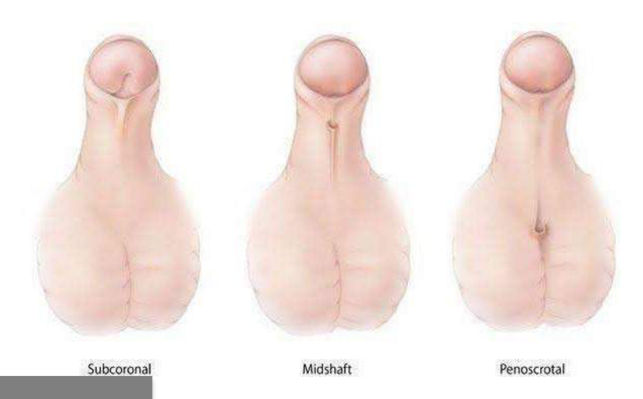  Most common hypospadias in:
Type | multiple_choice
Option | Anterior hypospadias
Option | None
Option | Middle penile shaft hypospadias
Option | Posterior hypospadias
Answer | 2
Solution | Rationale: Pediatric Diabetes Management: Type 1 diabetes requires insulin therapy, blood glucose monitoring, carbohydrate counting, and education for the child and family. Key Clues: Insulin therapy + blood glucose monitoring Why Not Others: Type 1 diabetes is autoimmune - most common pediatric diabetes type Exam Trap: Pediatric diabetes: Insulin injection technique, SMBG (self-monitoring of blood glucose), carbohydrate counting, hypoglycemia management, school nurse education. PNC Pearl: Pediatric diabetes: Insulin injection technique, SMBG (self-monitoring of blood glucose), carbohydrate counting, hypoglycemia management, school nurse education.
Positive Marks | 1
Negative Marks | 0.33

Question | 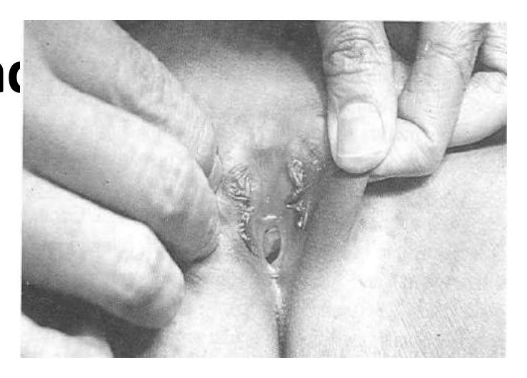  Bifid clitoris is seen in...:
Type | multiple_choice
Option | Female hypospadias
Option | Male epispadias
Option | Female epispadias
Option | Subsymphyseal epispadias
Answer | 2
Solution | Rationale: Pediatric Seizure Management: Protect head, position on side, time the seizure. Do NOT put anything in the mouth. Diazepam/lorazepam for active seizures lasting >5 minutes. Key Clues: Protect, time, do NOT put in mouth Why Not Others: Status epilepticus = seizure lasting >5 minutes - emergency treatment required Exam Trap: Pediatric seizure: Side position. Time duration. Nothing in mouth. If >5 min: Diazepam 0.2-0.5mg/kg IV or midazolam 0.1mg/kg buccal. Monitor ABCs. PNC Pearl: Pediatric seizure: Side position. Time duration. Nothing in mouth. If >5 min: Diazepam 0.2-0.5mg/kg IV or midazolam 0.1mg/kg buccal. Monitor ABCs.
Positive Marks | 1
Negative Marks | 0.33

Question | 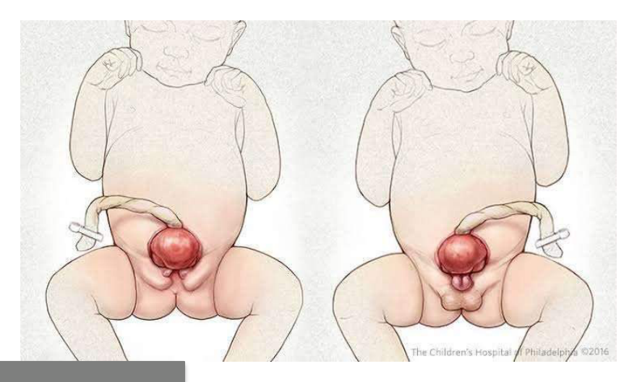  What nurse should do to prevent the:
Type | multiple_choice
Option | Sterile wet dressing.
Option | Sterile dry dressing
Option | Cover with Sterile plastic sheet
Option | B & C
Answer | 1
Solution | Rationale: Pediatric Fever Convulsions (Febrile Seizures): Common in children 6 months to 5 years. Associated with rapid rise in body temperature. Usually benign and self- limiting. Key Clues: 6 months to 5 years, associated with fever Why Not Others: Simple febrile seizure = <15 minutes, generalized, single episode Exam Trap: Febrile seizures: Usually benign. Do NOT require anticonvulsant prophylaxis. Treat fever. Educate parents about seizure management and when to seek emergency care. PNC Pearl: Febrile seizures: Usually benign. Do NOT require anticonvulsant prophylaxis. Treat fever. Educate parents about seizure management and when to seek emergency care.
Positive Marks | 1
Negative Marks | 0.33

Question | 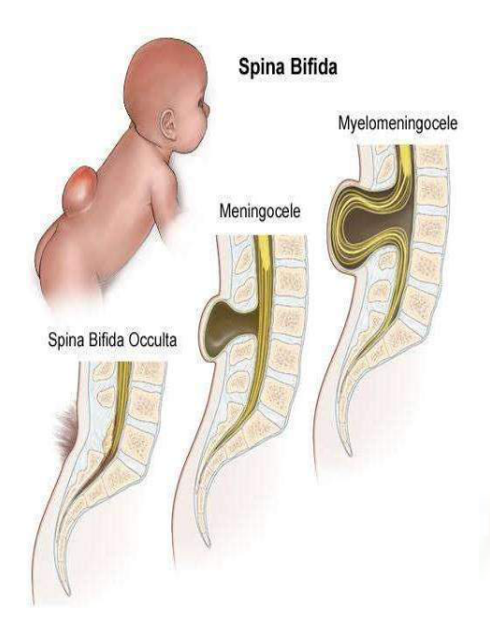  Which are the Neural tube defect except..:
Type | multiple_choice
Option | Spina bifida.
Option | Encephalocele.
Option | Anencephaly.
Option | Hydrocephalus
Answer | 2
Solution | Rationale: Childhood Meningitis: Signs include fever, headache, neck stiffness, photophobia, altered consciousness, and petechial rash (meningococcal). Emergency treatment required. Key Clues: Fever, neck stiffness, petechial rash Why Not Others: Lumbar puncture is definitive diagnostic test. Empirical antibiotics started immediately. Exam Trap: Meningitis: LP shows: turbid CSF, high WBC (neutrophils), high protein, low glucose. Ceftriaxone + vancomycin empirical. Dexamethasone reduces complications. PNC Pearl: Meningitis: LP shows: turbid CSF, high WBC (neutrophils), high protein, low glucose. Ceftriaxone + vancomycin empirical. Dexamethasone reduces complications.
Positive Marks | 1
Negative Marks | 0.33

Question | 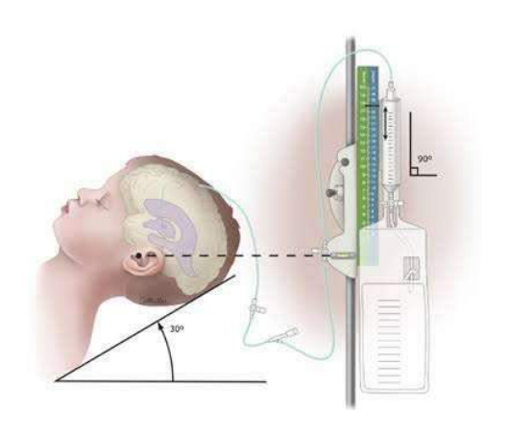  What is the following procedure and it:
Type | multiple_choice
Option | -
Option | Choroid plexotomy to reduce formation
Option | None of these
Option | VP shunt for non obstructive
Answer | 4
Solution | Rationale: Pediatric Dehydration Treatment: ORS (Oral Rehydration Solution) for mild-moderate dehydration. IV fluids (NS bolus) for severe dehydration or inability to tolerate oral fluids. Key Clues: ORS for mild-moderate, IV for severe Why Not Others: ORS: 50-100ml/kg over 4 hours for mild dehydration Exam Trap: Pediatric dehydration: Mild = ORS ad libitum. Moderate = ORS 50-100ml/kg over 4h. Severe = NS 20ml/kg bolus × 3. Monitor weight, urine output, clinical status. PNC Pearl: Pediatric dehydration: Mild = ORS ad libitum. Moderate = ORS 50-100ml/kg over 4h. Severe = NS 20ml/kg bolus × 3. Monitor weight, urine output, clinical status.
Positive Marks | 1
Negative Marks | 0.33

Question | 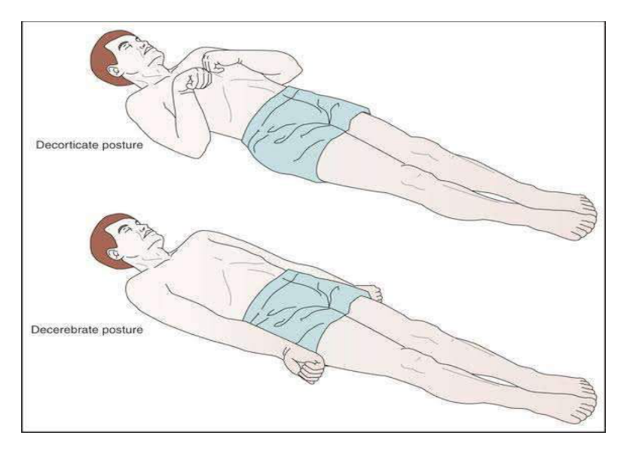  When a nurse check GCS of patient with:
Type | multiple_choice
Option | M 1 for decorticate
Option | M 2 for decerebrate
Option | M 3 for decorticate
Option | B &C
Answer | 1
Solution | Rationale: Normal Child Growth: Weight doubles by 5-6 months, triples by 1 year. Length increases 25cm in first year, 12cm in second year. Head circumference equals chest circumference at 1 year. Key Clues: Growth parameters by age Why Not Others: Head circumference = chest circumference at 1 year. Fontanelle closes by 12-18 months Exam Trap: Growth parameters: Birth weight doubles at 5-6mo, triples at 1yr. Birth length increases 50% by 1yr. OFC = chest at 1yr. PNC Pearl: Growth parameters: Birth weight doubles at 5-6mo, triples at 1yr. Birth length increases 50% by 1yr. OFC = chest at 1yr.
Positive Marks | 1
Negative Marks | 0.33

Question | 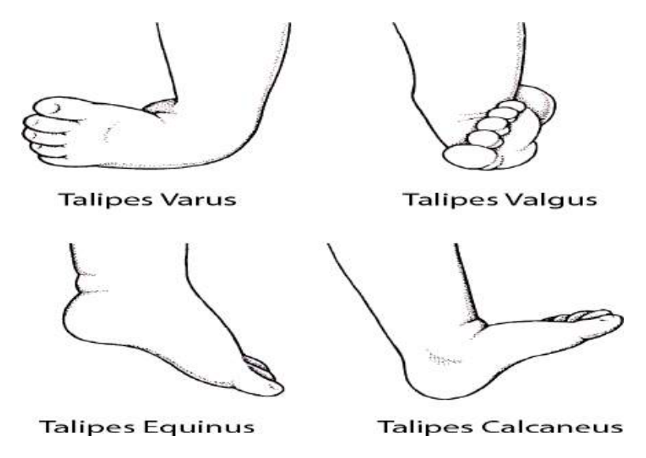  Most common congenital club:
Type | multiple_choice
Option | B
Option | C
Option | A
Option | D
Answer | 3
Solution | Rationale: Most Common Congenital Club Foot (Talipes Equinovarus): The deformity is characterized by equinus (plantarflexion), varus (inward turn), adductus, and cavus of the foot. Key Clues: Equinus + varus + adductus + cavus Why Not Others: Treatment: Ponseti method (serial casting + Achilles tenotomy) Exam Trap: Club foot: Ponseti method = weekly casting for 6-8 weeks · percutaneous Achilles tenotomy · brace until age 4. Early intervention is key. PNC Pearl: Club foot: Ponseti method = weekly casting for 6-8 weeks · percutaneous Achilles tenotomy · brace until age 4. Early intervention is key.
Positive Marks | 1
Negative Marks | 0.33

Question | 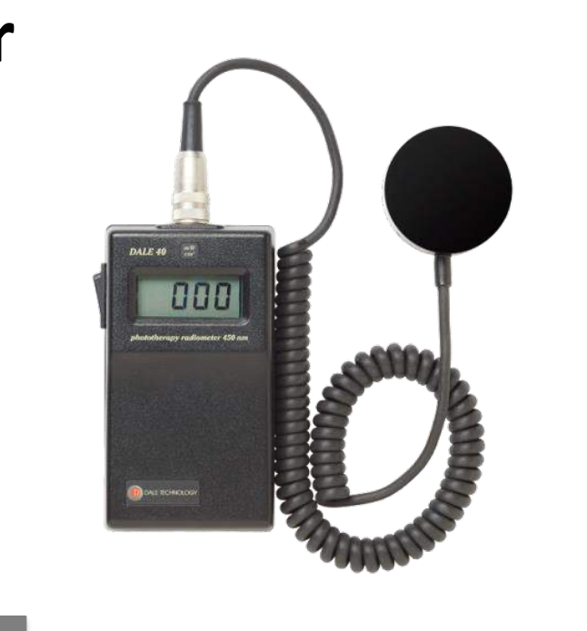  Identify the image that use in NICU:
Type | multiple_choice
Option | Dosimeter
Option | Hand held manometer
Option | Old Glucometer
Option | Phototherapy radian meter
Answer | 4
Solution | Rationale: Phototherapy Radiant Meter (Bilirubinometer): A device used in NICU to measure the intensity of phototherapy light and ensure therapeutic levels are maintained for treating neonatal jaundice. Key Clues: Measures phototherapy light intensity Why Not Others: A-Dosimeter measures radiation;C-Handheld manometer measures pressure;D-Glucometer measures blood sugar Exam Trap: Bilirubinometer vs dosimeter - bilirubinometer measures light intensity for phototherapy, dosimeter measures radiation exposure PNC Pearl: Phototherapy meter: Measures µW/cm²/nm. Therapeutic range: >30 µW/cm²/nm (conventional), >30 µW/cm²/nm (LED). Check at start and periodically during use.
Positive Marks | 1
Negative Marks | 0.33

Question | 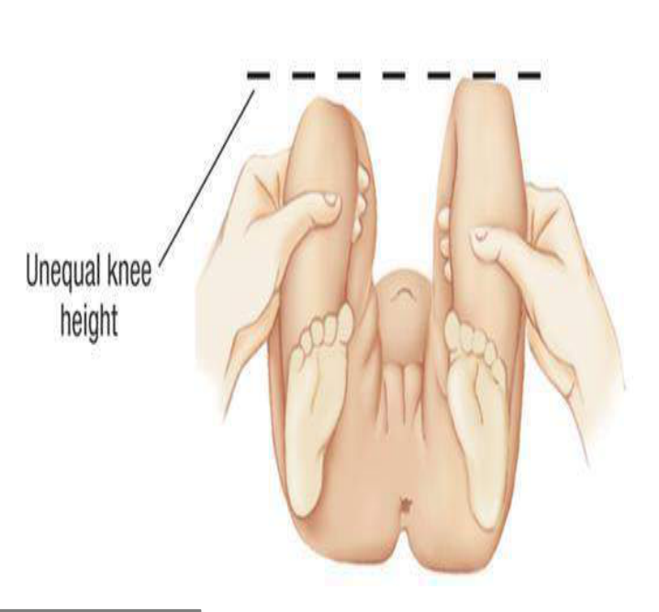  Identify the clinical sign denote in:
Type | multiple_choice
Option | Galeazzi sign
Option | Ortolani sign
Option | Humans sign
Option | Psoas sign
Answer | 1
Solution | Rationale: Galeazzi Sign: Asymmetry in thigh length when hips and knees are flexed. Positive sign indicates hip dislocation or developmental dysplasia of the hip (DDH) in neonates. Key Clues: Asymmetric thigh lengths, for hip assessment Why Not Others: A-Ortolani is hip click;C-Homans is for DVT;D-Psoas is for appendix Exam Trap: Galeazzi vs Ortolani - Galeazzi checks thigh length asymmetry, Ortolani checks for hip click/dislocation PNC Pearl: Galeazzi sign: Positive in DDH. Combined with Ortolani (reduction click) and Barlow (dislocation maneuver). Ultrasound is definitive test for DDH.
Positive Marks | 1
Negative Marks | 0.33

Question | 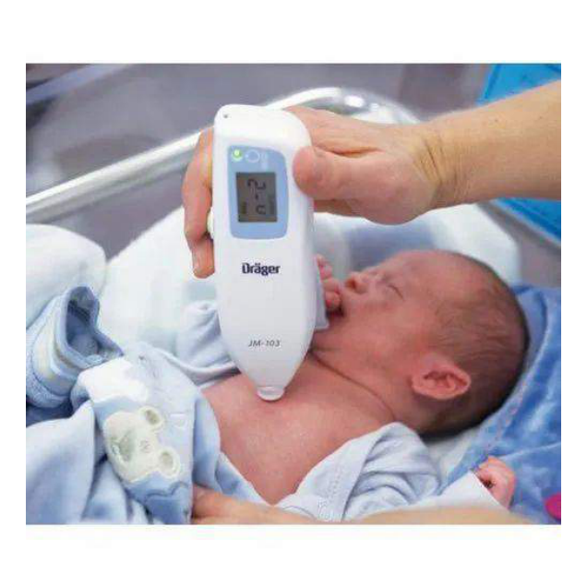  Identify the image:
Type | multiple_choice
Option | Billirubinometer
Option | Glucometer
Option | Cholesterol monitor
Option | Fetal thermometer
Answer | 1
Solution | Rationale: Billirubinometer: A device used to measure bilirubin levels in neonatal blood through transcutaneous or laboratory methods. Used to assess and monitor neonatal jaundice. Key Clues: Measures bilirubin levels, for jaundice assessment Why Not Others: B-Glucometer measures blood sugar;C-Cholesterol monitor measures lipids;D-Thermometer measures temperature Exam Trap: Transcutaneous bilirubinometer: Non-invasive screening tool. If elevated, confirm with serum bilirubin. PNC Pearl: Transcutaneous bilirubinometer: Non-invasive screening tool. If elevated, confirm with serum bilirubin.
Positive Marks | 1
Negative Marks | 0.33

