Question | 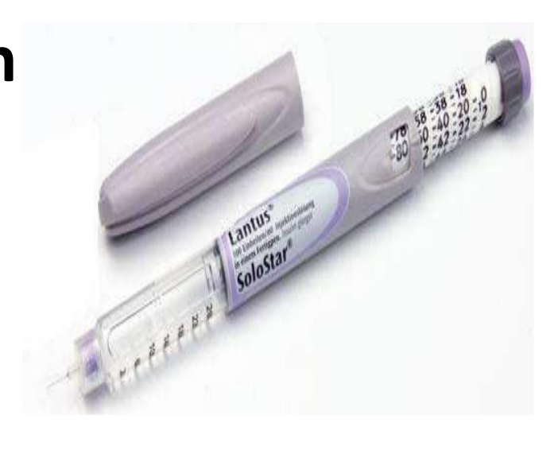  Identify the image:
Type | multiple_choice
Option | EPO injection
Option | Lantus injection
Option | Pentavalent injection
Option | Heparin injection
Answer | 4
Solution | Rationale: Heparin Injection: An anticoagulant given subcutaneously or intravenously to prevent and treat blood clots. Pre-filled syringes available in various doses. Monitor with aPTT for IV heparin. Key Clues: Anticoagulant, subcutaneous/IV Why Not Others: A-EPO is for anemia;C-Lantus is long-acting insulin;D-Pentavalent is a vaccine Exam Trap: Heparin vs Lovenox - heparin is IV/SC, Lovenox (enoxaparin) is SC only (LMWH) PNC Pearl: Heparin: Unfractionated = IV aPTT monitoring. LMWH = SC fixed dose. Antidote: Protamine sulfate. Never give IM (causes hematoma). Monitor: platelets (HIT risk), bleeding signs.
Positive Marks | 1
Negative Marks | 0.33

Question | 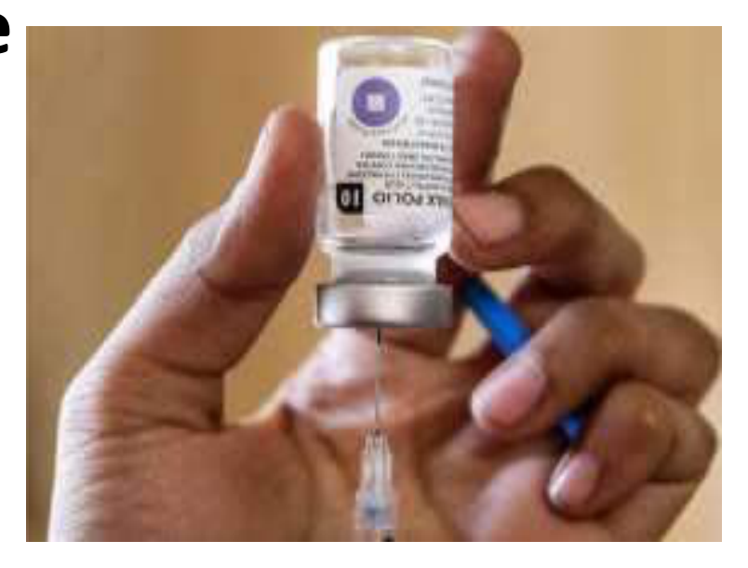  Identify the image:
Type | multiple_choice
Option | Potency of vaccine
Option | A And B
Option | None
Option | Unused vaccine
Answer | 4
Solution | Rationale: Unused Vaccine: Vaccines that have not been administered and are still in original packaging. Must be stored properly in cold chain (2-8C) and monitored for expiry dates. Key Clues: Original packaging, stored in cold chain Why Not Others: B-Potency is effectiveness;C-A and B is combined;D-None is incorrect Exam Trap: Unused vaccine management: Check expiry date. Store 2-8C. Monitor temperature log. Label opened multi-dose vials with date/time. Discard if cold chain broken. PNC Pearl: Unused vaccine management: Check expiry date. Store 2-8C. Monitor temperature log. Label opened multi-dose vials with date/time. Discard if cold chain broken.
Positive Marks | 1
Negative Marks | 0.33

Question | 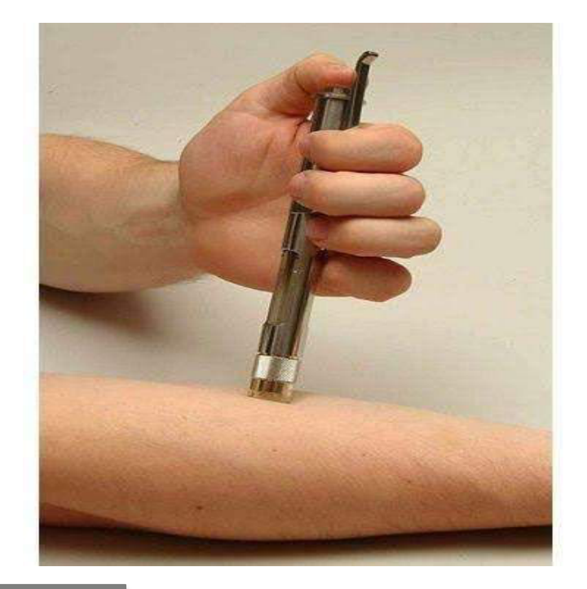  Identify the Route of Drug administration:
Type | multiple_choice
Option | Transdermal delivery
Option | Pellet implants
Option | Topical application
Option | Dermojet
Answer | 1
Solution | Rationale: Transdermal Drug Delivery: Drugs delivered through the skin via patches, gels, or ointments. Provides sustained, controlled release. Avoids first-pass metabolism in the liver. Key Clues: Patches/gels through skin, avoids first-pass metabolism Why Not Others: A-Pellet implants are subcutaneous;C-Topical is surface only;D-Dermojet is jet injection Exam Trap: Transdermal vs topical - transdermal delivers systemically, topical acts locally PNC Pearl: Transdermal examples: Fentanyl patch, nicotine patch, nitroglycerin patch, scopolamine patch. Application: clean dry skin, rotate sites, avoid broken skin. Remove old patch before applying new.
Positive Marks | 1
Negative Marks | 0.33

Question | 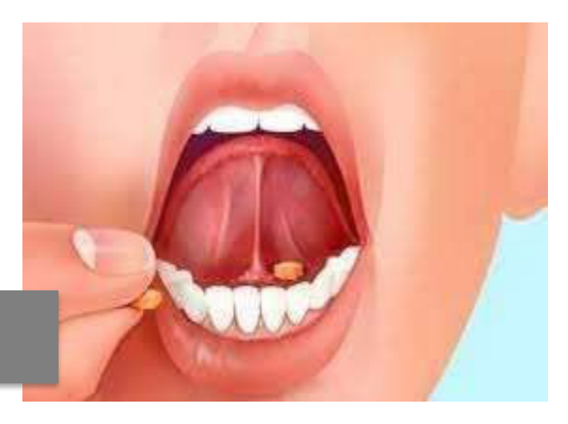  All are true for this route od drug:
Type | multiple_choice
Option | All drugs can be given
Option | Escape first pass metabolism
Option | Action can be terminated any
Option | Rapid absorption
Answer | 2
Solution | Rationale: Intravenous (IV) route advantages: Escapes first-pass hepatic metabolism, provides rapid onset of action, allows precise dosing, can terminate action by stopping infusion. Key Clues: Bypasses liver, rapid onset, precise dosing Why Not Others: B-Not all drugs can be given IV;C-Action termination is possible;D-Rapid absorption is true Exam Trap: IV route advantages: 100% bioavailability, immediate onset, precise control, can be reversed PNC Pearl: IV administration: Always verify patient identity, drug, dose, route, time. Check compatibility. Use infusion pump for high-risk drugs. Monitor for reactions.
Positive Marks | 1
Negative Marks | 0.33

Question | 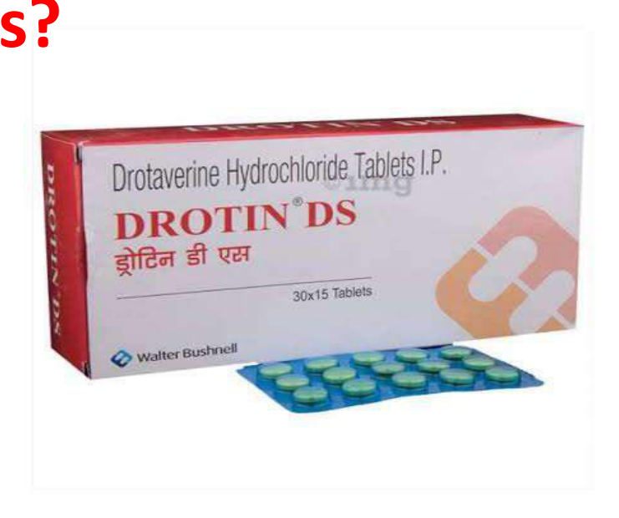  The drug shown in the "picture:
Type | multiple_choice
Option | -
Option | All of above
Option | Severe liver disease
Option | Severe kidney disease
Answer | 2
Solution | Rationale: Contraindications for certain drugs include severe liver disease, severe kidney disease, and multiple organ dysfunction. These conditions affect drug metabolism and excretion. Key Clues: Multiple organ failure contraindication Why Not Others: A is not specified;B-Severe liver disease is one factor;C-Severe kidney disease is another Exam Trap: Drug contraindications: Always assess organ function before prescribing. Liver metabolizes drugs, kidney excretes them. Both impaired = drug accumulation risk. PNC Pearl: Drug contraindications: Always assess organ function before prescribing. Liver metabolizes drugs, kidney excretes them. Both impaired = drug accumulation risk.
Positive Marks | 1
Negative Marks | 0.33

Question | 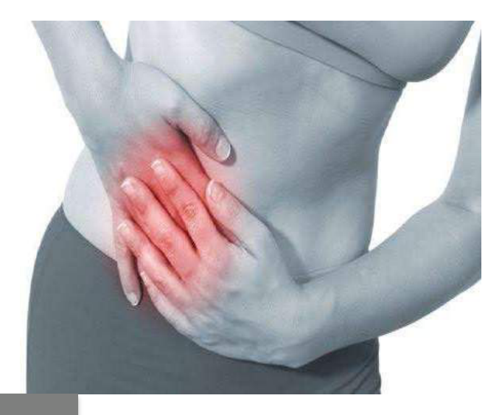  All medicines from the following:
Type | multiple_choice
Option | Hyoscyamine
Option | Dicyclomine
Option | Ranitidine
Option | Mebevarine
Answer | 3
Solution | Rationale: Ranitidine is an H2 receptor antagonist used for gastric acid reduction. Unlike the other options (antispasmodics), it works by blocking histamine H2 receptors on parietal cells. Key Clues: H2 receptor antagonist, reduces gastric acid Why Not Others: A-Hyoscyamine is anticholinergic;B-Dicyclomine is antispasmodic;C-Mebeverine is antispasmodic Exam Trap: Ranitidine vs antispasmodics - ranitidine reduces acid, others reduce spasms PNC Pearl: Ranitidine: 150mg BD or 300mg HS. Used for: peptic ulcer, GERD, Zollinger-Ellison. Contraindicated in: pregnancy (controversial). Now largely replaced by PPIs.
Positive Marks | 1
Negative Marks | 0.33

Question | 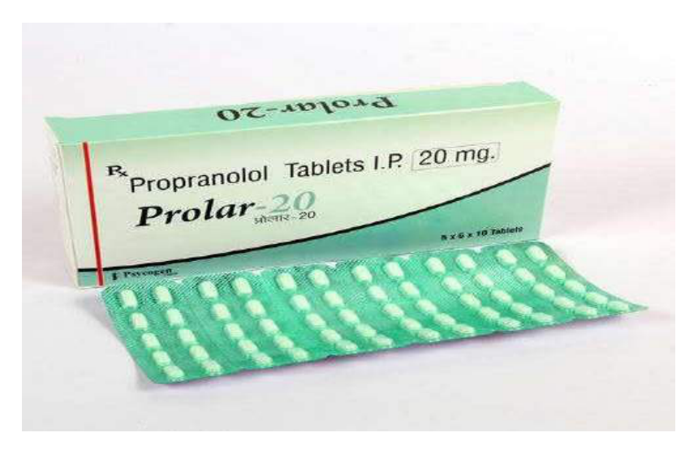  The drug shown in the "picture below":
Type | multiple_choice
Option | Asthma
Option | Slick sinus syndrome
Option | AV block
Option | All of above
Answer | 1
Solution | Rationale: Beta-blocker contraindications include asthma (due to bronchospasm risk), sick sinus syndrome (worsens bradycardia), and AV block (worsens conduction delay). Key Clues: Asthma is major contraindication for beta-blockers Why Not Others: B-Sick sinus syndrome is contraindication;C-AV block is contraindication;D-All of above is correct Exam Trap: All options are contraindications for beta-blockers - answer D is most complete PNC Pearl: Beta-blocker contraindications: Asthma/COPD, severe bradycardia, heart block, decompensated HF, Pheochromocytoma (give alpha-blocker first). Monitor: HR, BP, signs of HF.
Positive Marks | 1
Negative Marks | 0.33

Question | 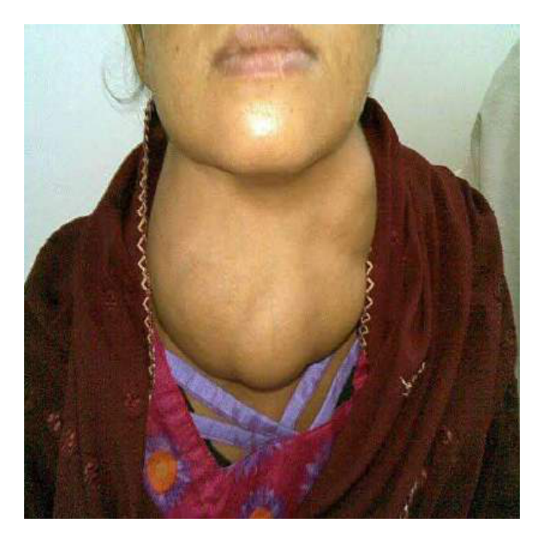  The drug of choice for toxic form of:
Type | multiple_choice
Option | Labetolol
Option | Metoprolol
Option | Propanolol
Option | Tolazoline
Answer | 3
Solution | Rationale: Propranolol: Drug of choice for thyrotoxicosis/thyroid storm. It is a non-selective beta-blocker that controls sympathetic symptoms (tachycardia, tremor, anxiety) and also inhibits peripheral T4 to T3 conversion. Key Clues: Beta-blocker, controls thyroid storm symptoms, inhibits T4·T3 Why Not Others: A-Labetolol is for hypertensive crisis;B-Metoprolol is selective ·1;D-Tolazoline is alpha-blocker Exam Trap: Propranolol in thyroid storm - blocks beta effects AND inhibits T4·T3 conversion PNC Pearl: Propranolol in thyroid storm: 1-2mg IV slow or 40-80mg PO q4-6h. Controls HR, tremor, anxiety. Also inhibits T4·T3 conversion. Give after thionamides to avoid worsening thyrotoxicosis.
Positive Marks | 1
Negative Marks | 0.33

Question | 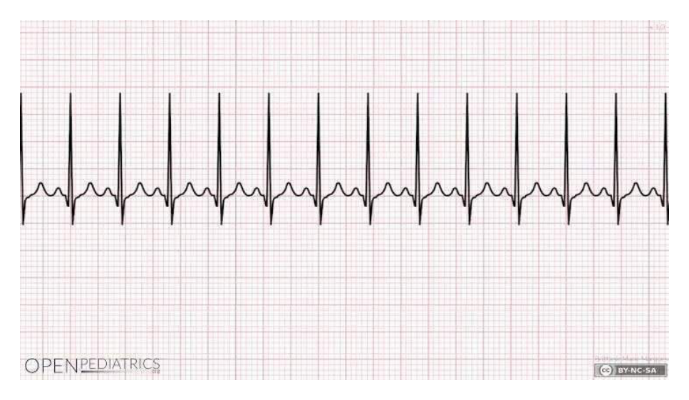  A patient develops condition as shown in:
Type | multiple_choice
Option | Propanolol
Option | Neostigmine
Option | Adrenaline
Option | Hyoscine
Answer | 2
Solution | Rationale: Neostigmine: An acetylcholinesterase inhibitor used to reverse neuromuscular blockade and treat myasthenia gravis. Increases acetylcholine at neuromuscular junction. Also used for urinary retention and paralytic ileus. Key Clues: Anticholinesterase, increases ACh, reverses NMB Why Not Others: A-Propranolol is beta-blocker;B-Adrenaline is sympathomimetic;C-Hyoscine is anticholinergic Exam Trap: Neostigmine vs Pyridostigmine - neostigmine is IV/IM, pyridostigmine is PO (longer acting) PNC Pearl: Neostigmine: Must give with glycopyrrolate (anticholinergic) to prevent bradycardia, SLUD effects. Monitor for cholinergic crisis (DUMBELS). Dose: 0.04-0.07 mg/kg.
Positive Marks | 1
Negative Marks | 0.33

Question | 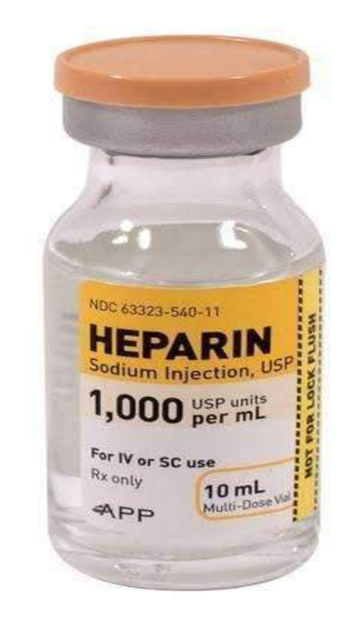  Drug of choice for Case of Poisoning:
Type | multiple_choice
Option | Flumazenil
Option | Physostigmine
Option | Protamine sulphate
Option | N acetyl cysteine
Answer | 1
Solution | Rationale: Flumazenil: Competitive benzodiazepine receptor antagonist used to reverse benzodiazepine overdose. Rapidly reverses sedation, respiratory depression, and amnesia caused by benzodiazepines. Key Clues: Reverses benzodiazepine effects, competitive antagonist Why Not Others: A-Physostigmine is for anticholinergic toxicity;C-Protamine sulphate reverses heparin;D-NAC is for paracetamol poisoning Exam Trap: Flumazenil specifically reverses benzodiazepines - not other sedatives PNC Pearl: Flumazenil: Dose 0.2mg IV over 30 sec, repeat 0.3mg, then 0.5mg q1min (max 3mg). Onset 1-2 min. Caution: seizures in chronic benzo use. Duration shorter than most benzos.
Positive Marks | 1
Negative Marks | 0.33

Question | 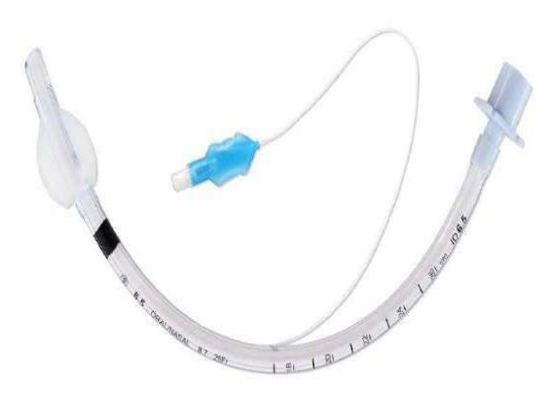  Muscle relaxant of choice for use for:
Type | multiple_choice
Option | Pancuronium
Option | Roxacuronium
Option | Succinylcholine
Option | Atrscurium
Answer | 3
Solution | Rationale: Succinylcholine: A depolarizing neuromuscular blocking agent used for rapid sequence intubation (RSI). Onset 30-60 seconds, duration 5-10 minutes. Provides excellent intubating conditions. Key Clues: Depolarizing NMB, rapid onset, for RSI Why Not Others: A-Pancuronium is non-depolarizing;B-Rocuronium is non-depolarizing;D-Atracurium is non-depolarizing Exam Trap: Succinylcholine vs Rocuronium - succinylcholine is depolarizing (fasciculations), rocuronium is non-depolarizing PNC Pearl: Succinylcholine: Contraindicated in: hyperkalemia, burns >24h, crush injury, denervation, malignant hyperthermia risk. Side effects: fasciculations, hyperkalemia, malignant hyperthermia.
Positive Marks | 1
Negative Marks | 0.33

Question |   Identify the person in below:
Type | multiple_choice
Option | Kevin systrom CEO Instagram
Option | Mark Zuckerberg CEO Facebook
Option | Susan wojciki, CEO YouTube
Option | Will cathcart CEO WhatsApp
Answer | 1
Solution | Rationale: Kevin Systrom: Co-founder of Instagram, a popular photo-sharing social media platform. (This question tests general knowledge as part of the NORCET examination). Key Clues: Instagram co-founder Why Not Others: A-Zuckerberg is Facebook;C-Wojcicki is YouTube;D-Cathcart is WhatsApp Exam Trap: Social media CEO identification - Kevin Systrom co-founded Instagram in 2010 PNC Pearl: General knowledge questions appear in NORCET. Stay updated with current affairs and technology leaders.
Positive Marks | 1
Negative Marks | 0.33

Question |   Following symbol on drugs packet:
Type | multiple_choice
Option | Keep away from sunlight
Option | Do not re-use
Option | Keep away from children
Option | Keep dry
Answer | 2
Solution | Rationale: Drug Symbol: The symbol shown indicates "Do not re-use" - single-use only. This applies to syringes, vials, and other medications that must be discarded after single use to prevent contamination and infection. Key Clues: Single-use symbol, do not reuse Why Not Others: B-Sunlight symbol is different;C-Child safety symbol is different;D-Dry symbol is different Exam Trap: Do not reuse vs keep from children - different symbols with different meanings PNC Pearl: Drug symbols: Learn all ISO symbols. Do not reuse = crossed-out number 2. Keep from children = child reaching. Store below 25 degC = thermometer. Do not freeze = snowflake with cross.
Positive Marks | 1
Negative Marks | 0.33

Question |   Following symbol on drugs packet:
Type | multiple_choice
Option | Do not re-use
Option | Keep away from children
Option | Keep dry
Option | Keep away from sunlight
Answer | 4
Solution | Rationale: Drug Symbol: The symbol indicates "Keep away from sunlight" - store in a dark place. Photosensitive drugs degrade when exposed to light, reducing efficacy and potentially creating harmful degradation products. Key Clues: Sun protection symbol, store in dark Why Not Others: A-Do not reuse is different;C-Child safety is different;D-Dry is different Exam Trap: Keep from sunlight vs keep dry - sunlight symbol shows sun with line through it PNC Pearl: Light-sensitive drugs: Nifedipine, nitroprusside, amphotericin B, IV iron. Store in amber containers. Administer via light-protected tubing when possible.
Positive Marks | 1
Negative Marks | 0.33

Question |   Following symbol on drugs packet:
Type | multiple_choice
Option | Do not re-use
Option | Keep away from sunlight
Option | Keep dry
Option | Keep away from children
Answer | 4
Solution | Rationale: Drug Symbol: The symbol indicates "Keep away from children" - store in a secure location inaccessible to children. Prevents accidental poisoning and ingestion. Key Clues: Child reaching symbol, secure storage Why Not Others: A-Do not reuse;B-Sunlight;D-Dry are different symbols Exam Trap: Keep from children - shows child reaching for shelf/bottle PNC Pearl: Child safety: Store all medications in locked cabinets. Use child-resistant caps. Keep original containers. Never transfer to food containers. Common childhood poisons: paracetamol, iron, cleaning products.
Positive Marks | 1
Negative Marks | 0.33

Question |   Following symbol on drugs packet:
Type | multiple_choice
Option | Keep dry
Option | Do not re-use
Option | Keep away from sunlight
Option | Keep away from children
Answer | 1
Solution | Rationale: Drug Symbol: The symbol indicates "Keep dry" - store in a dry location away from moisture. Moisture can degrade drugs, reduce potency, and promote microbial growth. Key Clues: Moisture protection symbol Why Not Others: A-Do not reuse;B-Sunlight;C-Child safety are different Exam Trap: Keep dry - shows umbrella or droplet with line through it PNC Pearl: Moisture-sensitive drugs: Aspirin, amoxicillin, vitamin C, effervescent tablets. Use desiccants in storage. Never store drugs in bathrooms (high humidity).
Positive Marks | 1
Negative Marks | 0.33

Question |   Following symbol on drugs packet:
Type | multiple_choice
Option | Do not re-use
Option | Keep away from children
Option | Caution, consult accompanying
Option | Keep dry
Answer | 3
Solution | Rationale: Drug Symbol: The symbol indicates "Caution, consult accompanying leaflet" - read the package insert before use. Provides important information about dosage, side effects, and contraindications. Key Clues: Consult information leaflet symbol Why Not Others: A-Do not reuse;C-Child safety;D-Dry are different Exam Trap: Consult leaflet - shows book/page symbol PNC Pearl: Always read drug leaflet: Check dose, frequency, route, side effects, contraindications, interactions. Especially important for OTC medications and new prescriptions.
Positive Marks | 1
Negative Marks | 0.33

