Question | 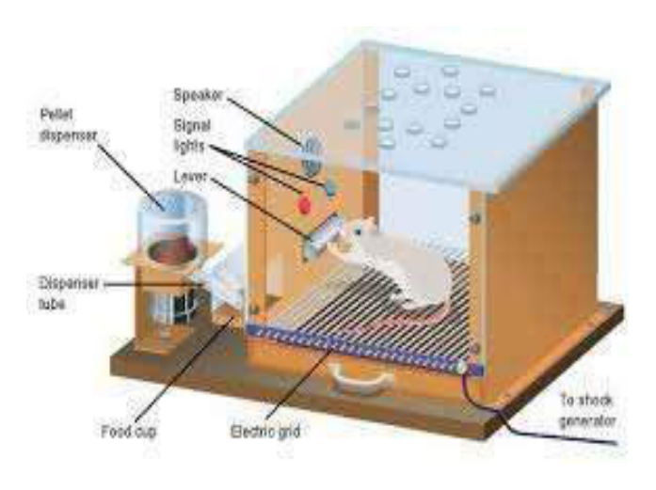  Identify the image:
Type | multiple_choice
Option | Classical condition learning
Option | Insight learning
Option | Operant conditioning learning
Option | Trial and error learning
Answer | 3
Solution | Rationale: Operant Conditioning: Learning through consequences - behavior is modified by reinforcement (positive/negative) or punishment. B.F. Skinner developed this concept using the Skinner box. Key Clues: Behavior modified by consequences, reinforcement/punishment Why Not Others: A-Classical conditioning is Pavlov (stimulus association);C-Insight is Kohler;D-Trial and error is Thorndike Exam Trap: Operant vs classical - operant is voluntary behavior + consequences, classical is involuntary + association PNC Pearl: Operant conditioning: Positive reinforcement (add pleasant), Negative reinforcement (remove unpleasant), Positive punishment (add unpleasant), Negative punishment (remove pleasant). Used in behavior modification therapy.
Positive Marks | 1
Negative Marks | 0.33

Question | 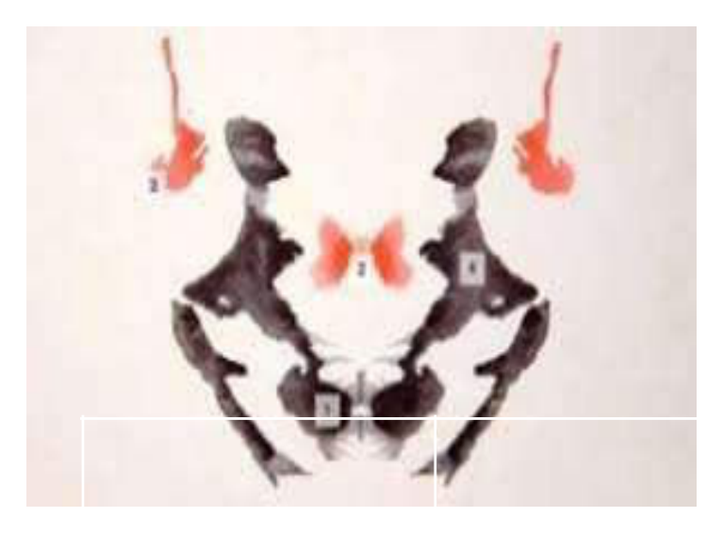  Identify the image:
Type | multiple_choice
Option | Horizontal ink blot test
Option | Rorschach ink blot test
Option | Myers·s test
Option | Thematic apperception test
Answer | 2
Solution | Rationale: Rorschach Ink Blot Test: A projective psychological test where the person describes what they see in ink blots. Used to assess personality characteristics, emotional functioning, and thought disorders. Key Clues: Ink blots, projective test, personality assessment Why Not Others: A-Horizontal ink blot is not standard;B-Myers is personality type;C-TAT shows ambiguous scenes Exam Trap: Rorschach vs TAT - Rorschach uses ink blots, TAT uses picture scenes PNC Pearl: Rorschach test: 10 ink blots (5 black/white, 2 color, 3 mixed). Responses analyzed for content, location, determinants. Used in forensic, clinical, and research settings.
Positive Marks | 1
Negative Marks | 0.33

Question | 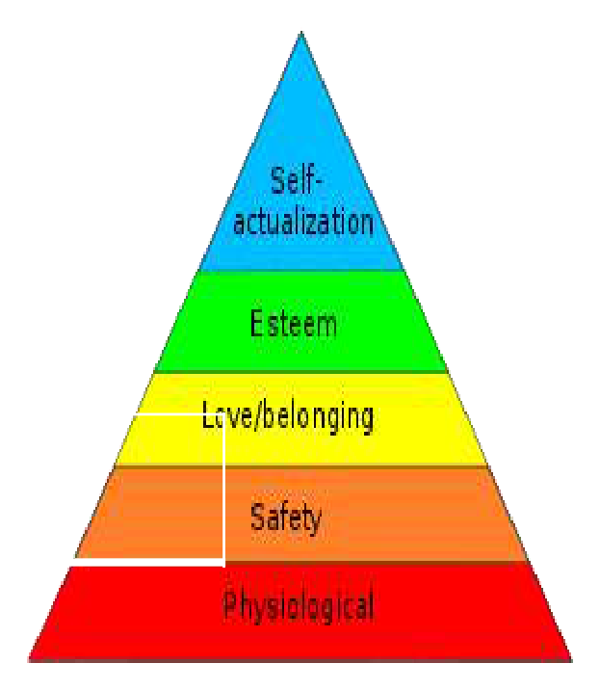  Identify the image:
Type | multiple_choice
Option | Hierarchy
Option | Hierarchy typography
Option | Informal hierarchy
Option | Mas hierarchy needs
Answer | 4
Solution | Rationale: Maslow's Hierarchy of Needs: A motivational theory with 5 levels: Physiological, Safety, Love/Belonging, Esteem, Self-Actualization. Basic needs must be met before higher-level needs. Key Clues: 5 levels pyramid, basic to complex needs Why Not Others: A-Hierarchy is generic;C-Hierarchy typography is not correct;D-Informal hierarchy is not standard Exam Trap: Maslow vs ERG (Alderfer) - Maslow has 5 fixed levels, ERG has 3 flexible levels PNC Pearl: Maslow's: Physiological (food/water) > Safety (security) > Love/Belonging (relationships) > Esteem (respect) > Self-Actualization (fulfillment). Nursing implication: assess and address needs at each level.
Positive Marks | 1
Negative Marks | 0.33

Question | 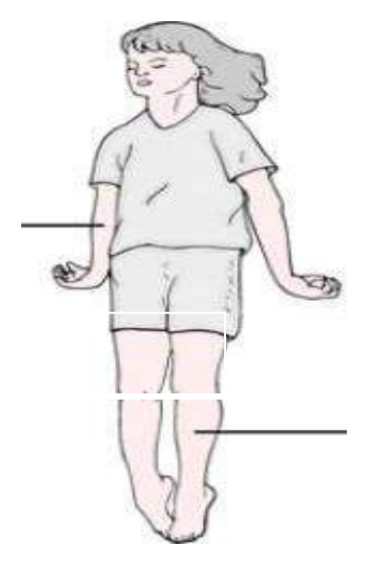  Identify the image:
Type | multiple_choice
Option | Decerebrate
Option | Decorticate
Option | Decelerate
Option | Accelerate
Answer | 1
Solution | Rationale: Decerebrate Posturing: Extension of all four limbs (arms extended and internally rotated, legs extended). Indicates brainstem damage below the red nucleus. Associated with severe brain injury. Key Clues: All limbs extended, arms internally rotated Why Not Others: A-Decorticate is flexion of arms, extension of legs;B-Decelerate is not a posturing type;D-Accelerate is not Exam Trap: Decerebrate vs decorticate - decerebrate = all extend (brainstem), decorticate = arms flex/legs extend (cortex) PNC Pearl: Decerebrate posturing: Indicates brainstem damage (midbrain-pons). Poor prognosis. GCS motor = 3 (extension). Always document and compare bilaterally. Precedes brainstem herniation.
Positive Marks | 1
Negative Marks | 0.33

Question | 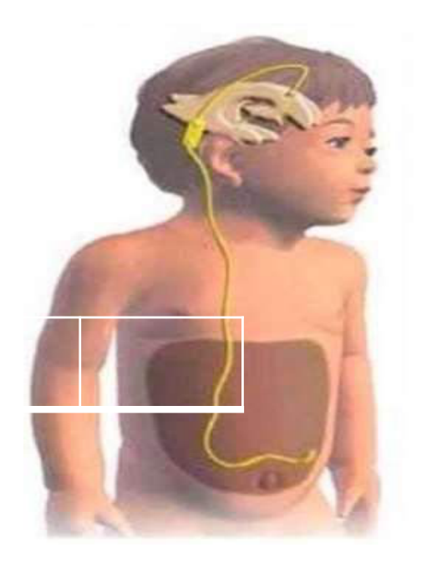  Identify the image:
Type | multiple_choice
Option | VA shunt
Option | VG shunt
Option | VP shunt
Option | LP shunt
Answer | 3
Solution | Rationale: VP Shunt (Ventriculoperitoneal Shunt): A device that drains excess cerebrospinal fluid from the ventricles to the peritoneal cavity to treat hydrocephalus. Has a valve to regulate CSF flow. Key Clues: Drains CSF from ventricles to abdomen, valve-regulated Why Not Others: A-VA shunt goes to atrium;C-VG shunt goes to gallbladder (rare);D-LP shunt goes to lumbar peritoneal Exam Trap: VP vs VA shunt - VP goes to peritoneum (most common), VA goes to right atrium (rare now) PNC Pearl: VP shunt: Most common shunt for hydrocephalus. Monitor for signs of overdrainage (headache, vomiting) or underdrainage (increasing head circumference). Always palpate valve function.
Positive Marks | 1
Negative Marks | 0.33

Question | 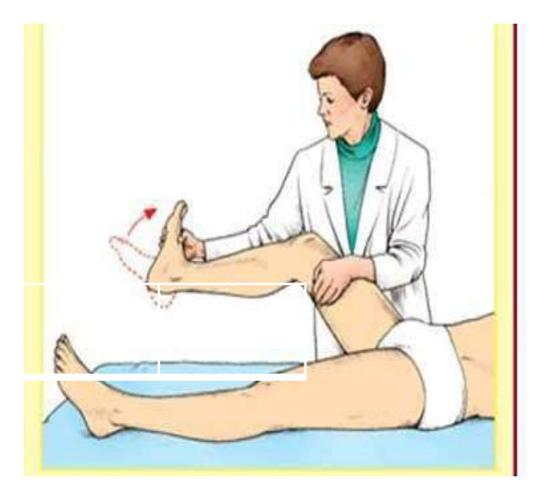  Identify the image:
Type | multiple_choice
Option | Homan sign
Option | Romberg sign
Option | Brudzinski sign
Option | Babinski sign
Answer | 3
Solution | Rationale: Brudzinski's Sign: Flexion of the hips and knees when the neck is flexed (passive). A positive sign indicates meningeal irritation, commonly seen in meningitis. Part of the meningeal signs assessment. Key Clues: Neck flexion causes hip/knee flexion, meningeal sign Why Not Others: A-Homan's sign is for DVT; B-Romberg is balance test; C-Babinski is plantar reflex Exam Trap: Brudzinski's vs Kernig's - both indicate meningeal irritation, tested differently PNC Pearl: Brudzinski's sign: Part of meningitis assessment. Also check Kernig's sign (resistance to knee extension with hip flexed). Nuchal rigidity is third meningeal sign. All three suggest meningitis.
Positive Marks | 1
Negative Marks | 0.33

Question | 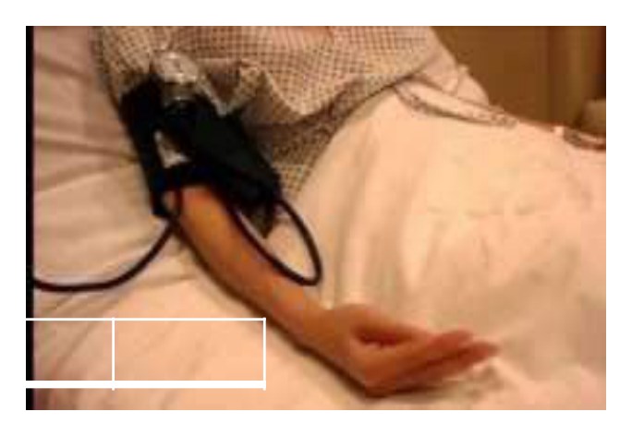  Identify the image:
Type | multiple_choice
Option | Choostek sign
Option | Trousseau sign
Option | Macwen sign
Option | Cullen sign
Answer | 2
Solution | Rationale: Trousseau's Sign: Carpal spasm induced by inflating a blood pressure cuff above systolic pressure for 3 minutes. Indicates hypocalcemia. The hand assumes an obstetrician's position (adducted thumb, flexed wrist and MCP joints). Key Clues: Carpal spasm with BP cuff inflation, hypocalcemia sign Why Not Others: B-Chvostek is facial twitch;C-Macewen is skull percussion;D-Cullen is periumbilical bruising Exam Trap: Trousseau vs Chvostek - Trousseau is induced (BP cuff), Chvostek is spontaneous facial twitch PNC Pearl: Trousseau's sign: Inflate BP cuff 20 mmHg above systolic for 3 min. Positive = carpal spasm. Indicates hypocalcemia (Ca <8.5 mg/dL). Treatment: IV calcium gluconate.
Positive Marks | 1
Negative Marks | 0.33

Question | 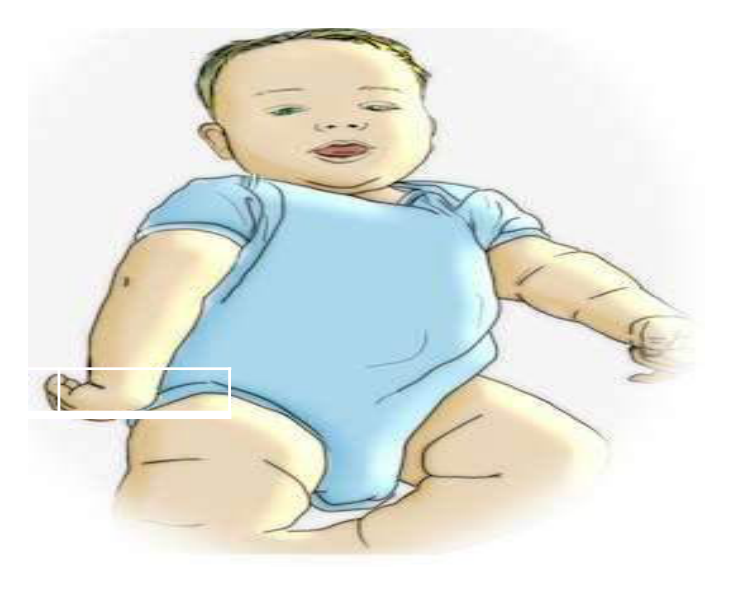  Identify the image:
Type | multiple_choice
Option | Bell·s palsy
Option | Erbs palsy
Option | Facial palsy
Option | Cerebral palsy
Answer | 1
Solution | Rationale: Bell's Palsy: Unilateral lower motor neuron facial nerve paralysis. Shows complete facial droop on one side including forehead, inability to close eye, drooling, and loss of taste on anterior 2/3 of tongue. Key Clues: Complete one-sided facial paralysis including forehead Why Not Others: A-Erb's palsy affects upper brachial plexus;B-Facial palsy is same as Bell's but more generic;C-Cerebral palsy is motor disability from birth Exam Trap: Bell's palsy: Forehead involvement distinguishes it from UMN facial palsy (stroke) PNC Pearl: Bell's palsy treatment: Prednisolone 1mg/kg for 10 days (within 72h). Eye protection essential. Acyclovir if viral cause suspected. Physiotherapy. Most recover fully in 3-6 months.
Positive Marks | 1
Negative Marks | 0.33

Question | 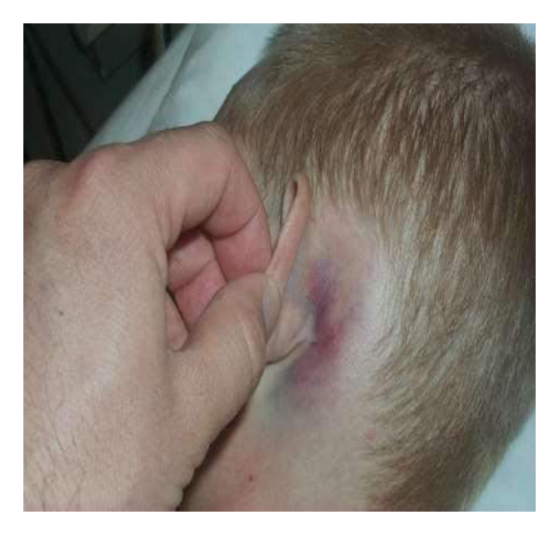  Injury sign shown in the image:
Type | multiple_choice
Option | McEwen Sign
Option | Raccoon Sign
Option | Kernig's Sign
Option | Battle's Sign
Answer | 4
Solution | Rationale: Battle's Sign: Bruising/mastoid ecchymosis behind the ear, indicating basilar skull fracture. It takes 12-24 hours to develop after the fracture. Associated with middle fossa fractures. Key Clues: Bruising behind ear (mastoid area), basilar skull fracture sign Why Not Others: B-McEwen sign is for mastoiditis;C-Raccoon sign is periorbital bruising;D-Kernig sign is for meningitis Exam Trap: Battle's vs Raccoon - Battle's is behind ear, Raccoon is around eyes. Both indicate basilar skull fracture PNC Pearl: Battle's sign: Basilar skull fracture indicator. Also look for Raccoon eyes (periorbital ecchymosis). CSF otorrhea/rhinorrhea. CT scan is investigation of choice. May need surgical repair.
Positive Marks | 1
Negative Marks | 0.33

Question | 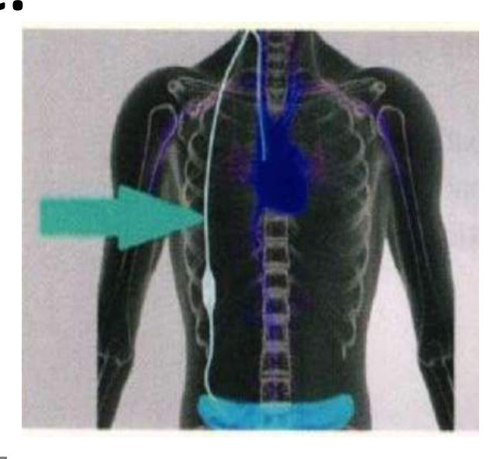  Shunt as represented by an arrow:
Type | multiple_choice
Option | Raised Intracranial pressure.
Option | Dialysis.
Option | Headache.
Option | Ascites.
Answer | 1
Solution | Rationale: VP Shunt shown is used to treat raised intracranial pressure (hydrocephalus) by draining excess CSF from the ventricles to the peritoneal cavity. Key Clues: VP shunt for hydrocephalus Why Not Others: A-Dialysis is for kidney failure;C-Headache is a symptom;D-Ascites is fluid in abdomen Exam Trap: VP shunt: Treats hydrocephalus by draining CSF. Monitor: ICP signs, shunt function, infection. PNC Pearl: VP shunt: Treats hydrocephalus by draining CSF. Monitor: ICP signs, shunt function, infection.
Positive Marks | 1
Negative Marks | 0.33

Question | 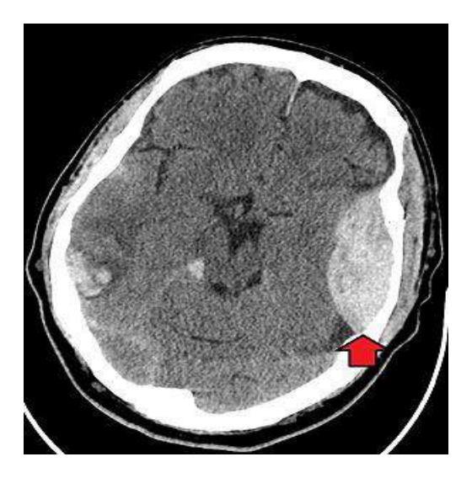  Identify the image:
Type | multiple_choice
Option | Epidural haemotoma
Option | Subdural haematoma
Option | Intra ventricular hemorrhage
Option | Sub arachnoid hemorrhage
Answer | 2
Solution | Rationale: Subdural Hematoma: Collection of blood between dura mater and arachnoid mater, typically from tearing of bridging veins. Common in elderly patients and those on anticoagulants. Key Clues: Blood between dura and arachnoid, bridging vein tear Why Not Others: A-Epidural is between skull and dura (arterial);C-Intraventricular is in brain ventricles;D-Subarachnoid is between arachnoid and pia Exam Trap: Subdural vs epidural - subdural is venous (gradual), epidural is arterial (rapid, lucid interval) PNC Pearl: Subdural hematoma: Cresent-shaped on CT. Types: Acute (<72h), Subacute (3 days-3 weeks), Chronic (>3 weeks). Treatment: Surgical evacuation if symptomatic.
Positive Marks | 1
Negative Marks | 0.33

Question | 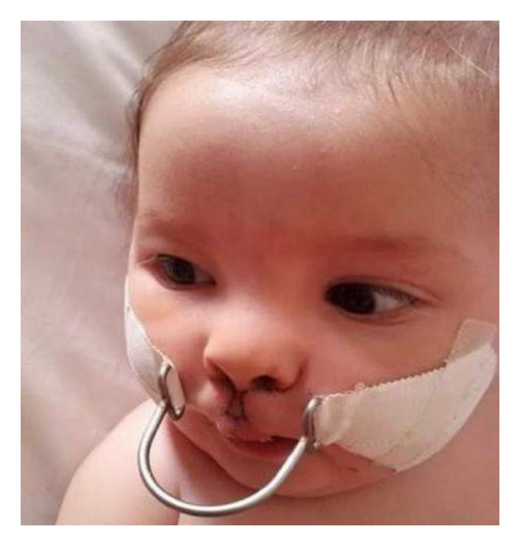  Identify the image:
Type | multiple_choice
Option | Logan bow
Option | Nasal retractor
Option | Halo traction
Option | None
Answer | 3
Solution | Rationale: Halo Traction: A circular metal ring fixed to the skull with pins, connected to a vest or bed frame. Used for cervical spine fractures and post-operative cervical spine immobilization. Key Clues: Metal ring on skull, for cervical spine stabilization Why Not Others: A-Logan bow is for jaw fractures;C-Nasal retractor is for nose;D-None is incorrect Exam Trap: Halo traction vs cervical collar - halo provides rigid immobilization, collar is less rigid PNC Pearl: Halo traction: Pins placed under local anesthesia. Pin care q8-12h. Monitor for: infection, neurological deficit, skin breakdown under vest. Never remove without authorization.
Positive Marks | 1
Negative Marks | 0.33

Question | 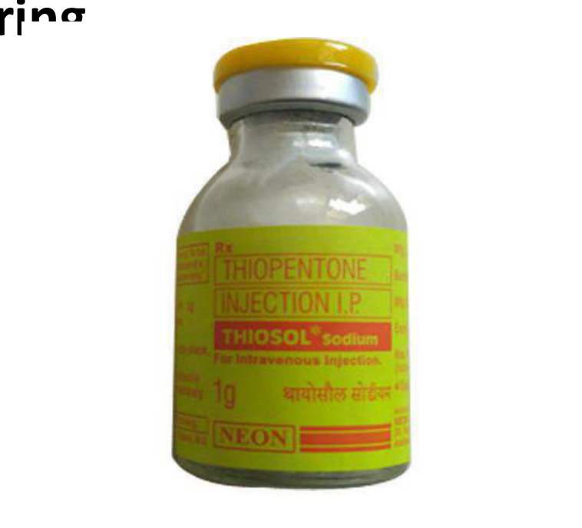  The given drug is used in ECT?
Type | multiple_choice
Option | To prevent aspiration
Option | It increased heart rate during
Option | To relaxant patient
Option | To increased effect of ECT
Answer | 1
Solution | Rationale: Drug used in ECT (Electroconvulsive Therapy): Succinylcholine is used as a muscle relaxant to prevent fractures and injuries during induced seizures. It provides brief neuromuscular blockade. Key Clues: Muscle relaxant for ECT, prevents injury during seizure Why Not Others: A-Increases HR is incorrect purpose;B-Relaxant patient is vague;D-Increased effect of ECT is incorrect Exam Trap: Succinylcholine in ECT - specifically prevents musculoskeletal injuries PNC Pearl: ECT drugs: Succinylcholine (muscle relaxant), Methohexital (anesthetic), Atropine (reduce secretions/bradycardia). Monitor: seizure duration (minimum 20 seconds), recovery, orientation.
Positive Marks | 1
Negative Marks | 0.33

Question | 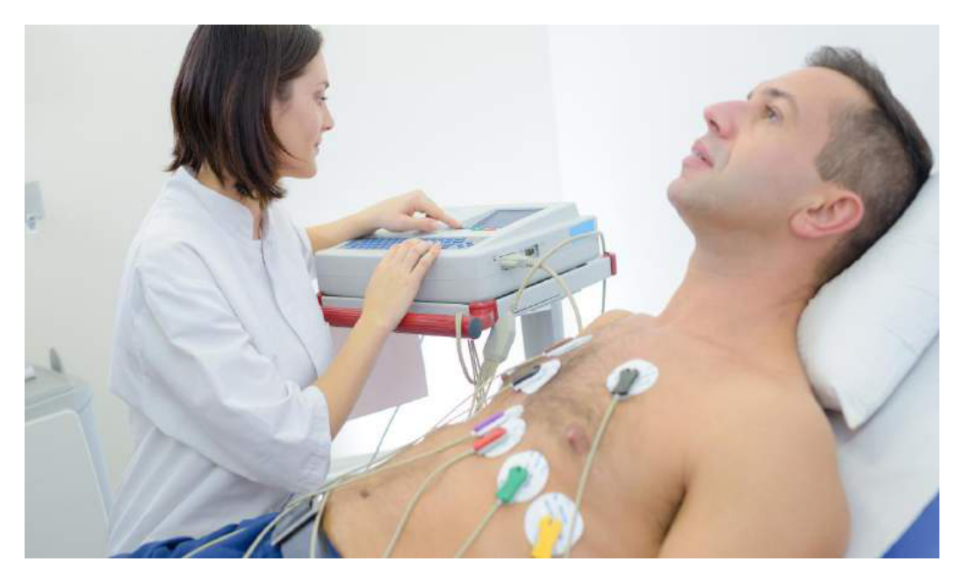  Depressive patient admit in a psychiatric ward,:
Type | multiple_choice
Option | escitalopram
Option | citalopram
Option | amitriptaline
Option | sertaline
Answer | 2
Solution | Rationale: Citalopram: An SSRI (Selective Serotonin Reuptake Inhibitor) commonly prescribed for depression. First-line treatment due to fewer side effects compared to TCAs. Blocks serotonin reuptake in the synaptic cleft. Key Clues: SSRI, first-line for depression, fewer side effects Why Not Others: B-Escitalopram is the S-enantiomer;C-Amitriptyline is TCA;D-Sertraline is also SSRI but different profile Exam Trap: Citalopram vs escitalopram - citalopram is racemic, escitalopram is the active S-form PNC Pearl: Citalopram: Start 20mg daily, max 40mg (60mg in elderly). Onset 2-4 weeks. Side effects: Nausea, headache, sexual dysfunction. Avoid with MAOIs (serotonin syndrome risk). QTc prolongation at high doses.
Positive Marks | 1
Negative Marks | 0.33

Question | 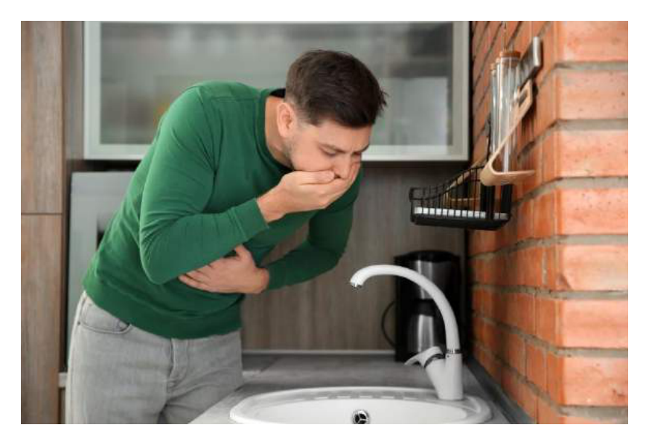  This is side effect of which type of antidepressant?
Type | multiple_choice
Option | Imipramine
Option | Sertaline
Option | Clomipramine
Option | Amitryptilline
Answer | 4
Solution | Rationale: Amitriptyline: A tricyclic antidepressant (TCA) that blocks norepinephrine and serotonin reuptake. Side effects include anticholinergic effects (dry mouth, constipation, urinary retention, blurred vision). Key Clues: TCA, anticholinergic side effects Why Not Others: A-Imipramine is TCA but different side effect profile;C-Sertraline is SSRI;D-Clomipramine is TCA for OCD Exam Trap: Amitriptyline side effects: Remember "Hot as a Hare, Dry as a Bone, Red as a Beet, Mad as a Hatter, Blind as a Bat" PNC Pearl: Amitriptyline: Toxic in overdose (cardiac arrhythmias). Start low, go slow. Avoid in elderly (confusion, falls). Don't stop abruptly (withdrawal syndrome). Monitor for suicidal ideation in first weeks.
Positive Marks | 1
Negative Marks | 0.33

