Question | 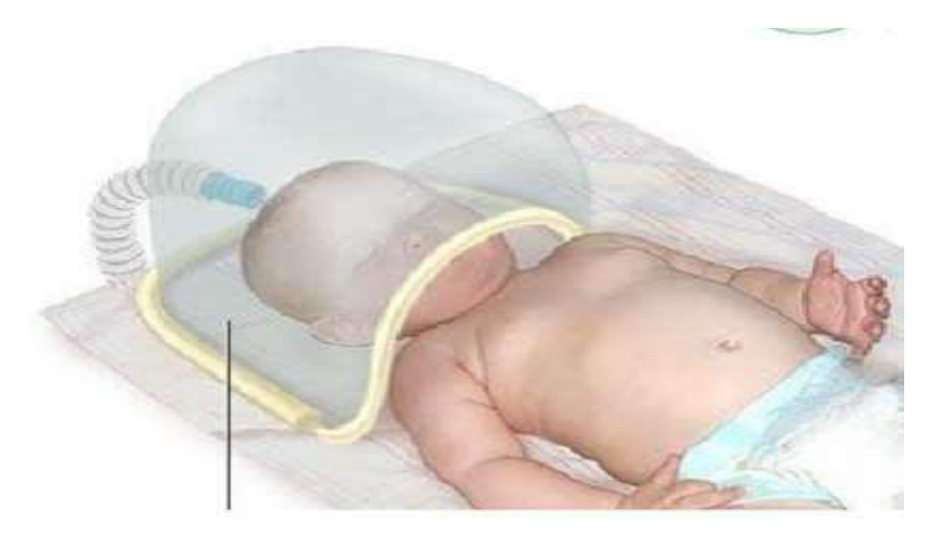  Identify the image:
Type | multiple_choice
Option | Oxygen tent
Option | Oxygen hood
Option | Bed cradle
Option | Face mask
Answer | 2
Solution | Rationale: Oxygen Hood: A transparent plastic hood placed over the infant's head to deliver controlled concentration of oxygen. Used in NICU for neonates requiring supplemental oxygen. Key Clues: Transparent hood over infant head, for oxygen delivery Why Not Others: B-Oxygen tent covers whole body;C-Bed cradle lifts linens;D-Face mask covers nose/mouth Exam Trap: Oxygen hood vs tent - hood covers head only (neonatal), tent covers body (pediatric/adult) PNC Pearl: Oxygen hood: Maintains precise FiO·. Monitor O· concentration continuously. Check infant temperature (heat loss risk). Keep head in center of hood. Humidify oxygen.
Positive Marks | 1
Negative Marks | 0.33

Question | 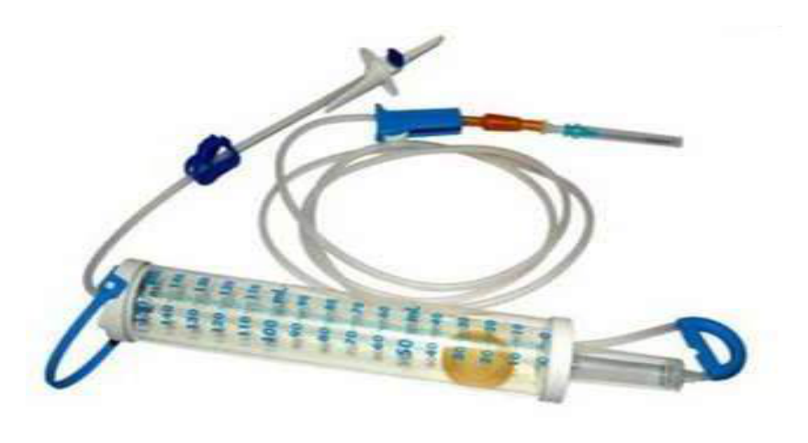  Identify the image:
Type | multiple_choice
Option | Pedia drip set
Option | Micro drip set
Option | Macro drip set
Option | Adult drip set
Answer | 2
Solution | Rationale: Micro Drip Set (Pediatric Drip Set): An IV administration set with 60 drops per ml (60 gtt/ml). Used for accurate small-volume fluid and medication delivery, especially in pediatric and cardiac patients. Key Clues: 60 drops/ml, for pediatric/cardiac patients Why Not Others: A-Pediatric drip set is not standard;C-Macro drip is 10-20 drops/ml;D-Adult drip set is same as macro Exam Trap: Micro vs macro - micro is 60 gtt/ml (pediatric), macro is 10-20 gtt/ml (adult) PNC Pearl: Micro drip: 60 gtt/mL. Formula: drops/min = (volume × 60) / time in minutes. Used when precise fluid delivery needed. Common in NICU and ICU.
Positive Marks | 1
Negative Marks | 0.33

Question | 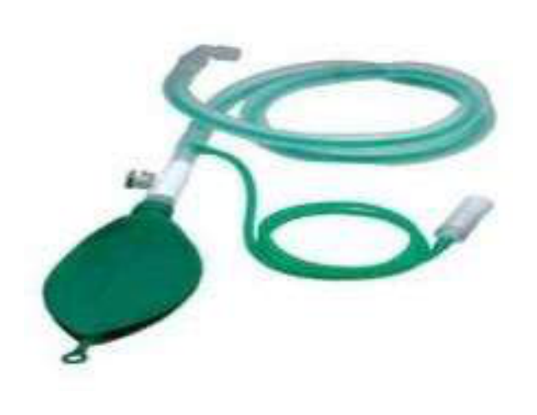  Identify the image:
Type | multiple_choice
Option | Venti circuit
Option | Bain circuit
Option | NIBP
Option | Ambu bag
Answer | 2
Solution | Rationale: Bain Circuit: A modified Mapleson system used for anesthesia delivery. It is a coaxial circuit with an inner fresh gas tube inside an outer breathing tube. Efficient for controlled ventilation. Key Clues: Coaxial design, inner fresh gas tube, for anesthesia Why Not Others: B-VMPI circuit is not standard; C-NIBP is blood pressure; D-Ambu bag is manual ventilation Exam Trap: Bain vs Jackson-Rees - Bain is modified Mapleson D, Jackson-Rees is modified Mapleson F PNC Pearl: Bain circuit: Always set fresh gas flow at >70 ml/kg/min to prevent rebreathing. Check for disconnection - can cause hypercapnia rapidly. Light weight, easy to use.
Positive Marks | 1
Negative Marks | 0.33

Question | 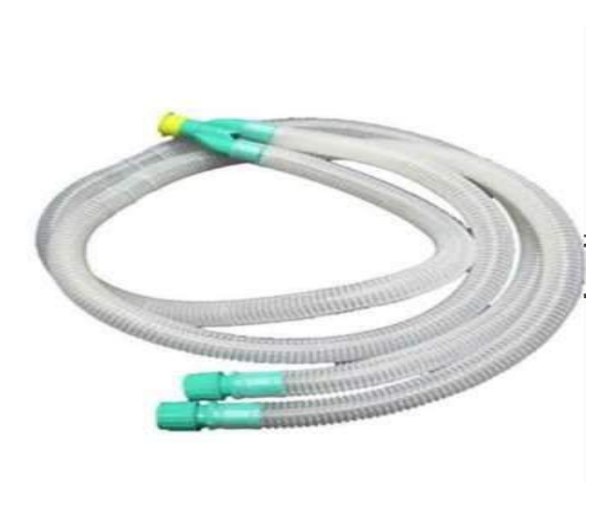  Identify the image:
Type | multiple_choice
Option | Bain circuit
Option | NIBP
Option | Venti circuit
Option | Ambu bag
Answer | 3
Solution | Rationale: Circle Circuit (Venti Circuit): A semi-closed breathing system used in anesthesia machines. Features unidirectional valves, CO· absorber, and reservoir bag. Allows rebreathing of gases after CO· removal. Key Clues: Unidirectional valves, CO· absorber, reservoir bag Why Not Others: A-Bain is coaxial; C-NIBP is blood pressure;D-Ambu bag is manual Exam Trap: Circle vs Bain - circle has CO· absorber and unidirectional valves, Bain is coaxial PNC Pearl: Circle circuit: Most common anesthesia circuit. CO· absorber (soda lime) removes CO·. Check unidirectional valves function. Fresh gas flow 1-2 L/min (low flow anesthesia).
Positive Marks | 1
Negative Marks | 0.33

Question | 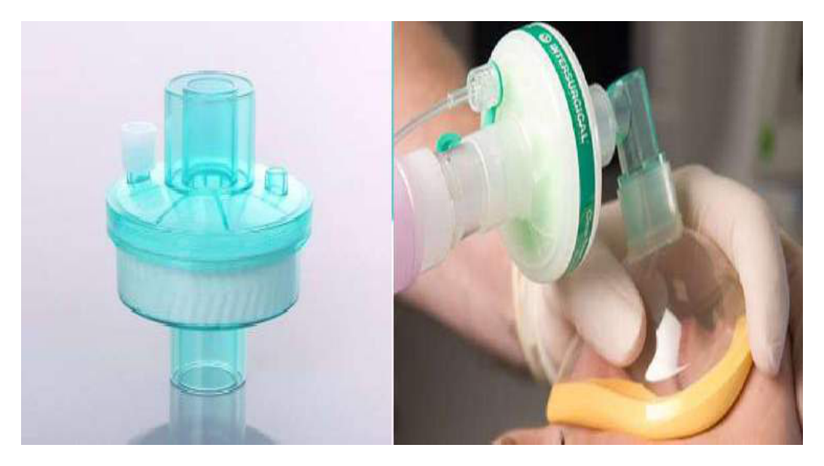  Identify the image:
Type | multiple_choice
Option | HEFA filter
Option | HME filter
Option | NRB filter
Option | PNRB filter
Answer | 2
Solution | Rationale: HME Filter (Heat and Moisture Exchanger): A device placed between the ET tube and ventilator circuit that conserves heat and moisture from exhaled gases. Also called artificial nose. Key Clues: Conserves heat/moisture, artificial nose Why Not Others: A-HEFA is not standard;C-NRB is non-rebreather mask;D-PNRB is partial non-rebreather Exam Trap: HME vs heated humidifier - HME is passive (no heat source), heated humidifier is active PNC Pearl: HME: Passive humidification. Not suitable for: thick secretions, high minute ventilation, pediatric patients. Change q24-48h or when soiled. Contraindicated with nebulized medications.
Positive Marks | 1
Negative Marks | 0.33

Question | 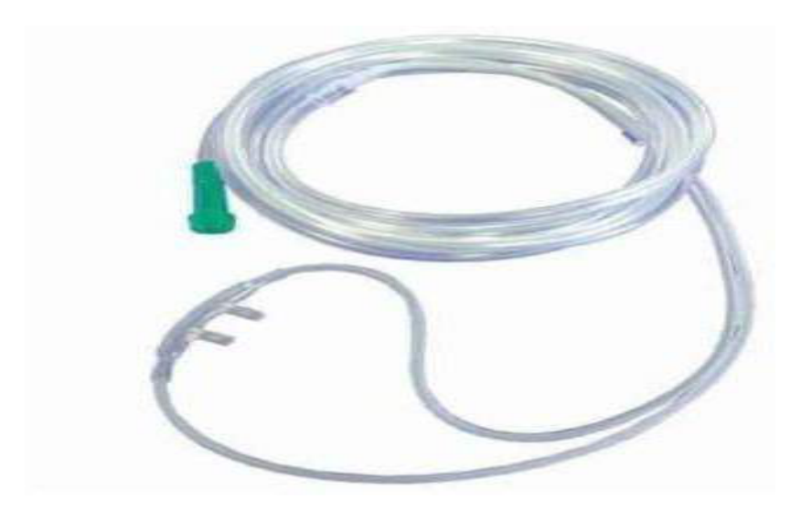  Identify the image:
Type | multiple_choice
Option | Nasal cannula
Option | PMO line
Option | Yankur catheter
Option | Bifurcation tube
Answer | 1
Solution | Rationale: Nasal Cannula: A simple oxygen delivery device with two prongs that sit inside the nostrils. Delivers 24-44% FiO· at 1-6 L/min. Most comfortable and commonly used oxygen device. Key Clues: Two nasal prongs, delivers 24-44% FiO· Why Not Others: A-PMO line is for medication;C-Yankur is for suctioning;D-Bifurcation tube is not standard Exam Trap: Nasal cannula vs face mask - nasal cannula is more comfortable but delivers lower FiO· PNC Pearl: Nasal cannula: 1L=24%, 2L=28%, 3L=32%, 4L=36%, 5L=40%, 6L=44%. Max 6L/min (higher = nasal mucosal drying). Check nares for irritation. Can wear while eating.
Positive Marks | 1
Negative Marks | 0.33

Question | 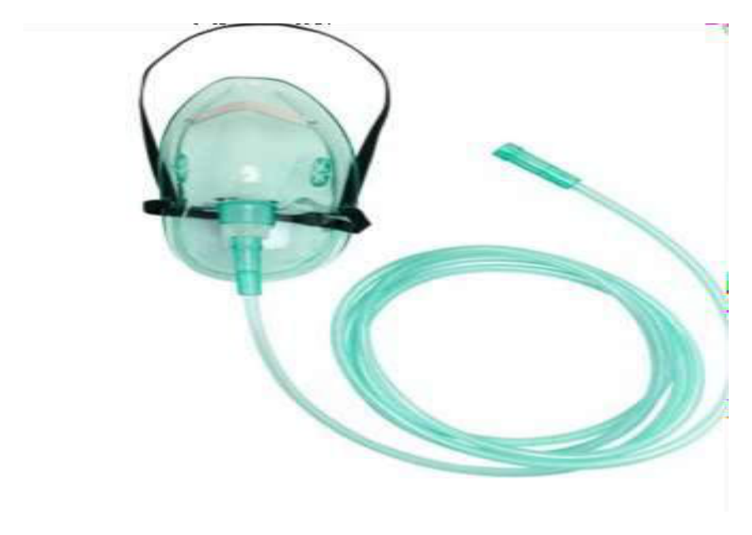  Identify the image:
Type | multiple_choice
Option | NRB mask
Option | Face mask
Option | Venturi mask
Option | PNRB mask
Answer | 4
Solution | Rationale: PNRB (Partial Non-Rebreather) Mask: An oxygen mask with a reservoir bag that allows partial rebreathing of expired gases. Delivers 40-60% FiO· at 10-15 L/min oxygen flow. Key Clues: Reservoir bag attached, partial rebreathing, 40-60% FiO· Why Not Others: A-NRB is full non-rebreather (no valve); C-Face mask delivers 35-50%; D-Venturi provides precise FiO· Exam Trap: PNRB vs NRB - PNRB has a small opening allowing some rebreathing, NRB has one-way valve PNC Pearl: PNRB: Always ensure reservoir bag is 1/3 to 1/2 full during inhalation. O· flow 10-15 L/min. FiO· 40-60%. Monitor patient comfort and O· saturation.
Positive Marks | 1
Negative Marks | 0.33

Question |   Identify the image:
Type | multiple_choice
Option | Venturi mask
Option | NRB mask
Option | Nabulizer mask
Option | Face mask
Answer | 1
Solution | Rationale: Venturi Mask: An oxygen delivery device that provides precise, controlled FiO· (24-60%) using the Venturi principle. Color-coded adapters indicate different oxygen concentrations. Key Clues: Color-coded adapters, precise FiO· delivery, air-entrainment Why Not Others: A-NRB delivers high FiO·;B-Nebulizer delivers medication;C-Face mask delivers 35-50% Exam Trap: Venturi vs simple face mask - Venturi provides exact FiO·, face mask is variable PNC Pearl: Venturi mask colors: Blue=24%, White=28%, Orange=31%, Yellow=35%, Red=40%, Green=60%. Ideal for COPD patients needing controlled O·. Uses Bernoulli principle.
Positive Marks | 1
Negative Marks | 0.33

Question | 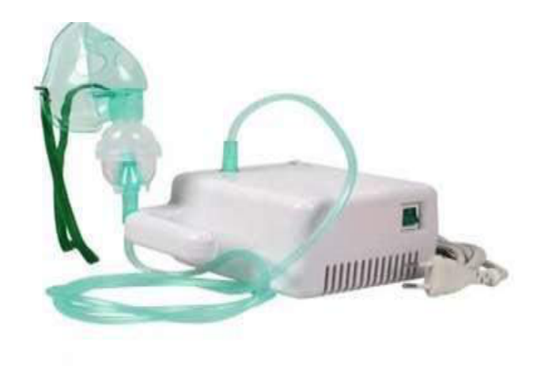  Identify the image:
Type | multiple_choice
Option | Bilal
Option | Nabulizer
Option | Suction machine
Option | Vaccum cleaner
Answer | 3
Solution | Rationale: Suction Machine: A device that creates negative pressure to remove secretions, blood, and debris from the body. Used for oropharyngeal, nasopharyngeal, and wound suctioning. Key Clues: Creates negative pressure, removes secretions Why Not Others: B-Bilal is not standard;C-Nebulizer delivers medication;D-Vacuum cleaner is for cleaning Exam Trap: Medical suction vs vacuum cleaner - medical suction is calibrated and sterile PNC Pearl: Suction machine: Wall suction or portable. Pressure: Adult 80-120 mmHg, Pediatric 60-80 mmHg, Neonate 40-60 mmHg. Always use sterile technique. Suction only on withdrawal.
Positive Marks | 1
Negative Marks | 0.33

Question | 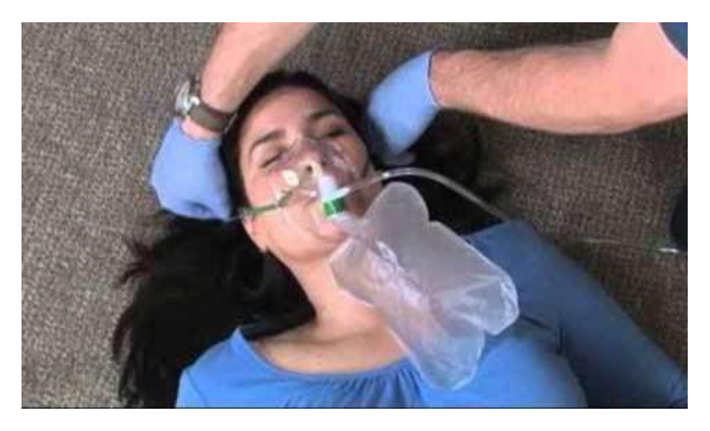  Identify the image:
Type | multiple_choice
Option | NRB mask
Option | PNRB mask
Option | Face mask
Option | Venturi mask
Answer | 3
Solution | Rationale: Face Mask (Simple Face Mask): A basic oxygen delivery device that covers nose and mouth. Delivers 35-50% FiO· at 5-8 L/min. Used for moderate oxygen supplementation. Key Clues: Covers nose and mouth, simple design, 35-50% FiO· Why Not Others: A-NRB delivers higher FiO·;B-PNRB has reservoir;D-Venturi provides precise FiO· Exam Trap: Simple face mask vs nasal cannula - face mask delivers higher FiO· but is less comfortable PNC Pearl: Simple face mask: O· flow 5-8 L/min. FiO· 35-50%. Remove for eating/drinking. Check for skin breakdown on face. Ensure proper fit.
Positive Marks | 1
Negative Marks | 0.33

Question | 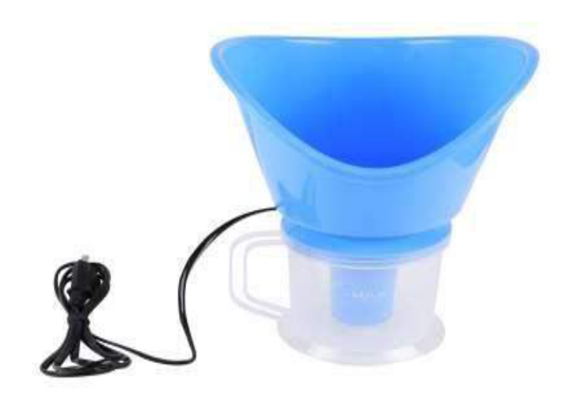  Identify the image:
Type | multiple_choice
Option | Nabulizer
Option | Heating lamp
Option | None of these
Option | Steam inhaler
Answer | 4
Solution | Rationale: Steam Inhaler: A device that produces warm, moist air for inhalation to relieve congestion and soothe irritated airways. Used for upper respiratory infections, sinusitis, and bronchitis. Key Clues: Produces warm moist air, for inhalation therapy Why Not Others: A-Nebulizer converts liquid to mist;C-Heating lamp provides radiant heat;D-None is incorrect Exam Trap: Steam inhaler vs nebulizer - steam uses heat to vaporize water, nebulizer uses compressed air PNC Pearl: Steam inhaler: Boiled water produces steam. Add eucalyptus oil or menthol for relief. Keep face 12 inches from steam. Never use with children (burn risk). Duration: 10-15 minutes.
Positive Marks | 1
Negative Marks | 0.33

Question | 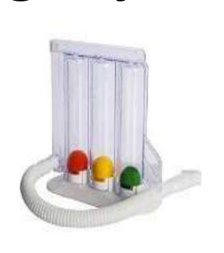  Identify the image:
Type | multiple_choice
Option | -
Option | Spirometery
Option | BiPAP machine
Option | 3 chamber drainage system
Answer | 3
Solution | Rationale: BiPAP Machine (Bilevel Positive Airway Pressure): A non-invasive ventilation device providing two pressure levels - IPAP for inspiration and EPAP for expiration. Used for respiratory failure. Key Clues: Non-invasive, two pressure levels Why Not Others: A-Spirometry measures lung function;B- is not standard;D-3 chamber drainage is for chest Exam Trap: BiPAP vs CPAP - BiPAP has two pressures (IPAP + EPAP), CPAP has one constant pressure PNC Pearl: BiPAP settings: IPAP 8-20, EPAP 4-12 cmH·O. Used for: COPD exacerbation, OSA, obesity hypoventilation, acute respiratory failure. Monitor for: mask leak, gastric distension, skin breakdown.
Positive Marks | 1
Negative Marks | 0.33

Question | 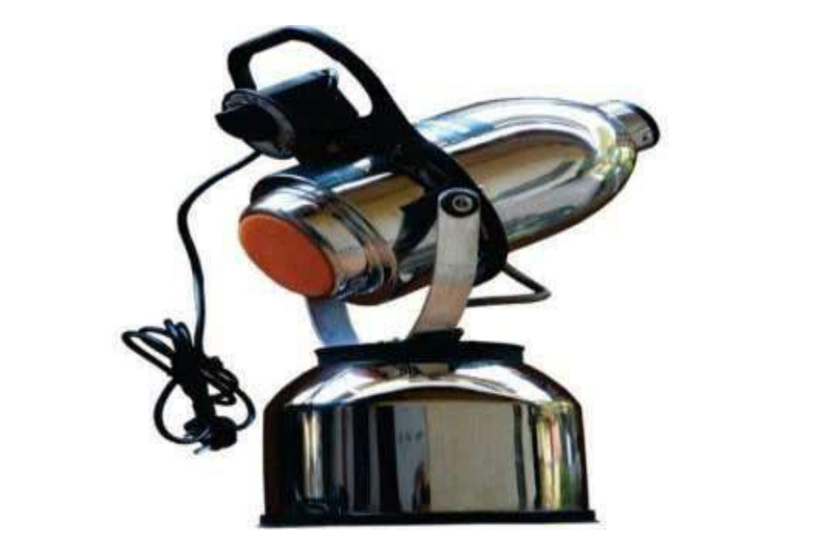  Identify the image:
Type | multiple_choice
Option | Ventilator
Option | Fumigation machine
Option | None of these
Option | Suction machine
Answer | 4
Solution | Rationale: Suction Machine (Portable): A compact, mobile unit for bedside or emergency suctioning. Uses canister to collect secretions. Battery or mains powered for use during transport. Key Clues: Portable, mobile, for bedside/transport use Why Not Others: A-Ventilator delivers breaths;B-Fumigation is for disinfection;D-None is incorrect Exam Trap: Portable vs wall suction - portable is mobile, wall is fixed but more powerful PNC Pearl: Portable suction: Always check battery charge. Have spare canister. Connect appropriate catheter. Test before use. Essential for: emergency trolley, transport, bedside.
Positive Marks | 1
Negative Marks | 0.33

Question | 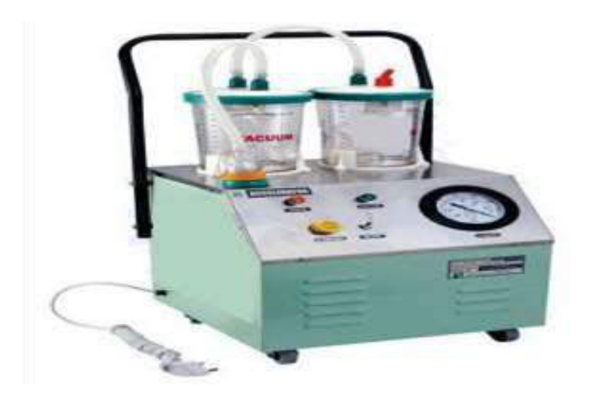  Identify the image:
Type | multiple_choice
Option | Suction machine
Option | Ventilator
Option | Fumigation machine
Option | None of these
Answer | 1
Solution | Rationale: Suction Machine: Same as above - a device that creates negative pressure for removing secretions from airways and wounds. Available as wall-mounted or portable units. Key Clues: Negative pressure device, for secretion removal Why Not Others: A-Ventilator;B-Fumigation are different Exam Trap: Wall suction vs portable: Wall provides 0-200 mmHg continuous, portable is limited by battery PNC Pearl: Suction technique: Hyperoxygenate before suctioning. Use appropriate catheter size. Suction 10 seconds max. Sterile technique. Irrigate catheter with saline between passes.
Positive Marks | 1
Negative Marks | 0.33

Question | 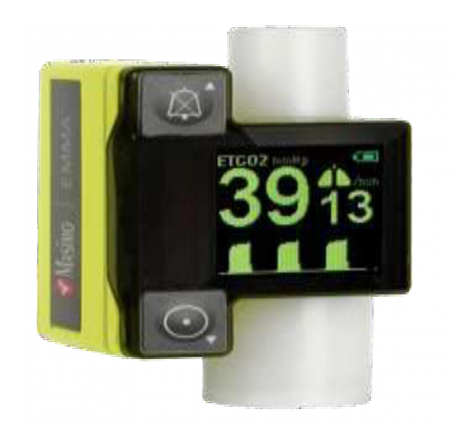  Identify the image:
Type | multiple_choice
Option | EtCO2 monitor
Option | Modern SPO2
Option | HME filter
Option | Catheter mount
Answer | 2
Solution | Rationale: Modern SPO2 Monitor: A pulse oximeter that provides continuous, non-invasive measurement of oxygen saturation and pulse rate. Uses light absorption through a finger probe. Key Clues: Continuous SpO2 and pulse rate, finger probe Why Not Others: A-ETCO2 is end-tidal CO·;C-HME is heat-moisture exchanger;D-Catheter mount connects ET tube Exam Trap: Pulse oximeter vs ABG - pulse oximeter is continuous and non-invasive, ABG is intermittent and invasive PNC Pearl: Pulse oximetry: Normal SpO2 95-100%. Accuracy ±2%. Affected by: nail polish, cold extremities, poor perfusion, CO poisoning, methemoglobinemia. Clean probe between patients.
Positive Marks | 1
Negative Marks | 0.33

Question | 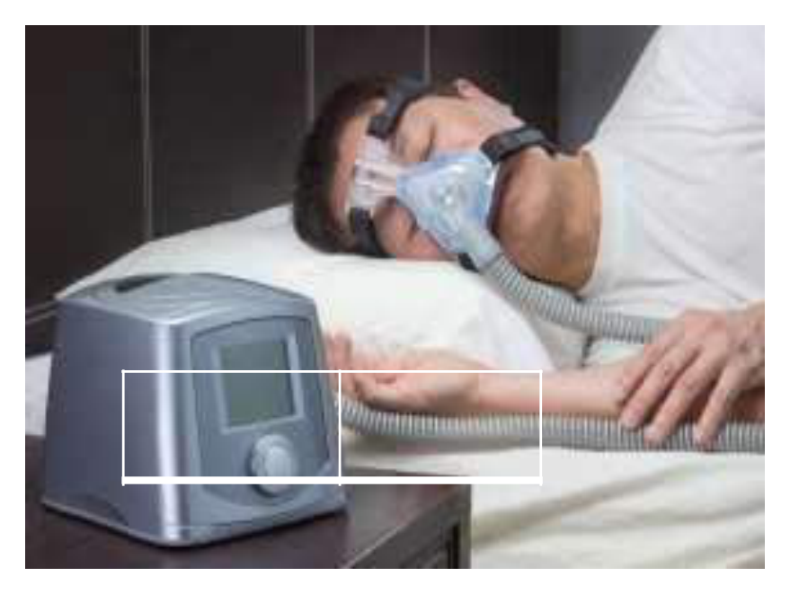  Identify the image:
Type | multiple_choice
Option | SIMV
Option | CMV
Option | PEEP
Option | BIPAP
Answer | 4
Solution | Rationale: BIPAP (Bilevel Positive Airway Pressure): A non-invasive ventilation device that provides two levels of pressure: IPAP (inspiratory) for breath delivery and EPAP (expiratory) for alveolar recruitment. Key Clues: Two pressure levels, non-invasive ventilation Why Not Others: B-SIMV is invasive ventilator mode;C-CMV is continuous mandatory ventilation;D-PEEP is positive end-expiratory pressure Exam Trap: BIPAP vs CPAP - BIPAP has two pressures (IPAP + EPAP), CPAP has one constant pressure PNC Pearl: BIPAP: IPAP 8-20 cmH·O, EPAP 4-12 cmH·O. Used for: COPD exacerbation, acute respiratory failure, obesity hypoventilation. Monitor: mask fit, skin breakdown, gastric distension.
Positive Marks | 1
Negative Marks | 0.33

Question | 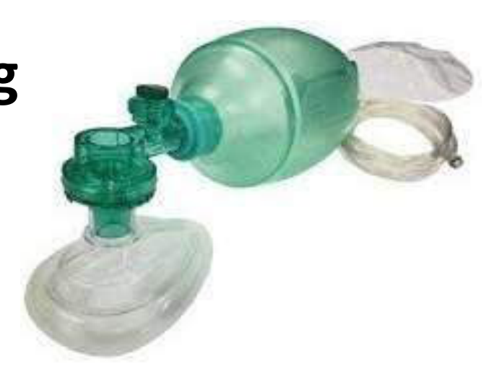  Identify the image:
Type | multiple_choice
Option | Ambu bag with reservoir bag
Option | Ambu bag with rebreathing
Option | Ambu bag
Option | Artificial manual breathing
Answer | 1
Solution | Rationale: AMBU Bag with Reservoir: A self-inflating ventilation bag with an attached reservoir bag and non-rebreathing valve. The reservoir allows higher FiO· (up to 100%) when connected to high-flow oxygen. Key Clues: Self-inflating bag + reservoir bag, for high FiO· Why Not Others: B-Rebreathing is incorrect concept;C-AMBU bag without reservoir gives lower FiO·;D-Artificial manual breathing is the full form Exam Trap: AMBU with reservoir vs without - with reservoir achieves FiO· up to 100%, without only 40-60% PNC Pearl: AMBU bag with reservoir: O· flow 10-15 L/min into reservoir. Non-rebreathing valve ensures patient gets fresh O· only. Always check valve function. Adult 1600ml, pediatric 500ml.
Positive Marks | 1
Negative Marks | 0.33

Question | 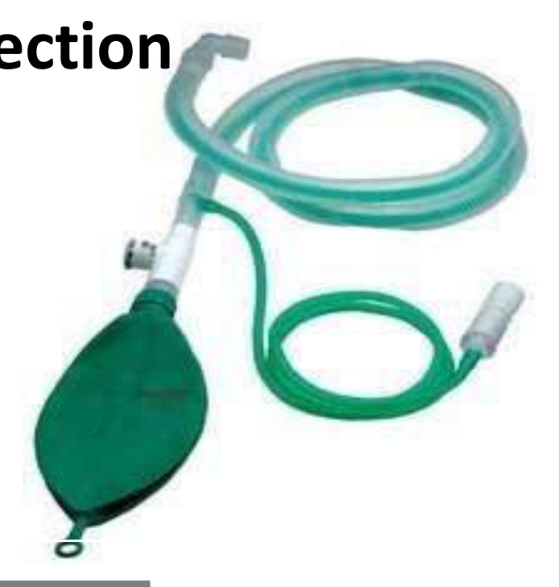  Identify the image:
Type | multiple_choice
Option | Bain circuit
Option | Mepalson catheter
Option | Ambu bag with L connection
Option | Respiratory circuit
Answer | 1
Solution | Rationale: Bain Circuit: A modified Mapleson D coaxial breathing system used in anesthesia. The fresh gas tube runs inside the expiratory tube. Lightweight and convenient for head and neck surgery. Key Clues: Coaxial design, Mapleson D modified, for anesthesia Why Not Others: A-Mepalson is not standard;C-AMBU with L is not standard;D-Respiratory circuit is generic Exam Trap: Bain circuit: Set fresh gas flow ·70 ml/kg/min to prevent rebreathing. Check for disconnection (can cause CO· retention rapidly). Lightweight advantage. PNC Pearl: Bain circuit: Set fresh gas flow ·70 ml/kg/min to prevent rebreathing. Check for disconnection (can cause CO· retention rapidly). Lightweight advantage.
Positive Marks | 1
Negative Marks | 0.33

