Question | 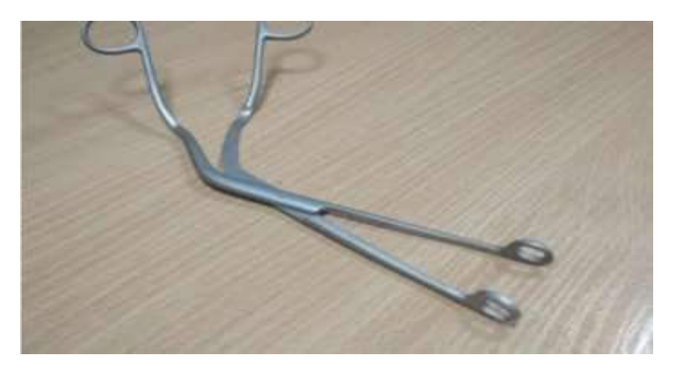  Identify the image?
Type | multiple_choice
Option | Sponge forceps
Option | Kocher forceps
Option | Magill·s forceps
Option | Artery forceps
Answer | 1
Solution | Rationale: Sponge forceps (Rampley sponge forceps) have ring handles with oval/round serrated tips. Used to hold gauze/sponges for skin preparation, cleaning surgical sites, and applying antiseptic solutions. Key Clues: Ring handles, oval serrated tips, holding gauze/sponge Why Not Others: A-Kocher has toothed tips for grasping tissue; B-Magill is angled for nasogastric tube placement; D-Artery forceps is for hemostasis Exam Trap: Sponge forceps vs tissue forceps - sponge forceps have larger, serrated oval tips PNC Pearl: Rampley sponge forceps: Used in surgical scrub, holding swabs, and applying betadine. Never use to grasp delicate tissue.
Positive Marks | 1
Negative Marks | 0.33

Question | 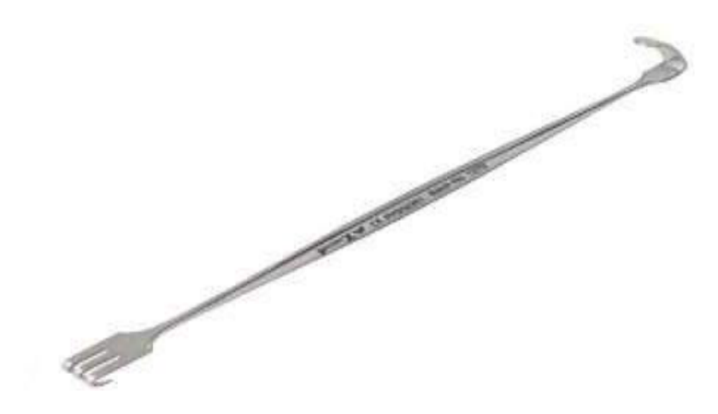  Identify the image:
Type | multiple_choice
Option | Cats paw retractor
Option | Nasal retractor
Option | Ali·s retractor
Option | Morris retractor
Answer | 4
Solution | Rationale: Morris retractor: A handheld retractor with a curved blade, used to retract superficial and moderate-depth incisions. It has a flat handle and curved blade for wound edge retraction. Key Clues: Curved blade, handheld, used for superficial to moderate retraction Why Not Others: A-Cats paw retractor has multiple prongs; C-Nasal retractor is small/specialized; D-Ali's retractor is not standard Exam Trap: Morris vs Richardson - Morris is smaller, Richardson is larger and deeper PNC Pearl: Morris retractor: Named after its inventor. Used in general surgery for superficial wound retraction. Always retract gently to avoid tissue ischemia.
Positive Marks | 1
Negative Marks | 0.33

Question | 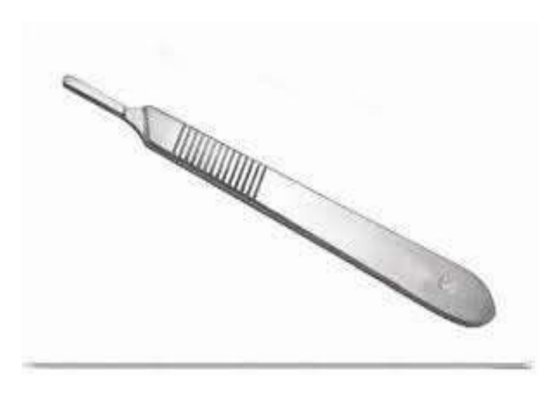  Identify this instrument:
Type | multiple_choice
Option | Dilator
Option | Spatula
Option | BP handle
Option | Dissecting Forceps
Answer | 4
Solution | Rationale: Dissecting Forceps: Toothed or non-toothed forceps used for grasping and dissecting tissues during surgery. Have fine tips for precise tissue handling. Toothed versions grip tissue more firmly. Key Clues: Fine tips, tweezer-like, toothed or non-toothed Why Not Others: B-Dilator is for expanding openings; C-Spatula is flat; D-BP handle holds scalpel blades Exam Trap: Dissecting forceps vs tissue forceps - dissecting forceps are finer and more precise PNC Pearl: Dissecting forceps: Adson (fine, for skin), DeBakey (atraumatic, for vessels), Russian (round, for bowel). Always handle tissue gently to minimize trauma.
Positive Marks | 1
Negative Marks | 0.33

Question | 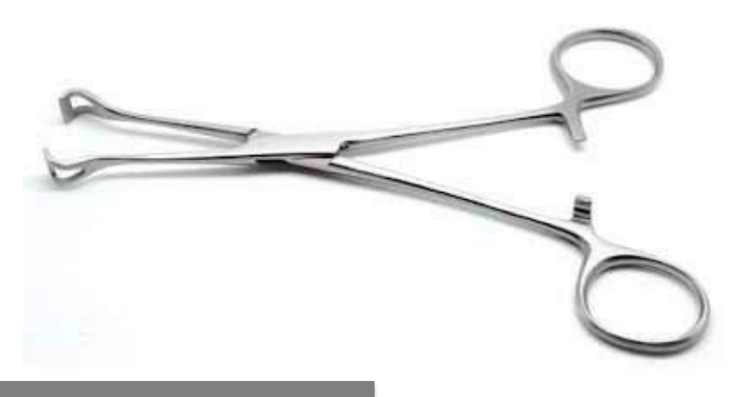  Identify this instrument?
Type | multiple_choice
Option | Artery forceps
Option | Allis forceps
Option | Babcock forceps
Option | Green armitage
Answer | 4
Solution | Rationale: Green-Armitage Forceps: Heavy serrated forceps used for grasping and removing tough tissue, especially in ENT and thoracic surgery. Named after the surgeon who designed them. Key Clues: Heavy, serrated jaws, ring handles, for tough tissue grasping Why Not Others: A-Artery forceps is for hemostasis; B-Allis has fine teeth; D-Babcock has fenestrated tips Exam Trap: Green-Armitage vs sponge forceps - Green-Armitage has heavy serrated jaws for tissue PNC Pearl: Green-Armitage: Used in thoracotomy for grasping lung tissue and removing tough materials. Heavy serrations prevent slipping.
Positive Marks | 1
Negative Marks | 0.33

Question | 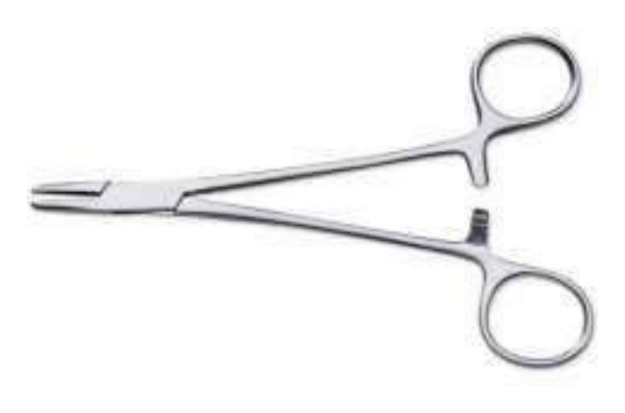  Identify the image:
Type | multiple_choice
Option | Needle holder
Option | Straight artery forceps
Option | Mosquito artery forceps
Option | Allies forceps
Answer | 3
Solution | Rationale: Mosquito Artery Forceps (Mosquito Hemostat): Small, fine-tipped hemostatic forceps with serrated jaws. Used to clamp small bleeding vessels during surgery. Has a ratchet locking mechanism. Key Clues: Small, fine-tipped, serrated jaws, ratchet lock Why Not Others: A-Needle holder has smooth jaws; B-Straight artery forceps is larger; D-Allis forceps has teeth Exam Trap: Mosquito vs Kelly - mosquito is smaller (fine vessels), Kelly is larger (medium vessels) PNC Pearl: Mosquito forceps: Smallest hemostat. For small vessel clamping. Never use to hold tissue - causes crush injury. Always check ratchet function.
Positive Marks | 1
Negative Marks | 0.33

Question | 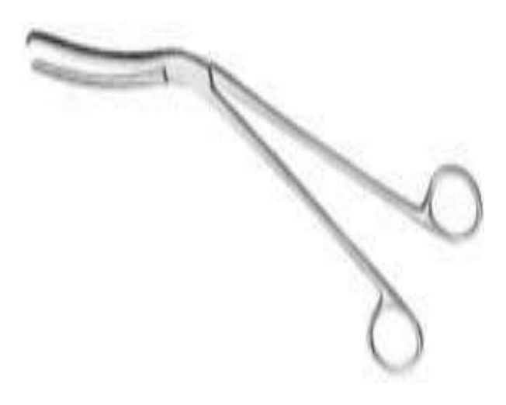  Identify the image:
Type | multiple_choice
Option | Green armytage forceps
Option | Cheatle forceps
Option | Kocher forceps
Option | Vulsellum forceps
Answer | 1
Solution | Rationale: Green-Armitage Forceps: Heavy, robust forceps with serrated jaws used for grasping tough tissue. Commonly used in thoracic and ENT surgery for removing tissue and foreign bodies. Key Clues: Heavy serrated jaws, ring handles, robust construction Why Not Others: B-Cheatle is for sterilizing instruments; C-Kocher has toothed tips; D-Vulsellum is for cervix Exam Trap: Green-Armitage vs Kocher - Green-Armitage has serrated jaws, Kocher has toothed tips PNC Pearl: Green-Armitage: Named after surgeon Green-Armitage. Essential in thoracotomy sets. Strong grip prevents tissue from slipping.
Positive Marks | 1
Negative Marks | 0.33

Question | 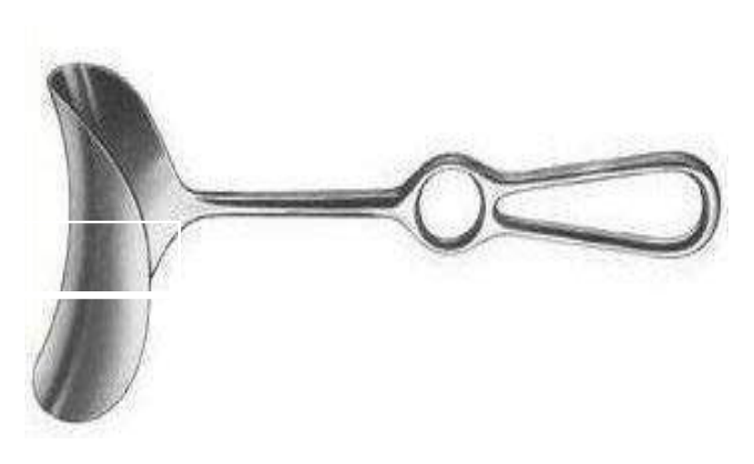  Identify the image:
Type | multiple_choice
Option | Doyen retractor
Option | Langenbeck retractor
Option | Parker retractor
Option | Kelly retractor
Answer | 2
Solution | Rationale: Langenbeck Retractor: An L-shaped handheld retractor with a flat blade and angled handle. Used for retracting superficial to moderate depth incisions, especially in orthopedic and general surgery. Key Clues: L-shaped, flat blade, handheld, angled handle Why Not Others: A-Doyen has curved serrated blade; C-Parker is a self-retaining retractor; D-Kelly is smaller Exam Trap: Langenbeck vs Richardson - Langenbeck is L-shaped, Richardson is larger with deeper blade PNC Pearl: Langenbeck: One of the most common retractors in general surgery. Available in various sizes. Named after German surgeon Bernhard Langenbeck.
Positive Marks | 1
Negative Marks | 0.33

Question | 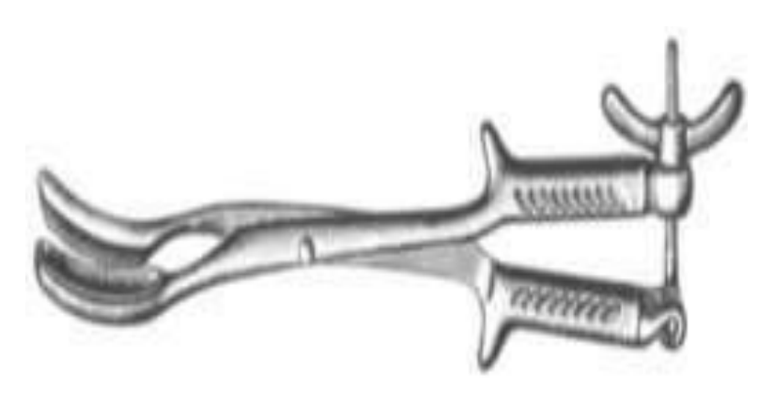  Identify the image:
Type | multiple_choice
Option | Simpson forceps
Option | Adson bayonet forceps
Option | Cranioclast
Option | Murphy retractor
Answer | 3
Solution | Rationale: Cranioclast: A heavy-duty instrument used in obstetrics to grasp and extract the fetal head during difficult deliveries, particularly after fetal demise. It is applied to the fetal skull. Key Clues: Heavy, strong jaws, used in obstetrics for fetal head Why Not Others: A-Simpson forceps is for normal delivery; C-Adson bayonet is neurosurgery; D-Murphy retractor is abdominal Exam Trap: Cranioclast vs obstetric forceps - cranioclast is used after fetal demise, forceps for live birth PNC Pearl: Cranioclast: Used only after fetal death for craniotomy. Has strong serrated jaws to crush and grip skull. Never used on live fetus.
Positive Marks | 1
Negative Marks | 0.33

Question | 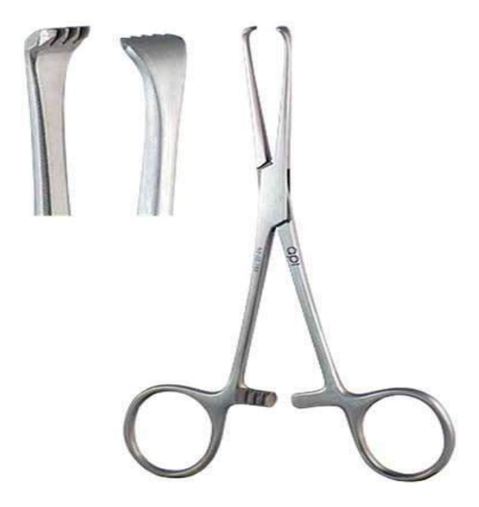  Identify the Instrument Shown in the:
Type | multiple_choice
Option | Mosquito forceps
Option | Allis forceps
Option | Mayo scissors
Option | Babcock forceps
Answer | 3
Solution | Rationale: Mayo Scissors: Heavy-duty scissors with blunt/sharp tips, used for cutting tough tissue like fascia, sutures, and heavy materials. Straight for superficial, curved for deep tissue. Key Clues: Heavy blades, blunt/sharp tips, straight or curved Why Not Others: A-Mosquito is hemostat; C-Allis grasps tissue; D-Babcock grasps delicate tissue Exam Trap: Mayo scissors vs Metzenbaum - Mayo is heavier for tough tissue, Metzenbaum is finer for delicate tissue PNC Pearl: Mayo scissors: Named after Mayo Clinic. Straight for cutting sutures/fascia at surface. Curved for deeper tissue cutting. Never use on skin.
Positive Marks | 1
Negative Marks | 0.33

Question | 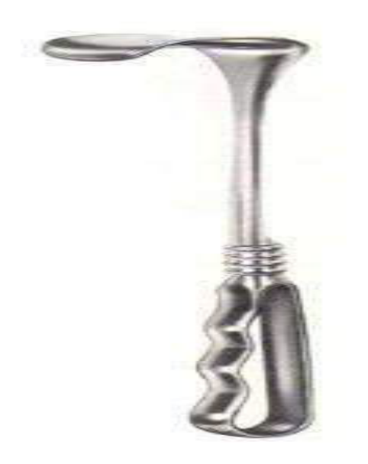  Identify the Instrument shown in:
Type | multiple_choice
Option | Doyen Retractor
Option | Deaver Retractor
Option | Goulet Retractor
Option | Richardson Retractor
Answer | 2
Solution | Rationale: Deaver Retractor: A large, flat, curved handheld retractor used for retracting deep abdominal structures. It has a broad blade for atraumatic retraction of organs like liver, intestines. Key Clues: Large, flat, curved blade, handheld, for deep retraction Why Not Others: A-Doyen has serrated blade; C-Goulet is not standard; D-Richardson has angled blade Exam Trap: Deaver vs Richardson - Deaver is flatter and wider, Richardson is narrower and deeper PNC Pearl: Deaver retractor: Essential in laparotomy. Always use with gauze padding to prevent organ damage. Named after surgeon Andrew Deaver.
Positive Marks | 1
Negative Marks | 0.33

Question | 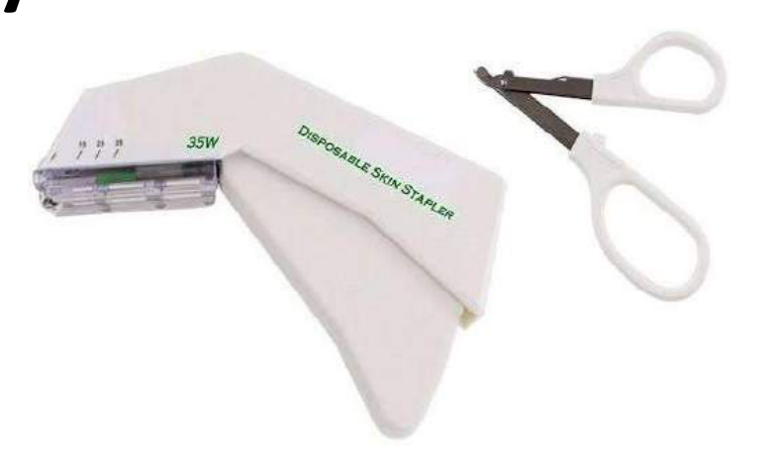  Identify the instrument shown in:
Type | multiple_choice
Option | Portable Electric Cautery
Option | Skin Stapler
Option | Biopsy Instrument
Option | None of the Above
Answer | 1
Solution | Rationale: Electrosurgical Unit (Portable Electric Cautery): A device that uses high-frequency electrical current for cutting and coagulation during surgery. Provides hemostasis during incision. Key Clues: Electrical current for cutting/coagulation Why Not Others: A-Skin stapler closes wounds;C-Biopsy instrument takes tissue;D-None is incorrect Exam Trap: Diathermy vs laser - diathermy uses electrical current, laser uses light energy PNC Pearl: Electrosurgery: Monopolar (current through patient to grounding pad) and Bipolar (current between two forceps). Monitor: grounding pad placement, fire risk, electrical burns.
Positive Marks | 1
Negative Marks | 0.33

Question | 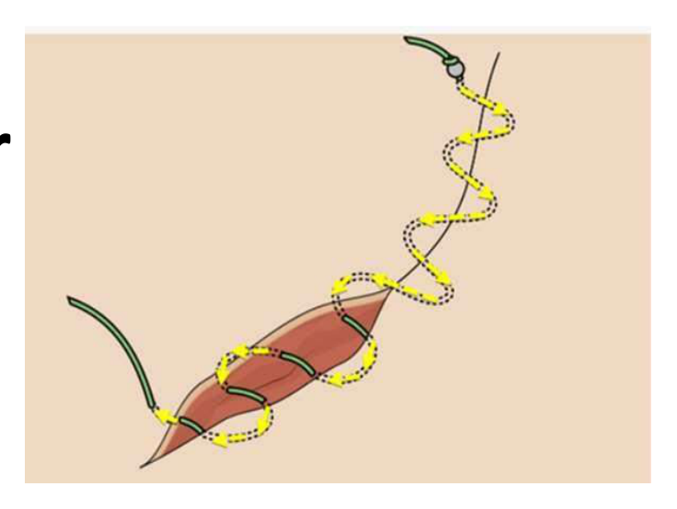  Type of Surgical suture shown:
Type | multiple_choice
Option | Simple interrupted
Option | Vertical mattress
Option | Horizontal mattress
Option | Continuous subcuticular
Answer | 2
Solution | Rationale: Vertical Mattress Suture: A suturing technique where the needle passes far-far then near-near. Provides deep tissue approximation and eversion of wound edges. Used in areas under tension. Key Clues: Far-far then near-near pattern, eversion, for tension areas Why Not Others: A-Simple interrupted is single loop;B-Horizontal mattress is side-to- side;D-Continuous subcuticular is under skin Exam Trap: Vertical vs horizontal mattress - vertical goes deep then superficial, horizontal goes parallel to wound PNC Pearl: Vertical mattress: Ideal for areas under tension (back, scalp). Everts wound edges. Good for elderly/thin skin. Remove in 10-14 days. Holds well under stress.
Positive Marks | 1
Negative Marks | 0.33

Question | 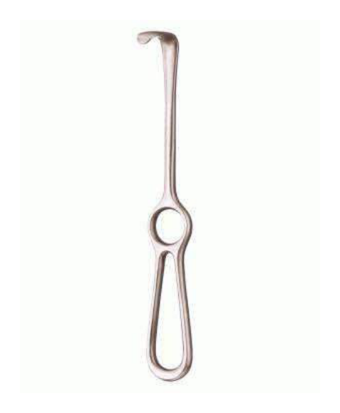  The Instrument used in surgery as shown in:
Type | multiple_choice
Option | Retract soft tissue for a temporary basis.
Option | Retract soft tissue for a permanent basis.
Option | Retract hard tissue for a temporary basis.
Option | Retract soft tissue for a permanent basis.
Answer | 1
Solution | Rationale: Self-retaining retractor: Used to retract soft tissue temporarily during surgery without requiring an assistant. Opens and locks in position to maintain wound exposure. Examples include Weitlaner, Gelpi, and Bookwalter. Key Clues: Retracts soft tissue, self-locking, temporary use Why Not Others: B-Permanent basis is incorrect; C-Hard tissue retractors are for bone; D-Permanent is incorrect Exam Trap: Self-retaining vs handheld - self-retaining stays in place, handheld needs assistant PNC Pearl: Self-retaining retractors: Weitlaner (superficial), Gelpi (orthopedic), Bookwalter (deep abdominal). Always pad to prevent pressure injury.
Positive Marks | 1
Negative Marks | 0.33

Question | 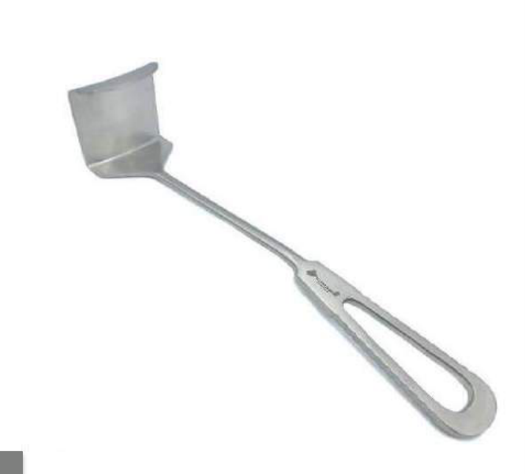  Identify the instrument used in:
Type | multiple_choice
Option | Deaver retractor.
Option | Langenbeck retractor.
Option | Morris retractor.
Option | Doyen retractor
Answer | 3
Solution | Rationale: Morris Retractor: A handheld retractor with a curved blade used for retracting superficial to moderate-depth incisions. Commonly used in general surgery, orthopedics, and emergency procedures. Key Clues: Curved blade, handheld, moderate retraction depth Why Not Others: A-Deaver is larger/deeper; C-Langenbeck is L-shaped; D-Doyen has serrated blade Exam Trap: Morris is a mid-size retractor - not as small as Army-Navy, not as large as Deaver PNC Pearl: Morris retractor: Versatile retractor used in many surgical specialties. Named after its inventor. Always retract perpendicular to wound edge.
Positive Marks | 1
Negative Marks | 0.33

Question | 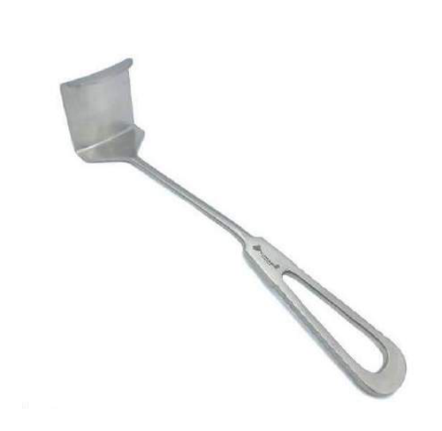  The surgical instrument shown in:
Type | multiple_choice
Option | Keep the incision open and to keep the skin
Option | Performing a caesarean delivery
Option | Work in the deep layers
Option | All of the above.
Answer | 2
Solution | Rationale: The instrument shown is used for Caesarean delivery. It is designed to keep the incision open during the procedure, allowing visualization and access to the uterus for delivery of the baby. Key Clues: Used in C-section, keeps wound open, curved for uterine access Why Not Others: A-Superficial retraction is too simple; B-Deep layers is possible but specific to C-section Exam Trap: C-section retractors are specially shaped for pelvic/uterine access PNC Pearl: C-section retractor: Finochetto or O'Sullivan-O'Conor retractor. Always ensure adequate exposure while minimizing tissue trauma.
Positive Marks | 1
Negative Marks | 0.33

