Question | 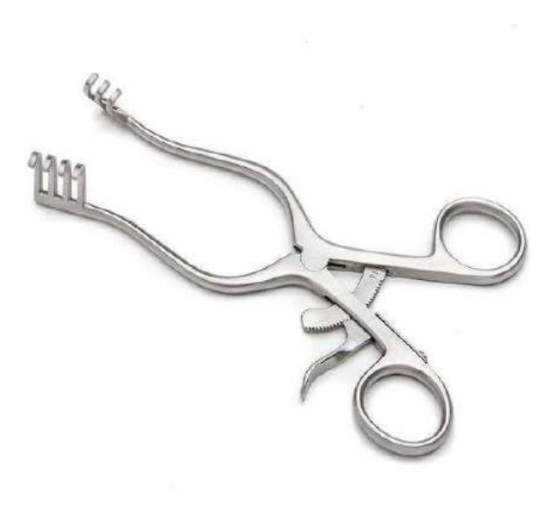  Identify the surgical instrument:
Type | multiple_choice
Option | Richardson retractor.
Option | Army-Navy retractor.
Option | Langenbeck retractor.
Option | Weitlaner retractor.
Answer | 4
Solution | Rationale: Weitlaner Retractor: A self-retaining retractor with sharp prongs that lock in position. Used for superficial to moderate retraction, commonly in orthopedic, hand, and foot surgery. Key Clues: Self-retaining, sharp prongs, locking mechanism Why Not Others: A-Richardson is handheld; B-Army-Navy is handheld double-ended; C-Langenbeck is handheld L-shaped Exam Trap: Weitlaner vs Gelpi - Weitlaner has prongs, Gelpi has hooks PNC Pearl: Weitlaner retractor: Named after Swiss surgeon. Available with sharp or blunt prongs. Popular in hand/foot surgery and wound closure.
Positive Marks | 1
Negative Marks | 0.33

Question | 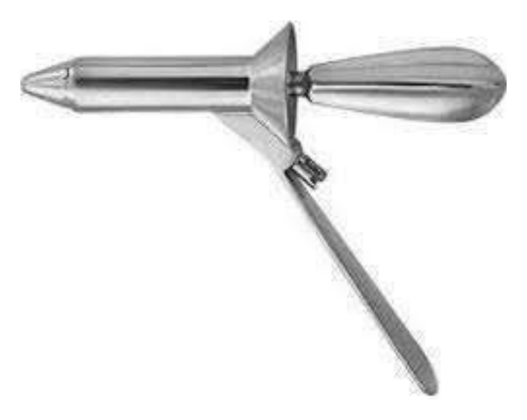  Identify the medical instrument:
Type | multiple_choice
Option | Twin clamp.
Option | Rheoscope.
Option | Payr's forcep.
Option | Proctoscope.
Answer | 4
Solution | Rationale: Proctoscope: A short, wide, conical or cylindrical instrument used for examining the anal canal and rectum. It has a light source and allows visualization, biopsy, and treatment of anorectal conditions. Key Clues: Short, wide, conical/cylindrical, used for anal/rectal exam Why Not Others: B-Twin clamp is not standard; C-Rheoscope is not standard; D-Payr forcep is for intestinal clamping Exam Trap: Proctoscope vs sigmoidoscope - proctoscope is shorter (6-8cm), sigmoidoscope is longer PNC Pearl: Proctoscope: Used for hemorrhoid banding, biopsy, and examination. Patient in left lateral (Sims) or lithotomy position. Lubricate tip before insertion.
Positive Marks | 1
Negative Marks | 0.33

Question | 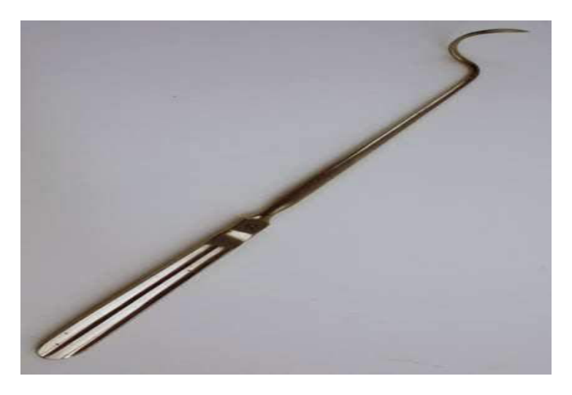  Identify the surgical instrument:
Type | multiple_choice
Option | Aneurysm needle.
Option | Satinsky Vena Cava needle.
Option | Periosteal needle.
Option | Doyen's needle.
Answer | 2
Solution | Rationale: Satinsky Vena Cava Needle/Clamp: A specialized vascular clamp/needle with angled jaws designed for partial occlusion of the vena cava during surgery. Allows controlled clamping without complete obstruction. Key Clues: Angled jaws, partial occlusion, for large veins Why Not Others: B-Aneurysm needle is for aneurysm repair; C-Periosteal is for bone; D-Doyen needle is not standard Exam Trap: Satinsky vs vascular clamp - Satinsky allows partial occlusion of large vessels PNC Pearl: Satinsky: Named after V. Satinsky. Used in cardiac and hepatic surgery for vena cava manipulation. Allows blood flow during partial clamping.
Positive Marks | 1
Negative Marks | 0.33

Question | 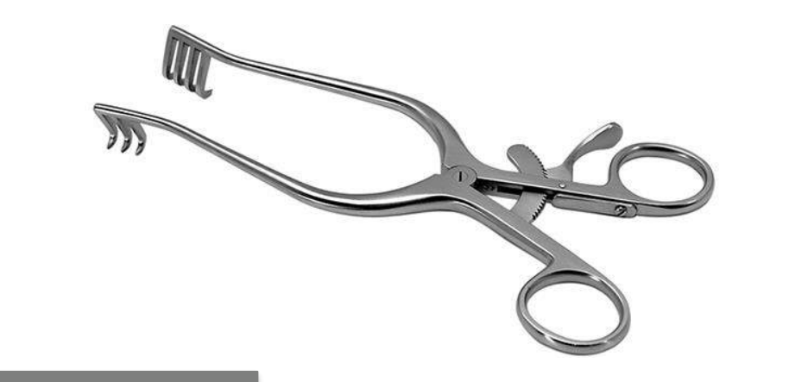  Identify the image:
Type | multiple_choice
Option | Weiltenter retractor
Option | Doyen retractor
Option | Bone retractor
Option | Grosset self retractor
Answer | 4
Solution | Rationale: Grosself Retractor (Self-Retaining Retractor): A self-retaining retractor that maintains wound exposure without an assistant. Locks in position to hold tissue edges apart. Key Clues: Self-retaining, locks in position Why Not Others: A-Weitlaner is self-retaining with prongs;C-Doyen is handheld;D-Bone retractor is specialized Exam Trap: Self-retaining retractors: Weitlaner, Gelpi, Bookwalter, Balfour - all lock in position PNC Pearl: Self-retaining retractors: Always pad edges. Monitor tissue color. Release periodically. Never leave unattended.
Positive Marks | 1
Negative Marks | 0.33

Question | 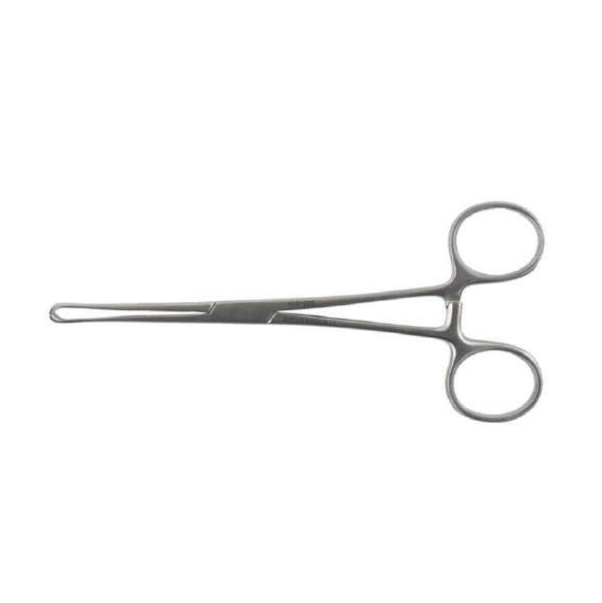  Identify the image:
Type | multiple_choice
Option | Kelley forceps
Option | Allis forceps
Option | Mayo scissors
Option | Mosquito forceps
Answer | 3
Solution | Rationale: Mayo Scissors: Heavy scissors with strong blades for cutting tough tissue (fascia, sutures, heavy material). Blunt/sharp or blunt/blunt tips. Straight for surface, curved for deep tissue. Key Clues: Heavy, strong blades, blunt tips, for tough tissue Why Not Others: B-Kelley forceps is hemostatic; C-Allis grasps tissue; D-Mosquito is small hemostat Exam Trap: Mayo scissors weight and purpose distinguish them from finer Metzenbaum scissors PNC Pearl: Mayo scissors: Named after Mayo Clinic, Rochester. Essential in every surgical set. Straight for suture cutting. Curved for tissue cutting in deep cavities.
Positive Marks | 1
Negative Marks | 0.33

Question | 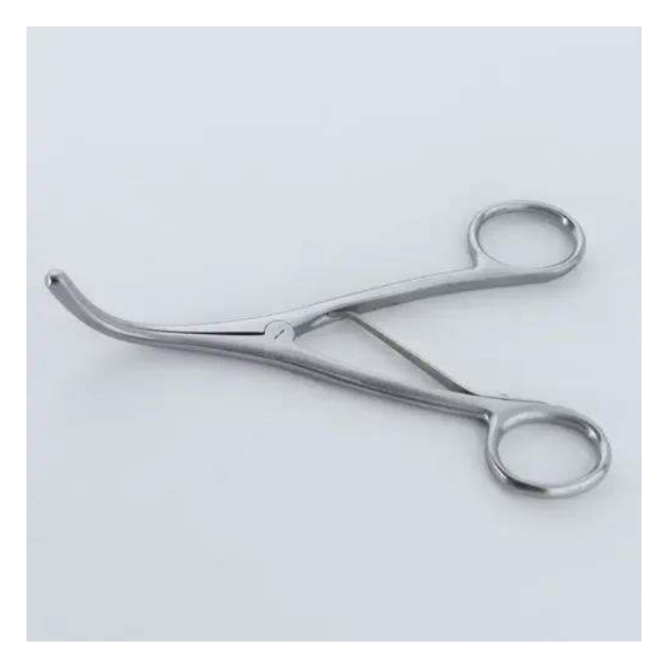  Identify the image:
Type | multiple_choice
Option | Uterine dilator
Option | Tracheal dilator
Option | Cervical dilator
Option | Uretheral dilator
Answer | 3
Solution | Rationale: Cervical Dilator (Hegar Dilator): A set of graduated metal rods used to progressively dilate the cervix. Used before D&C, IUD insertion, and other cervical procedures. Key Clues: Graduated metal rods, for cervical dilation Why Not Others: A-Uterine dilator is for uterus;C-Tracheal is for airway;D-Urethral is for urethra Exam Trap: Hegar dilator: Start small, increase gradually. Never force. Monitor for: perforation, bleeding, cervical laceration. PNC Pearl: Hegar dilator: Start small, increase gradually. Never force. Monitor for: perforation, bleeding, cervical laceration.
Positive Marks | 1
Negative Marks | 0.33

Question | 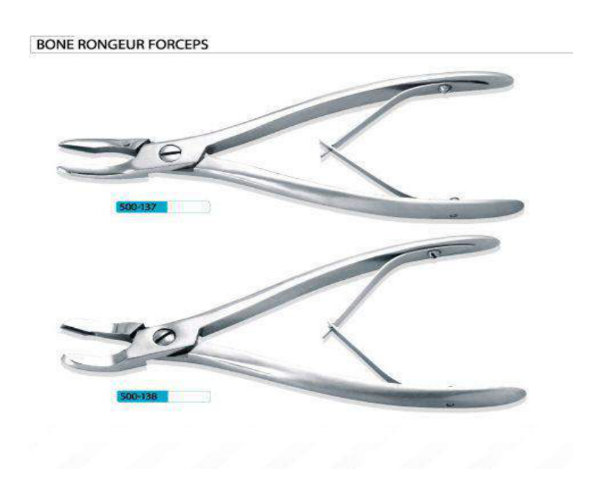  Identify the image:
Type | multiple_choice
Option | Ronguer forceps
Option | Kelley forceps
Option | Allis forceps
Option | Mosquito forceps
Answer | 1
Solution | Rationale: Rongeur Forceps: A heavy-duty biting instrument used to remove small pieces of bone or tough tissue. Has a spring mechanism and sharp cup-shaped tips. Key Clues: Heavy-duty, spring-loaded, for bone removal Why Not Others: B-Kelley is hemostatic;C-Allis grasps tissue;D-Mosquito is small hemostat Exam Trap: Rongeur vs Kerrison - both remove bone, Rongeur is larger, Kerrison is for spine PNC Pearl: Rongeur: Used in: laminectomy, craniotomy, bone trimming. Always check spring mechanism. Clean after each bite to remove tissue fragments.
Positive Marks | 1
Negative Marks | 0.33

Question | 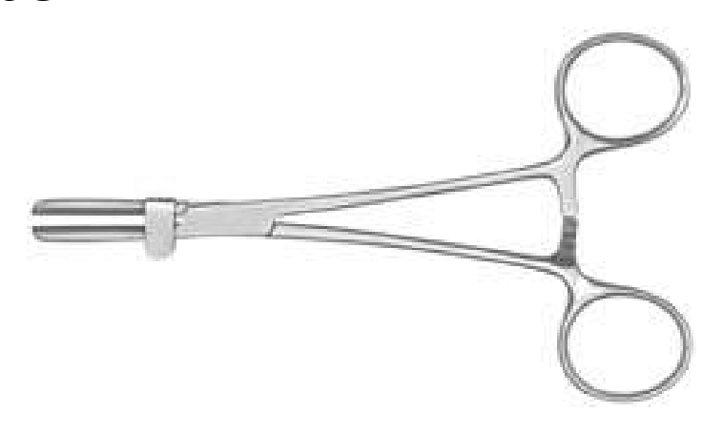  Identify the image:
Type | multiple_choice
Option | Mayo scissors
Option | Kelley forceps
Option | Allis forceps
Option | Tube occluding forceps
Answer | 3
Solution | Rationale: Allis Forceps: Tissue-grasping forceps with small teeth at the tips. Used to hold fascia, muscle, and other tough tissues during surgery. Not for delicate tissue or bowel. Key Clues: Small teeth at tips, for grasping tough tissue Why Not Others: A-Mayo scissors cut;B-Kelley clamps vessels;D-Tube occluding is different Exam Trap: Allis vs Babcock - Allis has teeth (grip firmly, may crush), Babcock is atraumatic PNC Pearl: Allis forceps: Used for grasping fascia, muscle, cervix. Never use on bowel (causes perforation). Small teeth provide firm grip. Remove before wound closure.
Positive Marks | 1
Negative Marks | 0.33

Question | 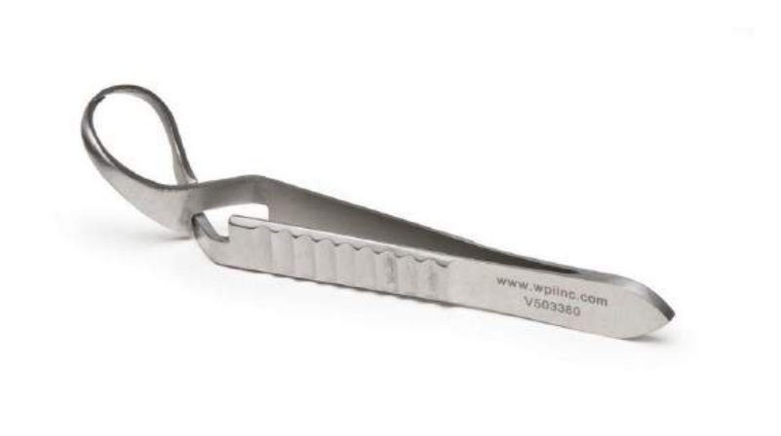  Identify the image:
Type | multiple_choice
Option | Mosquito forceps
Option | Mayo scissors
Option | Kelley forceps
Option | Jones towel clamp
Answer | 1
Solution | Rationale: Mosquito Forceps (Hemostat): Small, fine-tipped hemostatic forceps with serrated jaws. Used to clamp small bleeding vessels. Has a ratchet locking mechanism. Key Clues: Small, fine-tipped, for small vessel clamping Why Not Others: A-Mayo scissors cut;B-Kelley is larger;C-Jones towel clamp is for drapes Exam Trap: Mosquito vs Kelly - mosquito is smaller (tiny vessels), Kelly is larger (medium vessels) PNC Pearl: Mosquito forceps: Smallest hemostat available. For small vessels only. Always remove clamps when hemostasis achieved. Prolonged clamping causes tissue necrosis.
Positive Marks | 1
Negative Marks | 0.33

Question | 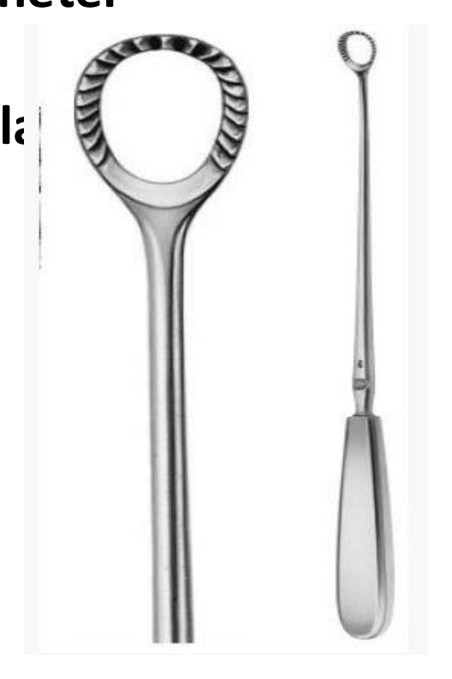  What is the following instrument used for?
Type | multiple_choice
Option | The Instrument shown is a Suction catheter
Option | The Instrument shown is a uterine Curette
Option | The instrument shown is a cervical dialator
Option | The instrument shown is used to take
Answer | 2
Solution | Rationale: The instrument shown is a uterine curette: A looped or spoon-shaped instrument used for scraping the endometrial lining during D&C (dilation and curettage) procedures. Key Clues: Loop/spoon shape, for endometrial scraping Why Not Others: B-Suction catheter is for drainage;C-Cervical dilator is for cervix;D-Takes biopsy is too vague Exam Trap: Curette vs suction - curette scrapes, suction aspirates PNC Pearl: Curette: Sharp (for D&C) or suction (for endometrial sampling). Used for: incomplete abortion, menorrhagia, endometrial biopsy. Monitor for: perforation, hemorrhage, infection.
Positive Marks | 1
Negative Marks | 0.33

Question | 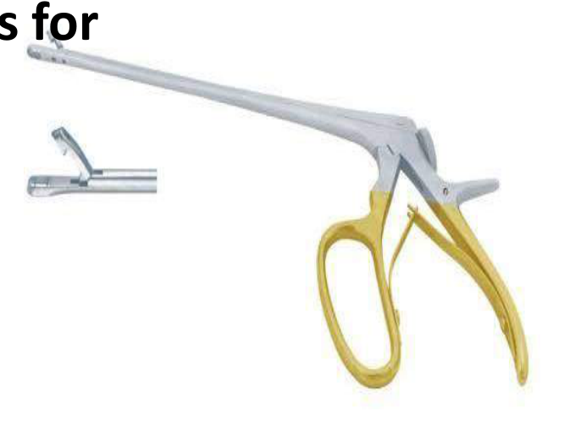  Identify the Purpose of the instrument:
Type | multiple_choice
Option | It is used to take punch biopsy from cervix
Option | It is used to tie suture in deep tissue
Option | It is used to apply Clips after surgery to seal
Option | It is used as Hemostatic forceps for
Answer | 3
Solution | Rationale: The instrument is used to apply clips after surgery to seal blood vessels. Liga clips or Hem-o-lok clips are applied with a clip applier for hemostasis. Key Clues: Apply clips for hemostasis Why Not Others: B-Punch biopsy is different;C-Tie suture is different;D-Hemostatic forceps clamps temporarily Exam Trap: Clip applier vs hemostat - clips provide permanent hemostasis, hemostats are temporary PNC Pearl: Surgical clips: Applied with clip applier. Used for: vessel ligation, tissue approximation. Types: titanium, polymer (Hem-o-lok). Monitor for clip dislodgement.
Positive Marks | 1
Negative Marks | 0.33

Question | 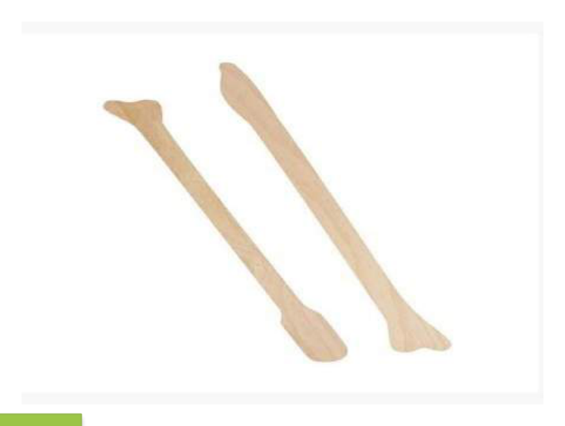  Identify the correct usage of the:
Type | multiple_choice
Option | Both of the Above
Option | it is used to take sample of
Option | It is used for PAP Smear
Option | None of above
Answer | 1
Solution | Rationale: The instrument is used for both: A) taking tissue samples and B) Pap smear. This combination makes it useful for both diagnostic procedures. Key Clues: Used for both tissue sampling and Pap smear Why Not Others: A-Takes tissue samples is correct;B-Used for Pap smear is correct Exam Trap: Both A and B are correct - C (both of the above) is the answer PNC Pearl: Pap smear and tissue sampling: Both require cervical visualization. Cervical biopsy forceps take tissue samples. Pap smear uses spatula/brush for cytology.
Positive Marks | 1
Negative Marks | 0.33

Question | 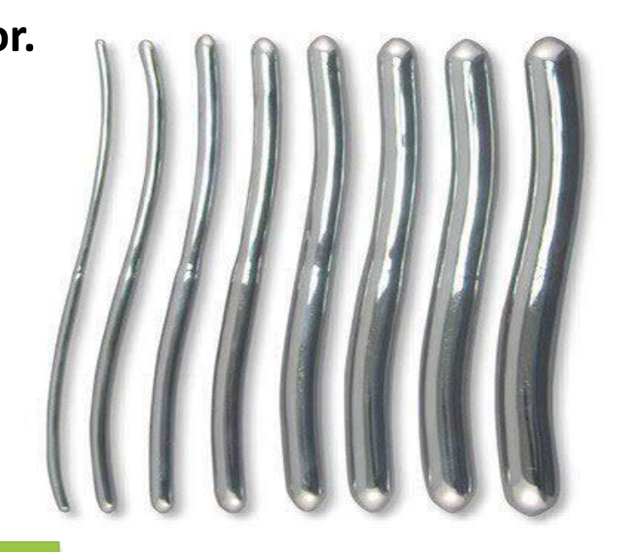  . Identify the Device/ Instrument:
Type | multiple_choice
Option | Das Cervical dilator.
Option | Hegar's Cervical dilator.
Option | Hawkin Ambler's Cervicaldilator.
Option | Female metal catheter.
Answer | 2
Solution | Rationale: Hegar's Cervical Dilator: A set of graduated metal dilators used to progressively dilate the cervix. Used before D&C, hysteroscopy, and other intrauterine procedures. Key Clues: Graduated metal rods, for cervical dilation Why Not Others: A-Das dilator is not standard;C-Hawkin Ambler is different;D-Female metal catheter is for urine Exam Trap: Hegar vs Pratt dilator - Hegar is cylindrical, Pratt is slightly tapered PNC Pearl: Hegar dilator: Sizes 1-12 (mm). Start smallest, increase gradually. Never force. Monitor for: perforation, bleeding, vasovagal response. Used under anesthesia.
Positive Marks | 1
Negative Marks | 0.33

Question | 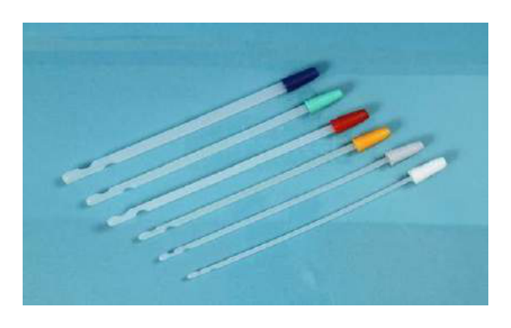  . The instrument shown below is used for:
Type | multiple_choice
Option | Dilatation and curettage
Option | Dye instillation in
Option | Fractional curettage
Option | Endometrial biopsy
Answer | 1
Solution | Rationale: Dilatation and Curettage (D&C): A procedure where the cervix is dilated and the endometrium is scraped with a curette. Used for: incomplete abortion, menorrhagia, endometrial biopsy. Key Clues: Dilation + curettage, for uterine procedures Why Not Others: A-Dye instillation is for fallopian tubes;B-Fractional curettage is cervical;D-Endometrial biopsy is sampling Exam Trap: D&C: Cervical dilatation with Hegar dilators · curettage with sharp or suction curette. Monitor: hemorrhage, perforation, infection. PNC Pearl: D&C: Cervical dilatation with Hegar dilators · curettage with sharp or suction curette. Monitor: hemorrhage, perforation, infection.
Positive Marks | 1
Negative Marks | 0.33

Question | 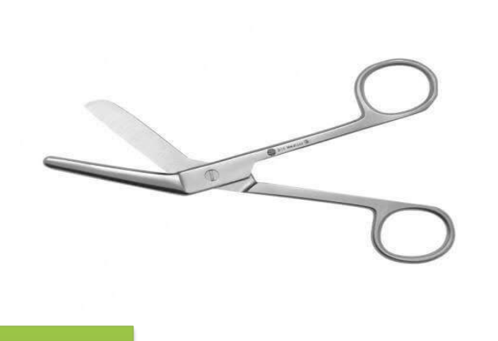  . Identify the instrument shown?
Type | multiple_choice
Option | Episiotomy scissor
Option | Ovum forceps
Option | Babcock forceps
Option | Cutting scissors
Answer | 2
Solution | Rationale: Ovum Forceps: Ring-shaped forceps used to remove products of conception (POC) from the uterus after abortion or delivery. Has oval fenestrated tips for grasping tissue. Key Clues: Ring-shaped, oval tips, for POC removal Why Not Others: A-Episiotomy scissors cut;B-Babcock grasps tissue;C-Cutting scissors are for cutting Exam Trap: Ovum forceps: Used for incomplete abortion, retained POC. Monitor: hemorrhage, perforation. Always check completeness of tissue removed. PNC Pearl: Ovum forceps: Used for incomplete abortion, retained POC. Monitor: hemorrhage, perforation. Always check completeness of tissue removed.
Positive Marks | 1
Negative Marks | 0.33

