Question | 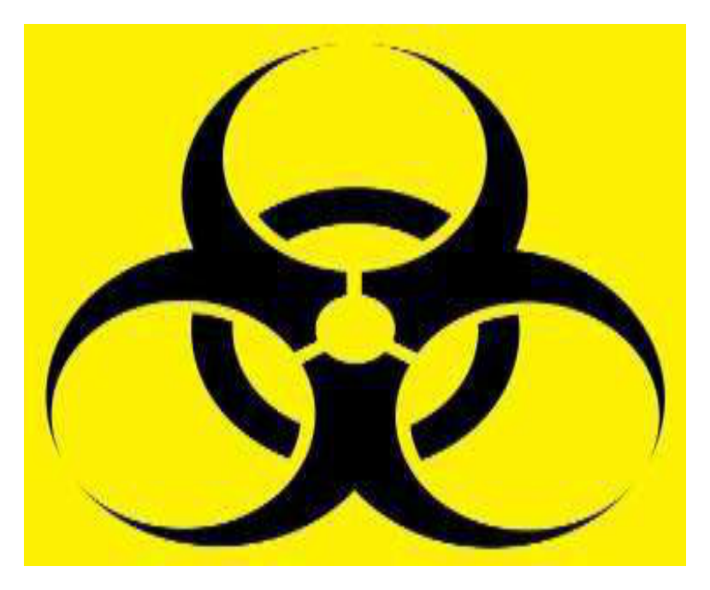  Identify the image..:
Type | multiple_choice
Option | Biohazard
Option | Cytotoxic
Option | Danger sign
Option | Radiation
Answer | 2
Solution | Rationale: Cytotoxic Symbol: Indicates materials contaminated with cytotoxic/chemotherapeutic drugs. These require special handling, disposal in yellow puncture-proof containers, and specific PPE during handling. Key Clues: Cytotoxic/chemotherapy waste symbol, special handling required Why Not Others: B-Biohazard is for infectious waste; C-Danger sign is generic; D-Radiation is for radioactive waste Exam Trap: Cytotoxic vs biohazard - cytotoxic is specifically for chemo drugs, biohazard is for infectious material PNC Pearl: Cytotoxic waste: Handle with double gloves (chemotherapy-rated), gown, mask, goggles. Dispose in yellow leak-proof, puncture-resistant containers. Never recap needles used for chemo.
Positive Marks | 1
Negative Marks | 0.33

Question |   Following symbol on drugs packet:
Type | multiple_choice
Option | Keep away from sunlight
Option | Keep away from children
Option | Do not re-use
Option | Keep dry
Answer | 3
Solution | Rationale: Drug Symbol: The symbol shown indicates "Do not re-use" - single-use only. This applies to syringes, vials, and other medications that must be discarded after single use to prevent contamination and infection. Key Clues: Single-use symbol, do not reuse Why Not Others: B-Sunlight symbol is different;C-Child safety symbol is different;D-Dry symbol is different Exam Trap: Do not reuse vs keep from children - different symbols with different meanings PNC Pearl: Drug symbols: Learn all ISO symbols. Do not reuse = crossed-out number 2. Keep from children = child reaching. Store below 25 degC = thermometer. Do not freeze = snowflake with cross.
Positive Marks | 1
Negative Marks | 0.33

Question |   Following symbol on drugs packet:
Type | multiple_choice
Option | Keep away from sunlight
Option | Do not re-use
Option | Keep away from children
Option | Keep dry
Answer | 1
Solution | Rationale: Drug Symbol: The symbol indicates "Keep away from sunlight" - store in a dark place. Photosensitive drugs degrade when exposed to light, reducing efficacy and potentially creating harmful degradation products. Key Clues: Sun protection symbol, store in dark Why Not Others: A-Do not reuse is different;C-Child safety is different;D-Dry is different Exam Trap: Keep from sunlight vs keep dry - sunlight symbol shows sun with line through it PNC Pearl: Light-sensitive drugs: Nifedipine, nitroprusside, amphotericin B, IV iron. Store in amber containers. Administer via light-protected tubing when possible.
Positive Marks | 1
Negative Marks | 0.33

Question |   Following symbol on drugs packet:
Type | multiple_choice
Option | Do not re-use
Option | Keep away from sunlight
Option | Keep away from children
Option | Keep dry
Answer | 3
Solution | Rationale: Drug Symbol: The symbol indicates "Keep away from children" - store in a secure location inaccessible to children. Prevents accidental poisoning and ingestion. Key Clues: Child reaching symbol, secure storage Why Not Others: A-Do not reuse;B-Sunlight;D-Dry are different symbols Exam Trap: Keep from children - shows child reaching for shelf/bottle PNC Pearl: Child safety: Store all medications in locked cabinets. Use child-resistant caps. Keep original containers. Never transfer to food containers. Common childhood poisons: paracetamol, iron, cleaning products.
Positive Marks | 1
Negative Marks | 0.33

Question |   Following symbol on drugs packet:
Type | multiple_choice
Option | Do not re-use
Option | Keep away from sunlight
Option | Keep away from children
Option | Keep dry
Answer | 4
Solution | Rationale: Drug Symbol: The symbol indicates "Keep dry" - store in a dry location away from moisture. Moisture can degrade drugs, reduce potency, and promote microbial growth. Key Clues: Moisture protection symbol Why Not Others: A-Do not reuse;B-Sunlight;C-Child safety are different Exam Trap: Keep dry - shows umbrella or droplet with line through it PNC Pearl: Moisture-sensitive drugs: Aspirin, amoxicillin, vitamin C, effervescent tablets. Use desiccants in storage. Never store drugs in bathrooms (high humidity).
Positive Marks | 1
Negative Marks | 0.33

Question |   Following symbol on drugs packet:
Type | multiple_choice
Option | Do not re-use
Option | Keep away from children
Option | Keep dry
Option | Caution, consult accompanying
Answer | 4
Solution | Rationale: Drug Symbol: The symbol indicates "Caution, consult accompanying leaflet" - read the package insert before use. Provides important information about dosage, side effects, and contraindications. Key Clues: Consult information leaflet symbol Why Not Others: A-Do not reuse;C-Child safety;D-Dry are different Exam Trap: Consult leaflet - shows book/page symbol PNC Pearl: Always read drug leaflet: Check dose, frequency, route, side effects, contraindications, interactions. Especially important for OTC medications and new prescriptions.
Positive Marks | 1
Negative Marks | 0.33

Question | 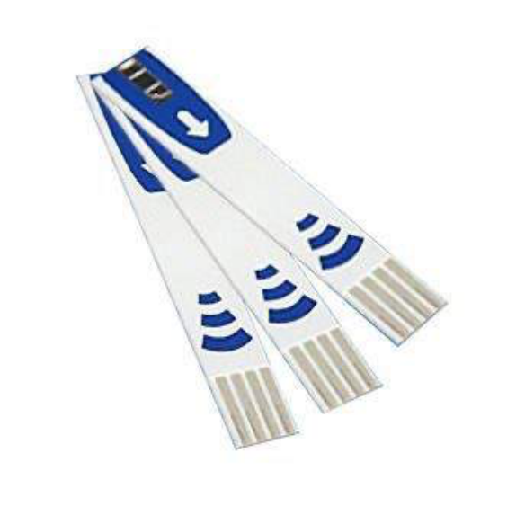  Given strips should be discarded in which of:
Type | multiple_choice
Option | Yellow
Option | Red
Option | White
Option | Blue
Answer | 1
Solution | Rationale: The given strips should be discarded in Yellow biohazard bag. Yellow bags are used for infectious waste that poses risk of infection (e.g., used dressings, catheters). Key Clues: Yellow biohazard bag for infectious waste Why Not Others: B-Red is for highly infectious;C-White is for sharps;D-Blue is for pharmaceutical Exam Trap: BMW color coding: Yellow=infectious, Red=highly infectious, White/Blue=sharps/pharma PNC Pearl: BMW guidelines: Yellow = infected waste. Red = highly infectious/radioactive. White = sharps. Blue = pharmaceutical. Always segregate at point of generation.
Positive Marks | 1
Negative Marks | 0.33

Question | 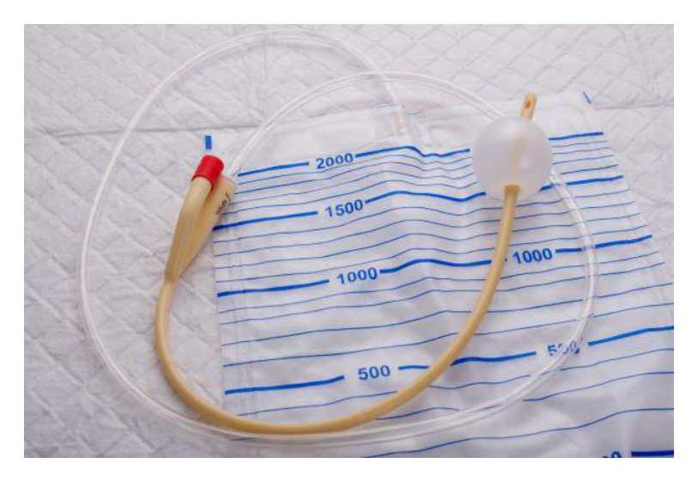  The given should be discarded according to BMW in:
Type | multiple_choice
Option | Red
Option | Yellow
Option | White
Option | Blue
Answer | 2
Solution | Rationale: The given item should be discarded according to BMW (Biomedical Waste Management) in Yellow bag. Yellow is for infectious waste including dressings, swabs, and contaminated materials. Key Clues: Yellow bag for infectious waste Why Not Others: B-Red is for highly infectious;C-White is for sharps;D-Blue is for pharma Exam Trap: Yellow bag: Infected waste, contaminated items, cultures, samples. Handle with PPE. Segregate at point of use. PNC Pearl: Yellow bag: Infected waste, contaminated items, cultures, samples. Handle with PPE. Segregate at point of use.
Positive Marks | 1
Negative Marks | 0.33

Question |   The given syringe should be discarded in?
Type | multiple_choice
Option | Red bag
Option | Yellow bag
Option | White bag
Option | Blue bag
Answer | 1
Solution | Rationale: The given syringe (contaminated with blood/body fluid) should be discarded in Red bag. Red is for highly infectious waste including blood-soaked items and sharps with infectious material. Key Clues: Red bag for blood-contaminated waste Why Not Others: A-Yellow is for infectious;C-White is for sharps;D-Blue is for pharmaceutical Exam Trap: Red bag: Highly infectious waste, blood-contaminated items, laboratory waste. Requires special handling and treatment. PNC Pearl: Red bag: Highly infectious waste, blood-contaminated items, laboratory waste. Requires special handling and treatment.
Positive Marks | 1
Negative Marks | 0.33

