Question | 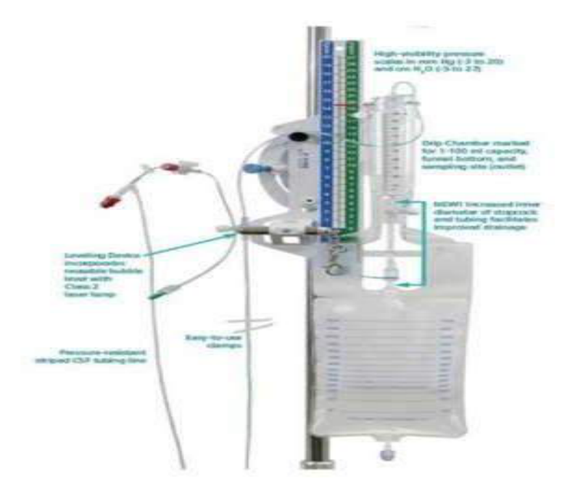  Identify the image:
Type | multiple_choice
Option | CVP set
Option | EVD set
Option | ICD set
Option | EBT
Answer | 1
Solution | Rationale: CVP Set (Central Venous Pressure Monitoring Set): A system for measuring central venous pressure through a central line. Includes manometer, stopcocks, transducer, and connecting tubing. Key Clues: Manometer/transducer, stopcocks, for CVP monitoring Why Not Others: A-EVD is for brain;B-ICD is for chest;C-EBT is for esophagus Exam Trap: CVP set vs arterial line - CVP measures venous pressure, arterial line measures arterial pressure PNC Pearl: CVP: Normal 2-6 mmHg. Measured at phlebostatic axis (4th ICS, mid-clavicular line). Use zero reference. Measure at end-expiration. Interpret: Low = hypovolemia, High = fluid overload/cardiac tamponade.
Positive Marks | 1
Negative Marks | 0.33

Question | 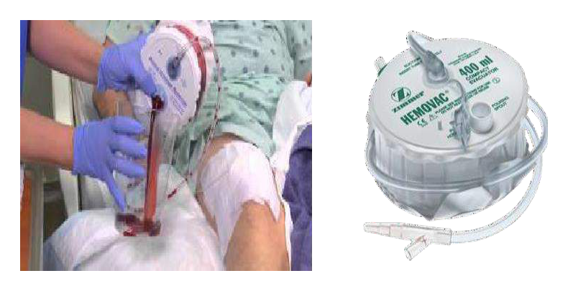  Identify the image:
Type | multiple_choice
Option | Removac drain
Option | J P drain.
Option | Penrose drain
Option | Devol drain.
Answer | 2
Solution | Rationale: JP Drain (Jackson-Pratt Drain): A closed suction drain with a silicone tube connected to a compressible bulb. Used post-operatively to remove fluid from surgical wounds. Creates negative pressure to drain fluid. Key Clues: Silicone tube, compressible bulb, closed suction Why Not Others: B-Removac is similar but uses different mechanism;C-Penrose is open passive drain;D-Devon drain is not standard Exam Trap: JP vs Penrose - JP is closed suction (active), Penrose is open passive drain PNC Pearl: JP drain: Empty and measure output q shift. Squeeze bulb to create suction. Record color/amount (serosanguinous normal first 48h, then clears). Never strip drain. Report >100ml/hr bright red.
Positive Marks | 1
Negative Marks | 0.33

Question | 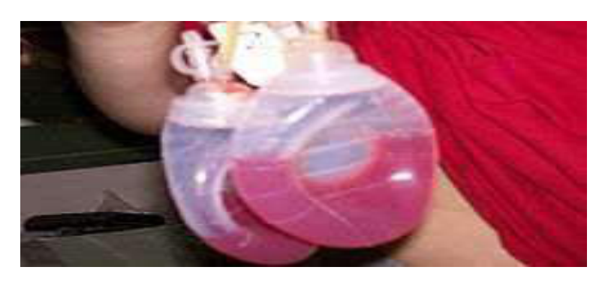  Identify the image:
Type | multiple_choice
Option | J P drain.
Option | Removac drain
Option | Penrose drain
Option | Devol drain.
Answer | 2
Solution | Rationale: Removac Drain (Hemovac Drain): A closed suction drain with a spring-loaded circular container that creates negative pressure. Used post-operatively for wound drainage, especially in orthopedic and breast surgery. Key Clues: Circular spring-loaded container, negative pressure drain Why Not Others: A-JP uses compressible bulb;C-Penrose is open;D-Devon is not standard Exam Trap: Removac vs JP - Removac uses spring mechanism, JP uses compressible bulb PNC Pearl: Removac/Hemovac: Twist top to activate spring and create suction. Empty when half full. Record output. Common in total joint replacement and mastectomy.
Positive Marks | 1
Negative Marks | 0.33

Question | 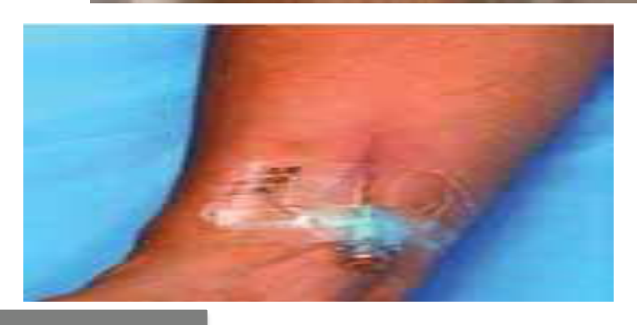  Identify the image.:
Type | multiple_choice
Option | Phlebitis
Option | Exravassation
Option | Infiltration
Option | Venous ulcer
Answer | 1
Solution | Rationale: Phlebitis: Inflammation of a vein, commonly caused by IV cannulation. Shows redness, warmth, pain, and swelling along the vein. Graded 0-4 based on severity. Key Clues: Vein inflammation, red/warm/painful along vein track Why Not Others: B-Extravasation is drug leakage;C-Infiltration is fluid leakage;D-Venous ulcer is on lower leg Exam Trap: Phlebitis vs infiltration - phlebitis is vein inflammation, infiltration is fluid in surrounding tissue PNC Pearl: Phlebitis grading: 0=None, 1=Mild (pain, no redness), 2=Moderate (pain + redness), 3=Severe (pain + redness + streak), 4=Suppurative. Remove IV, warm compress, elevate.
Positive Marks | 1
Negative Marks | 0.33

Question | 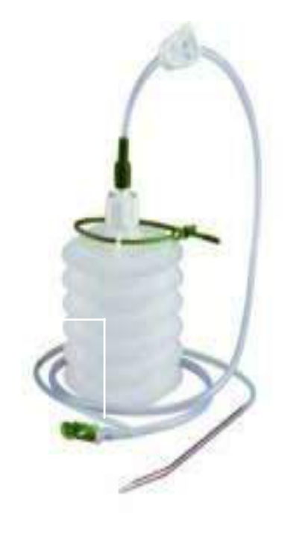  Identify the image:
Type | multiple_choice
Option | Romovac Drain
Option | Hemovac Drain
Option | Pigtail Drain
Option | Vario Drain
Answer | 3
Solution | Rationale: Pigtail Catheter: A thin, flexible catheter with a curled tip (pigtail shape) used for drainage of fluids from body cavities. Commonly used for pneumothorax, pleural effusion, and abscess drainage. Key Clues: Curled tip, flexible, for fluid drainage Why Not Others: A-Romovac is drainage system;B-Hemovac is spring-loaded;D-Vario is variable suction Exam Trap: Pigtail vs chest tube - pigtail is smaller bore, less invasive, for smaller collections PNC Pearl: Pigtail catheter: Minimal invasive drainage. Used for: pneumothorax, pleural effusion, abscess, ascites. Advantages: smaller incision, less pain, lower infection risk than large bore tubes.
Positive Marks | 1
Negative Marks | 0.33

Question | 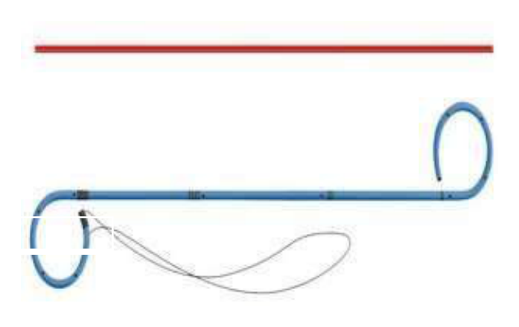  Identify the image:
Type | multiple_choice
Option | Pigtail catheter
Option | Multi loop stent
Option | Coronary stent
Option | DJ stent
Answer | 4
Solution | Rationale: DJ Stent (Double J Stent): A ureteral stent with curled ends (J-shape) at both the renal and bladder ends. Used to maintain ureteral patency after stone surgery, strictures, or obstruction. Key Clues: Double J-shaped ends, ureteral stent Why Not Others: A-Pigtail catheter has one curled end;C-Multi loop is different;D-Coronary stent is in heart Exam Trap: DJ stent vs pigtail - DJ has J-curls at BOTH ends, pigtail has curl at ONE end PNC Pearl: DJ stent: Remove cystoscopically after 4-6 weeks. Monitor for: frequency, urgency, flank pain, hematuria. Stent syndrome: bladder irritation, frequency. Encourage fluids.
Positive Marks | 1
Negative Marks | 0.33

Question | 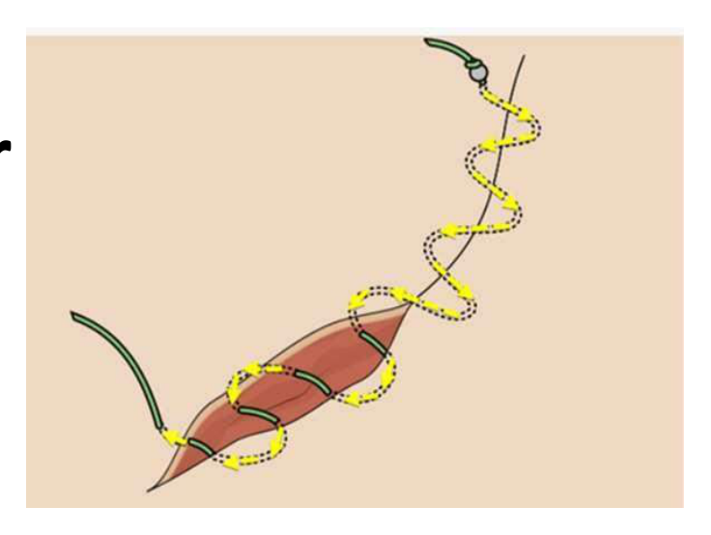  Type of Surgical suture shown:
Type | multiple_choice
Option | Simple interrupted
Option | Horizontal mattress
Option | Vertical mattress
Option | Continuous subcuticular
Answer | 3
Solution | Rationale: Vertical Mattress Suture: A suturing technique where the needle passes far-far then near-near. Provides deep tissue approximation and eversion of wound edges. Used in areas under tension. Key Clues: Far-far then near-near pattern, eversion, for tension areas Why Not Others: A-Simple interrupted is single loop;B-Horizontal mattress is side-to- side;D-Continuous subcuticular is under skin Exam Trap: Vertical vs horizontal mattress - vertical goes deep then superficial, horizontal goes parallel to wound PNC Pearl: Vertical mattress: Ideal for areas under tension (back, scalp). Everts wound edges. Good for elderly/thin skin. Remove in 10-14 days. Holds well under stress.
Positive Marks | 1
Negative Marks | 0.33

