2019 Monitoring Report of the Benthic Sampling Program for the Sacramento River Bank Protection Project

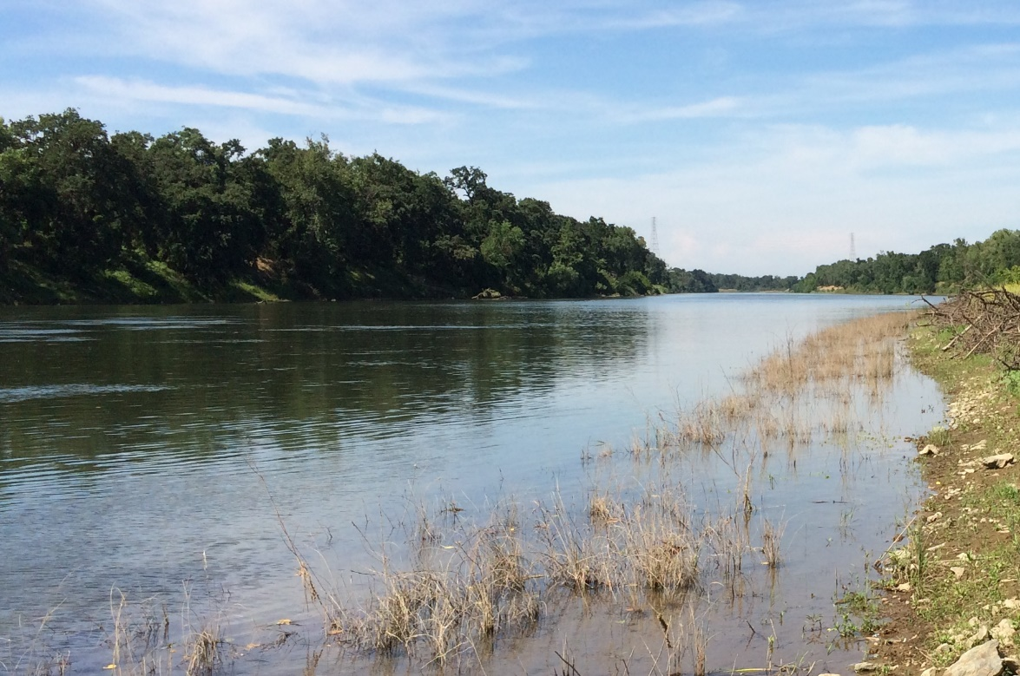

U. S. Army Corps of Engineers, Sacramento District
Environmental Planning Section
1325 J Street
Sacramento, CA 95814-2922


TABLE OF CONTENTS

1.0 INTRODUCTION 1
1.1 Authority 1
1.2 Purpose and Need 2
1.3 Location 3
1.4 Summary of Benthic Monitoring Program 3
1.5 Existing Literature on the Benthic Fauna of the Lower Sacramento 6
2.0 BENTHIC MONITORING PROGRAM METHODS 7
2.1 Benthic Sampling of the Lower Sacramento 7
2.2 Benthic Specimen Processing 7
2.2.1 Subsampling Protocol 8
2.3 Data Analysis 9
3.0 RESULTS 9
3.1 Initial Results 9
3.2 Focus on Clay-Associated Substrate and Excluding Corbicula fluminea 10
3.3 Comparison with Historical Results 12
3.4 Comparing Results with Flow Data 13
3.5 Lamprey Occurrence 14
4.0 DISCUSSION 15
4.1 Conclusions from Results 15
4.2 Data Gaps 16
4.3 Effects of a Highly Modified System 18
4.4 Considerations for Further Study 18
4.5 Informing the Green Sturgeon Habitat Mitigation and Monitoring Program 19
5.0 REFERENCES 20

LIST OF TABLES
Table 2-1. Benthic Specimen Taxonomic Identification Levels. 7
Table 3-1. Initial Results from USACE Benthic Sampling of the Lower
Sacramento River, Sorted by Sampling Event. 8
Table 3-2. Initial Results from USACE Benthic Sampling of the Lower
Sacramento River, Sorted by Sample Substrate Type. 9
Table 3-3. Comparison of SRBPP Benthic Sampling with Historical Results. 11
Table 3-4. Average Daily Flow for 30 Days Preceding Sampling and Associated 13
Substrate Types, Sorted by Average Daily Flow.
Table 3-5. Occurrence of Lampreys During Benthic Sampling. 13

LIST OF FIGURES
Figure 1-1. Locations of Benthic Sampling Transects Along the Lower
Sacramento River. 4
Figure 1-2. An Example of a Petite Ponar Benthic Sample Grabber. 4
Figure 1-3. Benthic Sampling Transects of the Sacramento River at River
Mile 55 and River Mile 55.2. 4
Figure 3-1. Fresh Benthic Sample with Clay-Associated Substrate. 10
Figure 3-2. Fresh Benthic Sample with Sandy Substrate and C. fluminea. 10
Figure 3-3. Proportion of Samples Containing No Benthic Fauna; Containing Only 10
C. fluminea; and Containing Benthic Macroinvertebrate (BMI).
Figure 3-4. Benthic Macroinvertebrate Density vs. Flow 12

1.0 INTRODUCTION

1.1 Authority
The Sacramento River Bank Protection Project (SRBPP) was originally authorized by Section 203 of the Flood Control Act of 1960 (Public Law 86-654, 74 Stat. 498) to provide protection to the existing levee and flood control facilities of the Sacramento River Flood Control Project. Under SRBPP, the U.S. Army Corps of Engineers, Sacramento District (USACE) was authorized by the Federal government to construct bank stabilization and setback levees. The State of California-funded Central Valley Flood Protection Board (CVFPB) is the local sponsor for SRBPP. The Corps in conjunction with its non-Federal sponsor, the CVFPB, is responsible for implementation of SRBPP.
Benthic monitoring for SRBPP is necessitated by Terms and Conditions outlined by several Biological Opinions (BOs) issued by the National Marine Fisheries Service (NMFS). Specifically, NMFS issued a BO dated 18 May 2018 for the SRBPP at Sacramento River Mile (SAC) 16.8 (NMFS No: WCR-2016-4550). On page 56, §2.9.4 (Terms and Conditions), subsection 1, paragraph f states in part:
The USACE shall begin implementation of a Green Sturgeon Habitat Mitigation and Monitoring Program (HMMP). At a minimum, this shall include develop an early work plan for implementation of the HMMP elements that have been described in the NMFS 2015 BOs for the West Sacramento and American River GRRs within 60 days of receiving this BO, conducting pre- and post-project hydraulic monitoring of the action area, conducting benthic sampling in the action shall be undertaken to characterize and evaluate green sturgeon food availability, and developing and implementing a compensatory mitigation strategy for offsetting the spatial footprint of permanently lost benthic habitat that will occur as a result of project construction.
In addition, NMFS had previously issued a BO dated 04 April 2017 for the SRBPP at SAC 71.3 (NMFS No: WCR-2017-6665). On page 57, §2.9.4 (Terms and Conditions), subsection 1, paragraph f states in part:
The USACE shall begin implementation of a Green Sturgeon Habitat Mitigation and Monitoring Program (HMMP). At a minimum, this shall include developing a work plan for implementation of the HMMP elements that have been described in the NMFS 2015 BOs for the West Sacramento and American River GRRs. This work plan should a plan for conducting pre- and post-project hydraulic monitoring of the action area, conducting benthic sampling in order to evaluate green sturgeon food availability, and developing a compensatory mitigation strategy for offsetting the spatial footprint of permanently lost benthic habitat that will occur as a result of project construction… Benthic sampling and green sturgeon diet studies shall be conducted in collaboration with the Interagency Ecological Program (IEP).
NMFS issued a BO dated 16 October 2017 for the SRBPP at SAC 71.3 (NMFS No: WCR-2017-7990). On page 38, §2 .9.4 (Terms and Conditions), subsection 1, paragraph f is identical to that corresponding paragraph found in NMFS No: WCR-2017-6665. Lastly, a BO was issued July 25, 2019 for Feather River Mile 1.0 Left Bank Erosion Repair Site (NMFS No: WCR-2018-9430). On page 107, §2.9.4 (Terms and Conditions), subsection 1, paragraph f is identical to that corresponding paragraph found in NMFS No: WCR-2017-6665 and WCR-2017-7990.
Thus, compliance with the terms and conditions as outlined in these NFMS documents stipulates that USACE develop a benthic monitoring program and subsequently conduct benthic monitoring.

1.2 Purpose and Need
The southern distinct population segment (sDPS) of green sturgeon (Acipenser medirostris) was listed as a federally threatened species in June, 2006 (71 FR 17757) and critical habitat for the green sturgeon sDPS was designated in October, 2009 (74 FR 52300), which includes the Sacramento River and Sacramento-San Joaquin Delta.
Bank stabilization and levee repair in the lower Sacramento as authorized to and conducted by SRBPP includes the introduction of significant amounts quarry stone revetment within the river itself. During environmental consultation between USACE and NMFS for the American River Common Features project (a different project than the SRBPP, but with similar bank stabilization and levee repair features), NMFS noted that the methods and models used by USACE to assess affects and impacts on other federally listed fisheries species (notably salmon and steelhead) had significant shortcomings for “reliably forecasting the growth and survival of green sturgeon” (NMFS No: WCR-2014-1377). This was because the model used for salmon and steelhead, the Standard Assessment Methodology, examines impacts at the seasonal riparian interfaces, and does not assess impacts to the benthos.
NMFS stated that USACE shall submit a development proposal for a green sturgeon habitat mitigation and monitoring plan (HMMP), saying that the HMMP “should focus on filling important data gaps on green sturgeon life history and micro and macro habitat ecology in both the Sacramento River and the north Delta within the project impact area, in regard to how bank stabilization measures … affect sturgeon ecology and survival, particularly in regard to juvenile rearing and survival.” NMFS stated that USACE shall refine or develop a “green sturgeon survival and growth response model … that reflects green sturgeon’s preference for benthic habitat and that accounts for the physical loss of habitat from revetment footprints…” (NMFS No: WCR-2014-1377).
One such data gap identified by NMFS in their BO for American River Common Features was that of green sturgeon diet. Mention is made of a decades-old study (Radtke, 1966) wherein juvenile green sturgeon in the Delta had their stomach contents inspected (findings were of shrimps and amphipods), but aside from that, “No additional information is available regarding the diet of sDPS green sturgeon in the wild, but they are presumed to be generalist, opportunistic benthic feeders” (NMFS No. WCR-2014-1377). Benthic monitoring as conducted by SRBPP is done to identify potential food sources for green sturgeon in the lower Sacramento River benthos, and site specific monitoring will help determine localized effects on benthos at levee repair sites.

1.3 Location
We conduct benthic monitoring along five-point transects throughout the lower Sacramento River at various river miles (RMs). Currently, we sample at RMs 15, 16.8, 25, 26, 35, 45, 55, 65, 71.3, 75, and 85. River miles ending in five were chosen to help establish what kinds of benthic communities characterize the system outside of SRBPP sites. RMs 16.8, 26, and 71.3 were chose because they are specific to SRBPP sites. All these sites can be viewed on a map provided in Figure 1-1.
Along each five-point transects, two petite ponar drops are conducted at each point within a given transect to help reduce aberrations in data. For instance, one drop may initially return little or no substrate, but the second drop may yield significantly different results. An example of a petite ponar can be seen in Figure 1-2. Examples of five-point, ten-drop transects can be seen in Figure 1-3, which shows the drop points for several sampling events for both RM 55 and the nearby RM 55.2.

1.4 Summary of Benthic Monitoring Program
Benthic monitoring is conducted to increase our knowledge about the benthic fauna in the lower Sacramento River and to inform USACE on benthic habitat conditions near Sacramento River Bank Protect Project (SRBPP) sites as they pertain to green sturgeon (Acipenser medirostris).
Benthic sampling was first conducted for USACE on the lower Sacramento River in 2015 from river mile 43.7 to RM 74.0. A report that details the results of the sampling event was prepared by FISHBIO in August of 2015.
Following that, USACE biologists conducted minor benthic sampling events in July and August of 2016, to help familiarize them with the task. In September of 2016, a five transect sampling of RM 71.3 – where the SRBPP had a potential project site, now since constructed – was also conducted. This was done to characterize the benthos upstream and downstream of the potential project site.
Sampling of the lower Sacramento River by USACE began in earnest in November of 2016, when USACE biologists sampled nine transects between RM 15 and RM 85 (RMs 15, 16.8, 25, 26, 45, 55, 65, 75, and 85). In August 2017, USACE biologists again sampled the lower Sacramento, this time also sampling RM 35, RM 55.2, and RM 71. In November 2017, USACE biologists sampled the same points as from August 2017, but neglected to sample RM 55. In March 2018, USACE biologists sampled the same points as from August 2017, but neglected to sample RM 55.2.
The transects every ten RMs from RM 15 to RM 85 establish baseline conditions for the benthic communities throughout the lower Sacramento River, that is, they help establish context for the benthic sampling conducted at project sites. Monitoring every ten RMs characterizes the benthos and benthic communities throughout the reach, ensuring that no project site will be too far from another sampling location for which we have established longer-term monitoring.
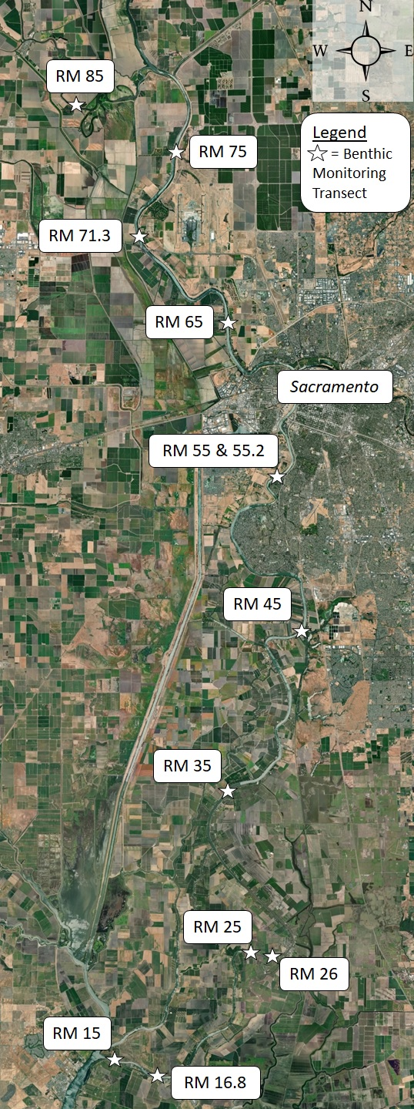
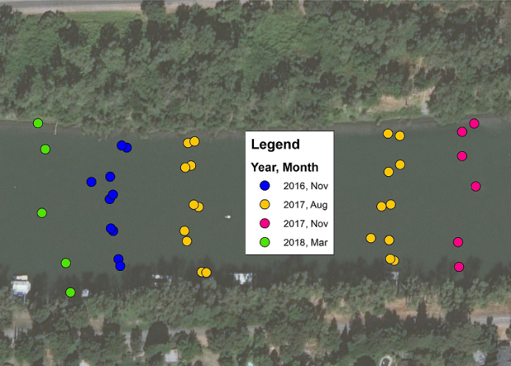
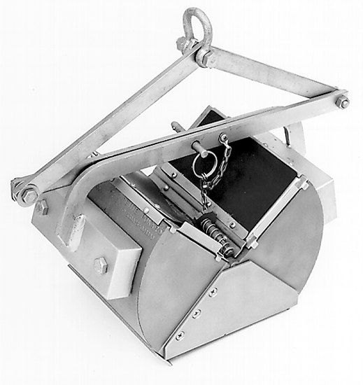
Figure 1-1. Locations of Benthic Sampling Transects Along the Lower Sacramento River.
Figure 1-3. Benthic Sampling Transects of the Sacramento River at River Mile 55 and River Mile 55.2.
Figure 1-2. An Example of a Petite Ponar Benthic Sample Grabber.
Benthic samples were processed by USACE biologists who are familiar with benthic fauna, or were otherwise trained and supervised by said USACE biologists. Data gleaned from processing the benthic samples was then analyzed to detect any existing correlations between benthic fauna and environmental conditions/variables.

1.5 Existing Literature on the Benthic Fauna of the Lower Sacramento
Scientific literature regarding benthic macroinvertebrates (BMI) in the lower Sacramento River is generally limited. Past studies of the area are often decades old and only look at a portion of the lower Sacramento River, or are otherwise examining other areas of the Sacramento River watershed altogether, such as wadable streams. Siegfried et al. (1980) studied the benthos of the river below Rio Vista, i.e. in the delta, and only during one dry year, 1976 – although even then researchers found that the benthic community was dominated in part by the freshwater clam Corbicula fluminea. Herbold and Moyle (1989) profiled the entire ecological community of the Sacramento-San Joaquin Delta, including the benthos, but again this study is by now a bit dated and was limited to the delta. Brown and May (2000) examined BMI assemblages in the Sacramento and San Joaquin watersheds but focused on sampling in tributaries and collected their samples from woody debris. Nelson and Lieberman (2002) sampled benthic invertebrates in the Sacramento River itself, but only above Chico. Rehn et al. (2008) produced a technical report for the California Water Board’s Surface Water Ambient Monitoring Program that developed an index of biotic integrity (IBI) for the Central Valley (by examining the results of 11 benthic sampling studies conducted over the previous 14 years) without the use of reference sites. However, this IBI was developed using data and sampling from studies conducted in wadable streams in the Central Valley. In 2015, fisheries consultant FISHBIO conducted a benthic fauna assessment of the Sacrament River from river mile (RM) 43.7 to RM 74.0, on behalf of USACE (Peterson, 2015). Peterson found C. fluminea to be the most prevalent species in the sampling, followed by annelids and dipterans, with other taxa observed infrequently.
In developing an IBI for the Central Valley, Rehn et al. (2008) also succinctly described the serious difficulties and obstacles to performing an accurate bioassessment in the Central Valley’s waterways:
Bioassessment is increasingly used throughout California by water quality monitoring programs, but in the Central Valley bioassessment is more challenging than in other regions of the state because the entire landscape and most streams are highly altered by human activities such as urbanization, agriculture and water diversions. This makes it impossible to evaluate how BMIs respond across a complete gradient of human disturbance within the region, that is, from minimally disturbed reference sites where human activity is absent or minimal and which therefore set the benchmark for biological expectations, to the most altered sites with degraded biology. In the Central Valley, minimally disturbed reference sites are no longer available. Even the ‘least-disturbed’ sites, which represent the best-available chemical, physical and biological habitat conditions given the current state of the landscape, are markedly disturbed.

2.0 BENTHIC MONITORING PROGRAM METHODS

2.1 Benthic Sampling of the Lower Sacramento
USACE conducts benthic monitoring along the lower Sacramento River at various RMs. Currently, we sample at RMs 15, 16.8, 25 ,26, 35, 45, 55, 65, 71.3, 75, and 85. River miles ending in five were chosen to help establish what kinds of benthic communities characterize the system outside of SRBPP sites. River miles 16.8, 26, and 71.3 were chose because they are specific to SRBPP sites.
Each location is sampled at five points along an imaginary line which transects of the river perpendicular to its direction of flow. Along these five-point transects, two petite ponar drops are conducted at each point along to help reduce aberrations in data. For instance, one drop may initially return little or no substrate, but the second drop may yield significantly different results. Failed deployments of the ponar (e.g., the ponar failed to close upon hitting the river bottom, or debris kept the ponar from closing completely) result in a redeployment of the ponar.
The ponar samples a six inch by six inch section of the river bottom, and has a closed volume of 2.4 liters. Geographic coordinates are recorded for each drop site. Once the ponar is retrieved, it is emptied onto screen classifiers to sift through any collected substrate and remove any potential invertebrates or detritus that may house invertebrates. The substrate recovered from the ponar sample is recorded as being either clay (meaning a substrate made up of clay-sized particles, not clay exclusively), sand, gravel, or some combination thereof, or nothing (indicating a ponar sample that was empty of substrate). If any vertebrates are noticed at the time of collection, their presence is documented, but not generally counted at this time. Any collected organisms or detritus is placed into labelled sample jars and filled with 90% ethanol for preservation.
Benthic sampling of the lower Sacramento River has not occurred with regular periodicity, but the plan moving forward is to sample the river in March and November of each year. Future modifications to the benthic monitoring program may be made, and would be annotated in future reports. Further development of the green sturgeon habitat mitigation and monitoring program could impact the future implementation of SRBPP benthic monitoring.

2.2 Benthic Specimen Processing
Benthic samples are processed by USACE biologists who are either familiar with benthic fauna or have otherwise undergone familiarization training. Benthic invertebrates are identified down to various taxonomic levels as described in Table 2-1.
Samples are processed with the aid of a dissecting microscope and identification guides tailored to identifying the benthic fauna of the lower Sacramento River. Once picked through, the samples are returned to their jars until district quality control (DQC) can be performed on a subset of the samples. For DQC, 10% of the specimen jars are selected at random and then re-examined by pre-assigned DQC personnel to check the veracity of previous specimen processing efforts.
Despite using classifiers when collected the samples from the river, some samples still have a great amount of detritus contained within them. Other samples have great amounts of detritus. In either case, processing the sample normally was too time consuming given the time constraints placed on USACE biologists. Such samples instead underwent a subsampling protocol treatment.
Table 2-1. Benthic Specimen Taxonomic Identification Levels.
Taxonomic Level | Taxa Identified
Phylum/Subphylum | Platyhelminthes (Flatworms)  Nematodes
Class/Subclass | Oligochaeta  Hirudinea (Leeches)  Polychaeta (Bristle worms)  Gastropoda (Snails)
Order | Amphipoda  Odonata (Dragonflies/Mayflies)  Coleoptera (Beetles)  Diptera (Flies)  Ephemeroptera (Mayflies)  Plecoptera (Stoneflies)  Trichoptera (Caddisflies)
Species | Corbicula fluminea

2.2.1 Subsampling Protocol
The subsampling protocol for SRBPP benthic monitoring was developed and adapted from the Surface Water Ambient Monitoring Program’s Standard Operating Procedures for Laboratory Processing and Identification of Benthic Macroinvertebrates in California (Woordward et al., 2012).
Troublesome samples which are to be subsampled are first washed to decrease the amount of fine sediment contained within. The sample jar is emptied over a set a classifiers, and then is washed with water to remove whatever sediment resides in that classification layer. Any detritus which is to be discarded from the sample is first very carefully inspected for macroinvertebrates. Any remaining gravel, sand, or sediment is carefully inspected, and all macroinvertebrates are removed and returned to the sample jar. This process is repeated for each successively fine classifier layer. The jar is refilled with 90% ethanol solution and stored until the sample is to be processed.
A flat bottom tray, gridded into 12 sections with a grease pencil, were used for subsampling. Each grid measures approximately 4.1 cm by 4.6 cm (approximately 1.6 in. by 1.8 in.), and two grids are selected at random (using a random number generator) to be examined. The tallies from processing the two subsamples are combined and extrapolated to give an approximate value of the entire sample’s benthic fauna.
After washing, some samples are clean and simple enough to be processed normally, i.e., without subsampling. This has been preferred to subsampling, especially if the sample jar contains relatively few macroinvertebrates, thus leaving a subsample of that jar vulnerable to data anomalies.

2.3 Data Analysis
Data are recorded by hand during both sampling events on the water and during benthic specimen processing and microscopy. Datasheets are reviewed for clarity, anomalies, and mistakes, with any issues dealt with quickly and discussed.
Data collected from sampling events and specimen processing are combined and entered into spreadsheets. The data are then analyzed using computer statistical packages and computer geographic information system packages, mainly R and ArcGIS, respectively.

3.0 RESULTS

3.1 Initial Results
The initial results from USACE benthic sampling events along the lower Sacramento River are detailed in Table 3-1 below.
Table 3-1. Initial Results from USACE Benthic Sampling of the Lower Sacramento River, Sorted by Sampling Event.
 | Sampling Event
 | Nov 2016 | Aug 2017 | Nov 2017 | Mar 2018 | Dec 2018 | Apr 2019
Mean BMI per m² | 441 | 734 | 1195 | 973 | 1442 | 140
Mean C. fluminea  per m² | 407 | 447 | 1054 | 468 | 1068 | 96
Percent C. fluminea | 92% | 61% | 88% | 48% | 74% | 70%
Mean BMI (ex. C. fluminea) per m² | 34 | 283 | 141 | 505 | 372 | 41
Percent BMI  (ex. C. fluminea) | 8% | 39% | 12% | 52% | 26% | 30%
As indicated by Table 3-1, the invasive clam C. fluminea makes up a majority of the BMIs found when collecting benthic samples. The exception to this was the sampling event that occurred in March 2018, when C. fluminea only contributed to 48% of all macroinvertebrates collected. The November 2017 sampling event was the high-mark for C. fluminea density.
While the initial results vary between sampling events, they vary greater when comparing samples by their associated substrate type, which was noted when the ponar was retrieved. These results are detailed in Table 3-2.
As indicated by Table 3-2, the highest densities of BMIs we found in samples that had clay-associated substrate, i.e., clay alone or sandy clay. A good example of a clay-associated sample can be seen in Figure 3-1. Sand was the dominant substrate type found throughout the sampling events, with sand alone making up 53.0% of the substrate of all samples, and sand-associated substrate (i.e., sand alone, sandy clay, or sandy gravel) characterizing 65.7% of all samples. A good example of a sand-associated sample can be seen in Figure 3-2. No substrate was the least productive in regard to BMI densities, but when C. fluminea is excluded, gravel-associated substrates were slightly less productive than no substrate.
Table 3-2. Initial Results from USACE Benthic Sampling of the Lower Sacramento River, Sorted by Sample Substrate Type.
 | Sample Substrate Type*
 | Clay | Sandy Clay | Sand | Sandy Gravel | Gravel | Nothing
№ of Samples | 89 | 40 | 368 | 32 | 6 | 103
Mean BMI per m² | 2418 | 1730 | 598 | 347 | 323 | 98.7
Mean C. fluminea per m² | 1138 | 1343 | 561 | 327 | 323 | 59.4
Mean BMI  (ex. C. fluminea) per m² | 1280 | 386 | 36.7 | 20.2 | 0.0 | 39.3
*There was also one recorded instance of clay-gravel mixed substrate returned with a sample. This categorical outlier had a BMI density of 2540 BMI per m², with 2368 of those being C. fluminea, and all other BMIs accounting for 172 BMI per m².
As indicated by Table 3-2, the highest densities of BMIs we found in samples that had clay-associated substrate, i.e., clay alone or sandy clay. A good example of a clay-associated sample can be seen in Figure 3-1. Sand was the dominant substrate type found throughout the sampling events, with sand alone making up 53.0% of the substrate of all samples, and sand-associated substrate (i.e., sand alone, sandy clay, or sandy gravel) characterizing 65.7% of all samples. A good example of a sand-associated sample can be seen in Figure 3-2. No substrate was the least productive in regard to BMI densities, but when C. fluminea is excluded, gravel-associated substrates were slightly less productive than no substrate.

3.2 Focus on Clay-Associated Substrate and Excluding Corbicula fluminea
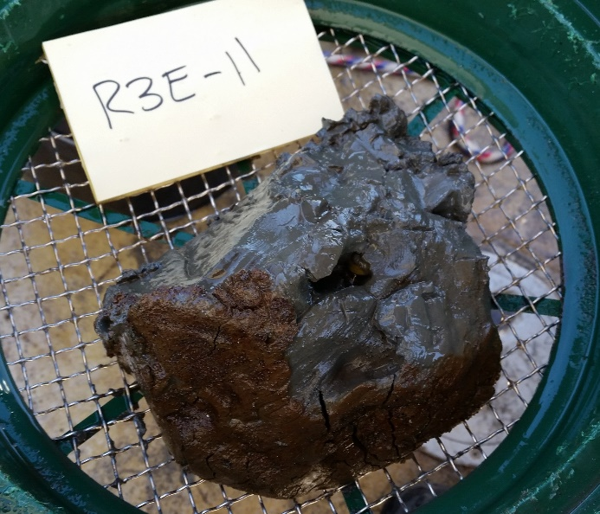
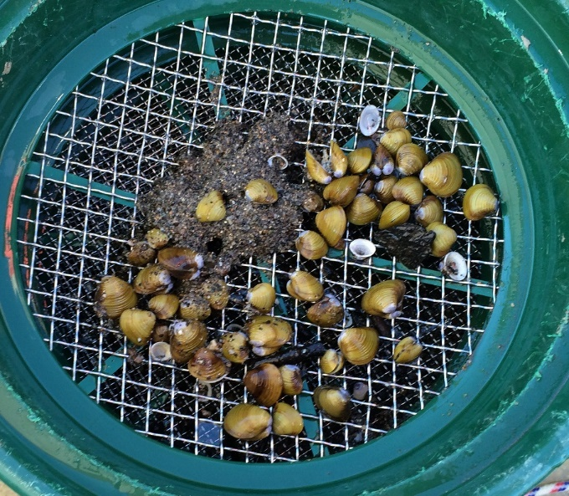
Due to the ubiquity and dominance of C. fluminea throughout the reach of study, numbers for the remaining BMIs are a bit obscured, and BMI densities are generally inflated by the inclusion of C. fluminea numbers. Although it is clear from Table 3-2 that BMI density generally increases as the substrate becomes finer, this relationship becomes even clearer when C. fluminea is excluded from consideration.
Figure 3-1. Fresh Benthic Sample with Clay-Associated Substrate.
Figure 3-2. Fresh Benthic Sample with Sandy Substrate and C. fluminea.

In Figure 3-3 below, two pie charts highlight the importance of focusing on soft substrate and excluding C. fluminea from further analysis. When examining all the benthic samples, nearly a third (33.0%) contain C. fluminea as the only organism recorded, while another 35.7% contain no BMIs at all. Less than a third (31.3%) of all samples contain some sort of BMI aside from C. fluminea. If one were merely considering whether any BMI were present in the sample, then it would initially appear that approximately two-thirds (64.3%) of all samples meet this criteria. However, it is not clear that C. fluminea are even a potential food source for A. medirostris (see Section 4.1.1), and so C. fluminea are skewing the result.
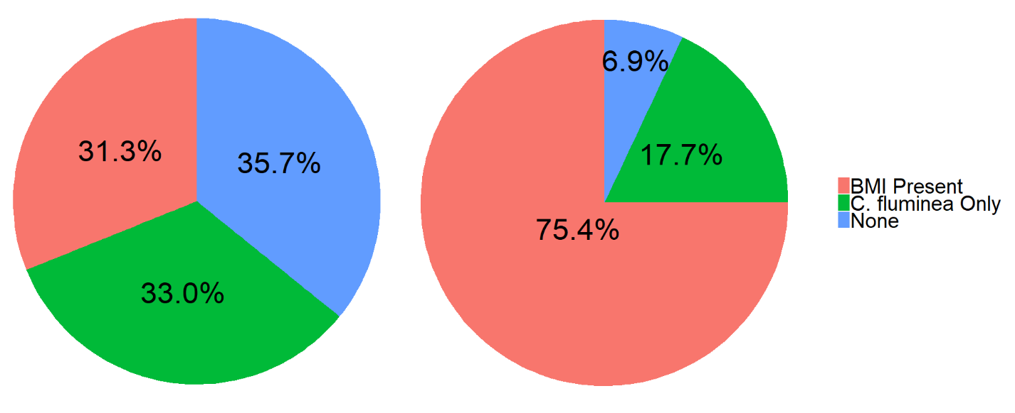
Figure 3-3. Proportion of Samples Containing No Benthic Fauna; Containing Only
C. fluminea; and Containing Benthic Macroinvertebrate (BMI).
Samples from All Substrate Types (n=639) Samples Associated with Clay Substrate Only (n=130)
Similarly, focusing on samples with clay-associated substrate produces powerful results. In this case, just over three-quarters (75.4%) of clay-associated samples had BMIs other than C. fluminea present. Samples that had only clay and clay-sized substrate (i.e., excluding samples that contained sandy clay substrate) made up just 13.9% (89 of 639) of all samples, yet contributed to 76.0% of all BMIs found over the four sampling events. When C. fluminea is excluded from consideration, clay “only” samples contributed 40.6% of BMIs other than C. fluminea included. All clay-associated samples made up 20.3% (130 of 639) of the total samples, and contributed 87.9% of all BMIs found (when C. fluminea is excluded from consideration).

3.3 Comparison with Historical Results
Although historical data on the benthic community structure of the lower Sacramento River are scarce (see Section 1.5), there do exist some relevant data, namely from a 2015 FISHBIO report and from a 1994 technical report produced jointly by the California Department of Water Resources (DWR) and the California Department of Fish and Wildlife (CDFW) (formerly California Department of Fish and Game). The 2015 FISHBIO report was produced on behalf of USACE, using methods very similar to that of SRBPP benthic monitoring, such as using a petite ponar to conduct benthic sample collection. For the report, FISHBIO sampled at four transects along the lower Sacramento River, from RM 43.7 to RM 74.0. The relevant results pulled from the 1994 technical report by DWR and CDFW reflect the results from 11 years (1980-1990) of sampling at DWR site D4, which is located in the delta near Sacramento RM 4.0. Thus, DWR site D4 is below the lowest sampling point in the river utilized by the SRBPP benthic monitoring program, which is RM 15.0. The figures from the DWR and CDFW technical report were estimated from charts given within the report. The relevant historical results are detailed in Table 3-3 below.

Table 3-3. Comparison of SRBPP Benthic Sampling with Historical Results.
 | SRBPP Benthic Sampling (2016-2019) | FISHBIO Benthic Sampling (May/June 2015) | DWR Benthic Sampling, Site D4 (1980-1990)
Mean BMI per m² | 830 | 2738 | 7757
Mean C. fluminea per m² | 595 | 1114 | 1220
Percent C. fluminea | 72% | 41% | 16%
Mean BMI (ex. C. fluminea) per m² | 235 | 1625 | 6530
Percent BMI (ex. C. fluminea) | 28% | 59% | 84%
Mean Insecta per m² | 17.9 | 775 | N/A
Percent Insecta (of Mean BMI) | 2.2% | 28% | N/A
Percent Insecta (of Mean BMI ex. C. fluminea) | 7.6% | 70% | N/A

3.4 Comparing Results with Flow Data
The April 2019 sampling event occurred during exceptionally high flows when compared to previous sampling events. The average daily flow in the 30 days preceding sampling for the April 2019 event was 66,418 cubic feet per second (CFS) as measured at the USGS Freeport gauge. For comparison, the commensurate flows for previous events were between 10,961 CFS and 24,053 CFS, with only one event averaging greater than 17,000 CFS.
The overall density of BMIs was absolutely lower across the board for the April 2019 sampling event when compared to all other sampling events, with one exception: the mean BMI (excluding C. fluminea) in the November 2016 sampling event was lower. These results are summarized in Table 3-1 above.
The April 2019 sampling event produced an average density of 140 BMIs per m2. Of that average density, 96 were C. fluminea and 41 were all other fauna. For comparison, the average densities of all other sampling events are charted vs. average daily flow (for the 30 days preceding sampling) in Figure 3-4 below. The term “soft BMI,” as used below, refers to BMI that exclude C. fluminea.
Figure 3-4. Benthic Macroinvertebrate Density vs. Flow.
Average daily flow and associated substrate types found during sampling events is summarized in Table 3-4 below. Note that gravel-only substrate is excluded from the table, as it makes up a very small proportion of samples. The majority of clay associated samples were clay only, although some of the samples were of sandy clay. Sandy samples include samples where only sand was found (a majority), but also include sandy clay samples, and sandy gravel samples.
Table 3-4. Average Daily Flow for 30 Days Preceding Sampling and Associated Substrate Types, Sorted by Average Daily Flow.
Sampling Event | Average Daily Flow* (CFS) | Clay Associated Samples | Sandy Samples | No Substrate (Nothing)
Dec 2018 | 10,951 | 23.6% | 75.5% | 7.3%
Nov 2017 | 11,715 | 25.9% | 63.9% | 17.6%
Nov 2016 | 13,903 | 13.3% | 70.0% | 22.2%
Aug 2017 | 16,728 | 29.2% | 59.3% | 16.7%
Mar 2018 | 24,053 | 21.5% | 67.3% | 17.8%
Apr 2019 | 66,418 | 6.4% | 78.2% | 16.4%
*For the 30 days preceding the sampling event, as measured at the USGS Freeport gauge.

3.5 Lamprey Occurrence
Although they are not the target of SRBPP benthic sampling, ammocoetes (larval lamprey) have been retrieved via ponar sampling. Table 3-5 below summarizes when and where ammocoetes have been found during benthic sampling. Although rarely found when sampling, ammocoetes have been found throughout much of the sampling reach, from RM 15 up to RM 65. The majority of recorded lamprey capture happened during the August 2017 sampling event, which also included the only lamprey found outside of strictly clay substrate.
Table 3-5. Occurrence of Lampreys During Benthic Sampling.
Sampling Event | № of Ammocoetes  Found (Total) | Location Where  Found (RMs) | Substrate Type  (№ Found Within)
August 2017 | 11 | 16.8, 25, 45, 55, 55.2 | Clay (2);  Sandy Clay (2); Sand (7)
November 2017 | 1 | 65 | Clay (1)
March 2018 | 2 | 15, 16.8 | Clay (2)
December 2018 | 5 | 16.8, 55 | Clay (5)
April 2019 | 1 | 55 | Clay (1)

4.0 DISCUSSION
The data gathered from the SRBPP benthic monitoring program can help to characterize the general benthic communities located in the lower Sacramento River, and may help to determine what impact, if any, SRBPP repair sites have on these benthic communities, and what impact the SRBPP sites may have on A. medirostris.

4.1 Conclusions from Results
Substrate Matters
A clear relationship exists between soft, muddy substrate (i.e., clay-associated substrate) and the soft-bodied BMIs (i.e., excluding C. fluminea) which serve as a possible food source for migrating adult and juvenile A. medirostris. Soft, clay-associated substrate is the primary habitat for such soft-bodied BMIs, as indicated by the data presented above in Section 3.2.
Seasonal Differences in Sampling
Seasonal differences did exist in SRBPP benthic sampling results, and could explain some of the data. For instance, in the November 2017 sampling event, C. fluminea density was more than twice as great as it was for any other SRBPP benthic sampling event. This could be a seasonal effect, even though a similar spike in C. fluminea density was not observed in the November 2016 sampling event. It has been shown by various researchers that C. fluminea often has two reproductive periods per year, probably influenced by water temperature, but that the number of reproductive events per year can vary with ecosystem (Sousa et al., 2008). In the Sacramento-San Joaquin Delta, C. fluminea reproduction has been observed to take place typically twice a year, with subsequent bimodal population spikes of C. fluminea annually (Herbold and Moyle, 1989). Presuming that water temperature is the parameter that triggers the C. fluminea reproductive cycle, then one should expect to see this spike occurring at slightly different times each year as water temperature fluctuates at slightly different times from year to year. Overall, the seasonal differences between sampling events is less than the difference between SRBPP sampling and the historical sampling by FISHBIO and DWR/CDFW.
Poor Showing versus Historical Results
It is easy to see in Table 3-3 that SRBPP sampling has provided far lower BMI densities than those found at DWR site D4 and even those found by the FISHBIO sampling in 2015. The higher density of BMIs found at DWR site D4 can partially be explained by the productivity of the delta, where BMI densities may be expected to be higher than in the mainstem of the lower Sacramento River. Even so, FISHBIO’s survey, conducted substantially further upstream from DWR’s, found much higher densities of BMIs than did SRBPP, both for C. fluminea, as well as other BMIs.
Although FISHBIO did find C. fluminea to be the dominant species, the species did not make up a majority of the BMIs found, unlike most of the SRBPP sampling events (all except the March 2018 benthic sampling event). Additionally, FISHBIO found that, when excluding C. fluminea, insects constituted 70% of BMIs, while SRBPP benthic sampling found only 6.3%. This difference is not easily explained: either an unknown environmental factor had a large effect on the insect population of the lower Sacramento River, or some unknown difference in methodology has produced mistakenly skewed results. The higher BMI densities found in the FISHBIO report are more in-line with the results from DWR site D4, and the lower BMI densities resulting from SRBPP benthic sampling has been reproduced through four separate sampling events, with a rotating cast of crew members conducting the monitoring using the same methodology described in this report. Although researcher error cannot be ruled out completely, neither can hitherto unknown environmental factors that may have led to a significant decrease in the benthic insect communities throughout the lower Sacramento River.
Effects of Flow
Below a certain, unknown threshold, there appears to be no relationship between the average daily flow and benthic monitoring results, for either substrate or BMIs captured. Above that threshold, high flows appear to drastically reduce the amount of clay associated benthos (i.e. soft, fine sediment) and leads to a massive drop-off in the density of BMIs, with a majority of samples taken during the high flows of the April 2019 sampling event resulting in no BMIs captured at all. Additionally, the sampling event with the lowest average daily flows preceding it (December 2018) had a markedly lower rate of “Nothing” substrate, that is, no substrate at all. It may be reasonable to suspect that low flows allow more substrate to settle where it otherwise might not. However, most of this additional substrate appears to have been sand, and the December 2018 sampling event did not have exceptionally high density of soft-bodied BMIs (that is, excluding C. fluminea).

4.2 Data Gaps
Acipenser Diet within the Lower Sacramento River
The diet of A. medirostris while within the lower Sacramento River is unknown. It is unknown if migrating adults feed or not. If they do not, it is not known if this is natural behavior or if it because of the paucity of food currently available in the lower Sacramento River (especially in light of the best evidence of historical results). It is also not known if juvenile A. medirostris feed within the lower Sacramento before reaching the delta, and again, if they do not, it would be unknown whether that is due to natural behavior or due to the highly modified river as it currently exists (i.e., a general paucity of food and fast flow versus historical conditions).
It is not currently known if A. medirostris prey upon the invasive clam C. fluminea, and it is also unknown if the clam is even digestible. In a report for CDFW, Kogut (2008) describes the observation of a mature white sturgeon (Acipenser transmontanus) after its capture in the Sacramento-San Joaquin Delta. The fish proceeded to defecate 43 unopened individuals of the invasive clam Corbula amurensis. The clams were placed in an aquarium, and 39 of the clams exhibited some sign of life over the next three hours of observation. Also found in the feces was one empty shell of the C. fluminea variety. The native clam Macoma balthica is known to be part of Acipenser diet within the San Francisco Bay, but it has largely been supplanted by the invasive C. amurensis, and a comparative study found that C. amurensis shells were more resistant to crushing than M. balthica shells (Richman and Lovvorn, 2004). No similar study has yet been conducted exploring the structural integrity of C. fluminea, however fish have previously been investigated as a possible vector for spreading C. fluminea through a river system via ingestion and live defecation (Voel et al., 1998). If adult Acipenser fish are acting as a vector for C. fluminea in the Sacramento River, then this is likely coming at a huge metabolic cost for the fish, particularly if they are heading upstream on a spawning run, facing swift currents and a dearth of other available food sources.
Ammocoetes (larval lamprey) are a suspected food source for the A. medirostris. Mulligan and Mulligan (2000) examined the stomach contents of 23 green sturgeon collected from fish harvested in the Klamath River, finding only four fish to have identifiable food items in their stomachs. Of these, one stomach contained the posterior portions of three ammocoetes, suspected to be Lampetra tridentata. In most sampling events when ammocoetes have been found, they have been found in clay or clay associated substrate (see Table 3-5). Ammocoetes are known filter feeders and require substrate suitable for burrowing (Dawson 2015). The invasive clam C. fluminea may be a direct competitor with the native larval lampreys for some food resources in the river system.
A better understanding of A. medirostris feeding habitats while in the lower Sacramento would greatly aid in the development of the Green Sturgeon HMMP.
Effects of Levee Repair on Adjacent Benthic Communities
At this time, no conclusions can be reasonably made regarding how SRBPP repair sites affect the adjacent upstream and downstream benthic communities. Particularly, there are no solid conclusions that can be currently made regarding how rock revetment, when placed in-water to reinforce the levee toe, affects the substrate of the river near a repair site. At the repair site, in-water rock revetment will effectively replace whatever substrate was previously present, but it is not well understood what happens to the revetment afterwards and in the long-term. Perhaps the interstitial spaces between rocks can capture sediment being transported by the river, thus providing a superstructure for recruiting the soft sediment that characterizes the best habitat for potential A. medirostris food sources. Perhaps the interstitial spaces in the revetment do no such thing, or perhaps the revetment periodically recruits sediment which is subsequently flushed out during high-water events. Any of these possibilities could have very real effects on the habitat quality of the lower Sacramento River regarding A. medirostris. If so, these effects could play a role in mitigation considerations for A. medirostris in the future. Future investigation for and of these effects could better inform the developing Green Sturgeon HMMP.

4.3 Effects of a Highly Modified System
Overall, the Sacramento River system is highly modified by human development, to include restricted access to natal streams and nutritive sediments by many dams, disconnection from large parts of the river’s floodplain, and run-off pollution from agricultural and urban areas. Resulting poor water quality is seen in the resulting low numbers of insect larvae captured in benthic monitoring (see Table 3-3), in particular the orders Ephemeroptera, Plecoptera, and Trichoptera (EPT), which are generally known to be sensitive to water quality and pollution (Wright and Ryan, 2016). Of 639 samples collected over the entire SRBPP benthic monitoring conducted by USACE personnel, only 19 samples were found to have EPT.
In the rivers pristine setting, high flow events would activate the floodplain, producing wide swaths of slow-moving water rich in potential food production for A. medirostris. In its highly modified form, high flow events only produce a fast-moving water column lacking in soft sediments and potential food with minimal activation of the floodplain outside of the Yolo bypass and a handful of other small areas through the study reach. Green sturgeon migration upstream into the Sacramento River is thought to be triggered by high flow events (Heublein et al., 2009). The result is that when A. medirostris migrates upstream, instead of having access to slow flows over a wide floodplain with plenty of food, they are instead subjected to unrelenting fast flows with little refugia or available food.

4.4 Considerations for Further Study
Benthic monitoring of the lower Sacramento River in support of SRBPP will continue, using the same sampling methodology outlined in this report, until changes to the monitoring are necessitated as conditions dictate, or unless the monitoring is ended or supplanted by a different monitoring program as outlined by the Green Sturgeon HMMP.
Further study should include an evaluation of the current sites used for creating a systemic baseline, i.e., the regular sampling at every ten RMs (RM 15, RM 25, RM 35, RM 45, RM 55, RM 65, RM 75, and RM 85). Further study should consider:
- Are these sufficient “reference sites”?
- Are there better sites to use for regularly describing the system, i.e., the lower Sacramento River benthic community?
Considering how heavily modified the lower Sacramento River is, it is unlikely there are any good candidates for reference sites, and it is questionable if there even exist any sites good for the task of regularly describing the system. However, the point deserves to be raised and considered further, especially as the implementation of the Green Sturgeon HMMP evolves.
Further study may include a review of the NMFS recovery plan for A. medirostris, finalized in August 2018. The plan includes a list of data gaps relevant to the understanding and recovery of the species. It is possible that some of those data gaps could be addressed by SRBPP monitoring, either entirely or partly. Careful consideration of the current monitoring program should be given in order to determine whether the program is able to better address the identified data gaps.
Further study at SRBPP project sites may also consider sampling transects located above and below the project site footprint, before and after construction, so as to help determine if and how SRBPP levee repair affects the surrounding benthic community.

4.5 Informing the Green Sturgeon Habitat Mitigation and Monitoring Program
The data gathered from the benthic monitoring program aids us in characterizing the general benthic communities located in the lower Sacramento River, and determining what level of impact, if any, SRBPP sites have on these benthic communities, and by extension, on A. medirostris.
A focus of the Green Sturgeon HMMP is filling in relevant data gaps, including a better understanding of A. medirostris diet while in the lower Sacramento River. The benthic sampling program will continue under the GS HMMP, though as data collection continues there may be changes to sampling methods including new sampling locations or more frequent sampling. For example, it may be the case that additional sites are identified as quasi-reference sites that should be sampled, or that future study questions for continued monitoring are refined leading to a shift in protocol.

5.0 REFERENCES
Aldrich, F. A. (1961). Seasonal variations in the benthic invertebrate fauna of the San Joaquin river estuary of California, with emphasis on the amphipod, Stimpson. Proceedings of the Academy of Natural Sciences Corophium spinicorne of Philadelphia, 21-28.
Brown, L. R., & May, J. T. (2000). Benthic macroinvertebrate assemblages and their relations with environmental variables in the Sacramento and San Joaquin River drainages, California, 1993-1997 (No. 2000-4125). US Department of the Interior, US Geological Survey.
Dawson, H. A., Quintella, B. R., Almeida, P. R., Treble, A. J., & Jolley, J. C. (2015). The ecology of larval and metamorphosing lampreys. In Lampreys: Biology, Conservation and Control (pp. 75-137). Springer, Dordrecht.
Herbold, B., & Moyle, P. B. (1989). The Ecology of the Sacramento-San Joaquin Delta: a Community Profile. U.S. Fish and Wildlife Service Biological Report 85(7.22).
Heublein, J. C., Kelly, J. T., Crocker, C. E., Klimley, A. P., & Lindley, S. T. (2009). Migration of green sturgeon, Acipenser medirostris, in the Sacramento River. Environmental Biology of Fishes, 84(3), 245-258.
Hymanson, Z. P., Mayer, D., & Steinbeck, J. (1994). Long-term Trends in Benthos Abundance and Persistence in the Upper Sacramento-San Joaquin Estuary: Summary Report, 1980-1990 (No. 38). Interagency Ecological Program for the San Francisco Bay/Delta Estuary.
Johns, C., Luoma, S. N., & Elrod, V. (1988). Selenium accumulation in benthic bivalves and fine sediments of San Francisco Bay, the Sacramento-San Joaquin Delta, and selected tributaries. Estuarine, Coastal and Shelf Science, 27(4), 381-396.
Kogut, N. J. (2008). Overbite clams, Corbula amurensis, defecated alive by white sturgeon, Acipenser transmontanus. California Department of Fish and Game, 2008(94), 143-149.
Leland, H. V., & Fend, S. V. (1998). Benthic invertebrate distributions in the San Joaquin River, California, in relation to physical and chemical factors. Canadian Journal of Fisheries and Aquatic Sciences, 55(5), 1051-1067.
Mulligan, H., & Mulligan, T. (2000). Genetic Analysis of Klamath River Green Sturgeon (Acipensar [sic] medirostris). Yurok Tribe Fisheries Program.
National Marine Fisheries Service (NMFS). (2018). Draft Recovery Plan for the Southern Distinct Population Segment of North American Green Sturgeon (Acipenser medirostris). Prepared by National Marine Fisheries Service, West Coast Region, California Central Valley Office.
Nelson, S. M., & Lieberman, D. M. (2002). The influence of flow and other environmental factors on benthic invertebrates in the Sacramento River, USA. Hydrobiologia, 489(1-3), 117-129.
Peterson, M. 2015. Lower Sacramento River (RM 43.7 – 74.0) Benthic Fauna Assessment. Prepared by Matt Peterson of FISHBIO.
Radtke, L. D. 1966. Distribution of smelt, juvenile sturgeon, and starry flounder in the Sacramento-San Joaquin Delta with observations on food of sturgeon, in Ecological studies of the Sacramento-San Joaquin Delta, Part II. (J. L. Turner and D. W. Kelley, comp.). California Department of Fish and Game Fish Bulletin 136:115-129.
Rehn, A.C., May, J.T., & Ode, P.R. (2008). An Index of Biotic Integrity (IBI) for Perennial Streams in California’s Central Valley. Surface Water Ambient Monitoring Program (SWAMP).
Richman, S. E., & Lovvorn, J. R. (2004). Relative foraging value to lesser scaup ducks of native and exotic clams from San Francisco Bay. Ecological Applications, 14(4), 1217-1231.
Robinson, J. V., & Wellborn, G. A. (1988). Ecological resistance to the invasion of a freshwater clam, Corbicula fluminea: fish predation effects. Oecologia, 77(4), 445-452.
Siegried, C. A., Kopache, M. E., & Knight, A. W. (1980). The benthos of a portion of the Sacramento River (San Francisco Bay Estuary) during a dry year. Estuaries, 3(4), 296-307.
Sommer, T. R., Harrell, W. C., Solger, A. M., Tom, B., & Kimmerer, W. (2004). Effects of flow variation on channel and floodplain biota and habitats of the Sacramento River, California, USA. Aquatic Conservation: Marine and Freshwater Ecosystems, 14(3), 247-261.
Sousa, R., Antunes, C., & Guilhermino, L. (2008, January). Ecology of the invasive Asian clam Corbicula fluminea (Müller, 1774) in aquatic ecosystems: an overview. In Annales de Limnologie-International Journal of Limnology (Vol. 44, No. 2, pp. 85-94). EDP Sciences.
Voelz, N. J., McArthur, J. V., & Rader, R. B. (1998). Upstream Mobility of the Asiatic Clam Corbicula fluminea: Identifying Potential Dispersal Agentsa. Journal of Freshwater Ecology, 13(1), 39-45.
Woodard, M. E., Slusark, J., & Ode, P. R. (2012). Standard operating procedures for laboratory processing and identification of benthic macroinvertebrates in California. Surface Water Ambient Monitoring Program (SWAMP).
Wright, I. A., & Ryan, M. M. (2016). Impact of mining and industrial pollution on stream macroinvertebrates: importance of taxonomic resolution, water geochemistry and EPT indices for impact detection. Hydrobiologia, 772(1), 103-115.

