Sanctions & Network-Risk Profile of a 50-Entity Watchlist
Sayari Forward Deployed Engineer — Technical Exercise (Scenario 2: Analytics Report)
Peter Nemrow · May 2026 · Dataset: list_1 (50 high-risk / state-owned entities)
Headline findings
- 98% coverage, overwhelmingly sanctioned: 49 of 50 entities resolved to the Sayari Knowledge Graph; 45 of those (92%) are currently sanctioned, and 0 are PEPs (the list is 100% corporate entities, so PEP — a person-level flag — is expected to be zero).
- The list looks Russian; the risk is global: HQs cluster in Russia (36) and Belarus (4), but Sayari surfaces network exposure across 50+ jurisdictions — including offshore holding hubs (Cyprus 10, Netherlands 6, Luxembourg, Ireland, Malta) and major Western economies (USA 14, Germany 7). That hidden reach is invisible to a name-only screen.
- Risk is multi-regime and ownership-deep: Entities appear on OFAC SDN (35), EU (35), Canadian (36), Swiss (34), UK, Japanese, Australian and NZ lists simultaneously; 30+ are tied through ownership or control to other sanctioned entities (OFAC/EU 50% rule) — the second-order exposure that drives most compliance failures.
- Every number is verifiable: the pipeline stores the raw API response behind each figure, so any claim here can be traced to its source field — no model guesswork.
Approach
I built a small, deterministic Python pipeline (no LLM in the loop, so it is fully reproducible) on top of the official Sayari SDK. For each row it runs the documented best-practice flow: resolution to find the best-match entity ID, then get_entity for the full profile, then deterministic aggregation. Each raw resolution and entity response is saved to disk as an audit trail, and a resolution log records which input matched which entity and how confidently. The same input always produces the same output — the property that makes the report defensible.
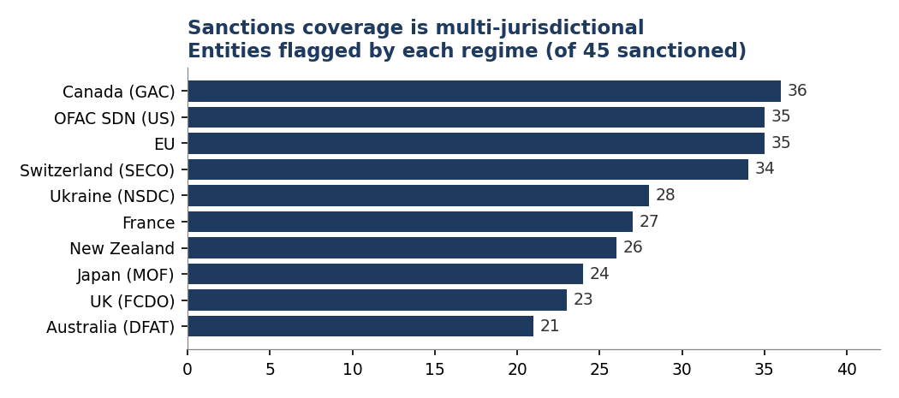
Assumptions
- Dataset: used list_1 as the highest-signal set for a risk narrative. The pipeline is list-agnostic and runs on list_2/3 unchanged.
- Resolution: accepted Sayari's best match as canonical, but verified marquee entities by relationship degree and pinned 3 confirmed parent IDs (see Challenges).
- Geography: “HQ” is taken from the input list's country column; “exposure” is the set of countries linked to each entity in the graph — two different, complementary views.
- Point-in-time: sanctions status reflects the API at run time (May 2026); designations change, so the report is a snapshot.
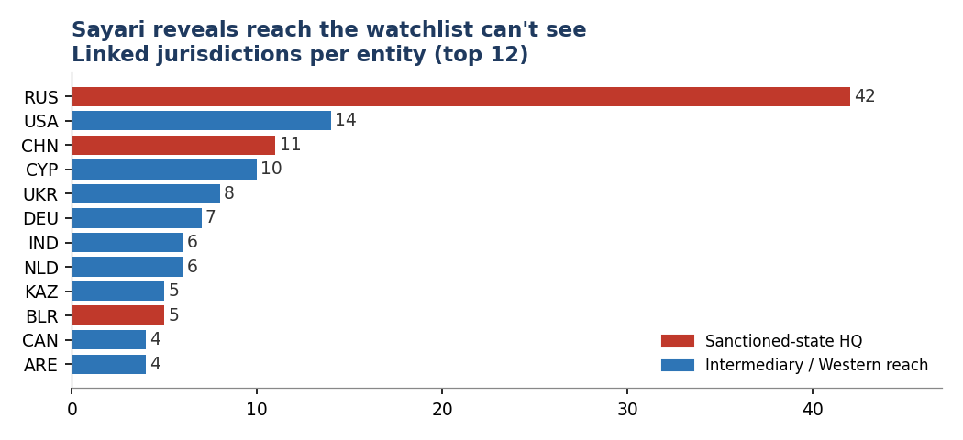
Challenges encountered & how I addressed them
- Entity resolution is the make-or-break step. Matching on the supplied street addresses surfaced subsidiaries over parents — “Sberbank” resolved to a back-office LLC (780 relationships) instead of PJSC Sberbank (59,632), and “VTB Bank” to VTB Capital Holdings instead of the bank itself. I caught these with a resolution audit log plus a name-mismatch flag (using unidecode transliteration and Sayari's translated_label to compare across Latin/Cyrillic), then verified candidates by relationship degree and pinned 3 confirmed parent IDs. The override is logged, so it stays auditable.
- Messy input names broke resolution. “Venezuelan State-Owned Oil Company (PDVSA)” and “VEB.RF” returned no match. Adding name-normalization and alternate-name retries lifted resolution from 92% to 98%.
- Honest gaps, not silent ones. One entity (Belnauchcompositit) did not resolve, and one (Cubametales) matched a different Cuban company; both are flagged and excluded from the counts rather than quietly included.
- Schema discovery. I confirmed field shapes against live responses — risk values are objects with value/level, and the resolution score is a raw relevance float, not a 0–1 probability — rather than trusting the docs.
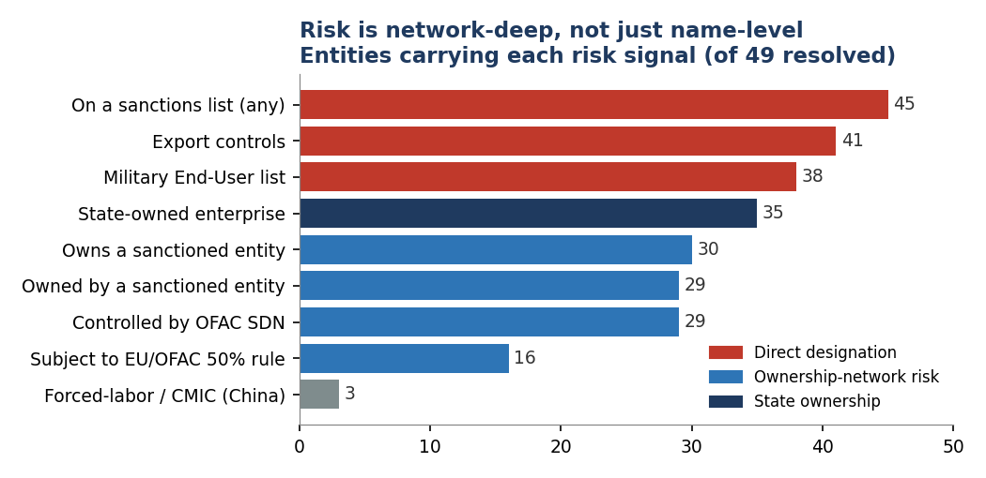
How this demonstrates the value of Sayari data
A compliance or procurement team can take a flat list of counterparties and, in minutes, get a defensible risk picture that a name-only sanctions screen cannot produce: simultaneous coverage across ten sanctions regimes, ownership-network exposure under the OFAC/EU 50% rule, hidden footprint through offshore and Western jurisdictions, and forced-labor / CMIC flags on Chinese suppliers. The decisive differentiator is not just breadth of data — it is that the output is traceable and reproducible, which is what survives an audit or a regulator's question. That trustworthiness is the real product.
With more time
Layer the interactive front-end (an analyst chat/upload experience) on top of this deterministic engine rather than in place of it; add UBO/ownership-chain traversal to render the full networks behind the 50%-rule flags; automate the parent-preference resolution heuristic; and enrich each designation with the underlying sanctions-list record (a Scenario 1 crossover).

