**Python function returns Stem plot from input file.**

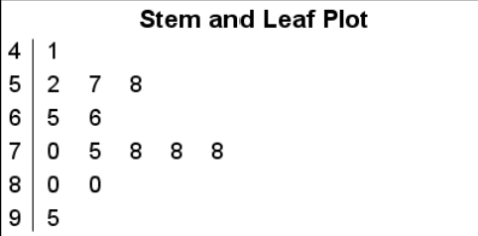

a) Greets the user.

b) Asks the user to input a StemAndLeaf 1, 2 or 3 text files.

c) Given the input, reads in the appropriate datafile and displays a stem-and-leaf plot. Leaves must be sorted.

d) Loops until the user wishes to exit.

Design a top-down structure chart for your program.