How DS1 balance heat

* Specially coated radiator surfaces to radiate waste heat to cold space
* Multi-layer insulation blankets to retain heat
  + Thin, radiating top layers of aluminized Kapton
    - High reflectivity
* Three types of blanket/ material to control heat (from sun)
  + Silver Teflon radiator coating material
    - A 0.010 inch layer of transparent Teflon coated with a few Angstrom thick layer of silver and a protective layer of Inconel
    - Use to protect the heat from sunlight (not pressure heat)

Gold thermal blanket

* + - Known as MLI
    - 0.001 inch Kapton film (separated into 4 layers) backed with a few thick layer of silver (separeted by a dacron netting to prevent contact). Supported by a coarse fiberglass netting to prevent tearing.
    - 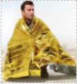
    - $5.99 for a lot!!! (amazon)
  + Black thermal blanket
    - Used on the shade side of the spacecraft
    - Outer layer is 0.001 in Kapton filled with carbon powder.
    - 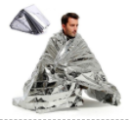
    - I might have but fairly cheap as well

Placing components onto the probe

* Components should be place according to the maximum heat that it can persist

What is the temperature range in which parts can function normally?

Heat shield types

* Ablative heat shield
  + A layer of plastic resin
  + Carry heat away by convection
  + 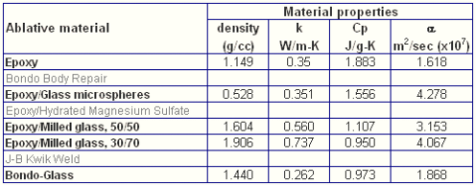
  + 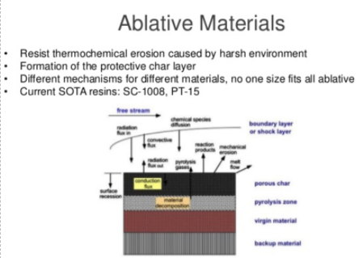
  + $20 for Epoxy resin and Epoxy hardener (Amazon)
  + Milled glass (powder) ~$20
  + Fiber glass?
  + Recall: Check out how DBF do their mold/ the front part of the plane.
    - Epoxy, fiber glass,
* Thermal soak heat shield
  + Uses an insulating material to absorb and radiate heat away (look at the blanket for DS1)
  + <http://www.autozone.com/sandpaper-and-body-repair-tools/heat-shield-material>
    - For car but generally can be apply to probe
    - If going forward, check price and WEIGHT. Compare expected weight to the 500g!
  + <https://www.heatshieldproducts.com/automotive/heat-shield-and-thermal-barriers>
    - Additional types of material

Look toward heal shield for airplane because most of the heat shield for probe are relating to reflecting the heat from the sun and not from the pressure due to air resistance on the surface of the probe.

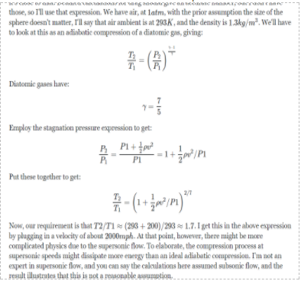

Possible ways to counter the aero-heating of the probe. Active approach are not very effective/possible.

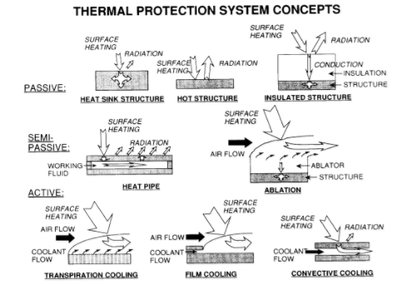

|  |  |  |  |  |  |
| --- | --- | --- | --- | --- | --- |
| **Insulation Material** | **Price/Sq Ft.** | **R-Value/ Inch** | Flammable | **Notes:** | **Picture** |
| Fiberglass | $$$ | R-3.1 | No | Does not absorb water. |  |
| Polyurethane Foam | $$$ | R-6.3 | Yes | Makes a great sound insulator too.    <http://www.fao.org/docrep/006/y5013e/y5013e08.htm> |  |
| Polystyrene (EPS)  (Styrofoam) | $ | R-4 | Yes | Difficult to work with |  |