**OOP1**

Mã SV: 19IT182

Tên: Phạm Dương Minh Nhật

# **Class Dice**

class Dice

{

private int sidesCount;

public int SidesCount

{

get

{

return sidesCount;

}

set

{

sidesCount = value;

}

}

public int RollDice()

{

Random random = new Random();

return random.Next(SidesCount) + 1;

}

}

# **Class Person**

class Person

{

protected string name;

protected int age;

public int Age

{

set

{

if (value >= 0 && value <= 100)

{

age = value;

} else

{

Console.WriteLine("re-Enter Age: ");

age = Convert.ToInt32(Console.ReadLine());

}

}

get { return age; }

}

public string Name

{

get { return name; }

set { name = value; }

}

public void DisplayPerson()

{

Console.WriteLine("Name Person is: " + name);

Console.WriteLine("Age Person is: " + age);

}

public void InputPerson()

{

Console.WriteLine("Enter name:");

Name = Console.ReadLine();

Console.WriteLine("Enter age:");

Age = Convert.ToInt16(Console.ReadLine());

}

public Person()

{

}

/*public toString()

{

}*/

}

**Class Student**

class Student : Person

{

protected double gpa;

public double Gpa

{

get { return gpa; }

set { gpa = value; }

}

public Student()

{

}

public void InputStudent()

{

base.InputPerson();

Console.WriteLine("Enter GPA:");

Gpa = Convert.ToDouble(Console.ReadLine());

}

public void DisplayStudent()

{

Console.WriteLine("Name Student is: " + name);

Console.WriteLine("Age Student is: " + age);

Console.WriteLine("GPA Student is: " + gpa);

}

}

# **Class Song**

class Song

{

private string typeList;

private string name;

private string time;

public string TypeList

{

get { return typeList; }

set

{

typeList = value;

}

}

public string Name

{

get { return name; }

set

{

name = value;

}

}

public string Time

{

get { return time; }

set

{

time = value;

}

}

public static Song addedSong()

{

string[] data = Console.ReadLine().Split("_");

Song song = new Song();

song.TypeList = data[0];

song.Name = data[1];

song.Time = data[2];

return song;

}

}

# **Class Fraction**

class Fraction {

private long a;

private long b;

public long A

{

get { return a; }

set { a = value; }

}

public long B

{

get { return b; }

set { b = value; }

}

public void DisplayFraction()

{

Console.WriteLine("Your Fraction is: " + A + "/" + B);

}

public void Input()

{

Fraction fraction = new Fraction();

string[] data = Console.ReadLine().Split("/");

A = Convert.ToInt32(data[0]);

B = Convert.ToInt32(data[1]);

}

public void normalize()

{

long gcd = GCD(A, B);

A = A / gcd;

B = B / gcd;

}

public static long GCD(long a, long b)

{

while (a != 0 && b != 0)

{

if (a > b)

a %= b;

else

b %= a;

}

return a | b;

}

public string ToString()

{

if (A % B == 0)

{

return $"-> {A / B}";

}

else

return $"-> {A}/{B}";

}

public string ShowAB()

{

if (A % B == 0)

{

return $"-> {A / B}" + "| A is: " + A + "| B is: " + B;

}

else

return $"-> {A}/{B}" + "| A is: " + A + "| B is: " + B;

}

public string ToDouble()

{

return "-> " + (double)A / (double)B;

}

public Fraction(long valuea, long valueb)

{

a = valuea;

b = valueb;

}

public Fraction()

{

}

private void multBy(long x)

{

A = A * x;

B = B * x;

}

public Fraction add(Fraction scd)

{

long ta = B;

long tb = scd.B;

scd.multBy(ta);

multBy(tb);

return new Fraction(A + scd.A, B);

}

public Fraction minus(Fraction scd)

{

long ta = B;

long tb = scd.B;

scd.multBy(ta);

multBy(tb);

return new Fraction(A - scd.A, B);

}

public Fraction multi(Fraction scd)

{

return new Fraction(A * scd.A, B * scd.B);

}

public Fraction divide(Fraction scd)

{

return new Fraction(A * scd.B, B * scd.A);

}

public static String DecimalToFraction(double dec)

{

string str = dec.ToString();

if (str.Contains('.'))

{

String[] parts = str.Split('.');

long whole = long.Parse(parts[0]);

long numerator = long.Parse(parts[1]);

long denominator = (long)Math.Pow(10, parts[1].Length);

long divisor = GCD(numerator, denominator);

long num = numerator / divisor;

long den = denominator / divisor;

String fraction = num + "/" + den;

if (whole > 0)

{

return whole + " " + fraction;

}

else

{

return fraction;

}

}

else

{

return str;

}

}

}

# **Program**

class Program

{

static void Main(string[] args)

{

while (true)

{

Console.WriteLine("Welcome to Minh Nhat EXERCISES OOP");

Console.WriteLine("Choose EXERCISES");

Console.WriteLine("1. EXERCISES 1: Dice");

Console.WriteLine("2. EXERCISES 2: Student");

Console.WriteLine("3. EXERCISES 3: Song");

Console.WriteLine("4. EXERCISES 4: Fraction");

int chooseFunc = Convert.ToInt32(Console.ReadLine());

if (chooseFunc > 4 || chooseFunc < 1)

{

Console.WriteLine("Please re-Enter");

chooseFunc = Convert.ToInt32(Console.ReadLine());

}

else

{

switch (chooseFunc)

{

case 1:

Ex1();

break;

case 2:

Ex2();

break;

case 3:

Ex3();

break;

case 4:

Ex4();

break;

}

}

}

static void Ex1()

{

Dice dice = new Dice();

Console.WriteLine("Enter the slides of the dice: ");

dice.SidesCount = Convert.ToInt32(Console.ReadLine());

if (dice.SidesCount < 6)

{

Console.WriteLine("re-Enter the slides of the dice >= 6: ");

dice.SidesCount = Convert.ToInt32(Console.ReadLine());

}

while (true)

{

Console.WriteLine("Enter the number of the dice: ");

int userDice = Convert.ToInt32(Console.ReadLine());

int slide = dice.RollDice();

/*Console.WriteLine(slide);*/

if (userDice == slide)

{

Console.WriteLine("You Win!!! ");

Console.WriteLine("Your Number is: " + userDice);

Console.WriteLine("Dice Number is: " + slide);

break;

}

else

{

Console.WriteLine("You Wrong!!! ");

Console.WriteLine("Your Number is: " + userDice);

Console.WriteLine("Dice Number is: " + slide);

}

}

}

static void Ex2()

{

Student student = new Student();

student.InputStudent();

student.DisplayStudent();

}

static void Ex3()

{

Console.WriteLine("Enter the Number of Song");

int numSongs = int.Parse(Console.ReadLine());

List<Song> songs = new List<Song>();

for (int i = 0; i < numSongs; i++)

{

Console.WriteLine("Enter the Informations of Song: Example: Classic_SomeThingJustLikeThis_2019");

string[] data = Console.ReadLine().Split("_");

string type = data[0];

string name = data[1];

string time = data[2];

Song song = new Song();

song.TypeList = type;

song.Name = name;

song.Time = time;

songs.Add(song);

}

Console.WriteLine("Enter the Type List: ");

string typeList = Console.ReadLine();

if (typeList == "all")

{

Console.WriteLine("All Songs of Your Type List: ");

foreach (Song s in songs)

{

Console.WriteLine(s.Name);

}

}

else

{

Console.WriteLine("Songs of Your Type List: " + typeList);

foreach (Song s in songs)

{

if (s.TypeList == typeList)

{

Console.WriteLine(s.Name);

}

}

}

/*List<Song> filteredSongs = songs.Where(s => s.TypeList == typeList).ToList();

foreach(Song song in filteredSongs)

{

Console.WriteLine(song.Name);

}*/

}

static void Ex4()

{

int choose;

while (true)

{

System.Console.WriteLine("Welcome to Minh Nhat Fractions");

Console.WriteLine("0. Input two fractions and display in normalize form.");

Console.WriteLine("1. Add two fractions.");

Console.WriteLine("2. Subtract two fractions.");

Console.WriteLine("3. Multiply two fractions.");

Console.WriteLine("4. Divide two fractions.");

Console.WriteLine("5. Display a fraction in form (A/B).");

Console.WriteLine("6. Display a fraction on the screen as a decimal number.");

Console.WriteLine("7. Exit");

System.Console.WriteLine("Type your choice:");

choose = int.Parse(Console.ReadLine());

if (choose == 7)

{

break;

}

Fraction frac = new Fraction();

switch (choose)

{

case 0:

System.Console.WriteLine("Enter the fisrt fraction");

Fraction frac1 = new Fraction();

frac1.Input();

System.Console.WriteLine("Enter the second fraction");

Fraction fr2 = new Fraction();

fr2.Input();

frac1.normalize();

fr2.normalize();

System.Console.WriteLine($"{frac1.ToString()}, {fr2.ToString()}");

break;

case 1:

frac = addFrtn();

frac.normalize();

System.Console.WriteLine($"{frac.ToString()}");

break;

case 2:

frac = minusFrtn();

frac.normalize();

System.Console.WriteLine($"{frac.ToString()}");

break;

case 3:

frac = multiFrtn();

frac.normalize();

System.Console.WriteLine($"{frac.ToString()}");

break;

case 4:

frac = divFrtn();

frac.normalize();

System.Console.WriteLine($"{frac.ToString()}");

break;

case 5:

Console.WriteLine("Enter Your Fraction: ");

frac.Input();

System.Console.WriteLine($"{frac.ShowAB()}");

break;

case 6:

Console.WriteLine("Enter Your Fraction: ");

frac.Input();

System.Console.WriteLine($"{frac.ToDouble()}");

break;

default:

break;

}

System.Console.WriteLine("Enter to continue");

Console.ReadKey();

}

static Fraction addFrtn()

{

System.Console.WriteLine("Enter the fisrt fraction");

Fraction fr = new Fraction();

fr.Input();

System.Console.WriteLine("Enter the second fraction");

Fraction fr2 = new Fraction();

fr2.Input();

return fr.add(fr2);

}

static Fraction minusFrtn()

{

System.Console.WriteLine("Enter the fisrt fraction");

Fraction fr = new Fraction();

fr.Input();

System.Console.WriteLine("Enter the second fraction");

Fraction fr2 = new Fraction();

fr2.Input();

return fr.minus(fr2);

}

static Fraction multiFrtn()

{

System.Console.WriteLine("Enter the fisrt fraction");

Fraction fr = new Fraction();

fr.Input();

System.Console.WriteLine("Enter the second fraction");

Fraction fr2 = new Fraction();

fr2.Input();

return fr.multi(fr2);

}

static Fraction divFrtn()

{

System.Console.WriteLine("Enter the fisrt fraction");

Fraction fr = new Fraction();

fr.Input();

System.Console.WriteLine("Enter the second fraction");

Fraction fr2 = new Fraction();

fr2.Input();

return fr.divide(fr2);

}

}

}

}

# **Product**

Ex1:

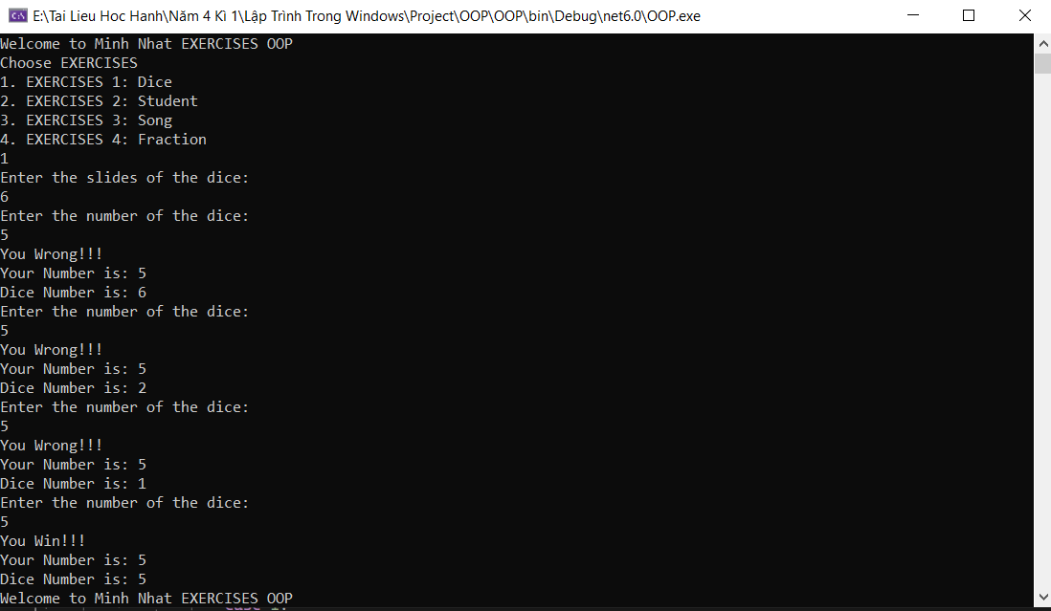

Ex2:

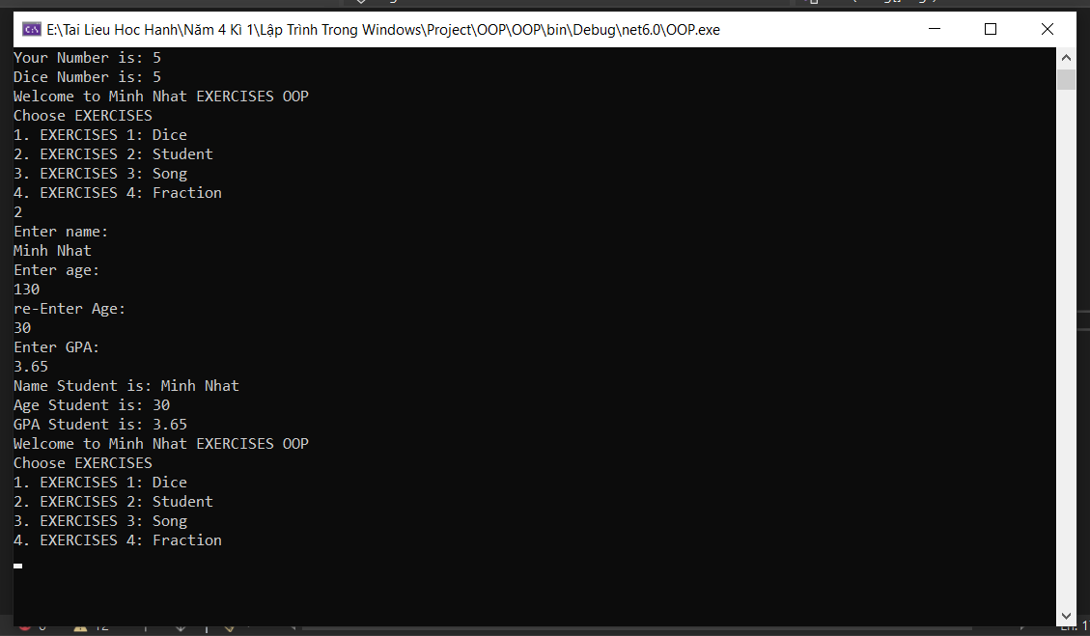

Ex3:

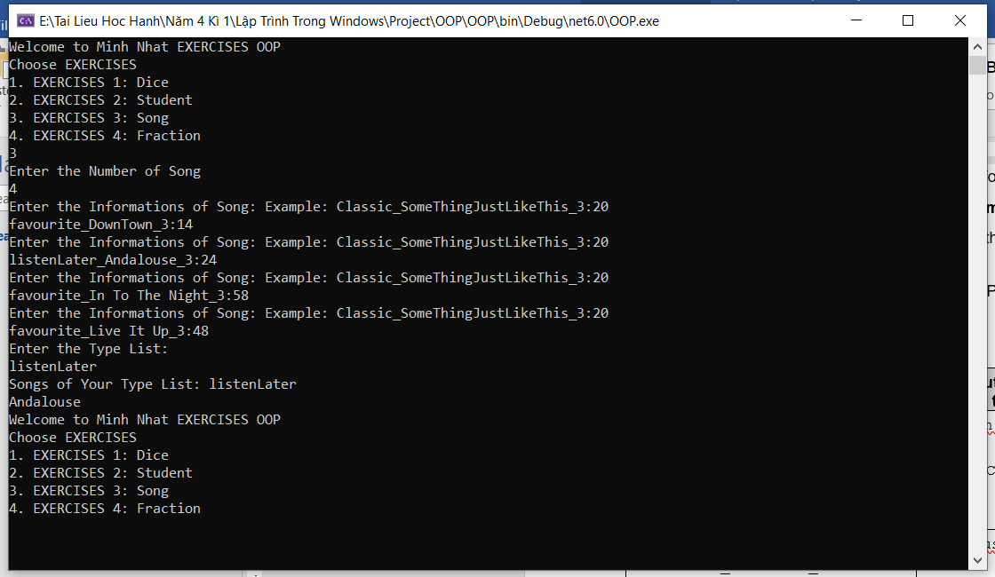

Ex4:

