Supplementary Information

Supplementary Figures
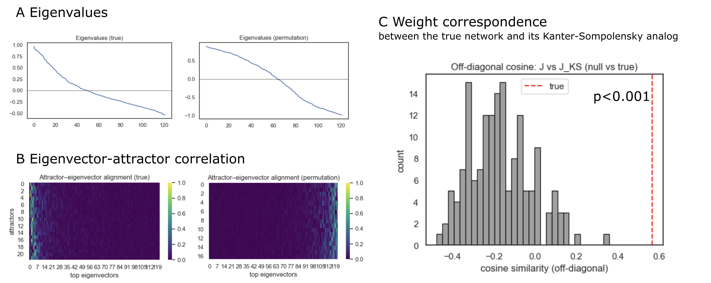
Figure 1: Eigenstructure and projector tests of the fcANN
A: Eigenvalue spectra of the empirical coupling matrix J (left) and null model 1 (coupling matrix based on phase randomized timeseries data, recalculated for each permutation) (right). B: Eigenvector–attractor alignment calculated from the empirical (left) and phase-randomized data (right). Attractors were obtained by deterministic relaxation from random initial states (with collapsing sign‑duplicates); alignment is the absolute cosine between collapsed attractor vectors and the top eigenvectors of J. C: Weight correspondence between J and its Kanter–Sompolinsky (K–S) analog. From the measured attractors we formed Σ (columns are attractors) and C=ΣᵀΣ/N, then computed the pseudo‑inverse projector $J_\{KS\}=(1/N)ΣC⁻¹Σᵀ$. Similarity was quantified as the cosine between the off‑diagonal elements of J and $J_\{KS\}$. The gray histogram shows the null distribution from null model 2 (symmetry‑preserving permutations of J, but see Source notebook for similar results with null model 1, i.e. phase randomized timeseries data); for each of the 1000 permutations $p$ we recomputed the own attractors of the surrogate network and $J_\{KS\}^\{(p)\}$. The red dashed line marks the empirical value; the one‑sided p‑value is the fraction of null cosines ≥ the empirical cosine. The empirical network shows stronger eigenvector–attractor alignment and substantially higher J↔J_KS off‑diagonal correspondence than the null, consistent with approximate K–S projector behavior.
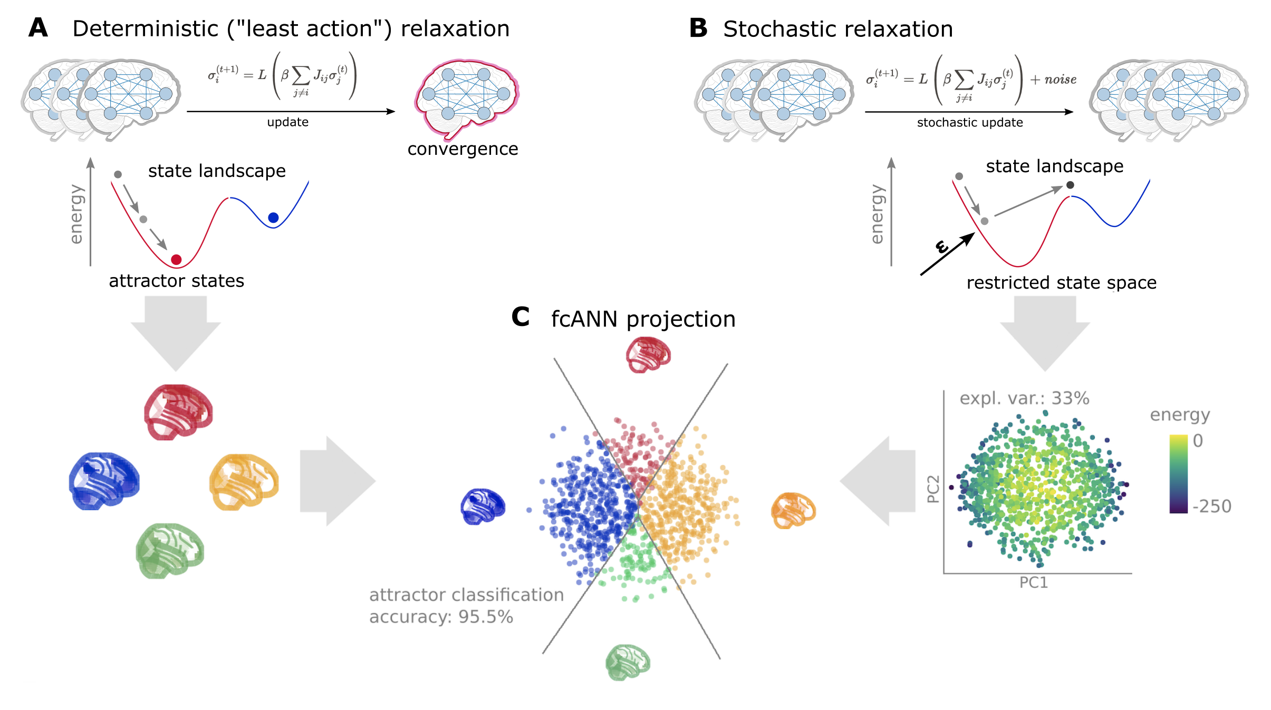
Figure 2: Schematic representation of the fcANN projection.
The fcANN projection is a 2-dimensional visualization of the fcANN dynamics, based on the first two principal components (PCs) of the states sampled from the stochastic relaxation procedure. The first two PCs yield a clear separation of the attractor states, with the two symmetric pairs of attractor states located at the extremes of the first and second PC.
To map the attractors’ basins on the space spanned by the first two PCs, we obtained the attractor state of each point visited during the stochastic relaxation and fit a multinomial logistic regression model to predict the attractor state from the first two PCs.
The resulting model accurately predicted attractor states of arbitrary brain activity patterns, achieving a cross-validated accuracy of 96.5% (permutation-based p<0.001).
The attractor basins were visualized by using the decision boundaries obtained from this model. We propose the 2-dimensional fcANN projection as a simplified visual representation of brain dynamics, and use it as a basis for all subsequent analyses in this work.
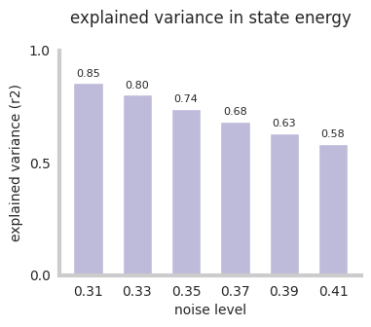
Figure 3: Explained variance in state energy by first two principal components. See supplemental​_material​.ipynb for details.
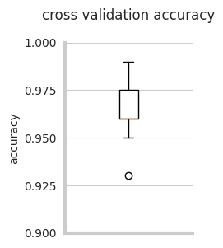
Figure 4: Cross-validation classification accuracy of the fcANN, when predicting the attractor state from state
activation. See supplemental​_material​.ipynb for details.
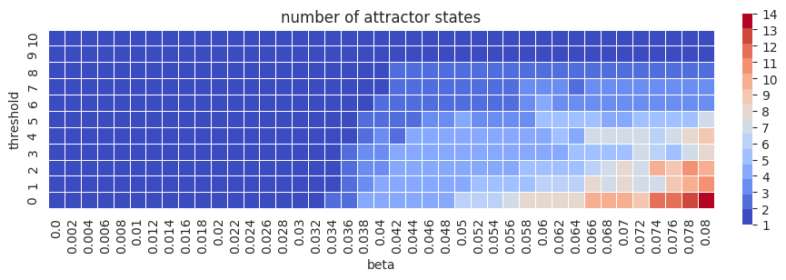
Figure 5: Parameter sweep of fcANN parameters threshold and beta. The number of attractor states is color‑coded. See supplemental​_material​.ipynb for details.
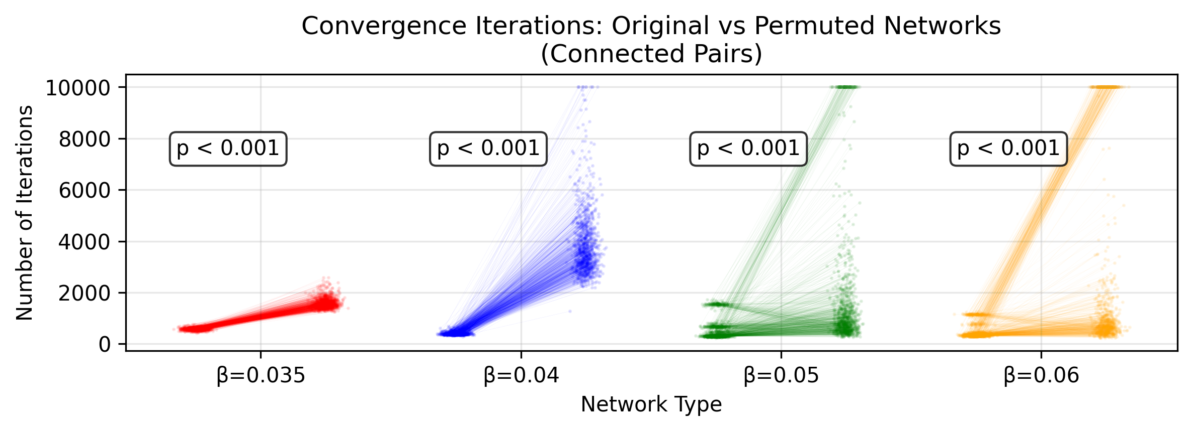
Figure 6: fcANNs initialized with the empirical connectome have better convergence properties than permutation‑based null models. We investigated the convergence properties of functional connectome‑based ANNs in study 1 by contrasting the number of iterations until reaching convergence to a permutation‑based null model. In more detail, the null model was constructed by randomly permuting the upper triangle of the original connectome and filling up the lower triangle to get a symmetric network (symmetry of the weight matrix is a general requirement for convergence). This procedure was repeated 1000 times. In each repetition, we initialized both the original and the permuted fcANN with the same random input and counted the number of iterations until convergence. Each point on the plot shows an iteration number; the lines connect iteration numbers corresponding to the original and permuted matrices initialized with the same input. Statistical significance of the faster convergence in the empirical connectome was assessed via a one‑sided Wilcoxon signed‑rank test (i.e., a non‑parametric paired test) on the paired iteration values (1,000 pairs), with the null hypothesis that the empirical connectome converges in fewer iterations than the permuted connectome. The whole procedure was repeated with $\backslash beta=0.3, 0.35, 0.4, 0.5$ and 0.6 (providing 2–8 attractor states). See convergence​-analysis​.ipynb for details.
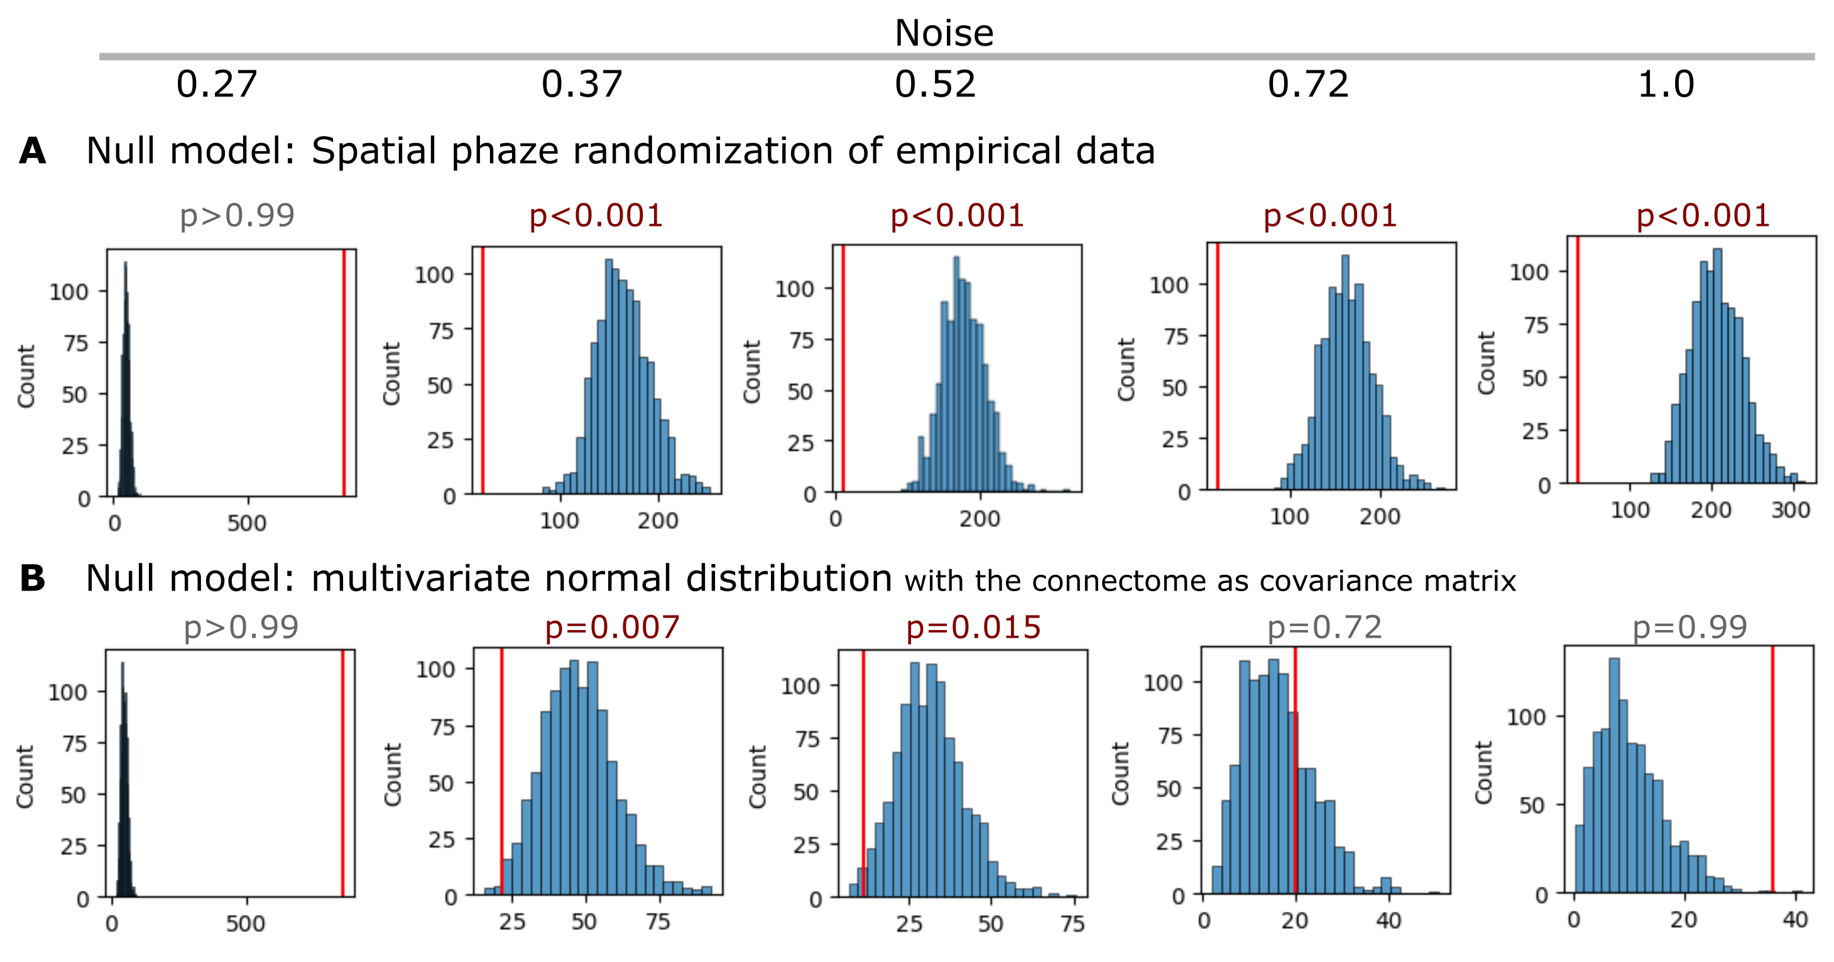
Figure 7: Statistical inference of the fcANN state occupancy prediction with different null models.
A Results with a spatial autocorrelation-preserving null model for the empirical activity patterns. See null_models.ipynb for more details.
B Results where simulated samples are randomly sampled from a multivariate normal distribution, with the functional connectome as the covariance matrix, and compared to the fcANN performance. See supplemental​_material​.ipynb for details.
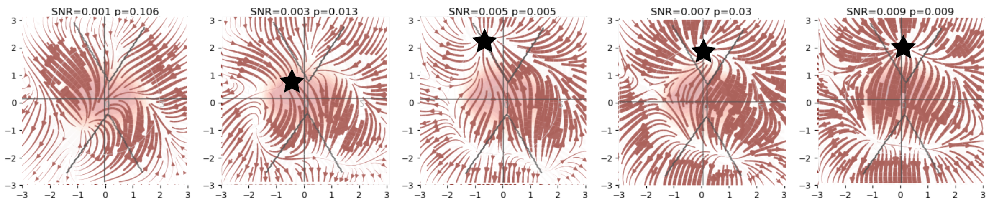
Figure 8: FcANN can reconstruct the pain “ghost attractor”.
Signal-to-noise values range from 0.003 to 0.009. Asterisk denotes the location of the simulated “ghost attractor”. P-values are based on permutation testing, by randomly changing the conditions in a per-participant basis. See main_analyses.ipynb for more details.
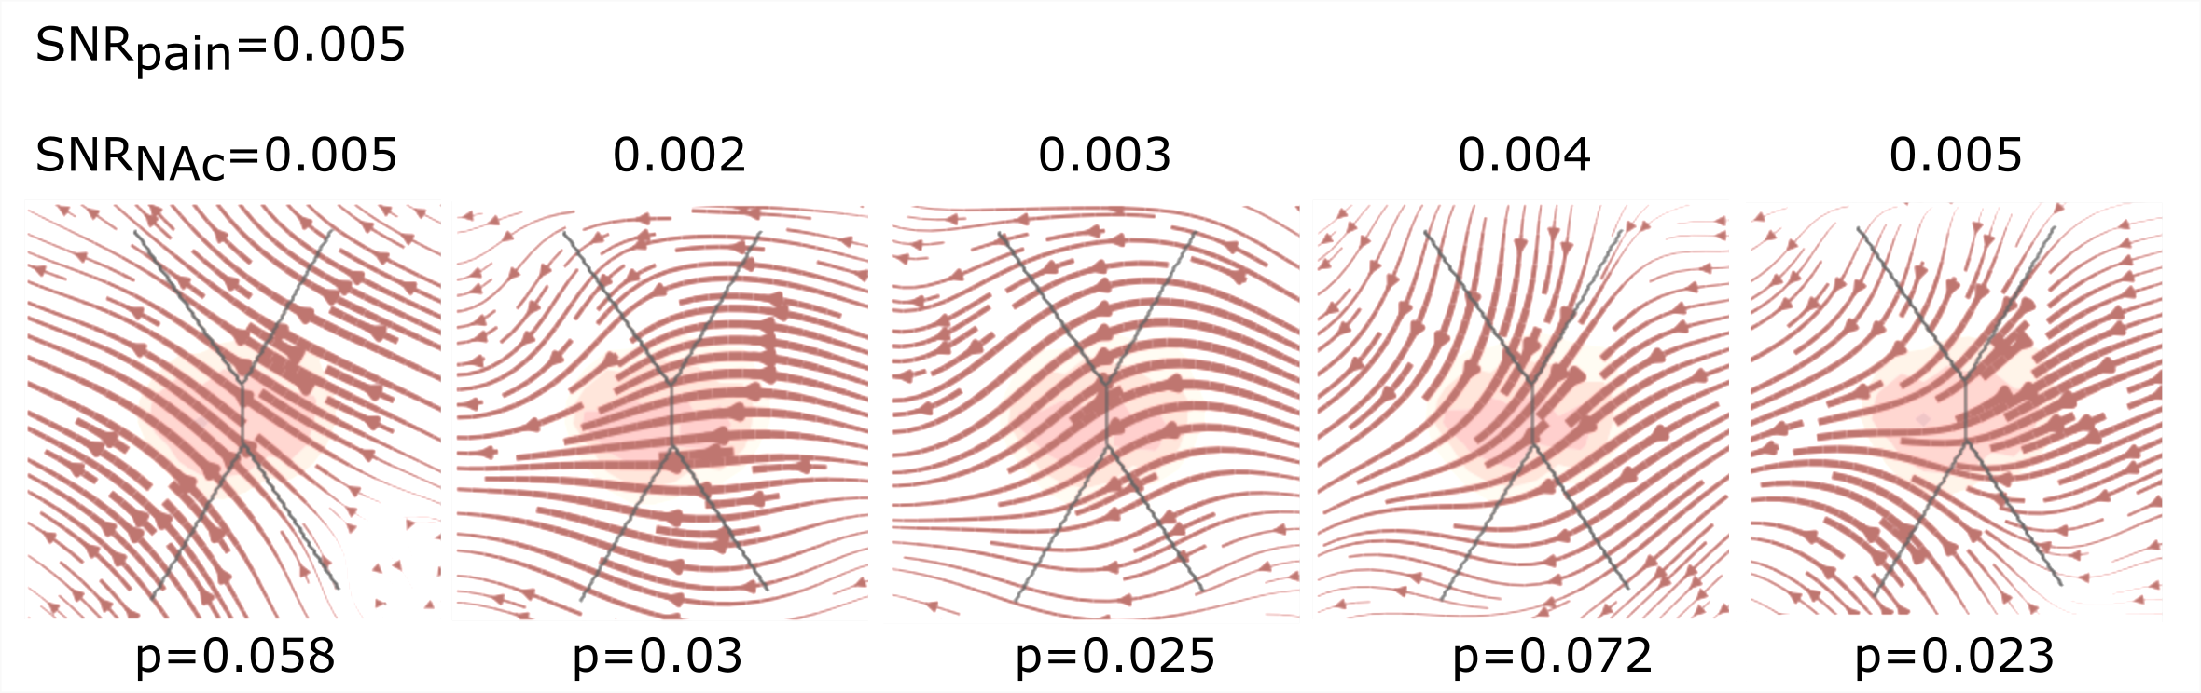
Figure 9: fcANN can reconstruct the changes in brain dynamics caused by the voluntary downregulation of pain (as contrasted to upregulation)
Signal-to-noise values range from 0.001 to 0.005. P-values are based on permutation testing, by randomly changing the conditions in a per-participant basis. See main_analyses.ipynb for more details.
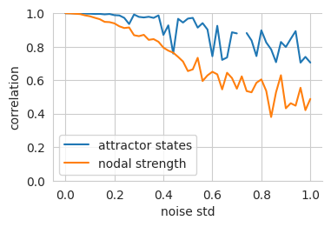
Figure 10: Robustness of the fcANN weights to noise.
We set the temperature of the fcANN, so that two attractor states emerge and iteratively add noise to the connectome.
To account for the change in dynamics, we adjust the temperature (beta) of the noisy fcANN so that exactly two states emerge. We then highlight the decrease in nodal strength of the noisy connectome (the fcANN weights) as a reference metric
vs the correlation of the attractor states that emerge from the noisy connectome. See supplemental​_material​.ipynb for details.
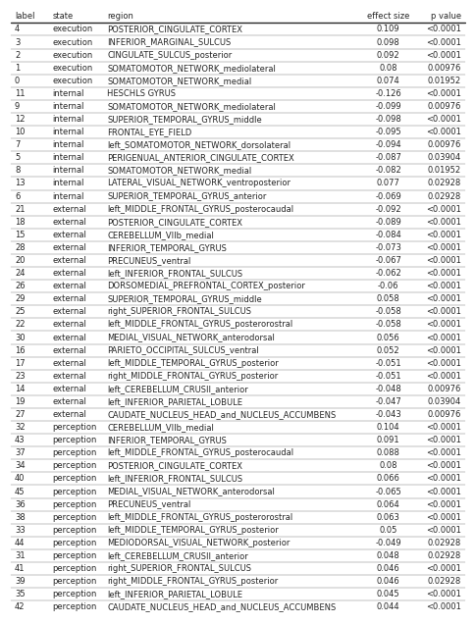
Figure 11: All significant differences of the mean state activation analysis on the ABIDE dataset; label denotes the region
in the BASC122 atlas. See supplemental​_material​.ipynb for details.

Supplementary Tables
Table 1: MRI acquisition parameters. TR: repetition time; TE: echo time; FA: flip angle; FOV: field of view; EPI: echo‑planar imaging; SPGR: spoiled gradient recall; SENSE/GRAPPA/ASSET: parallel imaging factors. Study 5-7 are metaanalyses or multi-center studies with varying data. Sequence parameters for these studies are available in the respective publications.
Parameter | Study 1 | Study 2 | Study 3 | Study 4
Scanner / head coil | Philips Achieva X 3T; 32‑ch | Siemens Magnetom Skyra 3T; 32‑ch | GE Discovery MR750w 3T; 20‑ch | Philips Achieva TX 3T; head coil per site
Anatomical sequence | T1 MPRAGE | T1 MPRAGE | T1 3D IR‑FSPGR | T1 SPGR (high‑resolution)
Anatomical TR / TE | 8500 ms / 3.9 ms | 2300 ms / 2.07 ms | 5.3 ms / 2.1 ms | — / —
Anatomical resolution / FOV | 1×1×1 mm³; 256×256×220 mm³ | 1×1×1 mm³; 256×256×192 mm³ | 1×1×1 mm³; 256×256×172 | —
Resting‑state EPI TR / TE / FA | 2500 ms / 35 ms / 90° | 2520 ms / 35 ms / 90° | 2500 ms / 27 ms / 81° | 2000 ms / 20 ms / —
Phase enc. | COL | A>>P | A>>P | —
FOV (voxels × slices) | 240×240×132; 40 slices | 230×230×132; 38 slices | 96×96×44; 44 slices | 64×64; 42 slices
Slice thickness / gap / order | 3 mm / 0.3 mm / interleaved | 3 mm / 0.48 mm / interleaved | 3 mm / 0 mm / interleaved | 3 mm / — / interleaved
Acceleration / fat suppression | SENSE 3× / SPIR | GRAPPA 2× / Fat sat. | ASSET 2× / Fat sat. | SENSE 1.5× / —
Volumes / dummies / scan time | 200 / 5 / 8 min 37 s | 290 / 5 / 12 min 11 s | 240 / 0 / 10 min | — / — / —

Table 2: Neurosynth meta-analyses. The table includes details about the term used for the automated meta-analyses, as well as the number of studies included in the meta-analysis, the total number of reported activations and the maximal Z-statistic from the meta-analysis.
search term | num. studies | num. activations | max. Z
pain | 516 | 23295 | 14.8
motor | 2565 | 109491 | 22.5
auditory | 1252 | 46557 | 25.3
visual | 3110 | 115726 | 15.4
face | 896 | 31842 | 26.8
autobiographical | 143 | 7251 | 15.7
theory of mind | 181 | 7761 | 15.1
sentences | 356 | 13461 | 16.5

Supplementary Methods
Study 4 instructions for upregulation.
“During this scan, we are going to ask you to try to imagine as hard as you can that the thermal stimulations are more painful than they are. Try to focus on how unpleasant the pain is, for instance, how strongly you would like to remove your arm from it. Pay attention to the burning, stinging and shooting sensations. You can use your mind to turn up the dial of the pain, much like turning up the volume dial on a stereo. As you feel the pain rise in intensity, imagine it rising faster and faster and going higher and higher. Picture your skin being held up against a glowing hot metal or fire. Think of how disturbing it is to be burned, and visualize your skin sizzling, melting and bubbling as a result of the intense heat.”
Study 4 instructions for downregulation.
“During this scan, we are going to ask you to try to imagine as hard as you can that the thermal stimulations are less painful than they are. Focus on the part of the sensation that is pleasantly warm, like a blanket on a cold day. You can use your mind to turn down the dial of your pain sensation, much like turning down the volume dial on a stereo. As you feel the stimulation rise, let it numb your arm, so any pain you feel simply fades away. Imagine your skin is very cool, from being outside, and think of how good the stimulation feels as it warms you up.”

Supplementary Information 1
Derivation of the joint steady-state probability of free energy minimizing attractor networks
See (Spisak & Friston, 2025) for details on the whole framework.

Outline

Note
Regularity assumptions
- Existence of a non-equilibrium steady-state density $p^\backslash ast$ with $\backslash Phi=\backslash log p^\backslash ast$ differentiable almost everywhere on its support; stationary edge fluxes are finite.
- Measurable jump kernel with finite total update rate at each configuration $\backslash sigma$; independent Poisson clocks as specified.
- Compact support of single-site updates $x\backslash in[-1,1]$ so boundary terms vanish in the summation-by-parts/test-function identities used for solenoidal orthogonality.
- Sufficient smoothness to justify differentiating the reversible increment at $x=\backslash sigma_i$; mixed partials commute where invoked.

Setup: Continuous–Bernoulli kernel
We assume that the single-site conditional distribution is the Continuous–Bernoulli on $[-1,1]$ with canonical parameter

$\backslash kappa_i(\backslash boldsymbol\{\backslash sigma\}_\{-i\}) = b_i + \backslash sum_\{j\backslash neq i\} J_\{ij\}\backslash sigma_j$ (1)

and density (for $x\backslash in[-1,1]$)

$K(x\backslash mid \backslash kappa) = h(x) e^\{\backslash kappa x - A(\backslash kappa)\}, \backslash qquad x\backslash in[-1,1]$ (2)

with $h(x)=\backslash tfrac12 \backslash mathbf\{1\}_\{[-1,1]\}(x)$ and $A(\backslash kappa)=\backslash log(\backslash sinh\backslash kappa)-\backslash log\backslash kappa$ (so the $\backslash kappa\backslash to0$ limit is uniform on $[-1,1]$).
The conditional mean is:

$L(\backslash kappa) =\backslash mathbb\{E\}_\{K(\backslash cdot\backslash mid\backslash kappa)\}[x] = \backslash coth\backslash kappa - \backslash frac\{1\}\{\backslash kappa\}$ (3)

1. Master equation
Let’s consider a precise formalization of the asynchronous update procedure: each site $i$ has an independent Poisson clock of rate $\backslash gamma_i$. When it rings, $\backslash sigma_i$ is replaced by a draw $x\backslash sim K(\backslash cdot\backslash mid\backslash kappa_i(\backslash sigma_\{-i\}))$.
With $\backslash sigma^\{(i,x)\}$ the configuration equal to $\backslash sigma$ but with coordinate $i$ set to $x$, the transition density is

$w_i(\backslash sigma^\{(i,x)\}\backslash mid\backslash sigma) =\backslash gamma_i K(x\backslash mid\backslash kappa_i(\backslash sigma_\{-i\}))$ (4)

The master equation for $p(\backslash sigma,t)$ is

$\backslash partial_t p(\backslash sigma,t) =\backslash sum_\{i=1\}^N\backslash int_\{-1\}^\{1\} \backslash Big[ \backslash underbrace\{w_i(\backslash sigma\backslash mid\backslash sigma^\{(i,x)\}) p(\backslash sigma^\{(i,x)\},t)\}_\{inflow\} - \backslash underbrace\{w_i(\backslash sigma^\{(i,x)\}\backslash mid\backslash sigma) p(\backslash sigma,t)\}_\{outflow\}\backslash Big] dx$ (5)

Note
In a small interval $dt$, probability in state $\backslash sigma$ changes by inflow from all one-site predecessors $\backslash sigma^\{(i,x)\}$ minus outflow from $\backslash sigma$ to those states. Multiple updates within $dt$ are $\backslash mathcal\{O\}(dt^2)$ and negligible. Because the updated value $x$ is continuous, we integrate over $x\backslash in[-1,1]$.

2. Probability currents
Let’s denote the site-wise flux density as:

$F_i(\backslash sigma \backslash to x) := w_i(\backslash sigma^\{(i,x)\}\backslash mid\backslash sigma) p^\backslash ast(\backslash sigma)$ (6)

At steady state $p^\backslash ast$, by definition we have:

$\backslash sum_i \backslash int_\{-1\}^1 \backslash Big(F_i(\backslash sigma^\{(i,x)\}\backslash to\backslash sigma)-F_i(\backslash sigma\backslash to x)\backslash Big) dx = 0$ (7)

Note
$\{\backslash sigma^\{(i,x)\}\}^\{(i,\backslash sigma)\} = \backslash sigma$

3. Detailed balance condition
A special (and maybe the most intuitive) way to satisfy the previous eq. is the case of detailed balance or equilibrium. In this case, every transition is balanced:

$F_i(\backslash sigma^\{(i,x)\}\backslash to\backslash sigma) = F_i(\backslash sigma\backslash to x)$ (8)

It can be shown that:

$w_i(\backslash sigma^\{(i,x)\}\backslash mid\backslash sigma) p^\backslash ast(\backslash sigma) = w_i(\backslash sigma\backslash mid\backslash sigma^\{(i,x)\}) p^\backslash ast(\backslash sigma^\{(i,x)\}) \backslash iff \backslash partial_\{\backslash sigma_i\}\backslash Phi(\backslash sigma) = \backslash kappa_i(\backslash sigma_\{-i\}) = b_i + \backslash sum_\{k\backslash neq i\} J_\{ik\} \backslash sigma_k$ (9)

I.e., the log-density $\backslash Phi$ changes by the local slope at $i$ (see detailed derivation below).
Hence for $j\backslash neq i$:

$\backslash partial_\{\backslash sigma_j\}\backslash partial_\{\backslash sigma_i\}\backslash Phi = J_\{ij\}, \backslash qquad \backslash partial_\{\backslash sigma_i\}\backslash partial_\{\backslash sigma_j\}\backslash Phi = J_\{ji\}$ (10)

Mixed partials commute, thus:

$J_\{ij\}=J_\{ji\} \backslash quad \backslash iff \backslash textit\{detailed balance\}$ (11)

Therefore, equilibrium (detailed balance) is possible only when the coupling is symmetric.

Note
Derivation
From:
$w_i(\backslash sigma^\{(i,x)\}\backslash mid\backslash sigma) p^\backslash ast(\backslash sigma) = w_i(\backslash sigma\backslash mid\backslash sigma^\{(i,x)\}) p^\backslash ast(\backslash sigma^\{(i,x)\})$
We take logs ($\backslash Phi=\backslash log p^\backslash ast$) and rearrange:
$\backslash Phi(\backslash sigma^\{(i,x)\}) − \backslash Phi(\backslash sigma) = \backslash log w_i(\backslash sigma^\{(i,x)\} \backslash mid \backslash sigma) − \backslash log w_i(\backslash sigma \backslash mid \backslash sigma^\{(i,x)\})$
Substitute $w_i = \backslash gamma_i K(\backslash cdot \backslash mid \backslash kappa)$ with $\backslash kappa = \backslash kappa_i(\backslash sigma_\{-i\}) = \backslash kappa_i(\backslash sigma^\{(i,x)\}_\{-i\})$:
$\backslash Phi(\backslash sigma^\{(i,x)\}) − \backslash Phi(\backslash sigma) = \backslash big[\backslash log \backslash gamma_i + \backslash log K(x \backslash mid \backslash kappa)\backslash big] − \backslash big[\backslash log \backslash gamma_i + \backslash log K(\backslash sigma_i|\backslash kappa)\backslash big] = \backslash log K(x \backslash mid \backslash kappa) − log K(\backslash sigma_i \backslash mid \backslash kappa)$
Use CB form $\backslash log K(z|\backslash kappa) = \backslash log h(z) + \backslash kappa z − A(\backslash kappa)$:
$\backslash Phi(\backslash sigma^\{(i,x)\}) − \backslash Phi(\backslash sigma) = \backslash big[ \backslash log h(x) − \backslash log h(\backslash sigma_i)\backslash big] + \backslash kappa(x − \backslash sigma_i)$
($A(\backslash kappa)$ cancels because $\backslash kappa$ is the same).
For Continuous–Bernoulli on [−1,1], $h(x) = 1/2$ on the support ⇒ $\backslash log h(x) − log h(\backslash sigma_i) = 0$, so:

$> \backslash Phi(\backslash sigma^\{(i,x)\}) − \backslash Phi(σ) = \backslash kappa(x − \backslash sigma_i) >$ (12)

Differentiating at $x=\backslash sigma_i$ yields

$> \backslash partial_\{\backslash sigma_i\}\backslash Phi(\backslash sigma) = \backslash kappa_i(\backslash sigma_\{-i\}) = b_i + \backslash sum_\{k\backslash neq i\} J_\{ik\} \backslash sigma_k >$ (13)

4. Non-equilibrium Steady State (NESS)
Detailed balance (equilibrium) is only one specific way the steady-state condition can hold:

$\backslash sum_i \backslash int_\{-1\}^1 \backslash Big(F_i(\backslash sigma^\{(i,x)\}\backslash to\backslash sigma)-F_i(\backslash sigma\backslash to x)\backslash Big) dx = 0$ (14)

Let’s consider the general case: an arbitrary (possibly asymmetric) $J$ coupling. $J$ can always be decomposed into:

$J = J^\{\backslash mathrm\{S\}\} + J^\{\backslash mathrm\{A\}\},\backslash qquad J^\{\backslash mathrm\{S\}\} := \backslash tfrac12(J+J^\backslash top), \backslash quad J^\{\backslash mathrm\{A\}\} := \backslash tfrac12(J-J^\backslash top)$ (15)

This leads to a decomposition of the edge currents on each directed edge $(\backslash sigma,\backslash sigma^\{(i,x)\})$:

$F_i^\{\backslash mathrm\{sym\}\}(\backslash sigma\backslash to x) := \backslash tfrac12\backslash Big(F_i(\backslash sigma\backslash to x)+F_i(\backslash sigma^\{(i,x)\}\backslash to\backslash sigma)\backslash Big),\backslash qquad F_i^\{\backslash mathrm\{sol\}\}(\backslash sigma\backslash to x) := \backslash tfrac12\backslash Big(F_i(\backslash sigma\backslash to x)-F_i(\backslash sigma^\{(i,x)\}\backslash to\backslash sigma)\backslash Big)$ (16)

so that $F_i = F_i^\{\backslash mathrm\{sym\}\} + F_i^\{\backslash mathrm\{sol\}\}$ and $F_i^\{\backslash mathrm\{sym\}\}(\backslash sigma\backslash to x)=F_i^\{\backslash mathrm\{sym\}\}(\backslash sigma^\{(i,x)\}\backslash to\backslash sigma)$.
Since $F_i(\backslash sigma\backslash to x) = e^\{\backslash Phi(\backslash sigma)\} w_i(\backslash sigma\backslash to x)$, define rates accordingly:

$w_i^\{\backslash mathrm\{sym\}\}(\backslash sigma\backslash to x) := e^\{-\backslash Phi(\backslash sigma)\} F_i^\{\backslash mathrm\{sym\}\}(\backslash sigma\backslash to x),\backslash qquad w_i^\{\backslash mathrm\{sol\}\}(\backslash sigma\backslash to x) := e^\{-\backslash Phi(\backslash sigma)\} F_i^\{\backslash mathrm\{sol\}\}(\backslash sigma\backslash to x)$ (17)

so $w_i = w_i^\{\backslash mathrm\{sym\}\} + w_i^\{\backslash mathrm\{sol\}\}$ and $F_i^\{\backslash mathrm\{sym\}\} = e^\{\backslash Phi\}w_i^\{\backslash mathrm\{sym\}\}$, $F_i^\{\backslash mathrm\{sol\}\} = e^\{\backslash Phi\}w_i^\{\backslash mathrm\{sol\}\}$.
We proceed in two steps: (i) the antisymmetric component is divergence-free and never changes the steady state; (ii) the remaining symmetric component yields exactly the same $p^\backslash ast$ as the equilibrium distribution obtained by setting $J=J^\{\backslash mathrm\{S\}\}$. Finally, as a bonus, we show that the induced circulating flow is indeed tangential to the level sets of $\backslash Phi$, in accordance to the Helmholtz decomposition.

i) Antisymmetric component is divergence-free (does not change $p^\backslash ast$).
Starting again from stationarity of the full current,

$\backslash sum_i \backslash int_\{-1\}^1 \backslash Big(F_i(\backslash sigma^\{(i,x)\}\backslash to\backslash sigma)-F_i(\backslash sigma\backslash to x)\backslash Big) dx = 0$ (18)

subtract the same identity written with $F^\{\backslash mathrm\{sym\}\}$ in place of $F$. Because $F^\{\backslash mathrm\{sym\}\}(\backslash sigma\backslash to x)=F^\{\backslash mathrm\{sym\}\}(\backslash sigma^\{(i,x)\}\backslash to\backslash sigma)$ on every edge, its contribution vanishes pairwise, giving

$\backslash sum_i \backslash int_\{-1\}^1 \backslash Big(F_i^\{\backslash mathrm\{sol\}\}(\backslash sigma^\{(i,x)\}\backslash to\backslash sigma)-F_i^\{\backslash mathrm\{sol\}\}(\backslash sigma\backslash to x)\backslash Big) dx = 0$ (19)

Thus $F^\{\backslash mathrm\{sol\}\}$ has zero divergence and does not change $p^\backslash ast$.

ii) Symmetric component determines $p^\backslash ast$ and matches the equilibrium solution with $J=J^\{\backslash mathrm\{S\}\}$.
From Section 3, only $J^\{\backslash mathrm\{S\}\}$ can appear in a potential gradient (commuting mixed partials). Therefore

$\backslash partial_\{\backslash sigma_i\}\backslash Phi(\backslash sigma) = b_i + \backslash sum_\{k\backslash neq i\} J^\{\backslash mathrm\{S\}\}_\{ik\}\backslash ,\backslash sigma_k$ (20)

which integrates to the same $\backslash Phi=\backslash log p^\backslash ast$ you obtain by enforcing detailed balance with the symmetric coupling $J=J^\{\backslash mathrm\{S\}\}$ (i.e., in the absence of $J^\{\backslash mathrm\{A\}\}$). Equivalently, the symmetric current $F^\{\backslash mathrm\{sym\}\}$ is reversible with respect to $p^\backslash ast$ and alone reproduces the same steady state.

Note: Tangency to level sets of $\backslash Phi$ (no work against the potential).
Multiply the preceding identity by a test function $\backslash psi(\backslash sigma)$ and integrate over $\backslash sigma$ (“summation by parts”) to obtain

$\backslash int d\backslash sigma\backslash , \backslash sum_i\backslash int_\{-1\}^1 F_i^\{\backslash mathrm\{sol\}\}(\backslash sigma\backslash to x)\backslash ,\backslash big[\backslash psi(\backslash sigma^\{(i,x)\})-\backslash psi(\backslash sigma)\backslash big] dx = 0$ (21)

Taking $\backslash psi=\backslash Phi$ yields

$-\backslash int d\backslash sigma\backslash , \backslash sum_i\backslash int_\{-1\}^1 F_i^\{\backslash mathrm\{sol\}\}(\backslash sigma\backslash to x)\backslash ,\backslash big[\backslash Phi(\backslash sigma^\{(i,x)\})-\backslash Phi(\backslash sigma)\backslash big] dx = 0$ (22)

so the solenoidal current is orthogonal to discrete gradients and flows tangent to the isocontours of $\backslash Phi$ (the level sets of $p^\backslash ast$).
- Link to $J^\{\backslash mathrm\{A\}\}$.
Under the linear Continuous–Bernoulli parametrization, $J^\{\backslash mathrm\{A\}\}$ cannot contribute to any scalar potential (mixed partials must commute). Therefore, varying $J^\{\backslash mathrm\{A\}\}$ at fixed $J^\{\backslash mathrm\{S\}\}$ leaves $\backslash Phi$ and $p^\backslash ast$ unchanged; it only affects the circulating, divergence-free component $F^\{\backslash mathrm\{sol\}\}$.

Conclusion: explicit steady-state $p^\backslash ast$ for arbitrary $J$
By the results above, only the symmetric component $J^\{\backslash mathrm\{S\}\} := \backslash tfrac12(J+J^\backslash top)$ can shape the potential $\backslash Phi=\backslash log p^\backslash ast$. Therefore, for arbitrary (possibly asymmetric) $J$, the non-equilibrium steady-state density takes the Boltzmann-like form:

$p^\backslash ast(\backslash sigma) = \backslash frac\{1\}\{Z\} \backslash exp\backslash Bigg( \backslash sum_i b_i\backslash ,\backslash sigma_i + \backslash sum_\{i,j\} J^\{\backslash mathrm\{S\}\}_\{ij\}\backslash ,\backslash sigma_i\backslash ,\backslash sigma_j \backslash Bigg)$ (23)

with $J^\{\backslash mathrm\{S\}\}_\{ii\}=0$ and partition function

$Z = \backslash int_\{[-1,1]^N\} \backslash exp\backslash Bigg( \backslash sum_i b_i\backslash ,\backslash sigma_i + \backslash sum_\{i,j\} J^\{\backslash mathrm\{S\}\}_\{ij\}\backslash ,\backslash sigma_i\backslash ,\backslash sigma_j \backslash Bigg) \backslash , d\backslash sigma$ (24)

The antisymmetric component $J^\{\backslash mathrm\{A\}\} := \backslash tfrac12(J-J^\backslash top)$ contributes only to divergence-free (solenoidal) probability currents tangent to the level sets of $\backslash Phi$ and thus does not alter $p^\backslash ast$. This expression matches the manuscript’s stationary density, with $J^\{\backslash mathrm\{S\}\}$ playing the role of the effective (symmetric) interaction matrix.

Supplementary Information 2
Here we provide a concise derivation of how $\backslash sigma$ and $J$ changes as a consequence of free energy minimization resulting in an inference (node update) rule and a local, incremental learning rule, respectively.
For more background and a detailed derivation, see (Spisak & Friston, 2025).
Let the instantaneous net input to node $\backslash sigma_i$ be

$u_i := b_i + \backslash sum_\{j\backslash ne i\} J_\{ij\}\backslash ,\backslash sigma_j,$ (25)

and let $q(\backslash sigma_i)\backslash propto e^\{b_q\backslash sigma_i\}$ be the variational marginal with mean $L(b_q)$, where $L$ is the Langevin function (the mean of the Continuous–Bernoulli).

Inference (Hopfield-style)
We start by writing up the local variational free energy from the point of view of a single node $\backslash sigma_i$:

$F = \backslash mathbb\{E\}_q[\backslash ln q(\backslash sigma_i)] - \backslash mathbb\{E\}_q[\backslash ln p(\backslash sigma_\{\backslash setminus i\}\backslash mid \backslash sigma_i)]$ (26)

Next we express:

$\backslash ln q(\backslash sigma_i)= b_q\backslash ,\backslash sigma_i - A(b_q) + \backslash ln h(\backslash sigma_i)$ (27)

with mean $\backslash mathbb\{E\}_q[\backslash sigma_i]=L(b_q)=A'(b_q)$.
and

$\backslash ln p(\backslash sigma_\{\backslash setminus i\}\backslash mid \backslash sigma_i) = \backslash text\{const\} + \backslash sigma_i\backslash ,\backslash sum_\{j\backslash ne i\} J_\{ij\}\backslash sigma_j.$ (28)

As it depends on $\backslash sigma_i$ only through the linear slope $\backslash sum_\{j\backslash ne i\}J_\{ij\}\backslash sigma_j$:

$\backslash mathbb\{E\}_q[\backslash ,\backslash ln p(\backslash sigma_\{\backslash setminus i\}\backslash mid \backslash sigma_i)\backslash ,] = \backslash text\{const\} + L(b_q)\backslash ,\backslash sum_\{j\backslash ne i\} J_\{ij\}\backslash sigma_j$ (29)

Now, we assemble the local free energy (dropping constants independent of $b_q$):

$F = (b_q - b_i)\backslash ,L(b_q) - \backslash big[A(b_q)-A(b_i)\backslash big] - L(b_q)\backslash sum_\{j\backslash ne i\}J_\{ij\}\backslash sigma_j.$ (30)

Equivalently, using $u_i=b_i+\backslash sum_\{j\backslash ne i\}J_\{ij\}\backslash sigma_j$ and $A'(b_q)=L(b_q)$,

$F = (b_q - u_i)\backslash ,L(b_q) - A(b_q) + \backslash text\{const\}.$ (31)

- Differentiate w.r.t. $b_q$ and use $A'(b_q)=L(b_q)$ to cancel terms:

$\backslash frac\{\backslash partial F\}\{\backslash partial b_q\} = (b_q-u_i)\backslash ,L'(b_q) + L(b_q) - A'(b_q) = (b_q-u_i)\backslash ,L'(b_q).$ (32)

Setting the derivative to zero gives $b_q^\backslash star=u_i$ and therefore the node-wise update

$\backslash boxed\{\backslash ;\backslash mathbb\{E\}_q[\backslash sigma_i] \backslash ;=\backslash ; L(b_q^\backslash star) \backslash ;=\backslash ; L\backslash !\backslash left(b_i + \backslash sum_\{j\backslash ne i\} J_\{ij\}\backslash ,\backslash sigma_j\backslash right)\backslash ;\}$ (33)

which is the stochastic Hopfield/Boltzmann-style activation with the Langevin nonlinearity.

Learning (Hebb − anti-Hebb)
Make the dependence on $u_i$ explicit by adding and subtracting the CB log-partition $A(u_i)$ (using $\backslash ln p(\backslash sigma_i\backslash mid\backslash sigma_\{\backslash setminus i\})=u_i\backslash ,\backslash sigma_i - A(u_i)+\backslash ln h(\backslash sigma_i)$ and Bayes’ rule):

$F = \backslash mathbb\{E\}_q\backslash big[(b_q-u_i)\backslash ,\backslash sigma_i\backslash big] + A(u_i) - A(b_q) + \backslash text\{const\}.$ (34)

Now

$\backslash frac\{\backslash partial F\}\{\backslash partial u_i\} = -\backslash mathbb\{E\}_q[\backslash sigma_i] + A'(u_i) = -\backslash mathbb\{E\}_q[\backslash sigma_i] + L(u_i),$ (35)

and by the chain rule with $\backslash partial u_i/\backslash partial J_\{ij\}=\backslash sigma_j$ we obtain

$\backslash frac\{\backslash partial F\}\{\backslash partial J_\{ij\}\} = \backslash big[\backslash ,L(u_i) - \backslash mathbb\{E\}_q[\backslash sigma_i] \backslash ,\backslash big] \backslash , \backslash sigma_j.$ (36)

Using a stochastic (sample-based) estimate $\backslash mathbb\{E\}_q[\backslash sigma_i]\backslash approx\backslash sigma_i$ and descending $F$ gives the local update

$\backslash boxed\{\backslash ;\backslash Delta J_\{ij\} \backslash ;\backslash propto\backslash ; \backslash underbrace\{\backslash sigma_i\backslash sigma_j\}_\{\backslash text\{Hebbian (observed)\}\} \backslash ;-\backslash ; \backslash underbrace\{L\backslash !\backslash left(b_i+\backslash sum_\{k\backslash ne i\} J_\{ik\}\backslash sigma_k\backslash right)\backslash sigma_j\}_\{\backslash text\{anti-Hebbian (predicted)\}\}\backslash ;\}$ (37)

This is a predictive coding-based learning rule that strengthens observed correlations and subtracts those already predicted by the current model.

Supplementary Information 3
Self-orthogonalization of attractor states
To illustrate how the learning rule in free energy minimizing attractor networks gives rise to efficient, (approximately) orthogonal representations of the external states, suppose the network has already learned a pattern $\backslash mathbf\{s\}^\{(1)\}$, whose neural representation is the attractor $\backslash boldsymbol\{\backslash sigma\}^\{(1)\}$ and associated weights $\backslash mathbf\{J\}^\{(1)\}$. When a new pattern $\backslash mathbf\{s\}^\{(2)\}$ is presented that is correlated with $\backslash mathbf\{s\}^\{(1)\}$, the network’s prediction for $\backslash sigma_i^\{(2)\}$ will be $\backslash hat\{\backslash sigma\}_i = L(b_i + \backslash sum_\{k \backslash neq i\} J_\{ik\}^\{(1)\} \backslash sigma_k)$. Because inference with $\backslash mathbf\{J\}^\{(1)\}$ converges to $\backslash boldsymbol\{\backslash sigma\}^\{(1)\}$ and $\backslash boldsymbol\{\backslash sigma\}^\{(2)\}$ is correlated with $\backslash boldsymbol\{\backslash sigma\}^\{(1)\}$, the prediction $\backslash hat\{\backslash boldsymbol\{\backslash sigma\}\}$ will capture variance in $\backslash boldsymbol\{\backslash sigma\}^\{(2)\}$ that is ‘explained’ by $\backslash boldsymbol\{\backslash sigma\}^\{(1)\}$.
The learning rule updates the weights based only on the unexplained (residual) component of the variance, the prediction error. In other words, $\backslash hat\{\backslash boldsymbol\{\backslash sigma\}\}$ approximates the projection of $\backslash boldsymbol\{\backslash sigma\}^\{(2)\}$ onto the subspace already spanned by $\backslash boldsymbol\{\backslash sigma\}^\{(1)\}$. Therefore, the weight update primarily strengthens weights corresponding to the component of $\backslash boldsymbol\{\backslash sigma\}^\{(2)\}$ that is orthogonal to $\backslash boldsymbol\{\backslash sigma\}^\{(1)\}$.
Thus, the learning effectively encodes this residual, $\backslash boldsymbol\{\backslash sigma\}^\{(2)\}_\{\backslash perp\}$, ensuring that the new attractor components being formed tend to be orthogonal to those already established.
For more details on self-orthogonalization in these networks, including an empirical demonstration, see (Spisak & Friston, 2025).

Supplementary Information 4
Reconstruction of the attractor network from the activation timeseries.
We start from Eq. (1), written in matrix notation: $E_\{HN\}(\backslash bm\{\backslash sigma\}) = -\backslash frac\{1\}\{2\} \backslash sigma^\backslash top J \backslash sigma + \backslash sigma^\backslash top b \backslash \backslash = -\backslash frac\{1\}\{2\} \backslash sigma^\backslash top J \backslash sigma + \backslash sigma^\backslash top J J^\{-1\} b \backslash \backslash = -\backslash frac\{1\}\{2\} \backslash sigma^\backslash top J \backslash sigma + \backslash sigma^\backslash top J J^\{-1\} b - \backslash frac\{1\}\{2\} b^\backslash top J^\{-1\} b + \backslash frac\{1\}\{2\} b^\backslash top J^\{-1\} b$
To complete the square, we added and subtracted $\backslash frac\{1\}\{2\} b^\backslash top J^\{-1\} b$ within the exponent.
We recognize that $\backslash sigma^\backslash top J J^\{-1\} b = \backslash sigma^\backslash top b$. Now add and subtract $\backslash frac\{1\}\{2\} b^\backslash top J^\{-1\} b$
$= -\backslash frac\{1\}\{2\} \backslash left[\backslash sigma^\backslash top J \backslash sigma - 2 \backslash sigma^\backslash top J J^\{-1\} b + b^\backslash top J^\{-1\} b \backslash right] + \backslash frac\{1\}\{2\} b^\backslash top J^\{-1\} b \backslash \backslash = -\backslash frac\{1\}\{2\} \backslash left[\backslash sigma - J^\{-1\} b \backslash right]^\backslash top J \backslash left[\backslash sigma - J^\{-1\} b\backslash right] + \backslash frac\{1\}\{2\} b^T J^\{-1\} b$
Given that $P(\backslash bm\{\backslash sigma\}) = \backslash exp(-E_\{HN\}(\backslash bm\{\backslash sigma\}))$, the expression simplifies to:
$P(\backslash sigma) \backslash propto \backslash exp\backslash left(-\backslash frac\{1\}\{2\} (\backslash sigma - J^\{-1\} b)^\backslash top J (\backslash sigma - J^\{-1\} b) \backslash right)$
Note that the term $\backslash frac\{1\}\{2\} b^\backslash top J^\{-1\} b$ is independent of $\backslash sigma$; we have absorbed it into the normalization constant.
This is exactly the exponent of a multivariate Gaussian distribution with mean $J^\{-1\} b$ and covariance matrix $J^\{-1\}$, meaning that the weight matrix of the attractor network can be reconstructed as the inverse covariance matrix of activation timeseries of the lower-level nodes:
$\backslash mathbf\{J\} = -\backslash Lambda = -\backslash Sigma^\{-1\}$

References
Spisak, T., & Friston, K. (2025). Self-orthogonalizing attractor neural networks emerging from the free energy principle. arXiv. 10.48550/ARXIV.2505.22749

