

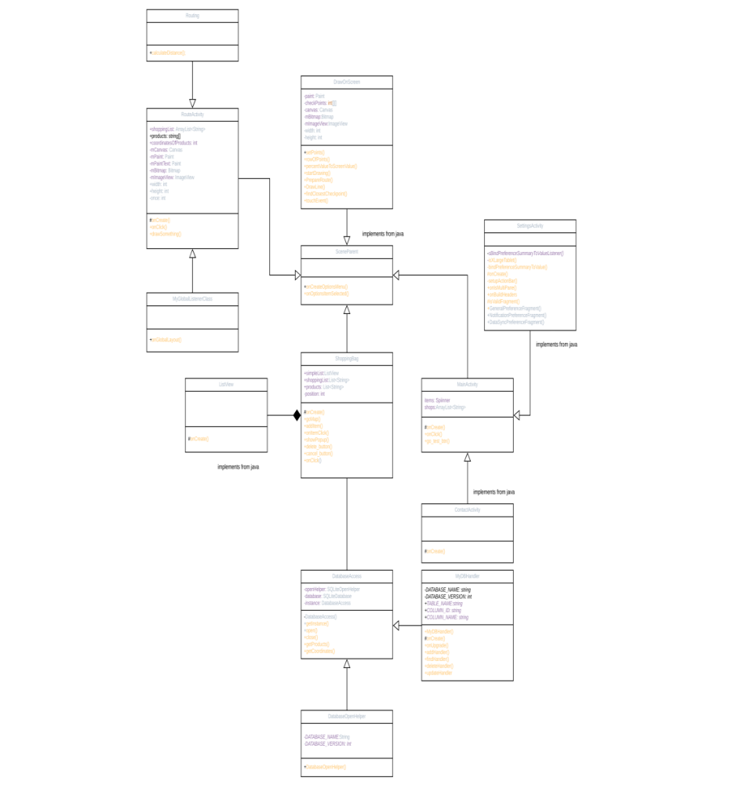

Mobile Software Project
ShopNavigator

Pascal Niedermeyer
Tobi Reinert
Rok Virant

Mobile Project work on software engineering
December 2018

table of contents
1DescriPtion 5
2USER GUIDE 6
3LEARNED LESSONS 7
4PROJECT WORK HOURS AND TASK MANAGING 8
5CLASS DIAGRAM 9
6APPLICATION SCREENSHOTS 10
7TEST REPORT 12

DescriPtion (muss mehr)
The project work is divided into three main categories on which the applications rely. The first one is application functionality, which includes the basic constructors of the application as well as the algorithm. Within the design and visual representation, we created a layout for the application which represents the actual blueprint of a Lidl shop (in our case we used the Lidl shop in Hervanta). The third categories are based on storage and connecting it to the main application. We created a fine example of 50 items in SQLite, which we then connected to the program. Each file consists of four attributes. The first one describes the name of the item and the other two are two X and Y coordinated each representing the location on the shops' blueprint and the other one representing the location on the shelve. The user has the option to view more precise location (the shelf level) of the item. The application is designed on a two-layer architecture, which means that the first layer implanted as the layout of the shop on which we placed the second layer. This layer is representing the coordinate system that provides the navigational algorithm to find the perfect path between the products. On the second layer, the algorithm places an active line which then connects the user and the selected items.
Used programs | Used languages
-Android Studio  -SQLite  -MySQL  -Blender  -JustinMind | -Java  -SQL

First, we divided the project in three parts. The surface and basis, the routing algorithm and the database with the connection.
Later in the development process, the different tasks melted together and the work was split to the active workers.

USER GUIDE

On the first page of the application, you can choose the shop, you want to get navigated through. In the current version of the shop navigator, only one shop is available.
Also to mention, you can go to the settings (currently only demo, planned to change e.g. the design of the map) and the contact page by clicking on the three dots in the upper right corner.
When going forward the next page, you can insert your shopping list. You do this by writing the needed products in the text field and adding them by clicking on the “Add” Button. It’s suggested to use the proposed results, otherwise a typo can prevent you from adding the item. If this would be the case, a small beacon would show you, that the item is not available. The items for the autocompletion are directly from the database, this way we can be sure, that the proposed items are really available, even after changing the database (in case of multiple shops). You need to add at least one item to your list, otherwise an other beacon would show you, that you cant go forward to the navigation without adding an item.
All the used strings are saved in the “strings.xml” file. This way we can easily add new languages and find misspellings.
On the navigation page, you can see the earlier selected items as a dot on the map and the suggested route in form of red lines. By clicking on them, the way to the next item is getting colored blue. As a small tip: You can use this function for identifying the next item, in the case it isn’t obvious. Therefore you click on the next possible items and the one that gets blue, is the optimal. The route always starts at the entrance and ends at the middle cashier. You can exit the navigation by clicking the “Exit” button and thereby return to the front page.

LEARNED LESSONS
Java was a language that Every member had a different focus of working with it. Some focused on the implementation and creation of the algorithm on which the program is based on, the others did construct the main bases of the program and the other created and implemented the database. We all learned the basic of Java and how implemented it in a working project. From the non-technical perspective, we also learned how imported it is to functions as a group. There could be some improvements to the meeting and defining task management. Besides the language, we also learned how important it is to fulfil and accomplished task on a fixed schedule.

During our works we learned many new things and gained many new experiences. Even thought some of us already had software projects, this was our first one for android.
That our group was build up from different nationalities with different working morales was a totally new experience for us and we learned how to act in upcoming projects.
From the technical view, everyone of ours had a knowledge of Java, that we built up on. Beside of that, we learned how to work in android, make database connections and built up an knowledge of navigation algorithms.

PROJECT WORK HOURS AND TASK MANAGING
Members | Individually work / per hours | Group work / per hour
Pascal | 100 | 10
Tobi | 85 | 10
Rok | 10 | 5

Members | Task per member
Pascal | - Setting up the project and git  - User interface  - Database rework  - Documentation rework
Tobi | - Designing the layout of the shop  - Navigation Algorithm  - Documentation rework
Rok | - Database ( + first Connection)  - Documentation

CLASS DIAGRAM

APPLICATION SCREENSHOTS

TEST REPORT
Testing was mostly performed while implementing the code. For testing we used our phones and VM's of phones. This was either white box testing from the one that created the specific code and made print out's over the console or also black box testing by the other members.
After finishing different software parts, we made bigger black box testings to ensure that following bugs will be only coming from the new code created in the new version.

