Issue No 1:
Descriptions: When hovering over the "Education" menu in the menubar, the "Ultimate Guide to Finger and Toenail Fungus" submenu is highlighted by default.
Step to reproduce:
Step 1. Launch the application from google chrome
Step 2. Global Nail Fungus Organization page should be display.
Step 3: Hover the mouse on “Education” menu in the menubar.
Actual Result: Ultimate Guide to Finger and Toenail Fungus submenu is highlighting by default.
Expected Result: Ultimate Guide to Finger and Toenail Fungus should not be highlighted by default as other sub menu is not highlighted .
Please refer below screenshot:
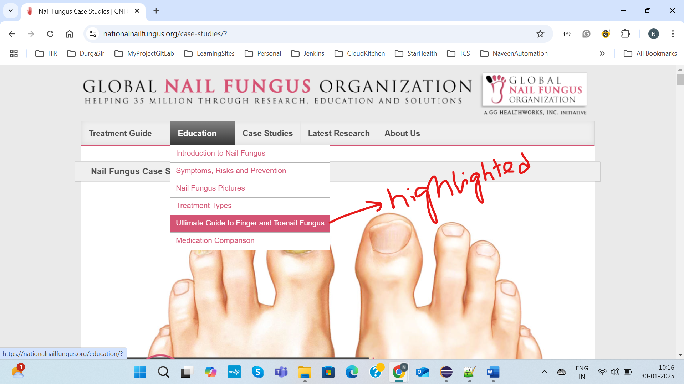
Issue 2:
Description: The alignment of the horizontal bar is inconsistent when navigating between the menu item and the sub-menu item across different pages.
Step to reproduce:
Step 1: Launch the application from Google Chrome
Step 2: Click on each menu item and the sub-menu item across different pages
Actual Result: The alignment of the horizontal bar is inconsistent.
Expected Result: The alignment should be proper while navigating between the menu item and the sub-menu item across different pages.
Please refer screenshot
