Bug Details
Issue No: 1
Title: Checkbox and label misalignment on QA AxiomPro homepage
Env: Dev
Browser: Chrome
Priority: Low
Severity: Low
Steps to Reproduce:
1. Open the Chrome browser and navigate to: https://qa.axiompro.biz/index.php
Actual Result: Check box and label not aligned properly
Expected Result: Check box and label should be aligned properly
Screenshot:
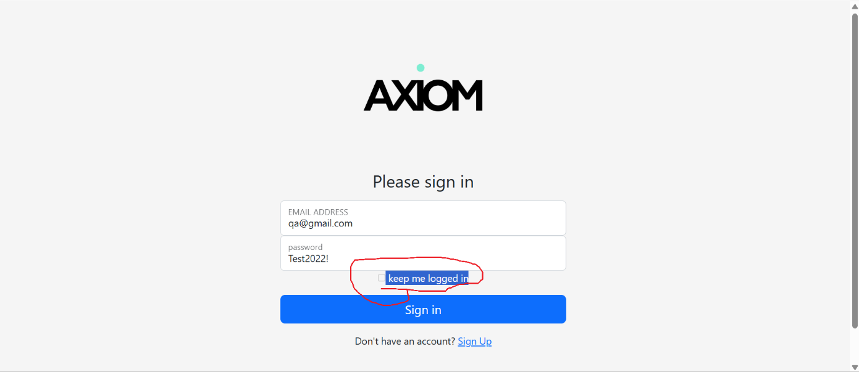

Issue No: 2
Title: Signup link navigates to 404 Not Found page
Env: Dev
Browser: Chrome
Priority: High
Severity: High
Steps to Reproduce:
1. Open the Chrome browser and navigate to: https://qa.axiompro.biz/index.php
2. Do not enter a username or password.
3. Click on the Signup link.
Actual Result: The page displays 404 Not Found.
Expected Result: The application should navigate to the user creation page, allowing users to sign up and create an account for login.
Note:
If the signup page is not ready, the link should be disabled or hidden from users.
Screenshot:
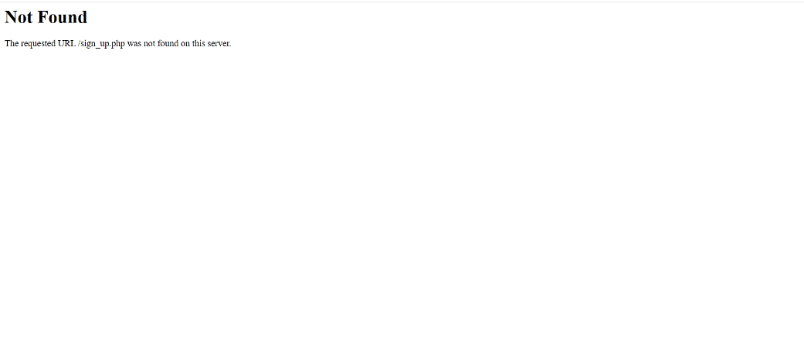

Issue No: 3
Title: Keep me logged in' checkbox is not clickable on login page
Env: Dev
Browser: Chrome
Priority: Medium
Severity: Medium
Steps to Reproduce:
1. Open the Chrome browser and navigate to: https://qa.axiompro.biz/index.php
2. Enter a valid username and password.
3. Click on the Keep me logged in checkbox.
Actual Result: The Keep me logged in checkbox is not clickable and appears to be disabled..
Expected Result: The user should be able to select the Keep me logged in checkbox to save login details in an encrypted form.
Screenshot:
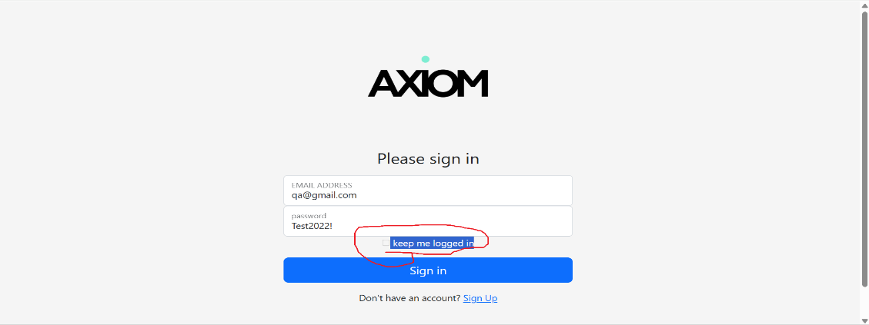

Issue No: 4
Title: Login password exposed publicly on login page
Env: Dev
Browser: Chrome
Priority: High
Severity: Critical
Steps to Reproduce:
1. Open the Chrome browser and navigate to: https://qa.axiompro.biz/index.php
2. Observe the login credentials section on the page.
Actual Result: The login password is visible publicly on the page...
Expected Result: Passwords should not be exposed publicly. Login credentials must be secured and not displayed to users.
Screenshot:
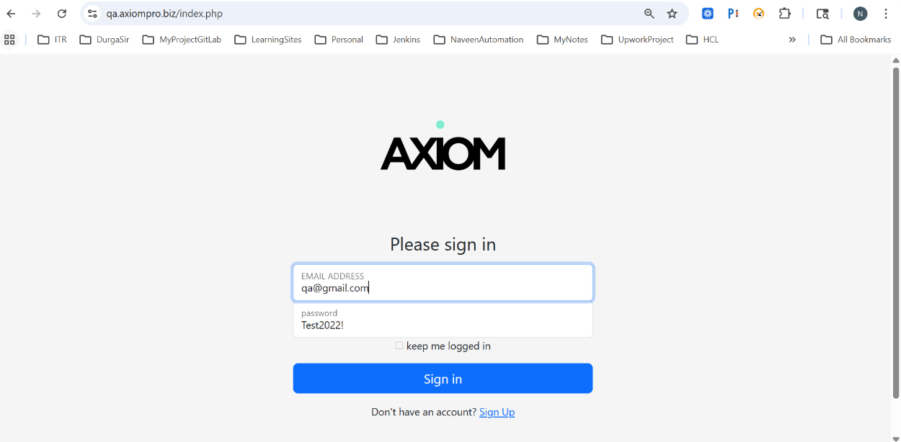

Issue No: 5
Title: Account not locked after multiple failed login attempts
Env: Dev
Browser: Chrome
Priority: Medium
Severity: High
Steps to Reproduce:
1. Open the Chrome browser and navigate to: https://qa.axiompro.biz/index.php
2. Enter an incorrect username and password.
3.Click on the Submit button.
4. Repeat the above steps three times with invalid credentials.
Actual Result: The application displays an error message for invalid credentials, but after three failed attempts, the user account is not locked.
Expected Result: After three consecutive failed login attempts, the application should lock the user account and display a message such as:
"User account is locked for 1 hour. Please try again after 1 hour."
Note: This is an expected security feature and should be implemented.
Screenshot:
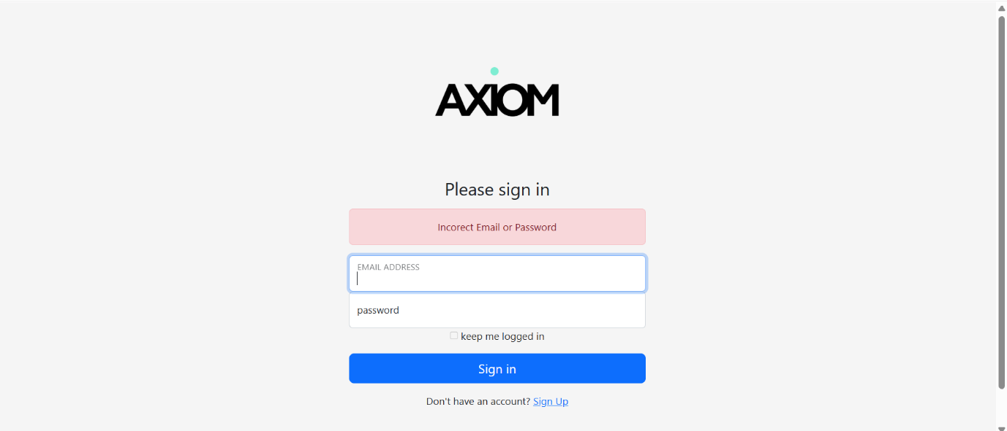

Issue No: 6
Title: Incorrect capitalisation in login error message
Env: Dev
Browser: Chrome
Priority: Low
Severity: Low
Steps to Reproduce:
1. Open the Chrome browser and navigate to: https://qa.axiompro.biz/index.php
2. Enter an incorrect username and password.
3. Click on the Submit button.
Actual Result: The error message "Incorrect Email and Password" is displayed, but the spelling and capitalisation are incorrect.
Expected Result: The message should be displayed as "Incorrect email and password," with proper spelling and formatting.
Screenshot:
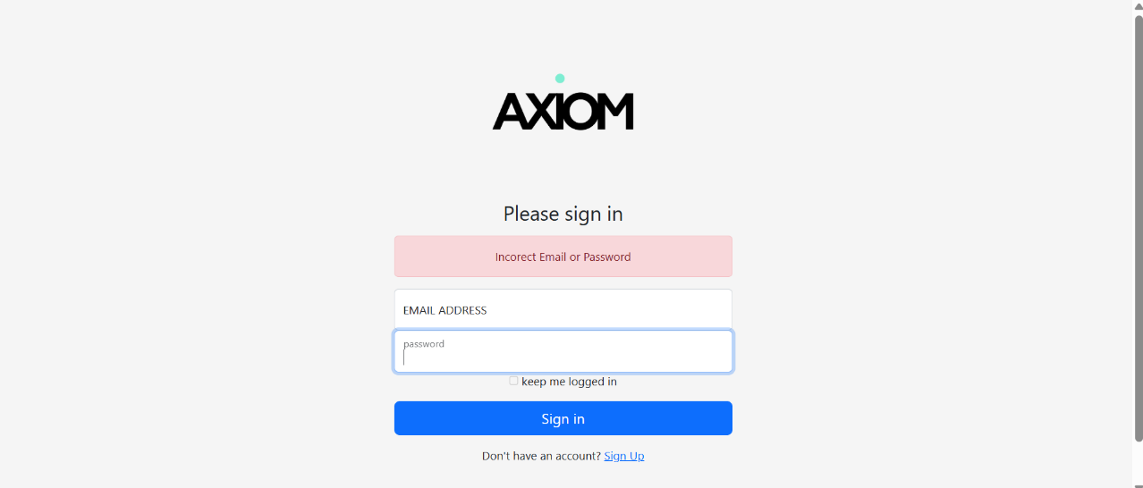

Issue No: 7
Title: Email Address floating label overlaps with input field on login page
Env: Dev
Browser: Chrome
Priority: Low
Severity: Low
Steps to Reproduce:
1. Open the Chrome browser and navigate to: https://qa.axiompro.biz/index.php
Actual Result: The Email Address floating label overlaps with the input field.
Expected Result: The Email Address label should be properly aligned and should not overlap with the input field.
Screenshot:
