**NAME:** Priyanka Nimmagadda

**StudentId:** 700734089

**GitHub Link: https://github.com/pnimmagadda0404/ML_Assignment4**

1. Apply Linear Regression to the provided dataset using underlying steps.

a. Import the given “Salary_Data.csv”

b. Split the data in train_test partitions, such that 1/3 of the data is reserved as test subset.  
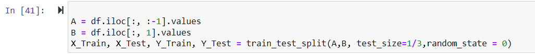

c. Train and predict the model.

d. Calculate the mean_squared error

e. Visualize both train and test data using scatter plot.

2. Apply K means clustering in the dataset provided:

• Remove any null values by the mean.

• Use the elbow method to find a good number of clusters with the K-Means algorithm

• Calculate the silhouette score for the above clustering

3. Try feature scaling and then apply K-Means on the scaled features. Did that improve the Silhouette score? If Yes, can you justify why

**3)Try feature scaling and then apply K-Means on the scaled features. Did that improve the Silhouette score? If yes, can you justify why**

A.) Accuracy not got improved, scaling the feature is required based on the use case and features what we are dealing, if two features’ scales in different in nature then scaling is required to put in same range.