

MINI PROJECT REPORT
On
CIVICBRIDGE-COMMUNITY COMPLAINT REPORTING AND
ESCALATION SYSTEM
Submitted in partial fulfilment for the award of degree
Of

Master of Computer Applications
By
ATHIRA ANIL (MLM24MCA-2022)
Under the Guidance of

Mr.ELDHOSE K PAUL
(Associate Professor, Dept. of Computer Applications)


DEPARTMENT OF COMPUTER APPLICATIONS

MANGALAM COLLEGE OF ENGINEERING, ETTUMANOOR
(Affiliated to APJ Abdul Kalam Technological University)
OCTOBER 2025

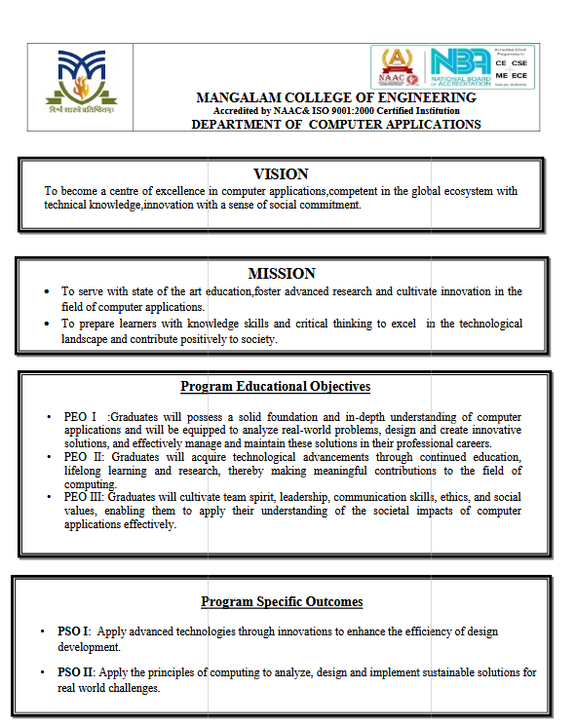

MANGALAM COLLEGE OF ENGINEERING, ETTUMANOOR

DEPARTMENT OF COMPUTER SCIENCE & ENGINEERING

OCTOBER 2025


DECLARARTION

I hereby certify that the work which is being presented in the project entitled “CivicBridge-Community complaint Reporting and Escalation System” submitted in the DEPARTMENT OF COMPUTER APPLICATIONS is an authentic record of my own work carried under the supervision of ELDHOSE K PAUL , ASSOCIATE PROFESSOR.This study has not been submitted to any other institution or university for the award of any other degree. This report has been checked for plagiarism by the college and the similarity index is within permissible limits set by the college.

Date: Name & Signature of Student

Place:

MANGALAM COLLEGE OF ENGINEERING, ETTUMANOOR DEPARTMENT OF COMPUTER SCIENCE & ENGINEERING OCTOBER 2025


CERTIFICATE

This is to certify that the Project titled “CivicBridge-Community complaint reporting and escalation system” is the bonafide record of the work done by ATHIRA ANIL (MLM24MCA-2022)of Master of computer Applications towards the partial fulfilment of the requirement for the award of MASTER OF COMPUTER APPLICATIONS by APJ ABDUL KALAM TECHNOLOGICAL UNIVERSITY, during the academic year 2025-26.

Internal Examiner
Project Guide  Mr.ELDHOSE K PAUL  Associate Professor  Department Of Computer Applications | Head of the Department  Ms. Divya S B  Associate Professor  Department of Computer Applications

ACKNOWLEDGEMENT

I am greatly indebted to the authorities of Mangalam College of Engineering for providing the necessary facilities to successfully complete my Project on the topic “CivicBridge-Community complaint reporting and escalation system”.
I express my sincere thanks to Dr. Vinodh P Vijayan, Principal, Mangalam College of Engineering for providing the facilities to complete my Project successfully.
I thank and express my solicit gratitude to Ms. Divya S B, HOD, Department of Computer Applications, Mangalam College of Engineering, for her invaluable help and support which helped me a lot in successfully completing this Project work.
I express my gratitude to my Internal Guide, Mr. Eldhose K Paul, Associate professor, Department of Computer Applications for the suggestions and encouragement which helped in the successful completion of our Project.
Furthermore, I would like to acknowledge with much appreciation the crucial role of the faculties especially Project coordinator, Ms.Banu Sumayya S, Department of Computer Applicarions, Mangalam College of Engineering, who gave the permission to use all the required equipment and the necessary resources to complete the presentation & report.
Finally, I would like to express my heartfelt thanks to my parents who were very supportive both financially and mentally and for their encouragement to achieve my goal.

ATHIRA ANIL (MLM24MCA-2022)

ABSTRACT
The CivicBridge project is a web-based application designed to improve the communication and problem-resolution process between citizens and local government authorities. Often, addressing civic issues such as road damage, waste disposal problems, streetlight malfunctions, or water supply interruptions involves slow and inefficient manual systems. CivicBridge provides a centralized online platform where citizens can conveniently register their complaints and monitor the progress of their resolution.
The system is developed using the Django framework in Python for the backend, and HTML, CSS, and JavaScript for the frontend. Once a complaint is registered, it is automatically categorized and assigned to the concerned officer based on the issue type and location. Officers can update the complaint status as they process it. If an officer is unable to handle a complaint, they can use the “Escalate” button to forward it to a higher-level officer for further action. The system also incorporates email notifications to inform users about complaint updates, ensuring smooth and transparent communication.
By offering a structured, user-friendly, and efficient platform, CivicBridge promotes accountability, enhances transparency, and simplifies the grievance redressal process. This project contributes to the development of smart governance by bridging the gap between citizens and administrative authorities.

Mapping with Sustainable Development Goals (Mention the Goal) | 9 – Industry Innovation and Infrastructure  11 –Sustainable Cities and Communities

 | TABLE OF CONTENTS
CHAPTER NO. | TITLE | PAGE NO.
 | List of Figures | I
1 | List of Abbreviations  INTRODUCTION | II  1
 | 1.1 Background | 1
 | 1.2 Introduction | 2
 | 1.3 Problem Statement | 3
 | 1.4 Motivation | 3
 | 1.5 Scope | 4
2 | LITERATURE REVIEW | 5
 | 2.1 Depression detection using emotional artificial | 5
intelligence and machine learning
  - Study of depression detection using deep learning 6
  - Depression detection and analysis using deep learning: 7
Study and comparative analysis
  - Facial emotion recognition using deep learning: 8
Review and insight
  - Emotion recognition and depression detection using 9
Deep learning

3 | PROPOSED SYSTEM | 12
 | 3.1 Users | 12
 | 3.2 Registration | 12
 | 3.3 Login | 12
 | 3.4 User Input | 13
 | 3.5 Pre-Processing | 13
 | 3.6 Feature extraction | 13
 | 3.7 Classification | 13
 | 3.8 Check result | 12
 | 3.9 Comprehensive user profile | 13

  - Online Appointment Booking 13
  - Rich Mental Health Resources 14
  - Doctor Recommendation System 14
- METHODOLOGY 16
- SYSTEM ARCHITECTURE 21
  - Dataset Collection 21
  - Data Preprocessing 21
  - Feature Extraction using CNN 22
  - Classification 22
  - Labels 22
  - Loss function 22
  - Classification 23
  - Training 23
  - Prediction 23
  - CNN 23
  - Deep reinforcement algorithm 23
  - Training image set 24
  - Data collection and analysis 24
  - Mental health prediction model 24
  - Doctor matching 25
  - Booking system 25
  - Communication platform 25
  - Feedback and monitoring 25
  - Security and privacy 25
  - integration with HER 25
  - Regular updates and maintenance 25
6 MODULES | 26
6.1 Data collection module | 26
6.2 Pre-processing module | 26
6.3 Deep learning module | 26
6.4 Reinforcement learning module | 27
6.5 Decision making module | 28
6.6 Logging and Reporting module | 28
6.7 User and registration module | 29
6.8 Loging module | 28
7 DIAGRAMS | 30
7.1 Data flow diagram (DFD) | 31
7.1.1 Level 0 DFD | 31
7.1………. | 31
7.2 | 32
7.3 | 33
7.4 | 34
8 TESTING | 35
8.1 Data collection and preparation | 35
8.2 Model training | 36
8.3 Validation and hyper parameter tuning | 37
8.4 Evaluation on test data | 38
8.5 Deploy and monitoring | 39
9 ADVANTAGES & DISADVANTAGES | 41
9.1 Advantages | 41
9.2 Disadvantages | 41
10 RESULTS | 42
11 CONCLUSION & FUTURE SCOPE | 46
APPENDICES | 48
REFERENCES | 51

