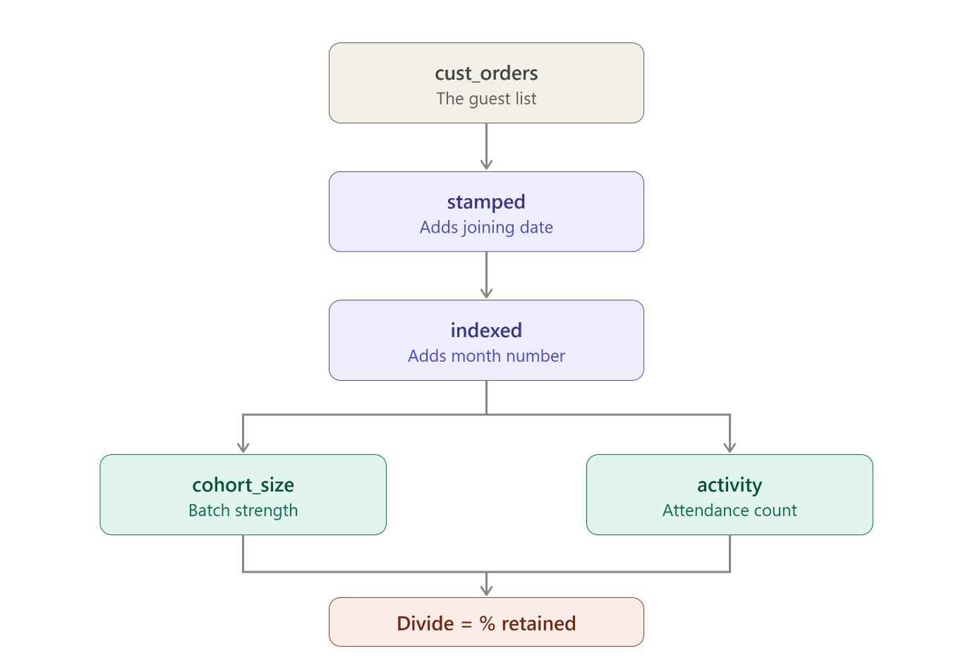
cust_orders — collect the guest list
Grab every order and attach the real person's ID to it. This is where the customers table gets joined in, because the orders table only has the throwaway customer_id. We also drop cancelled and unavailable orders — someone who tried to buy and got refunded didn't really "come back."
You end up with a simple list: person, order, date.
stamped — write the joining date on every row
For each person, find their earliest order date and write it next to all their orders.
So if you bought in January and again in March, both rows now say "this person joined in January." The March row still knows it's March. It just also knows where it came from.
That's what MIN(ts) OVER (PARTITION BY person) does. PARTITION BY person means "do this separately for each person," and OVER means "add the answer as a new column instead of squashing my rows together."
indexed — turn dates into month numbers
Two things happen. First, every date gets rounded down to the 1st of its month — Jan 15 and Jan 28 both become Jan 1, so they land in the same bucket. Second, we count how many months passed between joining and this order.
January order for a January joiner → month 0.
March order for a January joiner → month 2.
That number is the column in your heatmap.
cohort_size — how big was each batch
Count the people whose month number is 0. Those are the people joining that month, nobody else. This is the denominator — the "out of how many."
activity — how many showed up
Count distinct people for every combination of joining-month and month-number. This is the numerator.
The final SELECT — divide
Attendance ÷ batch size × 100. That's your percentage.
The is_observable column handles one last problem: someone who joined in August 2018 cannot have a month-3 order, because November 2018 doesn't exist in the data. Marking that cell as 0% would make churn look worse than it is. So we flag those cells and the chart leaves them blank instead of colouring them.

Cohort_retention
Draft of memo bullet one
Of 94,697 customers acquired between January 2017 and July 2018, only 3.5% ever placed a second order within 12 months. The rate did not improve across 20 months of trading — cohorts acquired in 2018 return at the same 1.0% within three months as those acquired in early 2017 — while monthly customer acquisition grew roughly eightfold. Growth has been entirely acquisition-driven.

