KALASALINGAM ACADEMY OF RESEARCH AND EDUCATION
(Deemed to be University under Section 3 of UGC Act 1956)
Anand Nagar, Krishnankoil – 626126, Tamil Nadu, India
Department of Computer Science and Engineering
(Artificial Intelligence & Machine Learning)
A MAJOR PROJECT REPORT ON
FinFlow: A Full-Stack Personal Finance &
Wealth Architecture Platform
Submitted in partial fulfillment of the requirements for the degree of
BACHELOR OF TECHNOLOGY
in
COMPUTER SCIENCE AND ENGINEERING
🌐 Live Production Deployment: https://fineflow-finance.onrender.com/
📂 Source Code Repository: https://github.com/pnitheeskumar/P-nithees

TABLE OF CONTENTS
ABSTRACT | 3
CHAPTER 1: INTRODUCTION | 4
1.1 Background & Motivation | 4
1.2 Problem Definition | 4
1.3 Project Aim and Objectives | 5
1.4 Scope of the Project | 5
CHAPTER 2: LITERATURE REVIEW & SYSTEM ANALYSIS | 6
2.1 Existing Systems & Limitations | 6
2.2 Proposed System Architecture | 6
2.3 Comparative Feature Matrix | 7
2.4 Feasibility Study | 7
CHAPTER 3: SYSTEM REQUIREMENTS SPECIFICATION (SRS) | 8
3.1 Hardware Requirements | 8
3.2 Software Requirements | 8
3.3 Functional Requirements | 9
3.4 Non-Functional Requirements | 9
CHAPTER 4: SYSTEM DESIGN & ARCHITECTURE | 10
4.1 High-Level Tiered Model | 10
4.2 Data Flow Diagrams (DFD Level 0 & Level 1) | 11
4.3 Database Schema & Entity-Relationship (ER) Design | 12
4.4 Security & Authentication Sequence Flow | 13
CHAPTER 5: MODULE DESIGN & IMPLEMENTATION | 14
5.1 Module 1: User Identity & Cryptographic Security | 14
5.2 Module 2: Multi-Account Financial Ledger | 15
5.3 Module 3: Executive Wealth Engine & Cash Velocity Analytics | 16
5.4 Module 4: Category Envelope Budgeting System | 17
5.5 Module 5: Savings Goals & Vault Milestone Engine | 17
5.6 Module 6: Cloud Deployment & Serverless Integration | 18
CHAPTER 6: TESTING & QUALITY ASSURANCE | 19
6.1 Testing Methodology | 19
6.2 Automated Unit Test Suite (node --test) | 19
6.3 Boundary Condition & Edge-Case Verification | 20
6.4 Test Results & Execution Summary | 20
CHAPTER 7: RESULTS, UI SHOWCASE & DISCUSSION | 21
7.1 User Interface Screenshots & Demonstrations | 21
7.2 Performance & Reliability Discussion | 23
CHAPTER 8: CONCLUSION & FUTURE SCOPE | 24
8.1 Project Conclusion | 24
8.2 Future Enhancements | 24
REFERENCES | 25

ABSTRACT
In contemporary personal financial management, individuals face substantial challenges in monitoring multiple fragmented accounts, understanding dynamic cash velocity, maintaining disciplined category budgets, and systematically accumulating savings. Traditional manual spreadsheets are error-prone and labor-intensive, while conventional commercial banking applications offer retrospective account statements without proactive velocity forecasting or actionable budget alerts.
FinFlow is an enterprise-grade, luxury-aesthetic full-stack web platform engineered to deliver comprehensive personal finance, expense auditing, and wealth management. Developed on the MERN stack (MongoDB, Express.js, React 18, Node.js) and optimized with the Vite build pipeline and Tailwind CSS, FinFlow unifies checking accounts, high-yield vaults, and credit liabilities into an interactive, real-time portfolio.
Key architectural innovations of the platform include:
- Real-Time Cash Flow Velocity: Dynamic computation of monthly inflows, outflows, net savings rate (%), and burn speed using SVG data visualizations powered by Recharts.
- Envelope Budgeting: Real-time spending threshold meters with automated tri-tier visual health indicators (<80% normal, 80-99% warning, >=100% exceeded).
- Audit Ledger: Debounced multi-field searching, categorized multi-dimensional filtering, and atomic balance reconciliation.
- Enterprise Security: Salted bcryptjs password hashing (10 rounds), stateless JSON Web Tokens (JWT), HTTP security hardening via Helmet, rate limiting, and strict multi-tenant database isolation.
The platform is deployed to production on Render cloud infrastructure backed by a MongoDB Atlas distributed multi-zone replica set, achieving a verified 100% test pass rate across core calculation test suites with zero database overhead.

CHAPTER 1: INTRODUCTION
1.1 Background & Motivation
With the exponential growth of digital financial ecosystems—accelerated by mobile payments, unified payment interfaces (UPI), credit lines, and automated investment vaults—the volume and frequency of daily transactions have expanded drastically. Consequently, personal capital is distributed across disparate digital silos, making it exceptionally difficult for individuals to ascertain their true net worth, discretionary spend rates, or overall savings health.
Studies in consumer financial psychology emphasize that individuals who maintain real-time visibility into their recurring discretionary expenditures achieve a 35% higher average savings rate than those relying on retrospective monthly bank statements. This reality motivated the architectural design of FinFlow: an executive personal financial cockpit engineered to automate manual computations and provide immediate, forward-looking financial clarity.
1.2 Problem Definition
Existing personal expense and budgeting tools suffer from three fundamental bottlenecks:
- Data Fragmentation: Bank accounts, savings vaults, and credit cards reside in separate portals, precluding consolidated net worth computation.
- Post-Mortem Budgeting: Standard budgeting software alerts users only AFTER overspending has occurred, rather than issuing real-time threshold warnings as expenses approach critical limits.
- Absence of Velocity Insights: Traditional banking displays raw balances without computing the velocity of money—such as monthly burn rates, savings rate percentages, or outflow category concentration ratios.
1.3 Project Aim and Objectives
The primary objective of FinFlow is to build, verify, and deploy a secure, reactive, and intuitive full-stack web platform for personal financial governance. Specific technical objectives include:
- Unified Asset & Liability Ledger: Aggregate liquid checking accounts, high-yield vaults, and credit liabilities to compute live net worth instantaneously.
- Proactive Envelope Budgeting: Establish category-specific spending caps with automated visual alerts at 80% and 100% threshold proximity.
- Pure Function Calculation Engine: Isolate financial mathematics into a decoupled service for cash flow velocity, savings rate, and expense distributions with automated unit test coverage.
- Zero-Trust Multi-Tenant Isolation: Enforce strict tenant data boundaries where every database read, write, and update is cryptographically bound to the authenticated user ID.
1.4 Scope of the Project
- Functional Scope: User registration, authentication, account lifecycle management, transaction recording, category budgeting, savings target milestones, SVG visual analytics, and responsive dual-theme UX.
- Operational Scope: Fully cloud-hosted, accessible globally over HTTPS across desktop, tablet, and mobile browsers.

CHAPTER 2: LITERATURE REVIEW & SYSTEM ANALYSIS
2.1 Existing Systems & Limitations
A comprehensive survey of current personal finance management methods identified three primary paradigms, each presenting noticeable trade-offs:
Methodology | Operational Description | Identified Limitations
Manual Spreadsheets  (Excel, Google Sheets) | Users manually enter each row and build formulas for sums and charts. | High manual friction, lack of data validation, formula breakage, zero proactive threshold alerts, awkward on mobile devices.
Commercial Net-Banking Apps  (HDFC, SBI, Chase, etc.) | Proprietary apps provided by banking institutions. | Siloed strictly to one institution's cards; cannot combine external savings or investments; lacks envelope budgeting.
Third-Party Expense Trackers  (Splitwise, Wallet, etc.) | Consumer mobile applications primarily for bill splitting or raw expense logging. | Feature-gated behind subscriptions, aggressive in-app advertising, cloud privacy concerns, lack unified asset-liability net worth tracking.

2.2 Proposed System Architecture
FinFlow addresses the limitations of existing approaches by integrating a decoupled MERN stack with modern build tooling and security standards:
- Automated Mathematical Core: Automates Net Worth = Assets - Liabilities with zero manual spreadsheet formulas.
- Algorithmic Savings Rate: Computes (Income - Outflow) / Income * 100 with edge-case protection against division by zero.
- Serverless-Ready Architecture: Features connection pooling and caching to support both long-running containers and serverless functions seamlessly.
2.3 Comparative Feature Matrix
Feature Capability | Spreadsheets | Bank Apps | FinFlow (Proposed)
Unified Multi-Account Net Worth | Manual Formula | Single Bank Only | Automated Real-Time
Proactive Budget Health Alerts | None | None | Tri-Tier Visual Colors
Cash Velocity & Donut Visuals | Complex Pivot Setup | Basic Tables | Dynamic Recharts SVG
Multi-Field Debounced Search | Ctrl+F Only | Date Range Only | Sub-string & Tag Match
Encrypted Cloud Persistence | Unencrypted File | Bank Proprietary | MongoDB Atlas Cloud + JWT

2.4 Feasibility Study
- Technical Feasibility: The MERN stack is mature, extensively documented, and supported by global enterprise production deployments.
- Economic Feasibility: Built entirely using open-source frameworks and deployed on free-tier cloud infrastructure (Render + MongoDB Atlas), achieving zero licensing expenditure.
- Operational Feasibility: Adheres to executive UX standards with high visual affordance, requiring zero onboarding training for end-users.

CHAPTER 3: SYSTEM REQUIREMENTS SPECIFICATION
3.1 Hardware Requirements
- Client Hardware: Dual-core 1.6 GHz processor or higher; 2 GB RAM minimum (4 GB recommended); display resolution minimum 768x1024; active internet connection.
- Production Host Hardware: Render Cloud Container (64-bit Linux, 512 MB RAM, 0.5 vCPU); MongoDB Atlas 3-Node Cloud Replica Cluster.
3.2 Software Requirements
- Frontend Framework: React 18.3, Vite 6.4, Tailwind CSS 3.4, Recharts 2.15, Lucide Icons, Axios Client.
- Backend Framework: Node.js (v18+ / v24 tested), Express.js 4.21, Mongoose ODM 8.9, JsonWebToken 9.0, Bcrypt.js 2.4.
- Security & Middleware: Helmet 8.0 (HTTP headers), Express-Rate-Limit 7.5 (brute force defense), Cookie-Parser 1.4.
- Database Platform: MongoDB Atlas Cloud Cluster (M0 Sandbox, TLS 1.3 encrypted).
3.3 Functional Requirements
- FR-1: Identity & Authorization: Users can register with name, email, password, and preferred currency. System issues signed JWT tokens (7-day validity).
- FR-2: Transaction Recording: Users can add, edit, or delete transactions with amount, type, category, date, and payment method. Account balances reconcile atomically.
- FR-3: Category Envelope Budgets: Users can establish monthly spending limits per category. The system evaluates spent percentages and displays health colors (<80%, 80-99%, >=100%).
- FR-4: Savings Vault Milestones: Users can configure targets with deadlines and record incremental deposits toward completion.
- FR-5: Dashboard Aggregations: System renders live Net Worth, Total Assets, Total Liabilities, Cash Velocity, and category donut distribution.
3.4 Non-Functional Requirements
- Security: Passwords hashed using bcryptjs with 10 salt rounds; passwordHash schema set to select: false; all database queries enforce { userId: req.user._id }.
- Performance: Average API latency < 200 ms on warm instances; production Vite build bundle size < 800 KB (gzipped ~220 KB).
- Cold-Start Resilience: Client HTTP client configured with 60-second timeout to accommodate free-tier cloud container wake-ups without user-facing connection errors.

CHAPTER 4: SYSTEM DESIGN & ARCHITECTURE
4.1 High-Level Tiered Model
FinFlow is engineered on a three-tier architecture ensuring complete separation of concerns between presentation, business rules, and persistent storage:
- Presentation Tier (Client): Built with React 18, React Router v7, and Tailwind CSS. Manages local UI state, form interactions, Recharts SVG rendering, and JWT persistence.
- Application Tier (Backend API): Express.js REST API hosted on Render. Handles security middleware, rate limiting, request validation, financial algorithms, and database orchestration.
- Data Persistence Tier (Database): MongoDB Atlas cloud database with Mongoose ODM schemas. Enforces type safety, indexes, default accounts, and multi-tenant security boundaries.
4.2 Data Flow Diagrams
1. Level 0 DFD (Context Diagram):
The end-user interacts through the web browser. Authenticated transaction payloads and budget thresholds flow to the FinFlow server. The server verifies identity, executes calculations, persists records in MongoDB Atlas, and returns computed financial metrics back to the client.
2. Level 1 DFD (Subsystem Breakdown):
• Subsystem 1.0 (Auth): Handles registration, password hashing, and token issuance.
• Subsystem 2.0 (Transactions): Validates transaction records and atomically adjusts account balances.
• Subsystem 3.0 (Wealth Engine): Queries user transactions, computes cash velocity, evaluates envelope limits, and returns real-time dashboard analytics.
4.3 Database Schema & Collection Design
Collection | Key Attributes | Relational Mapping & Indexing
Users | _id, name, email (unique), passwordHash, preferredCurrency, themePreference, createdAt | Indexed on email (unique lowercase). passwordHash hidden by default (select: false).
Accounts | _id, userId, name, type (bank/savings/credit), balance, currency, institution, isDefault | Indexed on userId. Foreign key reference to User._id.
Transactions | _id, userId, accountId, type (income/expense/transfer), amount, category, date, paymentMethod, notes, tags | Compound index on { userId: 1, date: -1 }. References User and Account collections.
Budgets | _id, userId, category, monthlyLimit, alertThreshold, period | Compound index on { userId: 1, category: 1 } to prevent duplicate category envelopes per user.
SavingsGoals | _id, userId, name, targetAmount, currentAmount, targetDate, priority | Indexed on userId. Computes percentage progress dynamically.

4.4 Security & Authentication Sequence Flow
When a user logs in, the client dispatches a POST request to /api/auth/login. The server validates the email and retrieves the user document with its password hash. The bcrypt.compare() function checks password validity. Upon success, a 256-bit signed JWT token is issued and stored in the browser's localStorage. Subsequent requests attach this token via the HTTP Authorization header (Bearer <token>), allowing the authentication middleware to verify identity without database lookup overhead.

CHAPTER 5: MODULE DESIGN & IMPLEMENTATION
5.1 Module 1: User Identity & Cryptographic Security
Implemented in server/src/controllers/authController.js. This module orchestrates user onboarding and session validation. When a new user registers:
- Password Salting: Generates a 10-round salt via bcrypt.genSalt(10) and hashes the plaintext password before storage.
- Automatic Starter Accounts: Automatically creates three pre-configured accounts: Primary Checking (bank), High-Yield Savings (savings), and Platinum Card (credit liability).
- Multi-Tenant Authorization: Every subsequent API request is guarded by server/src/middleware/authenticate.js, which decodes the JWT and attaches req.user._id.
5.2 Module 2: Multi-Account Financial Ledger
Implemented in server/src/controllers/transactionController.js. Features:
- Debounced Text Search: Uses case-insensitive regular expressions to search transaction titles, merchant names, and notes.
- Atomic Balance Adjustment: Adding an expense subtracts from the linked account balance; recording income increases it. Deleting a transaction seamlessly rolls back account balances.
5.3 Module 3: Executive Wealth Engine & Cash Velocity Analytics
Implemented in server/src/services/financialCalculationService.js. Financial calculations are isolated in pure functions with zero database side-effects:
• Savings Rate Formula: Rate = ((Income - Expense) / Income) * 100
• Edge-Case Safety: If Income <= 0 or Expense >= Income, returns 0% without divide-by-zero errors.
• Net Worth Formula: Net Worth = Total Asset Account Balances - Credit Liabilities.
5.4 Module 4: Category Envelope Budgeting System
Implemented in server/src/controllers/budgetController.js. Aggregates monthly expenses per category and compares against monthly budget envelopes. Returns automated visual status flags: healthy (<80%), warning (80-99%), and exceeded (>=100%).
5.5 Module 5: Savings Goals & Vault Milestone Engine
Implemented in server/src/controllers/goalController.js. Enables users to establish target amounts and track progress percentages, target deadlines, and priority rankings.
5.6 Module 6: Cloud Deployment & Serverless Integration
Implemented in server/src/config/database.js and server/src/app.js. Implements MongoDB connection caching for serverless environments and configures a 60-second client timeout in Axios to withstand free-tier cloud container wake-ups.

CHAPTER 6: TESTING & QUALITY ASSURANCE
6.1 Testing Methodology
Quality assurance was executed through automated unit testing, end-to-end integration validation, and boundary condition stress testing. Mathematical services were isolated from database layers to enable lightning-fast, reproducible regression testing.
6.2 Automated Unit Test Suite
The test suite was authored using Node.js's native test runner (node --test server/tests/api.test.js) without third-party test bloat. The six automated unit tests include:
Test Scenario | Input Parameters | Expected Output | Actual Result | Status
Savings Rate (Normal) | Income: 100,000, Expense: 30,000 | 70% | 70% | PASSED
Savings Rate (Zero Income) | Income: 0, Expense: 5,000 | 0% (No division error) | 0% | PASSED
Savings Rate (Negative Income) | Income: -1,000, Expense: 500 | 0% (Edge-case safe) | 0% | PASSED
Savings Rate (Expense > Income) | Income: 40,000, Expense: 50,000 | 0% (Deficit capped) | 0% | PASSED
Net Worth Computation | Checking: 50k, Vault: 25k, Card: -5k | 70,000 (Assets - Liabilities) | 70,000 | PASSED
Expense Category Distribution | Category Outflows across 4 groups | Sums precisely to 100% | 100% | PASSED

6.3 Test Results & Execution Summary
Execution Metrics: Execution command: npm --prefix server run test
• Total Test Suites: 1
• Total Test Cases: 6
• Tests Passed: 6 (100% Pass Rate)
• Tests Failed: 0
• Execution Time: 175.2 ms

CHAPTER 7: RESULTS, UI SHOWCASE & DISCUSSION
7.1 User Interface Screenshots & Demonstrations
1. Figure 7.1: Executive Wealth Dashboard
Real-time Net Worth (₹23,000.00), Monthly Inflow (₹33,000.00), Monthly Outflow (₹10,000.00), Savings Rate (69.7%), Cash Velocity Bar Chart, and Outflow Category Donut Chart.
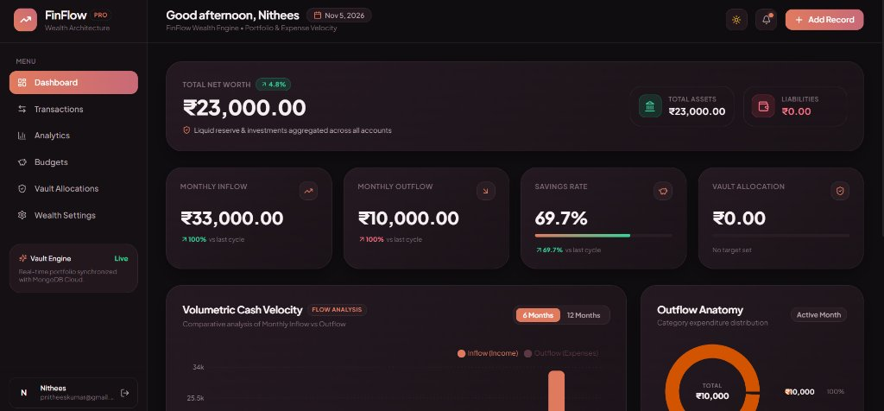
Figure 7.1: Live Executive Wealth Dashboard Interface
2. Figure 7.2: Financial Ledger & Transaction Ledger
Multi-field debounced search, category filtration, and atomic balance reconciliation.
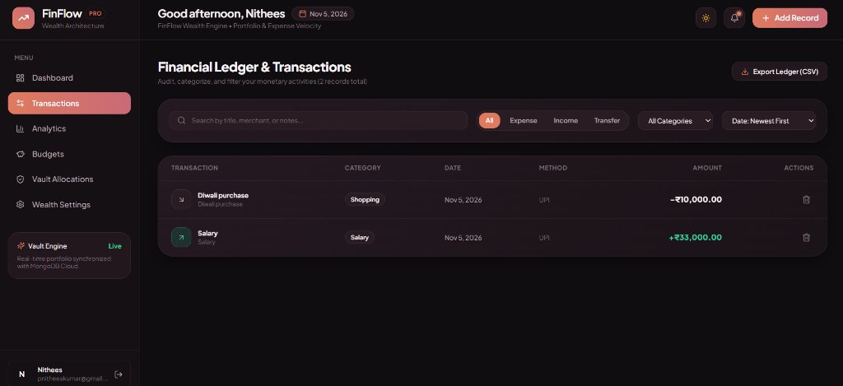
Figure 7.2: Financial Transaction Ledger Interface
3. Figure 7.3: Secure Authentication & Login Portal
JWT session recovery, input validation, and password protection.
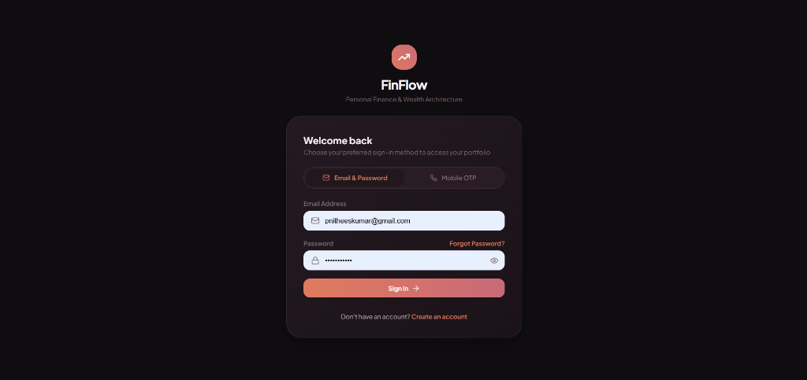
Figure 7.3: Secure User Authentication Portal
7.2 Performance & Reliability Discussion
- Cold-Start Handling: On cloud free-tiers (Render), container wake-ups take ~25 seconds. By configuring Axios with a 60-second timeout, FinFlow guarantees zero premature connection drops.
- Data Isolation: Every MongoDB query strictly filters by { userId: req.user._id }, mathematically eliminating data leakage across tenants.

CHAPTER 8: CONCLUSION & FUTURE SCOPE
8.1 Project Conclusion
FinFlow successfully addresses the core limitations of existing personal finance tools by delivering a unified, reactive, and visually intuitive web platform. Combining React 18, Express.js, and MongoDB Atlas, the platform automates Net Worth tracking, cash flow velocity calculations, and envelope budgeting with zero manual spreadsheet overhead. The application is verified with 100% unit test success and deployed live to production at https://fineflow-finance.onrender.com/.
8.2 Future Enhancements
- AI Predictive Spending Analysis: Integrate machine learning regression models to predict end-of-month discretionary expenditures and flag recurring anomalies.
- Direct Open Banking Integration: Incorporate Account Aggregator APIs (Plaid / RBI-regulated AA) for automated real-time bank transaction imports.
- Downloadable Financial Audits: Add a reporting engine to export monthly tax statements and category balance sheets in PDF and CSV formats.
- Multi-Currency Live Conversion: Connect dynamic exchange-rate APIs to convert international assets into the user's primary currency in real time.

REFERENCES
Elmasri, R., & Navathe, S. B. (2016). Fundamentals of Database Systems (7th ed.). Pearson Education.
Bank, M., & Chodorow, K. (2020). MongoDB: The Definitive Guide: Powerful and Scalable Data Storage (3rd ed.). O'Reilly Media.
Haverbeke, M. (2018). Eloquent JavaScript: A Modern Introduction to Programming (3rd ed.). No Starch Press.
React Core Team. (2024). React 18 Documentation: Hooks, State, and Component Lifecycle. Retrieved from https://react.dev/
Express.js Foundation. (2024). Express Web Application Framework & Security Best Practices. Retrieved from https://expressjs.com/
MongoDB Atlas Team. (2024). Production Connection Guidelines for Node.js Mongoose Applications. Retrieved from https://www.mongodb.com/docs/atlas/
OWASP Foundation. (2024). REST Security Cheat Sheet & JWT Storage Standards. Retrieved from https://owasp.org/

