**[The ACT Science Test: Biology Basics](http://grockit.com/blog/the-act-science-test-biology-basics/" \o "Permanent Link: The ACT Science Test:  Biology Basics)**

The ACT Science test contains passages on a variety of scientific subjects: biology, chemistry, physics, earth sciences, etc. According to the Official ACT website: *“Advanced knowledge in these subjects is not required, but background knowledge acquired in general, introductory science courses is needed to answer some of the questions. The test emphasizes scientific reasoning skills over recall of scientific content, skill in mathematics, or reading ability.”*

While this means that you do NOT have to be an excellent Science student to score highly on the ACT Science test, some knowledge of the concepts tested and a familiarity with the presentation of certain concepts will almost certainly lead to better scores.

[Test your ACT science skills with this ACT science practice question.](https://www.grockit.com/act/questions/638)

Passages dealing with Biology may feature some of these concepts: **body systems, cellular biology, photosynthesis, ecosystems, evolution,**and**genetics.** If you are currently in Biology, or have an old Biology book, you may want to review these fundamentals so that you are comfortable with the terminology in the passages. Again, however, ***all the information you need to answer the questions will be presented in the passages***. So there will be no questions such as, “what is the difference between mitosis and meiosis?”, unless that answer is to be found explicitly in the given text.

This example of a Biology passage is from actstudent.org. Look how we can approach it without any outside knowledge! The layout of the passage is very clear:

[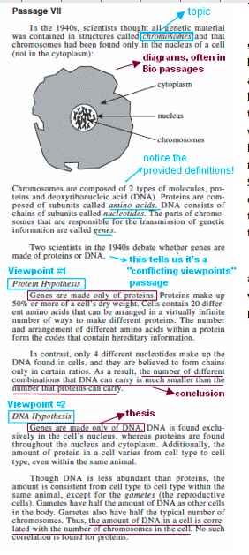](http://grockit.com/blog/wp-content/uploads/2011/07/Picture-1.png)-

Introduction of topic

–        Diagram

–        Definition of terms

–        Viewpoint #1

–        Viewpoint #2

Our understanding of the viewpoints makes this more like a Biology-themed Reading Test passage than anything you would see on a Biology quiz.

To practice your approach on this Conflicting Viewpoints passage, first refresh your strategy [here](http://grockit.com/blog/collegeprep/2009/11/02/act-science--conflicting-viewpoints/), then check out p.54 of the Official ACT Student guide [here](http://www.act.org/aap/pdf/preparing.pdf) to work on the questions that accompany this passage!

For more practice with Biology passages, create a Custom Game in[Grockit’s ACT lobby](https://grockit.com/act/info); use “Biology” as your skill tag. For even more help, schedule a 1-hour tutoring lesson with any of [Grockit’s ACT tutors](https://grockit.com/act/instructors). Check out the “Tutoring” tab in the ACT Grockit lobby for more info!