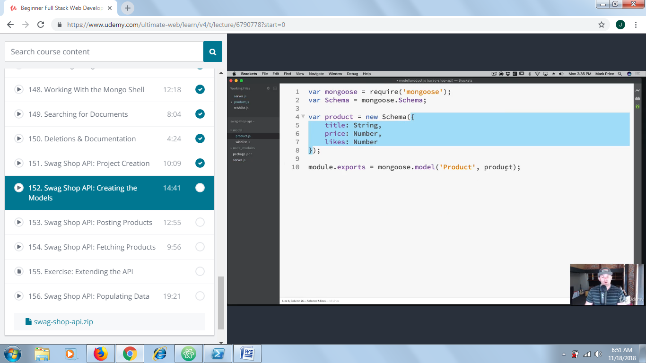

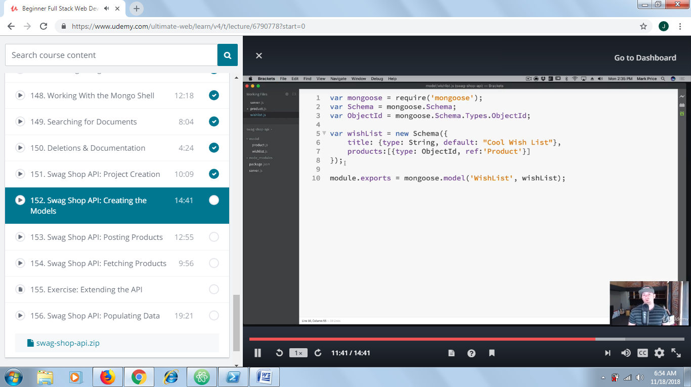

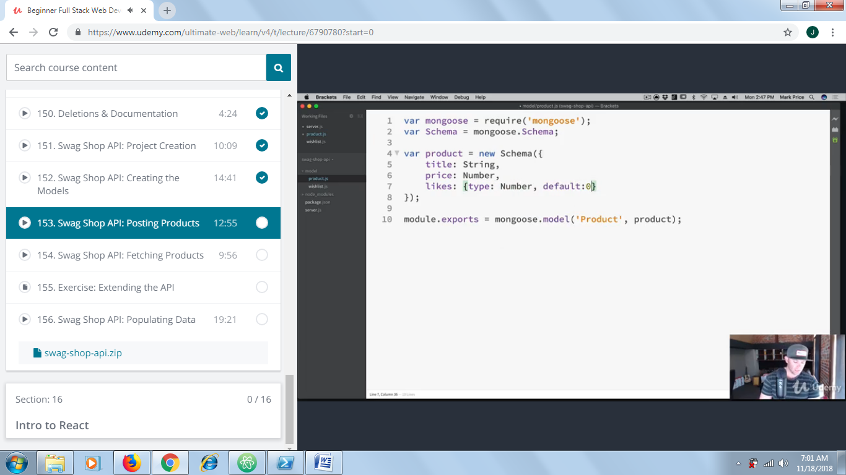

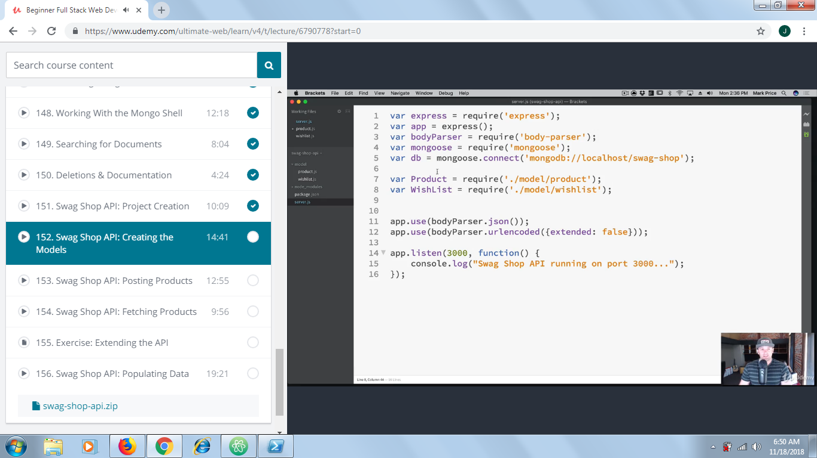

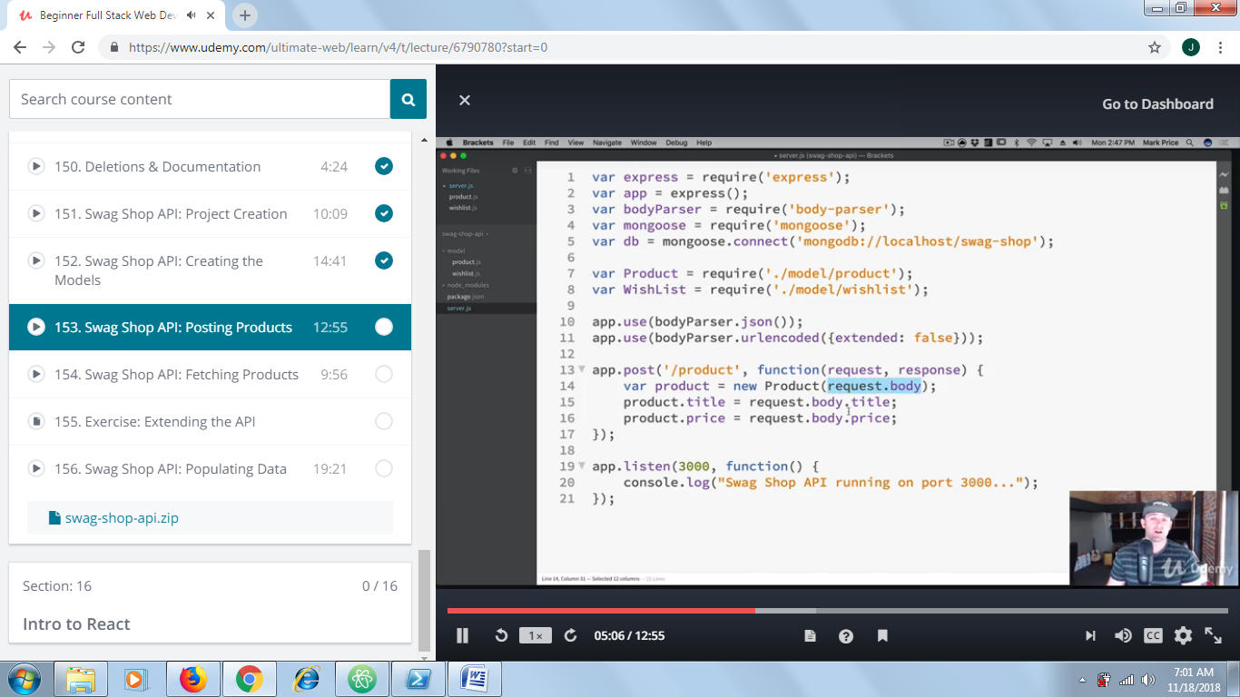

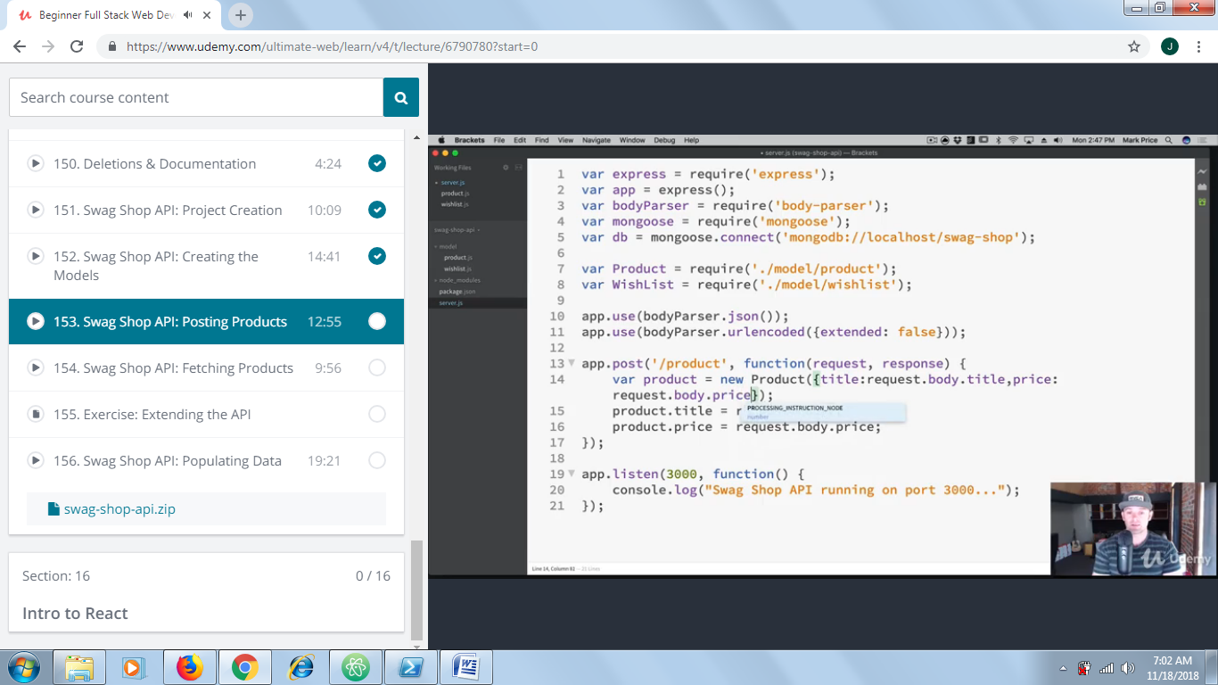

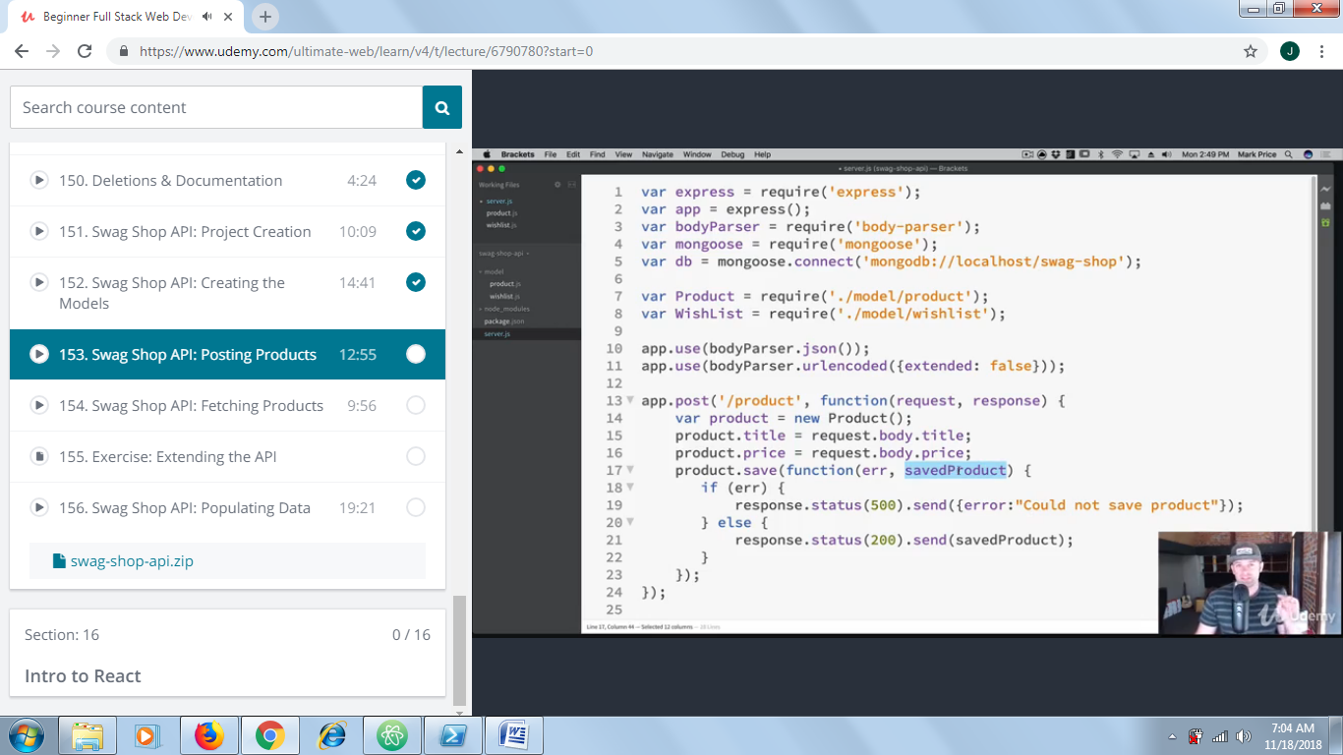

We can also do response.json(savedProduct)
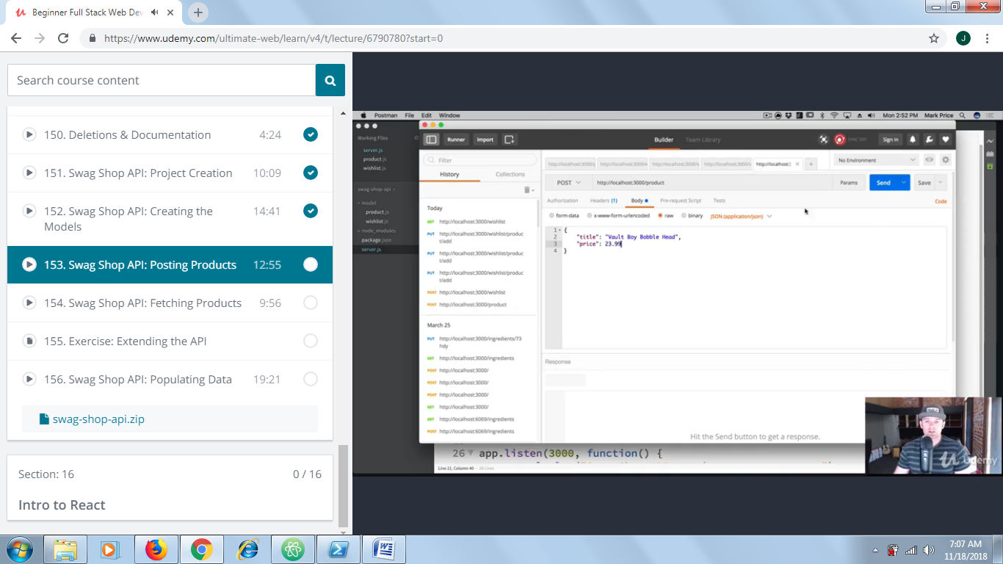

>show dbs;
>use <database>
>db.products.find({});
https://mongoosejs.com/docs/api.html#model_Model.find

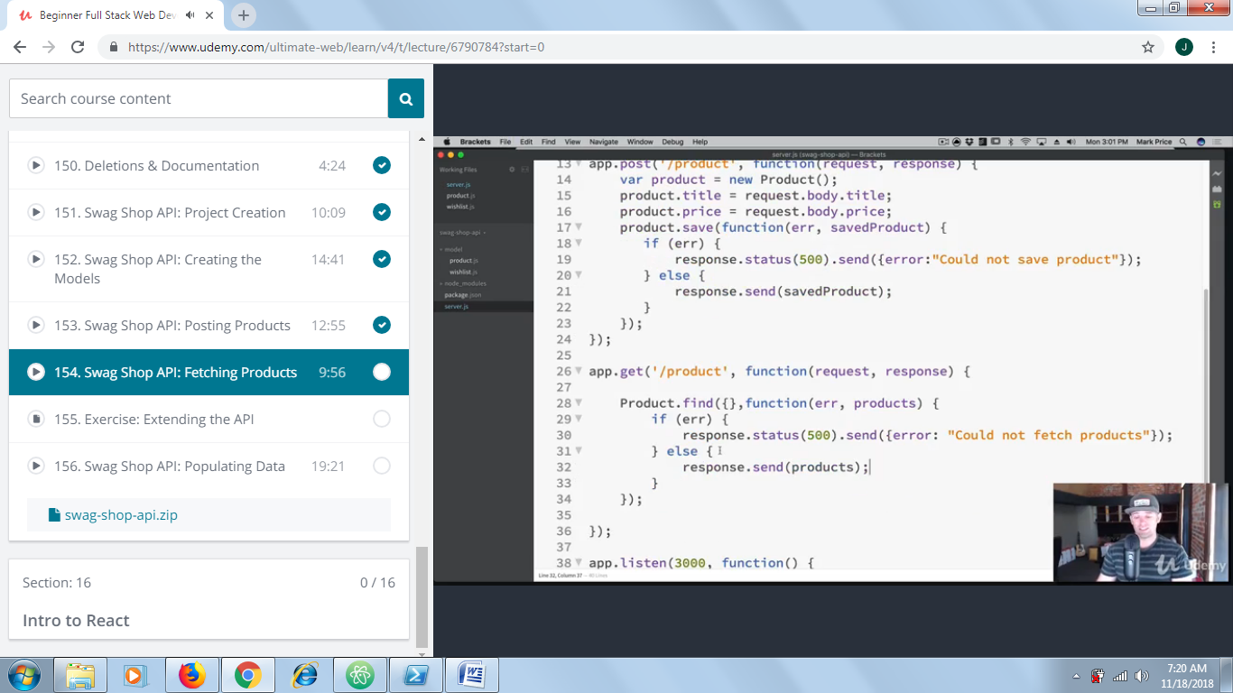
You are going to extend our API and add more functionality.
Requirements:
- Figure out how to move your routes ie app.get('/') into a separate routes file to clean up space in the server.js file
- Create endpoints for /cart and create the ability for a user to store and remove things from their cart. You will need to create the appropriate Mongoose Models.
- Create an endpoint for /sale-items. You will need to create the appropriate Mongoose Models. SaleItems model should have an array called relatedItems that shows other related products. Be sure to populate this array when fetching via the API.
- Experiment and have fun!
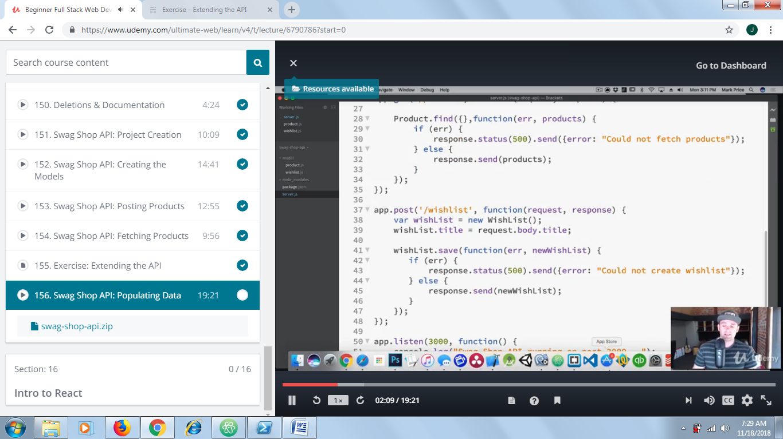

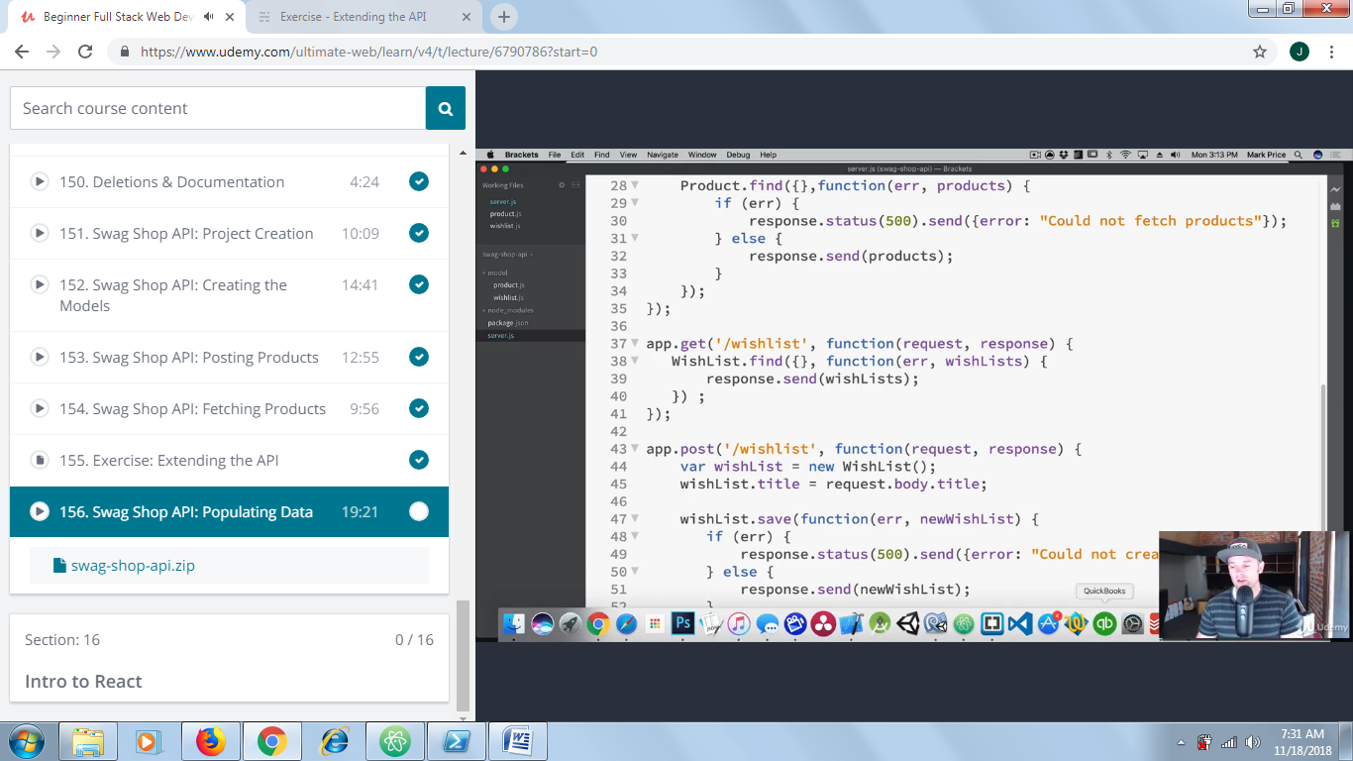
Test it out using postman.

Next is adding item to wish list – called put – wishlist/product/add

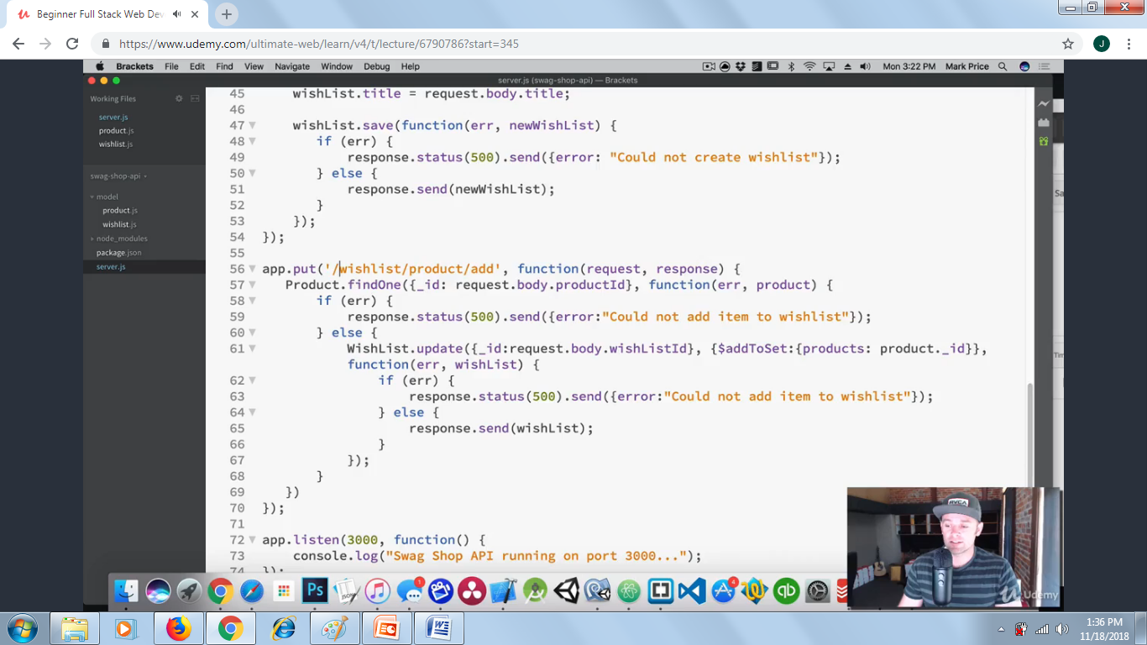
Testing
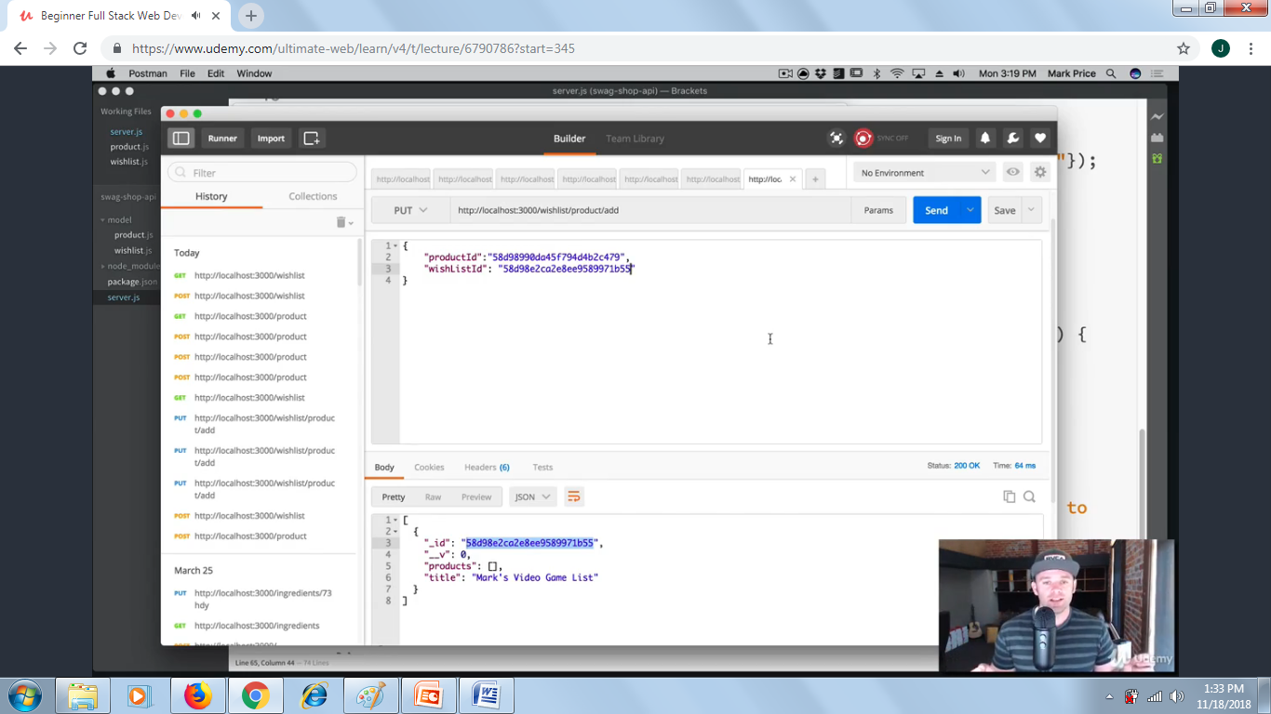
Now get the wish list again – but we have only the product Id – so we will go back and modify get wish list to show the product.


