Group members: Prachi Kapadia, Nishita Acharya, and Zaysham Asad (group#: 6)

Architecture of dummy Content Delivery Network:

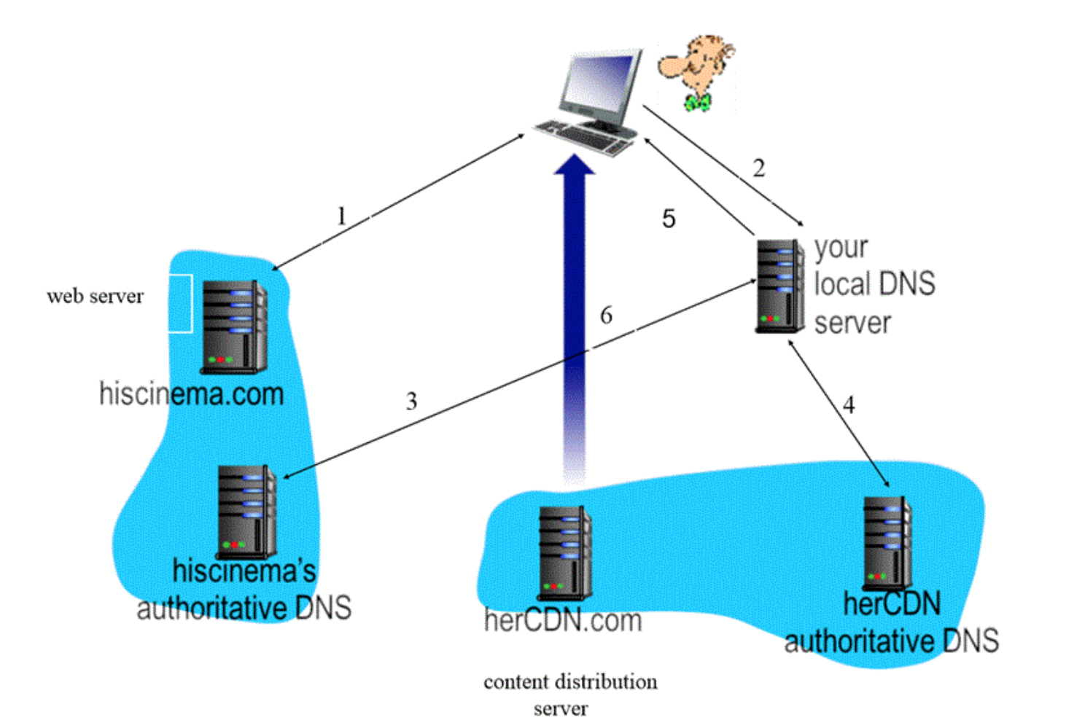

1. Firstly, the client would choose to contact hiscinema.com by writing the link of the video
2. This would direct client to the Local DNS server
3. Local DNS has hiscinema.com’s authoritative DNS and contacts it.
4. Hiscinema.com’s authoritative DNS responds with IP address of herCDN.com’s authoritative DNS server.
5. herCDN.com’s authoritative DNS server returns the IP address for [www.herCDN.com](http://www.herCDN.com).
6. We could not get this part to work but it is intended to perform this: The content server herCDN.com should deliver the content to client using HTTP.