THE UNIVERSITY OF DA NANG - UNIVERSITY OF SCIENCE AND TECHNOLOGY
FACULTY OF ELECTRONICS AND ARTIFICIAL INTELLIGENCE




FINAL PROJECT LOG BOOK

TEAM MEMBERS:  (with email and phone number) | Phan Nữ Kiều Hạnh (L)  pnkhbk@gmail.com  0935166106  Đoàn Minh Hiếu  hieudoan278@gmail.com  0845357988  Đỗ Lâm Khánh  dolamkhanh2603@gmail.com  0936426283  Nguyễn Minh Hoàng  nminhhoang001@gmail.com  0905639739
PROJECT NAME | BumbleBee - Smart Apiary Monitoring System
START OF PROJECT DATE: | 17/08/2026
COMPLETION OF PROJECT DATE:

EVALUATION GUIDELINES

Theoretical Knowledge | Theory Application skills | Use of advanced tools and measuring equipment | Integration of Skills Learned/  Competencies gained | Working speed | Accuracy | Interpersonal Relations | Diligence Motivation | RATING
Has little knowledge | Can not apply any theory | Can not use advanced  equipment effectively without assistance | Has not integrated any skills | Very slow | It is never accurate and always has to be reworked | Does not get along with any of the staff | Does nothing unless instructed | 1
Recalls some knowledge | Can apply theory with assistance | Slowly learns to use advanced equipment | Integrated some of the skills documented | Seldom finishes tasks on time | Often has to rework | Positively interacts with most of the staff | Does just enough to stay out of trouble | 2
Knows the basics | Can apply basic theory | Can use most advanced equipment | Competent in integrating skills documented | Just finishes tasks on time | Just according to spec. | Positively interacts with all the staff | Shows a willingness to work | 3
Good knowledge | Can apply high-level theory | Can select and use advanced equipment effectively | Effectively integrates theory and practice in all tasks | Normally on time or ahead of time | Work is always better than expected | Is accepted by staff as a person with good personal skills | Normally looks for work to do | 4
Excellent knowledge and continually improves knowledge | Can analyze and synthesize | Selects and uses advanced equipment optimally | Innovatively integrates all theoretical and practical skills learned | Always finishes ahead of the allocated time | Excellent levels of accuracy, consistency, and finish | Uses personality effectively to influence people positively | Ambitious and eager to prove talents /skills beyond requirements | 5

TABLE OF CONTENTS
TABLE OF CONTENTS 3
DESIGN STEPS 1: PROBLEM IDENTIFICATION 4
1.1. Brainstorm initial problem 4
1.2. Problem 9
1. Problem 1: Difficulty in maintaining optimal plant care due to lack of time, knowledge, and real-time monitoring. 9
2. Problem 2: Wasting electricity, increasing household expenses” 10
3. Problem 3: Manual attendance methods are time-consuming, error-prone, and inefficient, making it difficult to ensure accuracy, prevent proxy attendance, and generate reliable records. 11
4. Problem 4:Inefficient, unsafe, and hard-to-control electricity usage 12
5. Problem 5: Difficulty in maintaining stable water conditions in fish tanks due to lack of continuous monitoring and control, leading to risks for fish health and survival. 13
6. Problem 6: Lack of awareness and monitoring of household water quality, leading to potential health risks. 14
7. Problem 7: Children, pets, or disabled people can be trapped inside locked cars, creating serious risks of heatstroke, suffocation, or death. 15
8. Problem 8: Difficulty finding available parking spaces causes drivers to waste time and fuel, while parking operators struggle to manage parking spaces efficiently. 16
9. Problem 9: Poor air quality and high levels of dust and harmful gases at construction sites can threaten workers’ health and affect nearby communities. 17
10. Problem 10: Elderly people living alone may experience falls or sudden health problems without being able to call for help in time. 18
11. Problem 11: Lack of real-time inventory monitoring causes stockouts, overstocking, inaccurate inventory records, and inefficient supply chain management. 19
12. Problem 12: Difficulty in maintaining healthy bee colonies and monitoring hive conditions due to reliance on manual inspection and lack of real-time monitoring. 20
1.3. Evaluation Score Table (by group) 21
1.4 Need Identification process 24
1.4.1 Gather Raw Data - Customer survey 24
DESIGN STEPS 2: RESEARCH 28
1.1 Research Survey 28
1.1.1 Vietnamese Beekeeping Industry Overview and Environmental Threats 28
1.1.2 Export Pressures, Quality Standards, and Digital Compliance 28
1.1.3. Market Solutions and Technological Entry Barriers 29
1.2 Need Statement 30
1.3 Objectives statement 31
The primary objective of BumbleBee is to develop and validate a low-cost IoT and Edge AI smart beehive monitoring system tailored to the conditions of Vietnamese beekeepers. The system aims to enable non-invasive, continuous monitoring of key hive conditions, provide early warnings of abnormal colony events, and maintain time- and location-associated digital records for traceability. The project targets a total hardware cost of approximately 400,000 VND per hive, while applying Edge AI for automated acoustic analysis and maintaining a simple web-based interface for practical field use. Ultimately, BumbleBee aims to reduce dependence on frequent manual inspections, improve the timeliness of colony management, and support the digitalization and modernization of small-scale beekeeping in Vietnam. 33
1.4 Marketing requirements 33
1.5 Engineering requirements 33
Reference 36

DESIGN STEPS 1: PROBLEM IDENTIFICATION

1.1. Brainstorm initial problem

No. | Problem | Empathize | Need Statement | Ideas
1 | Plant care | Waters on a fixed weekly schedule.  Pain: symptoms appear 1-3 weeks after the cause, so she never learns which habit is wrong | A first-time indoor plant owner needs a way to learn which of her habits is harming a specific plant, because symptoms appear weeks after the cause and she therefore blames herself instead of correcting one behaviour | Soil probe with 3-state light (thirsty / fine / drowning); photo diagnosis with no hardware; care diary that later explains outcomes; species card paired to the pot; shared sensor lent between neighbours; auto-watering with monthly report
2 | Household electricity waste | Does not know the AC and water heater dominate the bill. Suspects the utility. Pain: feedback loop is 30 days long and collapsed into one number | A household bill-payer needs a way to connect a specific behaviour to a specific cost at the moment it happens, because a monthly aggregated bill arrives too late and too coarse to change aop;ny decision | Per-circuit clamp meters at the board; live "cost per hour now" display; monthly ranked top-3 consumers in VND; budget mode with overshoot warning; family leaderboard; load disaggregation from a single meter
3 | Attendance | Roll call eats 8 of 50 minutes; paper sheet gets signed by friends. Lecturer resents policing adults; admin fears an audit. Pain: the record exists but nobody trusts it | A lecturer needs a way to produce an attendance record that students and administrators both accept as true, without spending teaching time, because the current sheet is fast to complete but trivial to falsify | RFID or NFC tap at the door; entry plus random mid-class recheck; rotating 10-second QR on the projector; Bluetooth proximity to lecturer device; face recognition (privacy trade-off); track participation artefacts instead
4 | Smart power outlet (overlaps with No. 2) | Turns back on the road to check.  Pain: cannot verify state remotely, and the doubt itself is the burden | A homeowner who has already left the house needs a way to confirm and change the state of a single appliance, because unverifiable doubt costs more in stress and wasted trips than the electricity ever does | Remote on/off with state readback; auto-off timer per appliance type; geofence cut for high-risk sockets; overload and overheat auto-cut with a reason log; one-tap "leaving home" scene; physical override that works with Wi-Fi down
5 | Fish tank | Tests pH with drops every few days, stops when busy, which is exactly when risk peaks. Feels dread while away.  Pain: failure is silent, takes hours, and is total | An aquarium keeper needs a way to be warned of a water crisis within hours rather than days, because a heater failure or pH crash kills a whole tank overnight and stays invisible until the fish are dead | Temperature and pH alerts to phone; automatic cooling by water exchange or fan; redundant second temperature sensor for heater-stuck-on; daily heartbeat message; neighbour escalation after 30 minutes; local siren for internet outage
6 | Household water quality, Da Nang | Judges water by smell and appearance, boils for drinking but not bathing, bought a filter with no way to know if it works. Pain: senses give no signal for what matters, and a one-off lab test is costly and instantly out of date | A household using a variable water source needs a way to know whether today's water is safe, because appearance, smell and taste give no signal for the contaminants that matter and a single lab test describes only one moment | Continuous pH, turbidity, TDS, temperature with thresholds; before-filter versus after-filter comparison; traffic-light verdict per use (drink / cook / bathe); neighbourhood map of readings; alert tied to a recommended action; two-week rental diagnostic
7 | Child or pet left in a locked car | Says "I would never forget my child", which everyone says and which is the insight. Relies purely on memory, has no check ritual. Pain: this is memory failure under routine disruption, not negligence, so awareness campaigns fail | A parent needs a safety net that works precisely when their memory fails, because forgetting a child in a car comes from a break in routine rather than carelessness, and any solution requiring activation will be switched off by the people who need it | Occupancy sensing plus cabin temperature with escalating alert; escalation chain from driver to second contact to emergency services; automatic window venting at threshold; rear-door logic forcing a back-seat check on exit; child-operable large button; sensor in the car seat paired to the phone
8 | Urban parking | Driver circles the block, commits to a lot and finds it full, leaves early to buffer for parking. Pain: the cost is not the fee but unbounded uncertainty, which cannot be planned around | A driver heading to a busy district needs a way to know a space exists before committing to the journey, because the real cost is uncertainty rather than the fee. Secondary: a parking operator needs a way to fill spaces that sit empty at the wrong times, because he cannot see demand he never captured | Camera and AI slot detection with entrance display; app with live counts; reservation that holds a slot; dynamic pricing to spread demand; aggregation of underused private lots; in-lot guidance lights
9 | Construction site air quality | Worker says dust is part of the job and removes the mask because it is hot. Officer sprays water on a fixed schedule and documents compliance afterwards. Pain: harm is invisible and delayed, so the exposed person rationally discounts it | A site safety officer needs a way to trigger dust-control action at the moment conditions deteriorate, because pollution peaks are episodic and tied to specific activities while current controls run on a clock, so water is sprayed when the air is already clean | Fixed PM2.5, PM10 and gas sensor mesh with dashboard; automatic misting triggered by threshold; boundary display facing residents; wearable badge with vibration alert; correlation of spikes with activity logs; auto-generated compliance report
10 | Elderly living alone | Says she does not want to be a burden and is "not that old yet". Refuses a pendant because it marks her as frail. Daughter calls at 7pm and panics at no answer. Pain: the danger is not the fall but the hours undiscovered afterwards; fear of losing independence outweighs fear of falling | An older adult living alone needs help to arrive when she cannot ask for it, without carrying a device that announces her as frail, because it is the hours spent undiscovered that turn an accident into a life-threatening event, and any solution costing her dignity will be left in a drawer | Wrist wearable with fall detection and vital signs; passive ambient sensing with no worn device; absence-of-normal detection, such as no kettle by 9am; cascading alert from neighbour to family to emergency; two-way voice to cancel false alarms; framed and sold as a health tracker rather than an alarm
11 | Retail inventory | Says the system shows 12 but the shelf is empty. Does manual spot counts and back-room searches. A lost sale is invisible and never recorded. Pain: phantom inventory means he cannot tell a supply problem from a shelving problem from theft | A store manager needs a way to know what is actually on the shelf right now, because system count and shelf reality diverge continuously, leaving him unable to distinguish a supply failure from a replenishment failure from theft, and therefore unable to fix any of them | RFID tagged items with shelf and gate readers; weight-sensing shelves with no per-item tag; shelf cameras with gap detection; automatic reorder at threshold; exception reporting only; customer app showing live shelf availability
12 | Beekeeping | Opens hives to inspect, but the inspection itself stresses the colony and costs a day per round. Discovers swarming or queen loss after the fact. Feels helpless against theft during migration. Pain: the only diagnostic tool available damages the thing being diagnosed | A smallholder beekeeper needs a way to know which hives require attention without opening them, because the only inspection method available damages the colony it examines, forcing a choice between disturbing healthy hives and discovering queen loss weeks too late. Secondary: an export enterprise needs verifiable per-hive provenance, because shipments are rejected for undocumented origin rather than for defects | Weight, temperature, humidity, acoustics and GPS node; edge acoustic classification of queen presence; hornet detection by sound; anti-theft and hive-tipped geofence alarm; triage dashboard ranking all hives; automatic traceability log generating the export QR

1.2. Proposed Problems
- Problem 1: Difficulty in maintaining optimal plant care due to lack of time, knowledge, and real-time monitoring.

- Description: This project focuses on making plant care easier and more convenient. It allows users to track plant conditions through clear data visualization and daily updates. The idea can be applied not only in agriculture but also for indoor plants, helping people take better care of their greenery.
- Customer :
- The Users (Direct End-Users):
  - Individual plant owners (people who keep indoor plants at home).
  - Families growing vegetables, herbs, or flowers in their backyard or balcony.
  - Plant shop owners and nursery managers who directly use the system to monitor plant health.
  - Office staff, school staff, or building managers responsible for daily plant care.
- The Installer:
  - Technicians or service providers who set up the sensors, mobile app, and monitoring system.
  - Employees of landscaping or gardening companies who install the system for clients.
  - Tech enthusiasts who install the system by themselves at home.
- The Maintainer:
  - Plant shop employees or nursery workers who maintain and calibrate the sensors regularly.
  - Landscaping service providers who manage plant care in offices, hotels, or malls.
  - Facility management staff in schools, hospitals, or office buildings who ensure the system works properly over time.
- Key Interview Questions :
  - What are the difficulties you face when taking care of your plants?
  - How do you usually know if your plants are healthy or need extra care?
  - In a smart plant care system, which feature would you find most useful?
  - How would you prefer to receive updates: quick alerts, data charts, or specific care tips?
  - If this system works well, would you keep using it and recommend it to others? And how much would you be willing to pay for such a solution?

- Problem 2: Wasting electricity, increasing household expenses”
- Description: This project aims to design and implement a smart system that allows users to remotely control electrical devices and monitor power consumption in real time. The system provides manual and app-based control, monitors voltage, current, and power usage, and supports fault alerts such as overcurrent or power outage through SMS messages and an audible alarm.
- Customer :
- The Users (Direct End-Users):
  - Households that want to monitor power usage and control devices remotely (lighting, fans, water pumps)
  - Offices or small buildings that require energy management and device automation
  - Small factories or workshops that need to monitor load consumption and detect electrical faults quickly
- The Installers
  - Electrical contractors who provide smart home or office automation solutions
  - System integrators specializing in IoT and smart solutions
  - Small companies offering installation of energy-saving and remote-control devices
- The Maintainers
  - Technical service providers responsible for monitoring, repairing and maintaining IoT or electrical systems
  - Facility management companies handling buildings, offices, or factories
  - Independent technicians who specialize in electrical system maintenance and troubleshooting
- Key Interview Question
  - What are the main challenges you face when trying to monitor and reduce your household or workplace electricity consumption?
  - Would you be interested in a system that allows you to remotely control devices (such as lights, fans, or pumps) from your phone ?
  - In your opinion, which devices would be most useful to control remotely
  - How do you think this kind of this system could help save energy and reduce costs in daily life
  - How important is real-time monitoring of electricity consumption for you

- Problem 3: Manual attendance methods are time-consuming, error-prone, and inefficient, making it difficult to ensure accuracy, prevent proxy attendance, and generate reliable records.
- Description: This project aims to design and implement an intelligent system for managing student and employee attendance using RFID technology. The system records entry and exit events by reading RFID cards, stores data in an SQL database, and provides real-time validation through a WinForms application. It supports user and card registration, generates attendance logs and reports, and enhances accuracy and efficiency compared to manual methods.
- Customer:
- The Users (Direct End-Users):
  - Universities and colleges that need an efficient system for student attendance tracking.
  - Companies and offices that require accurate employee check-in and check-out records.
  - Training centers or organizations that want automated logging of participant presence.
- The Installers
  - IT service providers who set up RFID-based access and attendance solutions.
  - System integrators specializing in database-driven management systems.
  - Small tech companies offering RFID reader installation and software deployment.
- The Maintainers
  - Technical support teams responsible for database monitoring, system updates, and repairs
  - Facility service firms responsible for managing attendance platforms in schools, offices, or enterprises
  - Freelance IT specialists focusing on the upkeep of integrated hardware–software solutions.
- Key customers’ interview questions:
  - What challenges do you currently face with your existing attendance tracking process, and how do they affect efficiency or accuracy?
  - How important is real-time reporting and data access for you when managing student or employee attendance?
  - What specific features would you expect from an RFID-based attendance system to make it most useful for your organization?
  - How do you currently handle issues like proxy attendance or manual errors, and what improvements would you like to see?
  - What concerns, if any, would you have about adopting an RFID attendance solution in terms of cost, usability, or maintenance?

- Problem 4:Inefficient, unsafe, and hard-to-control electricity usage
- Description: This project introduces a smart power outlet that leverages IoT technology to make electricity usage safer, more efficient, and easier to control. The system allows users to remotely switch appliances on or off, monitor real-time energy consumption, and set automated schedules. With features such as overload protection and data visualization, this solution is applicable in households, offices, and industries where energy management is essential.
- Customer:
- The Users (Direct End-Users):
  - Homeowners who want to monitor and control their appliances remotely.
  - Families aiming to reduce electricity bills through smart energy usage.
  - Office workers and managers who need centralized control over multiple devices.
- The Installers:
  - Electricians or service providers who install the smart outlet and connect it to the IoT system.
  - Smart home system integrators who add the outlet into broader automation networks.
  - Tech-savvy individuals or hobbyists who set up the outlet themselves at home.
- The Maintainers:
  - Home appliance service providers who check the outlet’s safety and calibration.
  - IT or facility management staff in offices, hotels, or schools who maintain the IoT system.
  - Energy monitoring companies that provide maintenance and updates for smart home solutions.
- Key customers’ interview questions:
  - What specific problems or pain points does your Smart Power Outlet solve for households or businesses?
  - How does your system ensure security and privacy when users control devices remotely through IoT?
  - What are the main technical challenges you faced during the design and implementation of the smart outlet?
  - In what ways can this project be scaled or integrated with other smart home/IoT systems in the future?
  - How do you measure the effectiveness of the smart outlet in terms of energy savings and user convenience?

- Problem 5: Difficulty in maintaining stable water conditions in fish tanks due to lack of continuous monitoring and control, leading to risks for fish health and survival.
- Description: The system uses IoT technology to take care of and protect the fish tank by monitoring the water’s pH level, keeping it stable at the average level, which is best for the fish, and monitoring the water temperature. If the water temperature is too high, the system pumps external water to cool it down. Data is uploaded to a webserver, allowing users to control and monitor the tank anywhere, anytime, with just an internet connection and a smartphone with the monitoring app installed.
- Customer:
- The Users (Direct End-Users):
  - Fish owners.
  - Home aquarium keepers.
  - Aquarium hobbyists who want easier fish care.
- The Installers
  - Technicians or service providers who set up the sensors, mobile app, and monitoring system.
  - Aquarium shop employees or aquascaping service staff who install the system for customers.
  - Tech enthusiasts who buy the devices and install them by themselves at home.
- The Maintainers
  - Aquarium shop employees or nursery workers who maintain and calibrate the sensors regularly.
  - Aquarium care service providers hired for homes, offices, or restaurants.
  - Facility management staff in hotels, schools, or hospitals who ensure the system works properly over time.
- Key customers’ interview questions:
  - What’s the hardest part about taking care of your fish?
  - Would you like to check the water temperature and quality on your phone instead of doing it manually?
  - If there was a system that alerts you when the water is too hot or not good for your fish, would you use it?
  - Besides temperature and water quality, what other features would you like this system to have?
  - How much would you be willing to spend to set up and maintain this system?
- Problem 6: Lack of awareness and monitoring of household water quality, leading to potential health risks.
- Description: This project aims to develop a smart water quality monitoring system for households in some areas of Da Nang where the water quality may not meet recommended standards for daily domestic use. Many households continue to use water without knowing its actual quality because water quality can change over time and may not be visually detectable. Long-term use of contaminated or poor-quality water may increase the risk of digestive problems and skin diseases. The system monitors important water-quality parameters such as pH, turbidity, TDS, and temperature, provides real-time data through a mobile or web application, and sends alerts when measured values exceed safe or user-defined thresholds. This allows households to identify potential water-quality problems early and take appropriate actions, such as filtering, treating, or replacing the water source.
- Customer:
  - The Users (Direct End-Users):
    - Households in areas of Da Nang where water quality is a concern.
    - Families that use well water, stored water, or other potentially variable water sources for daily activities.
    - Households with children, elderly people, or individuals who may be more sensitive to poor water quality.
    - Residents who want to regularly monitor their domestic water quality instead of relying only on the appearance, smell, or taste of water.
  - The Installers:
    - Water purification and filtration service providers who install the sensors and monitoring system.
    - IoT technicians or system integrators who install and configure the monitoring device and application.
    - Local water-treatment companies that provide household water-quality monitoring solutions.
    - Tech enthusiasts who purchase the system and install it themselves at home.
  - The Maintainers:
    - Water-treatment service providers responsible for sensor calibration and periodic maintenance.
    - IoT technicians who inspect, repair, and update the monitoring system.
    - Water filtration companies that maintain the sensors and recommend appropriate treatment methods.
    - Homeowners who perform basic cleaning, sensor replacement, and system maintenance.
- Key customers’ interview questions:
  - How do you currently know whether the water you use at home is safe and suitable for daily use?
  - Have you ever been concerned about the quality of your household water because of its color, smell, taste, or other changes?
  - What type of water source do you use at home, and how often do you check its quality?
  - Would you use a system that continuously monitors water quality and sends an alert when abnormal values are detected?
  - Which information would be most useful to you: real-time water-quality data, warning notifications, historical charts, or recommendations for water treatment?
  - How much would you be willing to pay for a household water-quality monitoring system?
- Problem 7: Children, pets, or disabled people can be trapped inside locked cars, creating serious risks of heatstroke, suffocation, or death.
- Description: This project aims to develop an IoT-based intelligent car safety system that detects dangerous conditions inside a vehicle, such as high temperature, humidity, or the presence of a person or pet. When a dangerous situation is detected, the system can automatically send alerts to the car owner or emergency contacts through GSM/GPS and activate safety mechanisms such as ventilation or window opening. The system is designed to reduce the risk of accidents caused by children, pets, or vulnerable passengers being accidentally left inside locked vehicles.
- Customer:
  - The Users (Direct End-Users):
    - Families with young children who frequently travel by car.
    - Car owners who transport pets or elderly and disabled passengers.
    - Parents who want additional safety protection for children during transportation.
    - Taxi, school bus, and passenger transport service providers.
  - The Installers:
    - Automotive technicians who install sensors and safety devices inside vehicles.
    - Car accessory and smart-car service providers.
    - IoT system integrators specializing in vehicle safety solutions.
    - Car owners or technology enthusiasts who install the system themselves.
  - The Maintainers:
    - Automotive service centers responsible for checking and repairing the system.
    - IoT technicians who maintain sensors, communication modules, and software.
    - Car accessory companies that provide periodic maintenance and system updates.
- Key customers’ interview questions:
  - Have you ever been concerned about children, pets, or passengers being accidentally left inside a locked car?
  - What safety features does your vehicle currently have to protect passengers in such situations?
  - Would you be interested in a system that automatically detects dangerous temperature conditions and sends an emergency alert?
  - Which features would be most important to you: temperature monitoring, passenger detection, automatic ventilation, door/window control, or emergency notifications?
  - How much would you be willing to pay for an additional car safety system like this?

- Problem 8: Difficulty finding available parking spaces causes drivers to waste time and fuel, while parking operators struggle to manage parking spaces efficiently.
- Description: This project aims to develop an AI-based smart parking system that detects available and occupied parking spaces in real time using sensors and cameras. The system provides information about available spaces through a digital display or mobile application and can guide drivers to suitable parking locations. By providing real-time parking information, the system can reduce the time and fuel wasted searching for parking, decrease unnecessary traffic congestion, and help parking operators manage their spaces more efficiently.
- Customer:
  - The Users (Direct End-Users):
    - Vehicle owners and drivers who frequently park in crowded areas.
    - Customers visiting shopping malls, supermarkets, hospitals, and entertainment centers.
    - Office workers who need convenient parking during working hours.
    - Residents living in apartments or urban areas with limited parking spaces.
  - The Installers:
    - Smart parking solution providers who install sensors, cameras, and communication systems.
    - IoT system integrators specializing in smart city and parking solutions.
    - Electrical and network technicians responsible for installing parking hardware.
    - Parking management companies that deploy the system in their facilities.
  - The Maintainers:
    - Parking management companies responsible for maintaining the system.
    - IoT and IT technicians who maintain sensors, cameras, servers, and software.
    - Smart parking service providers who provide technical support and system updates.
- Key customers’ interview questions:
  - How often do you have difficulty finding a parking space in crowded areas?
  - How much additional time do you usually spend searching for an available parking space?
  - Would you use a mobile application that shows available parking spaces in real time?
  - Which features would be most useful to you, such as parking reservation, navigation, automatic payment, or real-time availability?
  - How much would you be willing to pay for a service that helps you find parking faster?

- Problem 9: Poor air quality and high levels of dust and harmful gases at construction sites can threaten workers’ health and affect nearby communities.
- Description: This project aims to develop an IoT-based air quality monitoring system for construction sites. Construction activities can generate high levels of particulate matter such as PM2.5 and PM10, as well as harmful gases including CO, NO₂, and VOCs. Continuous exposure can increase health risks for construction workers and nearby residents. Traditional monitoring methods often depend on manual inspections and periodic measurements, making it difficult to detect sudden increases in pollution. The proposed system continuously monitors air quality in real time and sends alerts when pollution levels exceed predefined thresholds, allowing construction companies to take appropriate actions such as reducing dust or improving ventilation.
- Customer:
  - The Users (Direct End-Users):
    - Construction workers who are directly exposed to dust and harmful gases.
    - Construction companies and contractors responsible for workplace safety.
    - Construction site managers who need to monitor environmental conditions.
    - Residents and communities living near construction sites.
  - The Installers:
    - IoT and environmental monitoring companies that install sensors and communication systems.
    - Construction safety service providers.
    - Electrical and IoT technicians responsible for deploying monitoring devices.
    - Environmental monitoring companies that integrate sensors with monitoring platforms.
  - The Maintainers:
    - Environmental monitoring companies responsible for sensor calibration and maintenance.
    - IoT technicians who maintain hardware, communication systems, and software.
    - Construction site safety teams responsible for checking system operation and responding to alerts.
- Key customers’ interview questions:
  - What are the main air-quality problems you currently experience at construction sites?
  - How do you currently monitor dust and harmful gases at your workplace?
  - Would real-time air-quality monitoring and automatic warnings help improve workplace safety?
  - Which parameters would be most important for you to monitor: PM2.5, PM10, CO, NO₂, VOCs, temperature, or humidity?
  - How much would your company be willing to invest in an IoT-based air-quality monitoring system?

- Problem 10: Elderly people living alone may experience falls or sudden health problems without being able to call for help in time.
- Description: This project aims to develop an IoT-based elderly health and safety monitoring system that can detect emergencies such as falls and abnormal health conditions. The system can use wearable or home-based sensors to monitor parameters such as heart rate, blood pressure, blood oxygen level, and daily activity. When an emergency is detected, the system automatically sends an alert to family members, caregivers, or emergency contacts through a mobile application. This can help reduce emergency response time and provide families with greater peace of mind when elderly people are living alone.
- Customer:
  - The Users (Direct End-Users):
    - Elderly people who live alone or spend significant periods of time alone.
    - Families who need to monitor elderly parents or relatives remotely.
    - Caregivers responsible for elderly people.
    - Nursing homes and elderly care facilities.
  - The Installers:
    - Healthcare technology companies that install and configure the monitoring system.
    - IoT technicians who install wearable or home-based sensors.
    - Nursing home or elderly care service providers.
    - Medical equipment and smart healthcare solution providers.
  - The Maintainers:
    - Healthcare technology service providers responsible for maintaining the system.
    - IoT technicians who calibrate and repair sensors.
    - Nursing home technical staff responsible for monitoring and maintaining the devices.
    - Medical equipment service providers who perform periodic inspections and maintenance.
- Key customers’ interview questions:
  - How concerned are you about elderly people experiencing falls or medical emergencies when they are alone?
  - Would you or your family member be comfortable using a wearable or home-based monitoring device?
  - Which features would be most important: fall detection, heart-rate monitoring, blood oxygen monitoring, emergency alerts, or activity tracking?
  - How important is it for you to receive real-time notifications when an emergency is detected?
  - How much would you be willing to pay for an IoT-based elderly safety and health monitoring system?

- Problem 11: Lack of real-time inventory monitoring causes stockouts, overstocking, inaccurate inventory records, and inefficient supply chain management.
- Description: This project aims to develop an IoT-based real-time inventory management system that automatically tracks products throughout stores, warehouses, and supply chains. Traditional inventory management often relies on manual counting or periodic scanning, which can lead to inaccurate records, stockouts, overstocking, and product losses. The proposed system uses technologies such as RFID tags, RFID readers, and IoT sensors to automatically identify and track products. Inventory data can be transmitted to a cloud-based platform, allowing users to monitor stock levels in real time, receive low-stock alerts, detect potential losses, and improve inventory management and replenishment.
- Customer:
  - The Users (Direct End-Users):
    - Supermarkets and retail stores that need real-time inventory monitoring.
    - Small and medium-sized businesses managing large numbers of products.
    - Warehouses and logistics companies.
    - E-commerce fulfillment centers.
    - Pharmaceutical and perishable-goods retailers that require accurate inventory tracking.
  - The Installers:
    - RFID and IoT solution providers that install readers, sensors, and communication systems.
    - System integrators specializing in inventory and supply chain management.
    - IT service providers responsible for integrating the system with existing ERP or POS systems.
    - Warehouse automation companies that deploy smart inventory solutions.
  - The Maintainers:
    - IT and IoT service providers responsible for system maintenance and troubleshooting.
    - RFID solution companies that maintain readers and sensors.
    - Warehouse technical staff who monitor hardware and network operation.
    - Software service providers responsible for maintaining the inventory management platform and database.
- Key customers’ interview questions:
  - How do you currently track and manage your inventory?
  - What are the biggest problems you experience with stockouts, overstocking, or inaccurate inventory records?
  - How often do inventory counting errors occur in your store or warehouse?
  - Would a real-time RFID/IoT inventory system help reduce your workload and improve inventory accuracy?
  - Which features would be most useful to you: automatic stock updates, low-stock alerts, product tracking, loss detection, or real-time inventory reports?
  - How much would your business be willing to invest in an automated inventory monitoring system?
- Problem 12: Difficulty in maintaining healthy bee colonies and monitoring hive conditions due to reliance on manual inspection and lack of real-time monitoring.
- Description: This project aims to develop a low-cost AIoT system to help Vietnamese beekeepers monitor and manage their bee colonies more effectively. Beekeeping is affected by climate change, pesticide exposure, diseases, predators, and colony swarming, which can cause significant colony losses and reduce honey production. Currently, many beekeepers rely mainly on manual hive inspections and personal experience, making it difficult to detect problems early without disturbing the bees. Existing commercial hive-monitoring systems can also be expensive for small-scale farmers. The proposed system uses sensors to monitor important hive conditions such as temperature, humidity, weight, sound, and location. AI can analyze acoustic and sensor data to identify abnormal hive conditions and provide early warnings, while the collected data can be displayed through a web or mobile application for easier monitoring and management.
- Customer:
  - The Users (Direct End-Users):
    - Small-scale beekeepers who manage a limited number of hives.
    - Professional beekeeping farms and cooperatives managing large numbers of hives.
    - Honey producers who need to monitor hive health and honey production.
    - Beekeepers who need digital records for production management and traceability.
    - Agricultural organizations involved in modernizing and digitizing beekeeping.
  - The Installers:
    - Agricultural IoT companies that install sensors and monitoring systems.
    - IoT technicians who configure the ESP32, sensors, communication modules, and monitoring platform.
    - Beekeeping equipment suppliers that provide and install smart hive-monitoring devices.
    - Technology enthusiasts or farmers who install the system themselves.
  - The Maintainers:
    - Agricultural IoT service providers responsible for maintaining sensors and communication devices.
    - Beekeeping equipment companies that calibrate and replace sensors.
    - IoT technicians responsible for maintaining the hardware, software, and AI system.
    - Farmers or farm technicians who perform basic cleaning, battery replacement, and device inspection.
- Key customers’ interview questions:
  - How do you currently monitor the health and condition of your bee colonies?
  - What are the biggest difficulties you face when manually checking your hives?
  - Have you ever experienced colony loss, swarming, queen loss, or predator attacks that were discovered too late?
  - Would you be interested in a system that continuously monitors hive temperature, humidity, weight, sound, and location?
  - Which information would be most useful to you: hive health alerts, weight changes, environmental conditions, acoustic analysis, or hive location?
  - Would automatic warnings about abnormal hive conditions help you reduce the need for frequent manual inspections?
  - How much would you be willing to invest in a low-cost smart hive-monitoring system?

1.3. Evaluation Score Table (by group)

Criteria | Weight | Description
Problem Impact | 25% | How important and meaningful the problem is
IoT Suitability | 20% | How well IoT sensors, connectivity, and monitoring can solve it
Technical Feasibility | 20% | Can the team realistically build and demonstrate it?
Cost & Resources | 15% | Availability and affordability of hardware/components
Innovation | 10% | Potential for an interesting/innovative solution
Scalability & Future Development | 10% | Potential to expand the system in the future
Total | 100%

Problem | Impact 25% | IoT Suitability 20% | Feasibility 20% | Cost 15% | Innovation 10% | Scalability 10% | Weighted Score / 5
P1. Smart Plant Care | 3 | 4 | 5 | 5 | 3 | 4 | 3.95
P2. Smart Electricity Monitoring | 5 | 5 | 3 | 3 | 4 | 5 | 4.20
P3. RFID Attendance | 4 | 5 | 5 | 5 | 2 | 4 | 4.25
P4. Smart Power Outlet | 5 | 5 | 3 | 3 | 4 | 5 | 4.20
P5. Smart Fish Tank | 4 | 5 | 4 | 4 | 4 | 4 | 4.20
P6. Smart Water Quality | 5 | 5 | 3 | 3 | 5 | 5 | 4.30
P7. Smart Car Safety | 5 | 5 | 2 | 2 | 5 | 5 | 3.90
P8. Smart Parking | 5 | 5 | 3 | 2 | 5 | 5 | 4.10
P9. Construction Air Quality | 5 | 5 | 3 | 3 | 5 | 5 | 4.30
P10. Elderly Safety | 5 | 5 | 2 | 2 | 5 | 5 | 3.90
P11. Smart Inventory | 5 | 5 | 3 | 3 | 4 | 5 | 4.10
P12. Smart Beekeeping | 5 | 5 | 4 | 4 | 5 | 5 | 4.65

=> Based on the evaluation results, Problem 12: Difficulty in maintaining healthy bee colonies and monitoring hive conditions due to reliance on manual inspection and lack of real-time monitoring is selected as the priority to be solved

Factor | Key External Factors | Impact on Project | Opportunity / Threat | Score
P – Political | Government support for agricultural modernization, digital transformation, and smart agriculture | Can support adoption of IoT solutions in beekeeping and agriculture | Opportunity | +4
E – Economic | Small-scale beekeepers may have limited budgets; colony losses directly affect honey production | A low-cost monitoring system can reduce unnecessary hive inspections and potential losses | Opportunity | +5
S – Social | Beekeepers traditionally rely on experience and manual hive inspection; increasing interest in convenient remote monitoring | The system can reduce manual inspection and provide easier access to hive information | Opportunity | +5
T – Technological | Increasing availability of ESP32, sensors, wireless communication, cloud platforms, and AI | Enables multi-sensor monitoring and AI-based abnormal-condition detection | Opportunity | +5
L – Legal | Requirements concerning data privacy, wireless communication, product safety, and agricultural regulations may apply | The system must consider compliance when collecting, transmitting, and storing data | Threat / Constraint | -3
E – Environmental | Climate change, pesticide exposure, diseases, predators, and colony swarming can affect bee colonies | Continuous monitoring can provide early warnings about abnormal hive conditions | Opportunity | +5

1.4 Need Identification process

1.4.1 Gather Raw Data - Customer survey
- Method: Google Form
- Subjects:
+ Consumers.
+ Beekeepers.
+ Enterprises/Cooperatives
+ Agricultural experts
- Number of surveyed people: 77
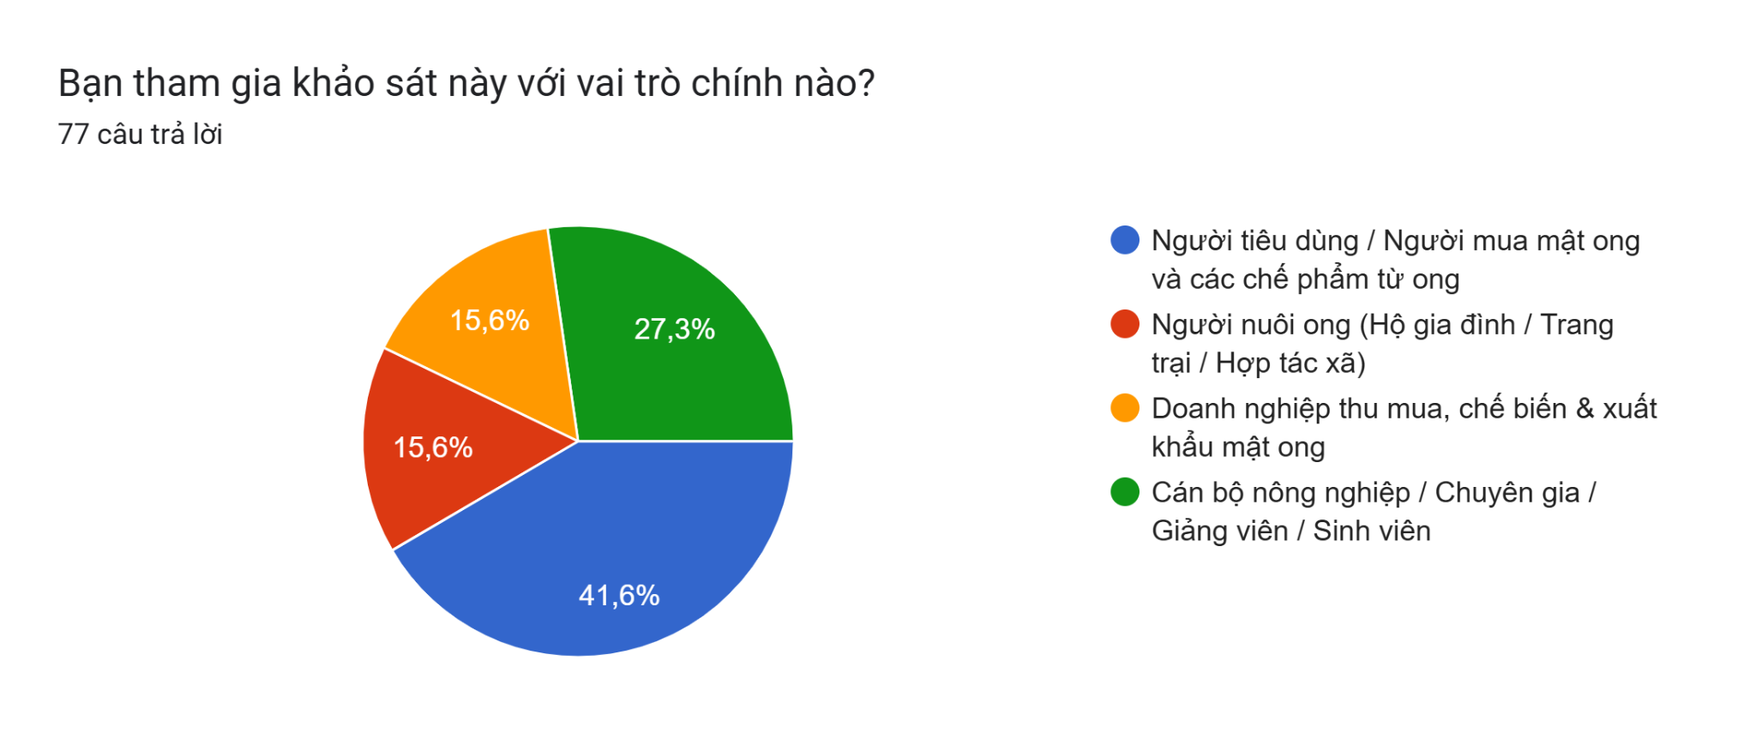
Figure 1: Distribution of Survey Respondent Roles in the Honey Industry Value Chain

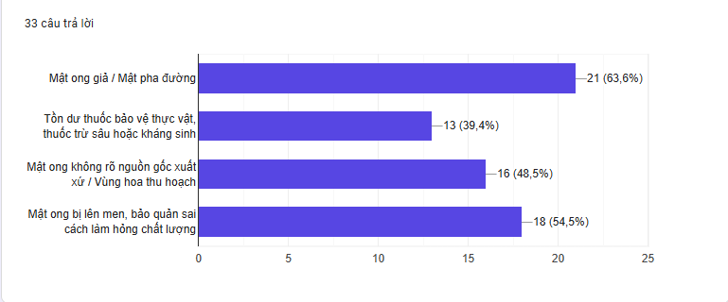
Figure 2: Level of Consumer Concern Regarding Honey Quality and Safety Risks
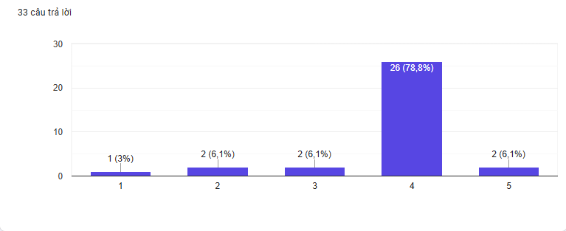
Figure 3: Increase in Consumer Trust When Provided Real-Time IoT Microclimate Logs and Hive GPS Location Data
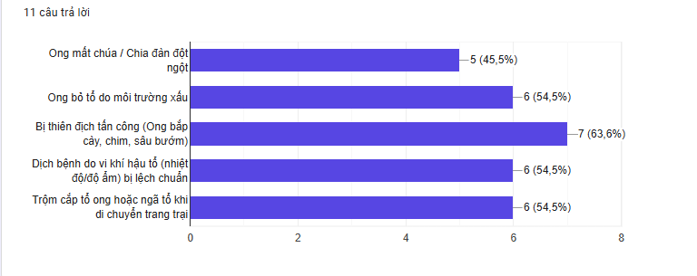
Figure 4: Assessment of Major Economic Risk Factors Causing Losses to Bee Colonies
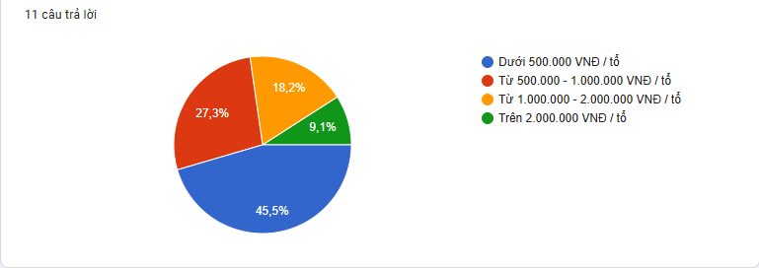
Figure 5: Suitable Price Range for Investing in Smart Hive Monitoring Devices
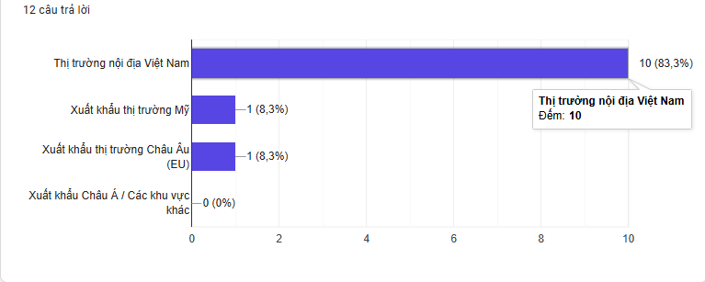
Figure 6: Target Market Distribution of Honey Processing Enterprises and Cooperatives

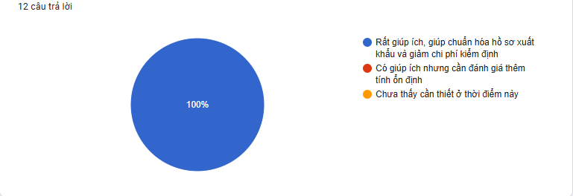
Figure 7: Enterprise Assessment of Real-Time Web Dashboard Functionality Integrating GPS Maps and IoT Sensors
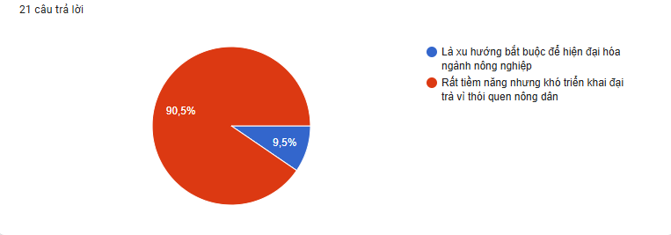
Figure 8: Stakeholder Perspectives on AIoT Adoption and Hive Digitization under Decision 898/QĐ-BNN-CN

DESIGN STEPS 2: RESEARCH

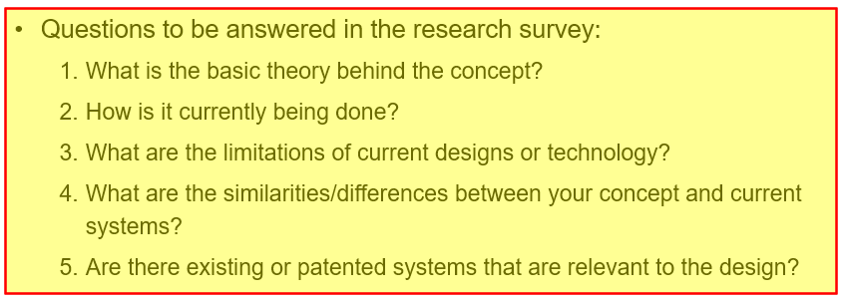

1.1 Research Survey

1.1.1. Basic Theory Behind the Concept

The BumbleBee system is based on the principles of hive condition monitoring, environmental sensing, hive-weight monitoring, wireless data communication, and digital traceability.

Hive Environmental Monitoring

Honeybee colonies require relatively stable environmental conditions to maintain colony development and normal activities. Temperature and humidity inside the hive can therefore provide useful information about changes in colony conditions. Environmental changes caused by weather, climate variation, or other external factors can affect honeybee colonies and their productivity [3], [4].

Continuous monitoring allows beekeepers to observe these changes without repeatedly opening the hive. This supports a more non-invasive approach to hive management and can provide information between conventional manual inspections [1], [17].

Hive Weight Monitoring

Hive weight is another important parameter for monitoring colony development and production. Changes in hive weight can reflect variations in food stores, nectar collection, honey accumulation, and other colony events. Continuous weight measurements provide a time-series record that can help beekeepers identify significant changes in hive condition.

Commercial systems such as BroodMinder demonstrate the practical application of digital hive weighing for remote monitoring [19], [20]. Research into smart beehive monitoring has also demonstrated the use of IoT-based sensing to continuously collect hive-related information [23].

Multi-Parameter Monitoring

A single parameter may not provide sufficient information to understand the overall condition of a hive. Combining environmental and physical measurements allows changes to be observed from multiple perspectives.

The general principle of BumbleBee is therefore to collect multiple parameters continuously or periodically and transform the measurements into structured digital data. This enables beekeepers to monitor trends over time instead of relying only on occasional manual inspections.

Digital Traceability

Digital traceability is increasingly important for agricultural products, particularly products intended for export markets. Honey production is subject to requirements concerning product quality, pesticide residues, food safety, and traceability [6], [8], [9].

The European market has specific requirements concerning honey and bee products, including registration and traceability through the TRACES system [7], [8]. Therefore, associating hive data with time and location information can provide a digital history that supports production management and traceability.

Vietnam has also introduced policies supporting digitalization and sustainable development of the beekeeping sector. Decision 898/QĐ-BNN-CN, issued in 2024, is related to the sustainable development of the Vietnamese beekeeping industry toward 2030 [15], [16]. Recent reports also describe the increasing application of digital technologies in Vietnamese beekeeping [1], [17], [18].

1.1.2. How It Is Currently Being Done

Vietnam has a significant honeybee industry. According to the statistics used in this project, the sector manages approximately 1.5 million honeybee colonies across more than 34,000 households, producing approximately 50,000–60,000 tons of honey annually, with more than 90% of production exported [1], [2].

The industry includes a large number of small-scale beekeepers who continue to rely on traditional experience and manual inspection. In conventional practice, beekeepers periodically open hives to observe colony condition, brood development, food reserves, and other visible indicators.

This approach can provide useful information, but it does not provide continuous monitoring. Changes occurring between two inspections may therefore not be observed immediately.

Traditional Monitoring

Traditional hive management mainly depends on:

Periodic visual inspection

Manual evaluation of colony condition

Observation of brood and food reserves

Manual recording of production information

Beekeeper experience

This approach remains common among small-scale producers. The development of digital technologies has therefore created opportunities to complement traditional knowledge with continuous data collection [1], [17].

Existing Digital Monitoring Systems

Several commercial and research systems have demonstrated the feasibility of connected hive monitoring.

BroodMinder provides digital hive-monitoring products, including environmental sensing and weight-monitoring solutions [19], [20].

BeeSage HiveScale provides a smart hive monitoring and weighing solution for tracking hive conditions [22].

BeeHero provides connected beekeeping solutions using distributed monitoring technologies for beekeeping and pollination management [21].

Academic research has also investigated IoT-based smart beehive monitoring systems for collecting and transmitting hive information [23].

These systems demonstrate that remote monitoring can complement traditional beekeeping practices by providing continuous digital information.

1.1.3. Limitations of Current Designs and Technologies

Limitations of Manual Inspection

Manual inspection has several limitations:

Limited monitoring frequency: Beekeepers cannot continuously observe hive conditions.

Colony disturbance: Opening the hive may disturb the colony and its internal environment.

Labor requirements: Regular inspection becomes increasingly difficult when managing many colonies.

Delayed detection: Changes occurring between inspections may remain unnoticed.

Limited digital records: Manual observations do not automatically create continuous time-series data.

These limitations are particularly relevant to Vietnam because of the large number of colonies and households involved in the sector [1], [2].

Environmental and Agricultural Risks

Honeybee colonies can be affected by environmental changes and agricultural chemicals. Climate-related changes have been reported as an increasing threat to honeybee populations [3].

Pesticide exposure is another concern. The project references research reporting that exposure to imidacloprid can reduce population growth rates by up to 71%, demonstrating that pesticide exposure can have substantial effects on bee colonies [4].

For honey intended for export, pesticide residues are also relevant because international markets impose requirements for residue control. European guidance provides specific procedures for determining pesticide residues in honey [6], while market requirements also emphasize food safety and traceability [8].

Therefore, monitoring hive conditions alone cannot guarantee product quality, but it can provide supporting production records and early information about changes in the hive environment.

Limitations of Commercial Monitoring Systems

Commercial smart-hive systems demonstrate the technical feasibility of remote monitoring, but their cost can be a barrier for small-scale producers.

Based on the commercial information collected for this project:

BroodMinder: approximately $549.99 USD (~13.7 million VND) for the referenced starter configuration, with additional subscription costs.

BeeSage: approximately $300–500 USD (~7.5–12.5 million VND) per hive [19], [22].

For Vietnamese smallholders managing multiple colonies, deploying a relatively expensive monitoring system on every hive may be difficult.

This creates a design opportunity for a system that focuses on low cost, essential monitoring functions, local usability, and scalable deployment.

1.1.4. Similarities and Differences Between BumbleBee and Existing Systems

Aspect | Existing Systems | BumbleBee
Monitoring | Remote digital hive monitoring | Remote digital hive monitoring
Data | Environmental and/or physical hive data | Multiple hive-condition parameters
Monitoring method | Continuous or periodic measurements | Continuous/periodic measurements
Weight monitoring | Available in systems such as BroodMinder and BeeSage [20], [22] | Included as an important hive-condition parameter
Communication | Wireless/connected monitoring | Wireless communication and cloud connectivity
Data storage | Digital/cloud-based platforms | Cloud-based data storage
Traceability | Depends on platform | Time- and location-associated hive records
User target | Commercial/international users | Vietnamese beekeepers, particularly smallholders
Cost | Commercial solutions can cost millions of VND per hive | Target system cost of approximately 400,000 VND/hive
Localization | Mainly international platforms | Vietnamese-oriented monitoring and visualization
Main objective | Remote hive monitoring | Affordable monitoring, management, and digital traceability
The main similarity is that BumbleBee follows the same general concept as existing smart-hive systems: collect hive data digitally and make the information available remotely [19]–[23].
The main difference is the project's emphasis on affordability and local adaptation. Instead of targeting a premium commercial monitoring platform, BumbleBee targets a system cost of approximately 400,000 VND per hive, making large-scale deployment more accessible to small-scale Vietnamese beekeepers.

1.1.5. Existing and Relevant Systems
Several existing systems and studies are directly relevant to the development of BumbleBee.

BroodMinder
BroodMinder provides commercial hive-monitoring products, including environmental sensors and digital hive scales [19], [20]. These products demonstrate the feasibility of continuously collecting hive information and remotely monitoring changes in hive conditions.

BeeSage HiveScale
BeeSage provides a smart hive-scale solution for monitoring hive weight and related information [22]. Its approach is particularly relevant to BumbleBee's weight-monitoring function.

BeeHero
BeeHero provides connected beekeeping solutions designed for monitoring bee colonies and supporting agricultural pollination management [21]. It demonstrates the application of large-scale connected monitoring in practical beekeeping environments.

IoT-Based Academic Research
Previous academic research has investigated smart beehive monitoring using IoT-based sensing and communication technologies [23]. These studies provide a technical foundation for the development of connected monitoring systems.
Research has also investigated vibration-based methods for detecting colony events such as swarming [24]. Although BumbleBee does not rely on AI-based classification, such research demonstrates that measurable changes in hive conditions can be used as indicators for monitoring and alert generation.

1.1.6. Research Gap
The literature and existing systems demonstrate that digital monitoring can improve the availability of hive-condition information [19]–[24]. However, the current solutions identified in this survey have several limitations when considered in the context of Vietnamese small-scale beekeeping.
First, many small-scale beekeepers still depend on manual inspection and traditional experience [1], [2]. Second, commercial monitoring products can involve relatively high costs compared with the economic conditions of smallholder producers [19], [22]. Third, international systems may not be specifically designed around Vietnamese users, local operating conditions, and local traceability requirements.
At the same time, Vietnam is promoting digital transformation and sustainable development within the beekeeping sector [1], [15]–[18].

1.2 Need Statement
Vietnam’s apiculture sector manages approximately 1.5 million honeybee colonies across more than 34,000 households, producing around 50,000–60,000 tons of honey annually, with over 90% destined for export. However, most small-scale beekeepers still rely on traditional manual inspections, which require opening hives, disturb colony conditions, and provide limited continuous records for detecting abnormal events. Environmental stress and pesticide exposure further increase risks to colony health, while international markets impose increasingly strict requirements on food safety, traceability, and production records. At the same time, commercial smart-beehive monitoring solutions remain relatively expensive for Vietnamese smallholders. This creates a clear need for an affordable, non-invasive, and digitally connected monitoring solution that can continuously track hive conditions, support early anomaly detection, and provide reliable records for management and traceability.

1.3 Objectives statement

The primary objective of BumbleBee is to develop and validate a low-cost IoT and Edge AI smart beehive monitoring system tailored to the conditions of Vietnamese beekeepers. The system aims to enable non-invasive, continuous monitoring of key hive conditions, provide early warnings of abnormal colony events, and maintain time- and location-associated digital records for traceability. The project targets a total hardware cost of approximately 400,000 VND per hive, while applying Edge AI for automated acoustic analysis and maintaining a simple web-based interface for practical field use. Ultimately, BumbleBee aims to reduce dependence on frequent manual inspections, improve the timeliness of colony management, and support the digitalization and modernization of small-scale beekeeping in Vietnam.

1.4 Marketing requirements
Table:
ID | Requirement | Why it matters | Stakeholder | Importance | Drives
M1 | Check hive condition without opening it | Physical inspection stresses the colony and hides queen loss or disease until it's already advanced. | Small-scale beekeeper | 5 | E1,E2
M2 | Be warned within hours, not weeks | Swarming, queen loss, disease and predator attacks currently surface only at the next scheduled inspection. | Small-scale beekeeper | 5 | E1,E2,E4,E5
M3 | Keep cost under roughly 1,000,000 ₫/hive | 45.5% of surveyed keepers will only invest under 500,000 ₫/hive; the cheapest import (BeeSage) still runs 7.5M+ ₫. | Small-scale beekeeper | 4 | E1,E2,E3
M4 | Prove where and how the honey was produced | EU TRACES registration and HACCP audits reject shipments for missing provenance; 78.8% of respondents said live IoT + GPS logs raise trust to level 4/5. | Export enterprise · Consumer | 4 | E1,E2,E4,E5
M5 | Run reliably in the field with no maintenance | 80% of Vietnam's ~30,000 keepers are non-technical smallholders with dispersed, nomadic apiaries — a dead or confusing device gets abandoned. | Beekeeper · Cooperative | 3 | E3,E5

1.5 Engineering requirements
Table:
ID | Requirement | Target spec | Function | Satisfies
E1 | Multi-parameter hive sensing | Temperature/humidity (30–32 °C, 50–60% RH), hive weight via load cell, entrance bee-traffic, and motion/vibration — all external to the hive body. | Monitor | M1,M2
E2 | Edge AI anomaly & queen-state classification | On-device model, sized and quantized for MCU memory/latency, classifies queen presence, swarm risk and disease-pattern deviation from sensor + acoustic fusion. | Optimize | M1,M2
E3 | Low-cost, low-power hardware platform | Bill of materials under ~1,000,000 ₫/node; duty-cycled sampling and radio; battery voltage monitored to prevent unplanned shutdown. | Optimize | M3,M5
E4 | GPS-linked cloud traceability | Every reading is geotagged and time-stamped; auto-synced to a central record that supports EU TRACES-style export documentation and anti-theft/tip alerts. | Automate | M2,M4
E5 | Localized dashboard with OTA update | Vietnamese-language web/mobile UI for non-technical users; firmware updates ship wirelessly (FOTA) without a farm visit. | Automate | M4,M5

1.6. House of quality
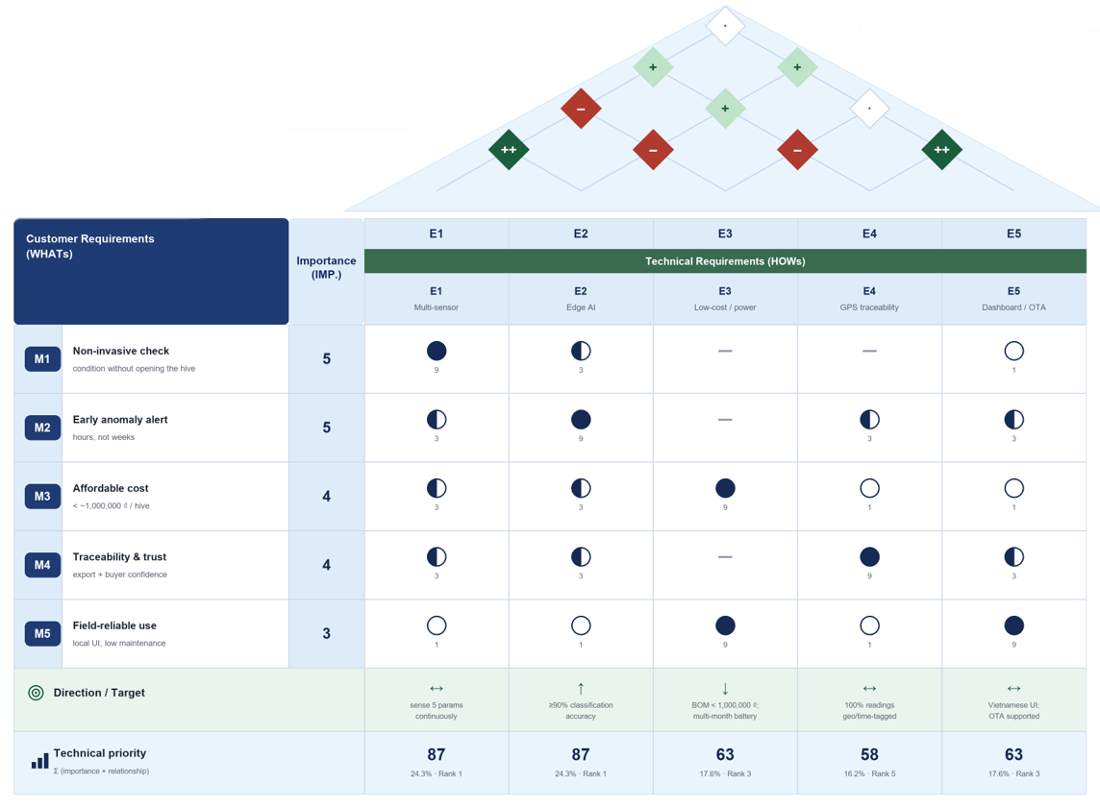

1.7. Solution & Technology Selection Matrix

ER ID | Engineering Requirement | Selected Technology / Approach | Specific Target Specification | Primary MR Satisfied
E1 | Multi-Parameter Hive Sensing | Multi-sensor monitoring system | Continuous monitoring of temperature, humidity, hive weight, bee activity, vibration, and location; non-invasive external installation | M1, M2
E2 | Local Data Processing & Anomaly Detection | On-device data processing | Real-time preprocessing, condition analysis, and abnormal-event detection before data transmission | M1, M2
E3 | Low-Cost & Low-Power Platform | Low-power embedded system with duty-cycled operation | Target hardware cost ~400,000 VND/hive; periodic measurement and transmission; extended battery operation | M3, M5
E4 | Location-Based Cloud Traceability | GPS + cellular communication + cloud database | Automatic time and location tagging; periodic data synchronization; secure cloud data transmission | M2, M4
E5 | Web-Based Monitoring & Management | Web dashboard + cloud services | Real-time monitoring, hive location visualization, historical data, trend charts, and abnormal-condition alerts | M4, M5

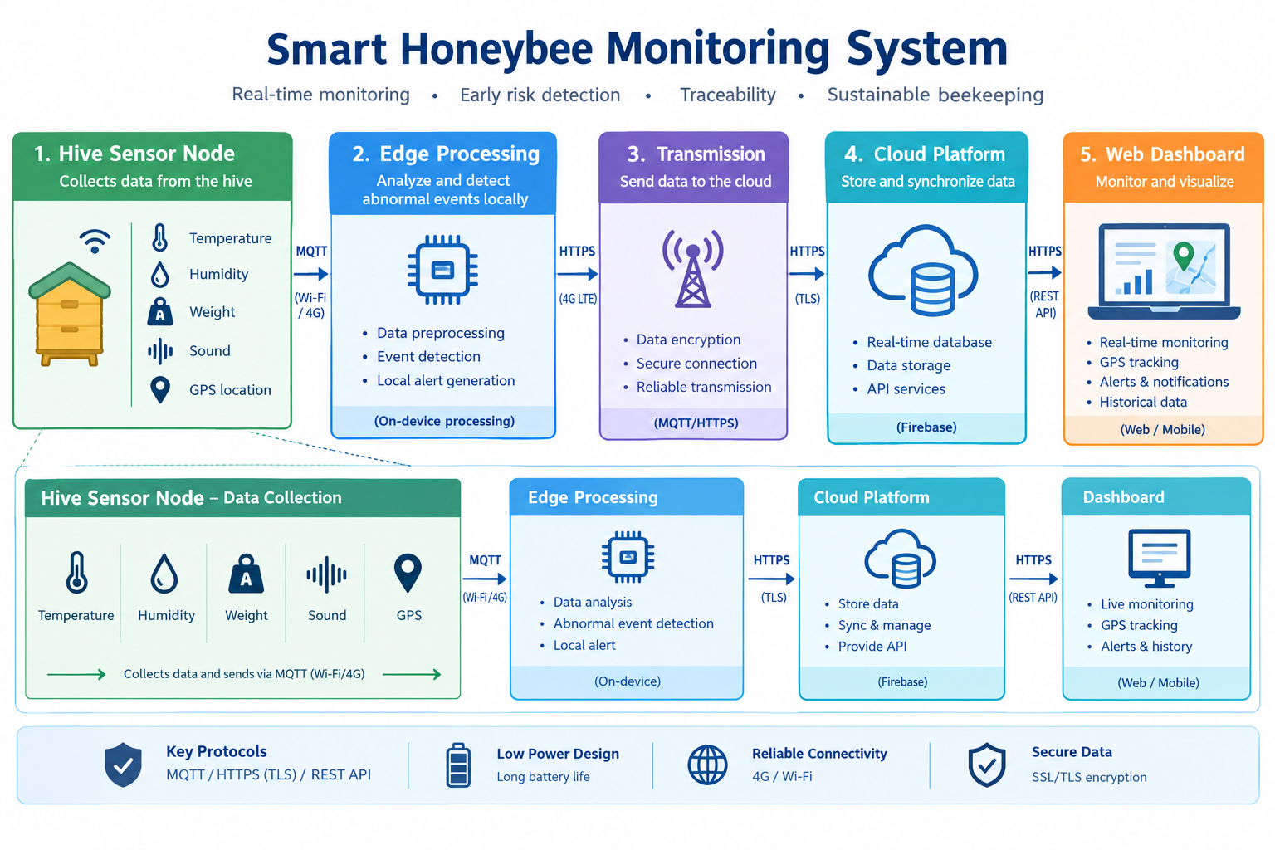

1.8 Top Down Methodology
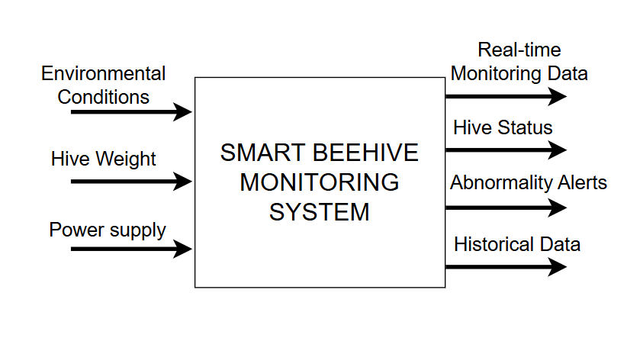

Module (Input / Output Functionality) | Description
Inputs (Environmental Conditions, Hive Weight, Power Supply) | Collects sensor data (temperature, humidity, weight) and provides continuous power to the system.
Real-time Monitoring (Real-time Data, Hive Status) | Displays live operational metrics and overall colony health status.
Alerts & Analytics (Abnormality Alerts, Historical Data) | Triggers warnings for anomalies and stores historical data logs for trend analysis.

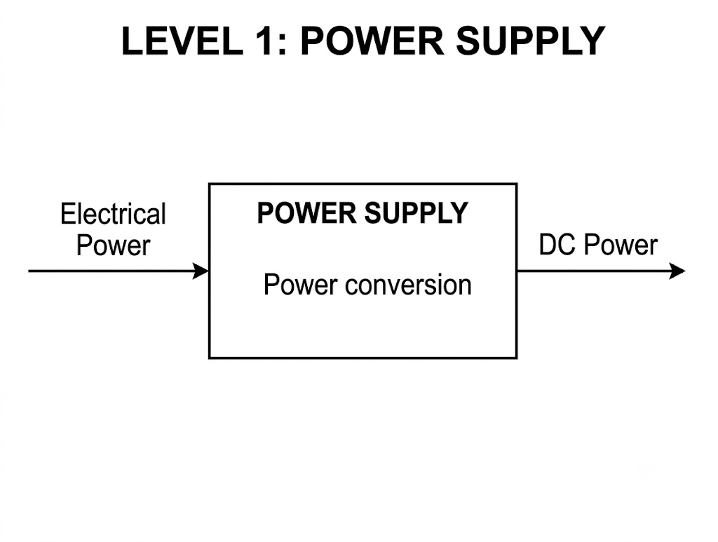

Module | Description
Input | Electrical Power
Output | Stable DC Power
Function and Description | Converts the input electrical power into stable DC power to supply the system.

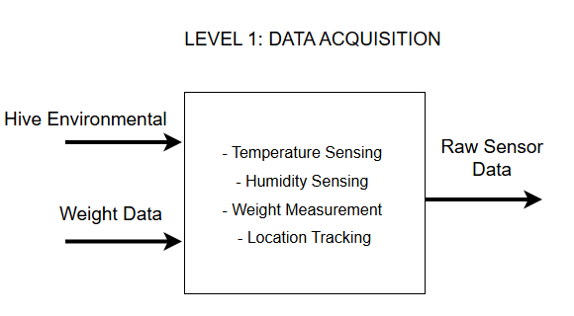

Module | Description
Input | Hive Environmental & Physical Data
Output | Raw Sensor Data
Function and Description | Collects environmental and physical parameters from the hive and generates raw sensor data for further processing.

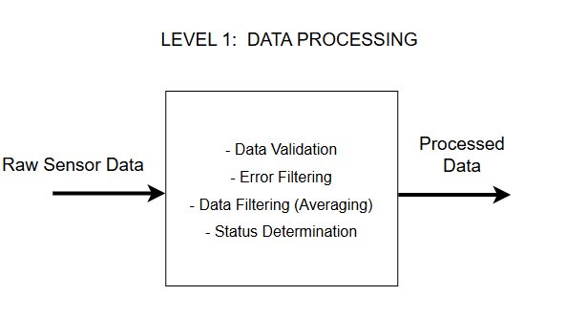

Module | Description
Input | Raw Sensor Data
Output | Processed Data
Function and Description | Validates, filters, averages, and analyzes raw sensor data to generate reliable processed data for transmission and monitoring.

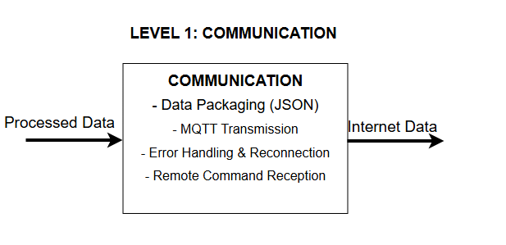

Module | Description
Input | Processed Data
Output | Internet Data
Function and Description | Packages data in JSON format, transmits data through the communication network, handles communication errors and reconnection, and receives remote commands.

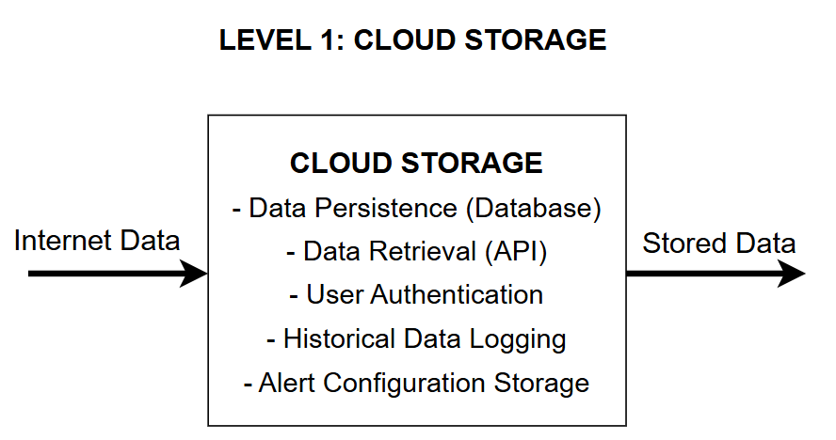

Module | Description
Input | Internet Data
Output | Stored Data
Function and Description | Provides persistent database storage, enables data retrieval through APIs, authenticates users, records historical data, and stores alert configurations.

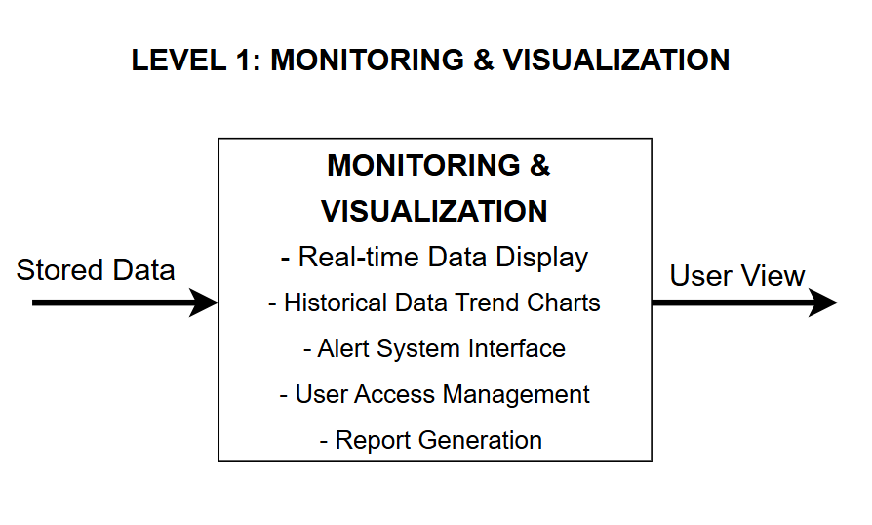

Module | Description
Input | Stored Data
Output | User View
Function and Description | Displays real-time data, historical trend charts, alert information, user access management, and system reports.

Reference
[1] Nhân Dân, “Đưa công nghệ số phát triển ngành ong Việt,” 2025. [Online]. Available: https://nhandan.vn/dua-cong-nghe-so-phat-trien-nganh-ong-viet-post884472.html
[2] Bộ Nông nghiệp và Phát triển Nông thôn, “Báo cáo thống kê ngành ong,” 2024. [Online]. Available: https://www.mard.gov.vn
[3] Báo Gia Lai, “Biến đổi khí hậu khiến loài ong mật đối mặt với nhiều mối đe dọa,” May 2024. [Online]. Available: https://baogialai.com.vn/bien-doi-khi-hau-khien-loai-ong-mat-doi-mat-voi-nhieu-moi-de-doa-post324181.html
[4] Nông Nghiệp Môi Trường, “Thuốc trừ sâu khiến ong mật vài thế hệ để phục hồi,” Jul. 2024. [Online]. Available: https://nongnghiepmoitruong.vn/thuoc-tru-sau-khien-ong-mat-vai-the-he-de-phuc-hoi-d308674.html
[5] Dân Việt, “Xuất khẩu mật ong 9 tháng đạt 24.000 tấn, Mỹ thu mua nhiều nhất,” Oct. 2022. [Online]. Available: https://danviet.vn
[6] European Commission, “Technical Guidelines for Determining the Magnitude of Pesticide Residues in Honey (SANTE/11956/2016 rev.9),” 2016. [Online]. Available: https://food.ec.europa.eu/document/download/06bcc245-57b5-47ff-b31b-25c05a8485cf_en?filename=pesticides_mrl_guidelines_honey.pdf
[7] European Commission, “Regulation (EU) 2023/2652 on Registration of Bee Products in TRACES,” Nov. 2023.
[8] CBI – Centre for the Promotion of Imports, “What Requirements Must Honey Comply with to Be Allowed on the European Market?” 2023. [Online]. Available: https://www.cbi.eu/market-information/honey/what-requirements-should-your-product-comply
[9] USDA Agricultural Marketing Service, “Honey Import Requirements and HACCP Compliance,” 2024. [Online]. Available: https://www.ams.usda.gov/sites/default/files/media/AA20380_Honey.pdf
[10] United Nations, “World Bee Day – 20 May.” [Online]. Available: https://www.un.org/en/observances/bee-day
[11] Food and Agriculture Organization of the United Nations, “World Bee Day.” [Online]. Available: https://www.fao.org/world-bee-day/en
[12] Apimondia, “Apimondia Statement on Honey Fraud.” [Online]. Available: https://www.apimondia.org/uploads/7/6/4/3/76436993/apimondia_statement_on_honey_fraud.pdf
[13] Hội Nuôi ong Việt Nam, “Giới thiệu về Hội Nuôi ong Việt Nam,” 1981. [Online]. Available: https://hoiong.org.vn ( …)
[14] Trung tâm Nghiên cứu Ong và Nuôi ong Nhiệt đới, Học viện Nông nghiệp Việt Nam, “Ứng dụng công nghệ 4.0 trong nuôi ong,” 2006. [Online]. Available: https://hvnvn.vn
[15] Bộ Nông nghiệp và Phát triển Nông thôn, “Quyết định số 898/QĐ-BNN-CN ngày 02/4/2024,” 2024. [Online]. Available: https://thuvienphapluat.vn/van-ban/Linh-vuc-khac/Quyet-dinh-898-QD-BNN-CN-2024-phe-duyet-De-an-Phat-trien-ben-vung-nganh-Ong-den-2030-625836.aspx
[16] Bộ Nông nghiệp và Phát triển Nông thôn, “Đề án Phát triển bền vững ngành Ong đến 2030,” 2024.
[17] Nông nghiệp & Môi trường, “Ngành ong mật chuyển dịch bằng số hóa,” 2024. [Online]. Available: https://nongnghiepmoitruong.vn/nganh-ong-mat-chuyen-dich-bang-so-hoa-d383804.html
[18] Nông nghiệp & Môi trường, “Ngành ong mật chuyển dịch bằng số hóa,” 2024.
[19] BroodMinder, “BroodMinder-BeeDar Sensor Products.” [Online]. Available: https://broodminder.com/collections/sensors/products/broodminder-beedar
[20] BroodMinder, “BroodMinder-W5 Weight Scale.” [Online]. Available: https://broodminder.com/collections/sensors/products/broodminder-w5-weight-scale
[21] BeeHero, “Beekeeping Solutions – IoT and AI for Beekeeping.” [Online]. Available: https://www.beehero.io/beekeeping-solutions
[22] BeeSage, “HiveScale – Smart Hive Monitoring System.” [Online]. Available: https://beesage.co/en/hivescale
[23] H. Zhang et al., “Smart beehive monitoring system based on IoT sensors,” Computers and Electronics in Agriculture, vol. 168, 2020, pp. 1–12.
[24] M. Ramsey et al., “Swarming detection in honeybee colonies using vibration analysis,” IEEE Transactions on Industrial Electronics, vol. 67, no. 4, pp. 3421–3431, 2020.

