22ECE — SYSTEM IOT DESIGN · GROUP 3 · THE UNIVERSITY OF DA NANG — UST
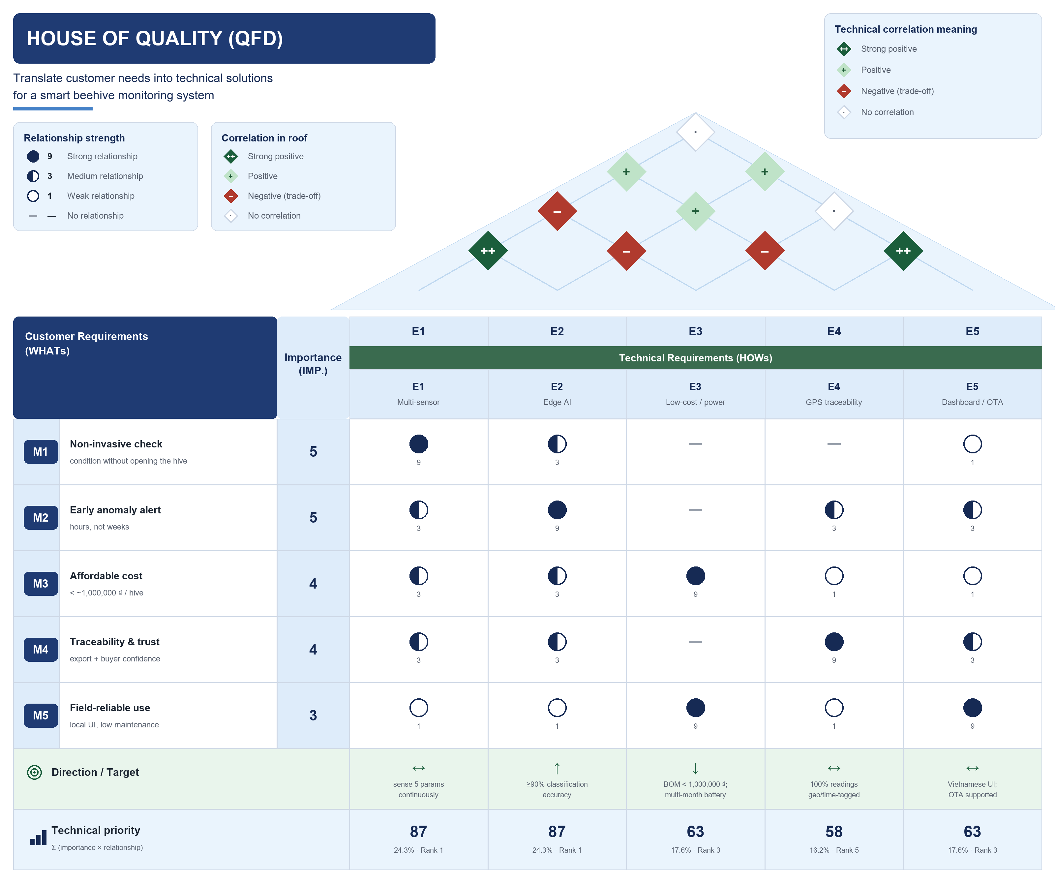
Source: 22ECE — System IoT Design, Group 3 final project log book — §1.2 Need Statement, §1.3 Objectives, §1.4 Monitor/Control/Optimize/Automate function table, and the 77-respondent stakeholder survey. Importance weights, relationship scores and the correlation roof are this document's QFD interpretation of that material.

