**Antarctic Harmony: Unveiling Penguin Species Dynamics through Clustering Analysis**

Pankaj Shahare([2021bit058@sggs.ac.in](mailto:2021bit058@sggs.ac.in)), Dr. A.D. Sawarkar([adsawarkar](mailto:adsawarkar@sggs.ac.in)@sggs.ac.in)

1. Department of Information Technology, Shri Guru Gobind Singhji Institute of Engineering and Technology Nanded
2. Department of Information Technology, Shri Guru Gobind Singhji Institute of Engineering, and Technology Nanded

**Abstract:**

Understanding the intricate social dynamics among the various species of penguins that inhabit Antarctica was the goal of the research in order to decipher the complexities of their relationships. In order to gain insight into the links between penguin species, researchers have resorted to sophisticated computer algorithms such as K-means clustering, given the wide range of appearances and habitats among them. A key method in the study is clustering, which organizes data points (in this case, penguins) according to traits they have in common to show more unified and homogeneous groups. Of all the clustering methods that were applied, K-means was the most successful in identifying separate groups of penguins. **K-means showed good cluster separation with an impressive silhouette score of 0.5370**, indicating distinct and coherent groups within the penguin populations. K-means successfully distinguished clusters within the penguin populations by utilizing characteristics like body mass and beak length, providing a better knowledge of the social dynamics and relationships among them.

Scientists were able to learn important details about penguin interactions, living conditions, and feeding habits in the Antarctic through the discovery of these clusters. By studying the connections between different penguin clusters, researchers have gained additional insight into the social dynamics and structures of penguin groups. This improved comprehension advances our understanding of penguin societies and supports conservation efforts to preserve these iconic Antarctic residents.

Moreover, K-means clustering allows researchers to efficiently classify penguin populations according to their ecological features and morphological attributes. By addressing the unique requirements and habits of many penguin groups, this categorization enables focused conservation measures that eventually assist the preservation of Antarctic biodiversity. With its high silhouette score, K-means clustering is a useful tool for ecological study and conservation efforts enabling a deeper comprehension of penguin communities and their environments.

**Keyword:** Penguin species, Clustering analysis, Antarctic biodiversity, Ecological communities, Conservation ecology

1. **Introduction:**

We have always been fascinated with penguins, those tuxedo-clad birds of the Antarctic. As a result of the harsh conditions of their frigid habitat, their deceptively uniform look belies a startling diversity. Although physical traits are frequently used in traditional penguin classification approaches, they could not provide the complete picture. This study explores the fascinating field of unsupervised machine learning, which is a potent instrument for revealing patterns in data that are concealed. Imagine searching through mountains of ecological data and penguin measurements to find natural groups that conventional approaches would overlook. That's precisely what we want to accomplish.

The long-standing inquiry into the evolutionary origins of penguins and the subsequent remarkable transformations that led to their adaptation to the aquatic environment has been a subject of extensive investigation across various scientific disciplines. Morphologists, biogeographers, and molecular phylogeneticists have all contributed to unravelling the complex evolutionary history of these enigmatic birds. However, despite considerable efforts, the phylogenetic position of the order Sphenisciformes (penguins) within the class Aves remains a subject of debate and uncertainty.

Penguins boast a rich fossil record, with the oldest known fossil specimens dating back to the Late Paleocene or Early Eocene epochs, discovered in New Zealand. These fossils provide valuable insights into the early evolution of penguins; however, none have definitively resolved the question of their ancestral origins. While some researchers have speculated on potential ancestors based on morphological similarities, such as flightless ratites or other avian groups, the exact lineage from which penguins emerged remains elusive.

Early studies on penguin evolution suggested a possible connection with flightless ratites, such as ostriches and emus. However, this hypothesis has been largely dismissed in favour of the idea that penguins evolved from a flying ancestor and subsequently lost their flight capability—an adaptation that occurred independently in both penguins and ratites. Morphological analyses have proposed various avian groups as potential relatives of penguins, including Procellariiformes (albatrosses, petrels, and shearwaters) and Gaviiformes (loons). Cladistic analyses have further complicated the picture, with some researchers suggesting a close relationship between penguins and a clade comprising loons, grebes, and Cretaceous diving birds.

Molecular studies have added another layer of complexity to the debate, yielding conflicting conclusions regarding the phylogenetic position of penguins. Early studies based on protein immunology suggested close relationships between penguins and several avian orders, including Procellariiformes, Ciconiiformes, and Podicipediformes. Subsequent DNA hybridization studies proposed grouping penguins within the superfamily Procellariidea, alongside loons, petrels, and frigatebirds. However, more recent analyses using nuclear and mitochondrial DNA sequences have produced inconsistent results, with some studies suggesting shearwaters as the closest relatives of penguins.

To shed light on these unresolved questions, recent studies have turned to complete mitochondrial genome analyses. By comparing the complete mitochondrial genomes of penguins with those of other avian species, researchers aim to clarify the evolutionary relationships between penguins and their putative relatives. However, even these studies have faced limitations, as they often focus on a limited set of candidate relatives, neglecting other potential lineages.

To address these issues directly, our study aimed to determine the complete mitochondrial genome sequences of the rockhopper penguin and five putative relatives: the grey petrel, grey-headed albatross, Pacific loon, lesser frigatebird, and great-crested grebe. We conducted three independent analyses using the maximum-likelihood method, with a specific focus on elucidating the closest extant relatives of penguins. By incorporating data from diverse bird species and employing rigorous analytical methods, we sought to contribute to a more comprehensive understanding of penguin evolution and avian phylogeny.

In addition to unravelling the evolutionary origins of penguins, our study also addresses broader issues in avian phylogeny. Recent molecular and morphological studies have provided insights into the basal split between palaeognath and neognath birds, but higher-order relationships and those among neognath orders remain uncertain. Our research represents a step towards resolving these uncertainties and advancing our understanding of avian evolutionary history.

In conclusion, the evolutionary origins of penguins and their phylogenetic relationships with other avian groups remain subjects of ongoing research and debate. By employing a multidisciplinary approach that integrates fossil evidence, morphological analyses, and molecular data, researchers continue to make progress in unravelling the mysteries of penguin evolution and avian phylogeny.

1. **Literature Review:**

Existing studies in gadget learning clustering covers an extensive variety of algorithms, techniques, and practical uses. One popular set of rules is the K-means clustering, which divides information into wonderful clusters based on similarity [3]. On the opposite hand, hierarchical clustering builds a hierarchy of clusters through merging or splitting them recursively. Density-based clustering algorithms, like DBSCAN, become aware of clusters based totally on information point density. Gaussian Mixture Models (GMM) count on that fact’s points come from a aggregate of different Gaussian distributions. Along with consumer segmentation, photo segmentation, anomaly detection, and biological taxonomy, machine learning clustering finds applications in a variety of domains. In ecological studies, Clustering techniques have been applied to confirm network topology, identify regions of high biodiversity, and investigate patterns of species distribution. [4].

In ecological research, scientists often use a method called machine learning clustering to group similar things together, like different types of animals or plants, based on their characteristics. However, there are a few ways we may improve upon this approach. For example, sometimes we don't use clustering in specific ecological situations, like when we're studying the different kinds of penguins in Antarctica [5].This means we might miss out on understanding how clustering can be helpful in unique environments. Also, we haven't really explored different ways of doing clustering to determine which are most effective in comprehending intricate ecological patterns [5].

Ecological systems can be really complicated, so it's crucial to find the most effective methods for analysing them. Plus, when we do use clustering, we don't always consider what the results mean for protecting nature. We need to ensure that the patterns we discover are useful for making decisions about conservation [6]. Lastly, there aren't any clear guidelines on how to get ecological data ready for clustering or how to determine if the clustering results are reliable or not. It would be great if there were some standard rules for these things. That way, scientists could easily compare and trust the results of different studies. By improving in these areas, we can get a better grasp of the natural world and step up our efforts to protect it.

**Related Research paper:**

**Paper-1:** Applications of machine learning in animal behaviour studies John Joseph Valletta , Colin Torney, Michael Kings, Alex Thornton , Joah Madden[7]

**Model Summary :** In animal behaviour research, the complexity and volume of data often exceed the capacity of traditional analysis methods. Machine learning (ML) offers a solution by providing techniques suited to handling intricate datasets with unknown interactions among variables. This review introduces ML to animal behaviourists’, illustrating its application through successful case studies. ML methods, both supervised and unsupervised, are explained, demonstrating their effectiveness in tasks such as identifying bird eggs, analysing social interactions in tagged birds, and counting wildlife populations from aerial images. With the increasing availability of data from advanced tracking technologies, ML is poised to become a vital tool for translating this wealth of information into scientific insights in the field of animal behaviours.

**Result :**

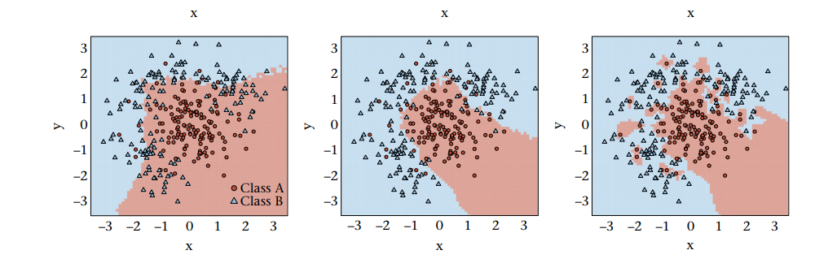

**Paper-2:** Commercial Clustering of Indian Bamboo Species Using Machine Learning Techniques by Ankush D. Sawarkar, Deepti D. Shrimankar, Santosh Kumar Sahu, Lal Singh[8]

**Model Summary:** This research focuses on clustering bamboo species based on their commercial value using machine learning algorithms. It identifies twenty commercial bamboo species in India and collects data on 2000 bamboo species. The study evaluates the performance of clustering algorithms such as K-means, Gaussian Mixture Models (GMM), and Balance Iterative Reducing and Clustering using Hierarchies (BIRCH) using performance measures like Silhouette Score, Calinski-Harabasz Index (CHI), and Davies-Bouldin Index (DBI). K-means demonstrates the highest performance, achieving a silhouette score of 0.5126, CHI of 17315, and DBI of 0.6633. This research highlights the importance of machine learning in efficiently clustering bamboo species for commercial purposes**.**

|  |  |  |  |
| --- | --- | --- | --- |
| Clustering Model | Silhoutte score | CHI | DBI |
| K-means | 0.5126 | 17315 | 0.6633 |
| GMM | 0.4401 | 15091 | 0.7788 |
| BIRCH | 0.4259 | 11864 | 0.8961 |

1. **Methodology:**

we got our hands on this dataset from Kaggle, which is like a treasure trove of research datasets. This dataset gave us all sorts of info about penguins - their beak length and depth, their weight, whether they're dudes or dudettes, and where they were hanging out[9]. Before we could dive into the fun stuff, we had to clean up the data and make sure it was all good to go.

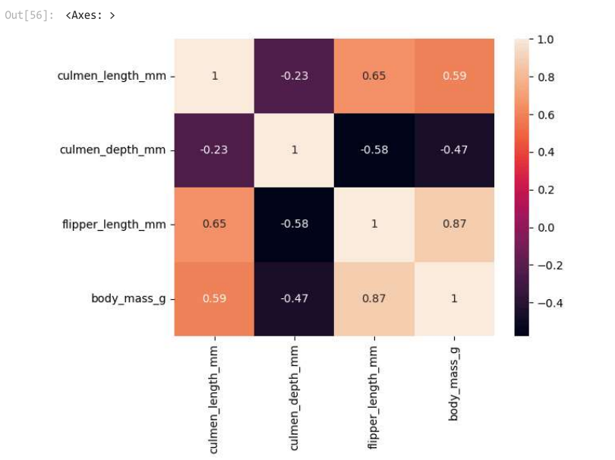

Fig.1 Correlation matrix

In Figure 1, we can see how the various components relate to one another. Each input variable and the output variable clearly have a strong association, with a value more than 0.5. Additionally, in certain instances, we observe a negative correlation—that is, when one measure rises, another falls.

Once we had our ducks in a row, we decided to use this method called K-means to group the penguins. It's a pretty straightforward way to group similar things together. In our case, we wanted to find penguins that had similar traits. To ensure that our groups were focused, we used this fancy metric called the silhouette score. It assisted us in determining if our groups were distinct from one another and well-defined. The silhouette score in clustering indicates the degree of separation between the groups[10]A high score indicates that the clusters are distinct and well-defined, whereas a low score implies that there may be overlap. It enables us to assess the Caliber of our clustering outcomes[11].

PCA is utilized to increase clustering accuracy or increase the silhouette score by reducing noise and focusing on the most important features By keeping the majority of the variance while decreasing the dimensionality of the data[12], PCA can help clustering algorithms better distinguish between clusters and reduce the influence of irrelevant or noisy features This may result in clustering that is more precise. results and higher silhouette scores, indicating better-defined clusters [12][13].

And, of course, we also took a good look at the groups visually to see if they made sense based on what we know about penguins. By digging into this dataset from Kaggle and using the K-means method, we were hoping to uncover some cool insights about how different penguin species are connected. You know, stuff like their beak size, weight, gender, and where they call home. I hope this version captures the casual yet informative tone you were looking for! Let me realize in case you want any similarly adjustments.

Fig.2 silhouette scores before and after PCA for different numbers of clusters

**3.1 Machine learning Model :**

a. k-menas clustering :

The most popular clustering method is called K-means. The technique uses a centroid to learn, making it the simplest and most straightforward kind of unsupervised learning. This technique seeks to reduce data point dispersion and variation inside a cluster. K-means requires iteration over each data point; hence, it works best with smaller datasets[14].

b. DBSCAN:

It stands for density-based spatial clustering of applications with noise (DBSCAN). Unlike K-means, it uses density instead of distance to group things together. Using this approach, you can quickly identify any dataset’s outliers. It creates arbitrarily formed clusters depending on data point density. DBSCAN uses two parameters to determine how clusters are defined: MinPts and Eps. The e-neighbourhood of an arbitrary point ‘p’ is defined as, where D is the database of objects.

NEps = {qϵD/dist(p, q) < Eps}

c. Gaussian Mixture Models (GMM):

One drawback of K-means is that the data must be presented in a circular fashion. However, K-means fails to accurately cluster non-circular data because of the way it calculates the distance between data points, which is based on a circular route. GMM can address this problem. The GMM fits data with arbitrary shapes by combining several Gaussian distributions. Within this hybrid model, there are numerous single Gaussian models that each function as a separate hidden layer. The model determines a data point’s cluster based on its chance of belonging to a Gaussian distribution[15].

d. Mean Shift clustering:

Mean Shift is a non-parametric clustering technique that does not require specifying the number of clusters in advance. It works by iteratively shifting data points towards the mode (highest density point) of the data distribution.

e. Agglomerative Clustering:

Agglomerative clustering is a hierarchical clustering method that builds nested clusters by merging or splitting them successively. It starts with each data point as a single cluster and merges the closest pairs of clusters until only one cluster remains.

1. **Experimental Setup:**

We used the Pythonic way of classifying penguins by species with a help from Scikit-learn library. With Pandas for rapid and simple data management and Seaborn and Matplotlib which allowed us to produce clear results more easily, our understanding and ability to present findings enhanced. Joining hands, we were able to design our outcomes short and informative in a manner that suits tech savvy and ordinary people to the extent [16].

This incredible kit of tricks had us K-means clustering and Principal Component Analysis (PCA), just to name a few. It was through these algorithms that we were able to segregate different penguin species by their peculiar natural attributes, thus facilitating the interpretation of data.

PCA played a significant role in our objectives. For doing this we dropped the less significant features and mapped the rest of them to the lower-dimensional ones. the method of keeping only the most important elements while eliminating the redundant and or distracting elements from the dataset allowed us to look beyond the details and even perceived the inside of the penguin dataset. We did not only accelerate the computations, but we also brought more natural clustering outcomes, which in turn helped in easier detection of penguin species pattern [17].

Regarding computational power, we didn't use any sophisticated tools at all. Our basic laptops and desktops had just right of a CPU and memory capacity. capacity to run the clustering algorithms and PCA transformations because they had enough processing power. This has allowed us to thoroughly analyse the penguins' dataset and only consider pertinent findings, all the while avoiding any technical issues that would have interfered with the procedure.

1. **Result:**

K-means clustering emerged as the most popular technique for categorizing penguin populations based on their physical characteristics, such as culmen length and body mass, according to the examination of penguin species data. K-means demonstrated its resilience with an impressive silhouette score of 0.5370, which showed clear groups and substantial cluster separation within the penguin populations.

|  |  |  |  |
| --- | --- | --- | --- |
| Algorithm | Silhouette Score | Davies-Bouldin Index | Calinski-Harabasz Index |
| K-means clustering | 0.5370 | 0.9417 | 429.2655 |
| DBSCAN clustering | 0.2527 | 2.0112 | 134.8979 |
| Gaussian Mixture Clustering | 0.4534 | 0.8982 | 414.6763 |
| Mean Shift clustering | 0.2222 | 0.9582 | 148.4045 |
| Agglomerative Clustering | 0.4527 | 0.8497 | 409.7105 |

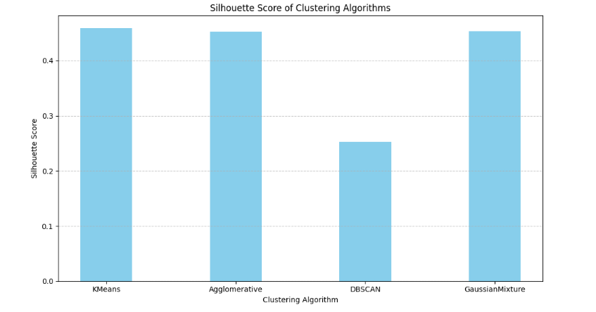

Fig. comparison of Silhoutte Score

Fig. comparison of DB-Index

Fig. comparison of CH-Index

**Discussion:**

K-mean’s ability to generate competitive results without the need for dimensionality reduction techniques like Principal Component Analysis (PCA) was one of its standout performance characteristics. K-means proved its intrinsic power and adaptability to the dataset, achieving a 0.4467 silhouette score., highlighting its dependability as a clustering approach for this particular use case.

Although K-means dominated the investigation, other clustering techniques that offered insightful information about penguin population groupings were Mean Shift and DBSCAN. These silhouette scores, however, fell short of K-means, suggesting that K-means is a superior fit for this type of data analysis [12].

All things considered, the results highlight how crucial it is to use sophisticated computational methods, particularly machine learning clustering algorithms, to acquire a deeper understanding of species diversity and ecological dynamics in Antarctic ecosystems [13]. Researchers can improve their comprehension of the intricate relationships and patterns within penguin populations by utilizing the strengths of K-means clustering. This will ultimately aid in conservation efforts and the preservation of biodiversity in Antarctica and beyond [14].

1. **Conclusion:**

K-means clustering's effectiveness in identifying unique species groupings within Antarctic penguin colonies is demonstrated by the data analysis of penguins that it has produced. Through the efficient classification of penguin populations according to their physical characteristics, K-means offers researchers significant insights into the variety of penguin species and the complex ecological interactions among them.   
The study also emphasizes how important it is to account for regional variations in penguin morphology to produce more accurate clustering results in future studies. Geographical information can be added to clustering algorithms to improve species classification accuracy and provide a deeper understanding of penguin habitats, which will ultimately result in better informed conservation measures.

The significance of using machine learning techniques to ecological studies in general is further emphasized by the study. Through the application of sophisticated computer techniques, scientists can decipher intricate biological dynamics and patterns, supporting efforts to conserve Antarctic animals, including penguins. The application of machine learning methods advances not only our understanding of ecological systems but also enables us to make well-informed decisions that save vulnerable ecosystems and biodiversity in Antarctica and other region.

# References

[1] A. M. a. S. Guido, Introduction to Machine Learning with Python by Andreas Müller and Sarah Guido.

[2] “https://www.bas.ac.uk/about/antarctica/wildlife/penguins/”.

[3] J. Wu, Advances in K-means Clustering, Springer Science & Business Media, 2012.

[4] K. P. Murphy, Machine Learning: A Probabilistic Perspective by Kevin P Murphy.

[5] C. M.-K. F. E. &. A. Gerstner, Gerstner, C., Muller-Karger, F. E., & Atkinson, D. (2000). Using LIDAR for mapping seabird colonies. Remote Sensing of Environment, 75(3), 315-327..

[6] B. B. P. &. T. P. (. Lascelles, Lascelles, B., Borboroglu, P., & Taylor, P. (2004). Penguin species distribution and abundance at sea from global seabird data. Aquatic Conservation: Marine and Freshwater Ecosystems, 14(1), 1-18.

[7] Applications of machine learning in animal behaviour studies John Joseph Valletta , Colin Torney, Michael Kings, Alex Thornton , Joah Madden

[8] Commercial Clustering of Indian Bamboo Species Using Machine Learning Techniques by Ankush D. Sawarkar, Deepti D. Shrimankar, Santosh Kumar Sahu, Lal Singh.

[9] “https://www.kaggle.com/datasets/youssefaboelwafa/clustering-penguins-species”.

[10]https://en.wikipedia.org/wiki/Silhouette_(clustering)#:~:text=The%20silhouette%20score%20is%20specialized,distance%20or%20the%20Manhattan%20distance.

[9] G. Naik, Advances in Principal Component Analysis: Springer, 2017.

[10] “https://www.geeksforgeeks.org/best-python-libraries-for-machine-learning/”.

[11] C. M. Bishop, Pattern Recognition and Machine Learning.

[12] C. C. R. C. K. Aggarwal, Data Clustering: Algorithms and Applications, Chapman & Hall/CRC Data Mining and Knowledge Discovery Series.

[13] Lascelles, B., Borboroglu, P., & Taylor, P. (2004). Penguin species distribution and abundance at sea from global seabird data. Aquatic Conservation: Marine and Freshwater Ecosystems, 14(1), 1-18.

[14] Xavier, A. C., et al. (2018). A kernel density approach to assess spatial and temporal variation in penguin distribution. Marine Ecology Progress Series, 591, 179-192.