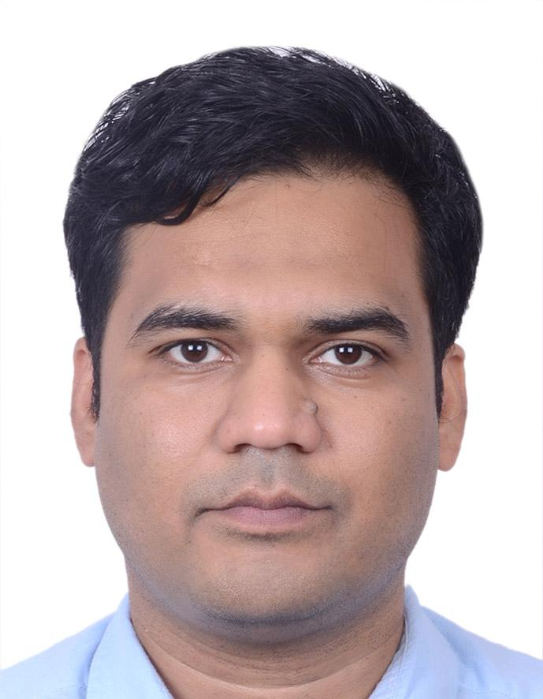
PANKAJ SHARMA
Project Tech Lead | Java, Microservices, AWS
✆ +91 8805524539 | ✉️ pnkjshrm08@gmail.com | LinkedIn/pankaj-sharma-97722434/

Professional Summary:
------------------------------------------------------------------------------------------------------------------------------------------------
- 13 + years Project Tech Lead Proven experience in Full Stack programming, with a deep understanding of JAVA/J2EE , data structures, threading, object-oriented programming (OOP), design patterns, functional programming, and memory optimization. ANGULAR (Typescript) CSS/HTML, BootStrap and System Security.
- Strong expertise in developing web applications and web services using Java, Spring, and Spring Boot frameworks , Build Deployed Docker / Kubernetes / Helm
- Good hands-on experience with microservice architecture and RESTful API development.
- Excellent exposure towards System Security using Security Framework and practices, (JWT/Oauth2/KeyCloak/HTTPS/SSL/TLS certificates/
- Experience with message brokers like Kafka and API Gateway/reverse proxy systems
- Proficient in working with relational and NoSQL databases such as Postgres, Redis, and Amazon Aurora.
- Good understanding of cloud infrastructure, particularly with Amazon Web Services (AWS).
- Hands-on experience developing and maintaining infrastructure as code using Terraform and best practices.
- Experience working with Continuous Integration and Delivery (CI/CD) pipelines using tools like Jenkins, Docker, Kubernetes, Artifactory, and CloudFormation (Terraform experience is a plus).
- Comfortable working in an Agile environment, utilizing tools like JIRA for work item management.
- Proficiency in version control systems like Git and TFS.
- Strong analytical skills and a problem-solving mindset.
- Excellent communication and collaboration abilities, able to work effectively in a team setting.
- **14 Months work experience of Canada Mississauga Ontario (client location)
- Good Exposure to System Design that involves setting up Pipeline for project deployment and cross cutting concerns, AutoScalable and Fault tolerance setup with proper health check monitor in place . Cache and Security Implementation as per system needs.

Technical Skills:
------------------------------------------------------------------------------------------------------------------------------------------------
• Programming : Java 8/11/17+, Spring Boot, Hibernate, JPA, Struts2, Spark, Micro-Service
• Databases: MySQL, Oracle, PostgreSQL, MongoDB, HBase
• Cloud Tech : AWS Cloud ( EC2 ,Load Balancers , IAM , S3 , EBS, Aurora & RDS, Route 53 DNS , EKS)
• Tools & Platforms: Docker,K8S ,Nginx Controller ingress , Git, Jenkins, Linux, Windows , Apache Kafka Key Cloak Auth Server , Eureka Server (GWY ), FeignClient , Resilience4J
• Web Technologies: Angular ,typescript , HTML, CSS, JavaScript
Proficiency with cloud technologies like Azure, AWS, GCP, and version control systems like GitHub & Proven track record of leading and delivering large-scale, complex software projects.

Work Experience
------------------------------------------------------------------------------------------------------------------------------------------------

Project Lead
LTI Mindtree Noida/Pune Dec 2022 - Present

- Lead a team of 8+ developers at Strategic Reporting BI to manage the GRU business data service, achieving 40% faster report generation compared to legacy applications.
- Designed architecture for SR Reconciliation system with a team of 4, using Java and Olympus Infra tools.
- Hosted application on CAS for a team of 5 using Harness, Lightspeed, and Kubernetes, reducing deployment time by close to 50 seconds.
- Collaborated with cross-functional teams to define project requirements and deliverables.
- Authorization Server Keycloak, LogStash ElasticSearch Kibana,
- Spring boot config server, eureka server and setup a resource server.
- Setup Load balancer Pipeline enabled by webHook
- Managed the project lifecycle from documentation to unit testing, prioritizing development
- On-site Client interaction and Vendor side Communication
- Infra setup as done by Harness, Lightspeed classic/ Enterprise edition. End to end deployment .
- Token based security enabled (JWT and spring security )

Apps Dev Tech Lead
Citi Bank (AVP) Pune June 2020 – Dec 2022

- Collaborated with 15+ experts across a range of domains to identify and study data sets to produce
Visuals and other tools
- Worked with R&D team to identify critical , emerging technologies and performed strategic research.
- Planned , tracked and managed 100+ deliverables on short-tem sprints and long-term software deployments.
- Collaborated with cross-functional teams to define project requirements and deliverables.
- Authorization Server Keycloak, LogStash ElasticSearch Kibana,
- Setup Load balancer Pipeline enabled by webHook
- Managed the project lifecycle from documentation to unit testing, prioritizing development
Project Lead
L&T Infotech Pune
Mar 2017 – June 2020
• Designed and developed a taxation processing platform (871m taxation law).
• Built scalable Spring Boot microservices integrated with Kafka and Storm.
• Mentored junior developers and ensured timely delivery.
Senior Java Developer
Atos Pune Mar 2015 – Mar 2017
• Visa Claim Resolution – Developed Java-based modules for dispute handling.
• SWIRA – Migrated .NET components to Java.
• CDJ – Delivered enhancements for financial applications.

Java Developer
CapGemini Pune (Barclays Bank) Aug 2013 – Mar 2015
• Developed Group Complaint Management System using Java/J2EE.
• Improved system performance and streamlined issue resolution.
Java Developer
CGI Bangalore Apr 2011 – Jul 2013
Client: Bell Canada
• Tapestry (Order Management) – Built and maintained order management solutions.
• Bell.ca – Developed customer portal applications with improved user experience.
Education
------------------------------------------------------------------------------------------------------------------------------------------------
Bachelor of Technology (B.Tech) in Computer Science– Engineering Rajasthan Technical University, Jaipur
Score: 68%
I hereby declare that the above information is authentic to the best of my knowledge.
PANKAJ SHARMA

