WIFI CONNECTIVITY STEPS
This Instruction is for Windows 7/Window XP users (not for Linux users) for connecting to “NITT Hostel WiFi” i.e. Wireless Access Points (WAP) in Hostel Zone.
Step 1
- Go to →Control Panel→Network and Internet→Manage Wireless Networks.
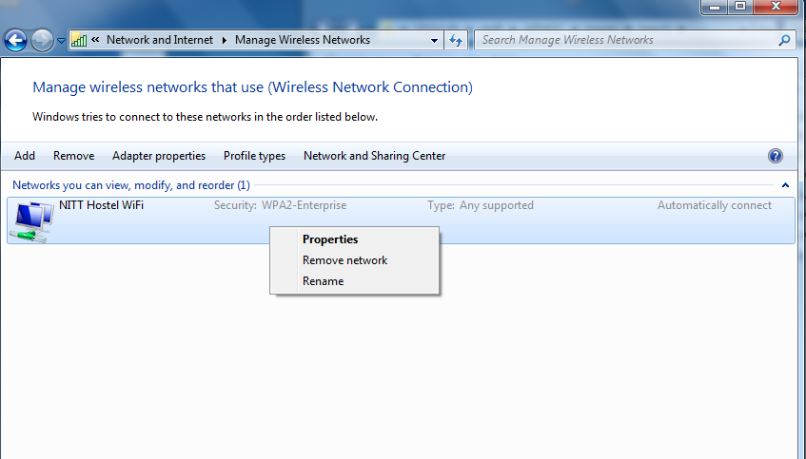
Right click here
Remove the
NITT Hostel WiFi

- Incase NITT Hostel WiFi not showing your screen just leave Step 1 and Go to step 2

Step 2

Install the Root Certificate:
- Double click here 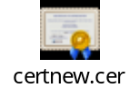(Download the Root certificate)
- Install the Root Certificate

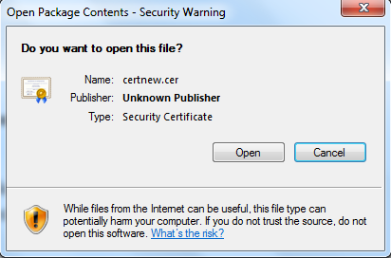
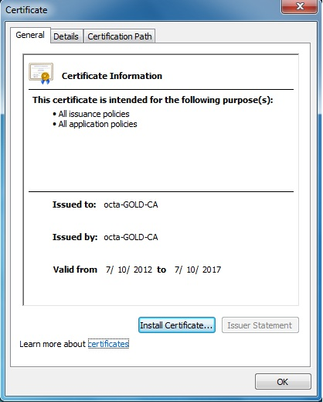
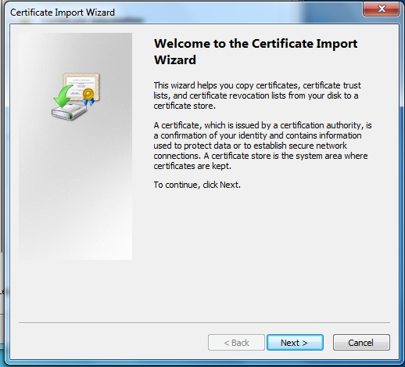

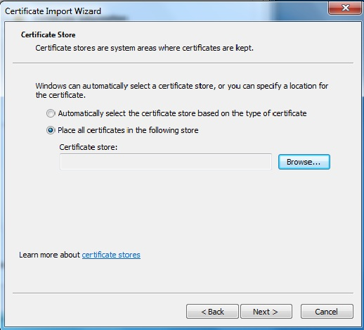
1
1
1
2
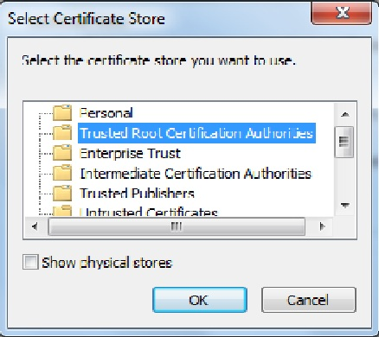
1
1
2
1
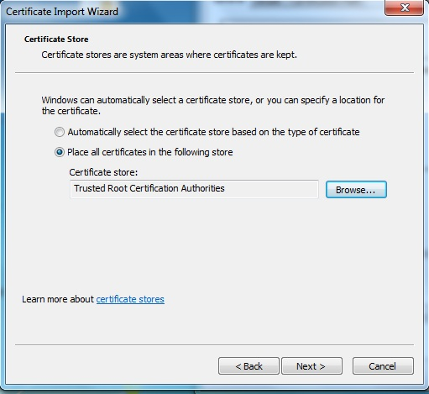
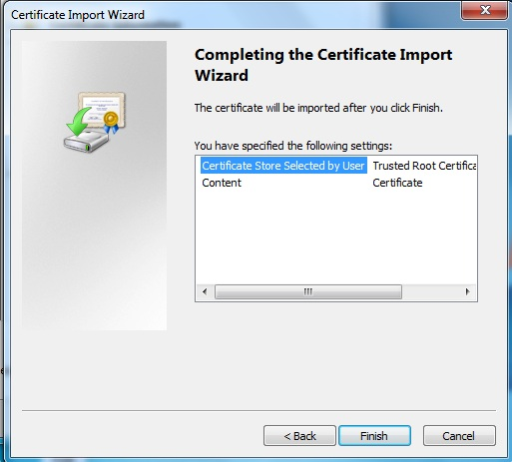
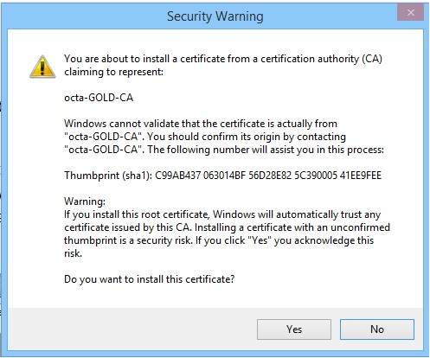
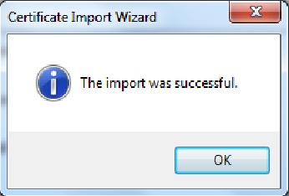
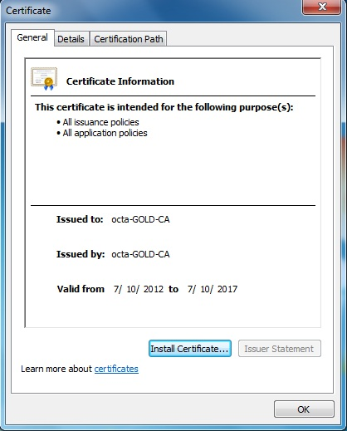
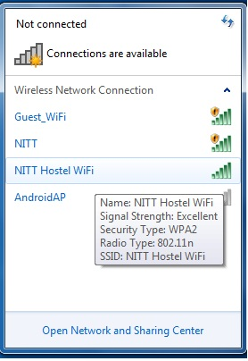
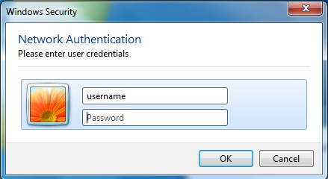
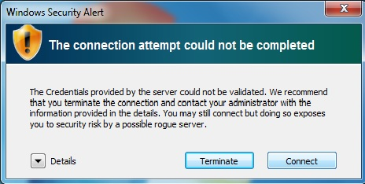
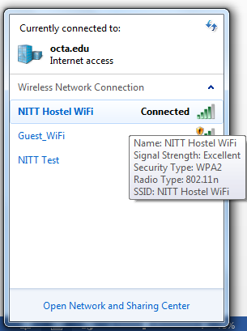
For any further problem contact Wi-Fi Onsite Engineers at CSG
E-Mail ID: wifi@nitt.edu , Contact No: 0431-2503803

