**#CODE**

The Training Institute

Sharpen your Programming Skills with industry experienced instructor.

A deep dive into subjects like

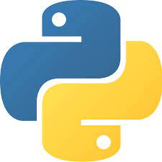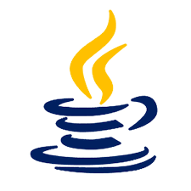 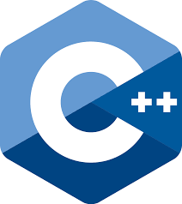

**Data Structures**

Python JAVA

Theory of Computation, Automata Theory, Discrete Mathematics.

**Special Batches for:**

**Get Hands-on training for Electronic Boards like Arduino, Node-MCU, Raspberry Pi and IoT sensors.**

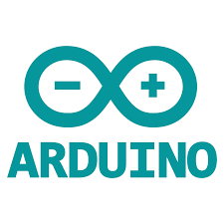 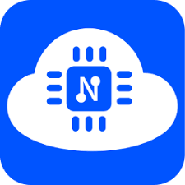 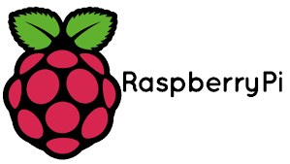 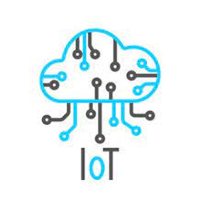

**Chance to interact with industry person with 10+ year experience from software and hardware domains**