Niagara Extremum Seeking Control Block
  - ESC RTO component reference and commissioning guide
Revision 1 | 29 September 2026

1 Overview
The ESC-RTO block continuously adjusts a bounded command Y in response to a measured objective U. Its relay search reverses direction when the objective increases after a minimum hold interval. Used with a suitable process and objective, this behavior seeks a minimum without an explicit process model.
Connect the measured cost or performance objective to U. Connect Y through supervisory selection and equipment protection logic to the manipulated command or setpoint. Y is the optimizer output; U is the process response.

Implemented control method
The implementation uses a constant-magnitude command increment and a direction variable of −1 or +1. It compares consecutive objective samples. There is no sinusoidal dither generator, demodulator, internal smoothing filter, normalized gradient calculation, or convergence detector. Search movement continues when the objective is unchanged.
The direct objective is minimization. To seek a maximum of a measured quantity, supply its negative as U using external logic. There is no objective-mode selector in this implementation.

System integration
Use ESC-RTO as a supervisory optimization layer. External logic must implement equipment interlocks, ventilation limits, temperature and pressure protection, operating permissions, objective conditioning, and fallback command selection. Setting Enable to false holds the stored Y value and changes its status; it does not generate a fallback command.

Document scope
The behavioral reference is ESC_RTO.java, containing Program lifecycle methods and a timer helper. The reference applies to that implementation. The module type, palette path, declared slot types and defaults, and supported Niagara versions must be recorded for the packaged release. Screenshots identify a Program component, rather than establish a published VykonPro module interface.
Sections 2–5 define the interface and operation. Sections 6–8 explain the supplied example, applications, and commissioning. Section 9 lists implementation issues to resolve before release.

2 Required inputs and output
The following interface is required by the source accessors. Numeric slots are expected to be status-bearing numeric values; Enable is expected to be a status-bearing Boolean. Confirm the exact Niagara types and spelling in the Program slot definitions.
Slot | Role and units | Implemented behavior
Enable | Input Boolean | A false value or any status failing isOk() stops algorithm updates and sets Y status to DISABLED. Startup attempts to set a null value to true.
U | Measured objective input | Objective to minimize, in application-defined units. Its status must pass isOk(). No default value, freshness check, or numeric validity check is implemented.
Ymin | Lower command limit | Same engineering units as Y. Startup attempts to set a null value to 0.0. Configure explicitly and require Ymin < Ymax.
Ymax | Upper command limit | Same engineering units as Y. Startup attempts to set a null value to 1.0. Limits are used for initialization, step size, and clamping.
TC | Tuning parameter in seconds | Used as both the minimum objective-based reversal interval and the command-rate scaling parameter. The calculation uses max(1.0, TC). Startup null assignment is 60.0.
PeriodSec | Requested period in seconds | Raw value is used as dT in the algorithm. Startup null assignment is 1.0. The scheduler truncates its selected value to integer seconds; see Section 5.
Y | Bounded command output | Written after each valid calculation. Y status is set to OK on a successful calculation; otherwise it is DISABLED or NULL as described in Section 4.

Required configuration
Before enabling, explicitly set valid values and OK statuses for Enable, U, Ymin, Ymax, TC, and PeriodSec. Use finite numeric values, ordered limits, TC of at least 1 second, and a positive whole-number PeriodSec of at least 1 second with the current timer implementation.
Startup assignments are conditional value assignments, not verified slot defaults: the source does not explicitly set the statuses of these inputs to OK. It also calculates the startup midpoint before applying null-value assignments.

External signals
An initial-command input, base-command input, Reset input or action, fallback value, invalid-input timeout, objective-mode selector, and separate reliability input are not implemented. Build any required supervisory functions around the block and document their wiring.

3 Diagnostics and search sequence
Diagnostic | Meaning | Interpretation
GOut | Current U minus the previous accepted U | Has objective units. It is not divided by command change or elapsed time, and is not a derivative with respect to Y.
EOut | Direction state after limit handling | Normally −1 or +1. A limit-triggered reversal is published after the current command step, so EOut may differ from the direction used for that step.
CTimeOut | Accumulated dT since the last reversal | Elapsed algorithm time in seconds during valid executions. It is not a timeout setting, countdown, or execution count. It may exceed TC.
The source calls getCtimeOut(); the screenshots display CTimeOut. Diagnostic writes are individually wrapped in try/catch. This suppresses runtime write exceptions, but does not make missing accessor methods compile successfully. Confirm the diagnostic slots in the Program definition.

Calculation order
Every execution first reschedules the timer. If Enable is not OK or is false, execution returns. Otherwise U, Ymin, Ymax, and TC statuses are checked; failure returns before state changes. PeriodSec is not part of this validation gate.
For the first valid sample, initialize the internal command at the midpoint of the limits, set direction and previous direction to −1, clear the counter, and store U as the previous objective. The same execution then performs a command step.
TCeffective = Math.max(1.0, TC)
dT = PeriodSec
K0 = dT * (Ymax - Ymin) / (5.0 * TCeffective)
ctime = ctime + dT
g = U - previousU
If g is strictly positive and ctime is at least TCeffective, reverse direction and clear ctime. A decreasing or unchanged objective does not trigger this reversal. The hold interval delays reversals; it does not pause command movement.
y = y + e * K0
If y reaches or crosses either limit, clamp it into the permitted range. At that boundary, reverse e and clear ctime only if e still equals the direction stored from the previous valid execution. This avoids a second reversal when the objective test already reversed direction in the same execution.
Finally, store the current U and direction, publish y to Y with OK status, and attempt to publish the diagnostics. A boundary reversal bypasses the TC hold requirement. With an exactly flat objective, the command keeps moving and reverses at the boundaries.

4 Startup status and recovery
Condition | Y behavior | Internal state
onStart | Publishes the midpoint of the currently read limits and sets OK, before checking Enable or input validity. | Starts the timer. Does not clear initialized or reset internal y, e, ctime, or previousU.
First valid execution | Steps from the midpoint toward Ymin, then applies limits. | Initializes state once when initialized is false.
Enable false or not OK | Numeric value is unchanged; status becomes DISABLED. | No algorithm-state updates. Timer continues.
U or limit or TC status not OK | Numeric value is unchanged; status becomes NULL. | No algorithm-state updates. Timer continues.
Inputs become valid again | Resumes stepping and publishes OK. | Resumes prior state; compares U with the last accepted sample before the pause.
onStop | Does not explicitly change Y value or status. | Cancels the timer ticket; does not reset search state.

State and restart considerations
Internal fields retain state between executions on the same object. They are not explicitly persisted through a station restart. A newly constructed object begins with initialized false; a stop/start on the same instance retains initialized and the previous search state. In that case, onStart can publish a midpoint that differs from the internal command used at the next valid execution.
Disable and invalid-input pauses do not advance ctime. On recovery, GOut spans the objective change across the pause, rather than a single regular sampling interval. There is no recovery settling period or automatic reinitialization.

Status and external command selection
GOut, EOut, and CTimeOut are not refreshed or marked invalid on early returns. They can retain previous values and OK statuses while Y is disabled or null. Evaluate Y status and the operating permission before interpreting diagnostics.
Use an external selector to choose between the optimizer command and the normal supervisory command. Confirm the actual downstream treatment of a linked disabled or null Y value, including Niagara priority-array behavior. Holding the numeric value in this Program does not specify what the final equipment command will do.
Changes to limits and TC affect the next valid calculation. A changed limit is not enforced while the block is returning early. Writing the Y slot externally does not synchronize the internal y state and is not a supported reset method.

5 Execution timing and tuning

Current timer behavior
updateTimer cancels the previous ticket, selects a delay, and schedules BProgram.execute. With an OK PeriodSec status, the selected delay is max(0.2, PeriodSec); with a non-OK status, it is 1.0 second. The selected delay is then cast to an integer before BRelTime.makeSeconds is called.
PeriodSec | Requested scheduler delay | Algorithm dT
5.0 with OK status | 5 seconds | 5.0 seconds
1.5 with OK status | 1 second | 1.5 seconds
0.5 with OK status | 0 seconds | 0.5 seconds
Non-OK status | 1 second | Raw slot value still used
The stated 200 ms minimum in the source comment is not achieved by this conversion. A zero-second request may produce rapid rescheduling; actual scheduler behavior requires runtime verification. Until corrected, use whole-number periods of at least 1 second. Negative, non-finite, or non-OK period values are not acceptable operating configurations.

Tuning relationships
TC controls two behaviors together: increasing it slows command movement and increases the interval before an objective-based reversal can occur. It is a tuning parameter, not an estimated process time constant computed by the block.
With consistent timing and no reversals, the nominal command rate is the allowed command span divided by five times TCeffective. A full-range traversal therefore takes approximately five times TCeffective; a midpoint-to-boundary traversal takes approximately 2.5 times TCeffective. Actual elapsed time also depends on scheduler timing and any additional executions.
Start with TC informed by the dominant response time of the command-to-objective path, including any external filter. As commissioning guidance, aim for PeriodSec no greater than one tenth of TC, subject to the whole-second restriction above. This is a starting heuristic, not an enforced constraint or a convergence guarantee. Increase TC if direction changes occur before the process response becomes informative.

Worked calculation
For Ymin = 0, Ymax = 1, TC = 60 s, and PeriodSec = 5 s, K0 is 1/60, approximately 0.016667 command units per valid execution. The first valid execution has g = 0, advances ctime to 5 s, and publishes Y ≈ 0.483333 with EOut = −1.
After 12 uninterrupted valid executions without a boundary reset, ctime can reach 60 s and permit a reversal if that execution has g > 0. With no reversal, the nominal full-span travel time is 300 s. U magnitude affects GOut, but only its sign comparison affects the direction decision.

6 Supplied wiresheet example
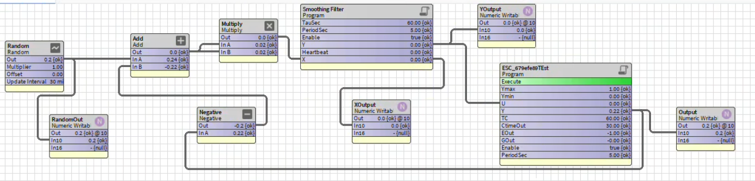
Figure 1 Supplied test wiresheet with the optimizer inside a simulated response loop
The visible wiring feeds the optimizer command Y back through Negative and Add. Add forms the difference between the Random target and the command. The same difference feeds both Multiply inputs, creating a squared-error objective. The Smoothing Filter output feeds ESC U. Writable points expose signals for observation.
This is a closed-loop test of a moving-target cost function. Random changes the target; it is not an internal ESC dither signal. The theoretical minimum of the unfiltered squared error occurs when Y equals the target, if the target lies inside the command limits. Filter dynamics delay the objective response.
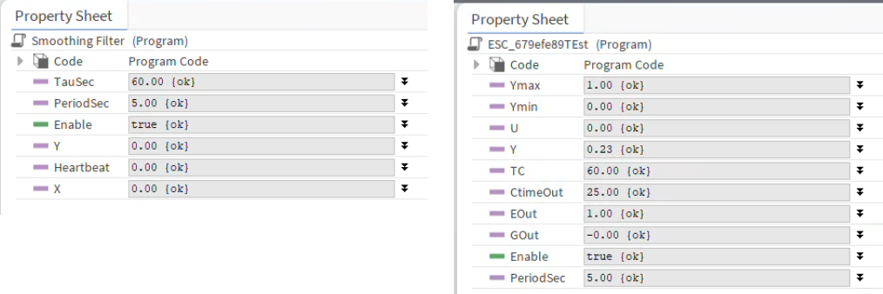
Figure 2 External smoothing filter at left Figure 3 ESC property snapshot at right
The filter is a separate Program. Its screenshot shows settings, but its implementation is not part of ESC_RTO.java. Filter timing, status handling, and initialization must be checked in its own code.
Both Programs show PeriodSec = 5 s. The filter shows TauSec = 60 s; ESC shows TC = 60 s.
U is the filtered objective and Y is the generated command. CTimeOut = 25 is a diagnostic snapshot, not a timeout configuration. EOut = +1 is the current direction state. GOut displays the latest objective difference, which may round to zero. Snapshots in these figures need not represent the same instant.

7 Application guidance
The following are integration examples. Operating constraints, objective construction, filtering, fallback selection, and measurement validation are implemented in surrounding station logic, not inside ESC-RTO.

Economizer optimization
Use Y as an outdoor-air damper command or outdoor-air-flow setpoint. Choose an objective U such as cooling valve signal.
Set Ymin and Ymax in the same units as the final command. Do not assume a fixed minimum damper position always provides the required outdoor airflow. Enforce ventilation, mixed-air and supply-air temperature limits, pressure limits, freeze protection, humidity limits, and economizer high-limit permissions independently.
Enable only when the fan and relevant control loops are operating in a suitable mode and measurements are usable. Use occupancy schedule and equipment availability in that permission. When the permission is removed, select the normal economizer sequence externally. Re-enable only after verifying that retained optimizer state is suitable for the current operating condition.

Supply air temperature reset
Use Y as the supply-air temperature setpoint and define Ymin and Ymax in temperature units. Supply U with a cost measure that reflects the intended tradeoff, such as combined fan, cooling, and reheat power. If comfort terms are included, document their units, scaling, and weights. Such penalties do not replace hard comfort or equipment constraints.
Keep the normal supply-air temperature loop active beneath the optimizer. Enforce humidity, condensation, heating and cooling mode limits, and zone-demand constraints in supervisory logic. TC should reflect the slower response of the entire setpoint-to-objective path, including terminal-unit and zone effects.
The first valid execution starts from the limit midpoint and immediately steps downward. It does not start from the current supervisory setpoint. If a bumpless transfer or a selectable initial command is required, provide a defined external handoff or revise the implementation before use.

Maximization and objective conditioning
For a performance quantity that should increase, negate that quantity before connecting it to U. Positive constant scaling preserves the sign-based direction decision, although resolution and numeric effects can matter. Time-varying objectives, unrelated load changes, sensor noise, or external overrides can produce misleading objective changes.
Apply any smoothing upstream of U and account for the added delay when tuning TC. The block has no noise threshold: any strictly positive sample difference can reverse direction once the hold interval expires. It also has no freshness test; a stale value with OK status can cause continued command movement.

8 Commissioning and troubleshooting

Configuration and functional checks
Record the Niagara version, module or Program revision, exact slot types, command units, objective definition, parameter values, and external supervisory sequence. Verify accessor names and diagnostic slots before compiling the Program in the target environment.
Check | Expected result from this implementation
First valid execution | Midpoint initialization followed by one negative-direction step; GOut is zero.
Enable false and non-OK Enable | Y number holds, Y status becomes DISABLED, diagnostics hold, and timer continues.
Non-OK U, Ymin, Ymax, or TC | With Enable valid and true, Y number holds and Y status becomes NULL.
Recovery after a pause | Previous state resumes; the next objective difference includes the pause.
Positive objective difference | Direction reverses only when accumulated algorithm time reaches TC, unless a boundary reversal occurs.
Constant or decreasing objective | No objective-based reversal; movement continues until another reversal condition occurs.
Boundary contact | Command clamps; direction reverses only when it was unchanged from the previous execution.
Timing and restart | Confirm observed interval, no extra execute triggers, and both fresh-object and same-instance restart behavior.
Supervisory override | Final equipment command follows the external fallback and all independent protections.

Trends and diagnosis
Trend U, Y with status, Enable with status, GOut, EOut, CTimeOut, limits, TC, PeriodSec, and the actual equipment command. Include timestamped execution evidence when checking timing. Avoid extra Execute invocations during normal operation: each invocation can take another step and reset the scheduling ticket.
If Y does not move, check its status first, then the timer and input statuses. If movement is erratic, check noise, process delay, objective changes unrelated to Y, and external overrides. If the command repeatedly traverses the whole range, check a flat or stale objective, incorrect signal wiring, and whether the optimum lies within the configured limits.
Test fractional or invalid periods, reversed limits, and non-finite values only in an isolated test station. These cases are not safely validated in the source. Confirm upstream rejection or corrected implementation before production use.

9 Implementation review and release notes
The following findings distinguish the current code from behavior that may be desired in a released component. They are documentation and engineering review items; no source changes are included in this revision.

Timer and numeric validation
Lines 140–148 truncate the scheduler delay to integer seconds, while lines 62–65 use raw PeriodSec in the calculation. Use a consistent validated duration for both scheduling and the algorithm, and preserve the intended subsecond precision if supported. Validate finiteness, positive period, and ordered command limits. Status checks alone do not reject NaN, infinity, or reversed limits.

Startup and restart state
Lines 19–31 schedule execution and publish a midpoint before applying null-value assignments or checking operating permission. Define and implement initialization order, input statuses, output status, and whether restart resets or resumes the internal state. onStart does not reset initialized, while onStop only cancels the ticket. A reset or initial-command interface would require additional code.

Pause recovery and diagnostics
Lines 40–55 return without updating previousU or diagnostic statuses. Define whether recovery should discard the first objective difference, impose a settling interval, or reset the search. Publish diagnostic validity consistently. The optional-debug comment at line 115 does not remove the need for resolvable getter methods at compile time.

