User-defined Model: Load Modulation
For any questions, or to report bugs, please email sameer.nekkalapu@pnnl.gov.
This document describes a user defined module (UDM) developed for the PSS/E simulation platform that modulates the demand of a load based on user-selected signal attributes. The UDM is intended to help transmission planning studies evaluating the impact of load-induced forced oscillations on the power grid.
Three versions of the model are available for use in PSS/E v34, v35, and v36. Model input parameters are specified in Table 1 and Figures 1 (a)-(c). Example model response is shown in Figures 2 and 3.
Table 1. Load modulation UDM input parameters.
ICONs | Parameter | Parameter Description
M | Flag1 | 0 (constant power), 1 (constant current), 2 (constant impedance) for P
M+1 | Flag2 | 0 (constant power), 1 (constant current), 2 (constant impedance) for Q
M+2 | Flag3 | 0 (monoperiodic), 1 (bi-periodic), 2 (triangular)
M+3 | Flag4 | 0 (Oscillation applied to only P), 1 (Oscillation applied to only Q)
CONs | Parameter | Parameter Description
J | X | Start time of the oscillation
J+1 | D | Duty cycle
J+2 | D_Fast | Duty cycle of the faster cycles in the bi-periodic waveform. Used only when Flag3 = 1
J+3 | Freq | Frequency of the oscillation
J+4 | Fast_Freq | Frequency of the faster component in the bi-periodic waveform. Used only when Flag3=1
J+5 | NC | Number of cycles that the oscillation persists
J+6 | Amp | Amplitude of the oscillation
J+7 | Amp1 | Lower Amplitude of the fast frequency cycles in the bi-periodic waveform. Used only when Flag3 =1

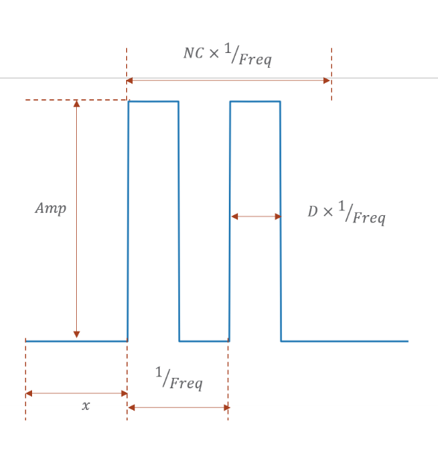  - Monoperiodic square wave (Flag3 = 0) | 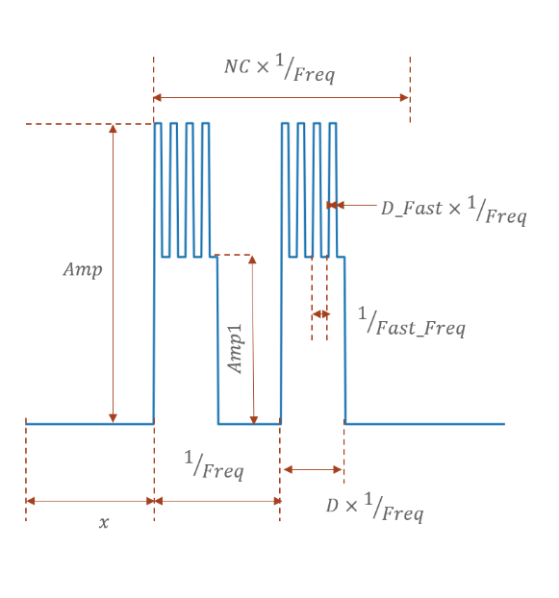 (b) Biperiodic pattern (Flag3 = 1)
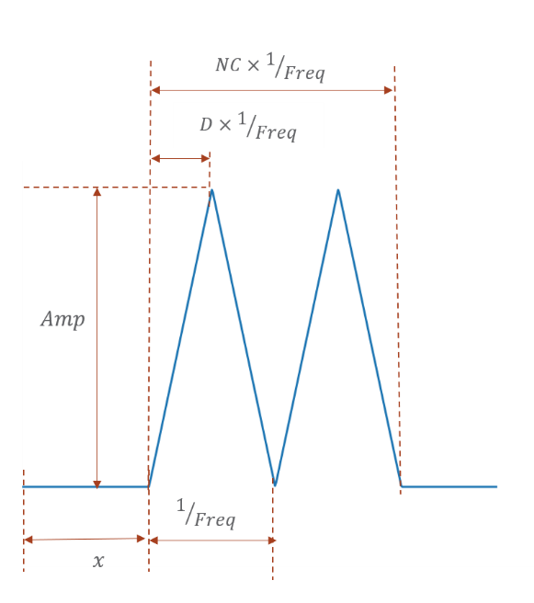
(c) Triangular pattern (Flag3 = 2)

Figure 1: Parametrized representation of different oscillatory load profiles in the load modulation UDM
Note: The parameters Amp1, Fast_Freq and D_Fast, in Table 1, are utilized in the UDM only when Flag3 is enabled (Flag3 = 1). However, the user should always have some default values for these parameters even when Flag3 = 0 to ensure the structure of the parameters being read from the DYR file by PSSE remains intact. Some example DYR file entries for different signals are shown in Appendix A.
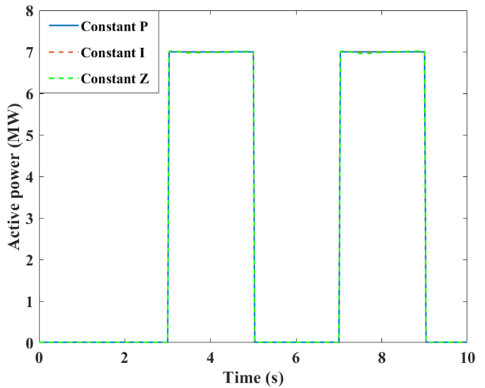
Figure 2. Comparison of different Load Type Representations for Square Wave Oscillation in Active Power

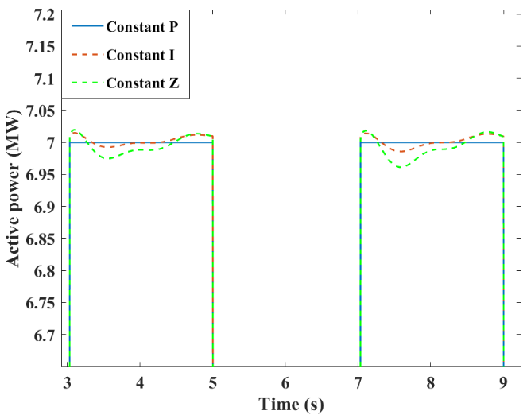
Figure 3. Zoomed in representation of Figure 2

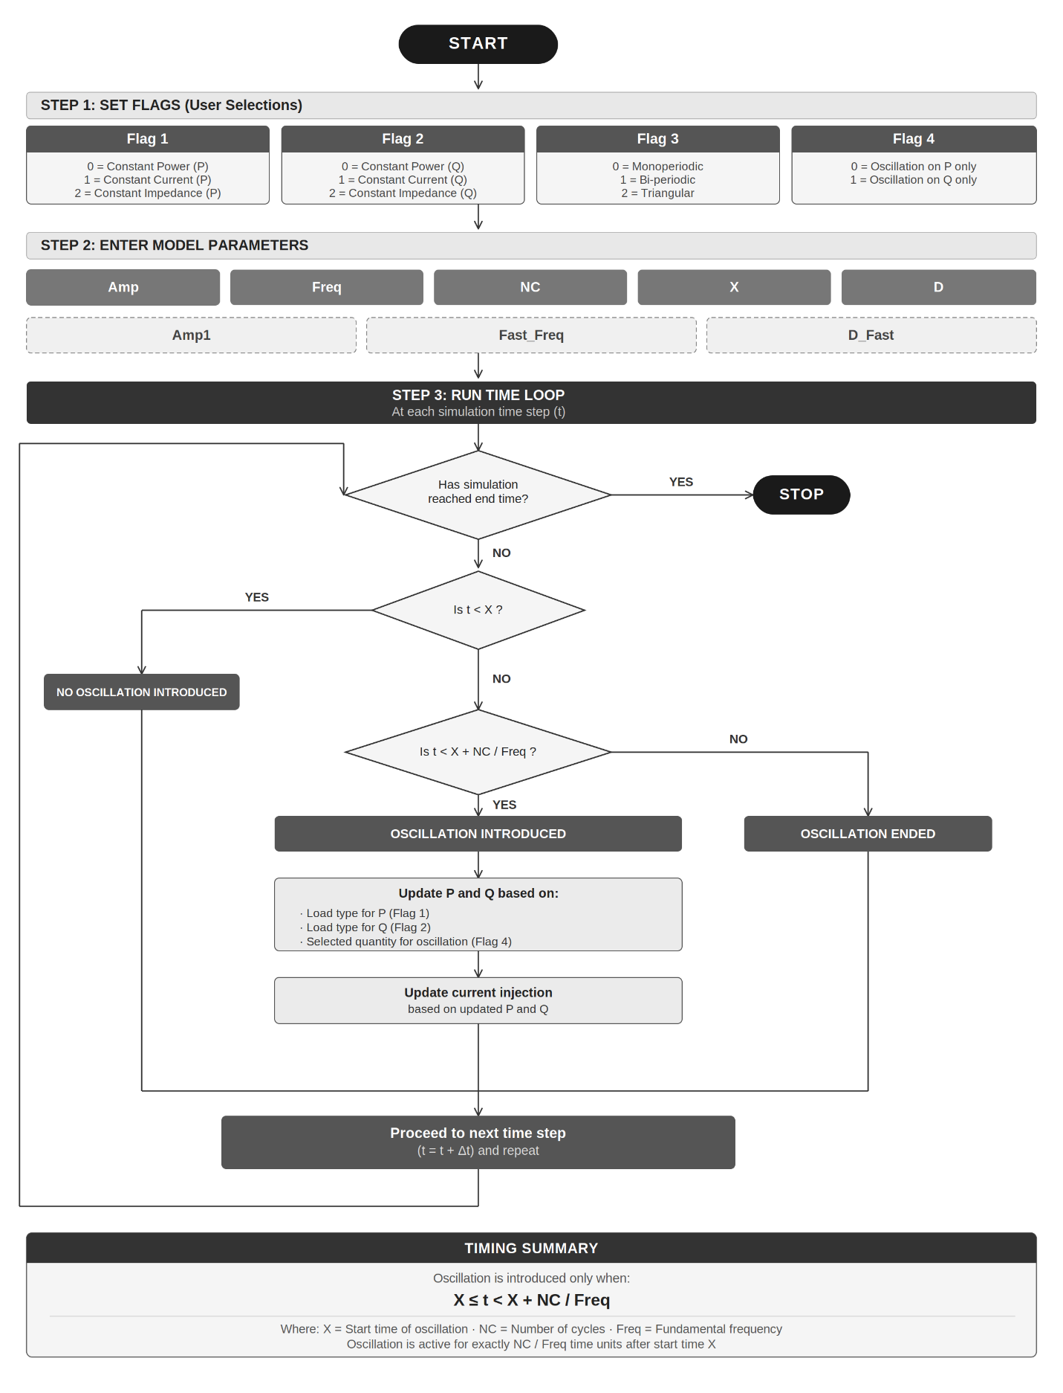
Figure 4. Flowchart of the UDM usage

Appendix A. Example DYR Entries

Example A.1. A load is connected at Bus 1401 with constant-current P and Q components. A bi-periodic oscillation is applied to the Q component, consisting of a slow component at 0.25 Hz (peak-to-peak amplitude: 7 MVar) and a fast component at 1 Hz (peak-to-peak amplitude: 3 MVar). The oscillation begins at t = 3 s and persists for 8 cycles of the 0.25 Hz component (i.e., 32 seconds). Duty cycle for each component is 0.5.

1401 'USRLOD', 'OS', 'LINJBL', 12 1 4 8 0 5 0
1 1 1 1
3 0.5 0.5 0.25 1 8 7 3

// parameters corresponding to line 2 - Flag1 Flag2 Flag3 Flag4
// parameters corresponding to line 3 - X D D_Fast Freq Fast_Freq NC Amp Amp1

Example A.2. A load is connected at Bus 1401 with constant-current P and Q components. A monoperiodic square wave oscillation is applied to the P component, at 0.25 Hz with peak-to-peak amplitude 10 MW. The oscillation begins at t = 3 s and persists for 8 cycles (i.e., 32 seconds). Duty cycle is 0.5

1401 'USRLOD', 'OS', 'LINJBL', 12 1 4 8 0 5 0
1 1 0 0
3 0.5 0 0.25 0 8 10 0

// parameters corresponding to line 2 - Flag1 Flag2 Flag3 Flag4
// parameters corresponding to line 3 - X D D_Fast Freq Fast_Freq NC Amp Amp1

