Instructions for importing a CSV file into the conversion table for the FRAMES 1.3 DOT

- Depending on what is to be imported (just new data or complete replacement) you may need to truncate the table contents first. To do this, perform the following steps:
  - Start the SQL Query Analyzer and select the FramesStructures databae.
  - Type in “TRUNCATE table tblConversion” in the query window and press the “play” button (Green arrow).
  - Make sure that the Messages windows says “The command(s) completed successfully.”
- Start Enterprise Manager
- Drill down to the FramesStructures Database
- Select “Tables” from the tree-view control
- Right-click on tblConversion in the right pane and select (“All Tasks / Import Data”)
- Press the “Next” button on the first screen of the DTS Import/Export Wizard
- Select “Text File” (bottom of the list) as the Data Source and enter the file name for the .csv file to be imported. When both options are set press the “Next” button
- Make the settings for the “Select file format” screen as shown below:
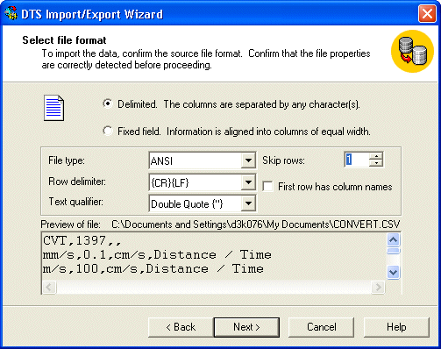
Make sure that the “Delimited” radio button is selected and the “Skip rows:” box is set to 1. When your settings match those in the picture above, press the “Next” button.
- Press the “Next” button on the “Specify Column Delimiter” page (the default is comma, which is correct).
- On the “Choose a destination” screen, make sure that the database selected is FramesStructures and press the “Next” button.
- On the “Select Source Tables and Views” screen, select the Destination to be tblConversion and then press the … button in the Transform column.
- On the “Column Mappings and Transformations” screen do the following:
  - Uncheck the “Enable identity insert” check box
  - In the Mappings table change the following settings:
    - Set the source for the row with the Destination that says “FromUnits” to Col001
    - Set the source for the row with the Destination that says “LinearFactor” to Col002
    - Set the source for the row with the Destination that says “ToUnits” to Col003
    - Set the source for the row with the Destination that says “ConertType” to Col004
    - All the rest of the rows in this table should have the source set to <ignore>
  - Press the “OK” button when all the above settings are in place
- Press the “Next” button on the “Select Source Table and Views” screen
- Press the “Next” button on the “Save, Schedule, and replicate package” page
- Press the “Finish” button on the “Completing the DTS Import/Export Wizard” page
- Make sure that no errors took place when the import is complete (it will say that it was successful if no errors took place).

