Internal algorithms of qFeature

Landon Sego

4 September 2015

The following is a mathematical description of the algorithms in the fitQ and discFeatures functions in the qFeature package:

Extracting features from continuous time series using fitQ

A quadratic regression model is fit to a moving window of the time series. To simplify the solution of the least square estimators, and thus avoid complicated (and expensive) expressions and/or matrix inversion, the linear and quadratic predictors are centered so that they are both orthogonal to the intercept, and if possible, orthogonal to one another. The usual quadratic regression model can be written as:

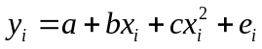

We can create an equivalent model by centering the linear and quadratic predictors as follows:

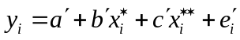
where
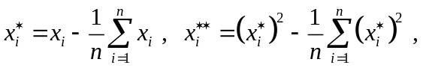
and n is the number of data points in the window. Note that 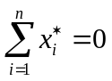and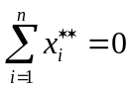, which implies that 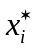 and 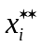 are orthogonal to the intercept. Furthermore, if the original x_{i} are evenly spaced, then 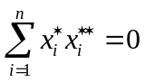. However, in the event there are missing data points in the window, the original x_{i} are not evenly spaced. Using and some algebra, we can rewrite as:

where
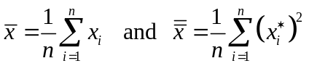

Using , we can equate the original parameters in to those in :

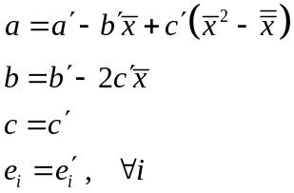

The advantage of the parameterization given in is that it simplifies the computation of the least squares estimates of the model parameters. To begin with, suppose the x_{i} are evenly spaced so that and are orthogonal. It can be readily shown that the least squares estimates are then given by:
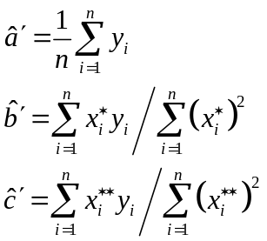

And the residual is calculated in the usual fashion:

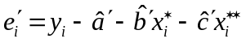

If x_{i} are not evenly spaced so that and are not orthogonal (which would occur if the window contained missing data), it can be shown that the least squares estimates are given by:

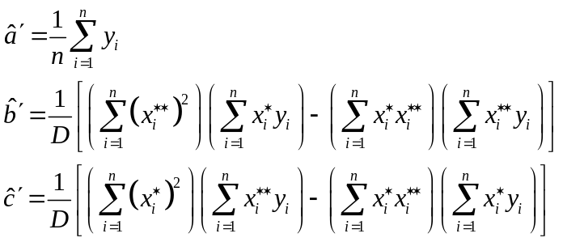

where
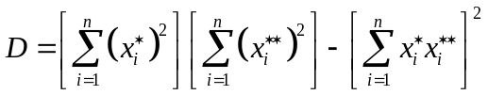

Note that reduces to when , i.e., when and are orthogonal. The fitQ function fits the quadratic model shown in by calculating the parameter estimates for each window using or and then “backtransforming” to the original parameterization using .
If the linear.only argument of fitQ is set to TRUE, a similar approach to the one described above is used, except the quadratic term in is omited, and the calculations are simpler.

Extracting features from a discrete time series using discFeatures

We will refer to the distinct values of a discrete time series as states, where the value of the state may change (or remain the same) for each time point in the series. The discFeatures function produces a summary of the percentage of time spent in each state, along with the number of transitions that occurred between the various states. Calculating the percentage of time that is spent within each state is a relatively simple matter and will not be discussed here.

The strategy of the algorithm is to create a mapping of the state labels to a set of integers such that first difference of those integers will uniquely identify all possible transitions between the states at a given point in time. The approach is easiest to explain using a simple example:

Suppose we have a discrete vector that has four states labeled 0, 1, 2, and 3. We found that the mapping 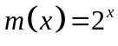 will produce unique differences among each of the states. That is, 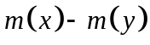 will be unique for every combination of 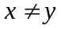, where x and y correspond to state labels 0, 1, 2, …. The approach works for 2 to 55 unique states. Beyond 55, some combinations of begin to repeat due to what appears to be machine error. The transition matrix below shows the values of for each of the 16 possible ways to move from state x (on the rows) to state y (on the columns).

 | 0 | 1 | 2 | 3
0 | 0 | -1 | -3 | -7
1 | 1 | 0 | -2 | -6
2 | 3 | 2 | 0 | -4
3 | 7 | 6 | 4 | 0

The diagonal elements correspond to the situation where the state does not change, which is why their matrix elements are zero. For purposes of this discussion, these diagonal elements are not of concern to us since they are easily summarized by the percentage of time spent in that particular state.

The off-diagonal elements of the matrix are unique. For example, if the discrete parameter transitions from state 3 to state 1, then that transition is uniquely identified in the matrix by 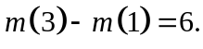 And the transition from state 1 to state 2 is represented by 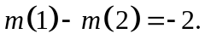

To count the number transitions from one state to another for a discrete time series Y, the first (or successive) differences of m(Y) are tabulated. The number of “6’s” that occur will indicate the number of times the variable transitions from state 3 to state 1. Likewise, the number of “-2’s” that occur in a given phase will indicate the number of times the variable transitions from state 1 to state 2, etc.

This approach helps to minimize the number of passes that need to be made through the vector of the discrete variable in order to count all the possible transitions.

