ABC Logistics Lead Time Analysis
Data Preparation, Cleaning, Descriptive Analysis, and Correlation Findings

STA 4233/6233 Final Project
Prepared for: ABC Management Team
Group Member: Periale Noutaha and Omer Khan
Document Type: Professional Report
Date: May 2026

Table of Contents
1. Project Overview .......................................................... 3
1.1 Business context and purpose ............................................. 3
1.2 Operational scope of the analysis ........................................ 4
1.3 Objectives of the project ................................................ 4
1.4 Audience and reporting approach .......................................... 5
2. Data Overview and Preparation ............................................. 6
2.1 Data source and workbook structure ....................................... 6
2.2 Key variables used in the analysis ....................................... 7
2.3 Preparation strategy ..................................................... 7
2.4 Derivation of Quarter and Year ........................................... 8
2.5 Construction of lead-time measures ....................................... 8
2.6 Identification of quality issues ......................................... 9
2.7 Cleaning and reshaping approach .......................................... 9
2.8 Final analytical dataset ................................................ 10
3. Data Cleaning and Quality Improvement .................................... 11
4. Descriptive Analysis ..................................................... 13
5. Correlation Analysis ..................................................... 17
5.1 Approach to Correlation Analysis ........................................ 17
5.2 One-Hot Encoding of Categorical Variables ............................... 17
5.3 Correlation Ranking with In-transit Lead Time ........................... 18
5.4 Interpretation of Major Correlation Patterns ............................ 19
6. Key Findings and Business Implications ................................... 20
6.1 Main Operational Findings ............................................... 20
6.2 Implications for Shipment Planning ...................................... 21
6.3 Implications for Customer Delivery Expectations ......................... 22
6.4 Implications for Inventory Risk ......................................... 22
7. Conclusion ............................................................... 23
Appendix A. Supporting Tables ............................................... 24
Appendix B. Supporting Figures .............................................. 25

1. Project Overview

1.1 Business context and purpose
ABC requested an analytical review of its inbound logistics data to better understand how shipment origin and transportation method affected delivery timing into its warehouse network. The company operated in an environment of elevated uncertainty, where planning accuracy had become increasingly important for both customer service and inventory control. In this setting, lead-time variability created two operational risks. Late arrivals increased the likelihood of missed customer commitments and weakened service reliability, while early arrivals increased inventory carrying costs and placed unnecessary pressure on warehouse capacity. The purpose of this project was to prepare, clean, and explore the available logistics dataset so that ABC could begin identifying the operational factors most closely associated with inbound lead-time behavior.
The project was designed as a data-preparation and exploratory-analysis exercise rather than a predictive modeling exercise. That scope was important because management first needed a dependable view of the quality, structure, and behavior of the lead-time data before any forecasting or optimization decisions could be supported confidently. The assignment therefore emphasized the construction of clean lead-time measures, the repair of unusual or missing values, and the presentation of business-facing descriptive and correlation findings rather than code-focused discussion.
Figure 1.1 introduces the operating footprint referenced in the assignment. It shows the main warehouse destination and the four origin sites that accounted for the vast majority of inbound shipments. The figure provided the geographic context for the later analysis of site-level and transportation-level differences in logistics timing.
Figure 1.1. ODM Sites and Warehouse Locations
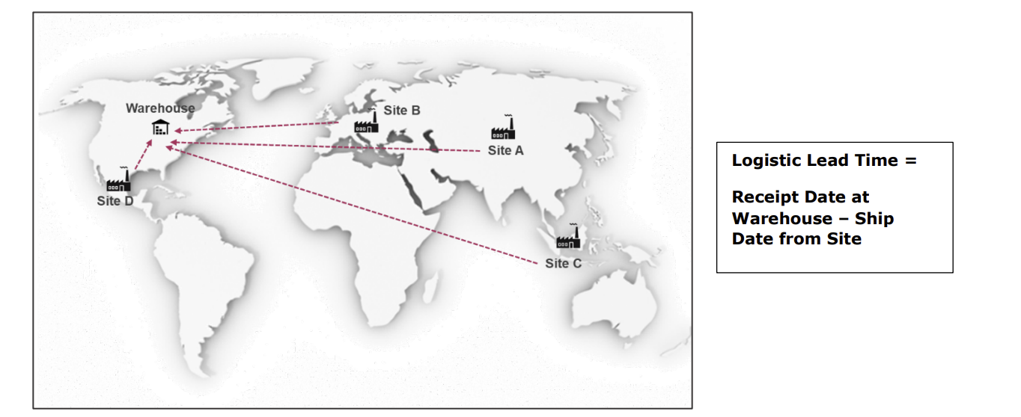

1.2 Operational scope of the analysis
The analysis centered on the movement of inventory from original design manufacturer sites to warehouse destinations. ABC’s process flow began when a purchase order was downloaded at the site, continued through manufacturing at the site, then shipment from the site, and ended when the product was received at the warehouse. Based on this process, two operational timing measures were central to the analysis. Manufacturing Lead Time represented the elapsed time between purchase-order download and site shipment, while In-transit Lead Time represented the elapsed time between shipment and receipt at the warehouse.
These timing measures were important because they reflected different sources of delay. Manufacturing Lead Time captured site-side production behavior, while In-transit Lead Time captured logistics performance after the product left the site. Because ABC used four major ship modes—Air, Fast Boat, Ground, and Ocean—the analysis was structured to examine whether lead-time behavior differed systematically across both origin sites and transportation methods.
Figure 1.2 clarifies the shipment process used in this report and shows how the two lead-time measures were defined. The figure is helpful because it separates production timing from transportation timing, which mirrors the logic used in the analytical workflow.
Figure 1.2. Inventory Movement Process and Lead-Time Definitions
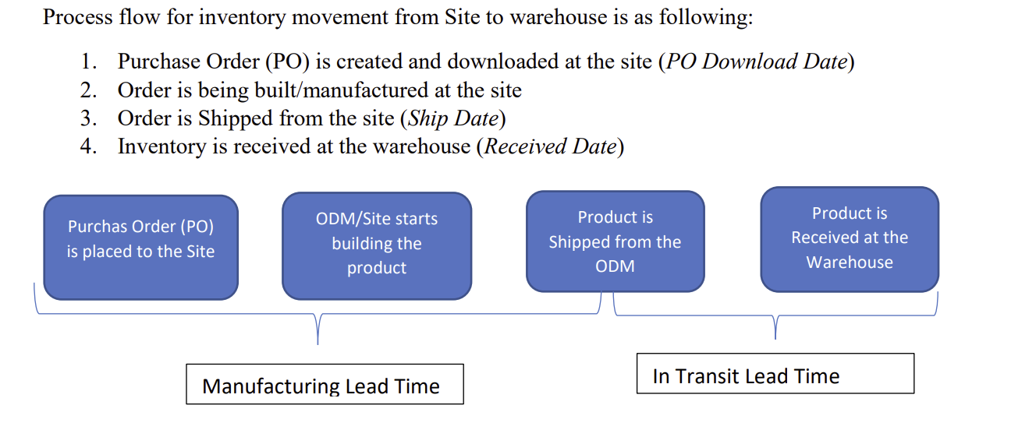

1.3 Objectives of the project
The objective of the work was threefold. First, the raw workbook needed to be converted into a reliable analytical dataset by joining the Raw-Data and Calendar worksheets, deriving Quarter and Year from calendar ranges, and calculating both required lead-time measures. Second, the dataset needed to be cleaned so that missing values, inconsistent text values, and implausible timing observations did not distort the analysis. Third, the cleaned dataset needed to be explored through descriptive statistics, graphical summaries, and correlation analysis so ABC could identify the operational variables most strongly associated with inbound logistics timing.
These objectives aligned directly with the project instructions, which required the calculation of Manufacturing Lead Time and In-transit Lead Time, the cleaning of unusual or missing values, the exploration of the cleaned data using both numeric and graphical methods, and the reporting of correlations between all predictors and In-transit Lead Time after converting categorical variables into numeric form through one-hot encoding.

1.4 Audience and reporting approach
This report was prepared for a management audience rather than a technical coding audience. For that reason, it focused on the business meaning of the preparation and exploration steps instead of reproducing R code. The report used tables and figures to organize the findings and wrote the discussion in a formal business style so that the main operational implications could be understood quickly by decision makers.
Throughout the report, each table and figure was introduced in the preceding paragraph and then interpreted in plain business language. This structure was chosen to meet the project rubric and to ensure that the final document was suitable for ABC’s management team.

2. Data Overview and Preparation

2.1 Data source and workbook structure
The project used the workbook supplied for the assignment, which contained two worksheets: Raw-Data and Calendar. The Raw-Data worksheet contained the transaction-level shipment records used for the analysis, while the Calendar worksheet supplied the date ranges needed to assign Quarter and Year values based on each record’s Receipt Date. The project instructions required both worksheets to be read and used together, and they specifically prohibited hardcoding quarter or year values.
The Raw-Data worksheet served as the main operational dataset. Each row represented one shipment record and included information related to product line, origin site, ship mode, and key operational dates such as Purchase Order Download Date, Ship Date, and Receipt Date. These variables allowed the shipment process to be reconstructed from order release through warehouse receipt. The Calendar worksheet functioned as a reference table, and its date boundaries made it possible to map each warehouse receipt into the correct reporting quarter and year in a consistent and auditable way.

2.2 Key variables used in the analysis
The preparation stage focused on variables that were operationally meaningful and analytically necessary. The principal categorical variables were LOB, Origin, Ship Mode, and Quarter. These fields described the business line, shipment origin site, transportation method, and reporting period associated with each transaction. The principal date variables were Purchase Order Download Date, Ship Date, and Receipt Date. These dates defined the shipment timeline and made it possible to calculate the required lead-time measures.
Table 2.1 summarizes the variables that were carried into the final analytical dataset. These fields supported descriptive summaries, graphical comparisons, and correlation analysis.
Table 2.1. Variables Included in the Final Analysis
Variable | Type | Role in Analysis
LOB | Categorical | Business line
Origin | Categorical | Origin site
Ship Mode | Categorical | Transportation method
PO Download Date | Date | Order release timing
Ship Date | Date | Shipment timing
Receipt Date | Date | Warehouse receipt timing
Quarter | Categorical | Reporting period
Year | Numeric | Reporting period
Manufacturing Lead Time Clean | Numeric | Production-cycle duration
In-transit Lead Time Clean | Numeric | Logistics-cycle duration

2.3 Preparation strategy
The data preparation process followed a structured sequence so that the final dataset could support meaningful exploratory analysis. The first step standardized the key categorical fields. Product line, origin, and ship mode values were reviewed for differences in capitalization, spacing, and inconsistent spellings. Standardizing these fields reduced the risk that the same category would be split into multiple labels during tabulation, graphing, and correlation work.
The second step converted the date variables into usable date fields. Purchase Order Download Date, Ship Date, and Receipt Date were treated as operational timeline markers. These dates were essential because the two lead-time metrics required by the assignment depended directly on accurate date arithmetic. Once the date structure had been validated, Quarter and Year were added by matching Receipt Date against the ranges defined in the Calendar worksheet.

2.4 Derivation of Quarter and Year
Quarter and Year were not entered directly in the Raw-Data sheet. Instead, they were derived by comparing each Receipt Date with the date ranges supplied in the Calendar worksheet. This approach ensured that period assignments followed a consistent calendar rule and complied with the project requirement that quarter and year values be created without hardcoding any specific dates. Where receipt information was incomplete, estimated receipt dates were later used to fill any remaining missing quarter and year values. As a result, the final analytical dataset contained complete quarter and year assignments.

2.5 Construction of lead-time measures
Two core timing measures were created for every shipment record. Manufacturing Lead Time was calculated as the number of days between Purchase Order Download Date and Ship Date. In-transit Lead Time was calculated as the number of days between Ship Date and Receipt Date. These variables were central to the report because they separated delays occurring during site production from delays occurring after the product entered the logistics network. The assignment specifically required both measures to be calculated and then reviewed carefully for unusual or missing values before analysis.

2.6 Identification of quality issues
After the derived variables were created, the dataset was reviewed for completeness, consistency, and plausibility. Four issue types were emphasized. First, some records contained missing values in fields needed for period assignment or lead-time calculation. Second, some lead-time values were operationally implausible, including negative values or extremely high observations that could reflect data-entry issues or timing anomalies. Third, some categorical fields showed inconsistent formatting, such as capitalization or spacing differences that could fragment categories. Fourth, incomplete receipt-related information created missing Quarter and Year assignments until additional repair logic was applied.

2.7 Cleaning and reshaping approach
The cleaning process followed the project rule that only rows that were mostly missing would be deleted, while other unusual or missing values would be imputed. In the final workflow, the dataset did not require row deletion. Instead, a group-based imputation strategy was used to preserve business context while reducing the influence of invalid or extreme observations. Manufacturing Lead Time was reviewed within Origin-and-LOB groupings, while In-transit Lead Time was reviewed within Origin-and-Ship Mode groupings.
Table 2.2 presents the main preparation outcomes produced by the analytical workflow. The table confirmed that all records were retained, while targeted imputation resolved the major quality problems in the lead-time fields and restored complete reporting-period coverage.
Table 2.2. Data Preparation Summary
Measure | Result
Original rows received | 9,124
Rows removed during cleaning | 0
Rows retained for analysis | 9,124
Manufacturing lead-time values imputed | 470
In-transit lead-time values imputed | 319
Remaining missing Quarter values | 0
Remaining missing Year values | 0

2.8 Final analytical dataset
After standardization, derivation, and cleaning were complete, the final analytical dataset contained the fields needed for descriptive analysis and correlation study: LOB, Origin, Ship Mode, Purchase Order Download Date, Ship Date, Receipt Date, Quarter, Year, Manufacturing Lead Time Clean, and In-transit Lead Time Clean. This final structure aligned with the stated goal of exploring the relationship between inbound logistics timing and key operational drivers such as site and transportation mode. It also supported the requirement to convert categorical fields into numeric form through one-hot encoding when calculating correlations.

3. Data Cleaning and Quality Improvement
The raw workbook was not used directly for analysis because the shipment records first had to be standardized, checked for inconsistencies, and repaired where necessary. ABC’s business question depended on reliable measures of manufacturing and logistics timing, so the cleaning stage focused on improving the quality of the operational fields that directly affected those measures. In particular, the project requirements emphasized that the lead-time variables, line-of-business field, origin field, and ship-mode field required careful treatment and that unusual values should be imputed rather than broadly deleted.
The cleaning process began with the categorical text variables. The workflow standardized the LOB, Origin, and Ship Mode fields by removing unnecessary spaces, aligning capitalization, and correcting inconsistent labels. For example, ship-mode values were converted to a consistent uppercase format, and nonstandard spellings such as FASTBOAT were normalized to FAST BOAT. This step was necessary because even minor text inconsistencies can split a single business category into multiple artificial categories, which would weaken descriptive summaries and distort later numeric encoding used for correlation analysis.
After the text fields were standardized, the workflow assessed the date-derived variables. The script calculated Manufacturing Lead Time as the number of days between PO Download Date and Ship Date, and it calculated In-transit Lead Time as the number of days between Ship Date and Receipt Date. The workflow then checked these measures for missing values and invalid observations. Negative values were treated as operationally implausible because a shipment cannot be received before it is shipped, and a product cannot be shipped before the order-release and production process begins. Extremely high values were also treated as problematic because they may reflect data-entry errors or unusual observations that would dominate averages and charts if left untreated.
Rather than deleting large portions of the dataset, the workflow applied a group-based imputation strategy. Manufacturing Lead Time values were evaluated within Origin–LOB groupings, and In-transit Lead Time values were evaluated within Origin–Ship Mode groupings. Within each group, a high-end threshold was defined using the 99th percentile. Values were flagged when they were missing, negative, or above that group-specific threshold. Once flagged, the values were replaced with the median of the relevant operating group. This method preserved business structure because it recognized that expected production timing differs by origin and product line, while expected transit timing differs by origin and transportation method.
The cleaning results were substantial but controlled. The original dataset contained 9,124 rows, 0 rows were removed during the cleaning stage, and all 9,124 rows were retained for future analysis. The workflow imputed 470 Manufacturing Lead Time values and 319 In-transit Lead Time values. After the repaired lead-time values were used to support period assignment, the remaining missing counts were 0 for Quarter and 0 for Year. These results demonstrated that the final dataset was both complete and internally consistent enough to support the later descriptive and correlation analysis.
Overall, the cleaning stage produced a materially stronger analytical dataset than the original raw file. The categorical variables were standardized, the lead-time measures were repaired, missing reporting fields were resolved, and the full record count was preserved. From a business standpoint, this meant that ABC’s subsequent analysis rested on a much more dependable data foundation.

4. Descriptive Analysis
Once the cleaning stage was completed, the dataset was explored using both numeric and graphical methods. The final analysis table contained 9,124 rows and 10 variables, including the cleaned versions of Manufacturing Lead Time and In-transit Lead Time, along with LOB, Origin, Ship Mode, Quarter, and Year. This final structure was appropriate for descriptive analysis because it retained the key business descriptors while also including standardized numeric measures suitable for summary statistics, visual exploration, and correlation analysis.
Table 4.1 presents the descriptive statistics for the numeric variables retained in the cleaned dataset. The table shows that the mean Manufacturing Lead Time was approximately 8.085 days, while the mean In-transit Lead Time was approximately 13.659 days. This indicates that the logistics segment of the process took materially longer than the production segment on average.
Table 4.1. Descriptive Statistics for Numeric Variables
Variable | Count | Mean | SD | Min | Q1 | Median | Q3 | Max
Year | 9124 | 2,019.995 | 0.068 | 2,019.000 | 2,020.000 | 2,020.000 | 2,020.000 | 2,020.000
Manufacturing Lead Time Clean | 9124 | 8.085 | 7.158 | 0.000 | 4.000 | 6.000 | 10.000 | 137.000
In-transit Lead Time Clean | 9124 | 13.659 | 12.100 | 0.000 | 5.000 | 8.000 | 23.000 | 85.000
Table 4.2 summarizes the categorical variables. Product B was the most common line of business, Site A generated the largest number of shipment records, AIR was the most common ship mode, and Q1 contained the highest number of observations. These results are important because concentration in a small number of categories means that variation in those categories can have a larger operational impact on ABC’s inbound network.
Table 4.2. Descriptive Statistics for Categorical Variables
Variable | Unique Values | Most Frequent Category | Frequency
LOB | 3 | Product B | 5915
Origin | 4 | Site A | 3467
Ship Mode | 4 | AIR | 3816
Quarter | 4 | Q1 | 3920
Table 4.3 provides a more detailed view of the volume distribution across ship modes. AIR accounted for the largest share of shipments, while FAST BOAT was used far less frequently. This distribution matters because later sections show that transportation mode was one of the strongest determinants of transit timing.
Table 4.3. Shipment Counts by Ship Mode
Ship Mode | Count
AIR | 3816
GROUND | 2434
OCEAN | 2344
FAST BOAT | 530
Table 4.4 shows the distribution of records by origin site. Site A contributed the highest number of records, followed by Site D, Site C, and Site B. These counts help frame the origin-level boxplot and the interpretation of site-related correlations.
Table 4.4. Shipment Counts by Origin Site
Origin | Count
Site A | 3467
Site D | 2434
Site C | 1653
Site B | 1570
Figure 4.1 displays the distribution of cleaned In-transit Lead Time. The shape of the distribution confirms that most shipments clustered around lower to moderate transit durations, while a smaller number of observations extended into much longer delivery windows. The average of approximately 13.659 days was therefore influenced by a meaningful right tail, even after the anomalous values had been cleaned.
Figure 4.1. Distribution of Cleaned In-transit Lead Time
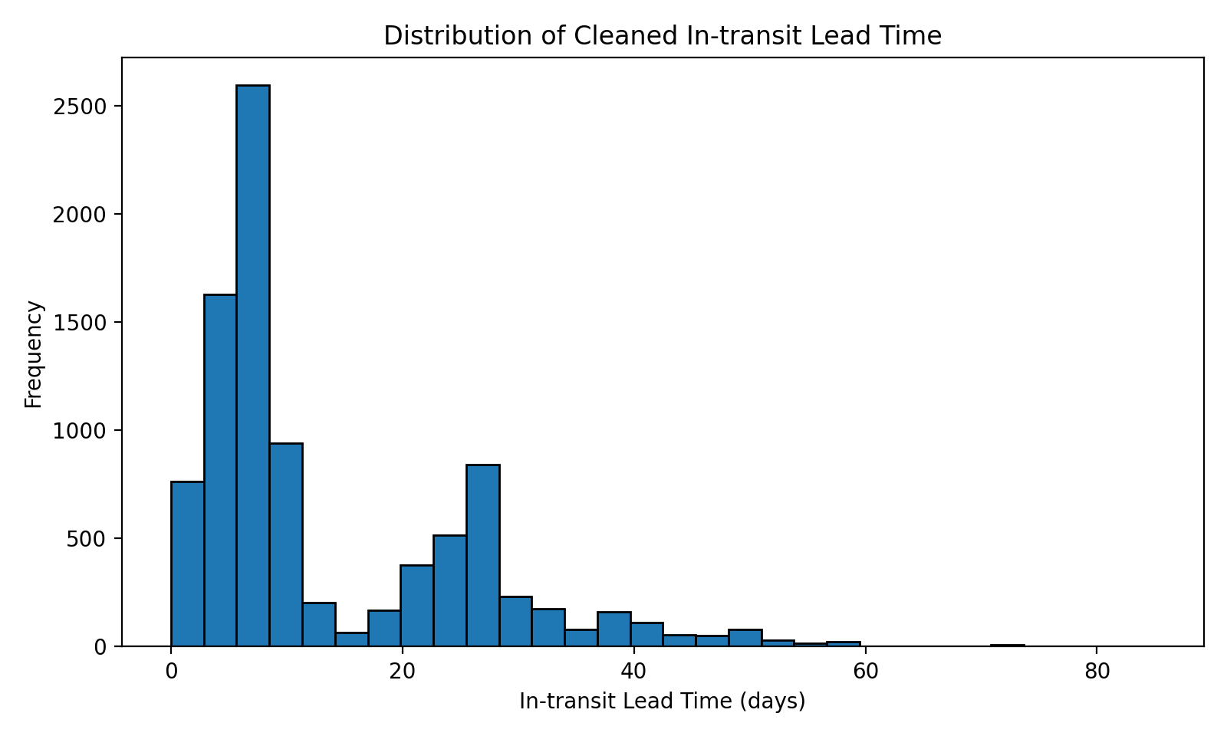
Figure 4.2 compares cleaned In-transit Lead Time across ship modes. The boxplot shows clear differences in both median transit time and dispersion. Ocean shipments were associated with the longest transit durations, while AIR shipments were associated with shorter transit times and lower central values. This visual difference foreshadowed the strong Ocean correlation reported later in the correlation analysis.
Figure 4.2. In-transit Lead Time by Ship Mode
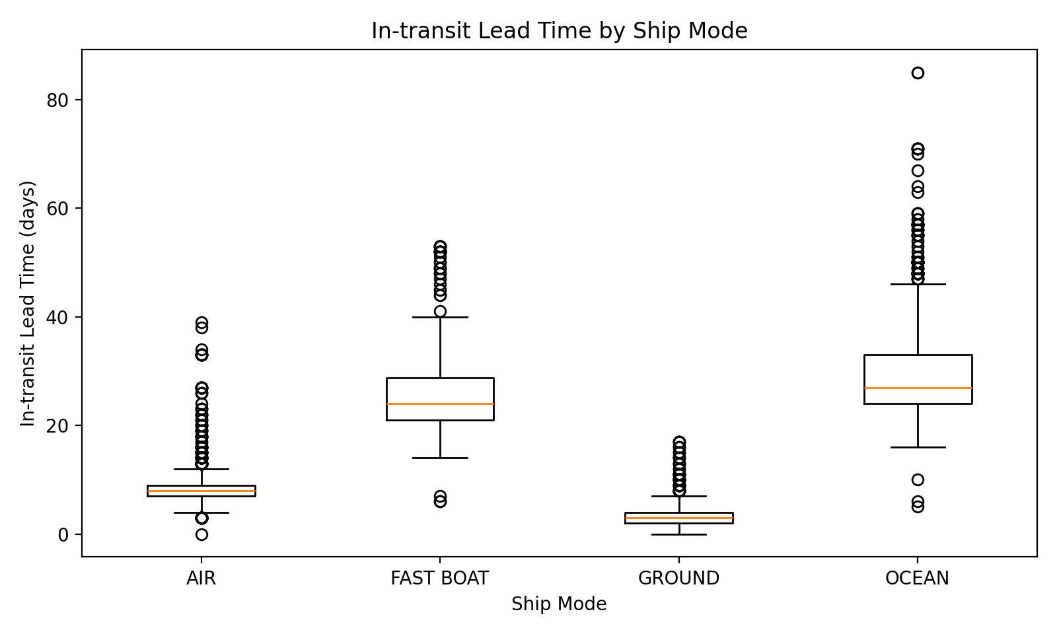
Figure 4.3 compares cleaned In-transit Lead Time by origin site. The figure shows that site-level distributions differed materially, indicating that ABC’s inbound timing experience was not uniform across origin locations. These differences likely reflected a mix of geographic distance, route design, and the transportation methods disproportionately used by each site.
Figure 4.3. In-transit Lead Time by Origin Site
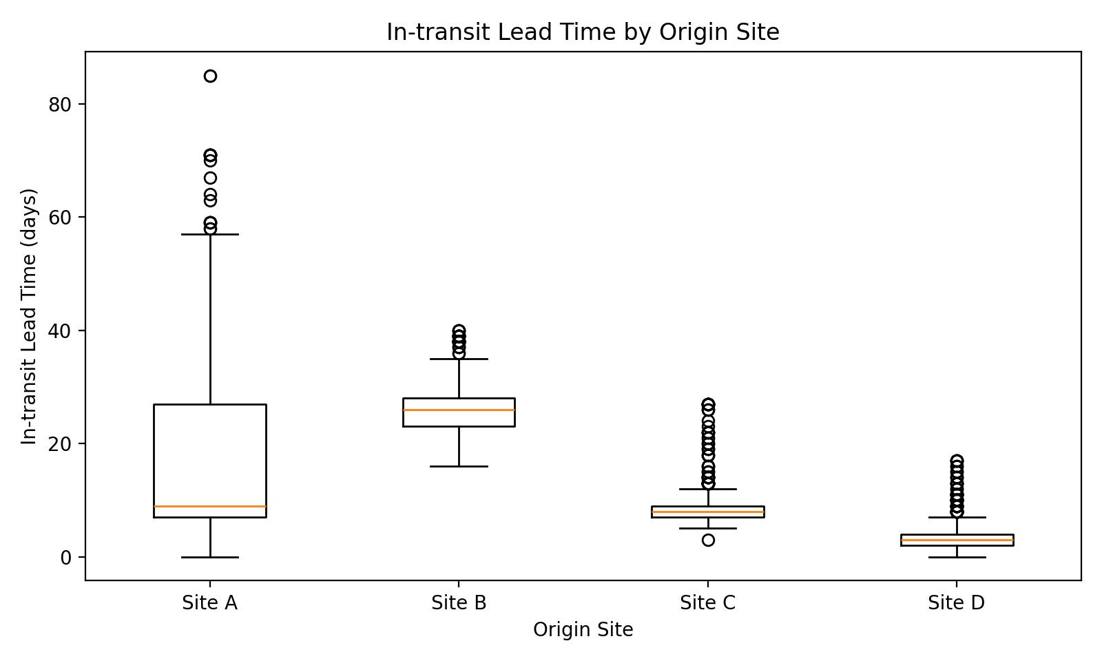
Figure 4.4 plots Manufacturing Lead Time against In-transit Lead Time and colors the observations by ship mode. The chart shows that the two lead-time measures were positively related, but the relationship was structured heavily by transportation method. In other words, longer production cycles tended to be associated with longer end-to-end fulfillment windows, but transportation choice remained a dominant source of variation.
Figure 4.4. Manufacturing versus In-transit Lead Time
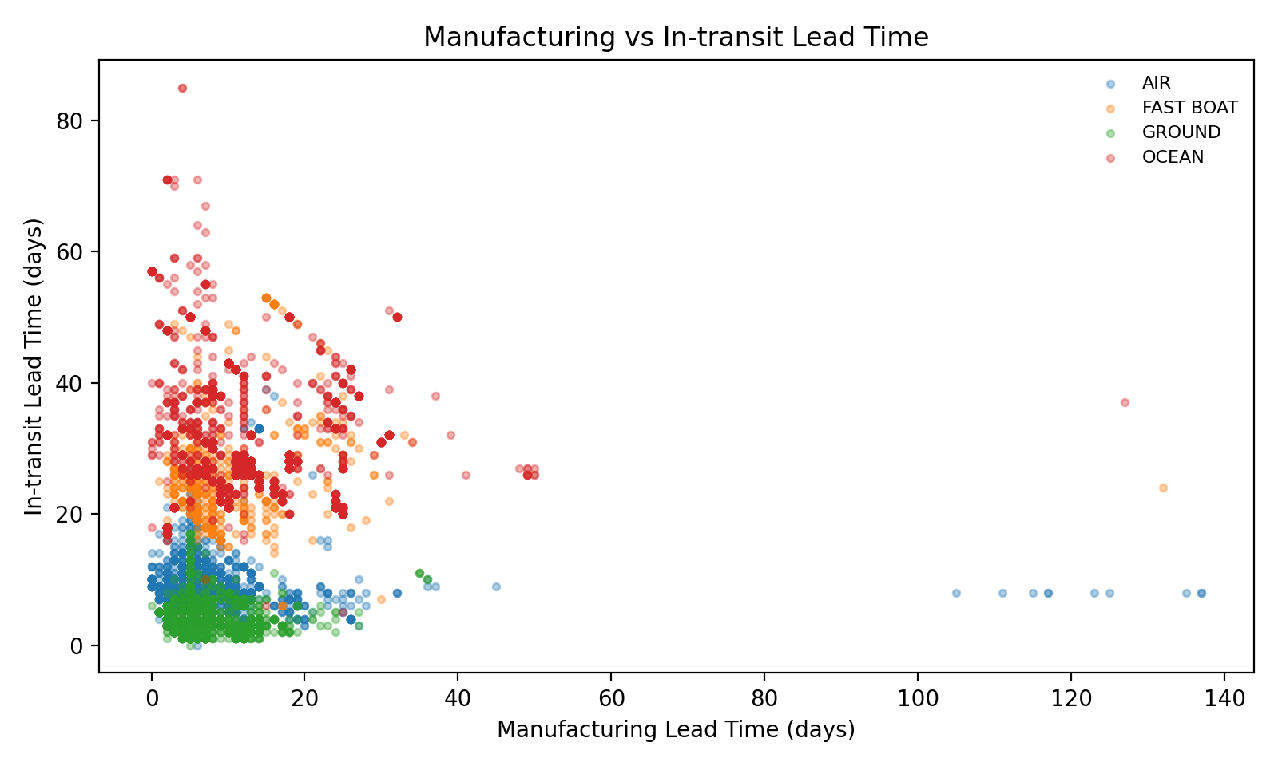

5. Correlation Analysis

5.1 Approach to Correlation Analysis
The correlation analysis was designed to identify which variables were most strongly associated with cleaned In-transit Lead Time. Because correlation requires numeric inputs, the analysis used the cleaned lead-time variables, Year, and numeric representations of the categorical variables. The workflow followed the project requirement that correlations be reported either as a correlation plot or as a table listing each predictor’s relationship with In-transit Lead Time in descending order.
The analytical logic was straightforward. First, the workflow selected Manufacturing Lead Time Clean, In-transit Lead Time Clean, Year, and the key categorical variables LOB, Origin, Ship Mode, and Quarter. Second, the categorical variables were converted into indicator variables using one-hot encoding. Third, the full correlation matrix was calculated, and the column corresponding to In-transit Lead Time Clean was sorted from the strongest positive association to the strongest negative association.

5.2 One-Hot Encoding of Categorical Variables
One-hot encoding was necessary because the categorical variables could not be used directly in a standard Pearson correlation matrix. Each category was therefore converted into a separate binary field, such as Ship Mode_OCEAN, Ship Mode_AIR, Origin_Site A, and Quarter_Q1. This conversion preserved the business meaning of the original categories while making it possible to rank their relationships numerically against cleaned In-transit Lead Time.
This step was particularly useful for management interpretation because it allowed the later results to identify specific operational conditions that were associated with longer or shorter transit times. Instead of only saying that ship mode mattered, the correlation ranking could show exactly which ship mode or origin category was most strongly connected with transit timing.

5.3 Correlation Ranking with In-transit Lead Time
Table 5.1 presents the strongest correlation results with cleaned In-transit Lead Time. The ranking shows that Ship Mode_OCEAN had the largest positive correlation at approximately 0.793217. Other strong positive relationships included Origin_Site B, Manufacturing Lead Time Clean, Origin_Site A, and Ship Mode_FAST BOAT. The table also shows several negative relationships, with Ship Mode_GROUND and Origin_Site D appearing among the strongest negative associations.
Table 5.1. Correlation Ranking with Cleaned In-transit Lead Time
Predictor | Correlation with In-transit Lead Time
In-transit Lead Time Clean | 1.000000
Ship Mode_OCEAN | 0.793217
Origin_Site B | 0.455872
Manufacturing Lead Time Clean | 0.314582
Origin_Site A | 0.258336
Ship Mode_FAST BOAT | 0.254830
Quarter_Q3 | 0.170866
Quarter_Q2 | 0.161997
LOB_Product C | 0.147759
LOB_Product A | 0.044550
Quarter_Q4 | 0.000482
Year | -0.000482
LOB_Product B | -0.095306
Origin_Site C | -0.197196
Quarter_Q1 | -0.287773

5.4 Interpretation of Major Correlation Patterns
The strongest positive result was Ship Mode_OCEAN, which had a correlation of approximately 0.793217 with cleaned In-transit Lead Time. This was a very strong relationship in operational terms and indicated that ocean shipments were far more likely than other shipment categories to be associated with longer warehouse receipt timing. The result also made intuitive business sense because ocean transportation typically prioritizes transportation cost over speed.
Origin_Site B and Origin_Site A also showed positive associations with In-transit Lead Time, while Origin_Site D showed a strong negative association. These site-level results suggest that geographic location, route structure, and the mix of transportation methods used by each site all affected ABC’s transit performance. In addition, Manufacturing Lead Time Clean was positively correlated with In-transit Lead Time, which indicates that longer production cycles tended to be associated with longer logistics cycles as well. This finding suggests that operational delay may accumulate across the end-to-end fulfillment process rather than remaining isolated in a single stage.
Figure 5.1 supports the table by showing the correlation heatmap for the top In-transit drivers. The heatmap makes the relative strength of the Ocean effect visually clear and also shows how several operational indicators moved together around the cleaned transit metric.
Figure 5.1. Correlation Heatmap for Top In-transit Drivers
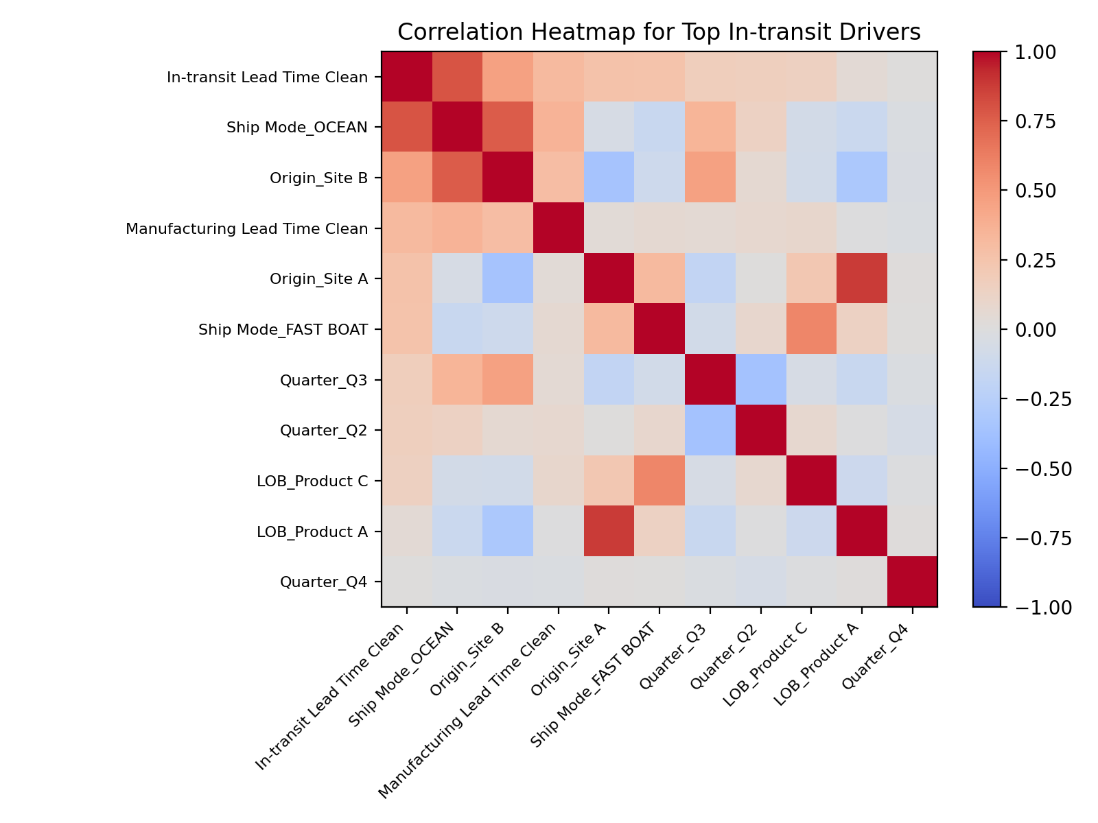

6. Key Findings and Business Implications

6.1 Main Operational Findings
The most important operational finding was that the logistics segment of the process took longer than the manufacturing segment on average. The cleaned mean Manufacturing Lead Time was approximately 8.085 days, while the cleaned mean In-transit Lead Time was approximately 13.659 days. This indicates that ABC’s inbound timing risk was more heavily concentrated in the post-shipment transportation stage than in the production stage.
A second major finding was that transportation mode strongly structured transit performance. Both the boxplot and the correlation analysis showed that Ocean shipments were associated with materially longer transit times than the other ship modes. A third major finding was that transit performance differed across origin sites, meaning that inbound timing was not uniform across the network. Finally, the positive association between Manufacturing Lead Time and In-transit Lead Time suggested that end-to-end delay tended to build across stages rather than remaining isolated within only one part of the process.

6.2 Implications for Shipment Planning
For shipment planning, the results imply that ABC should treat transportation mode as a strategic planning variable rather than only an execution variable. Because Ocean shipments were so strongly associated with longer transit times, planners should incorporate that expected delay explicitly when evaluating replenishment timing, safety stock positioning, and promised receipt windows. Where service urgency is high, lower-speed modes may need additional schedule buffer or earlier release decisions.
The origin-level differences also imply that planning rules should not be identical for all sites. Sites with consistently longer transit behavior may require earlier purchase-order release, more conservative receipt-date commitments, or stronger contingency planning. A network-wide average lead time would obscure this variation and could therefore result in planning targets that are too aggressive for some locations and too loose for others.

6.3 Implications for Customer Delivery Expectations
For customer delivery expectations, the findings suggest that ABC should avoid communicating a single uniform inbound timing assumption across all shipment scenarios. The results showed that both ship mode and origin materially affected transit duration, which means that more differentiated promise dates would likely improve customer communication accuracy. If customer-facing teams rely on undifferentiated average lead times, some customers will receive overly optimistic dates while others may be quoted unnecessarily conservative estimates.
The practical implication is that receipt-date expectations should be calibrated using operational context. At a minimum, customer delivery planning should distinguish among transportation modes and, where possible, incorporate site-level patterns as well. That change would help ABC reduce the frequency of missed delivery commitments and improve credibility in situations where logistics conditions remain unstable.

6.4 Implications for Inventory Risk
The findings also had direct implications for inventory risk. Longer and less predictable transit cycles increase the risk of stockouts if inventory arrives later than expected, but they also raise carrying-cost risk when supply is released too early in an attempt to compensate for uncertainty. The analysis showed that ABC faced both sides of this tradeoff. In particular, the strong Ocean effect indicates that lower-cost transportation can increase timing exposure if it is not matched with appropriate inventory buffers and planning lead time.
From an inventory-management perspective, the results support the use of differentiated inventory policies across shipment lanes. Slower or more variable transportation categories may justify additional safety stock, earlier order release, or more conservative promise-date logic. Conversely, faster and more consistent lanes may allow ABC to carry less buffer stock while still maintaining service performance.

7. Conclusion
This report prepared and explored ABC’s inbound logistics dataset to identify the operational variables most closely associated with lead-time behavior. The analytical workflow standardized the key categorical fields, derived quarter and year without hardcoding, calculated the required lead-time measures, repaired unusual and missing values through group-based imputation, and preserved the full record count of 9,124 observations.
The analysis produced three overarching conclusions. First, inbound timing risk was driven more strongly by the logistics stage than by the production stage, as shown by the higher mean In-transit Lead Time relative to Manufacturing Lead Time. Second, transportation mode—especially Ocean—was the dominant determinant of longer transit performance. Third, origin sites also mattered, which means that transit behavior varied materially across the network. Together, these results indicate that ABC should use more differentiated planning assumptions by site and by ship mode when estimating receipt timing, setting delivery expectations, and managing inventory risk.
Because the project scope emphasized data preparation and exploratory analysis, the report did not attempt to optimize or forecast lead times. However, it created a dependable foundation for future work. With a cleaned and well-structured dataset now established, ABC can move to the next stage of analysis with greater confidence.

Appendix

Appendix A. Supporting Tables
Appendix A contains supporting tables that complement the main text. These tables are included to provide fuller detail on the composition of the cleaned dataset and the relative weight of important categories used in the analysis.
Appendix Table A.1. Shipment Counts by Line of Business
LOB | Count
Product B | 5915
Product A | 2947
Product C | 262
Appendix Table A.2. Shipment Counts by Quarter
Quarter | Count
Q1 | 3920
Q2 | 3684
Q3 | 1477
Q4 | 43
Appendix Table A.3. Bottom Correlations with Cleaned In-transit Lead Time
Predictor | Correlation with In-transit Lead Time
LOB_Product C | 0.147759
LOB_Product A | 0.044550
Quarter_Q4 | 0.000482
Year | -0.000482
LOB_Product B | -0.095306
Origin_Site C | -0.197196
Quarter_Q1 | -0.287773
Ship Mode_AIR | -0.374396
Origin_Site D | -0.500839
Ship Mode_GROUND | -0.500839

Appendix B. Supporting Figures
Appendix B restates the operational images used to frame the report. These visual references support the interpretation of the process logic and the geographic footprint discussed in the main sections.
Appendix Figure B.1. ODM Sites and Warehouse Locations

Appendix Figure B.2. Inventory Movement Process and Lead-Time Definitions


