COVID-19, transmissibility and mobility of the population

**Methods**

**Data**

Count of deaths for every countries were sourced from ECDC [REF]. They reflect death counts reported by each country official bodies. Our analysis is based on a subset of countries which fulfil they following 3 criteria: 1) 10 deaths were reported in the week end XX, 2) as well as the week end XX and a total of 100 deaths since the start of the pandemic. These criteria were chosen to ensure that country included showed clear sign of active transmission.

Mobility data were sourced from Apple [REF]. They reflect the relative movement of people with an ?iphone? and the measure is separately reported for driving, walking and transit movement [REF]. The measures are aggregated for each day and country and are relative to the maximum mobility measured across the time series. Mobility data are were available from the 13th of January 2020 up to XX of xx 2020.

Our analysis is based on XX countries for which we had both epidemiological and mobility data (see Table XX for summary).

**Processing mobility**

For mobility data, the various streams showed variations as well as long terms variations. We combined the data streams by aggregating data on walking, driving and transit into a single measure, calculated a weekly (Monday to Thursday) average, assigned this average to the Thursday of the week, and interpolated other weekly day form this. This smoothed measure of mobility was then rescaled to the maximum observed to obtain a single daily measure by countries for relative mobility, (Fig. XX.a).

**Estimating transmissibility: baseline model**

*Estimating the instantaneous reproduction number.*

We estimate the instantaneous reproduction number based a well-established methodology [REFs] and implemented in the R package ‘epiestim’. Using a Bayesian framework, the methods estimates the instantaneous reproduction number based on daily death counts using a branching process characterised by the renewal equation:

Where is the instantaneous reproduction number at time t and location i based on reported deaths for the baseline model. The reported deaths at time t and location i, , is assumed to follow a Poisson distribution with mean equal to the product of the instantaneous reproduction number and a weighted measure of deaths in the past. The weighted relies on the distribution of the delay between a death being reported and its infector having died (e.g. a serial interval for death). The serial interval distribution, , is assumed Gamma distributed with mean6.48 days and standard deviation 3.83 days [REF]. We obtain daily measures of using a sliding window that assume constant level of transmissibility for 7-days (7-days sliding window).

The posterior estimates are robust to under-reporting but relies on assuming constant level of reporting.

**Estimating transmissibility using mobility: full model**

We define an effective reproduction number on day t, , which truly reflect the level of transmissibility on that day. We assume is linked to mobility on that day:

Where is the basic reproduction number in location i. When mobility is at its peak (100%) transmissibility is characterised by the basic reproduction number, and reduction in mobility leads to reduction in the effective reproduction number.

In this framework, the effective reproduction experienced by those dying at time t, , is a weighted average of the effective reproduction number on day t, :

Assuming that the delay of infection to death follows a Gamma distribution, ,with mean 18.8 days and standard deviation of 8.46 days [REF].

We can now relate the observed reported deaths to the basic reproduction number and the parameter linking transmissibility to mobility:

For each country, while the baseline model effectively estimate as many parameters as days in the time series of deaths, the full model estimates only 2 parameters relying on mobility pattern to inform temporal trends.

**Comparing output of both model**

We can compare the outputs of both models in term how they each estimate transmissibility.

From the baseline model, we have daily estimates of . From the full model, we have daily estimates of .

However, we must relate those reproduction numbers related to death to mobility patterns, , in the past when those dying were infected. We define an effective mobility, , at time t that characterise the mobility experience at time of infection of those who died at time t.

From above, we have:

We define:

And therefore, the effective mobility is found as:

We can now plot and against the effective mobility at time of infection.

Finally, We can relate the effective reproduction number on day t, , to any mobility (e.g. outside the observed range) given the functional relationship assumed above.

**Using the full model to produce short-term forecast and longer-term scenario modelling**

*Short-term forecasts*

In the framework of the full model, information about recent mobility is hardly used in the inference as the chance of being infected on the latest day of data available and dying on that day is vanishingly small.

Therefore, recent pattern of mobility can be used to inform future pattern of deaths.

We can use the same equation used for inference to project forward. Past and recent mobility pattern will inform , and a branching process simulation can be used to forecast future cases.

If forecast are produced for a 7-days horizon, we have to make assumptions about the mobility patterns during those 7-days. However, this assumed future mobility barely influenced the forecast as they are weighted by the distribution of the delay between infection and death. Given the assumed delay between infection and deaths, on the last day of forecast (day 7), the last 7 days for which mobility patterns will be weighted by .

For the purpose of our short-term forecasts, we assume the future mobility to equal the last measure of mobility.

*Longer-term scenario modelling*

For longer-term predictions (60 days forward), we explore two scenarios, assuming future mobility will be:

* maintained at reduced level of 5% of its maximum level
* gradually increased from its current level to its maximum over a period of 60 days (linear increase in mobility).

Results

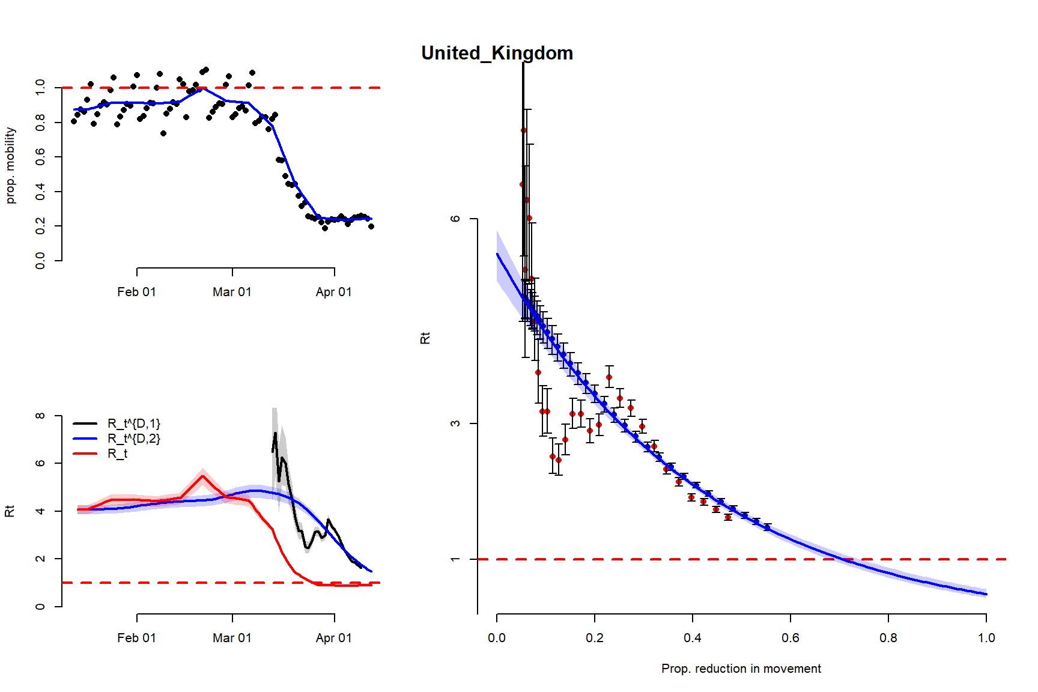

Short term forecast

Long term forecast

2 months with either

*Same restricted mobility as last dates*

*Mobility linearly increase back to 100% over 2 months*

|  |  |  |  |
| --- | --- | --- | --- |
| country | median | low | up |
| Austria | 0.63 | 0.56 | 0.74 |
| Belgium | 0.98 | 0.90 | NA |
| Brazil | 0.76 | 0.69 | 0.85 |
| Canada | 0.94 | 0.78 | NA |
| Colombia | NA | 0.92 | NA |
| Czechia | 0.65 | 0.54 | 0.78 |
| Denmark | 0.44 | 0.38 | 0.52 |
| Egypt | NA | 0.84 | NA |
| France | 0.72 | 0.71 | 0.74 |
| Germany | 0.55 | 0.53 | 0.59 |
| India | NA | NA | NA |
| Indonesia | 0.77 | 0.55 | NA |
| Ireland | 0.70 | 0.59 | 0.83 |
| Israel | 0.66 | 0.48 | NA |
| Italy | 0.70 | 0.69 | 0.71 |
| Mexico | 0.92 | 0.54 | NA |
| Morocco | 0.58 | 0.40 | 0.83 |
| Netherlands | 0.49 | 0.46 | 0.51 |
| Philippines | NA | 0.87 | NA |
| Poland | 0.95 | 0.75 | NA |
| Portugal | 0.63 | 0.54 | 0.72 |
| Romania | 0.68 | 0.56 | 0.79 |
| Russia | 0.28 | 0.20 | NA |
| Spain | 0.54 | 0.53 | 0.56 |
| Sweden | 0.40 | 0.36 | 0.45 |
| Switzerland | 0.46 | 0.43 | 0.51 |
| Turkey | 0.54 | 0.48 | 0.62 |
| United_Kingdom | 0.71 | 0.68 | 0.73 |
| United_States_of_America | 0.63 | 0.61 | 0.64 |

Discussion

SI

Main analysis per country

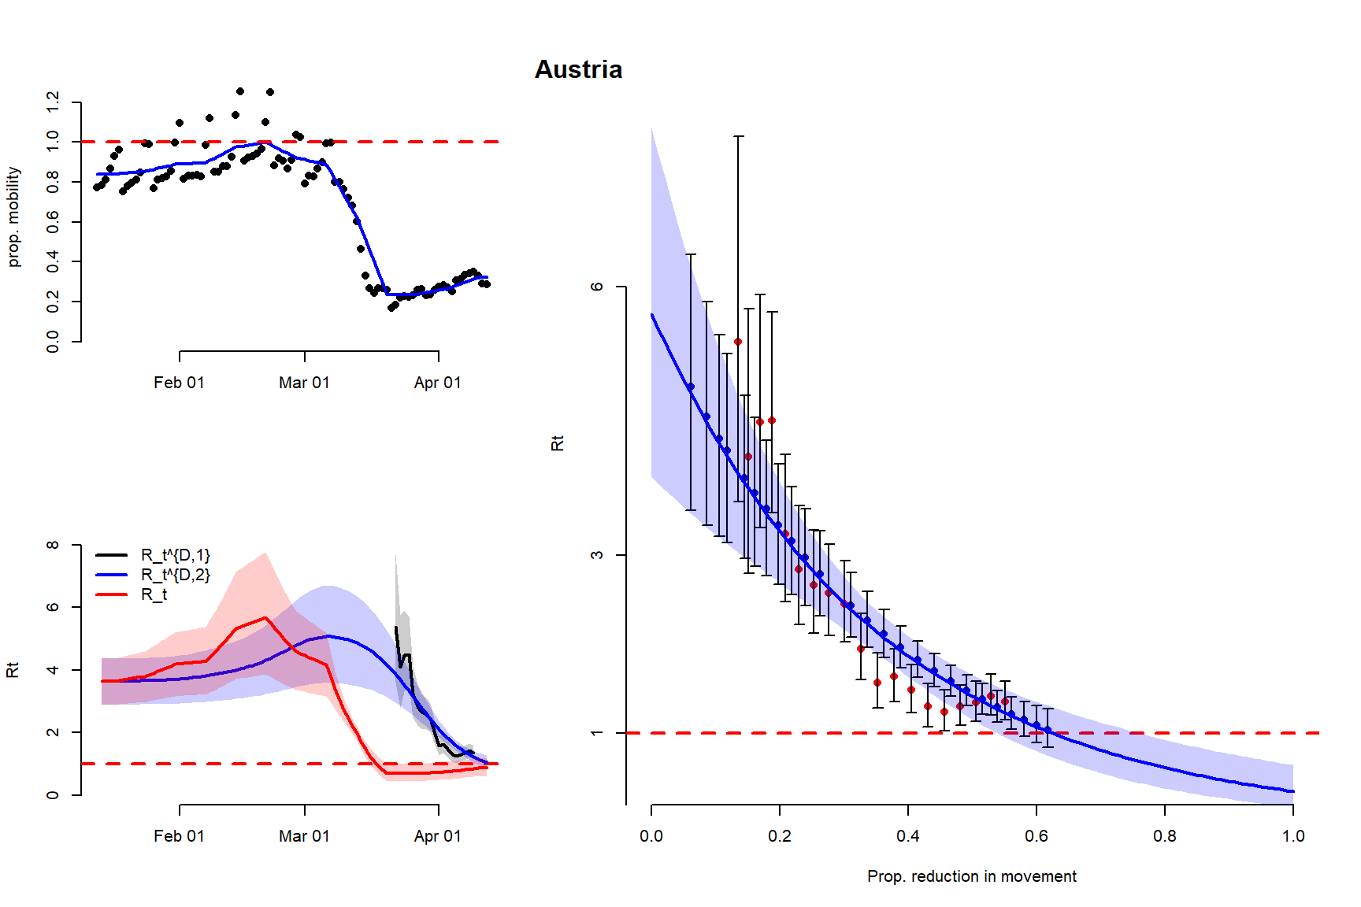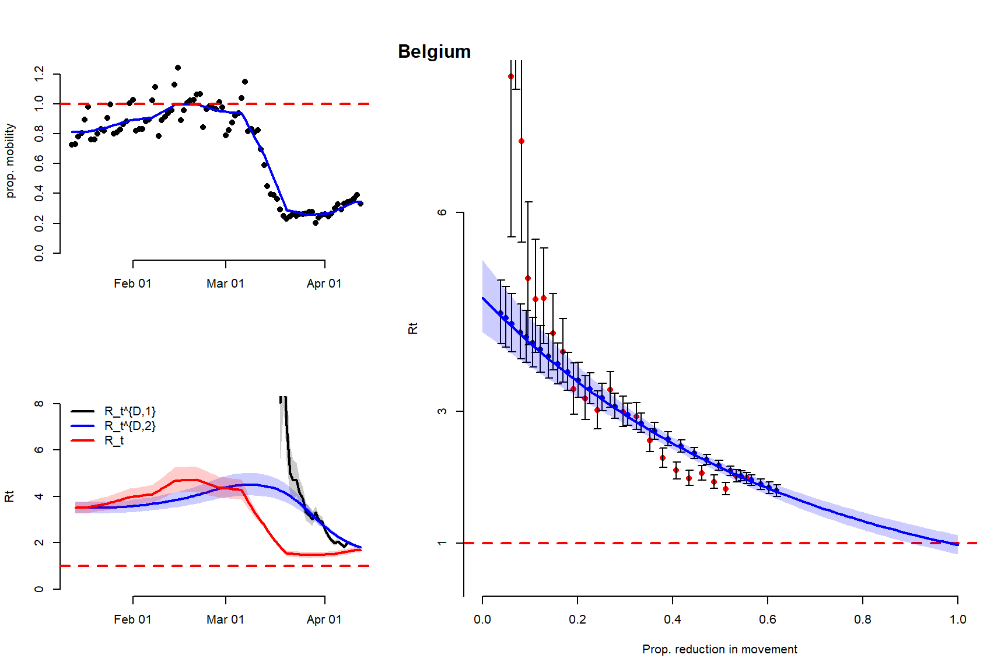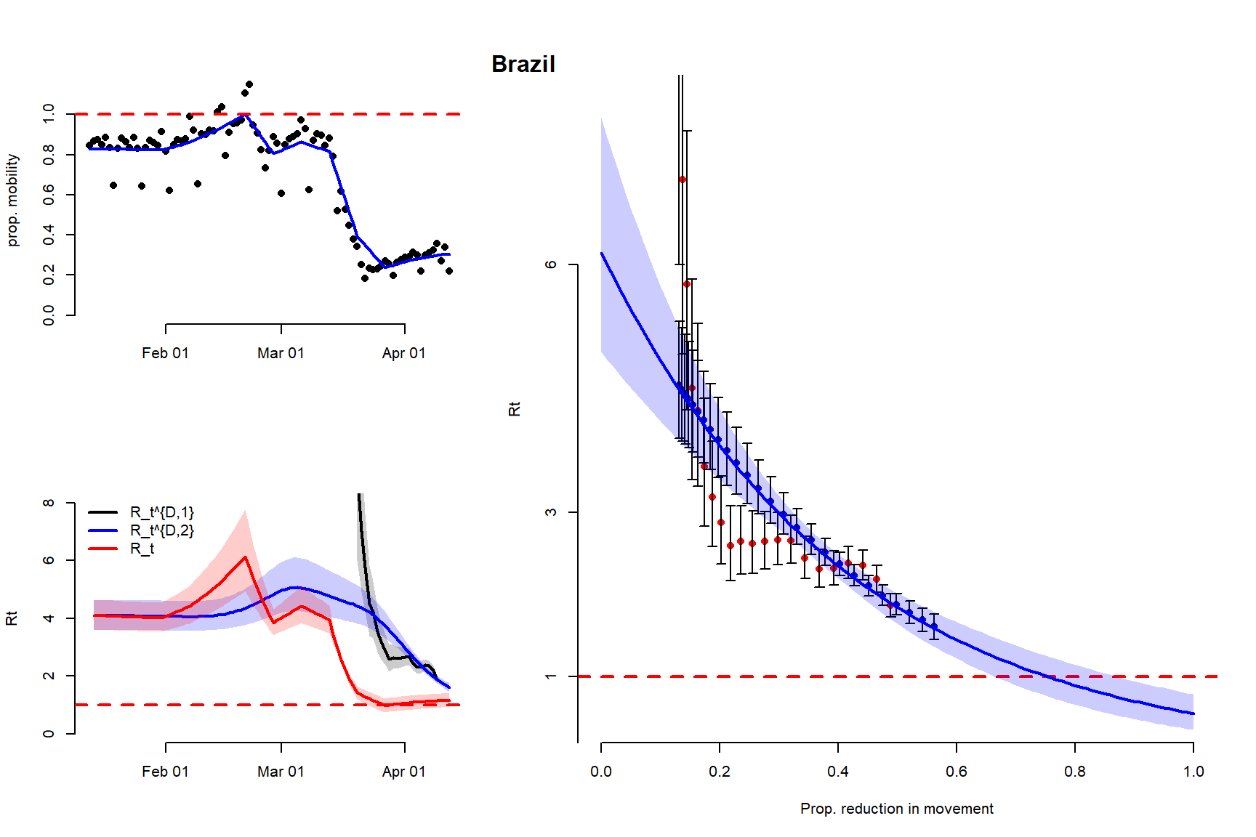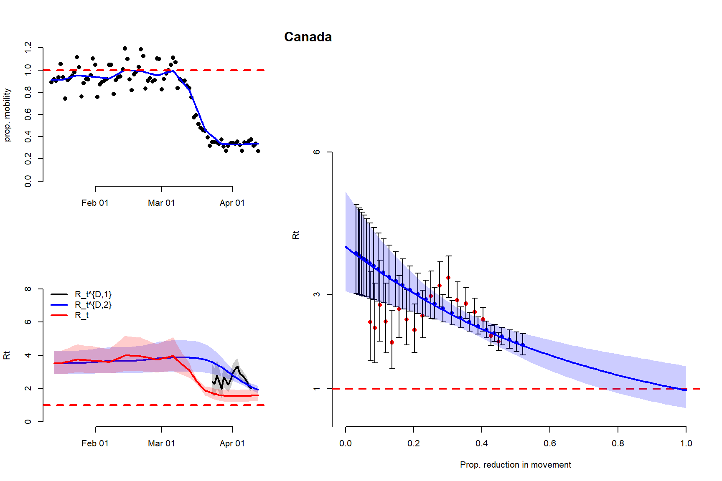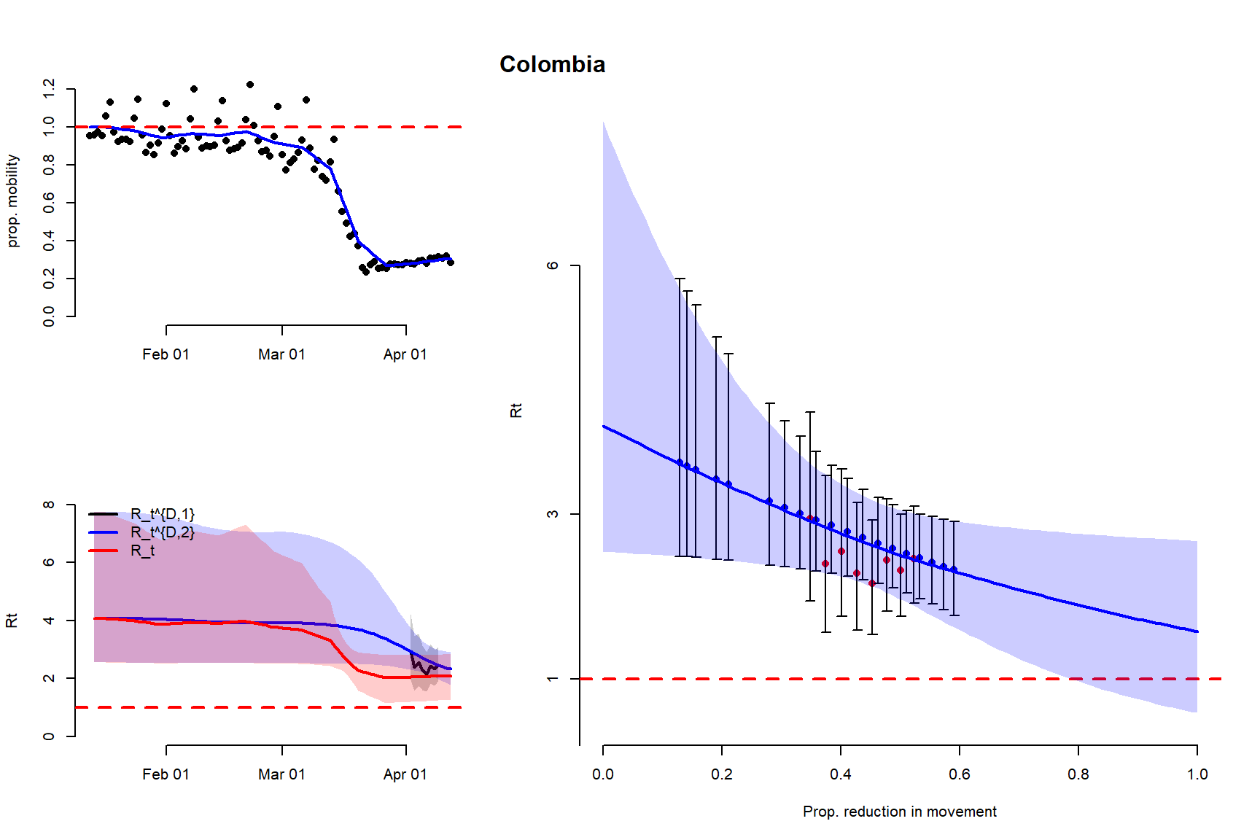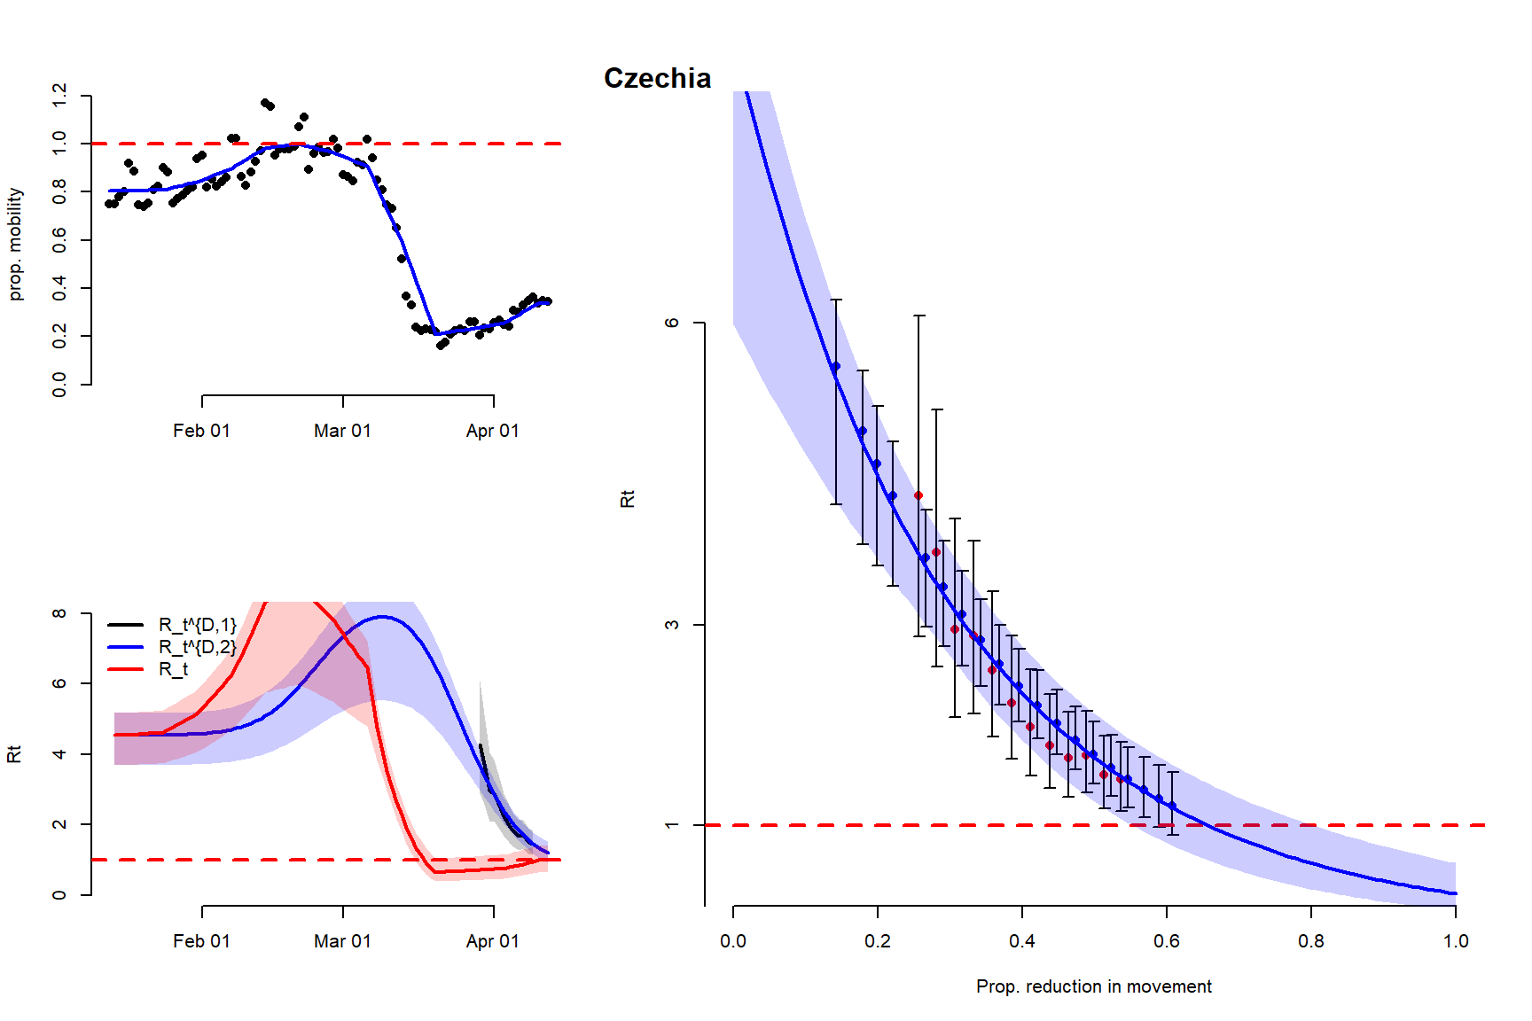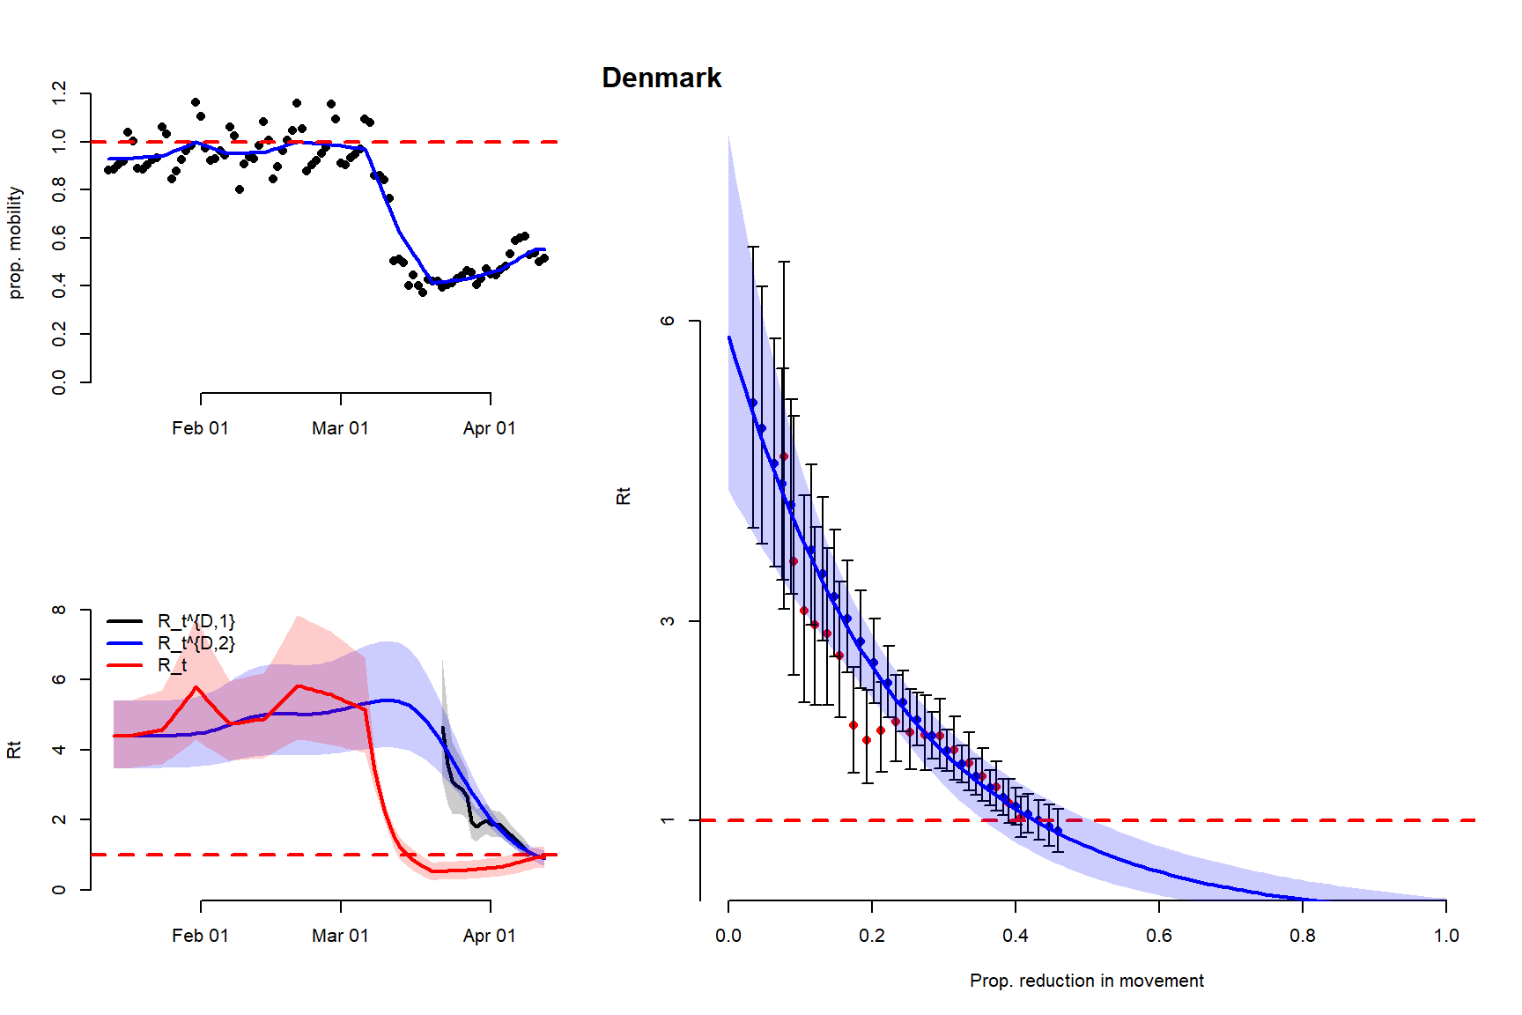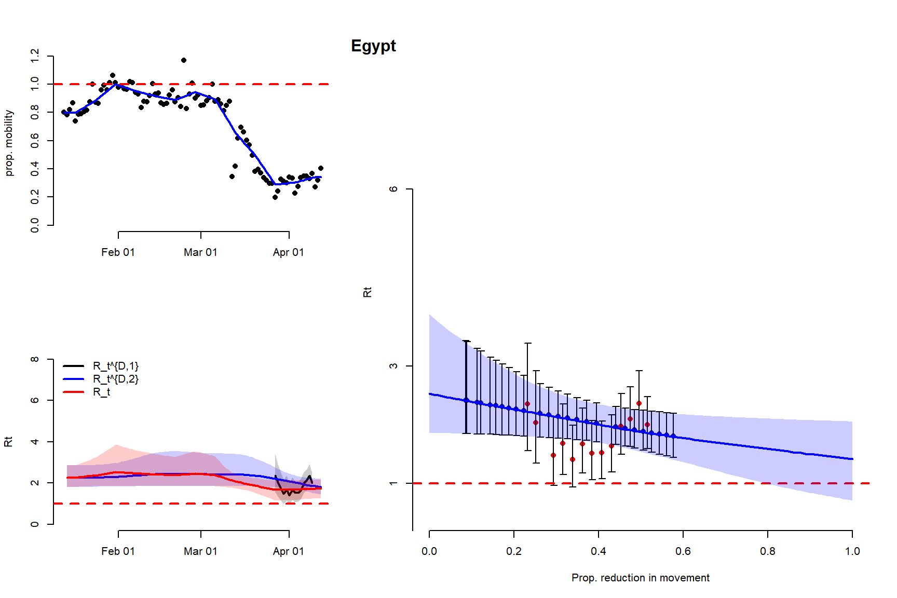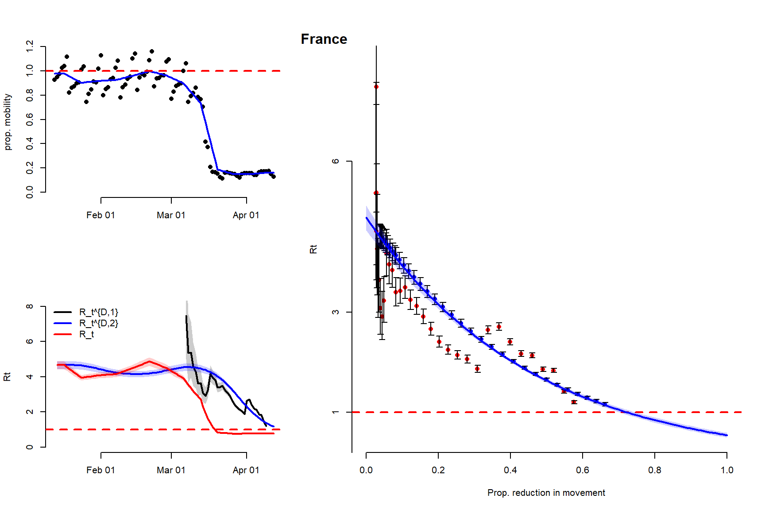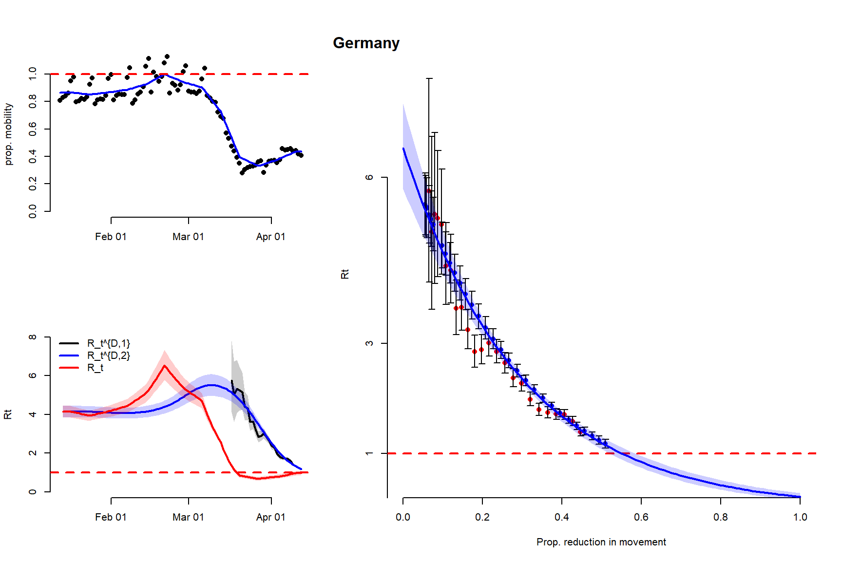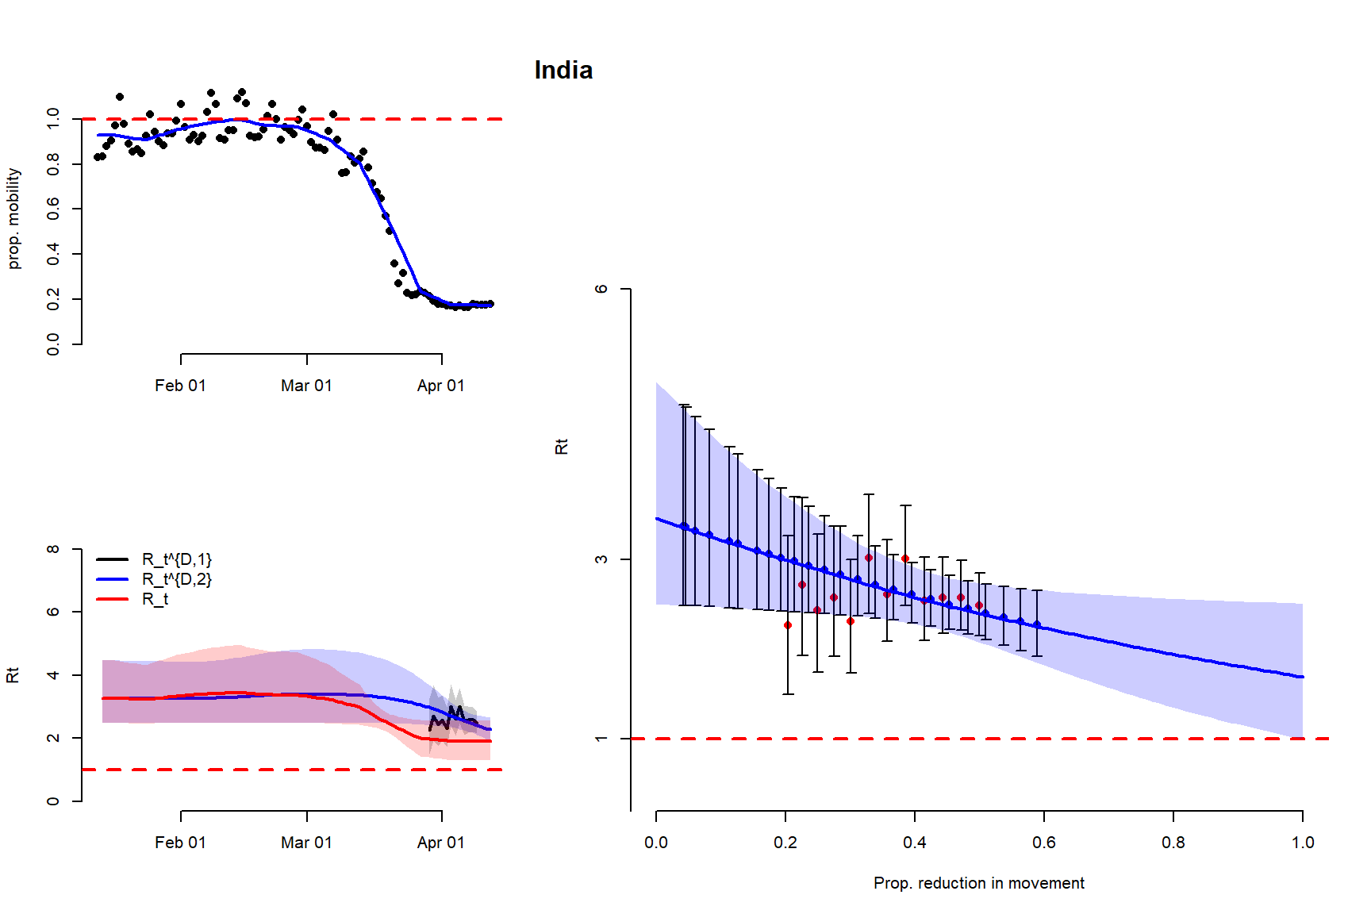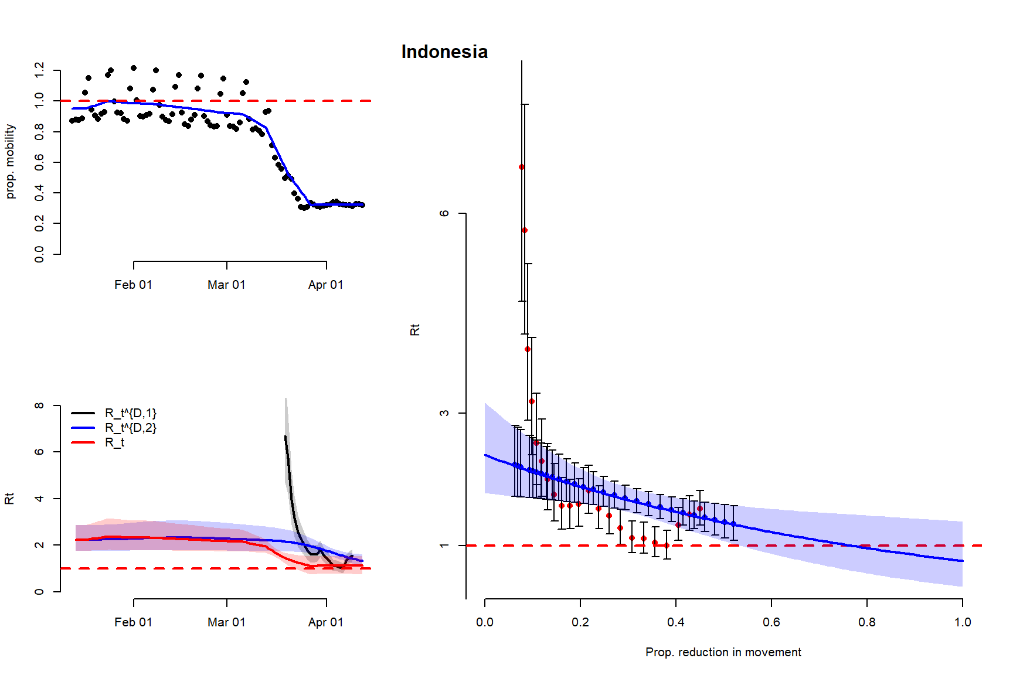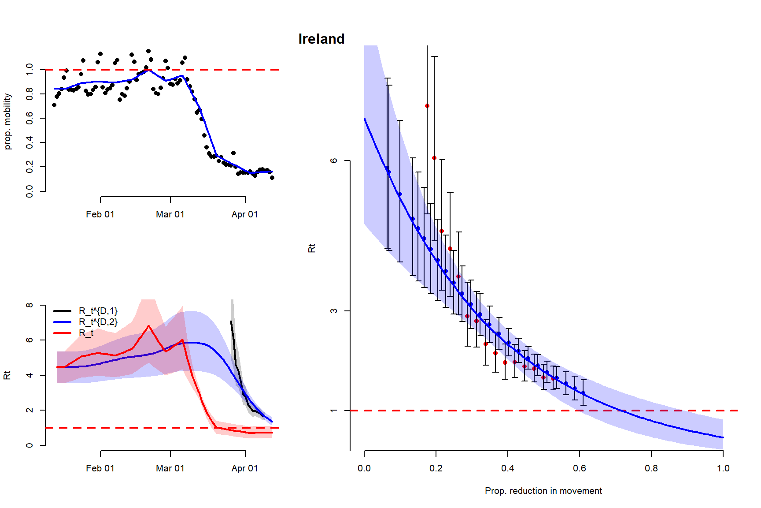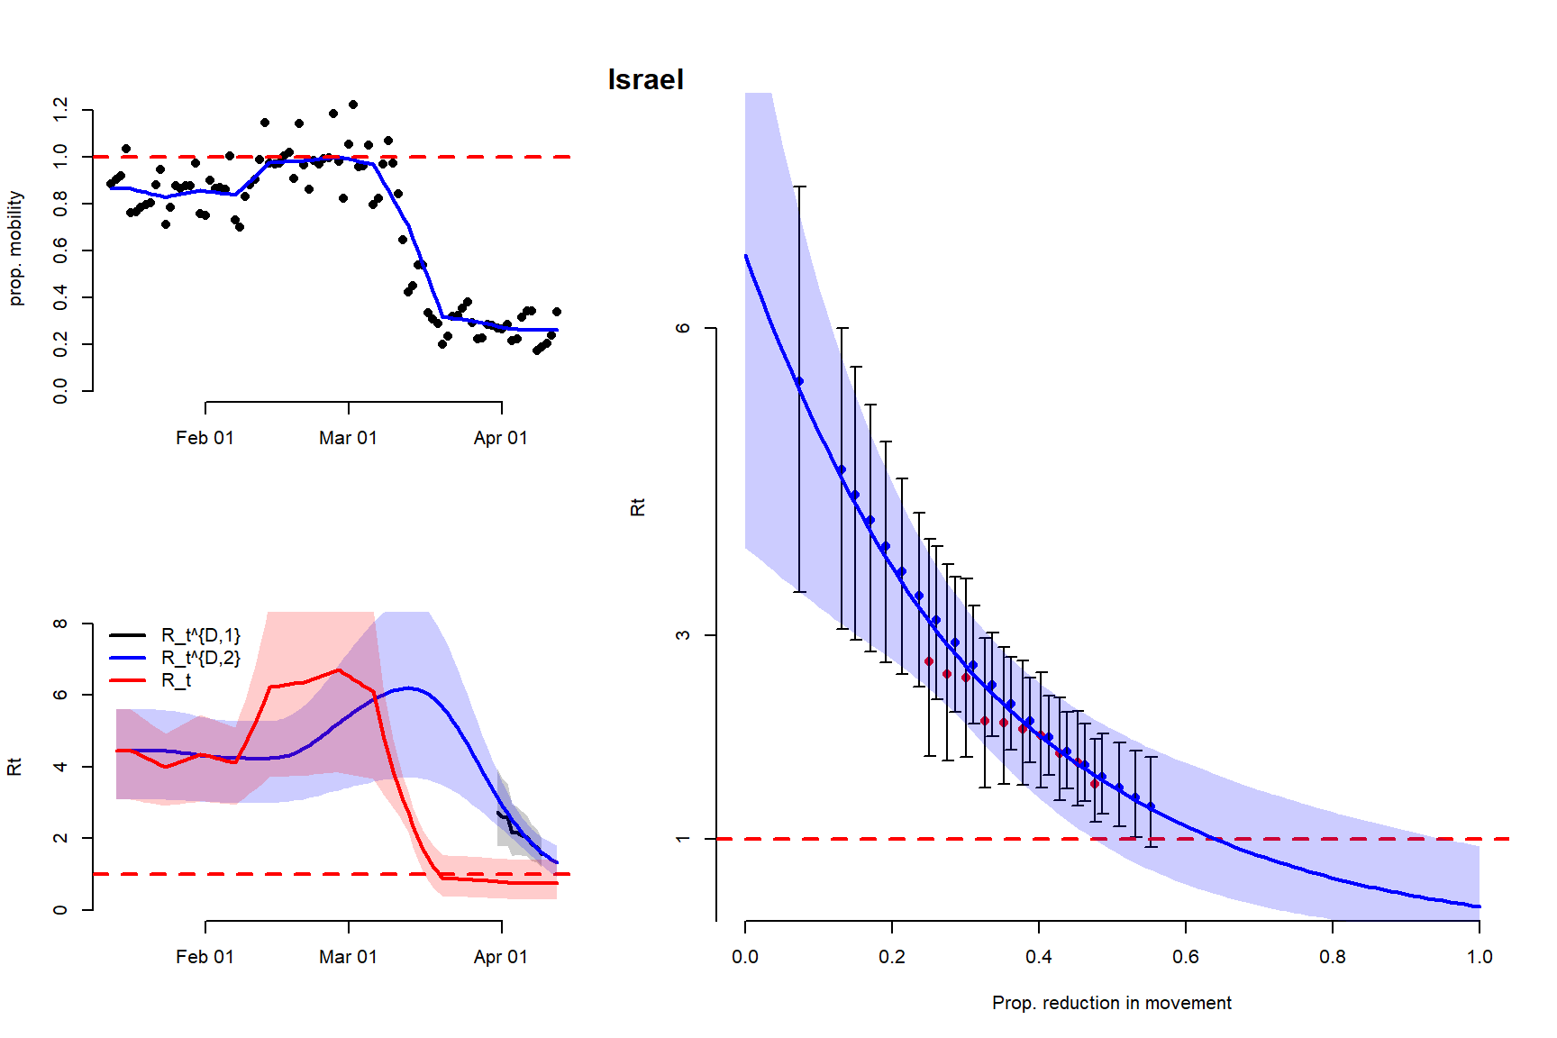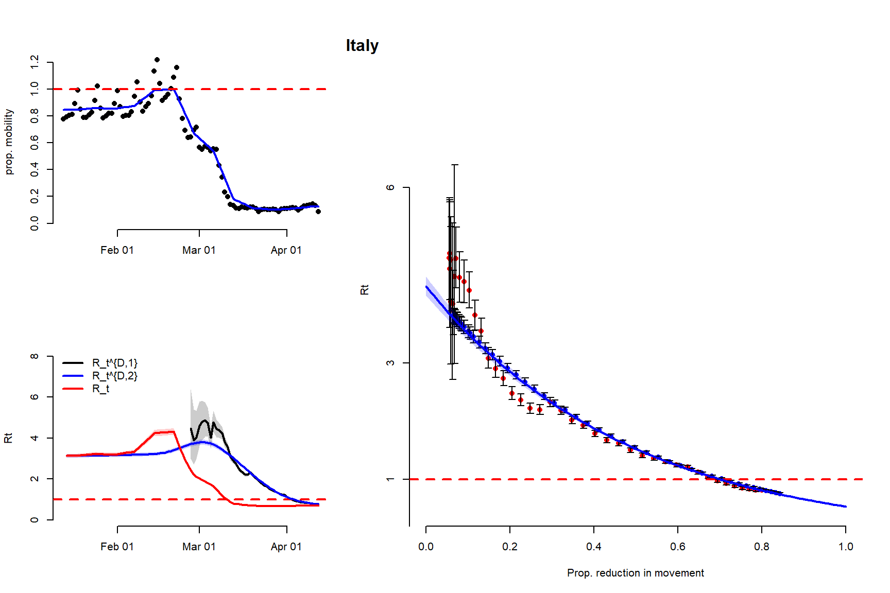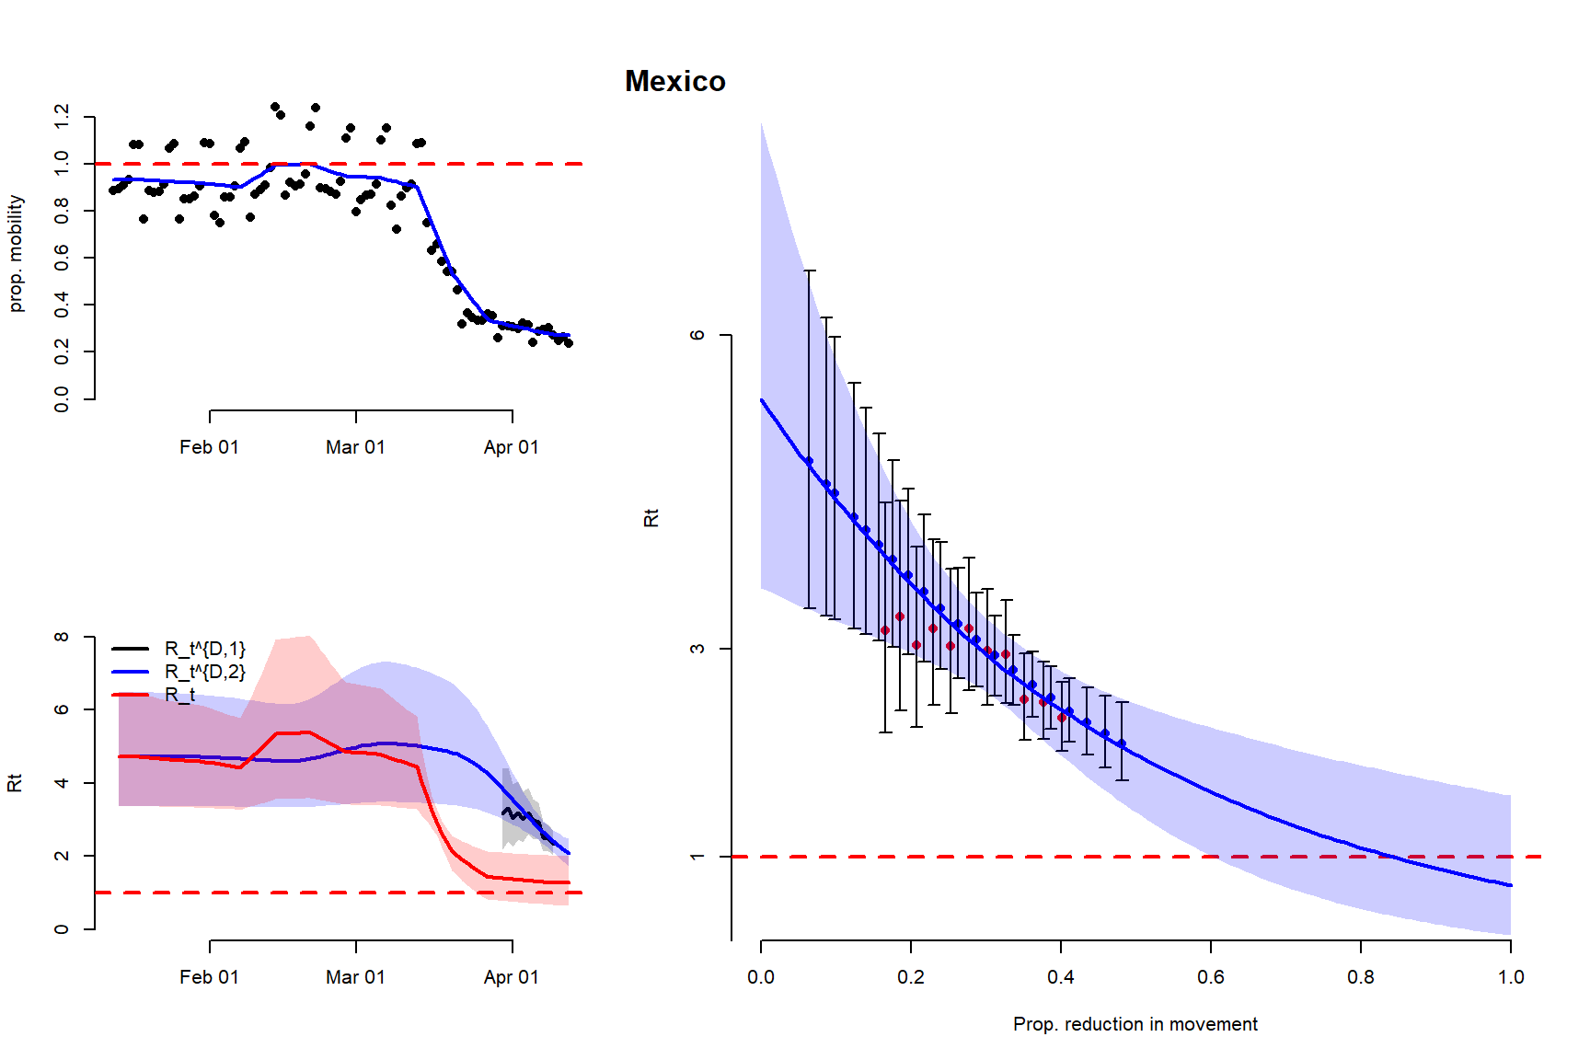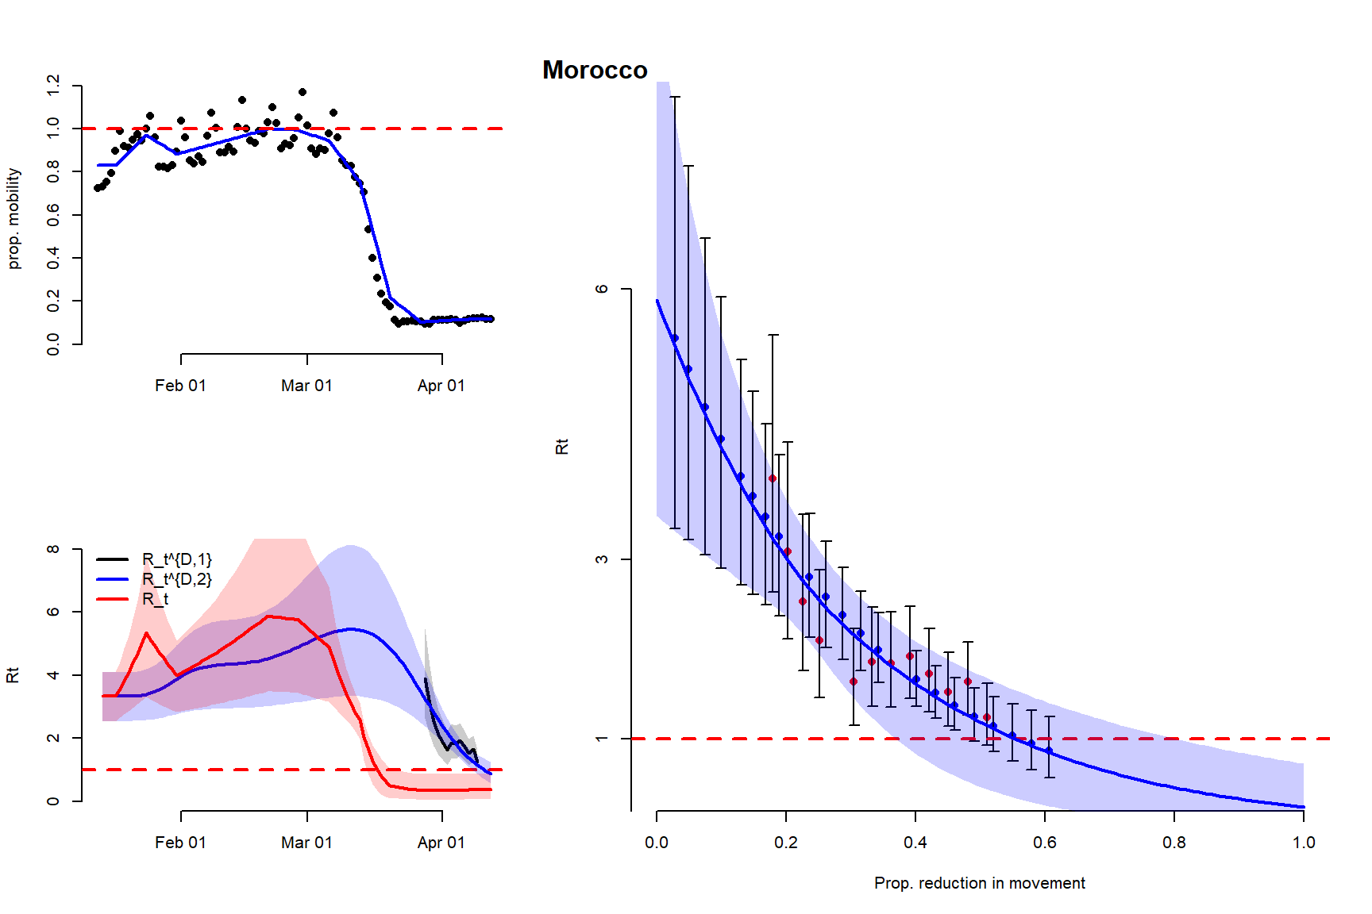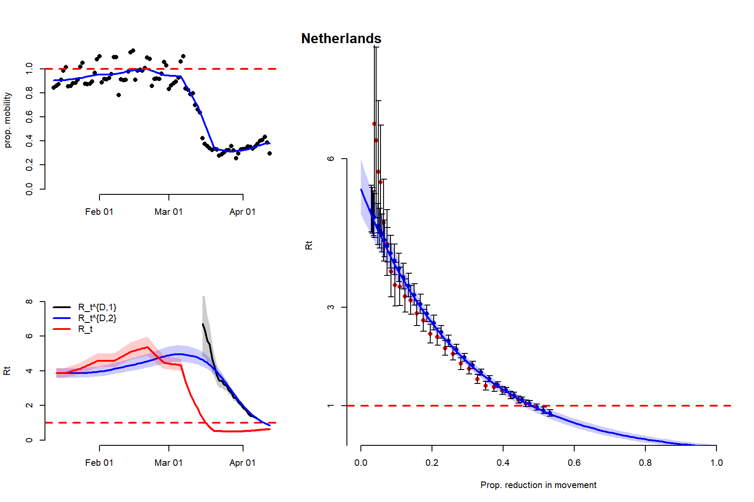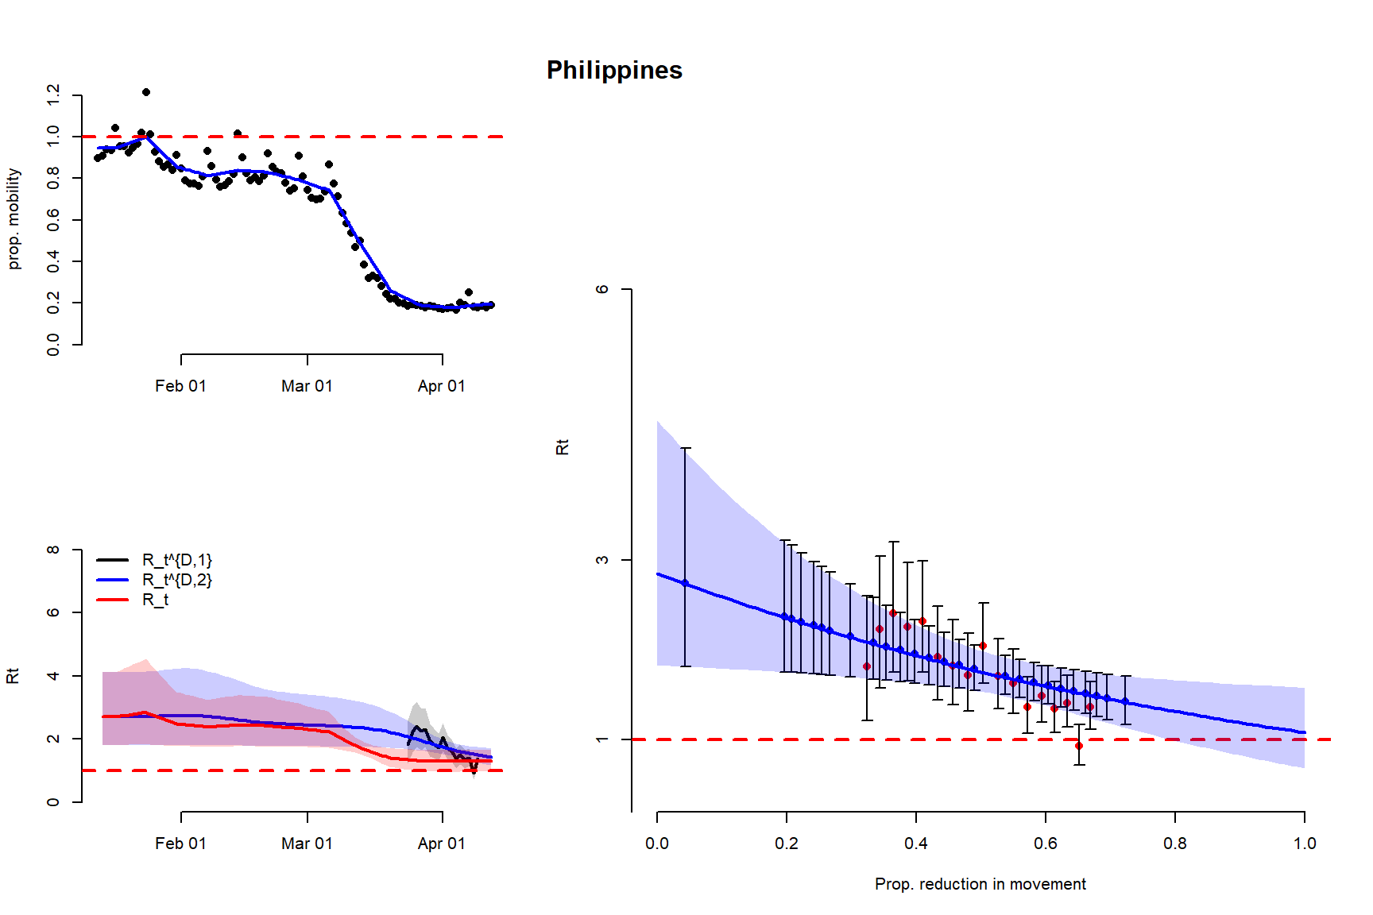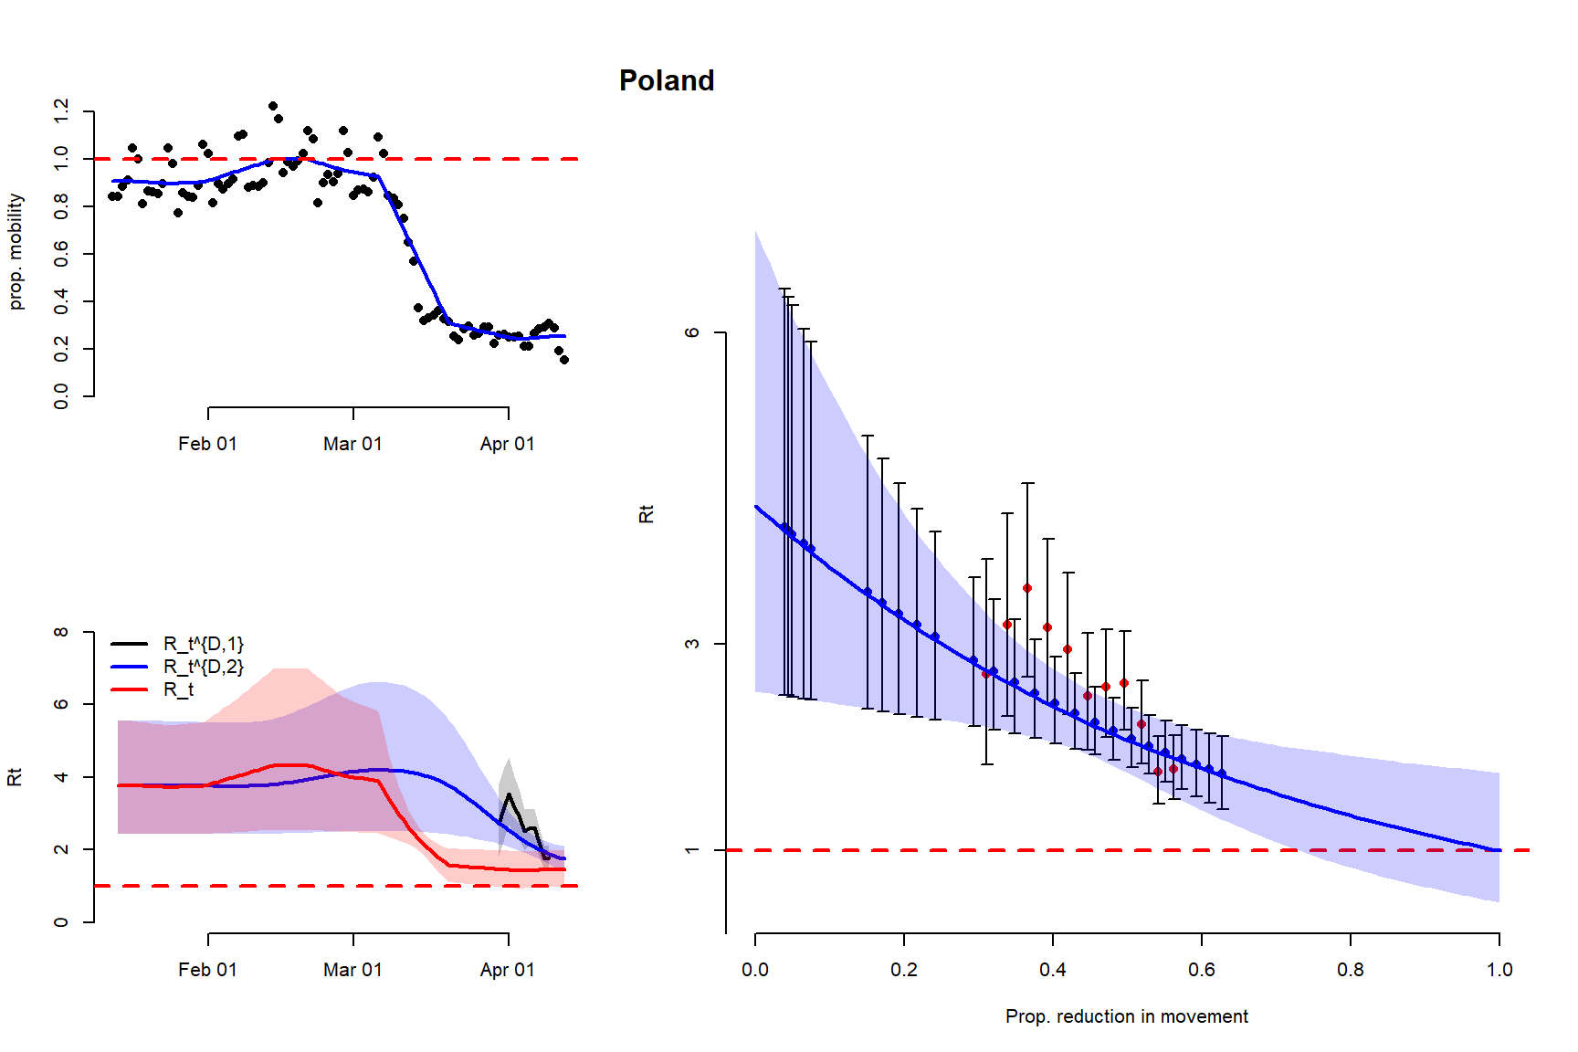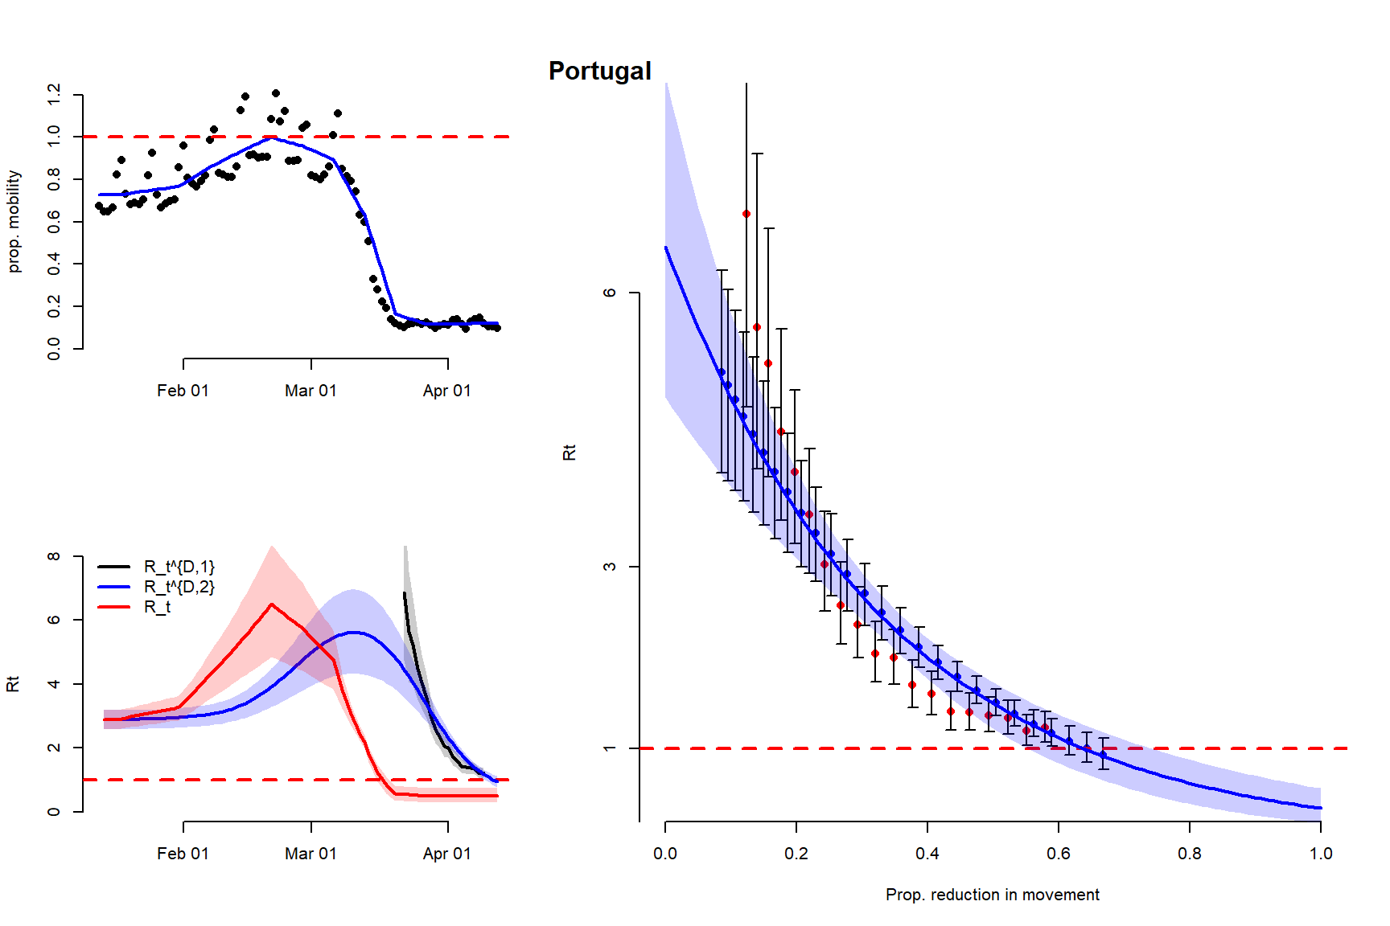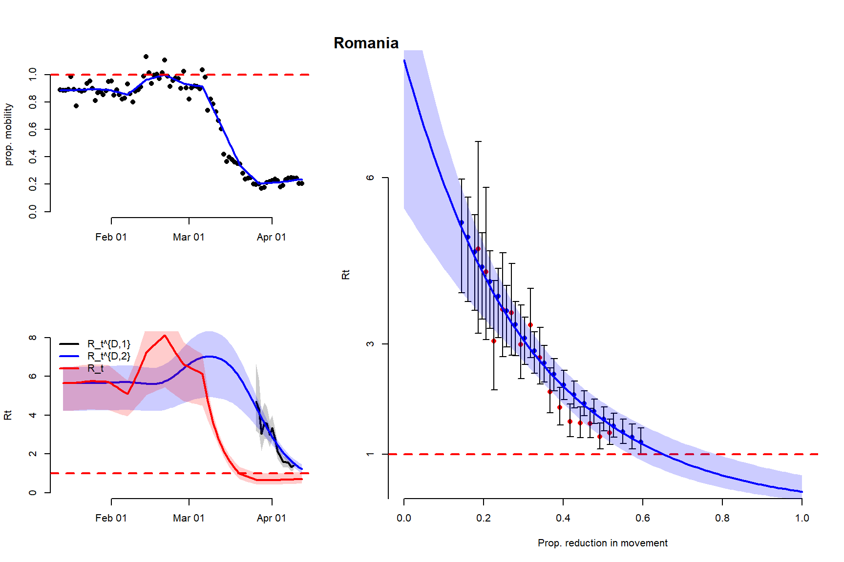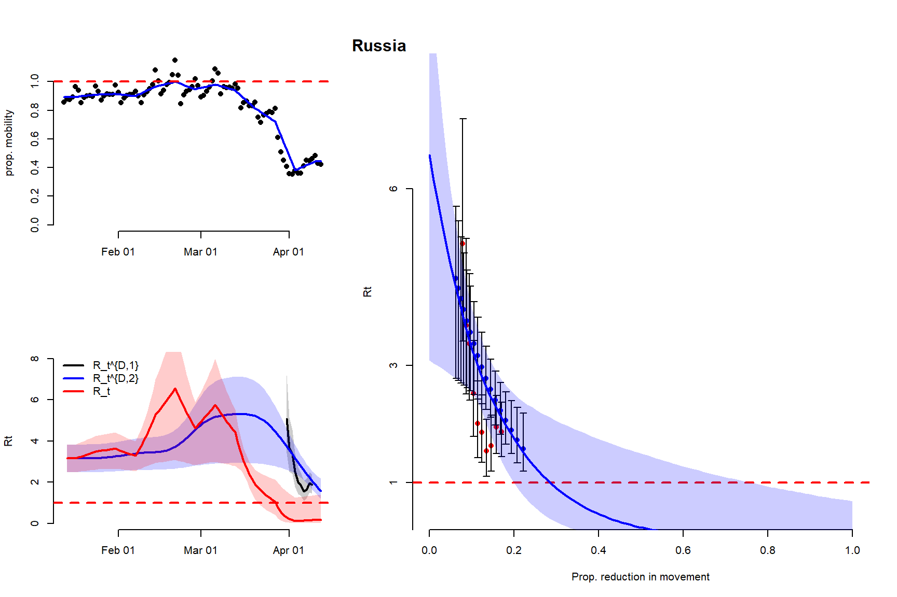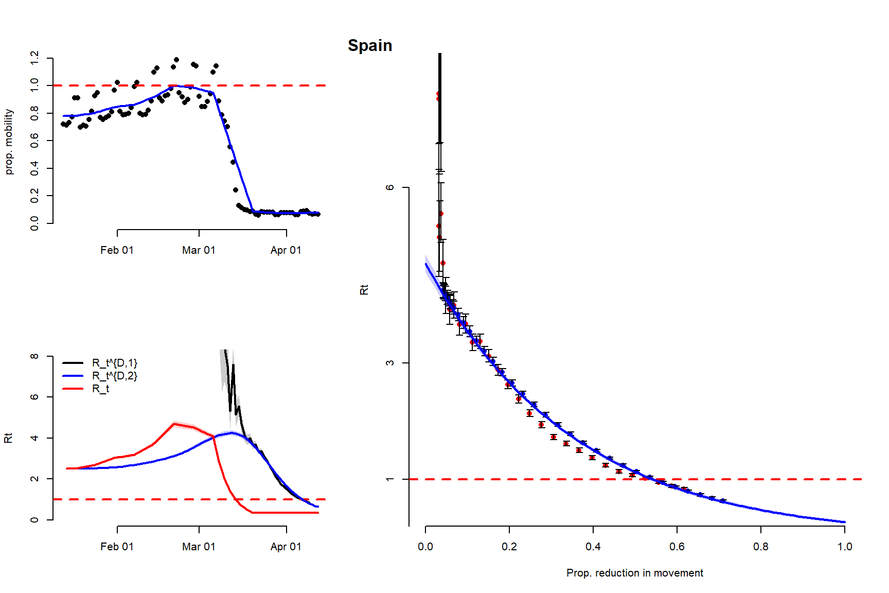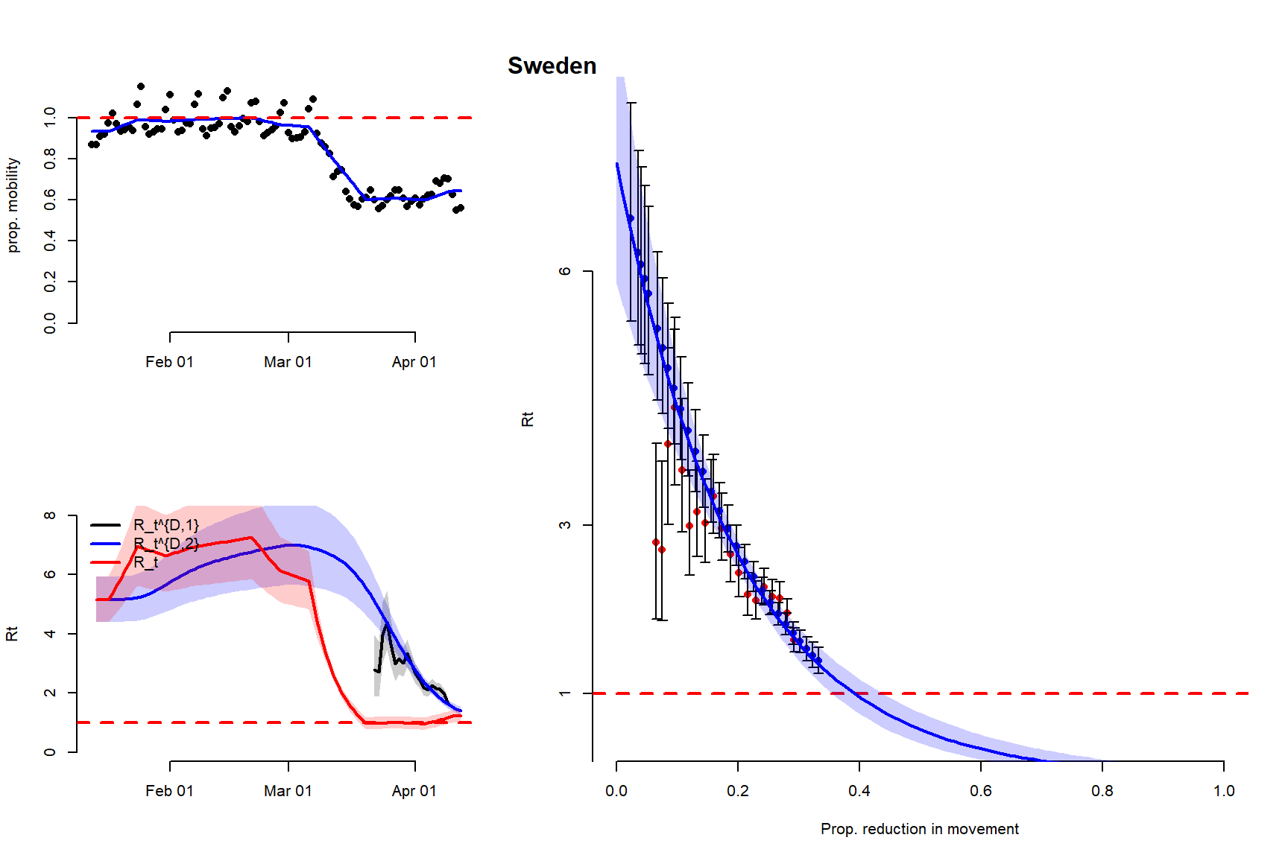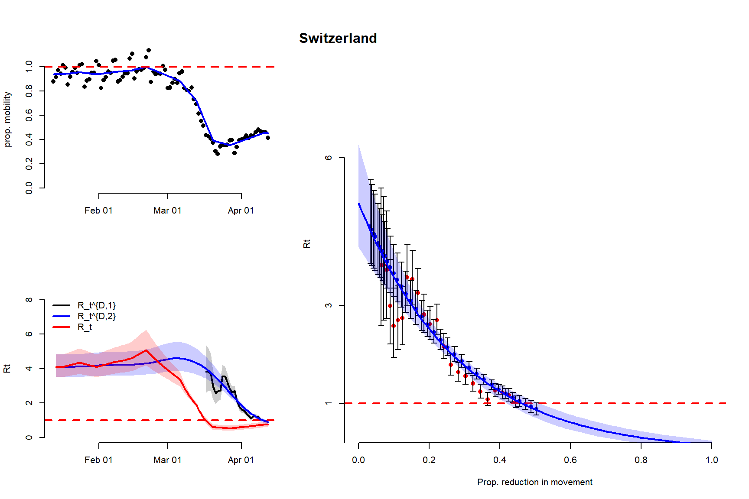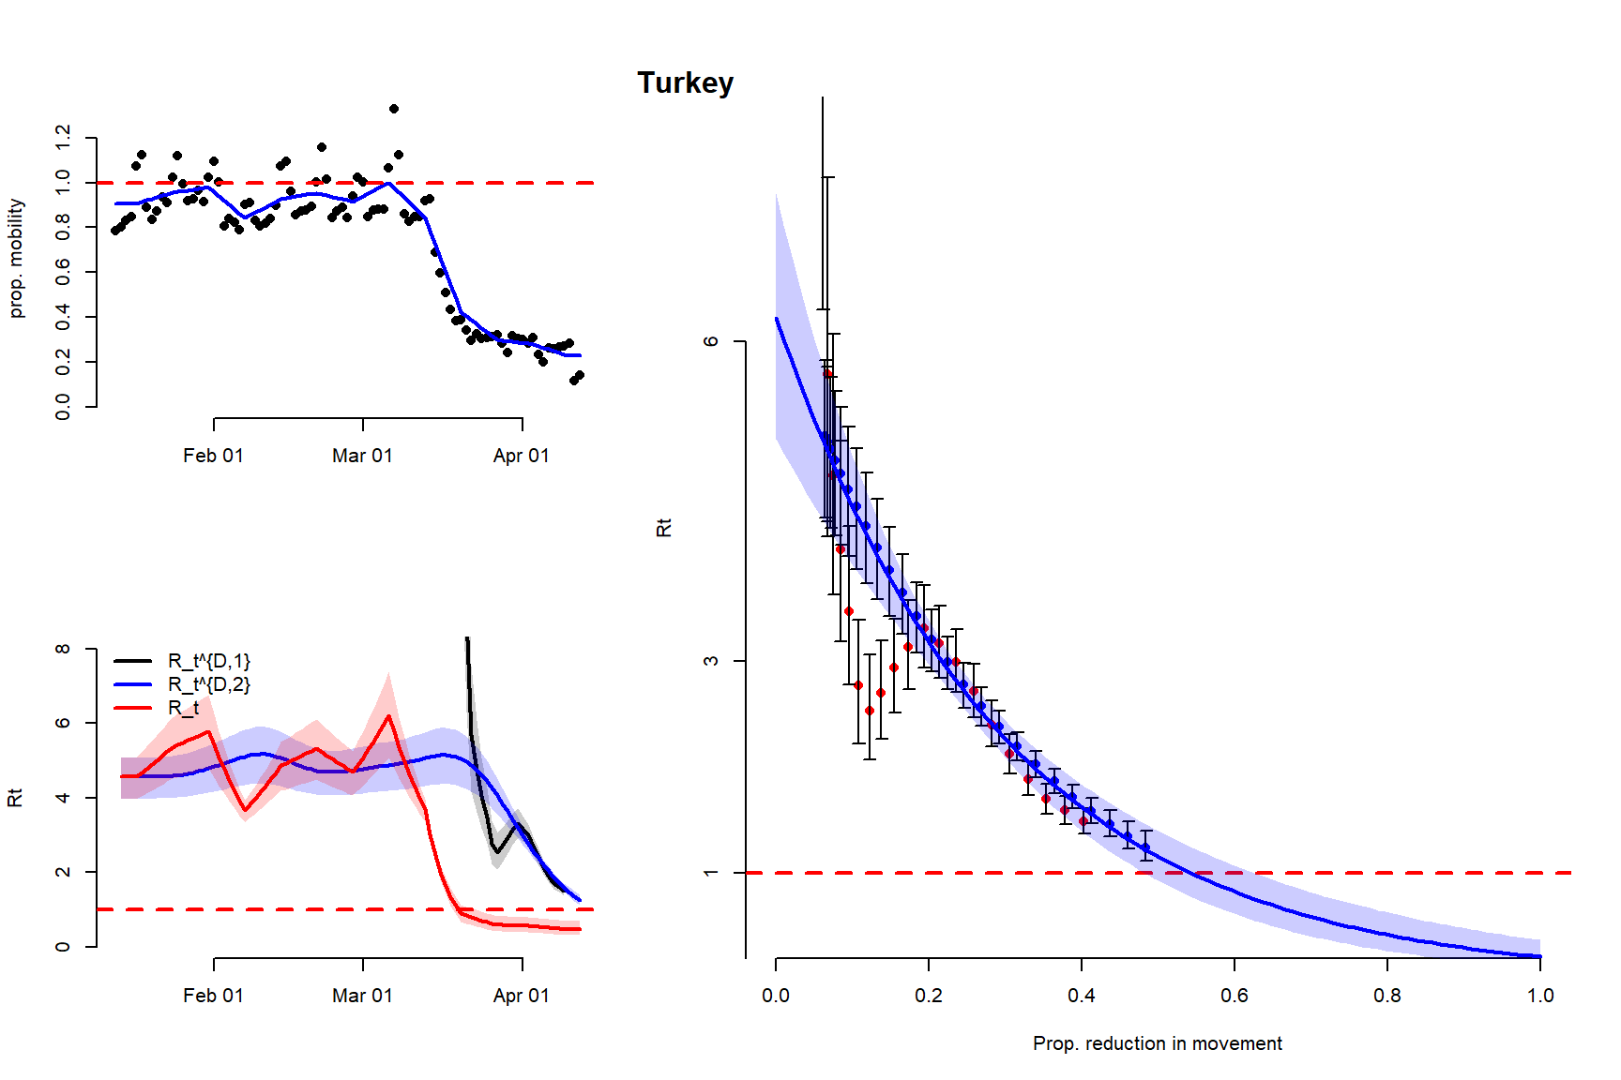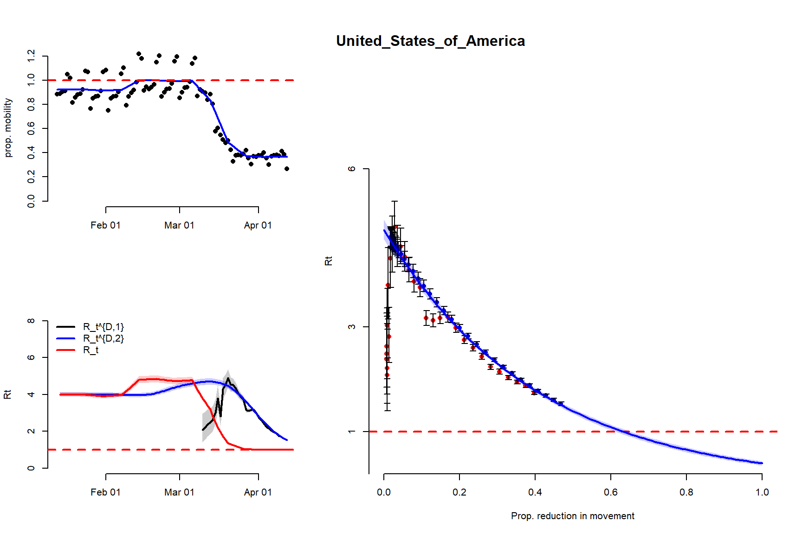

Short term forecasts

Long term forecasts scenario 1

Long term forecasts scenario 2

SI

Useful information for inference.

For epidemiological data:

We define a matrix of Deaths on day t, for location i:

Overall transmissibility matrix:

With

For mobility data:

We define a matrix of Deaths on day t, for location i:

The mobility at time of death relevant to the time of infection:

With

For the full model:

Given a vector of basic reproduction and parameter to link mobility and transmissibility, , the matrix of daily effective reproduction number is:

Where B is a matrix, of size ,with each column equal to .

The reproduction number relevant at the time of death become:

The likelihood is computed from and (with * the element by element product)

For short-term forecasts and longer-term predictions, we augment the mobility matrix above for future dates, get the effective reproduction matrices (using join posterior of estimate R0 and ), obtain the new augmented matrices of reproduction number at time of death , and finally compute the expected numbers of daily deaths in the future.

Using a Poisson random sampler, we get short-term forecasts or longer-term predictions.