Household model

**Methods**

Key assumptions:

* Each household infected once
* Precompute typical household dynamics
* Solve household dynamic
* Transmission rate between household is the same regardless of household size, BUT, larger households are infectious longer.

**Models**

***Deterministic model within household once index case appear:***

$$\frac{dS_{i,t}}{dt}=-β_{w}\frac{S_{i,t}I_{i,t}}{N_{i}}$$

$$\frac{dE_{i,t}}{dt}=β_{w}\frac{S_{i,t}I_{i,t}}{N_{i}}-δE_{i,t}$$

$$\frac{dI_{i,t}}{dt}=\left(1-IFR\right)δE_{i,t}-σI_{i,t}$$

$$\frac{dI_{i,t}^{d}}{dt}=IFR δ E_{i,t}-σI_{i,t}^{d}$$

$$\frac{dH_{i,t}}{dt}=σI_{i,t}^{d}-τH_{i,t}$$

$$\frac{dR_{i,t}}{dt}=σI_{i,t}$$

$$\frac{dD_{i,t}}{dt}=τH_{i,t}$$

With:

|  |  |  |  |  |
| --- | --- | --- | --- | --- |
| $$S_{i,t}$$ | Susceptible in household of size ‘i’ | $$β_{w}$$ | Within household transmission | Estimated  Constant throughout |
| $$E_{i,t}$$ | Exposed in household of size ‘i’ | $$δ$$ | Inverse of mean exposed period | 1/4 |
| $$I_{i,t}$$ | Infectious (will survive) in household of size ‘i’ | $$σ$$ | Inverse of mean infectious period | 1/4.5 |
| $$I_{i,t}^{d}$$ | Infectious (will die) in household of size ‘i’ | $$IFR$$ |  | 0.01 |
| $$H_{i,t}$$ | Those who will die and are hospitalised in household of size ‘i’  No transmission here  We don’t need to track those hospitalised who survive | $$τ$$ | Hospitalisation period prior to death | 1/(18.5-4-4.5)  18.5: delay infection-death |
| $$R_{i,t}$$ | recovered in household of size ‘i’ |  |  |  |
| $$D_{i,t}$$ | deaths in household of size ‘i’ |  |  |  |

***Deterministic model between households:***

Start with I0 infected households:

$$\frac{dS_{i,t}^{h}}{dt}=-β_{b}\frac{S_{i,t}^{h}\sum_{j}{I_{j,t}^{h}}}{N_{i}}$$

$$\frac{dE_{i,t}^{h}}{dt}=β_{b}\frac{S_{i,t}^{h}\sum_{j}{I_{j,t}^{h}}}{N_{i}}-δE_{i,t}^{h}$$

$$\frac{dI_{i,t}^{h}}{dt}=δE_{i,t}^{h}-σ_{i}^{h}I_{i,t}^{h}$$

$$\frac{dR_{i,t}^{h}}{dt}=σ_{i}^{h}I_{i,t}^{h}$$

With:

|  |  |  |  |  |
| --- | --- | --- | --- | --- |
| $$S_{i,t}^{h}$$ | Susceptible in household of size ‘i’ | $$β_{b}$$ | between households transmission | Estimated  weekly values within interpolation |
| $$E_{i,t}^{h}$$ | Exposed in household of size ‘i’ | $$δ$$ | Inverse of mean exposed period (as for within model) | 1/4 |
| $$I_{i,t}^{h}$$ | Infectious (will survive) in household of size ‘i’ | $$σ_{i}^{h}$$ | Inverse of mean infectious period of a household | Derived from solving the within household model |
| $$R_{i,t}^{h}$$ | recovered households of size ‘i’ |  |  |  |

From ONS data, household size in UK:

|  |  |  |  |  |  |  |
| --- | --- | --- | --- | --- | --- | --- |
| Household size | 1 | 2 | 3 | 4 | 5 | 6 |
| Number of households | 8197000 | 9609000 | 4287000 | 3881000 | 1254000 | 597000 |

**MCMC**

Fitting the model to:

* Aggregated death data

Allows overdispersion.

Use an MCMC to infer:

* One constant within household transmission rate
* Weekly between household transmission rates (with linear interpolation)

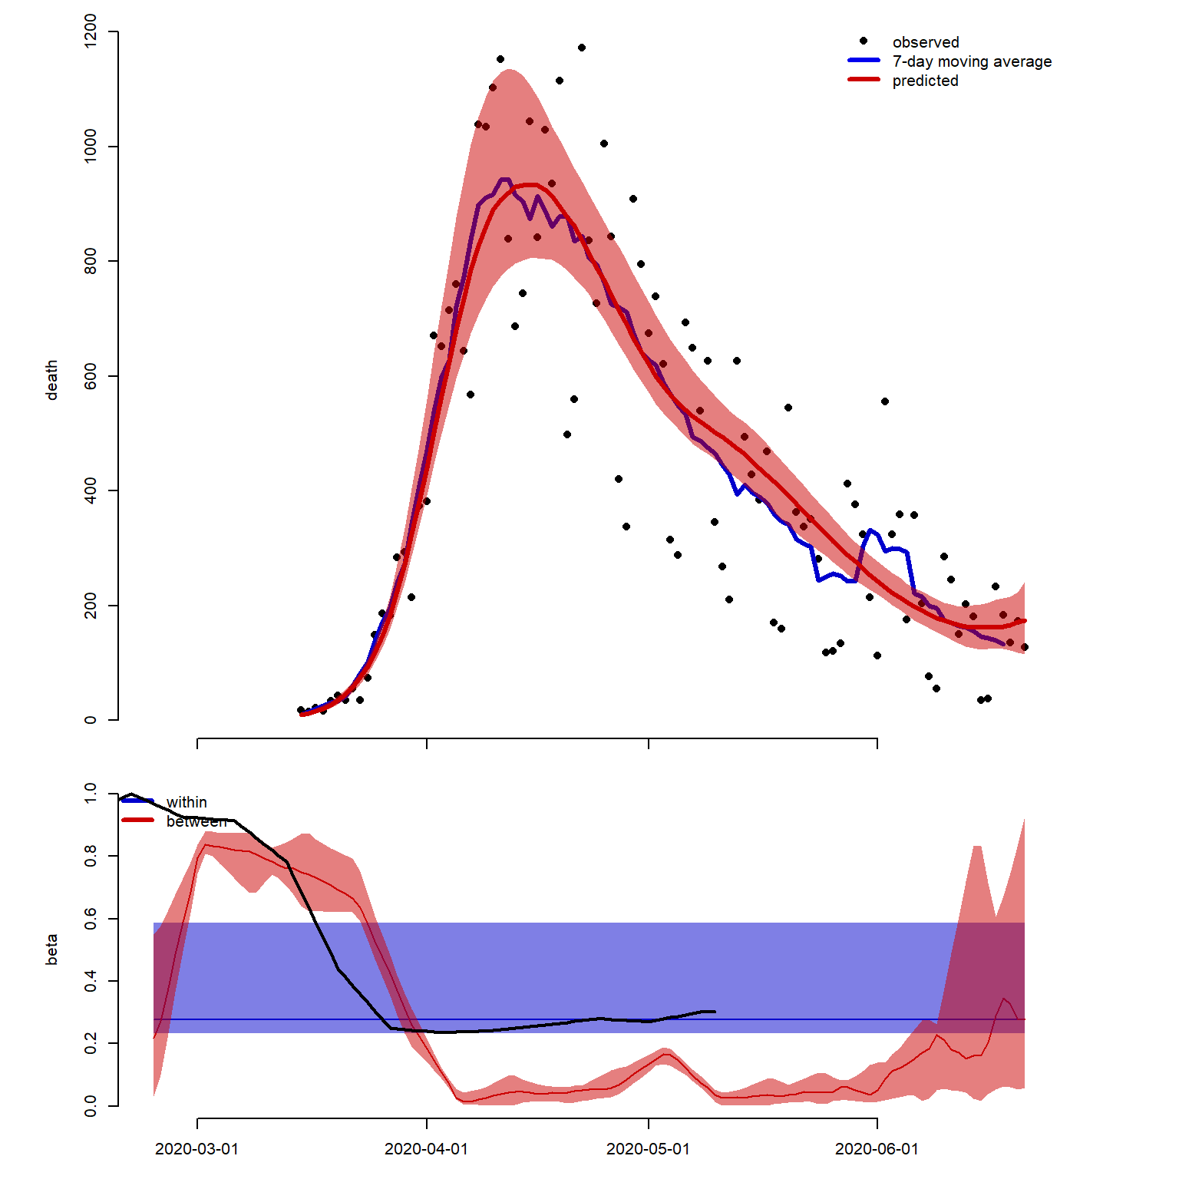

Figure1:

Upper panel: incidence of death in the UK. Black dots: reported deaths, blue line: 7-day moving average, red line/band: predicted incidence and 95%CrI.

Transmission within (blue) and between (red) households (medians and 95%CrIs). Also plotted as an indication in black: google mobility (mobility is not used in the model/inference).

Apparent delay in reduction of between household transmission may reflect too simplistic delay (introducing more compartment to simulate gamma-like distribution might improve this aspect).

*From the framework, we can extract:*

* How many households are affected any time
* The secondary attack rate within household

Every outputs can be specific for household size.

|  |  |  |  |  |  |
| --- | --- | --- | --- | --- | --- |
| Household size | 2 | 3 | 4 | 5 | 6 |
| Median | 0.63 | 0.59 | 0.56 | 0.54 | 0.52 |
| Lower 2.5% | 0.55 | 0.5 | 0.46 | 0.43 | 0.41 |
| Upper97.5% | 0.92 | 0.91 | 0.91 | 0.91 | 0.91 |

Clearly, we need more info as 2ndary attack rate seems too high?

***Some discussion point:***

In term of model:

* **Need stochasticity?** Perhaps not, given large number of households?
* **Age specific?**
* **Subnational analysis as transmission became much more local during lockdown, and will (hopefully) remain local in the future?**
* **Include care home as a ‘special’ household type?**
* **Break assumption of single index infection per households?**

Implementing all this would almost be equivalent of explicitly modelling each household? Micro-simulation model?

To a large extend, increasing model complexity depend on:

* Question addressed
  + Which in turns, depend on availability of data to fit the model…

In term of data:

* Fit to household sero-surveys? E.g. ONS Infection Survey pilot?