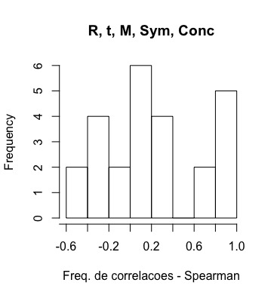

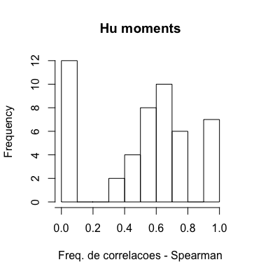

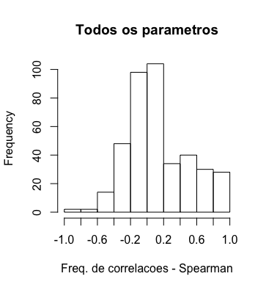

As frequências mostram o dobro da frequência real, pois o histograma foi calculado sobre toda a matriz de correlação.

Rm.re tp M_p Sim Conc

Rm.re 1.00000000 -0.28706123 -0.4944727 -0.09876811 -0.37276311

tp -0.28706123 1.00000000 0.7179655 0.04511436 0.23015566

M_p -0.49447271 0.71796549 1.0000000 0.12895607 0.32944101

Sim -0.09876811 0.04511436 0.1289561 1.00000000 0.03583238

Conc -0.37276311 0.23015566 0.3294410 0.03583238 1.00000000

I1 I2 I3 I4 I5 I6 I7

I1 1.00000000 0.74095122 0.63355215 0.60011808 0.37339876 0.49724489 0.08733847

I2 0.74095122 1.00000000 0.66838783 0.55513424 0.55373218 0.61933864 0.06829239

I3 0.63355215 0.66838783 1.00000000 0.64872823 0.42869161 0.50075714 0.06251216

I4 0.60011808 0.55513424 0.64872823 1.00000000 0.53148982 0.75477315 0.06920164

I5 0.37339876 0.55373218 0.42869161 0.53148982 1.00000000 0.72181764 0.08476966

I6 0.49724489 0.61933864 0.50075714 0.75477315 0.72181764 1.00000000 0.07512968

I7 0.08733847 0.06829239 0.06251216 0.06920164 0.08476966 0.07512968 1.00000000

Rm.re tm tp M_t M_p I1 I2

Rm.re 1.00000000 -0.094036174 -0.28706123 -0.174588057 -0.494472709 0.97597552 0.64802751

tm -0.09403617 1.000000000 0.83150416 0.711417123 0.552467095 -0.10238781 -0.14738409

tp -0.28706123 0.831504156 1.00000000 0.595338232 0.717965492 -0.24257462 -0.15414457

M_t -0.17458806 0.711417123 0.59533823 1.000000000 0.763198419 -0.21266962 -0.35004206

M_p -0.49447271 0.552467095 0.71796549 0.763198419 1.000000000 -0.44987374 -0.34215208

I1 0.97597552 -0.102387814 -0.24257462 -0.212669622 -0.449873738 1.00000000 0.74095122

I2 0.64802751 -0.147384093 -0.15414457 -0.350042059 -0.342152077 0.74095122 1.00000000

I3 0.55418660 -0.138561480 -0.15540866 -0.321126295 -0.334193410 0.63355215 0.66838783

I4 0.53897822 -0.121984580 -0.15385723 -0.291121857 -0.347507281 0.60011808 0.55513424

I5 0.29801558 -0.124633860 -0.10898841 -0.264124513 -0.206927075 0.37339876 0.55373218

I6 0.41761122 -0.132363658 -0.13896991 -0.299170274 -0.282967503 0.49724489 0.61933864

I7 0.09336241 0.014939367 -0.03065010 0.005054835 -0.051765193 0.08733847 0.06829239

a 0.64664057 0.102244766 -0.03080418 0.243363401 0.008033021 0.62242972 0.41039510

b -0.05564390 0.221868144 0.06744479 0.525256878 0.228867356 -0.17487198 -0.66103231

f.a.b.2 0.33901913 0.202526967 0.02750036 0.483000897 0.156144592 0.24955574 -0.18622753

tetha 0.01248371 -0.033518448 -0.01882858 -0.023519321 -0.020006127 0.01275618 0.01536975

Exc 0.39773761 -0.151518990 -0.07148082 -0.369603477 -0.213152723 0.51272092 0.94110785

flong 0.06431815 -0.021191884 -0.05981244 -0.020888882 -0.061502736 0.05255268 0.03106516

Sim -0.09876811 0.008186276 0.04511436 0.084002897 0.128956065 -0.10271289 -0.05575122

Conc -0.37276311 -0.053315407 0.23015566 -0.134334651 0.329441010 -0.21054262 0.20929815

I3 I4 I5 I6 I7 a b

Rm.re 0.554186596 0.538978217 0.29801558 0.41761122 0.093362410 0.646640572 -0.055643900

tm -0.138561480 -0.121984580 -0.12463386 -0.13236366 0.014939367 0.102244766 0.221868144

tp -0.155408663 -0.153857230 -0.10898841 -0.13896991 -0.030650096 -0.030804181 0.067444789

M_t -0.321126295 -0.291121857 -0.26412451 -0.29917027 0.005054835 0.243363401 0.525256878

M_p -0.334193410 -0.347507281 -0.20692707 -0.28296750 -0.051765193 0.008033021 0.228867356

I1 0.633552146 0.600118076 0.37339876 0.49724489 0.087338475 0.622429722 -0.174871981

I2 0.668387831 0.555134235 0.55373218 0.61933864 0.068292386 0.410395098 -0.661032312

I3 1.000000000 0.648728230 0.42869161 0.50075714 0.062512160 0.232276435 -0.439649614

I4 0.648728230 1.000000000 0.53148982 0.75477315 0.069201637 0.189598792 -0.333935403

I5 0.428691606 0.531489818 1.00000000 0.72181764 0.084769661 0.110558321 -0.468105618

I6 0.500757143 0.754773149 0.72181764 1.00000000 0.075129679 0.140079365 -0.492944822

I7 0.062512160 0.069201637 0.08476966 0.07512968 1.000000000 0.052689563 -0.027410945

a 0.232276435 0.189598792 0.11055832 0.14007936 0.052689563 1.000000000 0.298001666

b -0.439649614 -0.333935403 -0.46810562 -0.49294482 -0.027410945 0.298001666 1.000000000

f.a.b.2 -0.144276574 -0.100042063 -0.23626258 -0.23676686 0.014660268 0.775041577 0.822578574

tetha 0.000206061 0.006789588 0.06401932 0.02337752 -0.094187445 0.009019354 -0.003402182

Exc 0.583365744 0.451919469 0.54970328 0.58386754 0.048641992 0.234510351 -0.817874715

flong -0.051782311 0.007051662 0.14045685 0.08672316 0.023216667 0.082074371 0.030264301

Sim -0.103916184 -0.331413727 -0.14724186 -0.22936671 -0.042700220 0.034317142 0.036859927

Conc 0.164411633 0.078025284 0.24313317 0.22039745 -0.034309171 -0.260081369 -0.538547464

f.a.b.2 tetha Exc flong Sim Conc

Rm.re 0.339019128 0.012483710 0.397737608 0.064318150 -0.098768106 -0.37276311

tm 0.202526967 -0.033518448 -0.151518990 -0.021191884 0.008186276 -0.05331541

tp 0.027500356 -0.018828577 -0.071480817 -0.059812444 0.045114364 0.23015566

M_t 0.483000897 -0.023519321 -0.369603477 -0.020888882 0.084002897 -0.13433465

M_p 0.156144592 -0.020006127 -0.213152723 -0.061502736 0.128956065 0.32944101

I1 0.249555738 0.012756178 0.512720917 0.052552681 -0.102712891 -0.21054262

I2 -0.186227528 0.015369751 0.941107852 0.031065159 -0.055751219 0.20929815

I3 -0.144276574 0.000206061 0.583365744 -0.051782311 -0.103916184 0.16441163

I4 -0.100042063 0.006789588 0.451919469 0.007051662 -0.331413727 0.07802528

I5 -0.236262584 0.064019323 0.549703281 0.140456850 -0.147241860 0.24313317

I6 -0.236766861 0.023377521 0.583867545 0.086723164 -0.229366708 0.22039745

I7 0.014660268 -0.094187445 0.048641992 0.023216667 -0.042700220 -0.03430917

a 0.775041577 0.009019354 0.234510351 0.082074371 0.034317142 -0.26008137

b 0.822578574 -0.003402182 -0.817874715 0.030264301 0.036859927 -0.53854746

f.a.b.2 1.000000000 -0.000513961 -0.385480172 0.069173697 0.046072500 -0.49310074

tetha -0.000513961 1.000000000 0.012315558 -0.001763391 0.071022274 0.03389906

Exc -0.385480172 0.012315558 1.000000000 0.007502607 -0.016989529 0.40782017

flong 0.069173697 -0.001763391 0.007502607 1.000000000 -0.155774492 -0.05656536

Sim 0.046072500 0.071022274 -0.016989529 -0.155774492 1.000000000 0.03583238

Conc -0.493100742 0.033899060 0.407820166 -0.056565359 0.035832382 1.00000000