Installation

Minimal Path to Awesome
- Download the .msapp from the solution folder
- Within Power Apps Studio, use the .msapp file using File > Open > Browse and select the .msapp file you just downloaded.
- Select the Data tab
- Remove the 4 SharePoint data sources from the app:
  - MatrixApplication
  - MatrixLevel
  - MatrixRoster
  - MatrixNetwork
- Add new data sources for the 4 SharePoint lists you created in your environment. Make sure they have the same names; no spaces or special characters.
  - MatrixApplication
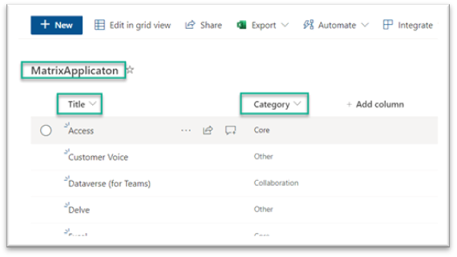
  - MatrixLevel
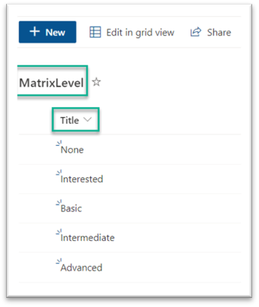
  - MatrixRoster
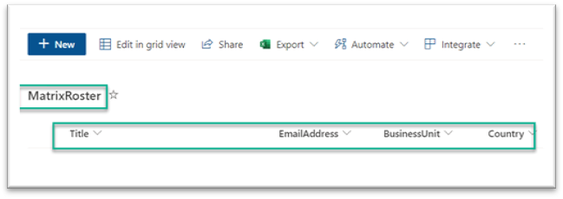
  - MatrixNetwork
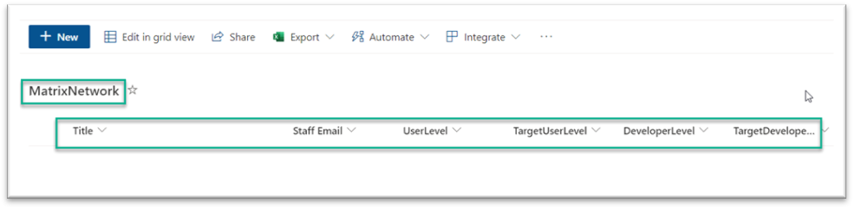
- Save and Publish

- Questions
I wanted to ask you the following two doubts:
- A doubt that comes to my mind is that for the “Title” column in all the tables I kept the one that already exists in Sharepoint. Do you think this is correct?
- As you can see in the following screenshot, all “collections” have no data records
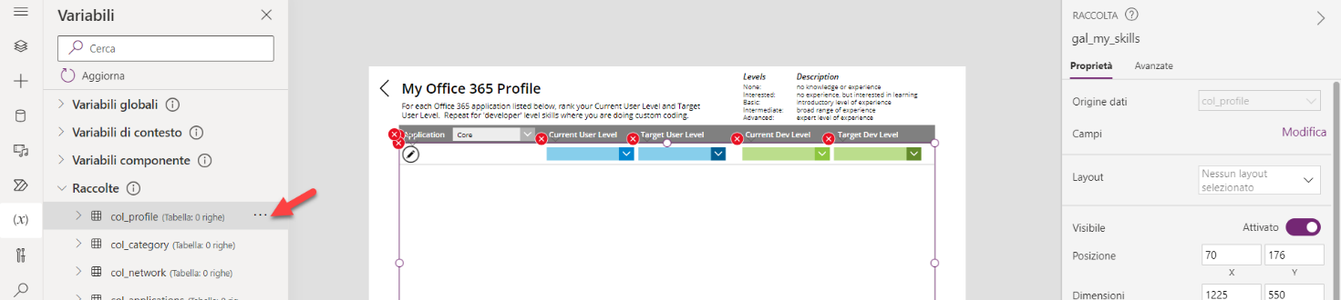
And when I run the page “My O365 Skills” …..
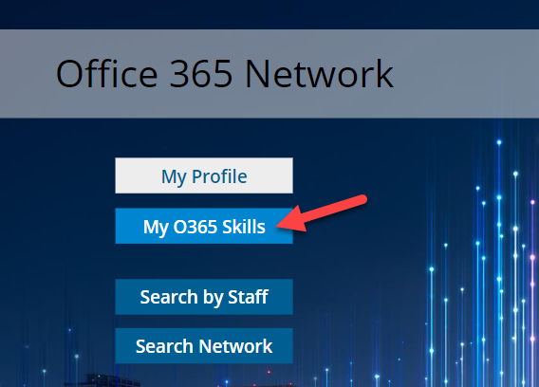
no records are displayed
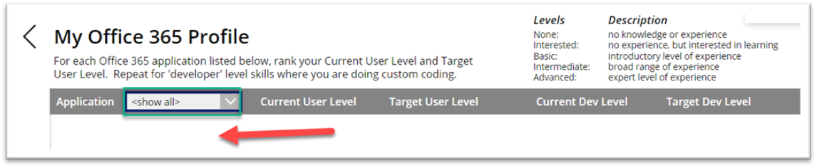
Thanks and regards
Giannino

