**MODULAR SOAPUI FRAMEWORK**

**SETUP AND CONFIGURATION**

**GUIDE**

|  |  |
| --- | --- |
| Author | Umamahesh Senagavarapu |
| Author Details | Test Automation Solutions Architect, L&G SSP Smart Quote Project |
| Document version | Draft |
| Issued Date | 25/03/2018 |

**Declaimer:**

The users should be well-versed with Basic concepts of Computer, Operating System, SOAPUI, MS EXCEL, Software testing and Web services before attempting to consume the modular framework. Above basics are not covered in this document. This document is the property of SSP and as of now in draft state. It shall be communicated to authorised personnel only. It is not to be disclosed outside the authorised group without prior written consent.

**FRAMEWORK SETUP:**

1. Before going thru the instructions please complete reading the Modular Framework Introduction and Overview document. And please make sure you are well-versed with basic concepts of Computer, Operating System, SOAPUI, MS EXCEL, Software testing and Web services .
2. 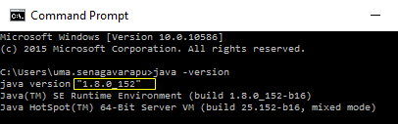Make sure you have Java Run Time Environment 8 (some of the code deveoped on jdk-8u152-windows-x64.exe, same version run time environment should be enough) is installed and added in Path environment variable on your test machine. So that you can use java from anywhere on your machine And make sure when you type ‘java –version” command on your command prompt it should confirm the JRE version as shown in the below screenshot.
3. Get the latest ‘ModularSOAPUIFramework’ from SVN’s current branch. How to use SVN is not in the scope of the document.

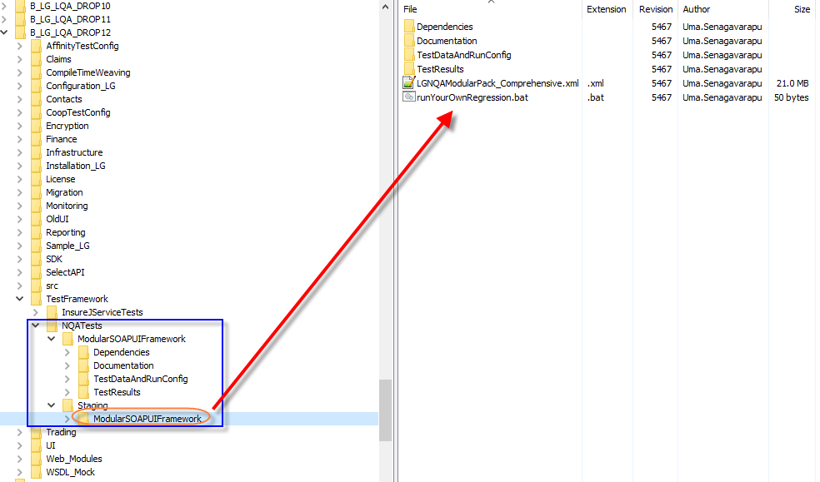

1. Now the ‘ModularSOAPUIFramework’ folder should contain following with the following contents as shown in the screenshot.

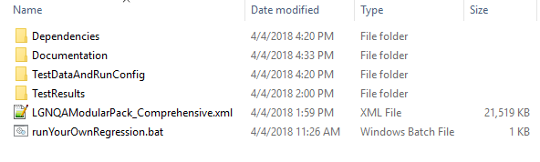

1. For the select connect testing, data driven and reporting capabilities, please make sure you copy sqlite-jdbc-3.21.0.jar , ‘poi-3.10-FINAL-20140208.jar ‘, ‘db2jcc.jar’ and ‘db2cc_license_cu.jar’ from “.\ModularSOAPUIFramework\Dependencies\external “ folder to your <SOAPUI_HOMEDIR>\bin\ext folder.

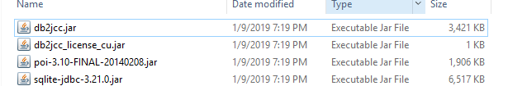

1. Copy ‘ssptestreporter.jar’ file from “.\ModularSOAPUIFramework\Dependencies\ssp “ folder to your <SOAPUI_HOMEDIR>\bin\ext folder, and restart the SOAPUI Application.

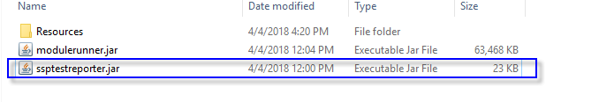

Note: *<SOAPUI_HOMEDIR>* location is depends on SOAPUI version you installed, either under ‘C:\Program Files\SmartBear’ or ‘C:\Program Files (x86)\SmartBear’ . Please copy to the correct <SOAPUI_HOMEDIR>\bin\ext folder.

1. Make sure that your C:\Users\<SYSTEM_USER_HOME>\ directory has “soapui-settings.xml”. Else copy “soapui-settings.xml” from “.\ModularSOAPUIFramework\Dependencies\external “ folder to that your C:\Users\<SYSTEM_USER_HOME>\ directory.
2. 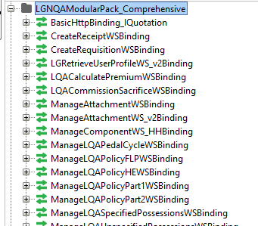 Import ‘LGNQAModularPack_Comprehensive.xml’ file in to SOAPUI application. As a result, you can see the **‘‘** project in SOAPUI workspace.
3. This ‘**ModularPack’** has, has 3 major sections
   * AutomationScriptsLibrary
   * ReusableWSRequestTemplates and ReusableTestCases
   * 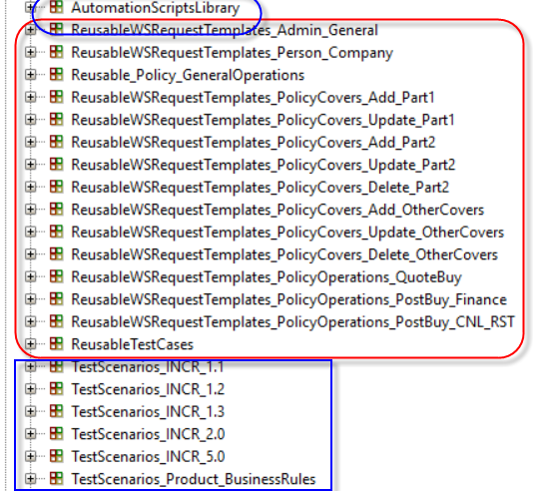TestScenarios
4. Now you are all set to consume the framework.