**MODULAR SOAPUI FRAMEWORK**

**Test Case Execution - SOAPUI**

|  |  |
| --- | --- |
| Author | Umamahesh Senagavarapu |
| Author Details | Test Automation Solutions Architect, L&G SSP Smart Quote Project |
| Document version | Draft |
| Issued Date | 25/03/2018 |

**Declaimer:**

The users should be well-versed with Basic concepts of Computer, Operating System, SOAPUI, MS EXCEL, Software testing and Web services before attempting to consume the modular framework. Above basics are not covered in this document. This document is the property of SSP and as of now in draft state. It shall be communicated to authorised personnel only. It is not to be disclosed outside the authorised group without prior written consent.

**Test Case Execution in SOAPUI :**

1. Before going thru the document please make sure you are well-versed with basic concepts of Computer, Operating System, SOAPUI, MS EXCEL, Software testing and Web services .
2. The framework built without hampering the SOAPUI ‘s own features. So you can execute the SOAPUI way, TestSuite level/test Case level as usaual, addditionally you would get benefits of impressive reports for each test case.
3. Prior to running your SOAPUI Test cases or Test Suites, as a first step, configure the project properties ‘environmentName’, ‘releaseCode’ ,’ xtrnlTestDataSheetName’ with the help of the given groovy script. This is to consume correct external Tets data and also to generate reports in a correct folder structure.
   1. ‘environmentName’ refers to the LG Application Under Test. Generally the Environments of NQA releases. Example : ‘LGDrop2’ or ‘LGBaseline’ (as shown in the screnshot). Please note that the ‘env’ URL is important to trigger tests. So be cautious when entering this.
   2. releaseCode’ is useful to track each run against a build with unique runID. Example “LGNQA_1_0_11_3_REGID_0001 means’ LGNQA_<RELEASE_NUM>_REGID_<REGRESSION_RUN_INCREMENT>’ . The suffix number (_<REGRESSION_RUN_INCREMENT>’ ) useful in identify the regression run ID. Make sure that increment that for each of your regression run.
   3. ‘xtrnlTestDataSheetName’ is the testData sheet name under ‘TestData.xls’. Each ‘xtrnlTestDataSheetName’ represents Test Area.
4. We have introduced an easy way to configure these project properties thru groovy script. Navigate to Project_ROOT > TESTSUITE “AutomationScriptsLibrary” > TESTCASE ”LQATestPackExecutionController” and open TESTSTEP “ConfigureModularRun”. In the groovy script, configure ‘environmentURL’, ‘environmentName’, ‘releaseCode’ ,’ xtrnlTestDataSheetName’ project property values through the below variable initialisations –

**def environmentURL**='http://${#Project#AppServerHostNameWithPort}/${#Project#environmentName}/TechnologyFrameworksWeb'

**def SOAPUILGEnvironmentName**='LGBaseline'

**def SOAPUILGTargetMileStone**='LGNQA_1_0_11_3_REGID_0001'

**def SOAPUILGTestAreaName**='S_G_GLD'

Note: If you are using different environments than GUIVMDB02 servers (LGDrop2, LGDrop66,..etc) and outside of SSP organisation, then change then only change ‘environmentURL’ .

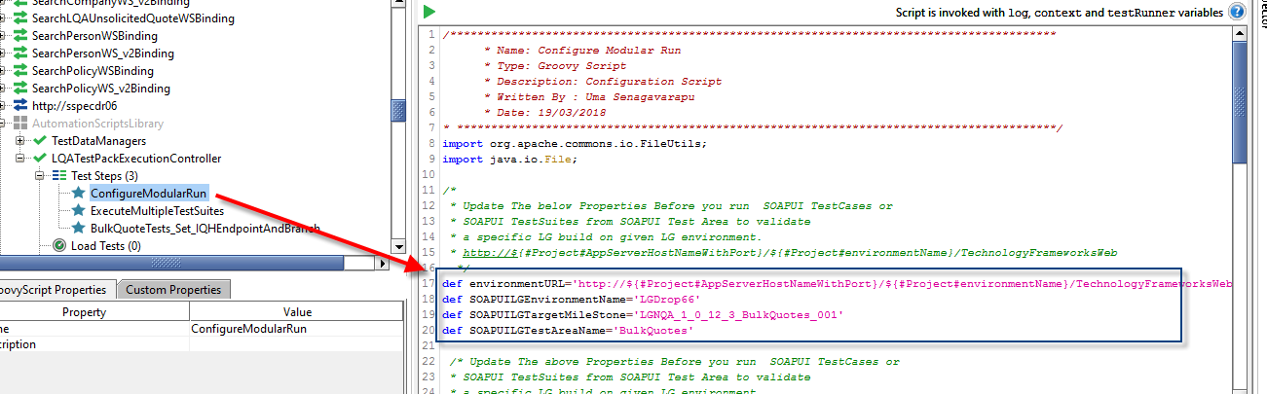

1. Leave other things in the code/script as it is and run the groovy script. When the script run finishes successfully, you are ready to run the SOAPUI Test Cases and Test Suites.
2. Run SOAPUI TestCase or SOAPUI TestSuite that you wanted.
3. When execution of the test finishes , then you can view <TESTCASE>_<TIMESTAMP>.log files and <TESTCASE>_<TIMESTAMP>.xml files under ‘C:\<PROJECT_HOME>\TestResults\<ENVIRONMENTname>\<releaseCode>\<TestArea>\<TestSuite>\’.

When C:\LG_LQA_Project\ModularSOAPUIFramework is the <PROJECT_HOME> then test results of a specific TESTSUITE “LGNQA_SchemeDependant_INCR_1.3_Quote_Requote_BasicTests “saved as belowsample heirarchy on file system -“C:\LG_LQA_Project\ModularSOAPUIFramework\TestResults\LGDROP2\Select_3.0.7_LGNQA_RC6\ S_G_GLD\ LGNQA_SchemeDependant_INCR_1.3_Quote_Requote_BasicTests\”

1. The .log files are created for each SOAPUI test case. And they contain REQ, RES flow in the test steps’ sequence. And .xml is the web report of test cases.

**Viewng .LOG files:**

* 1. Make sure you open .log files in Notepad ++ and .XML Web reports in InternetExplorer (as below).
  2. Log file contents in Notepad ++ as below:

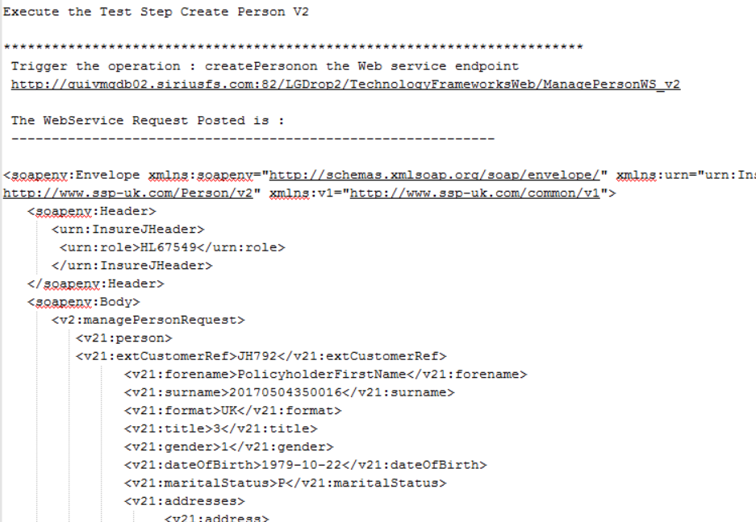

**Viewing .XML files on IE Web browser-**

* 1. Run the

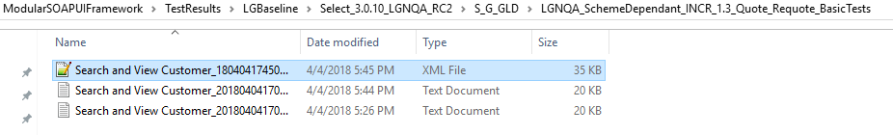

1. A sample Test case report appears as below:

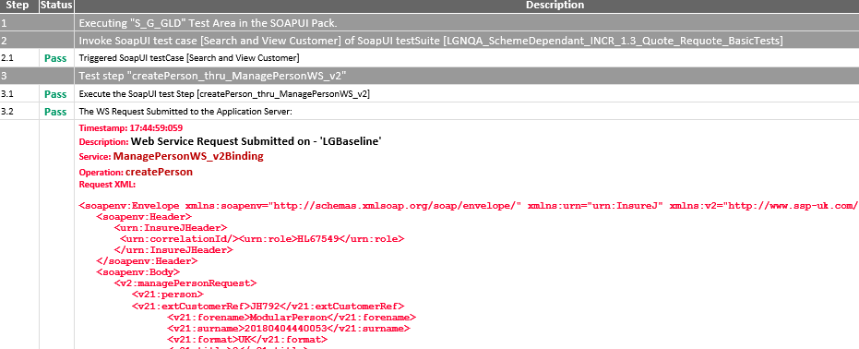

**Executing Multiple Test Suites on a Test Area from SOPAUI and gettting a Sumamry Report:**

1. You can execute multiple Test Suites on a Test Area from SOPAUI and gettting a Sumamry Report now.
2. There is a Properties file introduced to facilitate the bult execution of all testSuites in one go. The ‘runnableTestSuites.proeprties’ found in <PROJECT_HOME>\ TestDataAndRunConfig folder.

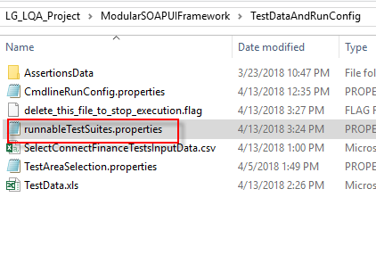

1. 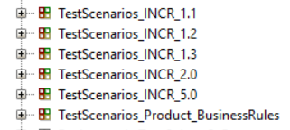The file has list of TestSuites (the same name as in the SOAPUI project. You can comment out by keeping a ‘#’ before the testSuite.

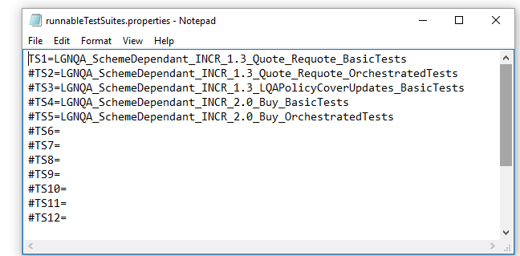

1. In the SOAPUI Project, under ‘AutomationScriptsLibrary’ testSuite, under ‘LQAtestPackExecutionController’ testCase, there is a groovy script named as ‘ExecuteMultipleTestSuites’. Just run script.

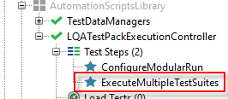

1. When execution of the test finishes , then you can view <TESTCASE>_<TIMESTAMP>.log files and <TESTCASE>_<TIMESTAMP>.xml files under ‘C:\<PROJECT_HOME>\TestResults\<ENVIRONMENTname>\<releaseCode>\<TestArea>\<TestSuite>\’.

When C:\LG_LQA_Project\ModularSOAPUIFramework is the <PROJECT_HOME> then test results of a specific TESTSUITE “LGNQA_SchemeDependant_INCR_1.3_Quote_Requote_BasicTests “saved as belowsample heirarchy on file system -“C:\LG_LQA_Project\ModularSOAPUIFramework\TestResults\LGDROP2\Select_3.0.7_LGNQA_RC6\ S_G_GLD\ LGNQA_SchemeDependant_INCR_1.3_Quote_Requote_BasicTests\”

1. Also a SumamryReport is Generated under “C:\<PROJECT_HOME>\TestResults\<ENVIRONMENTname>\<releaseCode>\” folder.

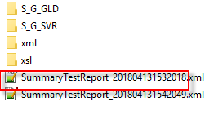

**What happens if externaltestdata =false:**

Sometimes you may want to experiment WS Requests by modifying test data thru SOAPUI properties section. Then you don’t require to use the external test data from EXCEL file. In this case, you can execute the tests one by one, by just tweaking the project properties manually. For that you just need to change the ‘**externaltestdata’** project property to ‘false’. when property is ‘false’ then we have to manually change the values in SOAPUI Project Properties for each Tetscase. Though we consume internal data (from SOAPUI), the web service log file and web report files are generated as usual.

**Note:** By default, keep this ‘**externaltestdata’** project property set to ‘true’ to make use of external testdata capabilities and also when running multiple TestCases or a TestSuite. By setting ‘**externaltestdata’** project property to ‘true’ you can save lot of manual configuration time.

