**MODULAR SOAPUI FRAMEWORK**

**Regression Guide**

|  |  |
| --- | --- |
| Author | Umamahesh Senagavarapu |
| Author Details | Test Automation Solutions Architect, L&G SSP Smart Quote Project |
| Document version | Draft |
| Issued Date | 25/03/2018 |

**Declaimer:**

The users should be well-versed with Basic concepts of Computer, Operating System, SOAPUI, MS EXCEL, Software testing and Web services before attempting to consume the modular framework. Above basics are not covered in this document. This document is the property of SSP and as of now in draft state. It shall be communicated to authorised personnel only. It is not to be disclosed outside the authorised group without prior written consent.

**Regression Runs- Configuration :**

1. Before going thru the document please make sure you are well-versed with basic concepts of Computer, Operating System, SOAPUI, MS EXCEL, Software testing and Web services .
2. Configure the properties ‘environmentName’, ‘releaseCode’, ‘SOAPUIProjectXMLFileName ‘, ‘SOAPUIProjectPropertyFileName ‘ properties in CmdlineRunConfig.properties file which is available under .\ModularSOAPUIFramework\TestDataAndRunConfig\ folder.

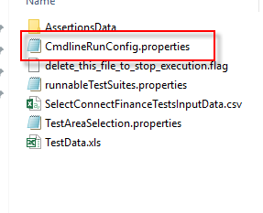

**Example:**

environmentName=LGDrop2

releaseCode=LGNQA_1_0_11_3_REGID_0002

SOAPUIProjectXMLFileName=LGNQAModularPack_Comprehensive.xml

SOAPUIProjectPropertyFileName=modularproject.properties

* 1. The project property ‘environmentName’ with LG Application Under Test Environments of NQA. Example : ‘LGDrop2’ or ‘LGBaseline’ (as shown in the screnshot). Please note that the ‘env’ URL is important to trigger tests. So be cautious when entering this.
  2. The project propertiy ‘releaseCode’ is useful in organising results based on releases. For example “LGNQA_1_0_11_3_REGID_0001 means’ LGNQA_<RELEASE_NUM>_REGID_<REGRESSION_RUN_INCREMENT>’ .

The suffix number (_<REGRESSION_RUN_INCREMENT>’ ) useful in identify the regression run ID. Make sure that increment that for each of your regression run.

1. Also there is one more properties file introduced to facilitate the bult execution of all testSuites in one go. The ‘TestAreaSelection.properties’ found in .\ModularSOAPUIFramework\TestDataAndRunConfig\. The file has list of TestAreas (You can commentout by keeping a ‘#’ before the testArea)

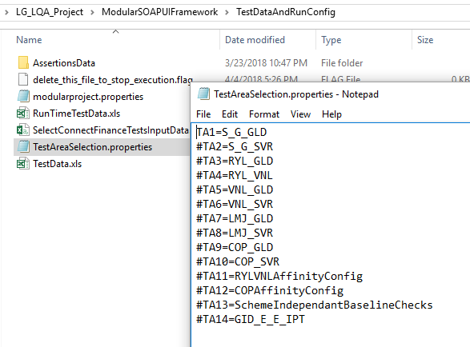

1. The test data of test cases belongs to the particular ‘TestArea’ are maintained under the specific TestArea sheet in ‘TestData.XLS’ file under .\ModularSOAPUIFramework\TestDataAndRunConfig folder.

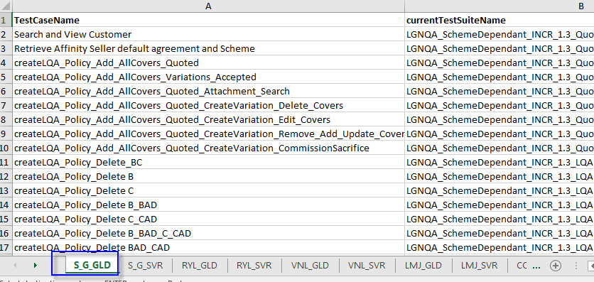

1. You can configure to run a particular test case by putting an ‘YES’ against the column ‘**RunThisTestCaseYESNO’.**

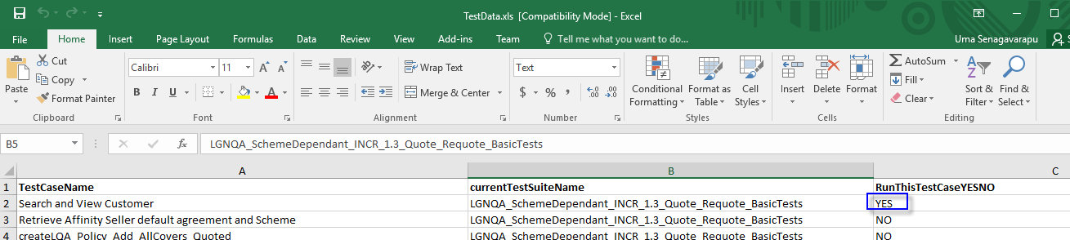

1. Make sure you close all EXCEL sheets and property files before you trigger the regression run.
2. To trigger regression just double click on “runYourOwnRegression.bat” windows batch file under .\ModularSOAPUIFramework\ folder

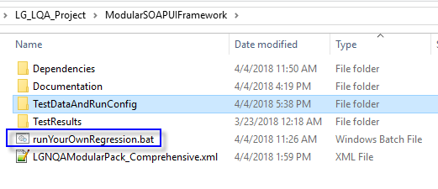

1. As a result, a command line opens and runs the regression. Once the regression finishes, you will see the results. If you want to stop the regression in between just remove the “delete_this_file_to_stop_execution.flag” file from .\ModularSOAPUIFramework\TestDataAndRunConfig folder.

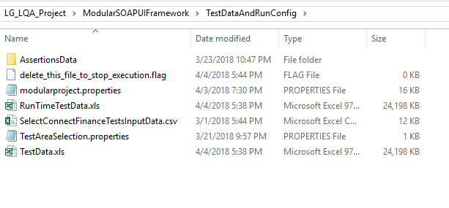

1. You can rerun the tests by using RunTimeTestData.xls.
2. The summary report generated under the <RegressionRunID> folder.

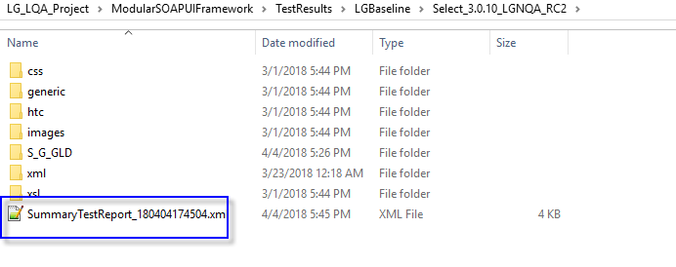

1. The summary results XML opened in IE and the web report appears as in the sample screenshot:

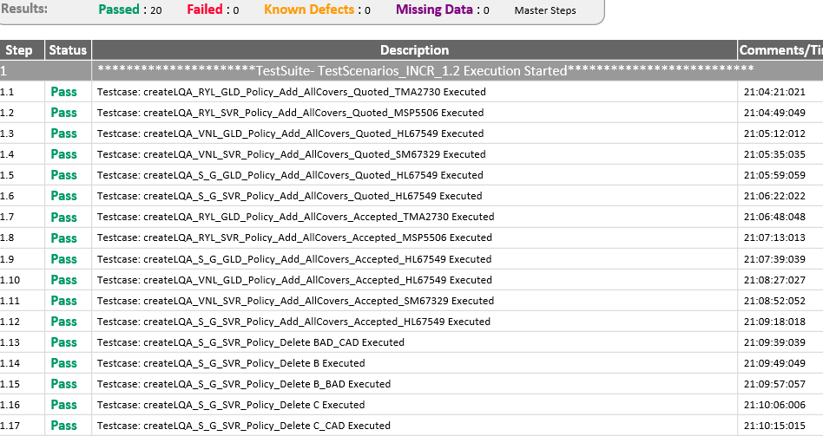

1. Each test case will have results generated in web format under specific TestSuite folder.

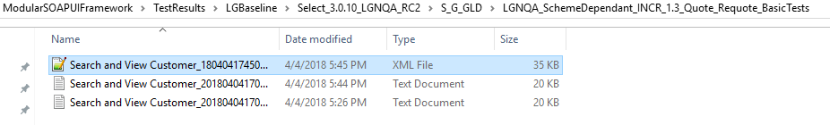

1. A sample Testcase specific report appears as below:

