**MODULAR SOAPUI FRAMEWORK**

**Testcase Development**

|  |  |
| --- | --- |
| Author | Umamahesh Senagavarapu |
| Author Details | Test Automation Solutions Architect, L&G SSP Smart Quote Project |
| Document version | Draft |
| Issued Date | 25/03/2018 |

**Declaimer:**

The users should be well-versed with Basic concepts of Computer, Operating System, SOAPUI, MS EXCEL, Software testing and Web services before attempting to consume the modular framework. Above basics are not covered in this document. This document is the property of SSP and as of now in draft state. It shall be communicated to authorised personnel only. It is not to be disclosed outside the authorised group without prior written consent.

**TEST SCENARIO DEVELOPMENT**

1. Before going thru the document please make sure you are well-versed with basic concepts of Computer, Operating System, SOAPUI, MS EXCEL, Software testing and Web services .
2. In this part we will focus on developing test cases using the existing reusable test case modules or reusable WS request templates.
3. Please note that, this chapter doesnot teach you how to create a reusable WS template or a reusable test case. This only focuses on how to create different test flows using already developed WS reusable templates.
4. As a first step, either you may be creating a new testSuite or consuming existing testSuite.
5. I’m sure you are familiar how to create a new testSuite in SOAPUI user interface.

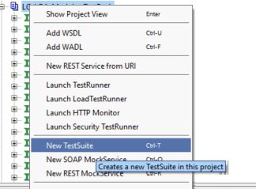

1. Then clone the Model TestCase “ **CloneableTestCase”** belongs to the Suite from **“CloneableTestCaseContainer”** to your TestSuite exists in the same project.

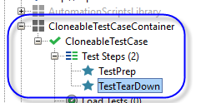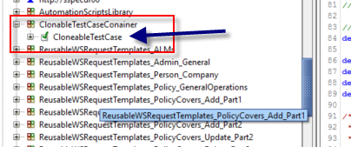

1. 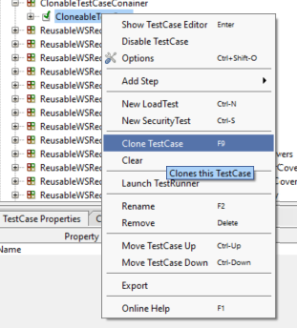We can clone a test case as shown in the screenshot beside.
2. 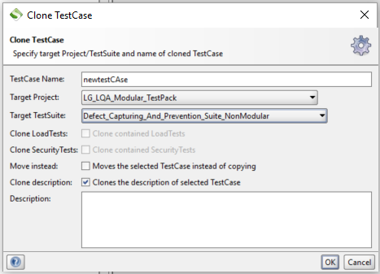And make sure you don’t use white spaces, special characters (except underscore) for the test case name.
3. Add The cloned testcase appears in your Suite as below:

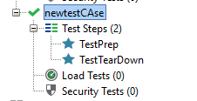

**Adding a testSteps to the test case:**

1. Now you can start adding new “Run TestCase” type test steps between ‘TestPrep’ step and “TestTearDown” steps.
2. We can add “Run TestCase’ type test step in SOAPUI by –
   1. Select testcase to which you intended to add test steps.
   2. “Insert Step”-> “Run TestCase”.

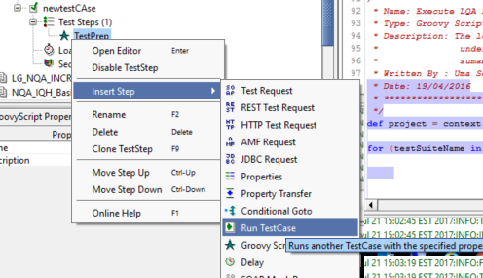

1. Give some meaningful name to the test step.

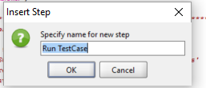

1. Select the required ‘modu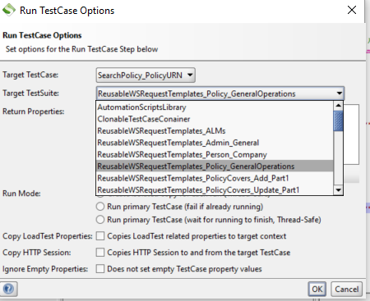lar/reusable test case’ from the listed testsuites.
2. We can reuse existing Reusable WS temaplates or existing reusable test cases from the below testSuites.

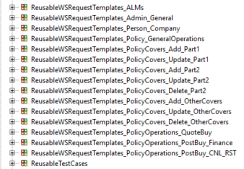

1. And make sure you select the 3rd option ‘Run Primary testCase (thread Safe)

(rounded with red in the below screenshot)

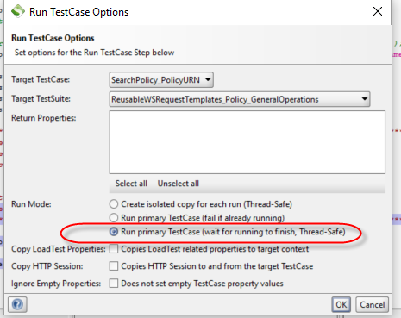

1. Same way add other teststeps as per your test flow.
2. Once you complete adding testSteps, make sure you add a row in the External testData file (EXCEL File) “TestData.xls” under the folder <PROJECT_HOME>\ ModularSOAPUIFramework\TestDataAndRunConfig\. Generally we copy paste existing row and change the testcase name, test Suite name and all required fields.

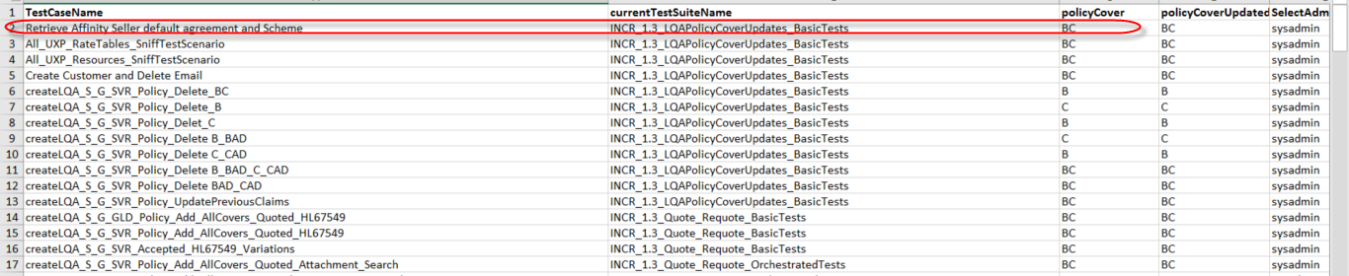

1. Now you are ready to run the test case.