**MODULAR SOAPUI FRAMEWORK**

**Modular WS Request Templates**

|  |  |
| --- | --- |
| Author | Umamahesh Senagavarapu |
| Author Details | Test Automation Solutions Architect, L&G SSP Smart Quote Project |
| Document version | Draft |
| Issued Date | 25/03/2018 |

**Declaimer:**

The users should be well-versed with Basic concepts of Computer, Operating System, SOAPUI, MS EXCEL, Software testing and Web services before attempting to consume the modular framework. Above basics are not covered in this document. This document is the property of SSP and as of now in draft state. It shall be communicated to authorised personnel only. It is not to be disclosed outside the authorised group without prior written consent.

**OVERVIEW OF Modular Web Service Request Templates :**

1. Before going thru the document please make sure you are well-versed with basic concepts of Computer, Operating System, SOAPUI, MS EXCEL, Software testing and Web services .
2. 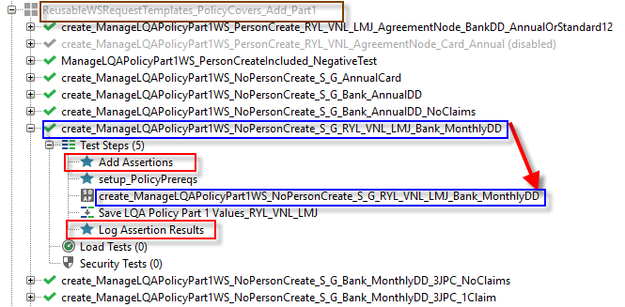ReusableWSRequestTemplates are called as “Modules”. So this is Modular framework.
3. Each ReusableWSRequestTemplate is typically of “SOAPUI TestCase” type.
4. 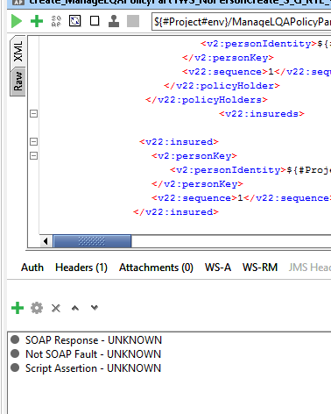Each testcase should strictly contain only one WS request step.
5. The testcase name and WS request Step name should be same.
6. The “ReusableWSRequestTemplate“ should have “Add Assertions” as first step. And “Log Assertion Results” is the last step.
7. Between these two steps, we can have some useful groovy needed for prerequisite preperations on particular request, and the actual WS Request tempalte and a proeprty trassfer.
8. All many nodes in the WS request step body should be parameterised as possible.
9. All (Proeprty Transfer Step as well as WS request Body) should use Project Level Properties.
10. WS Request template should have minimum 3 types of assertion attached to that, they are “SOAP Response”, “NOT SOAP Fault/SOAPFault(in case of negative test)”, and a “Script Assertion”.
11. Script Assertion is to log the Web Service Message Exchangeddetails. So Please copy paste the contents of exisitng Script Assertion of any existing “reusable WS template’s WS request Step” for accuracy.
12. 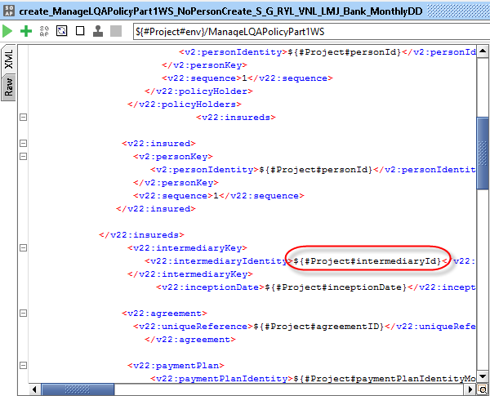Example Property Transfer as shown in the screenshot wich consume project level properties.
13. 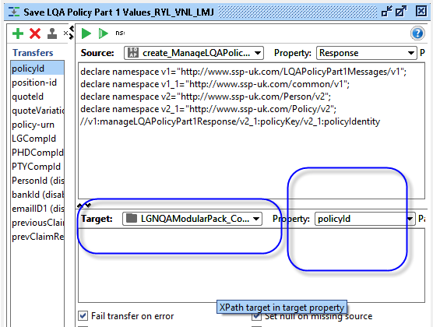Example WS Request template body, as shown in the screenshot wich consume project level properties.